Should Federal Law Enforcement Have a Presence at Protests

Introduction:
In 2020, protests against systemic racism and police violence have gained in frequency and size. While the majority of protests have been peaceful, violent outbreaks have unfortunately become common and detracted from the validity and focus of the protests. With the outbreak of violence, Local Law Enforcement and Officials have been unwilling or unable to maintain control and allow for peaceful protests to continue. As a result, the Federal Government has sent Federal Law Enforcement to numerous cities in an attempt to maintain peaceful protests and prevent violent outburst.
Summary:
The goal of the model and analysis is to determine what the best possible response (If any) can be given by the Federal Government. The analysis utilized the BOCR model which found that sending Federal Advisors to assist Local Law Enforcement with strategy and planning to be the best option considered. The least beneficial option considered was Physical Intervention/Presence by Federal Law Enforcement at future protests. It is important to note, this model was constructed envisioning the Federal Government as the Decision Maker.
Model:
Three alternatives were considered in the utilization of the model. They are as follow:
- Physical Intervention/Presence by Federal Law Enforcement
- Federal Advisors Assist Local Law Enforcement with planning and strategy
- No action taken at the Federal level
Moving forward in the model, the control criteria were implemented as follows:
- Benefits
  - Economic: The business/economic impact that can be achieved by varying levels of Federal law enforcement presence during protests
  - Social: The social benefits to public welfare that can be achieved by varying levels of Federal law enforcement presence during protests
  - Political: Political Benefits that can be achieved by varying levels of Federal law enforcement presence during protests
- Opportunities
  - Economic: The business/economic opportunities that can be realized by varying levels of Federal law enforcement presence during protests
  - Social: The social opportunities to public welfare that can be realized by varying levels of Federal law enforcement presence during protests
  - Political: Political opportunities that can be realized by varying levels of Federal law enforcement presence during protests
- Costs
  - Economic: The business/economic costs that could result from varying levels of Federal law enforcement presence during protests
  - Social: The social costs to public welfare that could result from varying levels of Federal law enforcement presence during protests
  - Political: Political costs that that could result from varying levels of Federal law enforcement presence during protests
- Risks
  - Economic: The business/economic risks that could be realized by varying levels of Federal law enforcement presence during protests
  - Social: The social risks to public welfare that could be realized by varying levels of Federal law enforcement presence during protests
  - Political: Political risks that that could be realized varying levels of Federal law enforcement presence during protests
The strategic criteria used were selected based on what was believed to be most impacted depending on the decision or alternative utilized by the federal government
- Public Safety
- Uphold Constitutional Rights
- Maintain Peace
- Economic Stability
Model – In Detail:
The following section will show data used in the Super Decisions software when creating the BOCR model and explanations.
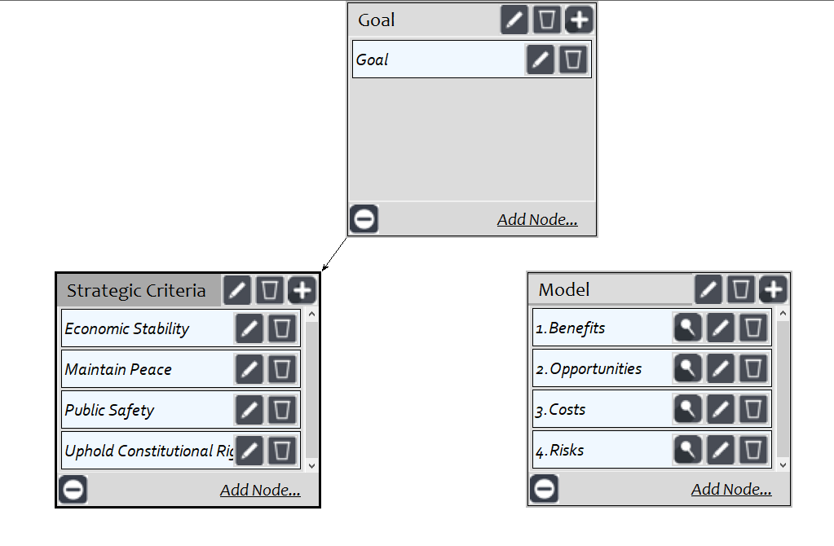
The control criteria shown below was utilized for Benefits, Opportunities, Costs and Risks
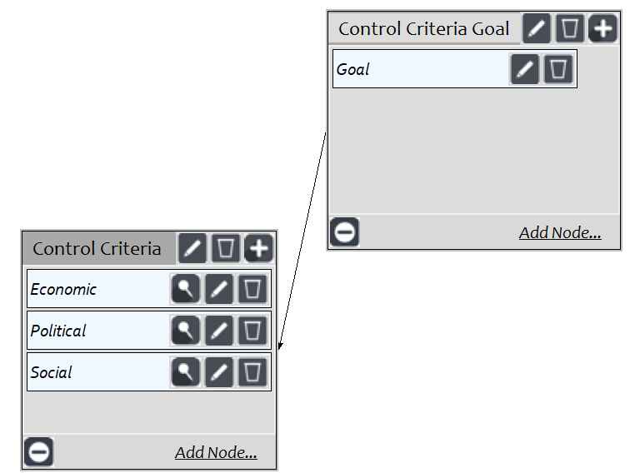
Benefits Subnets:
The benefits (Economic) subnet allows for the description of alternatives as they relate economically to important topics, upholding rights and interested parties.
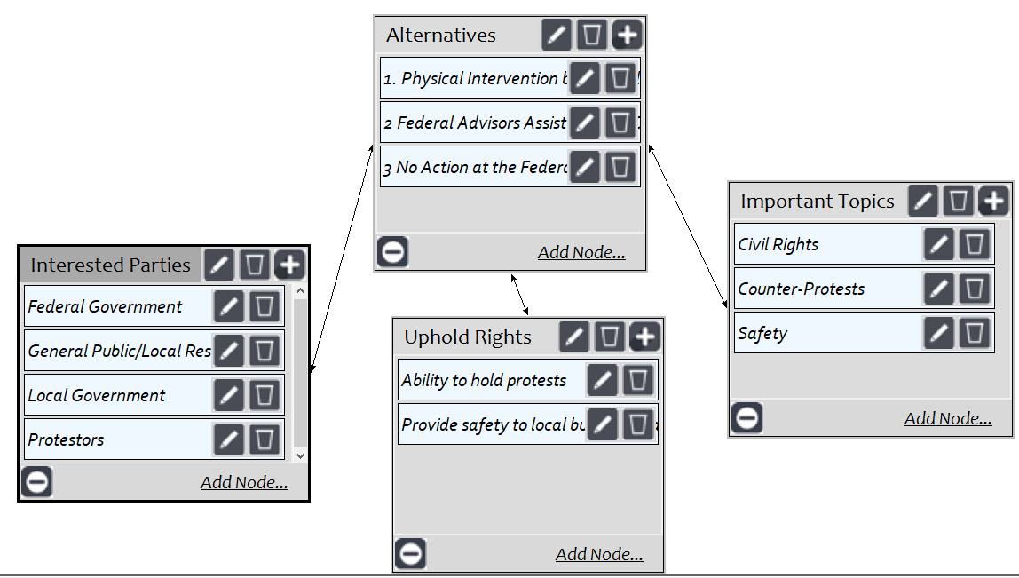
The following synthesized benefits returns a result indicating Physical Intervention by Federal Law Enforcement has a higher priority than our two other alternatives.
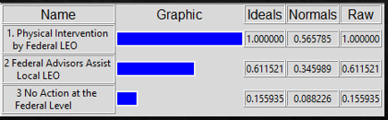

The benefits (Political) subnet allows for the description of alternatives as they relate politically to important topics, upholding rights and interested parties.
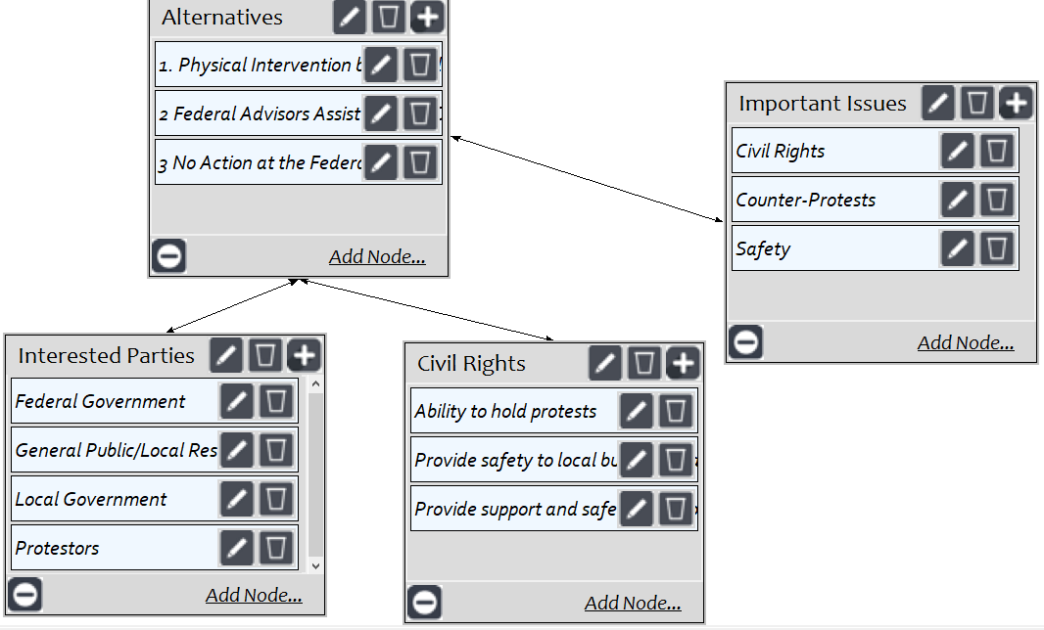
The following synthesized benefits returns a result indicating Physical Intervention by Federal Law Enforcement has a higher priority than our two other alternatives, with Federal Advisors assisting Local Law Enforcement having the second highest priority.
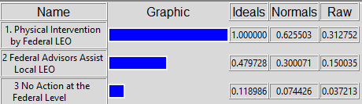

The benefits (Social) subnet allows for the description of alternatives as they relate socially to important topics, upholding rights and interested parties.
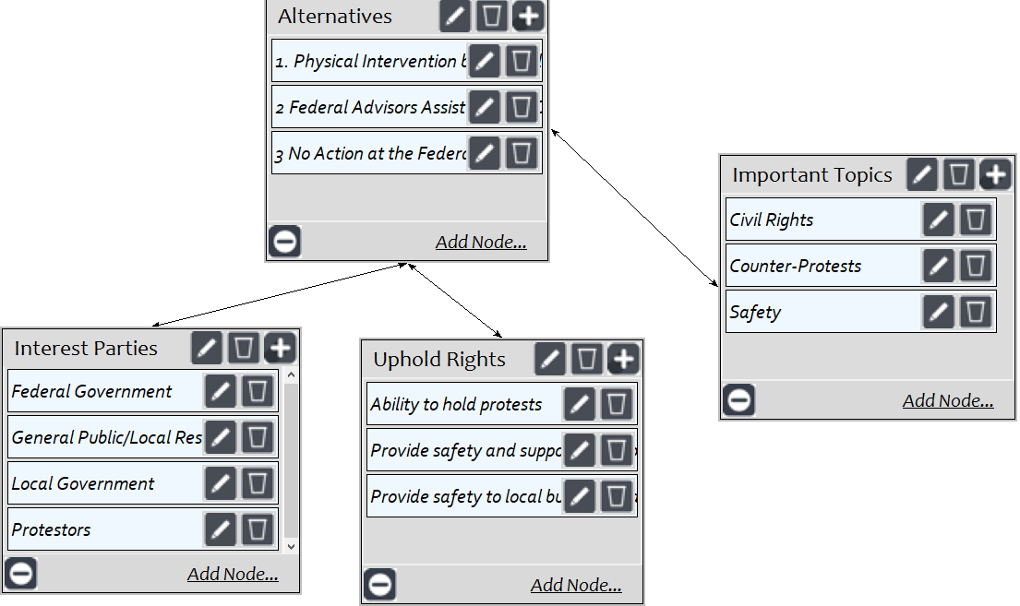
The following synthesized benefits returns a result indicating Physical Intervention by Federal Law Enforcement has a higher priority than our two other alternatives, with No Action taken at the Federal Level having the lowest priority.
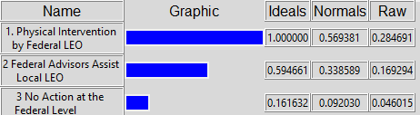

Opportunities Subnets:
The opportunities (Economic) subnet allows for the description of alternatives as they relate economically to important topics, upholding rights and interested parties.
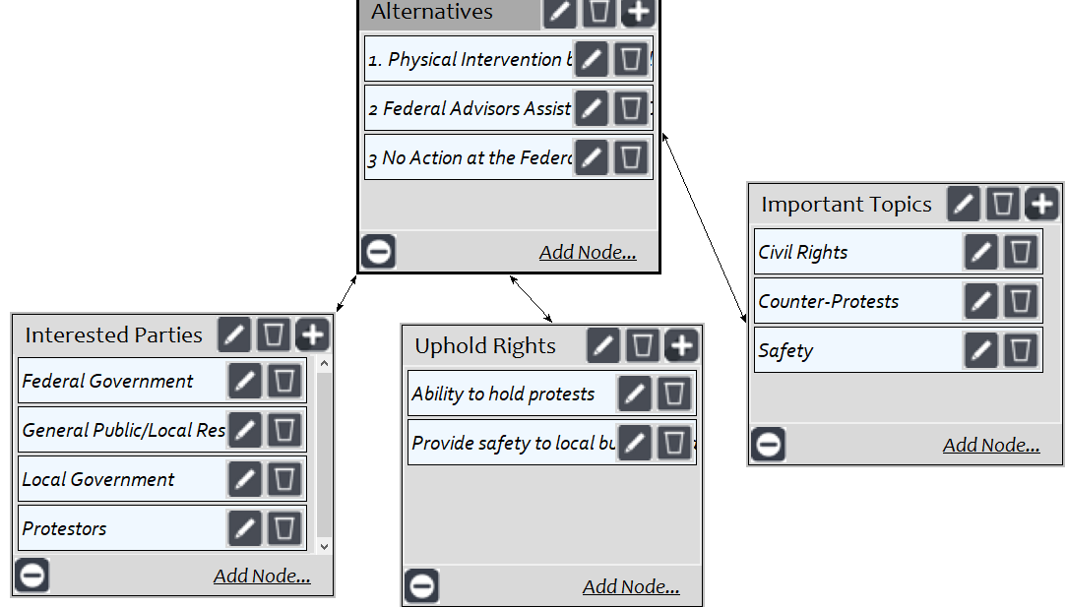
Similar to the results in the Benefits subnet, the following synthesized benefits returns a result indicating Physical Intervention by Federal Law Enforcement has a higher priority than our two other alternatives, with No Action taken at the Federal Level having the lowest priority.
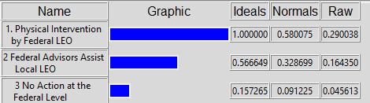
The opportunities (Political) subnet allows for the description of alternatives as they relate politically to important topics, upholding rights and interested parties.
The following synthesized benefits returns a result indicating Federal Advisors Assisting Local Law Enforcement with Planning and Strategy carries the highest priority, with Physical Intervention by Federal Law Enforcement carrying the lowest priority.
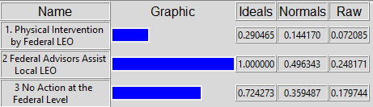
The opportunities (social) subnet allows for the description of alternatives as they relate socially to important topics, upholding rights and interested parties.
The following synthesized benefits returns a result that Physical Intervention by Federal Law Enforcement carries the highest priority, with no action at the federal level carrying the lowest priority.
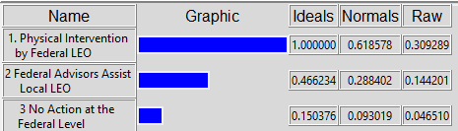
Costs Subnets:
The costs (Economic) subnet allows for the description of alternatives as they relate economically to important topics, upholding rights and interested parties.
The following synthesized benefits returns a result that Physical Intervention by Federal Law Enforcement carries the highest potential cost, with no action at the federal level carrying the lowest.
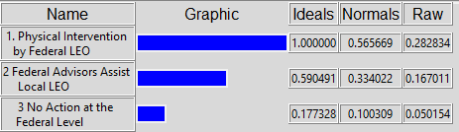
The costs (Political) subnet allows for the description of alternatives as they relate politically to important topics, upholding rights and interested parties.
The following synthesized benefits returns a result that Physical Intervention by Federal Law Enforcement again carries the highest potential political cost, with no action at the federal level carrying the lowest.
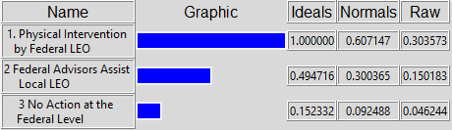
The costs (social) subnet allows for the description of alternatives as they relate socially to important topics, upholding rights and interested parties.
The following synthesized benefits returns a result that Physical Intervention by Federal Law Enforcement once again carries the highest potential political cost, with no action at the federal level carrying the lowest.
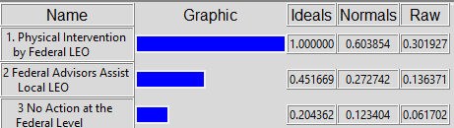
Risks Subnets:
The risks (Economic) subnet allows for the description of alternatives as they relate economically to important topics, upholding rights and interested parties.
The following synthesized benefits returns a result that Physical Intervention by Federal Law Enforcement carries the highest potential risk, with Federal Advisors assisting Local Law Enforcement carrying the lowest.
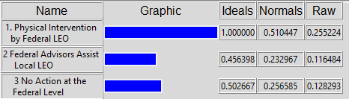
The risks (Political) subnet allows for the description of alternatives as they relate Politically to important topics, upholding rights and interested parties.
The following synthesized benefits returns a result that Physical Intervention by Federal Law Enforcement carries the highest potential risk, while Federal Advisors Assisting Local Law Enforcement has the second highest risk.
The risks (Social) subnet allows for the description of alternatives as they relate Socially to important topics, upholding rights and interested parties.
The following synthesized benefits returns a result that Physical Intervention by Federal Law Enforcement carries the highest potential risk, while Federal Advisors Assisting Local Law Enforcement has the second highest risk.
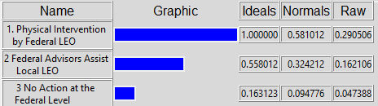
Subnet Analysis:
While Physical Intervention by Federal Law Enforcement presented the highest priority in much of the Benefits and Opportunities subnets. While this would initially indicate the bets course of action being Physical Intervention by Federal Law Enforcement, this alternative also carried the highest costs and risks as shown in the above costs and risk subnets.
BOCR Synthesis:
After retrieving the information of each subnet, the following BOCR synthesized results were found. Shown below, the benefits subnet favors the social control criteria as the highest benefit of the control criteria.
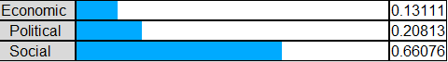
As expected, the highest synthesized result correlates to Physical Intervention by Federal Law Enforcement. With the viewpoint of the Federal Government as the decision maker, this would equate to the presence of Federal Law Enforcement as the alternative of choice as it could allow for Local law enforcement to focus on standard duties and responsibilities.
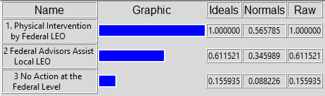
The Opportunities subnet also favors the social control criteria as the highest benefit of the control criteria.
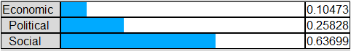
Again, as expected the highest synthesized result correlates to Physical Intervention by Federal Law Enforcement for the Opportunities results. With the viewpoint of the Federal Government as the decision maker, this would equate to the presence of Federal Law Enforcement as the alternative of choice as it could allow for a perception of equal law and order from the Federal Government and allow for the Federal Government to be part of dialogue and change.
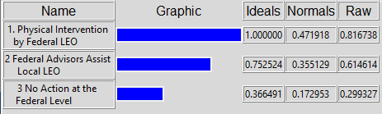
As found throughout the BOCR model, the Cost subnet also favors the social control criteria as the highest priority of the control criteria.
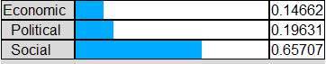
While Physical presence by Federal Law Enforcement carried the highest priority in the Benefits and Opportunities subnets, we now see that this alternative also carries the highest potential Costs as shown in the synthesized results below.
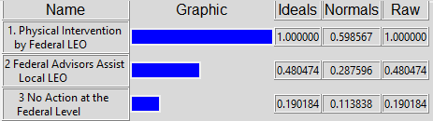
Likewise, Physical presence by Federal Law Enforcement also carries the highest Risks of all alternatives as shown in the synthesized results.
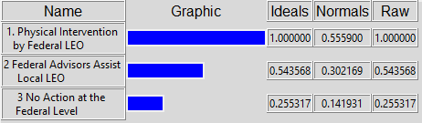
Conclusion:
Due in most part to Risks and Costs, the end result indicated that the best alternative/approach that could be implemented by the Federal Government was the use of Federal Advisors Assisting Local Law Enforcement in Planning and Strategy. Somewhat surprising initially, the second desired course of action was No Action at the Federal Level. From the prospective of the Federal Government (The Decision Maker in the Model), No Action at the Federal Level is logical as while the Benefits and Opportunities of this alternative are minimal, so are the Risks and Costs which as mentioned previously, were the drivers of the model. Again, as a result of the high level of potential Risks and Costs, Physical Intervention/Presence by Federal Law Enforcement was the least desirable alternative. As mentioned in the BOCR analysis, the higher levels of priority in Benefits and Opportunities related to a Physical Intervention/Presence by Federal Law Enforcement were more than offset by high Risks and Costs associated with implementing the alternative.
Additive: (Long Term)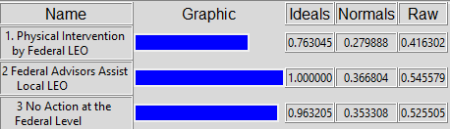
Multiplicative: (Short Term)
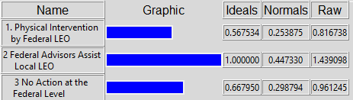
The multiplicative and additive synthesis indicates the Federal Advisors Assisting Local Law Enforcement alternative is the best course of action both in the long term (Additive) and short term (Multiplicative).
In each of the sensitivity analysis’, the model indicated a rank reversal. This means that if the importance of Benefits, Opportunities, Costs and Risks increased, the best option would change to the next desirable alternative.
