Should The U.S. Eliminate the Penny?

Introduction:
The penny coin is gradually becoming an obsolete form of currency in the United States. It cannot be used in most vending machines, toll booths, parking meters, and nearly any other machine that accepts coins. It creates incremental social inefficiencies whenever it is used, slowing down cash transactions and wasting the time of cashiers and customers alike. It takes up space in pockets, purses, jars, cash registers, bank vaults and armored trucks. Entire afternoons can be wasted counting and rolling spare pennies to convert them into money that can actually be used, and coin counting machines that speed up the process charge a hefty premium for the added convenience. The penny is a classic symbol of government waste, as it is now worth less than the metal used to make it. In 2012, the penny cost a little over 2 cents to produce. Canada, our neighbor to the North, has already begun the process of eliminating their pennies, and it has been successfully shown to reduce costs in that country. Legislation to eliminate the penny has been put forward from time to time since 2006, but has failed to overcome the hurdle of lobbyists for the coin industry and the objections of the American public, who view the penny with nostalgic fondness and who fear the possibility of negative repercussions that may result from the penny’s elimination.

Goal:
The goal of this paper will be to determine whether the US should discontinue the penny. The decision will be made using a complex ANP model with BOCR (Benefits, Opportunities, Costs, and Risks) merit nodes in the Super Decisions Software.

Alternatives and Decision Criteria:

The alternatives for the decision are:

- Eliminate the Penny
- Do Not Eliminate the Penny
There are a total of four merit nodes: Benefits, Opportunities, Costs, and Risks. Each merit node contains a sub-network that includes control criteria. The control criteria selected for the merit nodes are Economic, Social, and Political. High priority nodes in these control criteria clusters contain additional sub-networks. In addition to the merit nodes, control criteria, and sub-criteria, there are also four strategic criteria that have been identified as important to the decision: Cost Savings, Efficiency, Economic Stability, and Public Acceptance. An overview of the top-level network can be seen in the figure below.

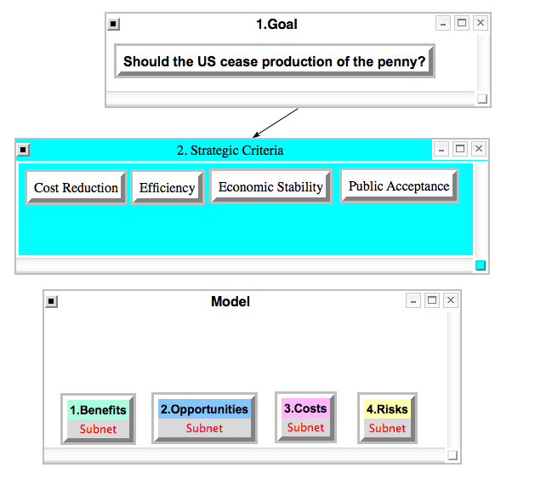

High priority nodes in the control criteria clusters underneath Benefits, Opportunities, Costs, and Risks include sub-networks with additional criteria. Below is a table of these subnetworks with brief descriptions of their criteria when necessary.
Merit Node | Subnet | Sub-Criteria Cluster | Criteria | Description
Benefits | Economic | U.S Govt. | Reduction in Govt. Spending | Currently costs 2 cents per unit to make pennies. Elimination would remove this cost.
 |  |  | More Efficient Govt. | Transportation/distribution costs would also be eliminated.
 |  | The Public | Taxpayer Savings | Costs cut by govt would be passed on to the public.
 |  |  | Shorter Cash Transaction Times | Using pennies is time intensive, and that time adds up.
 |  |  | Increased Social Efficiency | Reduced transaction times will make society more efficient.
 |  | Businesses/Industries | Shorter Transaction Times | This applies both to the consumer and the cashier
 |  |  | Increased Supply of Zinc and Copper | This will lower metal prices and raise the supply of the metals, which can be used by other industries.
 | Social | Public | Increased Social Efficiency
Opportunities | Economic | U.S. Govt. | Defecit Reduction | The money saved from eliminating the penny could be used to pay down debt.
 |  |  | Resource Re-allocation | Materials and Resources once used to make pennies can be diverted to other purposes.
 |  | Public | Opportunities for Collectors | Once the penny is discontinued, pennies will become collectable
 |  | Businesses/Industries | Banks- Opportunities to Run More Efficiently | Banks will no longer have to carry pennies, adding efficiency to their operation
 |  |  | Opportunities Related to Increased Metal Supply | Industries can take advantage of the additional metal supply
 | Social | Public | Increased Free Time | Less time spent counting and rolling pennies
 |  |  | Increased Space - Less Clutter | No more giant jars of spare change
Costs | Economic | U.S. Govt. | Cost of Changing Status Quo | It will be costly to educate the public about the transition
 |  |  | Increased Demand for Nickel | Without pennies, more nickels may need to be produced, at a cost of 10 cents per unit
 |  | Public | Cost of Rounding | Prices would be rounded to the nearest nickel, and therefore could be higher
 |  |  | Cost of Inflationary Prices | Rounding to the nickel could have adverse effects, particularly on lower income families.
 |  | Businesses/Industries | Lower Sales due to Higher Prices | Higher prices due to rounding could cut into sales
 | Social | Public | NostalgiaFactor | People have a fondness for the penny
 |  |  | Difficulty Adjusting | The public may have trouble with the transition
Risks | Economic | U.S. Govt. | Short Term Inflation | It is argued that eliminating the penny will lead to short term inflation
 |  |  | Higher Unemployment Numbers | Lost jobs in industries related to making pennies.
 |  | Public | Rounding Could Unfairly Target Lower Income Individuals
 |  |  | Penny as a Savings Tool | People who save pennies will no longer be able to.
 |  |  | Reduction in Charitable Donations | Some charities are reliant on penny drives. People may be less likely to part with higher denomination coins.
 |  |  | Higher Prices for Goods Due to Inflation
 |  | Businesses/Industries | Difficulty Training Consumers/Employees
 |  |  | Job Losses in Industries Related to Pennies
 |  |  | Lower Sales Due to Inflation
 | Political | U.S. Govt. | Higher Unemployments Numbers
 |  |  | Dissaproval of Public

Below are two examples of these decision sub-networks: Benefits – Economic and Risks – Economic.
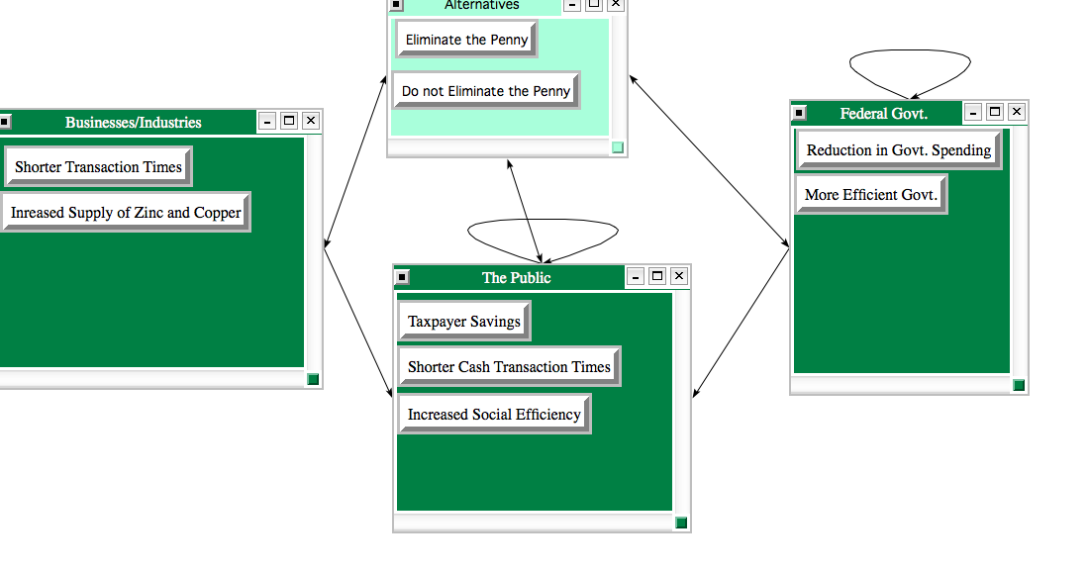
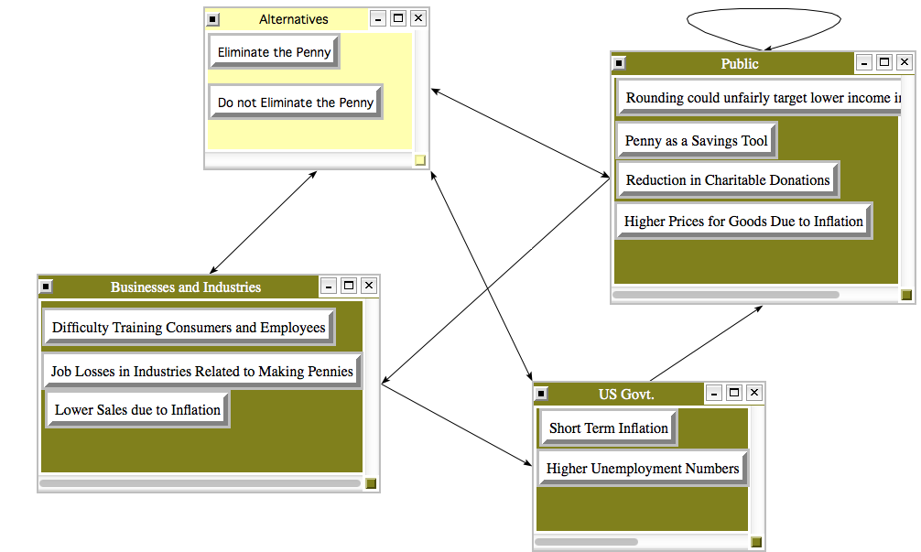
Synthesis of each merit node sub-network yields the following results for the alternatives.

Benefits:

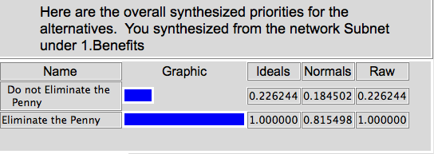

Opportunities:

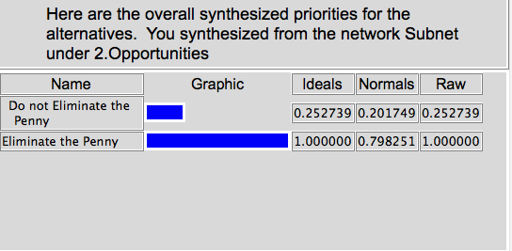
Costs:

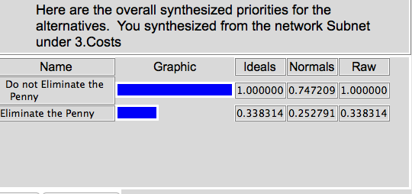

Risks:

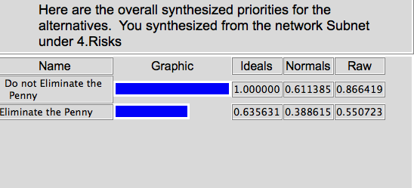

Ratings Spreadsheet:

The strategic criteria are pairwise compared and Benefits, Opportunities, Costs, and Risks are entered as Alternatives so that they may be ranked with respect to the strategic criteria in the following ratings spreadsheet.

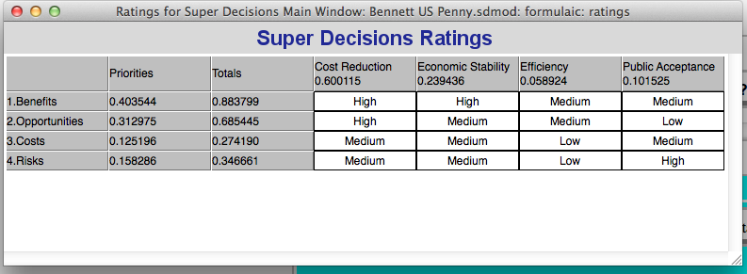

Results:

Once the ratings spreadsheet is generated, the entire model can be synthesized using both the additive negative and multiplicative formulas to yield the following best alternatives for the short and long term.

Addative Negative:

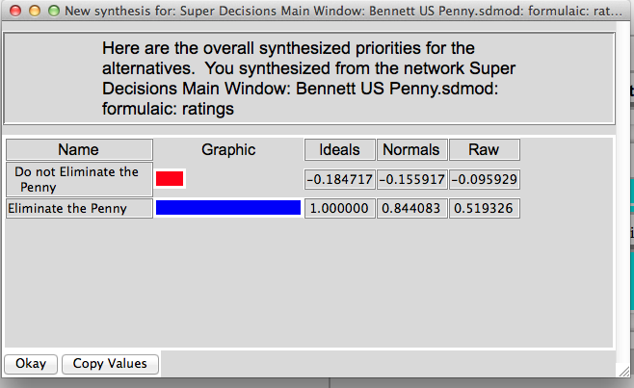

Multiplicative:

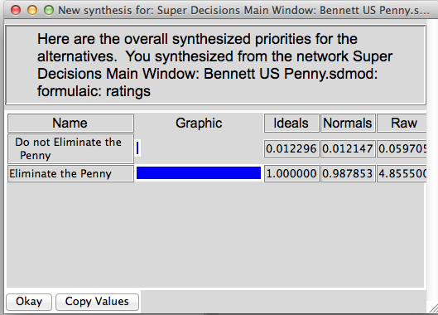

The results clearly indicate that eliminating the penny is the best alternative for both the short and long term.

Sensitivity Analysis:

Sensitivity analysis for each of the four merit nodes further enforces elimination of the penny as the best option.

Sensitivity Analysis – Benefits:

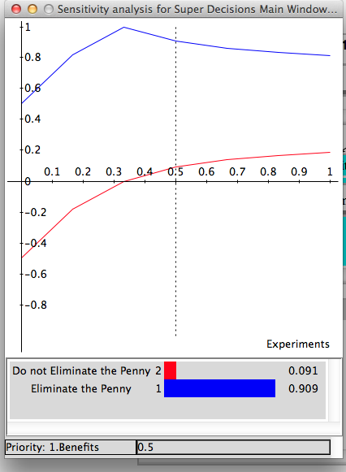
Sensitivity Analysis – Opportunities:

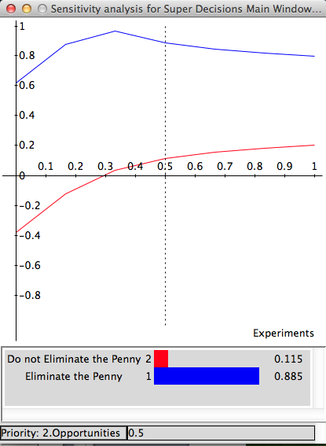

Sensitivity Analysis – Costs:

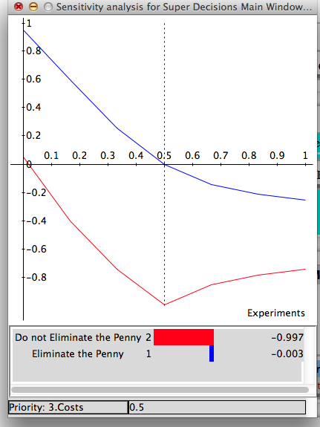

Sensitivity Analysis – Risks:

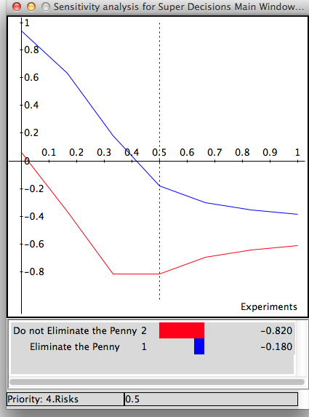

Conclusion:

The model overwhelmingly indicates that eliminating the penny is the best option. The costs associated with penny elimination may be numerous, and the public’s nostalgia for the penny may run deep, but these concerns are heavily outweighed by the benefits. The penny should be eliminated.

