Decision Making in Complex Environments
The Future of Andhra Pradesh, India
ANP/BOCR model – Final Report

Megan Callihan, Sylekhya Muddana, Robert Puhl
4/19/2011

The following report describes and outlines our approach to make a decision about the future of Andhra Pradesh, a state belonging to the Republic of India. With regard to the historical and current situation in this particular state, we built and designed our model to make the best possible decision. We generally built a BOCR model that considers and evaluates a certain set of alternatives for the future of the state.
This report mainly serves as a write up illustrating our assumptions, consideration and development of the final model. It consists of the following parts:
Table of Contents
1. Introduction 3
1.1 Background 3
1.2 Alternatives 4
2. The Model 4
a. The BOCR model 5
i. Benefits Cluster/Nodes 5
ii. Opportunities Cluster/Nodes 6
iii. Costs Cluster/Nodes 7
iv. Risks Cluster/Nodes 8
b. Hierarchical Models 9
i. Benefits 9
ii. Opportunities 9
iii. Costs 10
iv. Risks 10
c. Priorities after Pairwise Comparison 11
i. Benefits 11
ii. Opportunities 12
iii. Costs 12
iv. Risks 13
v. Priorities Summary 14
d. ANP Models 15
i. ANP model for Benefits Economic Subcriteria Employment 15
ii. ANP Model for Benefits Cultural Subcriteria Social Systems 16
iii. ANP Model for Opportunities Economic Subcriteria Foreign Direct Investment Increase 17
iv. ANP Model for Opportunities Cultural Subcriteria Population Distribution 18
v. ANP Model for Opportunities Cultural Subcriteria Upward Mobility 19
vi. ANP Model for Costs Political Subcriteria Violence 20
vii. ANP Model for Costs Political Subcriteria Election Spending 21
viii. ANP Model for Costs Cultural Subcriteria Social Instability 22
ix. ANP Model for Risks Political Subcriteria Government Instability 23
x. ANP Model for Risks Cultural Subcriteria Societal Imbalances 24
e. The Ratings Model 24
3. Sensitivity Analysis 27
3.1 Benefits 29
3.2 Opportunities 30
3.3 Costs 31
3.4 Risks 32
4 Results and Conclusion 33
4.1 Additive (Negative) 33
4.2 Multiplicative 34
4.3 Conclusion 35
Works Cited 36

Introduction

1.1 Background
Andhra Pradesh is one of the 28 states of India with Hyderabad as its capital city. The formation of this state is significantly different from the others. The basis of Andhra Pradesh was a 10-point “Gentlemen’s Agreement” between the then chief ministers of Andhra and Hyderabad (which then included the Telangana Region).The demand for Telangana is one of the oldest concerns for a separate state in independent India. It has seen its share of talks and violence since the early 1960s. (Wikipedia - The Free Encyclopedia, 2011)
A brief historical review of the region will provide insight into the current agitation. Telangana is a region comprising ten of Andhra Pradesh's 23 districts. Originally, the region was part of the former Nizam's Kingdom state of Hyderabad. In 1948, India put an end to the rule of the Nizam and a Hyderabad state was formed. In 1956, the Telangana part was merged with the Andhra state. (Vepachedu) However, the people from Telangana were against merger with Andhra as they feared job losses as education levels and development in Andhra were better than in Telangana. In addition to this were the cultural differences between the two regions that were merged. (Telangana Interactive Inc., 2004)
However, there has been a strong assertion of a distinct Telangana identity through two major agitations in 1969 and in 2000. These sharpened the Telangana people’s sense of discrimination and highlighted the region’s educational backwardness and “developmental backlog”.
Statehood’s proponents rightly argue that Telangana has not received state development assistance proportional to its size. (Biswas, 2010)
At the heart of the dispute is the status of Hyderabad, geographically within the proposed new state, but claimed by both sides. Opponents of Telangana say the city was built into an economic powerhouse by investments from entrepreneurs from other regions of the state. Some investors are concerned business would not be at the top of the new state’s priorities, making Hyderabad a less attractive destination for multinational firms. They also fret about what sort of labor and tax laws the new state would adopt. The changed political equations could hit businesses such as real estate and infrastructure firms, many of whom have relied on political ties for their growth. But Telangana, with few resources of its own, would necessarily have to open up to investors if it is to remain viable and not run on federal aid. (BBC, 2010)
Violent protests for and against carving a new state called Telangana out of India’s Andhra Pradesh have been disrupting life in the State. The central government postponed a decision to bifurcate the southern state following protests by political parties. As protests continue, the central government seems to have backpedalled, saying no decision would be taken in haste and it would try to work out a consensus. The final decision to create states lies with the central government although a resolution approving the formation of Telangana by the state legislature, which is sharply divided on the issue, would make the process less problematic. (Deccan Chronicle, 2011)

1.2 Alternatives
The following are the alternatives that have been formulated in order to get a consensus on the issue being faced by both the state government of Andhra Pradesh as well as Central government of India.
- Do not split the State (Status Quo)

- Do not split the State, but create a Development Committee for the betterment of the Telangana Region

- Split the State, keeping Hyderabad as the capital of Telangana and develop a new capital for Andhra

- Spilt the State and convert Hyderabad into a Union Territory

The Model
To ensure that we arrive at the best possible decision considering all relevant as well as significant influencing factors, we divided the overall decision about the future of Andhra Pradesh into two major parts each one requiring a certain type of model. We first designed and developed a BOCR model, which evaluated the benefits, opportunities, costs and risks of each alternative and by combining those outcomes providing us with the best decision with regard to each of the above mentioned aspects. Additionally, we developed a ratings model that combined the best decisions for each area of the BOCS model by weighting them against more superior and universally control criteria, then resulting in the overall best decision.
Below, we show an illustration of the very surface of the model giving an impression of the overall structure and the link between the BOCR and the Rating part of the model:
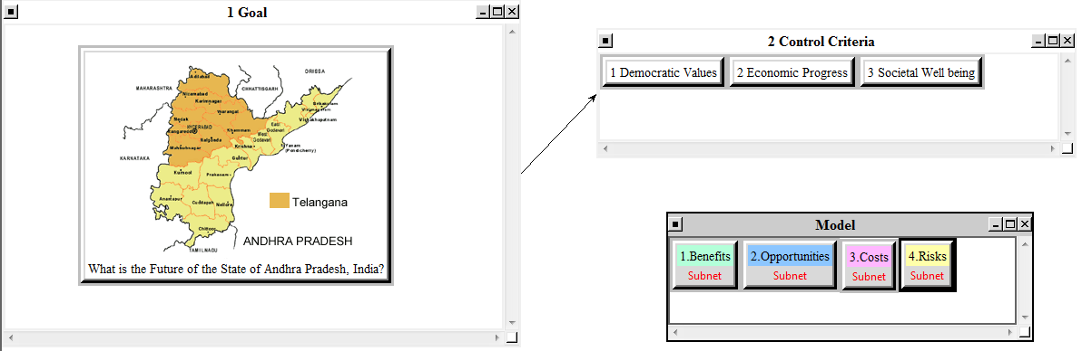
The following part focuses on the development, structure and underlying assumptions of the BOCR model, we used as the base for our decision.

The BOCR model
To begin, we started with a brainstorming session in order to identify the overall structure of the BOCR model establishing relevant criteria as well as subcriteria for the benefits, the opportunities, the costs and the risks. Those criteria and subcriteria are shown and briefly explained in the respective tables below:

Benefits Cluster/Nodes
For benefits, we developed the following criteria and subcriteria:

Opportunities Cluster/Nodes
Below, the criteria and subcriteria for the opportunities are illustrated:

Costs Cluster/Nodes
The structure for the costs Cluster with criteria and subcriteria is the following:

Risks Cluster/Nodes
Finally, we look at the structural concept of the Risks cluster and the criteria/subcriteria:
After developing the above mentioned and explained criteria with its subcriteria and structured them according to the BOCR, we then were able to build the hierarchical models under each of the BOCR criteria. The following screenshots should give an impression how the hierarchical models looked like in the model:

Hierarchical Models

Benefits
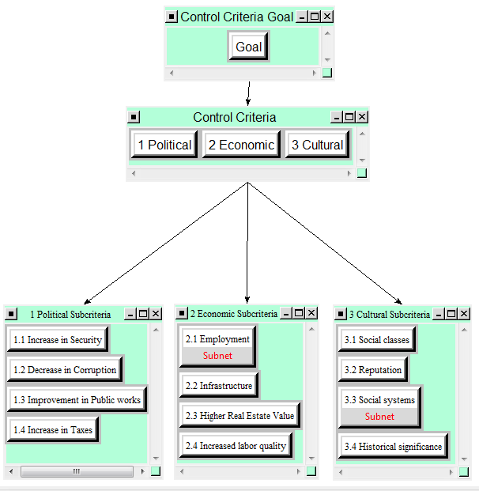

Opportunities
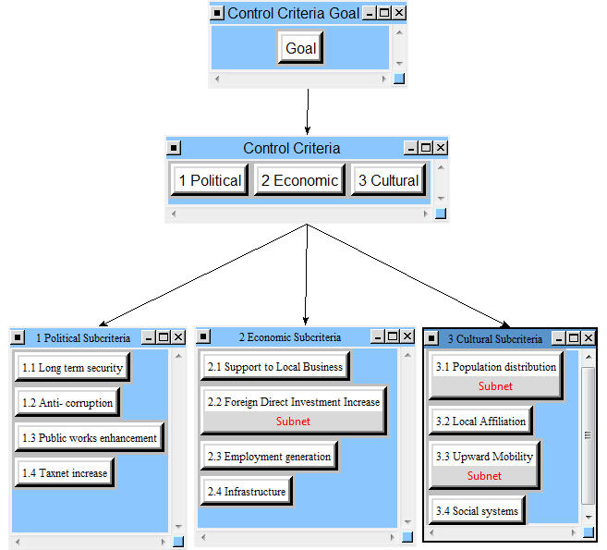

Costs
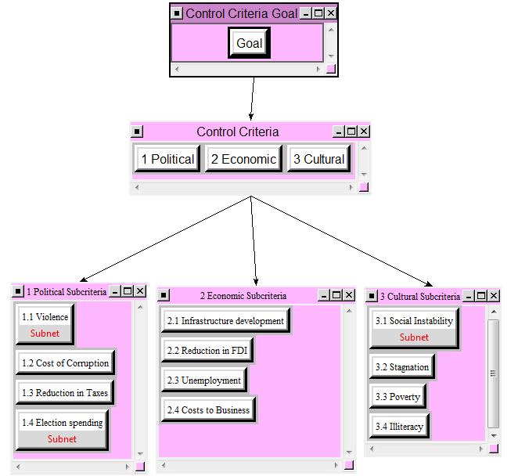

Risks
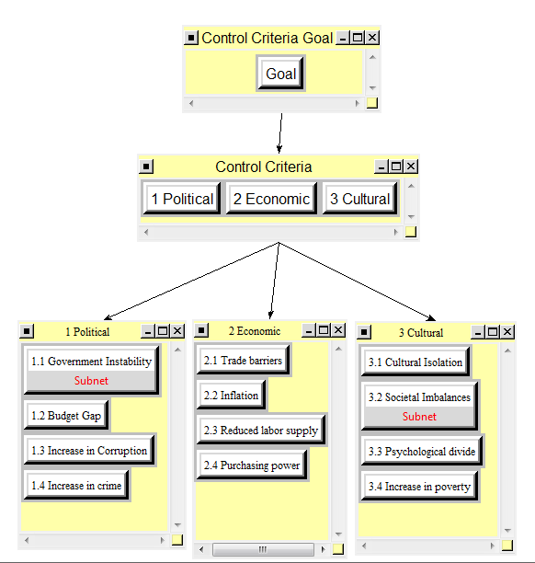
In the following step of developing the model, we compared the criteria as well as the subcriteria pairwise in order to enable the SuperDecisions Software to calculate the respective priorities for every criterion and sub-criterion. Doing so, we finally identified the most important subcriteria for each Control Criteria Goal (Benefit, Opportunity, Cost, Risk) by considering the “top 70%” of the respective priorities. For the pairwise comparison we ensured that the inconsistency values were never higher than the given 0.1 threshold. An example for the pairwise comparison is shown below:
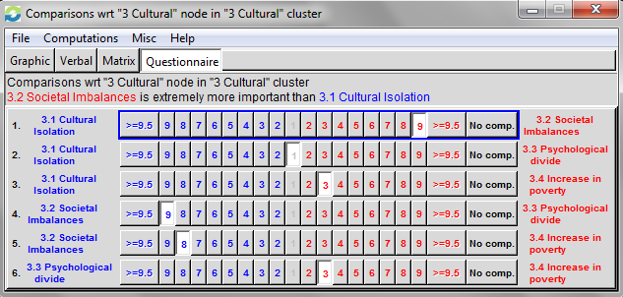

Priorities after Pairwise Comparison
As mentioned above, after pairwise comparing all criteria and subcriteria in the model, we got the priorities accordingly:

Benefits
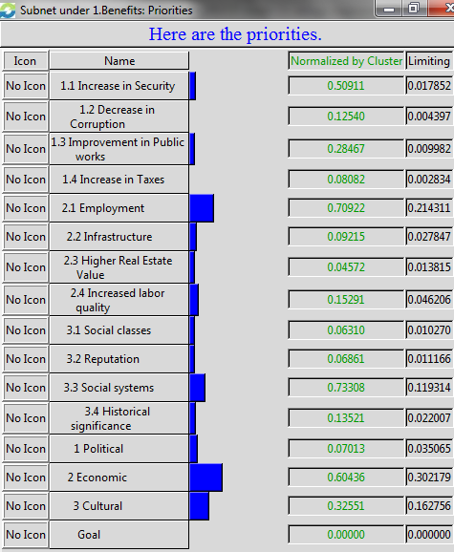

Opportunities
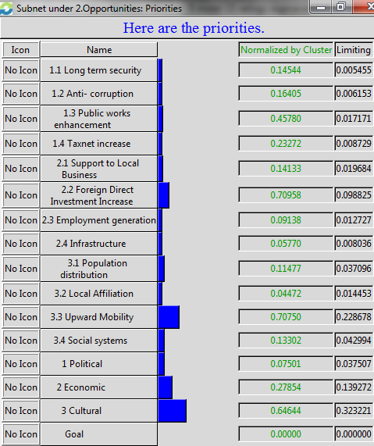

Costs
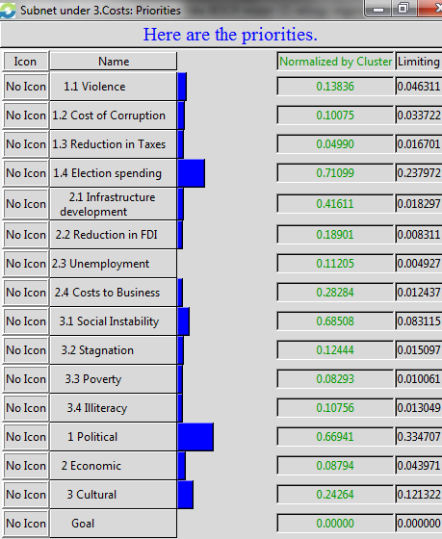

Risks
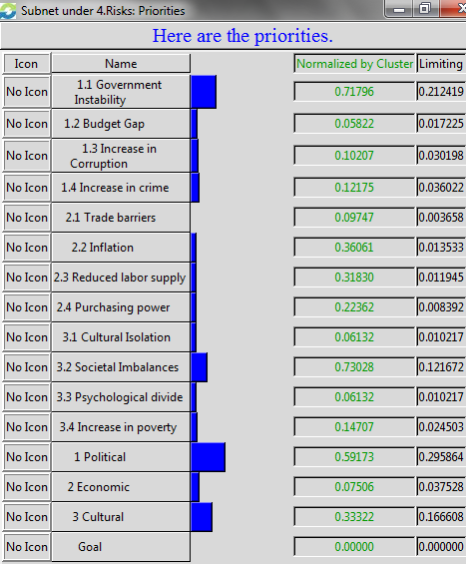
Taking these priorities and calculating the “top 70%” for each Hierarchy model (BOCR), we get the overview that is shown below:

Priorities Summary
The above overview highlights the most important subcriteria for each merit according to the “top 70%” rule. Deriving the most relevant subcriteria allows us to then develop and design the last and most detailed level of our overall model: the ANP networks for the top subcriteria, at that point bringing in the alternatives that were introduced at the beginning of this report. The evaluation of the four alternatives is done based on the “stakeholders-approach.” That means that we basically included the most relevant stakeholders having an interest in the respective underlying subcriteria and pointed out their relationships and influences among each other as well as towards the alternatives.

ANP Models
In the ANP models we used the following abbreviations for the alternatives to make the model more clearly arranged:
Abbreviation | Description
No Split | Do not split the State (Status Quo)
NS-Committee | Do not split the State, but create a Development Committee for the betterment of the Telangana Region
Split | Split the State, keeping Hyderabad as the capital of Telangana and develop a new capital for Andhra
S-Union Territory | Spilt the State and convert Hyderabad into a Union Territory

ANP model for Benefits Economic Subcriteria Employment
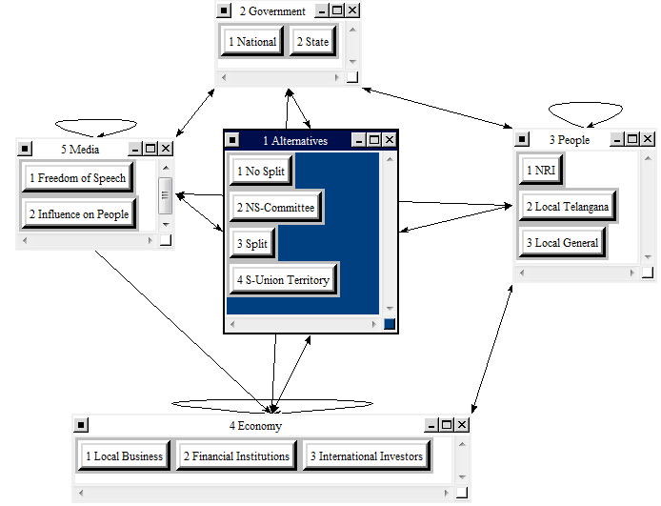
For this model, we identified the following stakeholders having an interest towards the benefits for employment:
- Government
  - National
  - State
- People
  - Non-Resident-Indians (NRIs – basically Expats having relatives or close friends in India, whom they mostly support financially)
  - Local population of Telangana
  - The remaining portion of the state’s population
- Economy
  - Local Businesses
  - Financial Institutions
  - International Investors
- Media
  - Influence on people
  - Freedom of Speech
All of the above mentioned parties have an influence on the alternatives and vice versa; they all are affected by the decision that is made, in the one way or in the other. Furthermore, a lot of the stakeholders influence each other also (which can be seen in the arrows going back and forth between the stakeholders clusters.

ANP Model for Benefits Cultural Subcriteria Social Systems
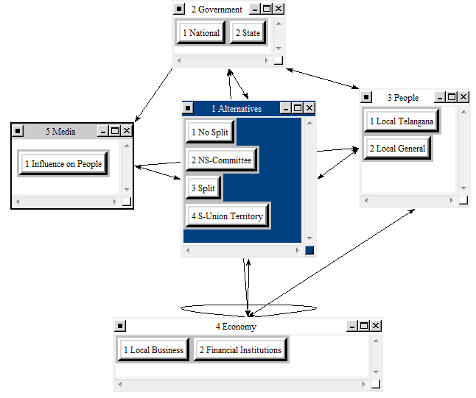
For this model, we identified the following stakeholders having an interest towards the benefits for employment:
- Government
  - National
  - State
- People
  - Local population of Telangana
  - The remaining portion of the state’s population
- Economy
  - Local Businesses
  - Financial Institutions
- Media
  - Influence on people
Compared to the first ANP model we developed, it can be seen, that for this model, we removed some of the stakeholders, since we felt that they are not necessarily relevant for the Social Systems subcriteria. However, the interactions and influences are again very strong and are illustrated by the arrows in the model.

ANP Model for Opportunities Economic Subcriteria Foreign Direct Investment Increase
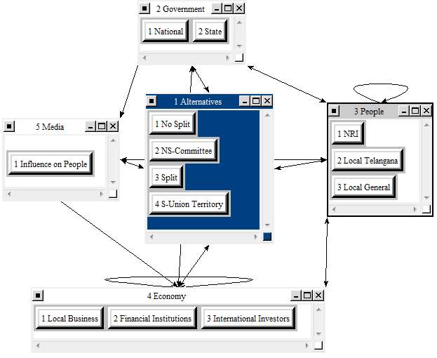
For this model, we identified the following stakeholders having an interest towards the benefits for employment:
- Government
  - National
  - State
- People
  - NRIs
  - Local population of Telangana
  - The remaining portion of the state’s population
- Economy
  - Local Businesses
  - Financial Institutions
  - International Investors
- Media
  - Influence on people
Here again, the stakeholders are adapted according to the subcriteria.

ANP Model for Opportunities Cultural Subcriteria Population Distribution
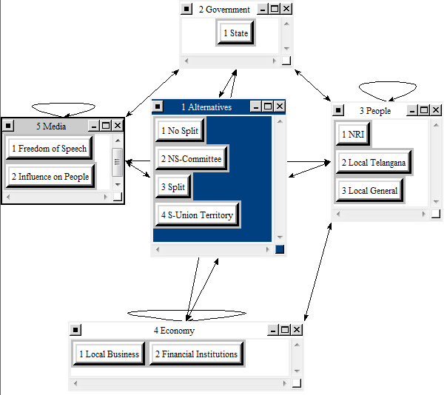
For this model, we identified the following stakeholders having an interest towards the benefits for employment:
- Government
  - State
- People
  - NRIs
  - Local population of Telangana
  - The remaining portion of the state’s population
- Economy
  - Local Businesses
  - Financial Institutions
- Media
  - Influence on people
  - Freedom of Speech
Here again, the stakeholders are adapted according to the subcriteria.

ANP Model for Opportunities Cultural Subcriteria Upward Mobility
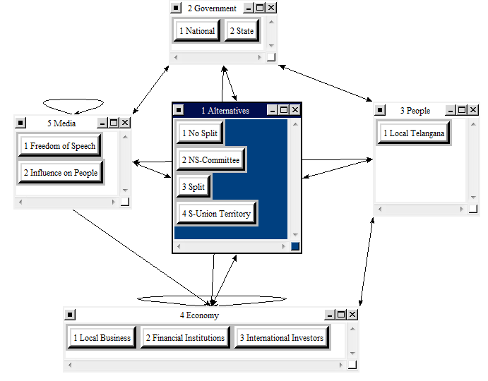
For this model, we identified the following stakeholders having an interest towards the benefits for employment:
- Government
  - State
  - National
- People
  - Local population of Telangana
- Economy
  - Local Businesses
  - Financial Institutions
  - International Investors
- Media
  - Influence on people
  - Freedom of Speech
Here again, the stakeholders are adapted according to the subcriteria.

ANP Model for Costs Political Subcriteria Violence
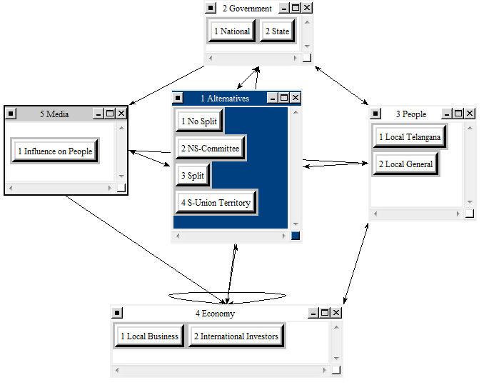
For this model, we identified the following stakeholders having an interest towards the benefits for employment:
- Government
  - State
  - National
- People
  - Local population of Telangana
  - Local General
- Economy
  - Local Businesses
  - International Investors
- Media
  - Influence on people
Here again, the stakeholders are adapted according to the subcriteria.

ANP Model for Costs Political Subcriteria Election Spending
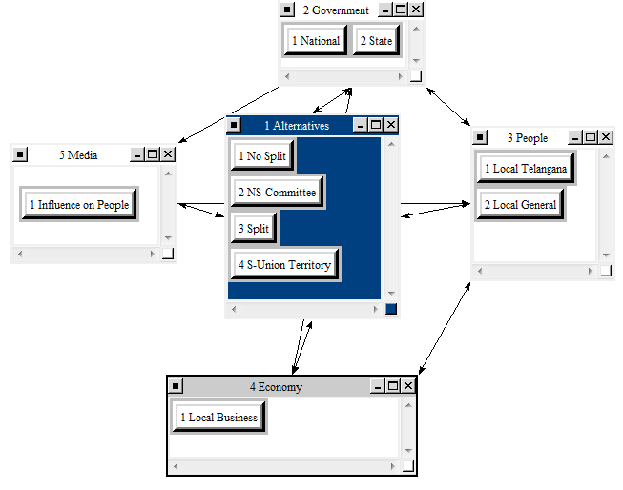
For this model, we identified the following stakeholders having an interest towards the benefits for employment:
- Government
  - State
  - National
- People
  - Local population of Telangana
  - Local General
- Economy
  - Local Businesses
- Media
  - Influence on people
Here again, the stakeholders are adapted according to the subcriteria.

ANP Model for Costs Cultural Subcriteria Social Instability
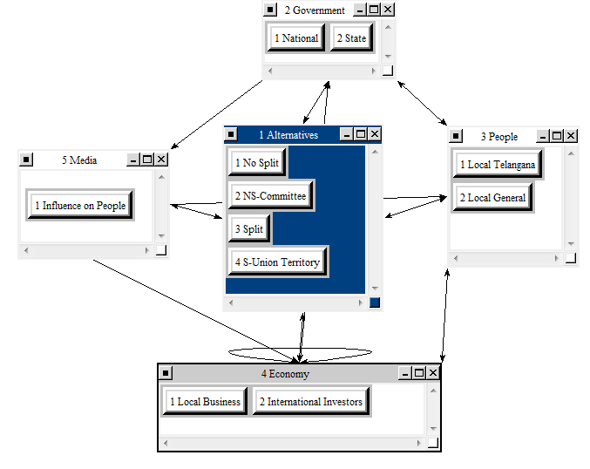
For this model, we identified the following stakeholders having an interest towards the benefits for employment:
- Government
  - State
  - National
- People
  - Local population of Telangana
  - Local General
- Economy
  - Local Businesses
  - International Investors
- Media
  - Influence on people
Here again, the stakeholders are adapted according to the subcriteria.

ANP Model for Risks Political Subcriteria Government Instability
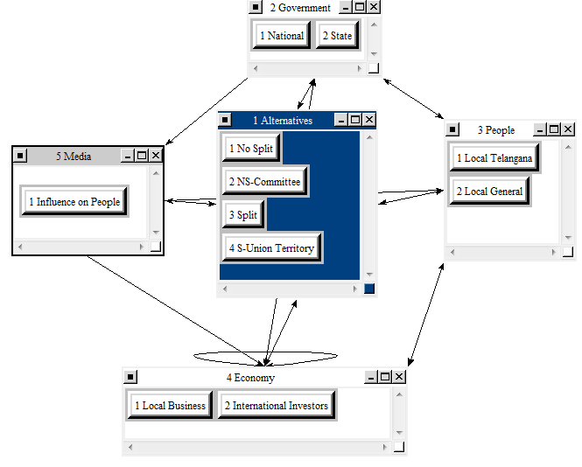
For this model, we identified the following stakeholders having an interest towards the benefits for employment:
- Government
  - State
  - National
- People
  - Local population of Telangana
  - Local General
- Economy
  - Local Businesses
  - International Investors
- Media
  - Influence on people
Here again, the stakeholders are adapted according to the subcriteria.

ANP Model for Risks Cultural Subcriteria Societal Imbalances
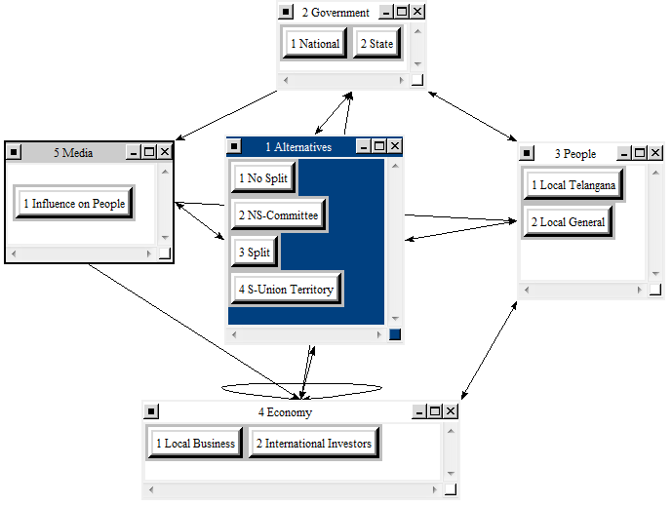
For this model, we identified the following stakeholders having an interest towards the benefits for employment:
- Government
  - State
  - National
- People
  - Local population of Telangana
  - Local General
- Economy
  - Local Businesses
  - International Investors
- Media
  - Influence on people
Here again, the stakeholders are adapted according to the subcriteria.

The Ratings Model
Once we fully developed the BOCR part of the model, we then were able to finish the whole decision model by designing the ratings model, forming the second and final part. We completed the decision making process by taking the results from the BOCR part to provide us with the final and most adequate decision to make about the future of Andhra Pradesh.
For the Ratings model, we first identified possible strategic and overarching criteria, which we best could apply to all relevant alternatives coming out of the BOCR part of the model. In that context the most important and universal criteria are the following:
- Democratic Values
  - The democratic values that are conveyed by the respective alternatives clearly is a very important measurement and evaluation criteria, since protecting or if necessary extending the democratic values should be the most important and pursued goal for every administration and society in general.
- Economic Progress
  - Being successful in establishing and increasing a certain degree of wealth, forcing and supporting the economic progress doubtlessly is crucial. Hence, every alternative that is favored for each of the BOCR control criteria has to be evaluated with regard to its impact on the economic progress of Andhra Pradesh.
- Societal Well being
  - Finally, the societal well-being also plays an important and decisive role for the final decision. Only if the aspect of societal well-being is well considered, it will be possible to successfully make and implement a decision for the long-term. Basically every governmental or economic activity largely relies on and thus depends on the societal well-being. If this should not be the case, the decision will not be easily and widely accepted by the population and the society. Furthermore, businesses and investors are more likely to invest into a region, where the societal structure is clearly aiming at or has already achieved a status of overall well-being.
Given the fact that the above mentioned strategic evaluation criteria have a different importance with regard to the decision making about the future of Andhra Pradesh, we weighted the criteria as follows:
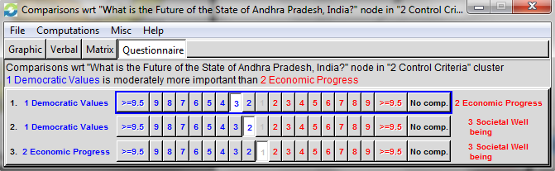
Resulting in the respective priorities:
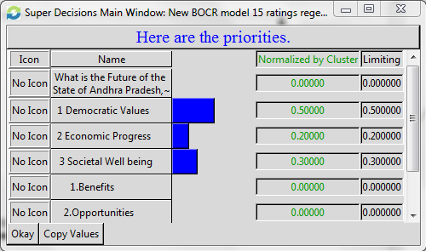
Next, after prioritizing the criteria, we established the ratings-values/options describing the impact of the recommended decision from each of the BOCR control criteria as follows:
- high impact
- average impact
- low impact
Assessing the comparison of those ratings, we get the following for the Democratic Values criteria:
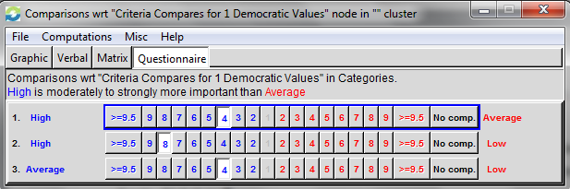
For Economic Progress:
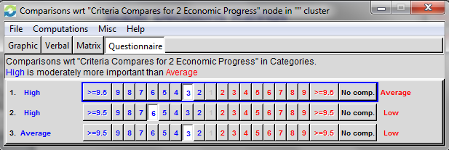
And finally for Societal Well-being:
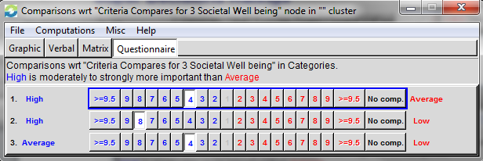
As the last step in developing the model and before getting the final result, we rated the BOCR criteria according to the above introduced “impact-on-the-strategic-criteria” values, resulting in the below shown ratings table:
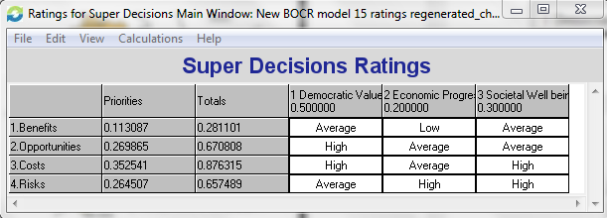
This final ratings table illustrates our rating towards the impact of the recommended alternatives (please refer to the following results part for the actual alternatives that were recommended) for each of the benefits, opportunities, costs and risks on the strategic criteria of democratic values, economic progress and societal well-being.
Note in context that the benefits and costs parts rather focus on the short term impact, whereas opportunities and risks put more emphasis on the longer-term impact on the strategic criteria.
In particular, we had the impression that the impact of the suggested alternative for benefits has an average impact on the democratic values, a low (positive) impact on the economic progress and an average impact on the societal well-being. In contrast to that, for the best alternative in opportunities, we see a high long-term impact on democratic values, an average on economic progress and also an average impact on the societal well-being in the long-term.
The costs alternative has a high cost impact on the democratic values, however comes along with average costs on economic progress and again relatively high costs on the societal well-being. For the recommended alternative in risks, we evaluate the impact on the democratic values in the long term from a risk perspective as average, as highly risky on the economic progress and also with high risk in the societal well-being.
Once the rating is finalized, we get the overall result and recommendation of the model what alternative is the best choice for our question/decision problem about the future of Andhra Pradesh by synthesizing the model.

Sensitivity Analysis
To better understand how the priority weights will affect the model outcomes, a sensitivity analysis was conducted for each of the BOCR nodes. The results of the exercise are in the following section. The figure below represents the best option, Alternative 2, based on the normalized results from the overall model using the Additive (negative) feature. Sensitivity analysis cannot be conducted in the Multiplicative formula will cause the B, O, C, and R to cancel each other out.
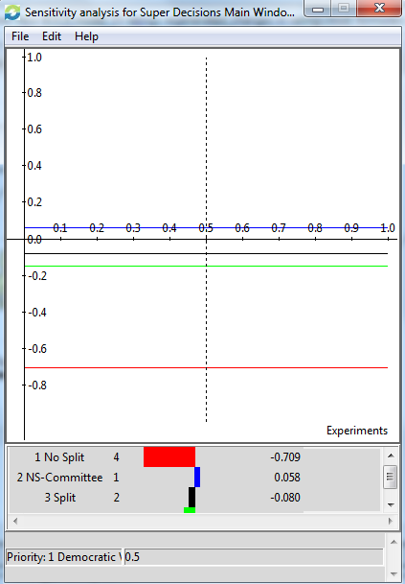

Benefits
Despite the weighting of the BOCR model, Alternative 2 (No Split but Form Development Committee) will be the highest ranked alternative. However, Alternative 3 and 4 are more closely ranked to Alternative 2, if Benefits is weighted under 5%. Interestingly, Alternative 2 levels out at the best option with .458 rating if Benefits is rated between 40-60%.
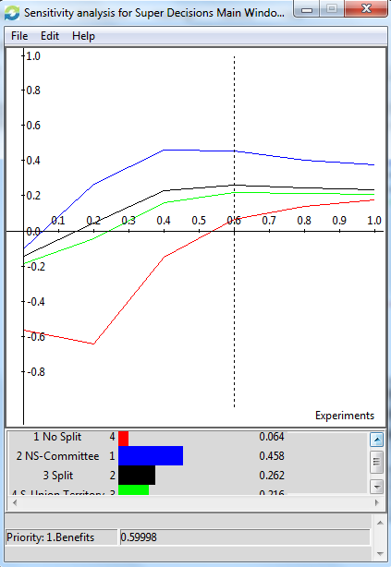

Opportunities
Similar to Benefits, Alternative 2 (No Split but Form Development Committee) will be the highest ranked alternative no matter what the rating weight applied to Opportunities, though the Alternative 2, 3, and 4 are very close if the weight is under 10%. Alternative 1 will ranked the lowest regardless of the weighting. Alternative 2 has its highest rating when Opportunities is weighted at approximately 60%.
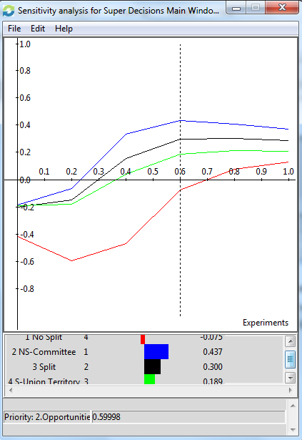

Costs
Alternative 2 (No Split but Form Development Committee) is still the preferred option despite the weighting applied to Costs. Similar to Benefits and Opportunities, the Alternatives 2, 3 and 4 are closely ranked if Costs is weight over 90%. However, Alternative 1 (No Split) is still the less preferred since it would be the most costly option.
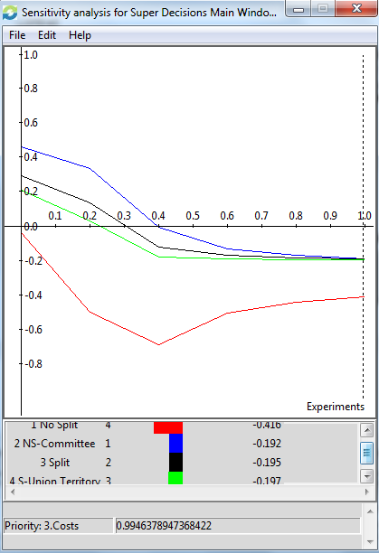

Risks
Alternative 2 (No Split but Form Development Committee) would be the most preferred option despite the weight of importance applied to Risks. However, if a rating of 78.4% is applied to Risks, Alternatives 2, 3, and 4 would tie in the rankings. If a weighted rating of approximately 80.25% or above is applied to Risks, then Alternative 4 (Union Territory) is the preferred option.
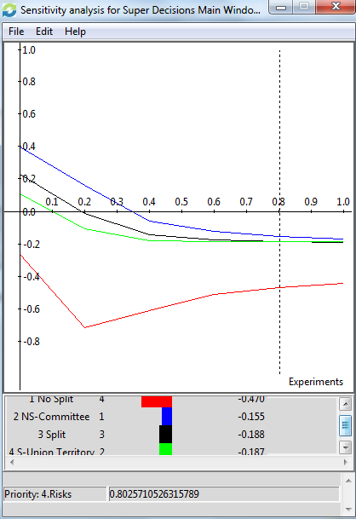

Results and Conclusion

4.1 Additive (Negative)
Based on the additive sensitivity analysis, the best short term option is Alternative 2, (No Split but Form Development Committee).
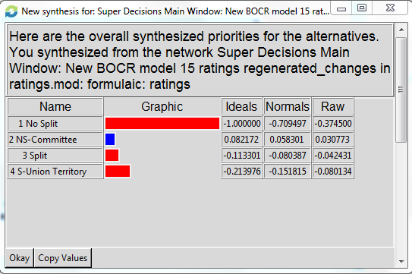
The same conclusion of selecting Alternative 2 (No Split but Form Development Committee) is rated the highest in the Benefits and Opportunities sub-networks. For the Costs and Risks sub-networks, Alternative 1 (No Split) was considered the most costly and Alternative 4 (Union Territory) was least costly option. However, Alternatives 2 and 3 were close to Alternative 4, particularly under Risks.
Benefits | Opportunities
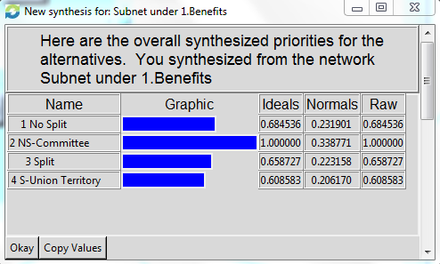 | 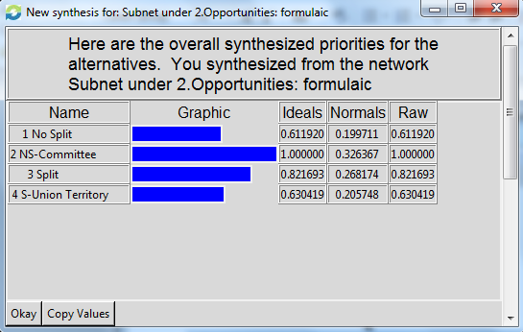
Costs | Risks
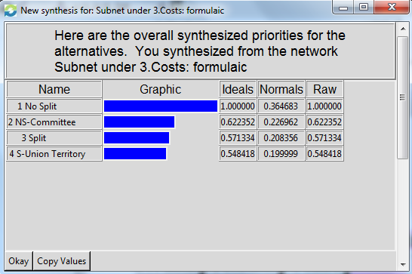 | 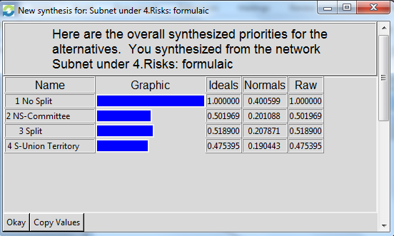

4.2 Multiplicative
Based on the multiplicative computation, the best short term option is still Alternative 2, (No Split but Form Development Committee).
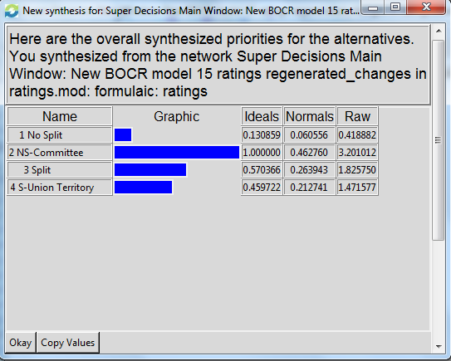
The same conclusion of selecting Alternative 2 (No Split but Form Development Committee) is rated the highest in the Benefits and Opportunities sub-networks. For the Costs and Risks sub-networks, Alternative 1 (No Split) was considered the most costly and Alternative 4 (Union Territory) was least costly option. However, Alternatives 2 and 3 were close to Alternative 4, particularly under Risks.
Benefits | Opportunities
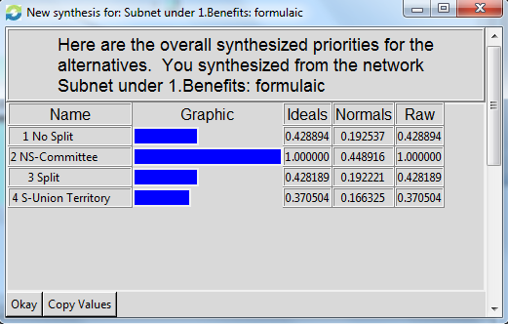 | 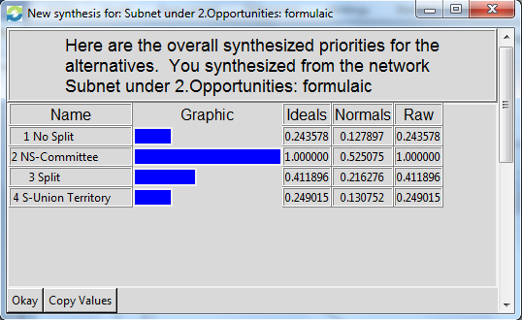
Costs | Risks
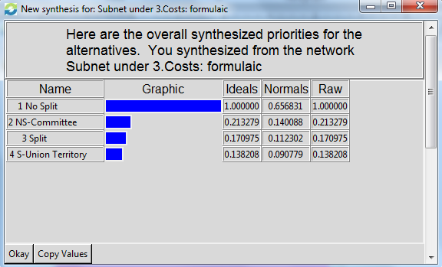 | 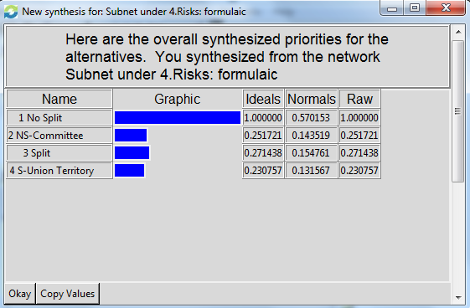

4.3 Conclusion
Based on the results of the model, the best alternative selection for the region of Telegana in Andhra Pradesh is to not split into a separate state but create a development committee for the betterment of the region. Not only is this the best option selected by the model both in the short and long term, but this alternative was also designated the preferred, most workable choice by the Srikrishna Committee. (New Delhi Television Ltd., 2011)

Works Cited
BBC. (2010, January 18). Retrieved April 17, 2011, from Indians divided over the formation of a new state: http://news.bbc.co.uk/2/hi/south_asia/8407984.stm
Deccan Chronicle. (2011, March 7). Retrieved April 17, 2011, from Hyderabad to 'turn into Cairo' as Telangana million-man march is a go: http://www.deccanchronicle.com/channels/nation/south/hyderabad-turn-cairo-telangana-million-man-march-go-604
New Delhi Television Ltd. (2011, January 7). Retrieved April 17, 2011, from Telangana Report: Srikrishna Committee narrows choice to three options: http://www.ndtv.com/article/india/telangana-report-srikrishna-committee-narrows-choice-to-three-options-77448
Wikipedia - The Free Encyclopedia. (2011, April 17). Retrieved April 17, 2001, from Telangana-History of the Movement: http://en.wikipedia.org/wiki/Telangana#History_of_the_movement
Biswas, S. (2010, December 31). BBC. Retrieved April 17, 2011, from India's tussle over new state of Telangana: http://www.bbc.co.uk/blogs/thereporters/soutikbiswas/2010/12/india_trouble_in_the_new_year.html
Telangana Interactive Inc. (2004). Telangana.com. Retrieved April 17, 2011, from Telangana.com - Commited for Development of Telangana: http://www.telangana.com/
Vepachedu. (n.d.). Retrieved April 17, 2011, from Andhra Pradesh: http://www.vepachedu.org/TELANGANA.html

