Mandatory National Service: An Analytical Network Decison

Jamison Benson & Gaurab Misra
Professor Saaty – Decision Making in a Complex Environment

Analytical Network Process Model
The purpose of this study, is to derive whether the US should adopt a 2-year mandatory service requirement, and if so, what form of mandatory public service should be adopted. The question of mandatory public service has been a debated issue for many years, including being mentioned in John Kerry’s presidential platform in 2004, and also proposed in Congress. The following is a summary of the proposed mandatory service legislation:
A new bill called the Universal Service Act of 2003, would require Americans between the ages of 18 and 26, to complete two years of service for the nation in one of various programs.
This service could include participation in the military or Non-Government Organization (NGO) programs such as Peace Corps, Teach for America or AmeriCorps. The president would determine the number of people needed and the means of selection. Deferments would be available to those completing high school, up to the age of 20, with no exemptions for college or graduate students. Payment of some sort would be provided for young people's service. One plan allows for four years of college tuition in exchange for two years of service. Participants who do not choose college might be able to apply for funds to pay for job-training programs or to help start a small business.
Many young people already volunteer to join the U.S. military as an act of self-service, and other programs such as AmeriCorps also draw more than 50,000 volunteers annually. In addition to tutoring children, building homes, cleaning up the environment and helping communities through disaster relief, AmeriCorps members work with 2,100 nonprofits, public agencies, and faith-based organizations. Other service programs, such as Teach for America, work toward eliminating educational inequality throughout the United States. Young people generally make up most of the volunteer staff that spend two years in low-income, urban areas to teach children.
Participants would choose the venue of their service- education, military, or social
service - and spend two year living as a contributing member of society.
Aside from the obvious benefits to the nation as a whole in terms of
increased national service which would provide a strategic workforce, high school grads could benefit
from the extra 2 years of directed service that could help cultivate more mature, independent, and focused students. Students then know who they are and what they want to do because they've had more time to think and benefit from increased skills. Mandatory two year of public service could raise the dismal 40 percent of students graduating in four years to a much more respectable figure which would decrease college debt, much of which is subsidized by the Federal Government.
Less debt means increased financial independence. With the average college student graduating with about $18,000 in debt according to the College Board, debt is a huge factor in a graduate's decision to
return to live with mom and dad. Eliminating a fifth year can save students up to 25 percent.
However, there are many ideas which oppose mandatory service. Some view mandatory public service as a violation of the Universal Declaration of Human Rights, which guarantees the free choice of employment. To help these rights, young adults would be given their choice of service opportunities without being forced into the military or any specific service.
Many countries, such as Austria, Germany, Turkey, and Libya, mandate military or civilian service allowing some room for personal preference. In Germany, an individual must present a case for exemption from military service to be placed into civilian service, but the American policy
would be different. Instead of being placed directly into the military, young adults could choose the path that suited their interests and career goals.
High School grad could spend a couple of years working with the Hispanic population of New York? Try it out for a year. Those who want to study politics could spend a year working in D.C.
Perhaps the strongest objections come from those that propose that a national service requirement is an unwieldy task, requiring intense supervision, financial investment, and high levels of organization.
It cannot be denied that it would take an immense effort to enact a mandatory service program, and these risks must be assessd.
Richard Posner made a good summary of the issue and the economic risks and some of his numbers were used as assumptions in our study. The following is an abridged version of his article:
There are perennial calls for drafting all 18 year olds to serve in either the military or some civilian alternative. Congressman Charles Rangel has repeatedly introduced bills in Congress (the "Universal National Service Act") that would do this. But universal national service is one of those seductive ideas that refuse to die completely, and perhaps therefore it deserves a serious analysis. It is analytically interesting and can serve as an example of the utility of a cost-benefit approach to public programs.

Roughly 4 million Americans reach the age of 18 every year. There are only 1.4 million active-duty military personnel, so only a small fraction of each vintage of 18 year olds could be assigned to the military. At their present size, our active-duty armed forces require only about 150,000 new recruits each year. So any universal national service obligation would have to be primarily an obligation to do civilian work.
Civilian national service (in the United States--thus excluding the Peace Corps, and the missionary work that young Mormon men are required to perform for two years without compensation) funded by the federal government exists already. The "AmeriCorps" program provides federal grants to a large number of service organizations, both public and private. Although these organizations pay only the living expenses of their volunteers plus a modest education grant, the federal contribution amounts to some $27,000 per volunteer.

The number of volunteers supported by AmeriCorps grants is small--well under 100,000. But of course total volunteer activity is much greater than that, and by no means limited to young persons--an affiliate of AmeriCorps is the "Senior Corps." A survey by the U.S. Department of Labor found that there were some 60 million American engaged in volunteer activities in 2006 and that the median number of hours that the volunteers devoted to such activities was about 50 hours a year. Thus, assuming that the average is not much different from the median and that a full-time job is 2000 hours a year, there were the equivalent of 1.5 million full-time volunteers (50/2000 x 60 million). That number is important because a universal national service obligation would have a substitution effect: someone required by law to provide a year of national service would be likely to reduce the amount of volunteer service that he would provide in the future. If, for example, there were a two-thirds reduction in volunteering, from 1.5 million full-tine equivalents to 500,000, and thus a loss of 1 million full-time-equivalent volunteers, universal national service would augment volunteer activities by only 3 million full-time equivalents a year (4 million - 3 million). Granted, this number would rise if universal national service had a complementary effect on volunteer service rather than or, more plausibly, as well as a substitution effect--if, that is, the year of obligatory service created a taste for such service. I find this implausible.

If 4 million persons were conscripted for one year's national service, at an annual expense of $27,000 per person, the program would cost more than $100 billion a year--probably much more, because the $27,000 figure excludes the overhead expenses of the service organizations that receive the per capita grants. The $100 billion (or whatever the correct figure is) would be a transfer payment, but it would generate costs of two types. The first would be the deadweight costs that the taxes required to fund the payment would impose. The second and doubtless greater cost would be the difference between the value of the conscripts' national service work and the value of their output in whatever jobs they would have had were it not for their national service obligations. About half the 18 year olds would (but for their national service obligation) be in college rather than working, and so the effect of universal national service on them would be to postpone their entry into the job market by a year. Their lost wages in their first job would be a rough estimate of the value of their work in that job. The starting salary for college graduates is more than $40,000, other than for liberal-arts majors, and this is about twice the starting salary for high school graduates. That is some evidence that a universal national service program would be inefficient: it would in effect reallocate a year of a college graduate's working life from after college to before college, when he would be less productive.

Against this it could be argued that the national service work that the 18 year olds would perform would have a social value in excess of its private value. But this seems unlikely for most jobs that these teenagers would perform, such as helping out in hospitals and nursing homes and picking up litter on roadsides and in parks. A possible exception is tutoring children, since education produces significant social benefits. But only a small fraction of the 4 million national service conscripts could usefully be employed in that activity.
Universal national service would also have peculiar effects on the distribution of income. The unpaid national service workers would replace low-paid service workers, pushing many of them into poverty.

Proponents argue that, all narrowly "economic" issues to one side, universal national service would confer intangible social benefits in the form of increased solidarity, as all Americans would share in the experience of working for the overall social good without compensation beyond modest living expenses. But given the heterogeneity of the jobs that the national service workers would be performing, the solidarity-enhancing effect would surely be quite limited. It would be different if the 4 million were all drafted into the armed forces for a year, but that is infeasible.

The forms of mandatory public service being discussed in this model are based upon the model proposed in Congress in 2003. However, a public service-only form of mandatory service is included, as well as a military-only mandatory service. These three types, are also compared to not implementing a mandatory public service, since there are inherent risks and cost involved, and these risks and cost must be compared.

The Alternatives:
- Mandatory Public or Military Service
  - 2 years from the ages of 18 to 26 in either with a humanitarian or public service NGO or military
- Mandatory Public Service
  - 2 years from the ages of 18 to 26 with a humanitarian or public service NGO
- Mandatory Military Service
  - 2 years from the ages of 18 to 26 with a US military branch
- No Public Service
  - No requirement for anyone to participate in public or military service
The Model:
The four alternatives: Mandatory Public or Military Service, Mandatory Public Service, Mandatory Military Service, and No Mandatory Service, were contrasted with the following strategic criterion:
- Political Stability
- Economic Productivity
- Individuals’ Priorities
- The National Community
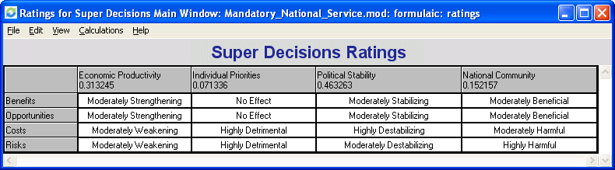
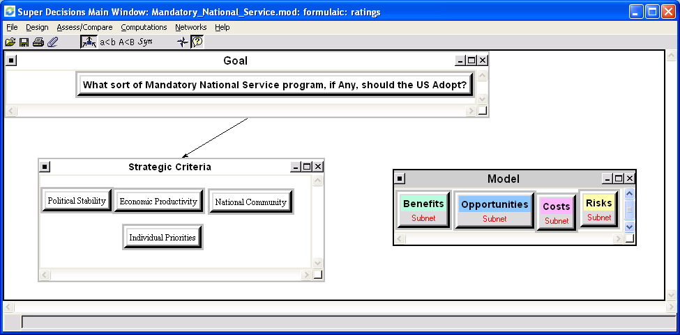

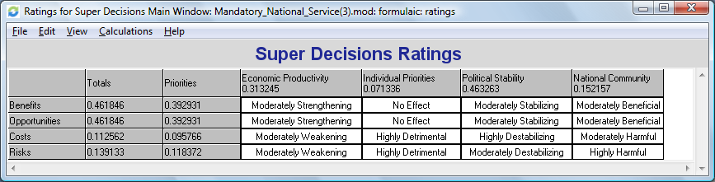

The BOCR framework was divided into the following subnetworks and elements:
Priorities were assigned via pair-wise comparisons.

BENEFITS:
Control Criteria | Clusters | Elements | Priorities
Political | Domestic | Staffing Gov't + Services | 0.466
Political | Domestic | Staffing Military | 0.433
Political | Domestic | Civil Awareness + Responsibility | 0.1
Political | Foreign Policy | Foreign Humanitarian Aid | 0.218
Political | Foreign Policy | Goodwill | 0.151
Political | Foreign Policy | Civilian Support for Mil + Gov't Overseas | 0.63
Economic | National Economy | Labor Force | 0.414
Economic | National Economy | Lower Unemployment | 0.169
Economic | National Economy | Future Contributors | 0.042
Economic | National Economy | Lower Gov't Spending | 0.267
Economic | National Economy | Lower Cost of Train + Recruit | 0.108
Economic | Infrastructure | Roads | 0.311
Economic | Infrastructure | Housing | 0.196
Economic | Infrastructure | Public Works | 0.493
Social | Overall Societal Benefit | Safety Net | 0.23
Social | Overall Societal Benefit | Lower Crime | 0.122
Social | Overall Societal Benefit | Creating Contributors | 0.648
Social | Stability | Available Reserve | 0.143
Social | Stability | Public Safety | 0.286
Social | Stability | Disaster Recovery | 0.571
Individual | Experiential | Develop Self-sufficiency | 0.223
Individual | Experiential | More Focus for HS Grads | 0.07
Individual | Experiential | Skills Development | 0.707
Individual | Personal | Cultural/Civic Awareness | 0.571
Individual | Personal | Financial | 0.143
Individual | Personal | Moral Imperative | 0.286

OPPORTUNITIES:
Political | Civic Opportunity | Civic Conscience (of the population) | 0.667
Political | Civic Opportunity | Civic Responsibility (of the population) | 0.333
Political | Political Relations | Military Relations | 0.065
Political | Political Relations | NGO Relations | 0.242
Political | Political Relations | Domestic Goodwill | 0.451
Political | Political Relations | Foreign Goodwill | 0.242
Economic | US Economy | Earnings Potential | 0.167
Economic | US Economy | Skills and Experience Improvement | 0.74
Economic | US Economy | Incentives/Scholarships/Bonds | 0.094
Economic | Workforce | Unemployment Reduction | 0.073
Economic | Workforce | Military Cost Reduction | 0.073
Economic | Workforce | Public Sector Recruiting Pool | 0.259
Economic | Workforce | Strategically Aimed Workforced | 0.594
Social | Societal Effects | Community outreach | 0.091
Social | Societal Effects | Crime/Unemployment reduction | 0.15
Social | Societal Effects | Environmental Effects | 0.21
Social | Societal Effects | Expansion of Safety Net | 0.46
Social | Societal Effects | Social/Cultural Integration | 0.091
Social | Educational Effects | Educational Provisions expansion | 0.25
Social | Educational Effects | Expanded Educational Opportunity | 0.095
Social | Educational Effects | Teacher Pool | 0.655
Individual | Experiential | Multicultural exposure | 0.297
Individual | Experiential | Improved Development towards career path | 0.163
Individual | Experiential | Civic Virtue | 0.54
Individual | Psychological | Discipline | 0.087
Individual | Psychological | Leadership | 0.284
Individual | Psychological | Openmindedness | 0.2
Individual | Psychological | Personal Growth | 0.43

COSTS:
Political | Delay Implementation/Effect |  | 0.076
Political | Enforcement |  | 0.229
Political | Legislative Resistance |  | 0.329
Political | Lower Quality |  | 0.123
Political | Oversight |  | 0.243
Economic | Bureaucratic Expense |  | 0.276
Economic | Enforcement Expense |  | 0.167
Economic | Loss of Economic Production |  | 0.395
Economic | Maintenance Expense |  | 0.162
Social | Death or Injury |  | 0.526
Social | Displacement of Person |  | 0.079
Social | Disruption of Family |  | 0.212
Social | Social Services Support |  | 0.182
Individual | Deferment of Personal Goals |  | 0.238
Individual | Loss of Freedom of Choice |  | 0.396
Individual | Loss of Privacy |  | 0.175
Individual | Loss of Time |  | 0.192
RISKS:
Political | Bureaucratic Failure |  | 0.046
Political | Civil/Gov't Relations |  | 0.414
Political | Enforcement |  | 0.164
Political | Lack of Provable Positive Affectivity |  | 0.054
Political | Military Conscription |  | 0.195
Political | Public Opinion |  | 0.128
Economic | Bureaucratic Maintenance |  | 0.065
Economic | Financial Opportunity Cost |  | 0.317
Economic | Implementation Costs |  | 0.146
Economic | Loss of Workforce to Job Market |  | 0.152
Economic | Poor Utilization |  | 0.1
Economic | Substitution Effect on Volunteerism |  | 0.073
Economic | Taxes |  | 0.147
Social | Fairness |  | 0.214
Social | Family Upheaval |  | 0.297
Social | Human Rights |  | 0.44
Social | Public Sector Job Security |  | 0.05
Individual | Freedom of Choice |  | 0.22
Individual | Hazards |  | 0.516
Individual | Opportunity Costs |  | 0.15
Individual | Resentment |  | 0.113

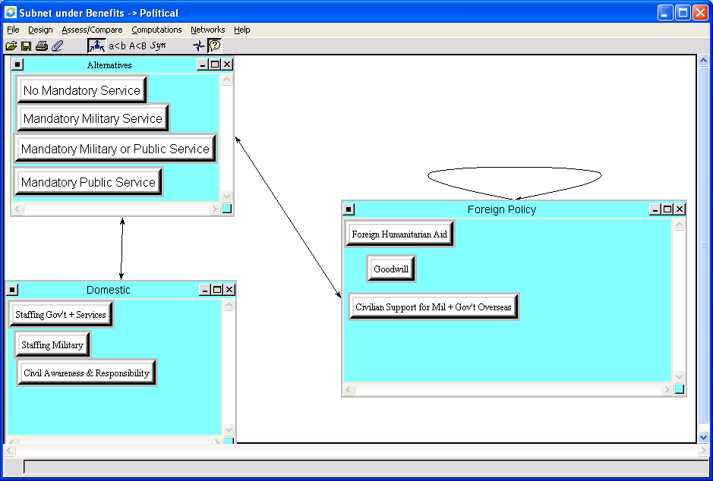
The Political Benefits took into account both the foreign policy and domestic aspects, including the potential increase in the workforce for aid, as well as bureaucratic organizations, along with an increased sense of being good citizens. Goodwill is a dependency of Foreign Humanitarian aid.
Name Ideals Normals Raw
Mand. Military /Pub. Service 1.000000 0.391867 0.193875
Mandatory Military Service 0.832195 0.326110 0.161342
Mandatory Public Service 0.576295 0.225831 0.111729
No Mandatory Service 0.143396 0.056192 0.027801

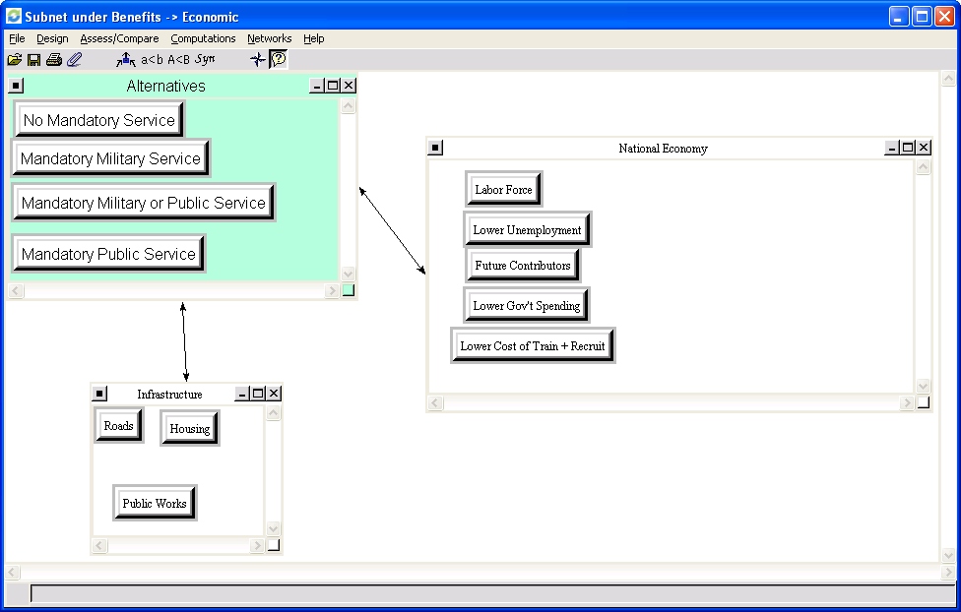
The Economic Benefits analysis included such aspects as how the infrastructure would be improved by a the differing mandatory national service options (or a lack of one), along with how a mandatory national service would improve the national economy, including improving the labor force by providing young people with practical skills gained through service, lower unemployment due to millions of young people leaving the private sector work force, and lower government spending since the government would require less private contracting.
Name Ideals Normals Raw
Mand. Mil. or Public Service 0.652199 0.280682 0.140341
Mandatory Military Service 0.210397 0.090547 0.045273
Mandatory Public Service 1.000000 0.430363 0.215182
No Mandatory Service 0.461024 0.198408 0.099204
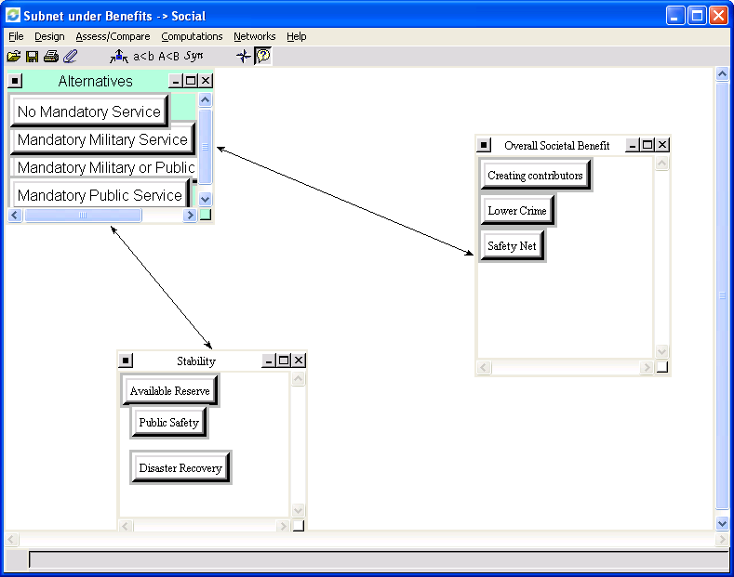
Name Ideals Normals Raw
Mand. Mil. or Public Service 1.000000 0.332181 0.166090
Mandatory Military Service 0.524712 0.174299 0.087150
Mandatory Public Service 0.858119 0.285050 0.142525
No Mandatory Service 0.627579 0.208470 0.104235
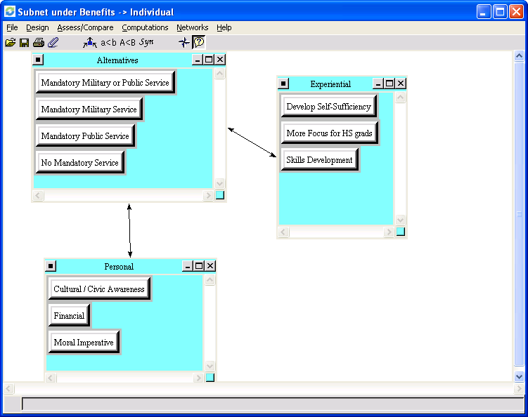
The Individual Benefits took into account the experiential and personal benefits from the respective alternatives. Again, skills gained through service were an important factor along with the increased development of self-sufficiency and career focus for High School grads.
Name Ideals Normals Raw
Mand. Mil. or Public Service 1.000000 0.496717 0.248358
Mandatory Military Service 0.167953 0.083425 0.041713
Mandatory Public Service 0.631290 0.313572 0.156786
No Mandatory Service 0.213977 0.106286 0.053143

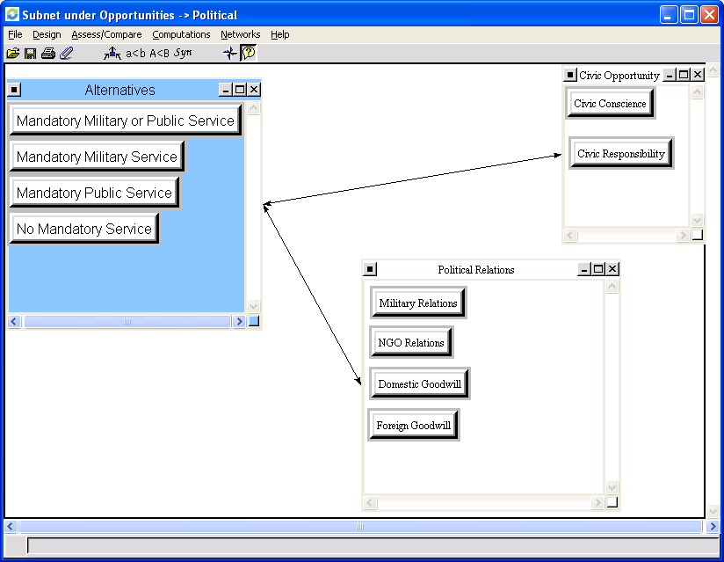
Political Opportunities took into account the improved relations to be gained for such entities such as the military, and non-government organizations, goodwill that could be generated domestically as well as internationally, and the opportunities for civic conscience and responsibility.
Name Ideals Normals Raw
Mand. Mil. or Public Service 1.000000 0.481054 0.240527
Mandatory Military Service 0.188240 0.090554 0.045277
Mandatory Public Service 0.705280 0.339278 0.169639
No Mandatory Service 0.185247 0.089114 0.044557
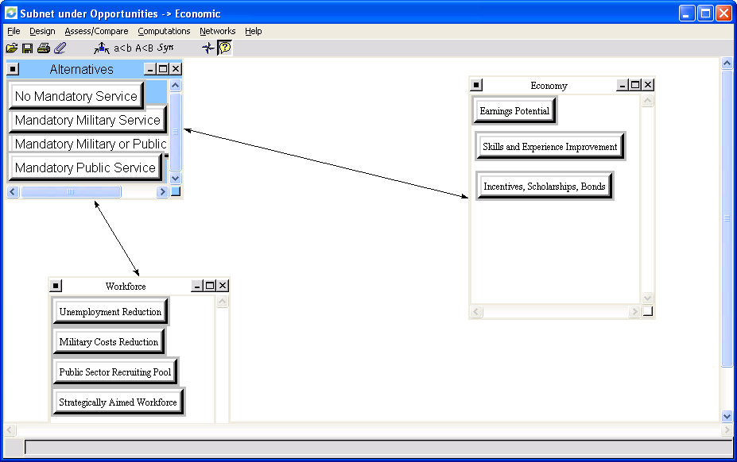
Economic opportunities took into account the opportunities for both the US workforce and the economy at-large. The existence of the strategically-aimed workforce was the most important aspect in this subnetwork.
Name Ideals Normals Raw
Mand. Mil. or Public Service 0.628014 0.321086 0.160543
Mandatory Military Service 0.145906 0.074598 0.037299
Mandatory Public Service 1.000000 0.511271 0.255636
No Mandatory Service 0.181987 0.093045 0.046523

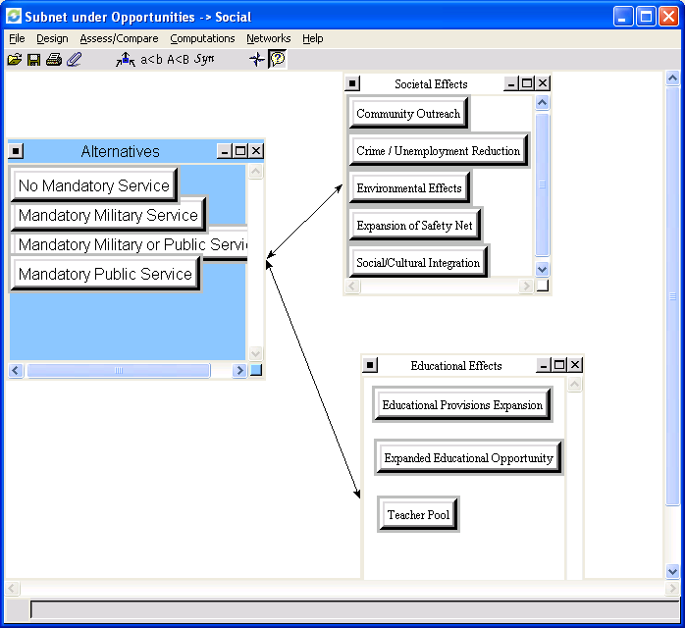
Under Social Opportunities, the educational effects and societal effects of the alternatives were assessed.
Name Ideals Normals Raw
Mand. Mil. or Public Service 0.587037 0.327070 0.163535
Mandatory Military Service 0.108536 0.060471 0.030236
Mandatory Public Service 1.000000 0.557154 0.278577
No Mandatory Service 0.099264 0.055305 0.027653
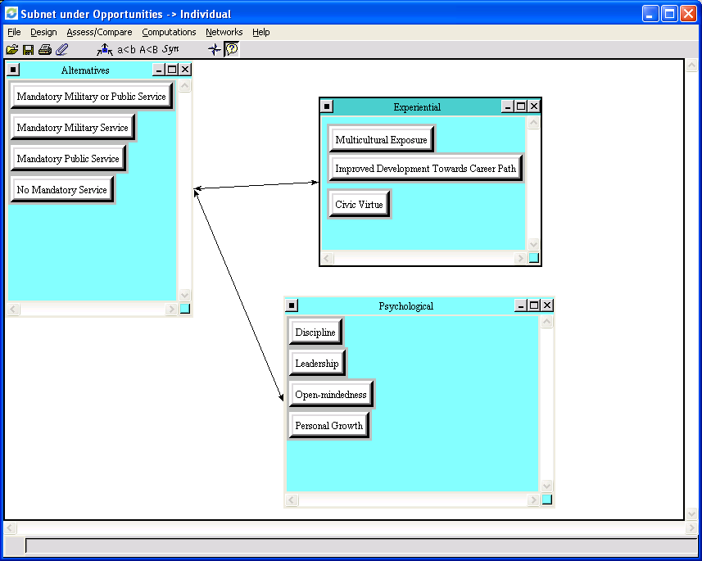
Name Ideals Normals Raw
Mand. Mil. or Public Service 1.000000 0.412086 0.206043
Mandatory Military Service 0.434957 0.179240 0.089620
Mandatory Public Service 0.849801 0.350191 0.175095
No Mandatory Service 0.141921 0.058484 0.029242

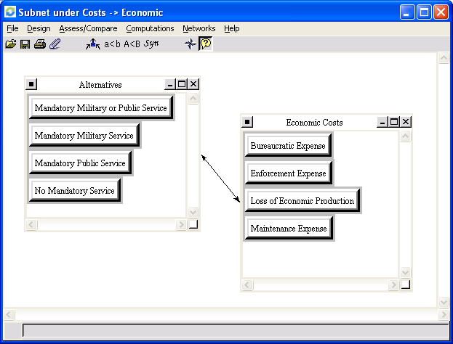
Name Ideals Normals Raw
Mand. Mil. or Public Service 0.513732 0.229701 0.114850
Mandatory Military Service 1.000000 0.447122 0.223561
Mandatory Public Service 0.624208 0.279097 0.139548
No Mandatory Service 0.098588 0.044081 0.022041
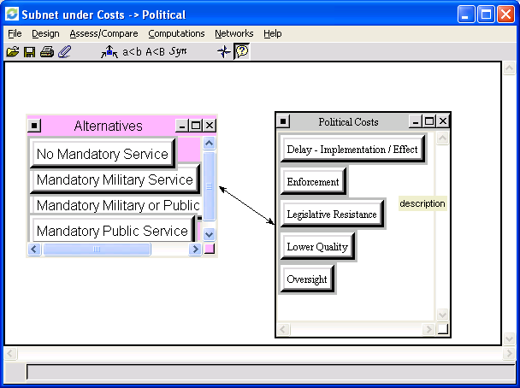
Name Ideals Normals Raw
Mand. Mil. or Public Service 0.522035 0.282048 0.141024
Mandatory Military Service 1.000000 0.540286 0.270143
Mandatory Public Service 0.247177 0.133546 0.066773
No Mandatory Service 0.081660 0.044120 0.022060
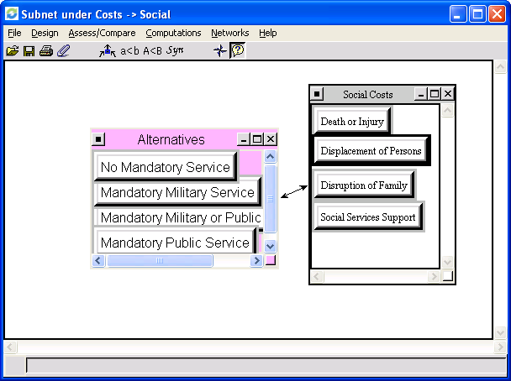
Name Ideals Normals Raw
Mand. Mil. or Public Service 0.508503 0.280221 0.140110
Mandatory Military Service 1.000000 0.551070 0.275535
Mandatory Public Service 0.228169 0.125737 0.062869
No Mandatory Service 0.077980 0.042973 0.021486
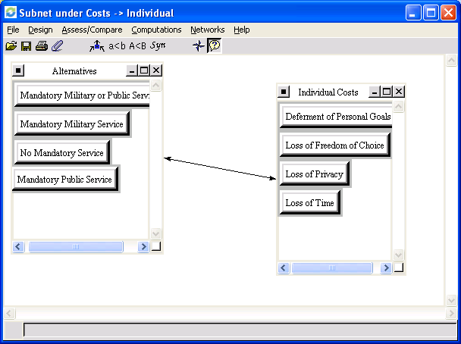
Name Ideals Normals Raw
Mand. Mil. or Public Service 0.435482 0.225113 0.112557
Mandatory Military Service 1.000000 0.516929 0.258465
Mandatory Public Service 0.423741 0.219044 0.109522
No Mandatory Service 0.075277 0.038913 0.019457

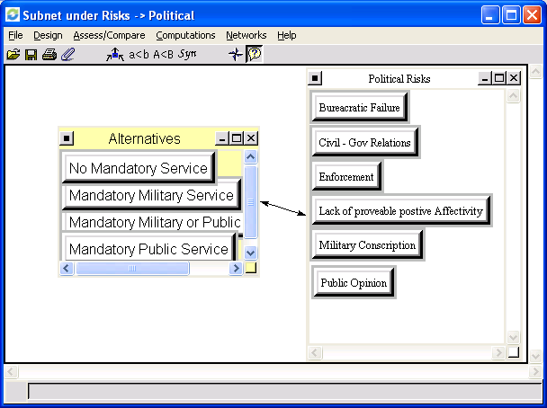
Name Ideals Normals Raw
Mand. Mil. or Public Service 0.488809 0.231296 0.482886
Mandatory Military Service 1.000000 0.473182 0.987882
Mandatory Public Service 0.534922 0.253115 0.528440
No Mandatory Service 0.089621 0.042407 0.088535
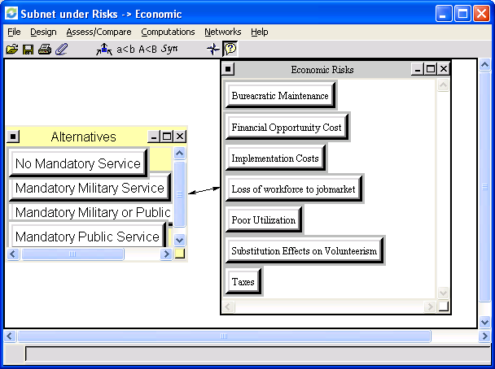
Name Ideals Normals Raw
Mand. Mil. or Public Service 0.674115 0.245578 0.122789
Mandatory Military Service 0.963647 0.351053 0.175527
Mandatory Public Service 1.000000 0.364297 0.182148
No Mandatory Service 0.107253 0.039072 0.019536

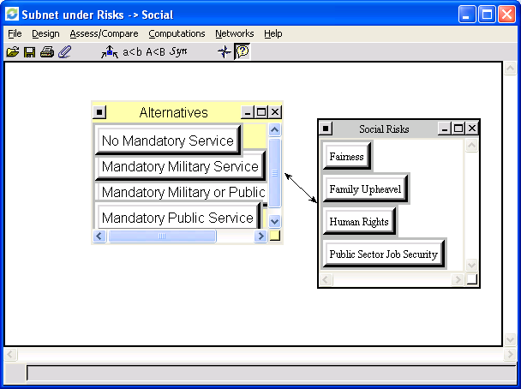
Name Ideals Normals Raw
Mand. Mil. or Public Service 0.331784 0.197130 0.098565
Mandatory Military Service 1.000000 0.594153 0.297076
Mandatory Public Service 0.273419 0.162453 0.081226
No Mandatory Service 0.077866 0.046265 0.023132

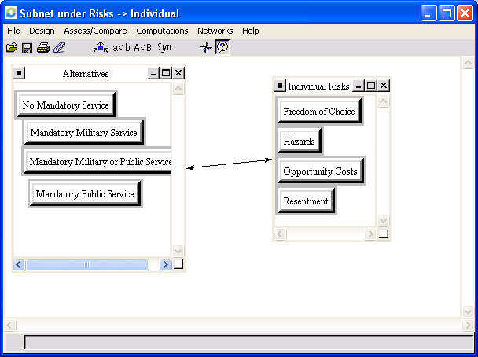
Name Ideals Normals Raw
Mand. Mil. or Public Service 0.343558 0.204467 0.102233
Mandatory Military Service 1.000000 0.595144 0.297572
Mandatory Public Service 0.266913 0.158852 0.079426
No Mandatory Service 0.069793 0.041537 0.020769

When the model is complete and synthesized, the alternatives are ranked:
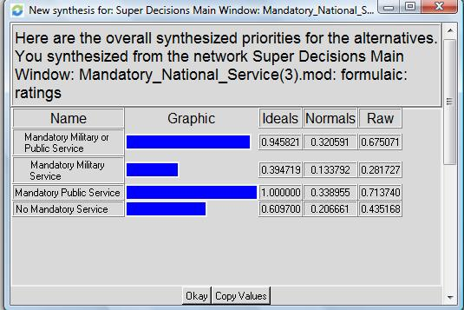
It should be noted that these priorities are heavily influenced by how Benefits, Opportunities, Costs, and Risks are compared with each other. It is interesting that Mandatory Public service comes up as the best opportunity. It is also important to note that the additive reciprocal formula was used in the synthesis, and was necessary for the synthesis to be done correctly.
For example, in the sensitivity analysis, once Risks reached a priority of 0.20, No Mandatory Service comes up as the best Alternative.
Sensitivity Analysis
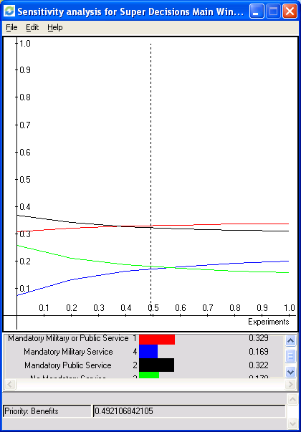
The Sensitivity analysis with respect to the priority of the Benefits Merit revealed that Mandatory Public Service and Mandatory Military or Public Service were nearly equal in priority across the board. In terms of priority they are equal when “Benefits” is given a priority of approximately 0.39212. Above that, Mandatory Military or Public Service takes priority, and below that priority is taken by Mandatory Public Service.
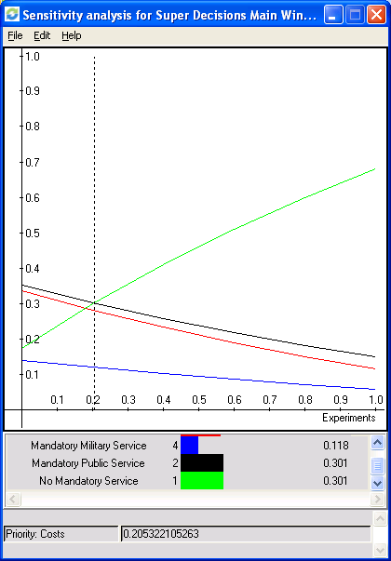
With respect to Costs as the independent variable, sensitivity analysis shows that No mandatory service is the winner across the range of priorities. At a priority of 0.20532 mandatory public service is equal in priority to No mandatory service.
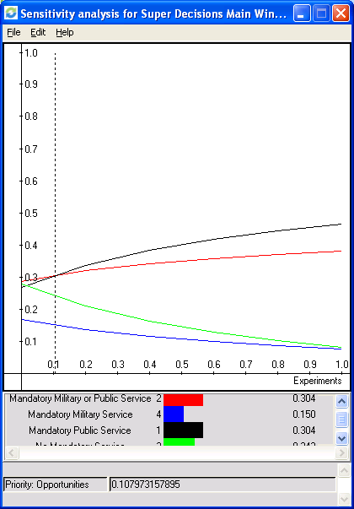

Regarding the sensitivity with respect to Opportunities, Mandatory Military or Public Service and Mandatory Public service seem to run somewhat parallel given the priority on Opportunities. The two alternatives are equal at a low priority (0.10797) on Opportunities but do not diverge much across the range of priority.

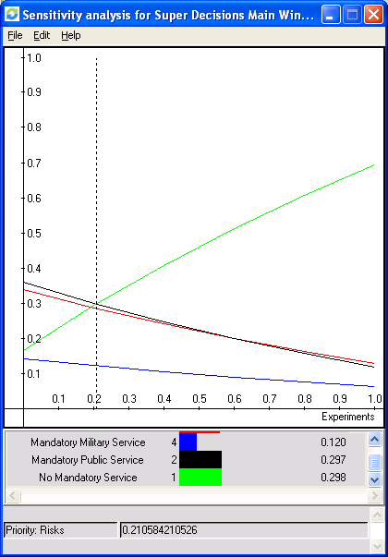
Prioritizing Risk shows sensitivity similar to that of the Cost merit, as No Mandatory service is a clear winner across the priority range, with Mandatory Public Service equaling it at a low priority of 0.21.

REFERENCES:
http://chronicle.com/blogs/footnoted/677/debating-mandatory-national-service

http://www.elon.edu/e-web/pendulum/Issues/2005/03_17/features/specialprojects.xhtml

http://www.becker-posner-blog.com/archives/2007/09/universal_natio_1.html

http://stinet.dtic.mil/cgi-bin/GetTRDoc?AD=ADA364045&Location=U2&doc=GetTRDoc.pdf

