Should Poland Join the EMU?
Decision Making in a Complex Environment

University of Pittsburgh
Joseph M. Katz Graduate School of Business

Anna K. Connor
Bryan T. Mullins

April 26, 2011

Table of Contents

Abstract………………………………………………………………………………………........ 2

Introduction……………………………………………………………………………………...... 2

Methodology…................................................................................................................................ 3

Data………...................................................................................................................................... 4

Analysis…….................................................................................................................................. 13

Summary……………………………………................................................................................ 15

Conclusion………………………………………………………………………………………. 16

Future Research and Applications…............................................................................................. 16

Bibliography…………………………………………………………………………………….. 17

Appendicies……………………………………………………………………………………… 18

Abstract

For this paper we evaluated whether Poland should join the European Monetary Union (EMU) of the European Union. We considered the benefits, opportunities, costs, and risks of alternative decisions using economic, social, and political control criteria. Although all 27 members of the EU are expected to participate in EMU and eventually adopt the euro as a single currency, joining EMU is a difficult decision that involves a loss of independence and national identity. Our BOCR model and decision criteria suggested that Poland should continue using its strong zloty currency and in fact not join EMU.

Introduction

Poland joined the EU in May 2004 along with nine other countries. Synonymous with the eurozone, EMU synthesizes the policies that are targeted at converging the economies of EU members in three stages. Stage Three of EMU began on January 1, 1999 and includes the following goals according to the European Central Bank (ECB) in Frankfurt:

- Irrevocable fixing of conversion rates
- Introduction of the euro
- Single monetary policy by the European System of Central Banks
- Entry into effect of the intra-EU exchange rate mechanism (ERM II)
- Entry into force of the Stability and Growth Pact

With the exception of Denmark and the United Kingdom, all EU members have committed themselves by treaty to join EMU. Seventeen EU members now use the euro. The original vision for the EU was to achieve both economic and political union. But the path toward finding common ground at the intersection of politics, economics, and culture is a difficult one that requires intestinal fortitude. A pan-European outlook is now permeating a continent that is experiencing a tremendous push toward regionalization and super-regionalization. Joining EMU also requires a readiness among EU members to absorb negative shocks in other member states’ domestic economies including financial crises, terrorist attacks, political turmoil, oil disruptions, and natural disasters, all of which are typically more influential than central banks’ monetary policy in managing real GDP volatility.

This is why the decision to join EMU is important. EU member states that join EMU relinquish their national currencies and cede monetary and fiscal policy decision-making authority to the ECB. This creates increased interdependence among EU member states that includes benefits, opportunities, costs, and risks. The recent financial crises in Greece and Portugal demonstrate how negative events in lesser-developed member nations force members such as Germany to intervene and provide bail-out packages in order to preserve the EU and EMU. This raises questions about whether EU members should join EMU and whether the overall concept of the EU is feasible over the long term.

Methodology

During the course of this research we identified three alternative decisions for Poland regarding EMU:

- Enter EMU as soon as possible
- Wait to enter EMU
- Do not enter EMU

These alternatives are straightforward. Some EU members are eager to join EMU in order to enjoy the benefits of membership. Others wait to join either because they do not yet meet the criteria for EMU or because they want to weigh the costs and benefits of joining. Other EU states such as Denmark and the United Kingdom have opted not to join EMU and continue to use their own currencies. Each alternative has advantages and disadvantages.

In our model we used strategic criteria encompassing economic, social, and political arenas and extended these to be control criteria within our BOCR model. We believe that these three criteria are holistic and capture the most important issues that factor in to a decision about whether to join EMU. From a macroeconomic standpoint, these criteria should be the most important factors for an EU member state to consider when making the decision. We used the PEST (Political, Economic, Social, and Technological factors) analysis to derive our strategic criteria. This framework is normally used to evaluate the macroeconomic environment of a company. Even though this technique is usually not applicable to countries, it is particularly useful when considering the risks and opportunities associated with strategic decisions.

The economic criterion should cover all economic and financial implications of joining EMU. The social criterion focuses on implications for Polish citizens such as national identity, independence, and cross-cultural communications. The political criterion addresses issues such as national security or implications for politicians and public officials in deciding whether to join EMU. Overall, politics tends to take precedence over economics and certainly social influences for major decisions in the global economy. But all three strategic criteria are extremely important for any EU member state to consider.

There are considerable interdependencies among the clusters and nodes within the benefits, opportunities, costs, and risks categories. For example, when we evaluate the benefits of EMU membership using the political control criterion, we can see that there are linkages between the three alternatives and the clusters for security and political aspects. Overall, the EU has been more successful at realizing economic union than political union. From a political standpoint, EU members join EMU in order to gain benefits related to military and currency speculation. The thinking here is that EMU can improve the economic prosperity and stability of member nations, which has positive implications for national security. Similarly, nations that join EMU seek to benefit from improved international relations, deeper political integration, more political power, and a stronger voice at the ECB.

We made pairwise comparisons for the various interdependencies and elaborate on these in the next section of the report using graphics excerpted from Super Decisions.
Data

Strategic Criteria

We used economic, social, and political strategic criteria in our model. We also used these as control criteria consistently throughout the benefits, opportunities, costs, and risks that we identified. Further detail regarding our model is presented below.

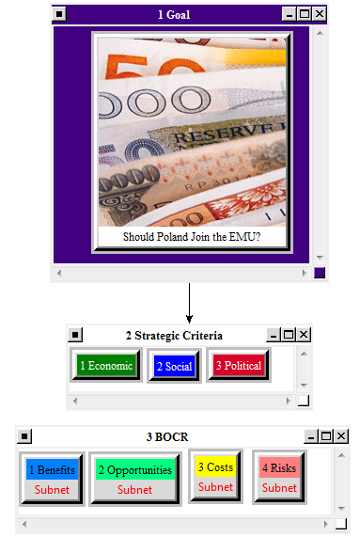

Benefits

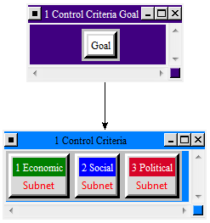
Economic Control Criterion:

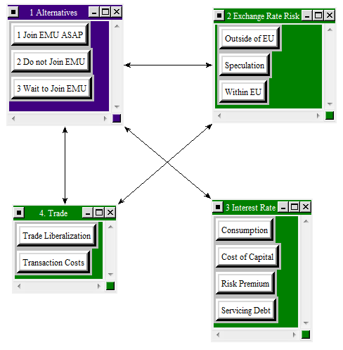

The interdependencies between the three alternatives, exchange rate risk, interest rates, and trade have the following implications for Poland:

- Exchange Rate: Eliminate exchange rate risks within EU; diminish exchange rate risks outside EU; reduce transaction costs (increase in trade within EU); decrease effect of speculation
- Interest Rates: Lower costs of obtaining capital
- Increased stability of economic growth
- Restructuring of unprofitable companies
- Increased international trade
- Lower cost of protection against exchange rate risk
- Increase in investments (decline in interest rates)
- Increase in consumption (decline in interest rates)
- Servicing debt will become cheaper due to increased fiscal credibility and lower interest rates
- Increased economic stability and credibility of country’s macroeconomic policies
- Integration of financial markets
- Decreased market risk premium for investments (perception of improved macroeconomic credibility); liquidity risk and risk of default will decrease

Social Control Criterion:

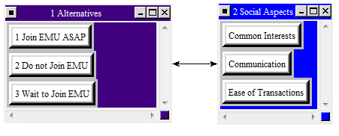

The linkages between the three alternatives and social aspects including common interests, communication, and ease of transactions result in an enhanced feeling of unity and closeness with the EU.

Political Control Criterion:

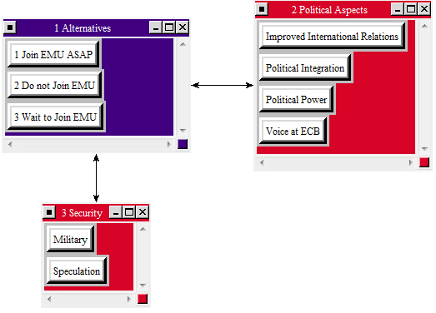

The interdependencies between the three alternatives, the security cluster, and the political aspects cluster include increased decision-making power in the EU and participation in EMU decision making. Poland could also benefit from increased political integration and convergence of interests.

Opportunities

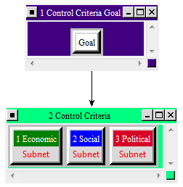

Economic Control Criterion:

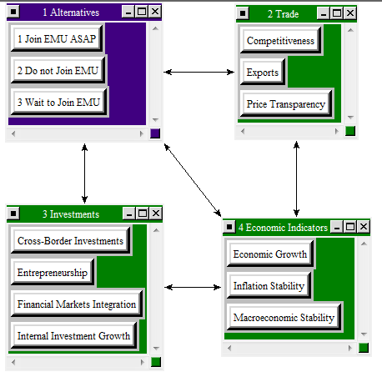

From an economic perspective, joining EMU could yield the following opportunities for Poland:

- Lower variability of inflation resulting from more aggressive monetary policy and less fluctuation in prices of imported articles
- Increase in exports
- Investment capital inflow
- Manufacturing unit costs decrease
- Financial system stability
- Economic growth
- Increased trade exchange can lead to economic growth
- Increased competitiveness
- Increased macroeconomic stability
- Financial markets integration
- Intensified trade exchange

Social Control Criterion:

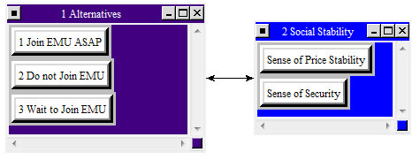

From a social perspective, EMU membership could result in lower taxes and stronger free markets. Price stability would also put Polish citizens at ease.

Political Control Criterion:

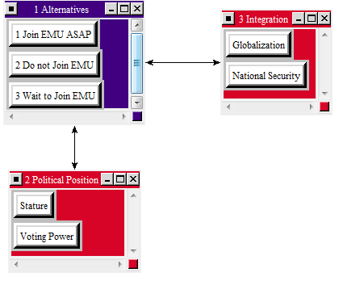

Political opportunities associated with joining EMU include peace, world integration and globalization, and a stronger position for Poland in the EU.

Costs

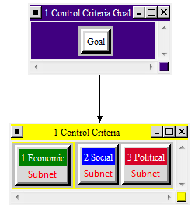

Economic Control Criterion:

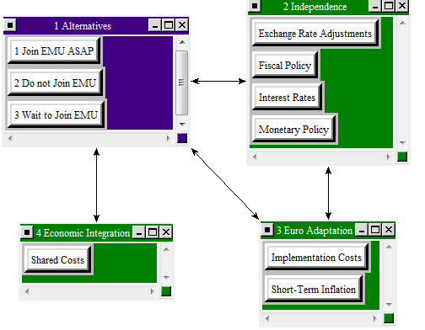

Joining EMU would result in the following economic costs for Poland:

- Adaptation of monetary policy instruments and open-market operations to ECB requirements
- Dependence on EU economic trends
- Short-term inflation (rounding of prices, especially for low-priced products, might lead to increase in prices)
- Perception of higher prices might lead to higher pay demands and curbed consumption
- Temporary decline in export dynamics
- Limitations on country's fiscal policy imposed by EMU
- Possible disappearance of certain financial instruments based on exchange rates
- Administrative costs associated with introducing euro

Social Control Criterion:

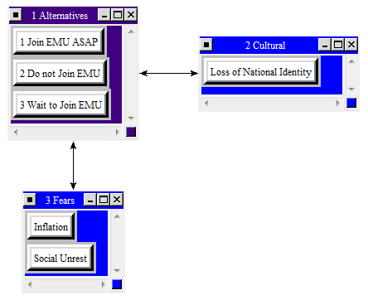

Poland would have to face the following social implications if it were to join EMU:

- Increase in number of bankrupt companies
- Decrease in economic growth
- Relinquish monetary policy
- Lack of knowledge about euro can lead to social unrest
- Loss of independence
- Worries about price increases

Political Control Criterion:

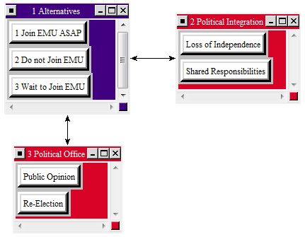

Joining EMU could also have several political costs for Poland:

- Loss of monetary independence
- Loss of exchange rate independence
- Dependency on ECB for fiscal and monetary decision making
- Negative public opinion and no re-election for politicians advocating EMU

Risks

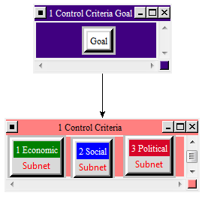

Economic Control Criterion:

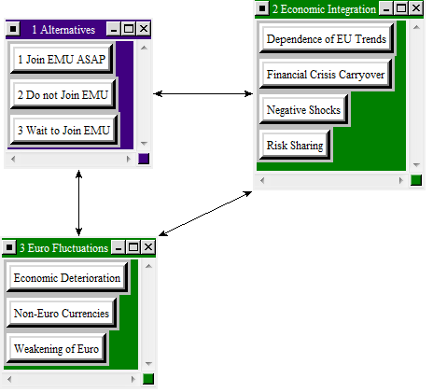

Poland could face the following economic risks if it were to join EMU:

- Euro rate decline and strengthening of currencies outside EEA
- Lack of competitiveness outside new products and quality increase
- Energy price increase outside EU
- Speculating capital inflow
- Slowdown in economic growth due to weaker countries
- Sub-optimal conversion rate
- Loss of competitiveness

Social Control Criterion:

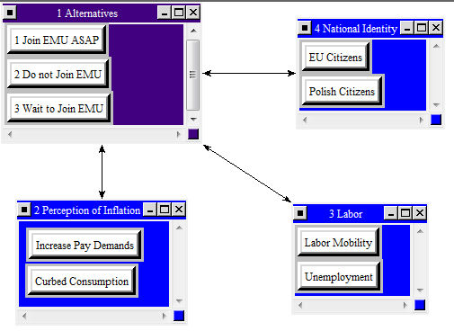

Social risks for Poland in joining EMU could include a rise in unemployment, diminished national identity, and social unrest. Poland could also face an “identity crisis” in that nationals might wrestle with the prospect of being both Polish and EU citizens.

Political Control Criterion:

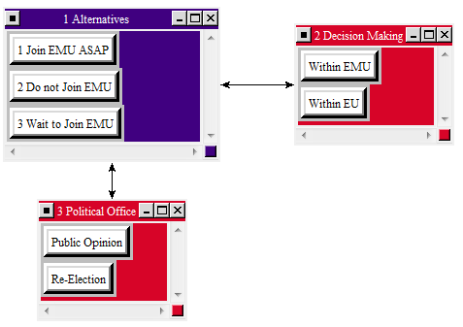

Political risks for Poland could include the possibility of different interests and sub-optimal use of monetary power. Additionally, politicians could face negative public opinion and risk not being re-elected.

Analysis

We assigned the highest priorities to costs, risks, and benefits and rated these very high for the economic criterion, which is the most important control criterion of the three. Opportunities are also rated high on the economic criterion. Our model indicates that there are high political costs associated with Poland’s entry in EMU. The priorities suggest that the disadvantages of joining EMU outweigh the advantages.

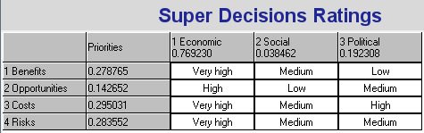

Multiplicative (Short Term)

The multiplicative formula is best for short-term results. The graphic below illustrates very clearly that Poland should not join EMU. This is most likely due to the very high costs and risks associated with the economic control criterion.

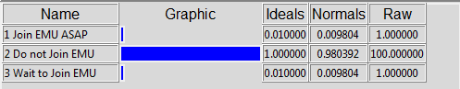

Additive Negative (Long Term)

The additive negative formula is best for long-term results. The graphic below also indicates that Poland should not join EMU.

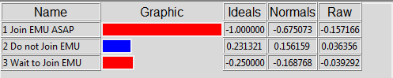

Sensitivity Analysis

We performed a sensitivity analysis using benefits, opportunities, costs, and risks as independent variables and set the priority of the “what-if” node at 50 percent. The graphs below and on the following page illustrate that Poland should not join EMU when benefits, costs, and risks are the independent variables. The opportunities associated with joining EMU appear to be high, but these do not outweigh the other three variables.

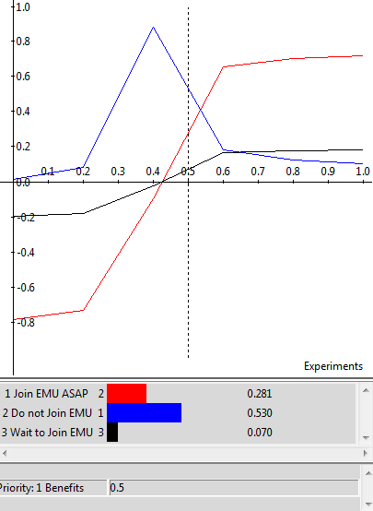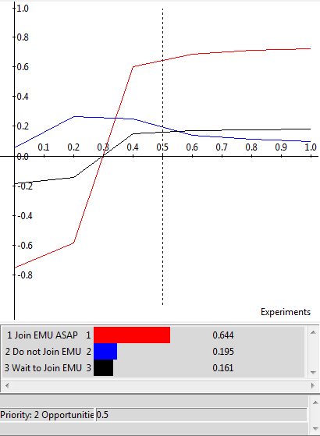

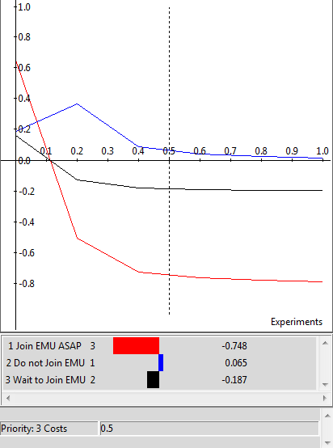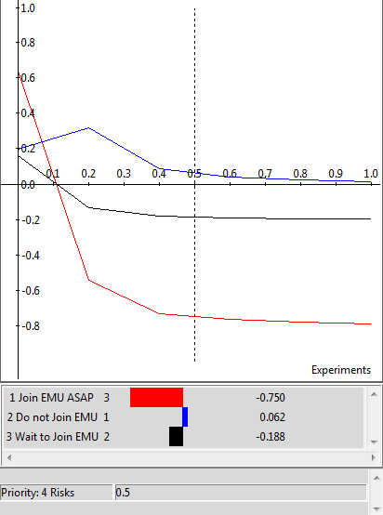

Summary

The decision whether to join EMU is complex and includes a number of factors. Poland was one of 10 countries that joined the EU in 2004 and has since experienced a protracted debate about the merits of joining EMU. There is considerable upside potential to joining EMU. Deeper economic integration strengthens the EU’s position in the global economy and boosts trade within the EMU. A single currency makes it easier for citizens to travel across borders and eliminates exchange rate risk within the EU while diminishing it outside of the EU. A decline in interest rates can fuel increases in consumption and investments. From a social perspective, joining EMU can lead to a stronger sense of unity within the EU and facilitate transactions. It can also lead to lower taxes, stronger free markets, and increased price stability. EMU membership also yields political benefits and opportunities including increased national security, more decision-making power in the EU, and an overall stronger position in the EU.

Our BOCR model, however, suggested that there is more downside potential for Poland and that remaining independent would be in the country’s best interest. Joining EMU requires both give and take from EU member states. It is true that EMU requires nations to lose part of their national identity when they adopt a single currency and relinquish fiscal and monetary policy decision-making power to the ECB. This can be especially difficult when an EU member’s currency is outperforming the euro, which is currently the case with Poland, or when financial crises in countries such as Greece and Portugal drag down the overall performance of the EMU and force other members to button up and provide bailout packages.

Conclusion

EU member states must evaluate the pros and cons of joining EMU and can use a BOCR model as a tool to make sound decisions in a complex and tumultuous global economy. Effective decision making must involve elements of both the heart and the mind. We cannot rely solely on intuition or “gut feel” to make important decisions because this often results in the wrong decision. In professional settings we have to use analytical models and sometimes management science decision making to validate our intuition and make the most effective decisions that we can given the information and resources that we have at the time. Our analysis and analytical judgment led us to conclude that Poland should not join EMU. Other students and professionals might disagree with our conclusion. That is acceptable as long as they can back up their assertions with an analytical framework or tool such as Super Decisions.

That said, it is important to be aware of the influence of bias or past experiences in using a tool such as Super Decisions. Our results overwhelmingly indicate that Poland should not join EMU. In terms of our team, Anna is Polish and has strong views about whether Poland should join EMU. Bryan is American and has worked and studied in Germany. He has often questioned why Germany, which will continue to be the powerhouse of the EU, gave up the Deutsche Mark in favor of the euro, particularly in view of Germany’s recent bailout of the Greek economy. Overall, bias can be an influential determinant of the results of a BOCR model in Super Decisions.

Future Research and Applications

The decision of whether to join EMU will continue to be important as the EU enlarges and strives to realize its vision of economic and political union. The future of the EU attracted significant attention during the global financial crisis and brought the viability of EMU and a single currency into question. Our prior research indicates that the leaders and visionaries in Europe must pursue pan-European strategies in order to compete and survive in light of the current push toward regionalization and super-regionalization on the continent. We believe that our BOCR model could be an important tool for both EU members and prospective members to use in deciding whether to join EMU and lends structure to the complexity of the decision and its implications. Nations such as Denmark and the United Kingdom serve as examples of EU members that have opted not to join EMU in order to preserve their national currencies and economic independence. These nations and other EU member states can use a BOCR model and incorporate new information stemming from the European financial crisis to make wise decisions for their futures.

Bibliography

Adamus, Wiktor. “When Shall Poland Enter the Euro Zone? Decision Making with the ANP.” August 3-6, 2007.

Pszczółka, Ireneusz. “Advantages and Disadvantages of Introducing the Euro.” The Dilemmas of Regional Economic Integration.

Rybiński, Krzysztof. “The Euro Adoption – Assessing Benefits and Costs.” June 2007. BIS Review.

The European Central Bank › History › Economic and Monetary Union (EMU). The European Central Bank Website. www.ecb.int/ecb/history/emu/html/index.en.html.

Appendicies

