Project Airport Berlin | April 22  2008
This paper was prepared by Christian Wielage and Sebastian Kuszmierczyk from the KATZ Graduate School of Business at the University of Pittsburgh. |  | Decision Making in Complex Environments

Table of Contents
Background 3
The Airports 4
The alternatives 6
The Decision Model 7
Benefits 9
Economic 9
Social 10
Political 11
Environmental 12
Costs 13
Economic 13
Social 13
Political 14
Environmental 14
Opportunities 15
Economic 15
Social 16
Political 16
Environmental 17
Risks 18
Economic 18
Social 18
Political 19
Environmental 19
Overall Result 20
Sensitivity Analysis 21
Benefits 21
Costs 22
Opportunities 23
Risks 24
Final Words 25

Background
Berlin is the capital of Germany and has approximately 3.5 million inhabitants. It’s the largest German city, but compared to other international cities, such as New York or Mexico City it is rather small. However, Berlin currently uses 3 commercail airports to handle its flight traffic, which was 20 million passengers in 2007. The 3 airports, named Tegel, Tempelhof and Schoenefeld, combined serve 173 destinations. While Schoenefeld lies outside the city, Tegel and Tempelhof are located within the city. Tegel can be reached from Berlin downtown within 15 minutes by car and is the smallest airport. Tempelhof is located in the heart of downtown.
Regarding their functions, Tegel is known for handling frequent flyers, Schoenefeld is specialized on vacation-traffic and Tempelhof often is the destination for private jets, smaller machines and important business people.
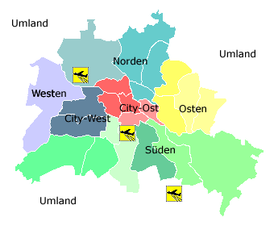
Legend:
- Norden = NORTH
- Osten = EAST
- Sueden = SOUTH
- Westen = WEST
- Umland = SURROUDING AREA
Dark Blue and Red areas are considered to be downtown.
For years now, people have complained about the complex structure of the Berlin airport system. People are often confused about which airport they are actually flying from and it is very common for customers to miss their flights because they arrived at the wrong airport. Furthermore, the noise and pollution situation in the city are not satisfactory, due to frequent starts of airplanes close to the downtown area. Administrative costs are high, due to the high amount of coordination required between the airports.
The government realized that a new solution must be found in the long-run. However, government-internal, as well as external opposition can be expected, since the airports are located conveniently for business flyers and governmental employees.
In this paper we try to assess the situation and the key issues that drive the decision, come up with hypothetical solutions and evaluate these solutions using a BOCR-model (Benefits, Opportunities, Costs and Risks). The government has already announced a decision, which was not known to us, when we created the model. We will afterwards compare our result with the government’s decision.

The Airports
As mentioned before, there are three commercial airports in Berlin: Tegel, Tempelhof and Schoenefeld. Here is a short overview about the Airports:
Airport Berlin-Tegel:
- Biggest airport among the three
- Most important airport in Berlin
- Located 15-20 minutes from Downtown Berlin by car
- Own highway exit for airport
- Split into North and South (governmental and public part of the airport, respectively)
- 13.3 million passengers in 2007
- Capacity: 12 million passengers per year
- 6,850 employees
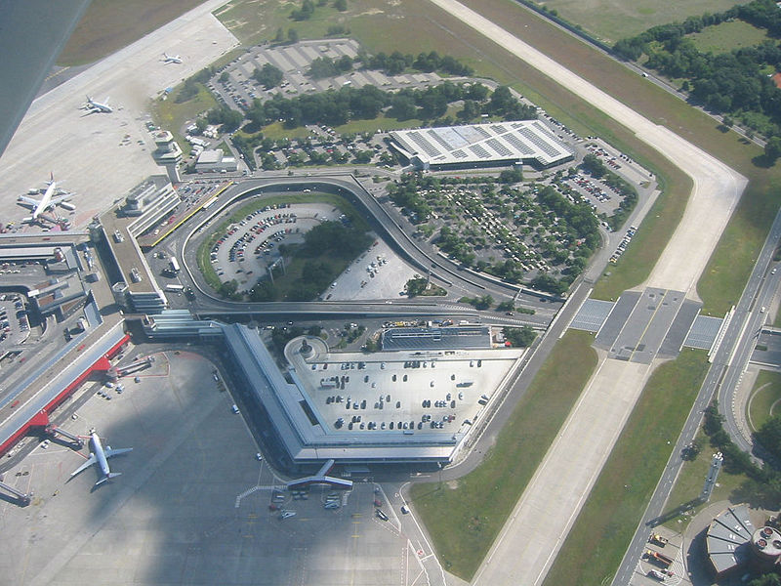
Airport Berling-Tempelhof:
- Oldest and smallest airport in Berlin
- Located in Downtown Berlin
- Often used by smaller commercial planes and private jets
- Closure of Airport has already often been considered
- 350,000 Passengers in 2007
- Capacity: 1.5 million passengers/year
- 1,300 employees

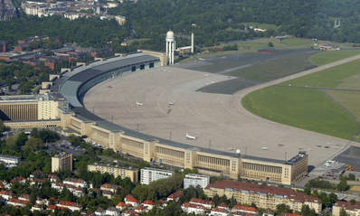
Airport Berlin-Schoenefeld:
- Mainly used for vacationers
- Home of many low-cost airlines
- Located 10 miles south of Berlin
- 6.3 million passengers in 2007
- Capacity: 7 million passengers per year
- 5,200 Employees

The Alternatives
We identified three suitable alternatives:
- Keep the three airports
This would not change anything in the current situation, but would save money. Other pros are the convenient location of Airport Berlin-Tempelhof and avoiding a lot of uncertainty when not initiating any constructions. However, one of the biggest cons would be the dissatisfaction of the people and high expenses for running costs and result in a bad image for the city and the politicians. Furthermore the noise of three airports close to the city is a strong argument to reduce the number of airports and select a better location.
- Expand Airport Berlin-Tegel
Berlin-Tegel is the largest Airport in Berlin with a capacity of already 12 million passengers per year and more than 13 million actual passengers in 2007. This fact suggests an expansion of the existing airport and a closure of the remaining two. This would allow for much more sufficient flight scheduling, making use of economies of scale and reducing administrative costs. The location would still be very convenient for many people, including business traveler, but factors like noise are unlikely to change dramatically. Additionally, this scenario would require a medium to high amount of investments.
- Build new airport in the outskirts of Berlin
This model allows to get rid of the three existing airports and to build a state of the art airport. The airport could be build to Berlin’s requirements. However, this would require a lot of change, such as a relocation of workforce, planes and offices. The airport would furthermore be very inconvenient for many people living downtown Berlin. But the biggest factor is the capital required to realize this project.

The Decision Model
The overall model dealt with the question: “What is the best solution for Berlin’s airport-problem?” For this decision we identified 5 strategic criteria, which were:
- Investment
- Spending associated with a specific solution
- Efficiency
- Determines how efficient the Airport is (e.g. economies of scale, idle times, etc.)
- Capacity
- The new solution must be able to transport more than 20million people
- Public Perception
- The new solution should be backed up by the population
- Convenience
- Air transport should be able without accepting major inconveniences (e.g. time to the airport, etc.)
- Environment
- The new solution should be better for the environment and relieve the inner city’s pollution situation

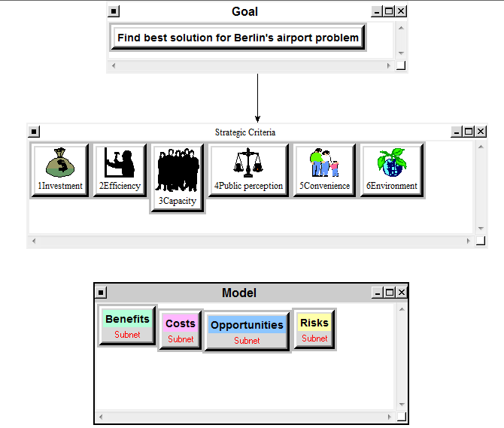
The importance of the respective strategic criteria in the model has been evaluated by pair-wise comparison and the relative importance for each of the BOCR-elements has been determined by using a ratings approach. The ratings table is displayed below:
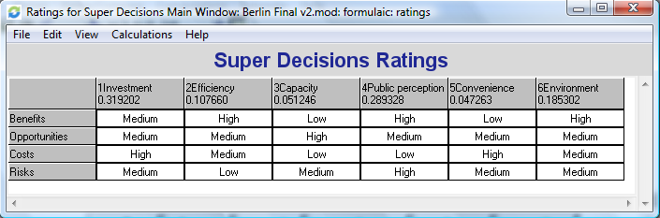
It turned out that the most important strategic criterion is Investment with almost 32%, closely followed by the public perception (29%), Environment (18.5%) and Efficiency (10.7%).
Each element of the BOCR is broken down into a subnet, containing Economic, Social, Economic and Political control criteria. An example is given in the figure below:
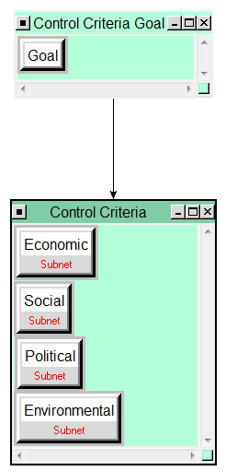
Figure 1: Subnet under each of the BOCR elements

Every control criteria contains again a subnet, including the most important issues, having an influence on the alternatives. These elements in the subnets are compared on the basis of the ANP with feedback. These are displayed in the following figures:

Benefits

Economic
The subnet under Benefit – Economic Benefits split up into Airline, Airport operator and Society. The economic impact for these stakeholders has been evaluated and compared.
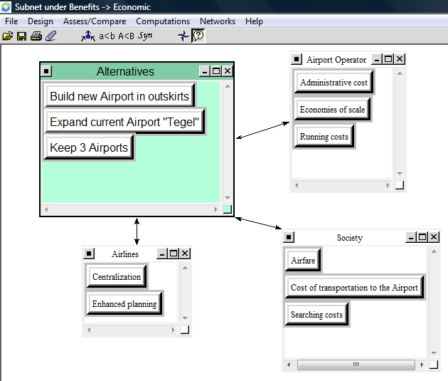

Social
Social considers Public Interest and Public Welfare. Public Interest includes factors, such as the convenience to reach the airport and to check in, as well as safety and simplicity (e.g. reduces confusion). Public Welfare touches on the impact on employment for the population and the improvement of transportation means.
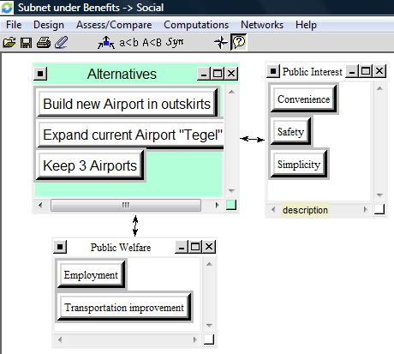

Political
Political includes businesses as a stakeholder, the government itself and the impact on overall city measures, such as city attractiveness.
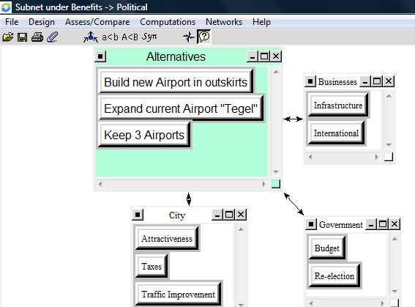

Environmental
Environmental is split up into impact the solution itself has on the environment and indirect impact, caused by the airports customers or staff.
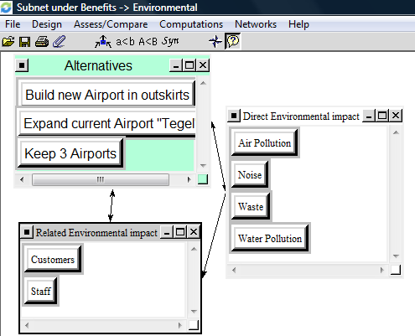
After having compared all of the nodes and clusters, we synthesized the sub-network under benefits. This revealed a surprisingly close order of the alternatives, when considering only Benefits:
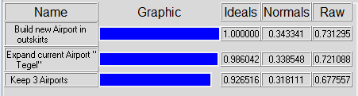
The new airport in the outskirts was expected to bring the most benefits, closely followed by the expanded airport Berlin-Tegel.

Costs

Economic
This subnet takes a closer look at the stakeholders of the decision.
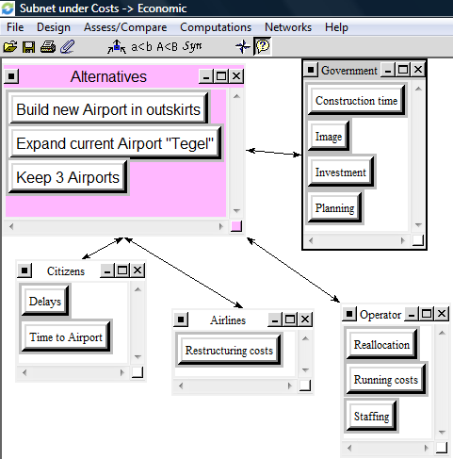

Social
Considers Public Welfare and Public Safety, including accidents resulting from uncertainty (confusion) and constructions.
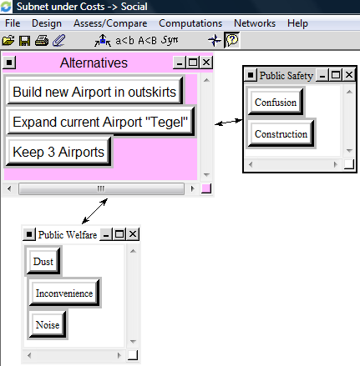

Political
Assesses the impact of the decision on the government’s image and the budget. Tax Increase in this sub-network means the impact of a tax increase (which might be necessary to fund the project) on the government’s image.
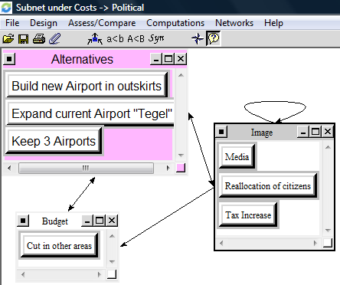

Environmental
Assesses the impact of the decision on the physical environment and the climate.
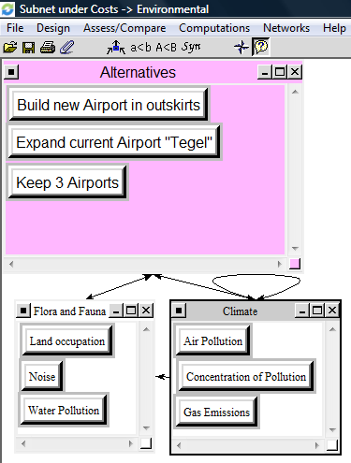
After synthesizing, the following ranking occurred:
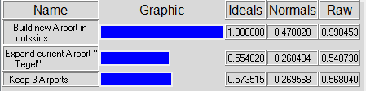
Even though being the solution with the most benefits, building a new airport was also by far the most expensive solution. Considering also factors, such as running costs, expanding the airport Berlin-Tegel and keeping the three existing airports were approximately equally expensive.

Opportunities

Economic
Includes the anticipated development of the business sector, impact on population and government-related measures. In this network tax-increase means additional money collected by the government. This node is interconnected with other clusters, because developments like Job-creations or higher salaries have an immediate impact on taxes collected.
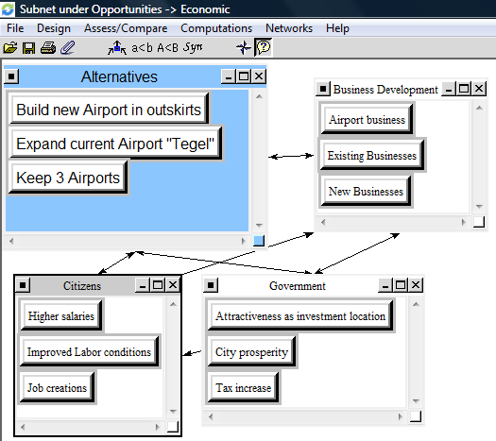

Social
Includes the development of tourism and public interests (neighborhood improvements due to the absence of flight-noise, etc.)
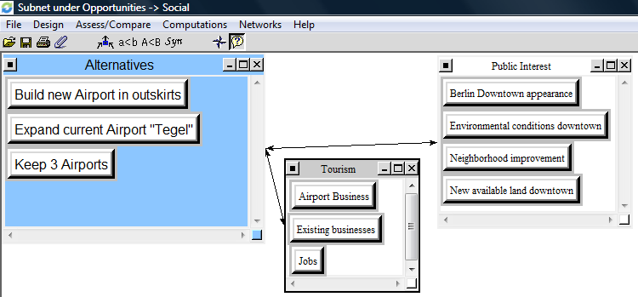

Political
Assesses political criteria, such as the impact of the decision on the reputation of the politics, international recognition of the decision or impact on technological leadership.
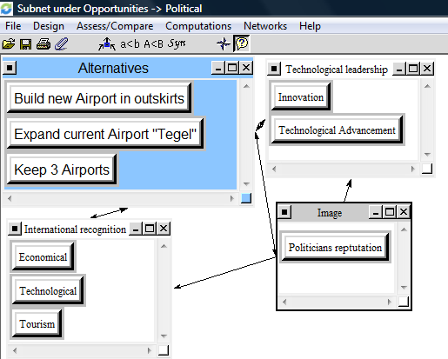

Environmental
Includes the opportunities to make waste management more efficient and to reduce pollution in the long-run (downtown and elsewhere).
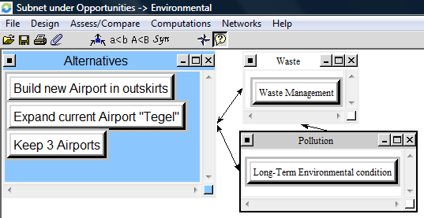
The solution of building a completely new airport turned out to create the most opportunities, closely followed by expanding the airport Berlin-Tegel. The fact that the current situation doesn’t have the same effect was expected in advance.
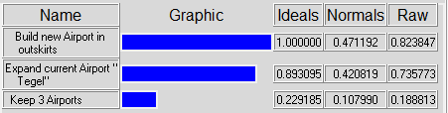

Risks

Economic
Describes and compares financial risks, risk of job losses and risk for businesses. Airport location means that the survival of some businesses strongly depends on the Airport’s location. Furthermore Germany is famous for being a very bureaucratic country.
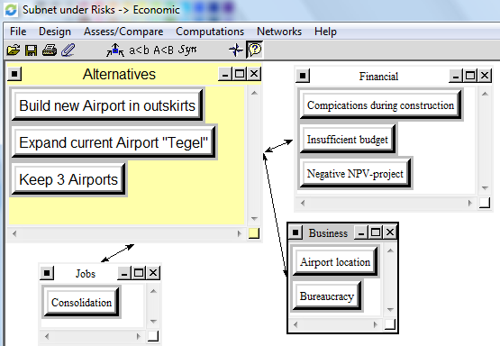

Social
Describes the side effects the decision can have on areas of public interest.
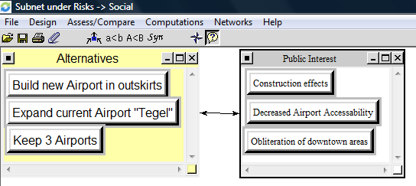

Political
Includes political obstacles and impact certain sources have on the city’s and government’s image.
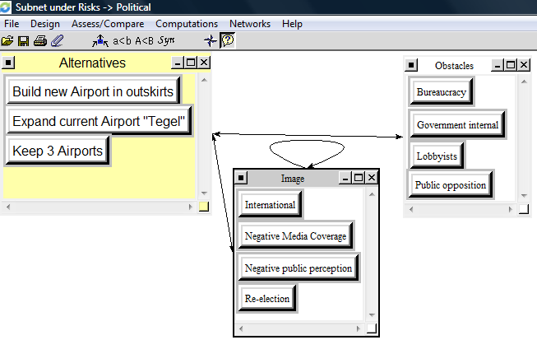

Environmental
Construction describes, what impact possible mistakes in productions might have on the environment and location focuses on the aspect of concentration of pollution (for example many small airports have a less severe impact on pollution than one big airport, since pollution is distributed geographically and less concentrated).
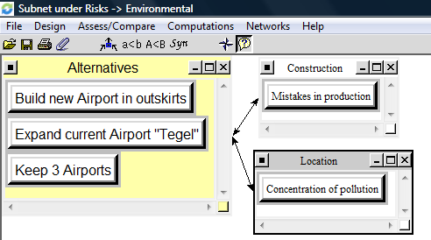
Related to Risks, the least risky alternative was to leave everything as it is, because there’s no uncertainty involved. Building a complete new airport turned out to be more risky then only expanding an existing one.
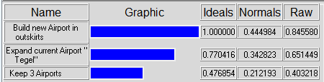

Overall Result
When combining all of the results from the sub-networks, the synthesis of the overall model looks like the following:
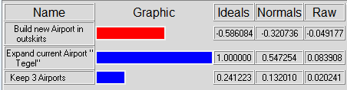
For the first solution, building a new airport in the outskirts, risks and costs outweigh benefits and opportunities. This leads to a negative value in the table above.
It can be concluded that under the assumptions made the most feasible solution is to expand the current airport Berlin-Tegel and close the other two airports to reduce noise and pollution downtown. Of course this solution is not perfect, but the best one of the three identified by us.

Sensitivity Analysis
To underline our findings, we conducted a sensitivity analysis. This analysis shows how preferences change as the importance of a certain BOCR element changes.

Benefits
Solution 2 remains the solution of choice up to assigning an importance of .91 to benefits. At this point it is overtaken by solution 1. The graph below shows the development of the preferences under certain weights:
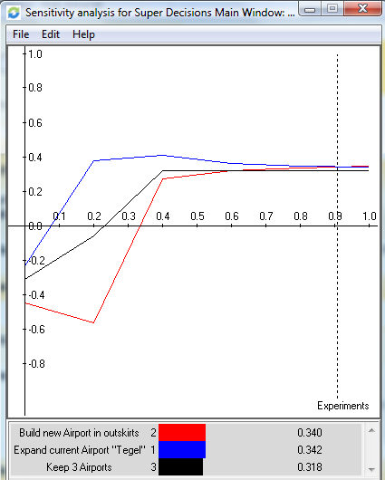

Costs
Considering costs, solution 2 remains the most feasible alternative, no matter how much importance is assigned to costs. However, assigning an importance of 1 to costs the solution of keeping all three airports comes very close.
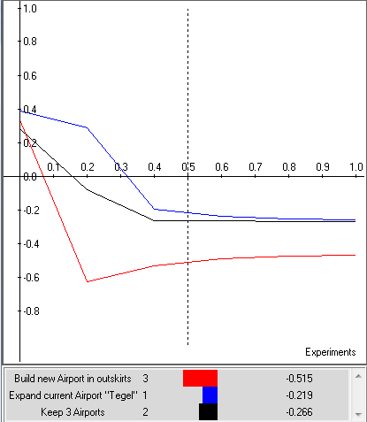

Opportunities
When changing the importance of opportunities, solution 1 becomes more feasible than solution 2 when assigning an importance of higher than .58. At a value of lower than .05 solution 3 is most feasible.
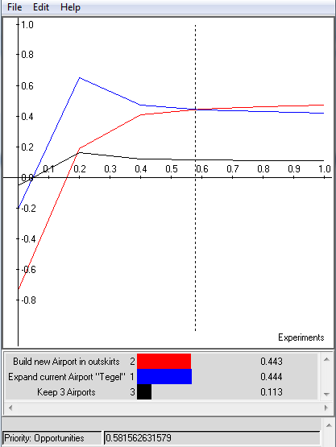

Risks
As pointed out earlier in this paper solution three is the one with the least risk. However, if the importance of risk in the overall model is changed to below .36, solution 2 overtakes solution one in feasibility. When assigning an importance of less than .025, even solution 1, which is the riskiest one, becomes more feasible than solution 3.
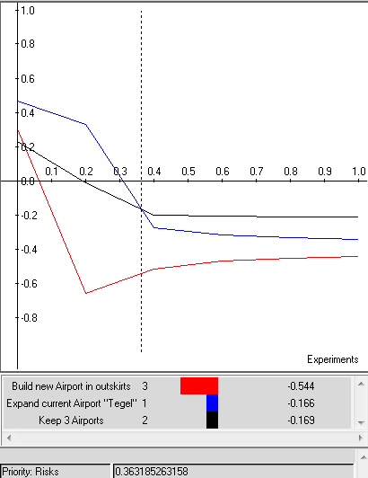
In general it can be concluded that the overall model is very consistent.

Final Words

Some time ago the German government announced plans to expand the airport Berlin-Schoenefeld and call it “Flughafen (=Airport) Berlin Brandenburg International”. With a planned capacity of 22 to 25 million Passengers annually it alone exceeds the current passenger volume of Berlin in total. Furthermore, an optional extension after completion to up to 40 million annual passengers is possible. The airport will be completed by 2011 and start a test-phase.
The new airport is intended to deal with all of the air traffic in Berlin. Berlin-Tegel and Berlin-Tempelhof are expected to be closed after a successful test-run of Berlin Brandenburg International.
The solution reached in our model comes very close to the actual decision, reached by the German government. The model shows that building a new airport would be too expensive and would involve too much risk and the current solution is unsatisfactory. It also showed that a location outside of downtown is feasible for environmental and social reasons. We assumed that the German government would be most likely to expand the biggest airport, which is Berlin-Tegel. In reality, expanding the existing airport located outside of Berlin combines the lower cost and improved benefits. Therefore the model was highly appropriate, just the identified solutions were too narrowly defined.

Christian Wielage & Sebastian Kuszmiercyzk

