Matthew Wierzchowski
Maw168@pitt.edu
Should Marcellus Shale Drilling Continue?
Abstract: The problem analyzed was the conflict with regards to Marcellus Shale drilling in the region. Drilling operations have accelerated in the past 10 years and there are positive and negative consequences to those who reside in the affected area. The two options considered were to continue drilling operations or to suspend drilling operations. A BOCR ANP model was developed with these two alternatives. Research was conducted on drilling operations and an employee for the companies performing the drilling was consulted as an expert in the area. The ANP model developed demonstrates how to segment a complex issue into distinct and quantifiable areas for sake of comparison. The results of this analysis are provided in the report to follow.
Introduction: The decision on drilling operations in the Marcellus Shale region is very controversial and potentially lucrative for those in the affected area. There are known and un-known environmental impacts to the region that could affect landowner’s property value, wildlife or personal health. There are also extreme financial benefits for those who live in the region, specifically increased employment opportunities, royalties to landowners and commercial land opportunities. This dichotomy is the source of conflict for many. Do the immediate benefits and potential opportunities outweigh the known cost and potential risks of continued drilling? The benefits, opportunities, costs and risks were brainstormed and structured in a way to bring consistency to the thought process behind structuring the BOCR model. This structure is critical to effectively make the pair-wise comparisons in a logical manner and bring accuracy to the decision model. A more detailed discussion of model development is provided below.
Methodology: In the model, there are only two outcomes that are possible; continue drilling operations in the region or suspend drilling operations. These two possibilities became the Alternatives for the Super Decisions model. Within the benefits and opportunities clusters, two categories were defined that could best describe and compartmentalize the benefits and opportunities.
- Financial – The financial subnet was defined as the monetary value provided to individuals and companies within the region. This was chosen because the drilling operations have immediate and long term financial benefits that are main drivers for continuing to drill
- Social – The social subnet was defined as the inherent social impact that drilling could have to the region. To support this influx in activity, there are infrastructure improvements and increased business development that help those who live in the region.
The costs and risk of drilling are also important to understand the impact of this decision. The two categories defined that best describe and compartmentalize the costs and risk are environmental and social.
- Environmental – The environmental subnet was defined as the environmental effects of drilling operations. This is a key factor in the decision making process and the main argument against drilling.
- Social – The social subnet was defined as social impacts to the region. This cluster defines some of the more residual effects of drilling.
Finally, strategic criteria were selected that encompassed the key areas the decision makers would assess when determining whether drilling should continue. These criteria are as follows;
- Economic
- Environmental
- Social
- Unknown Side Effects
The model was developed using a complex BOCR template with subnets created for Benefits, Opportunities, Costs and Risks. The ANP subnets described above have more detailed clusters and nodes created that help further dissect the problem statement. Pair-wise comparisons in each subnet were performed to obtain the relative priorities for each criterion. Ratings were then assigned with respect to each criteria and alternative. In this case, the strategic criteria were rated with respect to benefits, opportunities, costs and risks. A simple rating scale of ‘low’, ‘medium’ and ‘high’ were chosen with values of 0.1, 0.5 and 0.9 respectively. A linear relationship between each category was selected as no distinctive weight towards either rating was discernable.
Pair-wise comparisons in the Benefits subnet
In general, priority was given to local business and individuals in the financial benefits cluster versus large corporation. The incremental benefit for both local business and individuals was great in that the influx of income for those groups represented a step change in there demographic. The large businesses also have much to profit from this relationship, however the percentage impact to corporations was deemed less than that of the individual. Within the social cluster, the priority was given to gas stations who would receive the gas over the restaurants and stores that would benefit from the additional throughput of people through their establishment.
Pair-wise comparisons in the Opportunities subnet
The potential for future land development dominated priority within the opportunity subnet. The possibility for growth within the affected areas is much greater than the opportunity to reduce dependency on foreign oil and reduce natural gas prices.
Pair-wise comparison in the Costs subnet
Within the Costs subnet, the costs associated with Environmental far outweigh the Social costs. The known up-front costs to dispose of waste water, controls to prevent spillage and effect on the surrounding natural ecosystem is much more than that to repair infrastructure, prevent negative publicity and other societal affects. The scale of priorities within this cluster is close to 7 to 1 with respect to environmental costs.
Pair-wise comparison in the Risks subnet
Similar to the Costs subnet, environmental risks outweighs social priorities close to 7 to 1. The reason for this shift towards environmental risks is the costs associated with controlling and managing a catastrophic event during drilling. The impact to human life, wildlife, and surrounding eco-systems would be devastating to those involved. The social risks are tangible, however, not nearly as impactful as an environmental event.

Data and Analysis: The model suggests that over the short term suspending drilling operations would be the best alternative, however over the long term, it suggests that continued drilling will offer the most benefits (See Figures 1 and 2 respectively). When performing the ratings against each strategic criteria (see Figure 3), the Opportunity subnet held the most weight while the Risks held the least. This is a logical result as the Marcellus Shale drilling program is relatively new and is expected significant future growth. The risks naturally will be less as the drilling companies invest a lot of money (see Cost subnet) in prevention in an effort to mitigate potential risks to their business. With respect to the strategic criteria, Economics held the highest priority with Environment coming in second. Since there is so much money and potential earnings associated with drilling operations, this result is also logical. Environmental criteria being the second most important factor also makes sense in that a lot of investment is being made to protect and in some instances enhance the affected eco-systems. Because this is criteria posses the most risk to operations, it is logical that its priority would fall second behind the economics of the decision. When a sensitivity analysis was performed against benefit, opportunity, cost and risk (see Figures 5 through 8), there is no point on the spectrum where they intersect and one would become more dominant than the other. This suggests strong polarity between the alternatives of drilling or not drilling.
Conclusion: Based upon the model results, drilling in the Marcellus Shale region should continue. The short term synthesis suggest suspending drilling but because the operation is a long term investment in the region with respect to its infrastructure and its commercial development opportunities, the long term synthesis gives a more accurate rendition of the proper decision. Because the synthesis favors the long term aspect and opportunity subnet of the model, those involved in the drilling operations should act with future interests in mind when conducting their business. The key to success in the Marcellus Shale region is sustainability and the opportunities it creates for all the inhabitants of that region. Although short term profitability is important to shareholders, it should not be prioritized over the long term stability of the drilling operations and the region. The model constructed and synthesized illustrates this as fact.
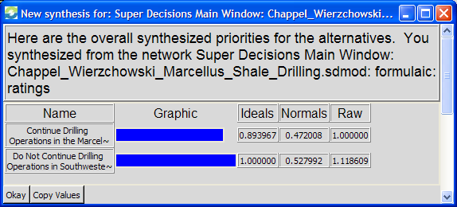
Figure 1 - Multiplicative Synthesis – Short Term

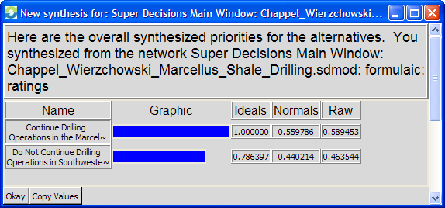
Figure 2 - Additive Synthesis – Long Term

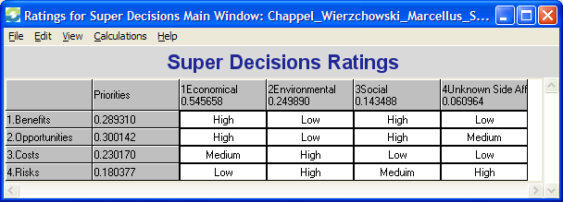
Figure 3 – BOCR Ratings

Benefits |  |  |  |  | Opportunities
Name | Ideals | Normal | Raw |  | Name | Ideals | Normal | Raw
Continue Drilling Operations in the Marcellus Shale in Southwestern PA | 1.000 | 0.844 | 1.000 |  | Continue Drilling Operations in the Marcellus Shale in Southwestern PA | 1.000 | 0.768 | 1.000
Do Not Continue Drilling Operations in Southwestern PA | 0.185 | 0.156 | 0.185 |  | Do Not Continue Drilling Operations in Southwestern PA | 0.302 | 0.232 | 0.302
Costs |  |  |  |  | Risks
Name | Ideals | Normal | Raw |  | Name | Ideals | Normal | Raw
Continue Drilling Operations in the Marcellus Shale in Southwestern PA | 1.000 | 0.839 | 1.000 |  | Continue Drilling Operations in the Marcellus Shale in Southwestern PA | 1.000 | 0.794 | 1.000
Do Not Continue Drilling Operations in Southwestern PA | 0.192 | 0.161 | 0.192 |  | Do Not Continue Drilling Operations in Southwestern PA | 0.260 | 0.206 | 0.260
Figure 4 – BOCR Synthesis
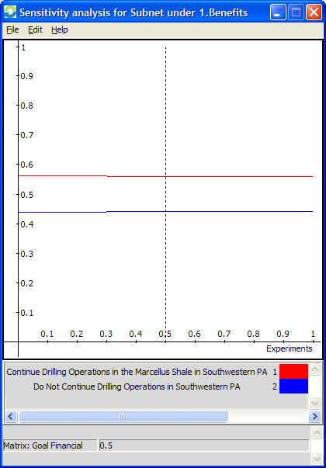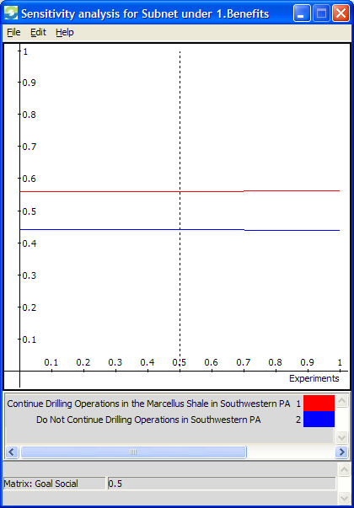
Figure 5 - Sensitivity Analysis for Benefits

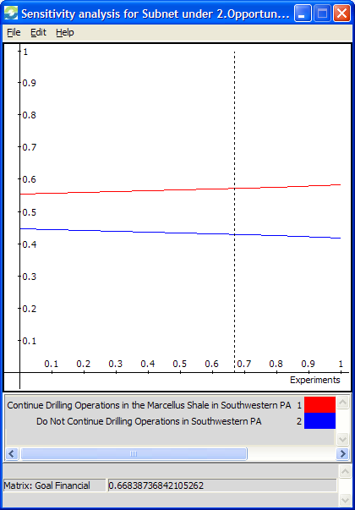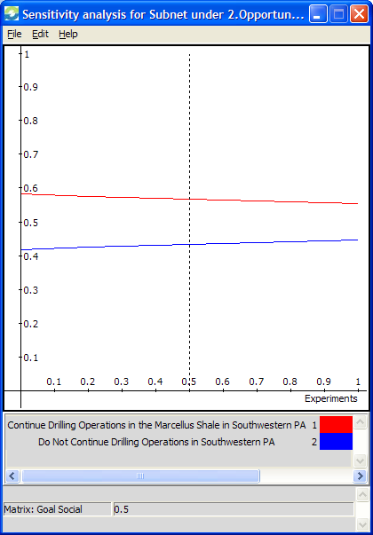
Figure 6 - Sensitivity Analysis for Opportunities

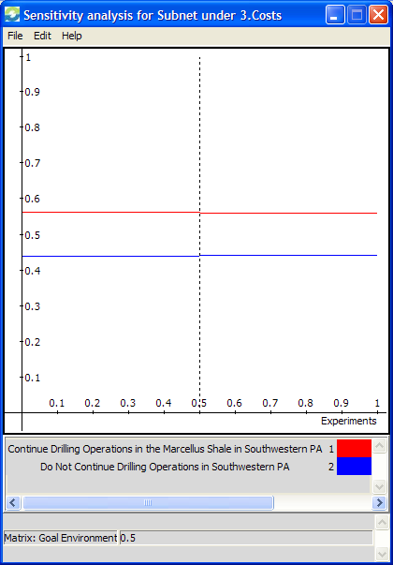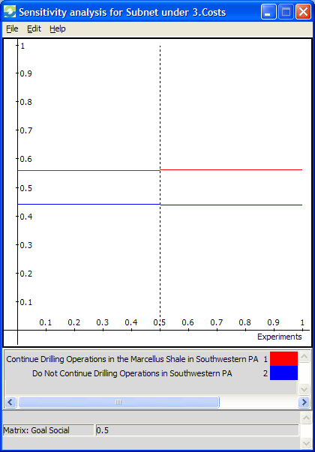
Figure 7 - Sensitivity Analysis for Costs

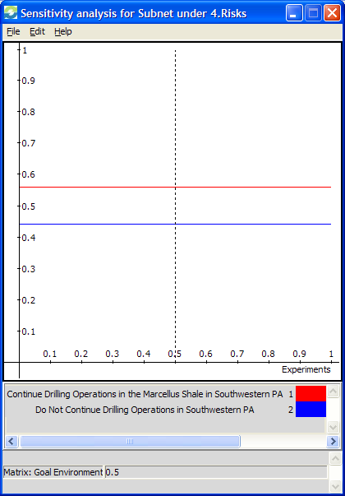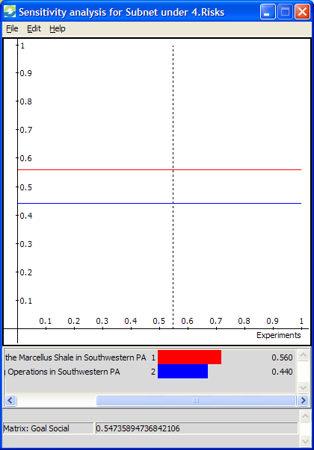
Figure 8 - Sensitivity Analysis for Risks

