BOCR Model of Carbon Tax in the United States

Bob Johnson & Stephen Lichtenfels
BQOM 2521
Spring 2019

Contents
Carbon Tax 1
Overview and Importance 1
Alternatives 2
Strategic Criteria 2
About the Model 3
Benefits 3
Political 3
Financial 3
Social 4
Opportunities 5
Political 5
Financial 5
Social 6
Costs 7
Political 7
Financial 7
Social 8
Risks 9
Political 9
Social 9
Sensitivity Graphs 10-11
Syntheses 12
BOCR 12
Short-term Multiplicative – Overall Synthesis 13
Conclusion 13

Carbon Tax

Overview and Importance

The conversation and severity of climate change has grown. The pentagon and UN have both published reports outlining the economic impact and adverse consequences of climate change. The UN has also said that the previous goal of limiting the warming of earth by 2 degrees Celsius is not sufficient to stop the adverse impacts of climate change. Something many countries have begun to do is implement a carbon tax in attempt to curb the dangerous emission of greenhouse gasses. This spread sheet tracks which countries have implemented/begun implementing a carbon tax:

https://docs.google.com/spreadsheets/d/1LtaBOv70pvXVPDgLUGtTKnSxofjfZy7jx06bTSaMaH4/pubhtml?gid=14385633&single=true

In the U.S. there are a number of political and economic arguments related to why the U.S. should or shouldn’t implement a carbon tax. The following model will explore the BOCR of those:

Alternatives
There are two alternatives used in the model:

- No Carbon Tax
- Implement Carbon Tax

The first alternative concerns continuing to not have a carbon tax in the United States. The second alternative has to do with implementing a carbon tax – something many countries have already formally done.

Strategic Criteria
There are two strategic criteria:

- Public Wellbeing
- Impact on the Economy

The two main issues related to the carbon tax are the wellbeing of the public and the impact on the economy. Politicians are responsible to their constituents and should look out for their wellbeing. However, they prioritize getting reelected which is sometimes linked to the economy.

About the Model

Benefits

Political
The political benefits criteria are US compliance with the Paris Agreement as well as campaign support. The Paris Agreement is an agreement amongst nations in the UN that is aimed a reducing greenhouse gases.
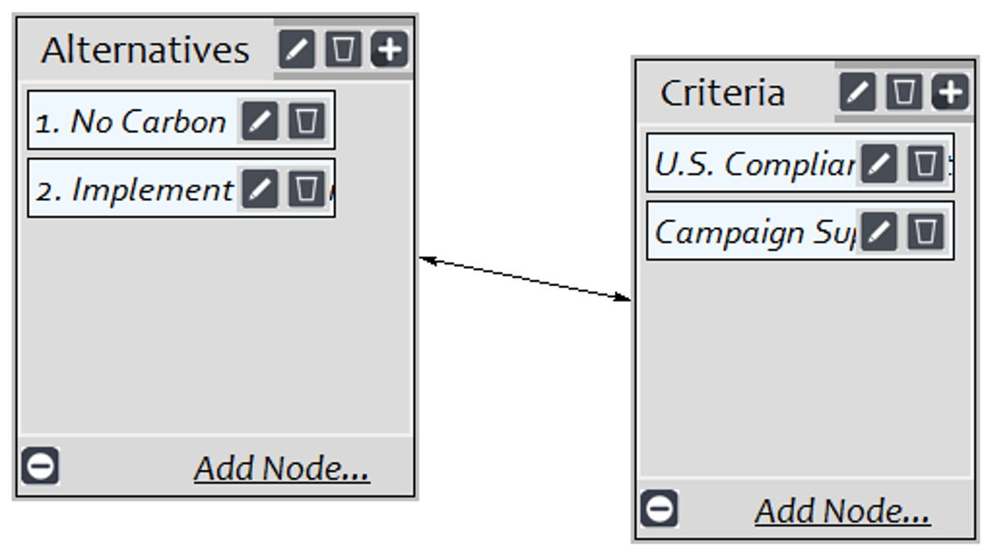

Financial
The financial benefits criteria are reduction of future economic damage, cheap electricity, and new jobs. Electricity could get more expensive if fossil fuels are no longer used, but it could create new clean jobs.
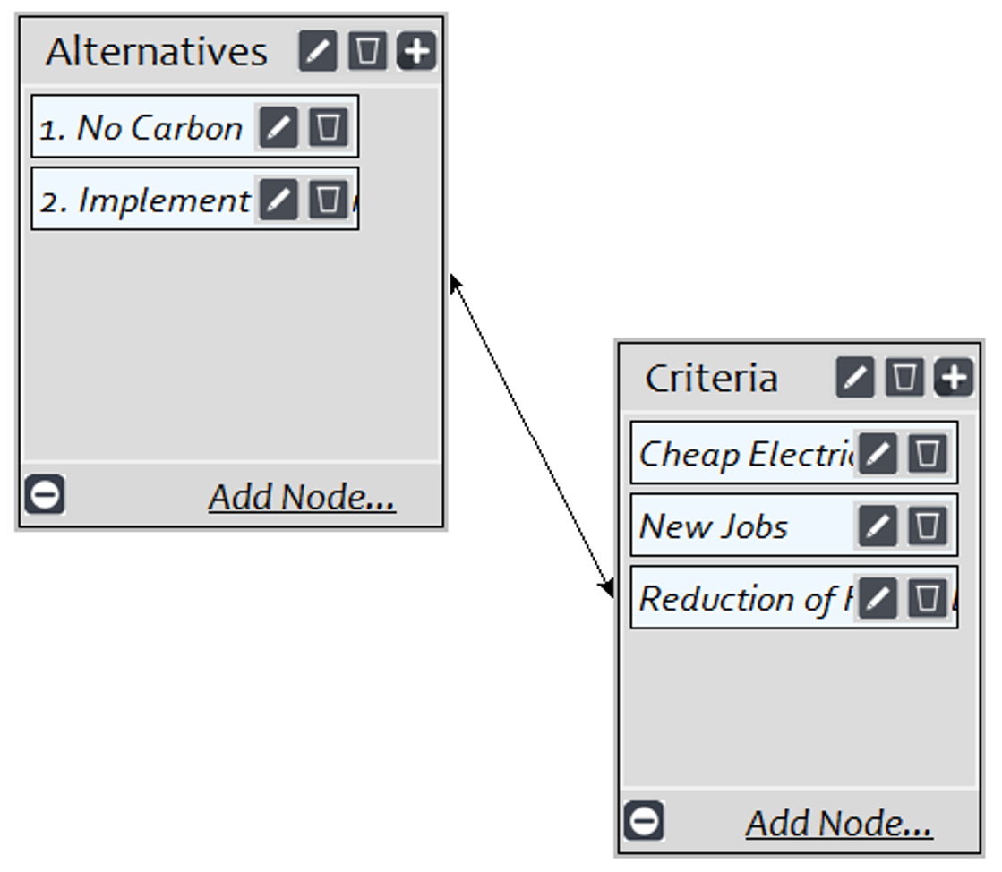

Social
The social benefits criteria are deterrent of pollution and public wellbeing. If the carbon tax is implemented it could have the effects of deterring pollution and increasing the public’s health.

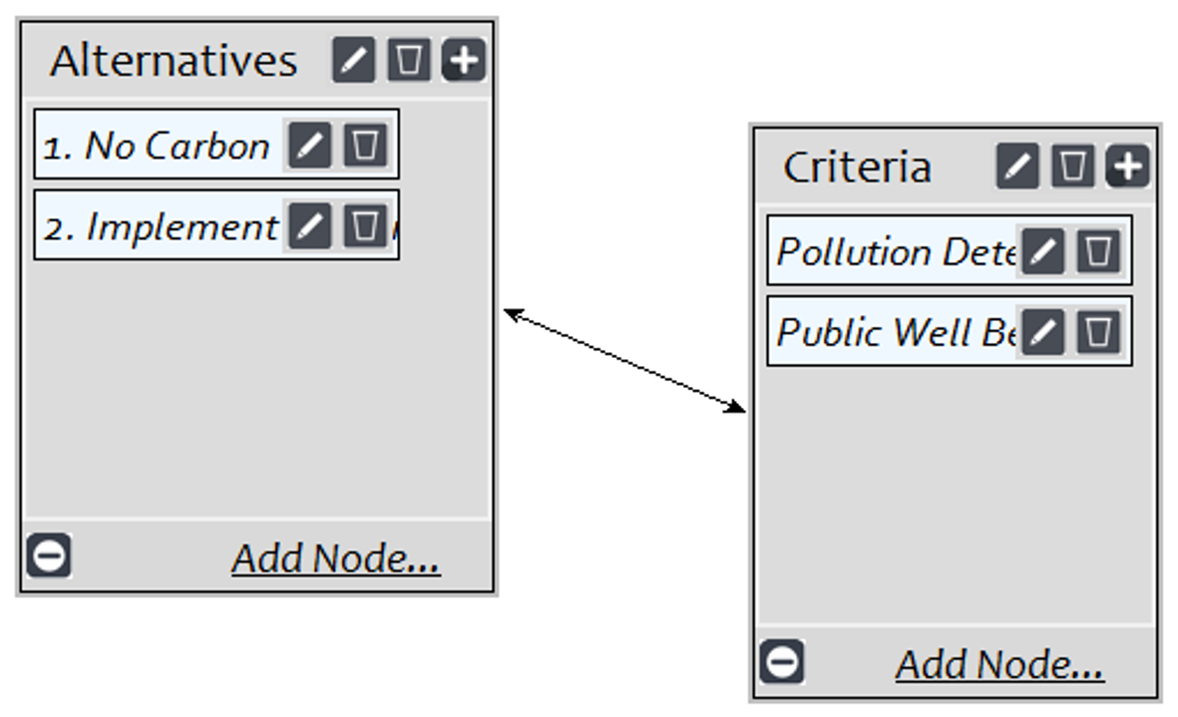

Opportunities

Political
The political opportunities criteria are bargaining chip and ethics. Depening on the partissinship and political climate a bargainning chip could be used based on the support for a carbon tax.
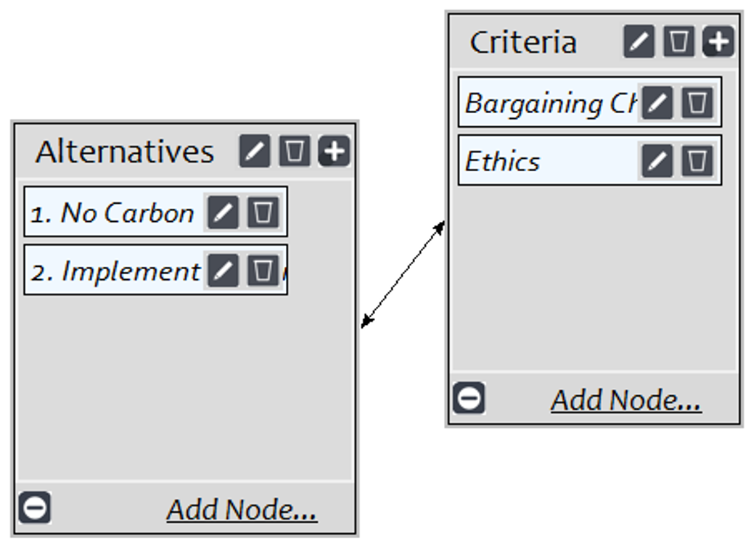

Financial
The financial opportunities criteria are reduction of future economic damage and cheap electricity.
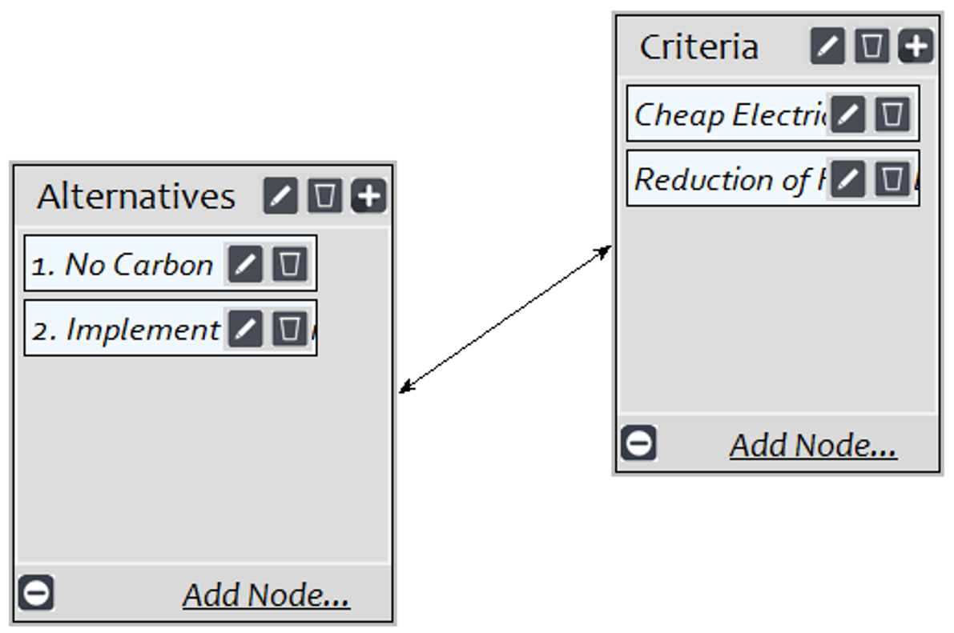

Social
The social opportunities criteria are, again, deterrent of pollution and public wellbeing, but in addition to these we are also considering green innovation. With the implementation of a carbon tax, the need to innovate new, green ways of reducing greenhouse gases could come into focus.
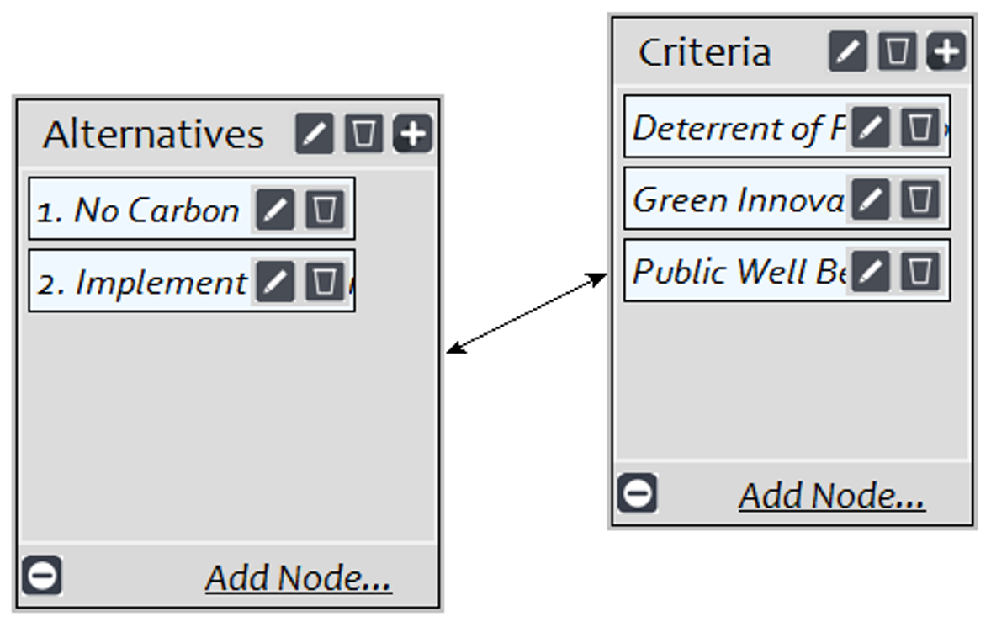

Costs

Political
The criteria under political costs are loss of campaign contributions and bias. The potential loss of campaign contributions would be a significant loss to any politician as they rely heavily on these.
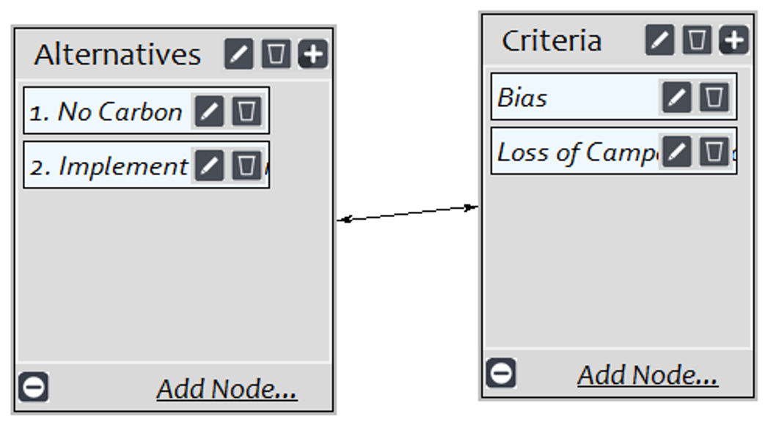

Financial
The financial costs criteria are economic damage and resources.
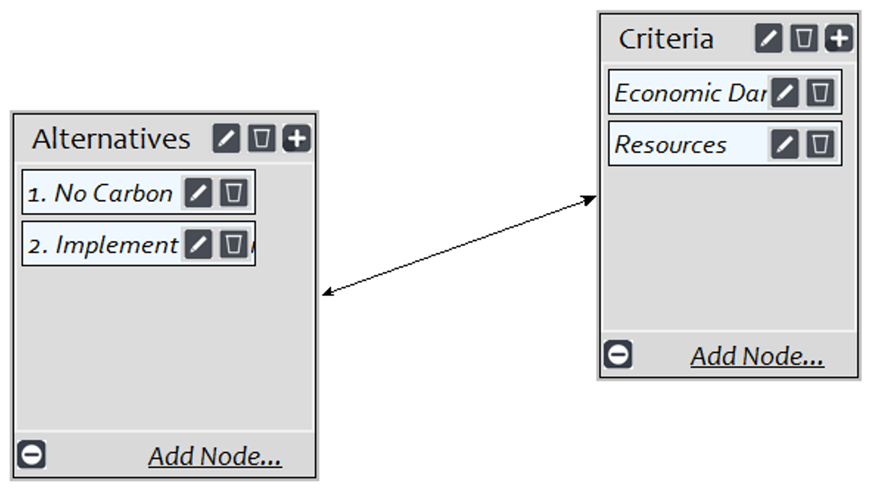

Social
The social costs criteria are ethics and public wellbeing.
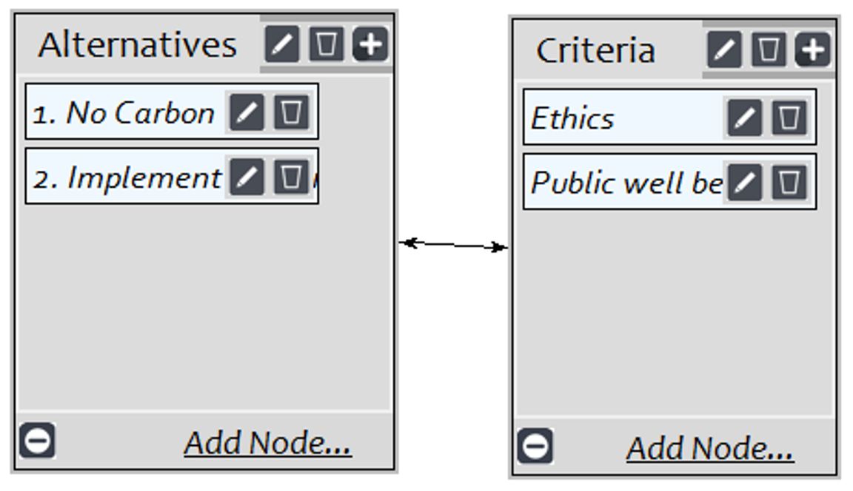

Risks

Political
The political risks criteria are bias, ethics, and loss of office.
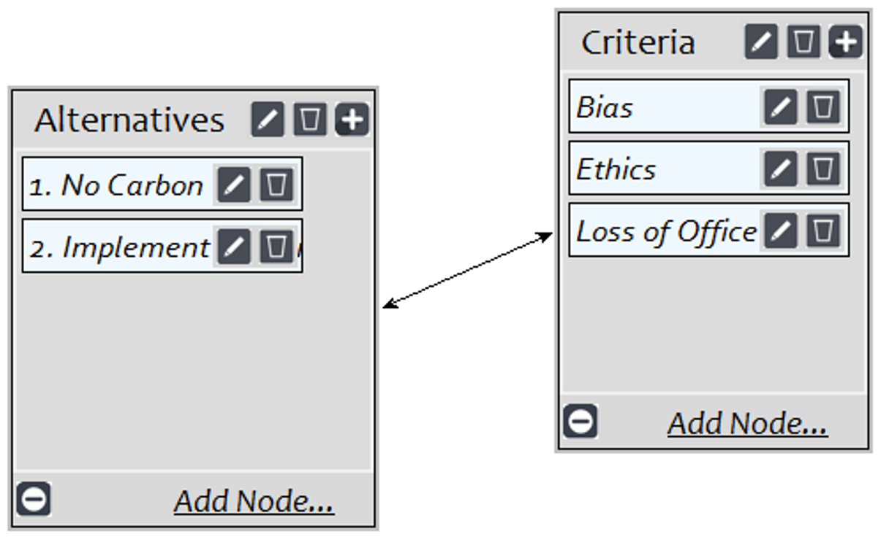

Social
The social risks criteria are effectiveness and public perception.
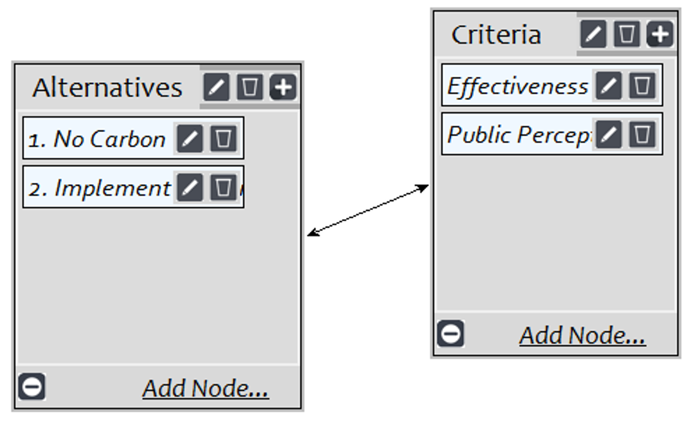

Sensitivity Graphs

Overall, as seen in the graphs below, the model demonstrates that implementing a carbon tax in the United States takes priority.

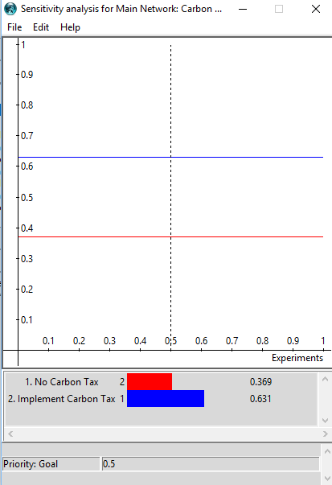

Syntheses

BOCR
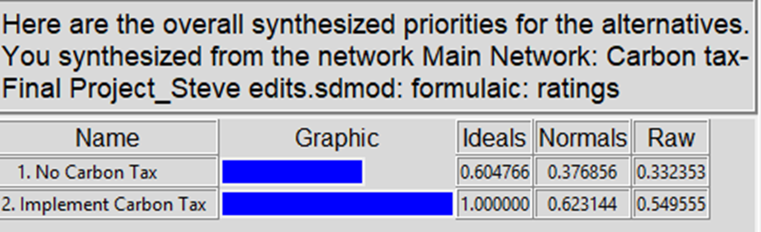
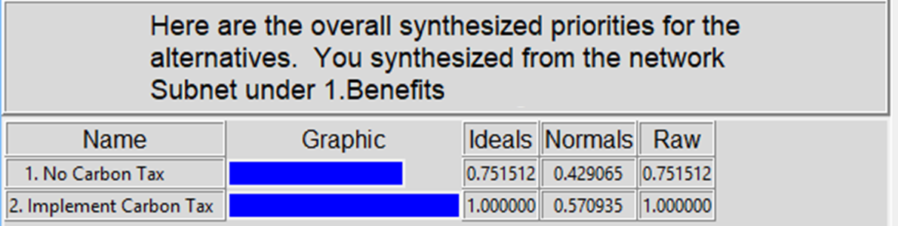
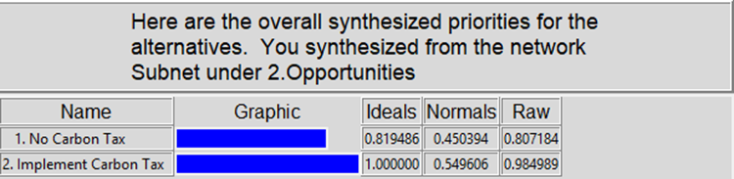
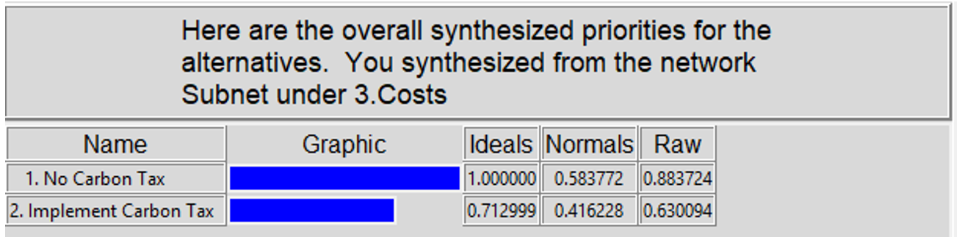
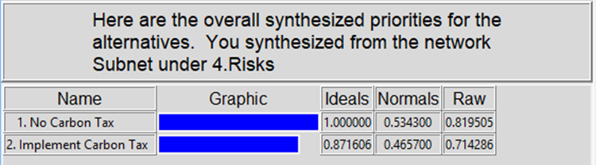

Short-term Multiplicative – Overall Synthesis
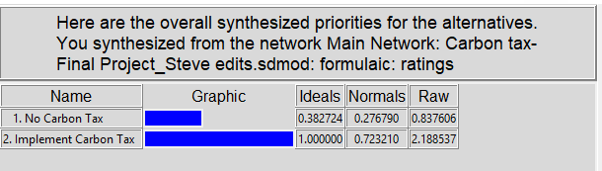

Conclusion
The BOCR synthesis shows that implementing a carbon tax in the United States is the best alternative for the future. By doing so, this will hold corporation to be thoughtful of their greenhouse gas emissions and preserve a better future for our planet.

