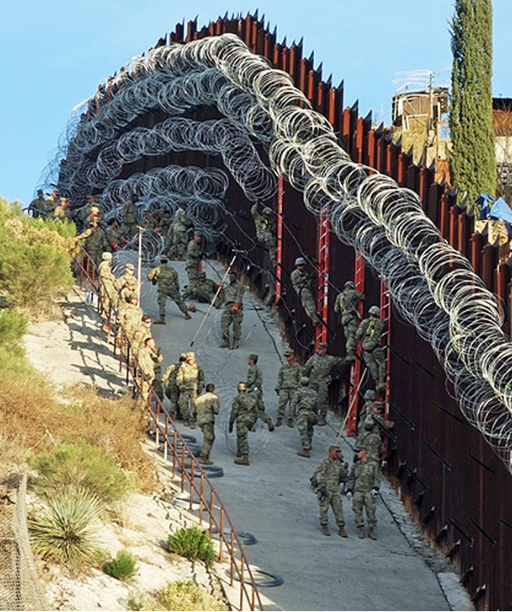  Figure 1. U.S. troops install razor wire on the barrier at Nogales, AZ  SHALL THE UNITED STATES BUILD A SOUTHERN BORDER WALL?  A decision from the standpoint of the U.S. Government. | Summary  The decision to build a wall across the U.S.-Mexico border is a hotly debated current topic. The first federally-built fence, erected in 1909, prevented tick-infested cattle from crossing the U.S.-Mexico border at Baja. Over the ensuing century, barriers have been lengthened and strengthened, notably with the 2006 Secure Fences Act adding 652 miles of fence at critical points. The 2016 U.S. presidential election campaign saw candidate Donald Trump promising to construct “a great, great wall on our Southern border”, and Mr. Trump’s election elevated discussion of merits and worth of this infrastructure effort. The SuperDecisions BOCR model described in this report assumes the U.S. Government point of view to calculate a long-term and short-term best decision option regarding building a wall on the U.S. southern border.  Sarah L. Topper, John M. Iaconis  University of Pittsburgh  Katz Graduate School of Business  22 April 2019

A BRIEF HISTORY
To understand Cuba and her economy today we must be aware of her rich past. Christopher Columbus explored the New World in four voyages between 1492 and 1502 and colonization began immediately. In 1511, Diego Velazquez de Cuellar led the first Cuban settlements. Two hundred fifty years later the port city of Havana was an international trading hub three times the size of New York City. With Antilles’ largest landmass and population, Cuba is the region’s natural focus. A healthy Cuba, well integrated into the world economy, will invigorate the Caribbean Basin. The following brief historical review helps set the Cuban story.
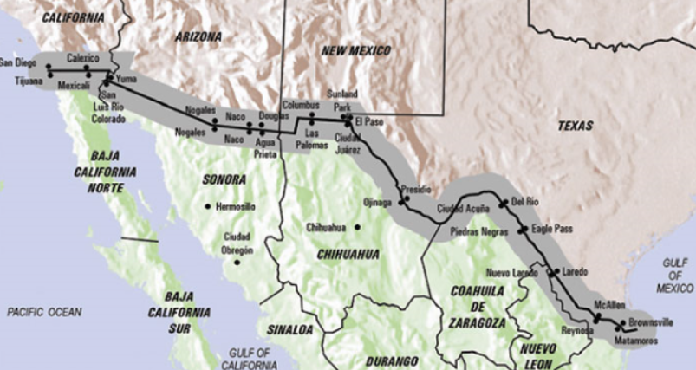
Figure 1. Its central location and large size make Cuba a natural leader of the Caribbean Basin.

Section 1 – Background
The US – Mexico Border^{1,2}
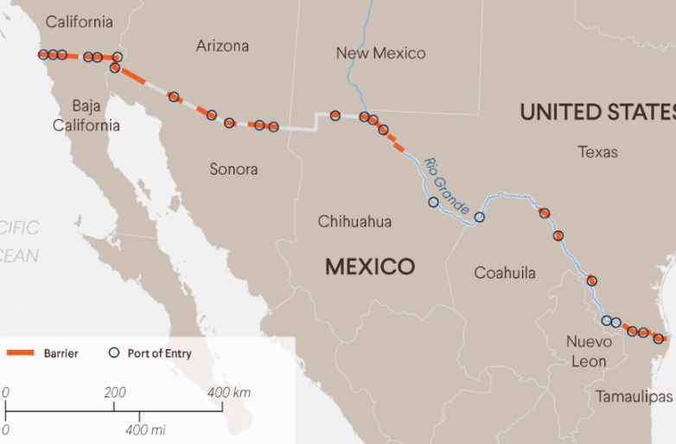
The US-Mexico border was shaped by independence of Mexico from Spain (1821), war between Texas and Mexico (1836), and war between the U.S. and Mexico (1845). The resulting boundary was not well marked, and in 1882 the U.S. and Mexico formed a joint commission to re-survey this border. Early immigration laws blocked convicts and prostitutes from entering the U.S., and in 1909 the first federally-built fence prevented fever-bearing Mexican cattle from crossing the border at Baja. By 1910 U.S. legislation added “Chinese, lunatics, polygamists, and anarchists” to the list of perceived undesirables. By the 1920’s permanent fences were maintained by the U.S. government at major points of entry. Over time wood and wire fences were upgraded to chain link fences, brick, masonry and metal sheets. In 2006 President George H. W. Bush signed the Secure Fences Act, a bipartisan measure which built almost 700 miles of new border fencing. In the 2016 U.S. presidential election campaign, candidate Donald Trump promised to construct “a great, great wall on our Southern border” and to have Mexico pay for that wall. His stated reasoning for this was to control illegal migration that was “hurting all Americans.”
Figure 2. The U.S.-Mexico border is about 1,960 miles long. Over 652 miles has been fenced. Building a border wall was a 2016 campaign promise of President Trump.

Calls for a Wall
The decision to build a wall across the U.S.-Mexico border is a hotly debated current topic. Opinions differ on the nature and magnitude of threats originating from illegal border crossing. While a number of illegal immigrants do cross the southern border, officials estimate that twice as many people overstay visas. The mix of immigrants is changing – while the improved Mexican economy may reduce northern migration, worsening social situations in Central America (e.g., powerful drug gangs and political persecution) have increased the number of refugees seeking political asylum in the U.S. The Council on Foreign Relations notes³:
While apprehended individuals in previous years were Mexican migrants, an increasing number—about one in three—are now asylum seekers from Honduras, Guatemala, and El Salvador. Rather than seeking to evade border patrols, they are turning themselves in, to enter through legal channels. They say they are fleeing gang recruitment, protection rackets, abusive police, and inept criminal justice systems, as well as poverty.
The U.S. Department of Homeland Security cites illegal border crossings as a potential terrorist threat, and apprehends Special Interest Aliens at the border⁴:
… a “Special Interest Alien” (SIA) is a non-U.S. person who potentially poses a national security risk to the United States. DHS analysis includes an examination of travel patterns, points of origin, and/or travel segments that are tied to current assessments of national and international threat environments. … Last year at our Southern Border, DHS encountered more than 3,000 “special interest aliens” …
However, the DHS concedes that most of these individuals attempt to enter the U.S. by air.
Locals who live on the border often express puzzlement at external perceptions of border threats. After floor-to-ceiling concertina (or ‘razor’) wire was installed on the Nogales, Arizona border wall (see Figure 1), the Associated Press reported⁵:
[The Nogales] economy is largely reliant on Mexican shoppers and cross-border trade. Illegal crossings have dropped steeply ... City leaders were critical of military exercises at the border during the holiday season, saying they believed it scared shoppers during one of the busiest times of the year. U.S. Rep. Raul Grijalva, a Democrat, called the additional wire a stunt by the Trump administration, which he said is “trying to create the perception of rampant lawlessness and crime. … [Nogales] Mayor Arturo Garino asked U.S. Sen. Martha McSally to help the city have the wire removed. “That wire is lethal, and I really don’t know what they’re thinking by putting it all the way down to the ground,” he said.
Walling off the entire border, estimated to cost anywhere between $2B to more than $30B, would be a momentous expense which Mexico has declined to pay. Critics question whether a wall would effectively prevent or even reduce drugs, illegal migration, smuggling, and potentially terrorists from transiting the border. Besides the complicated logistics of construction across deserts, wetlands, and mountains, the creation of a physical barrier would disturb fragile ecosystems and disrupt migratory pathways for animals that live there. Building such a wall is likely to take a decade to build, or longer.
The perceived need for a wall at the southern U.S. border varies depending upon one’s political orientation, proximity to the border, heritage, and many other factors. Despite the issue being contentious enough to result in a federal government shutdown, no decisive action has been taken to date. In this report, we discuss the BOCR model developed to explore these conflicting factors, and to arrive at a decision to build, or not build, this wall that balances the needs of the government to provide security for its people with the realities of a massive infrastructure project.
Result
Our decision model weighed the three alternatives defined in Table 1 from the U.S. Federal Government point of view. They were selected in part because they have been the options on the table in the most recent political arena debates. President Trump requested $5.7B for wall building in the Fiscal Year 2019 budget, a sum which would likely only suffice to build a partial wall. Opponents wanted to allocate no funding (the “status quo” option). While a more nuanced option incorporating enhanced border security through technological improvements and expanded manpower coupled with revised legislative policy would certainly be an appealing option, it significantly increased the complexity of the model. For the scope of this project, we have constrained the decision to one of infrastructure only. Using BOCR analysis we determined building a partial wall is the preferred solution.
Table 1. Three Alternatives for Building a Wall at the Southern Border
- Build the Wall – build a massive impenetrable wall along the entire length of the U.S.-Mexico border.
- Build a Partial Wall – build a less obtrusive impenetrable wall at select border locations, targeting those areas most likely to be points of crossing
- Status Quo – maintain current border infrastructure and security
Section 2 – A Brief Description of Merits Analysis using the BOCR method
The BOCR model
Figure 3 shows the Border Wall BOCR model overall structure; Figure 4 shows the top-level network. Our goal is to determine whether the U.S. Government should build a wall at the border between the U.S. and Mexico. The alternatives: to 1) build a full border wall; 2) build a partial border wall, or; 3) maintain the status quo.
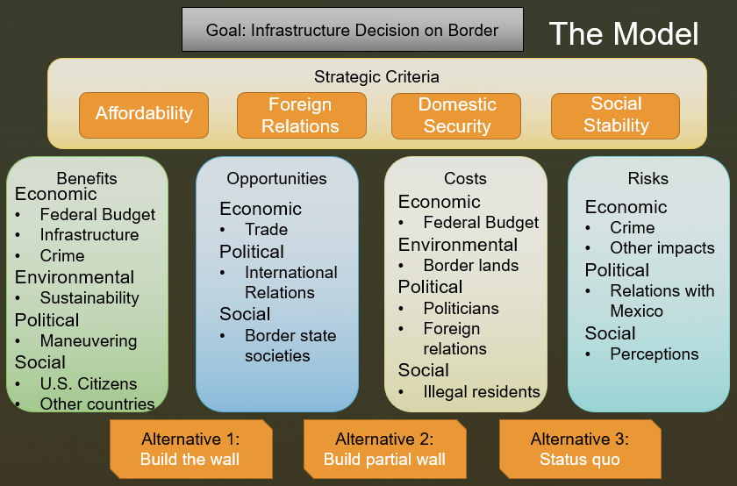
Figure 3. Strategic criteria weighed Affordability, Foreign Relations, Domestic Security, and Social Stability. Control criteria clustered Economic, Environmental, Political, and Social perspectives.

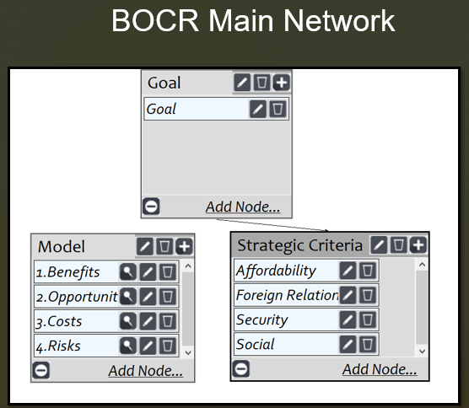
Figure 4. The top-level model within SuperDecisions.
In Figure 4, we show the top level analytical hierarchical process (AHP) model as developed using Super Decisions. Once we established the overall network structure, we brainstormed all of the factors influencing the decision points from a benefits, opportunities, costs, and risk standpoint. We grouped these and used them to build analytical network process (ANP) subnets under the relevant categories. Figures 5-8 show the merit models under which the ANP subnets are configured. Connections between the various factors in the subnetworks were created, and relevant judgements were made for each node/cluster. Based on these, we obtained the preferred alternative for each of the BOCR networks. These were used to inform the ratings model based on the four selected strategic criteria using customized ratings scale.
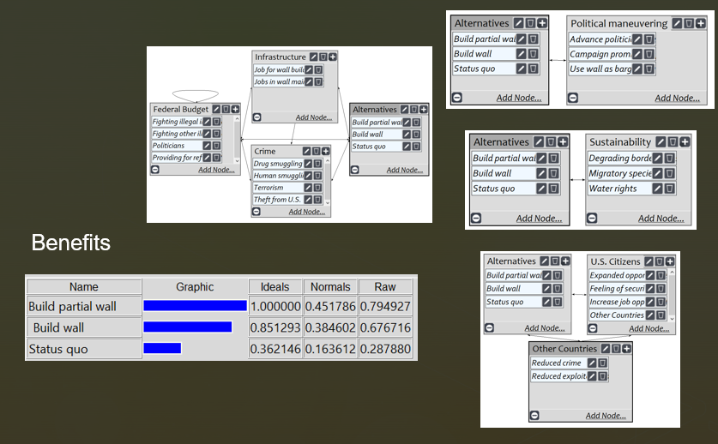
The Benefits ANP is shown in Figure 5. This was our most complex ANP due to the number of nodes and their interactions. We considered the political aspects. Building a full wall would represent the fulfilment of Trump’s prime campaign promise. Building a partial wall could also be spun as a promise kept, and tangible evidence of Trump’s action taken to protect U.S. citizens. Building or not building the wall can be a political bargaining chip used for political gain. There are environmental benefits to be gained, as current illegal border crossing is negatively impacting fragile ecosystems. The biggest benefits would ostensibly be to the U.S. citizens, who should be safer with a reduction in illegal border crossing. Citizens of Mexico and other countries would also benefit from enhanced border security as it should reduce overall crime in border regions and exploitative trafficking of people. The economic benefits should materialize in the form of jobs for wall builders and maintainers, and from lower crime levels.
Figure 5. The Benefits model in Super Decisions indicates building a partial wall as the alternative with highest priority

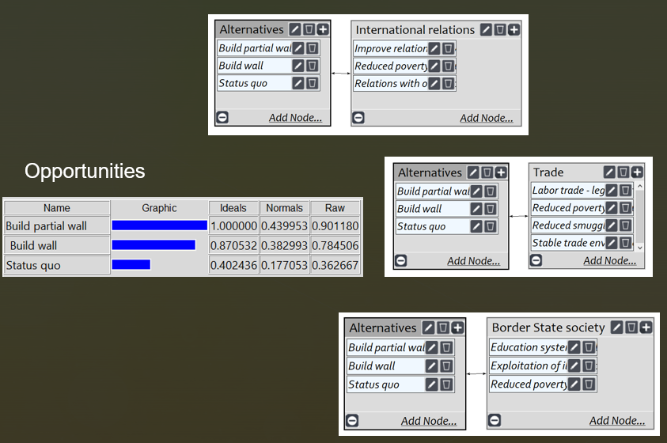
In Figure 6, we explore the Opportunities from the three alternatives. This network does not include an environmental component, as we feel the long-term environmental implications of a full or partial wall are not positive. From an economic standpoint, we considered the impact of a full or partial wall on trade, both domestically and internationally. Political opportunities would be in the form of improved international relations, both with Mexico and with the broader international community, and through a potential reduction in overall poverty levels in southern border states. The social benefits would be realized through a reduction in burdens on educational and other social support systems associated with illegal immigration, and exploitation of illegal workers.
Figure 6. Synthesis of the Opportunities model indicates that building a partial wall is the preferred alternative.

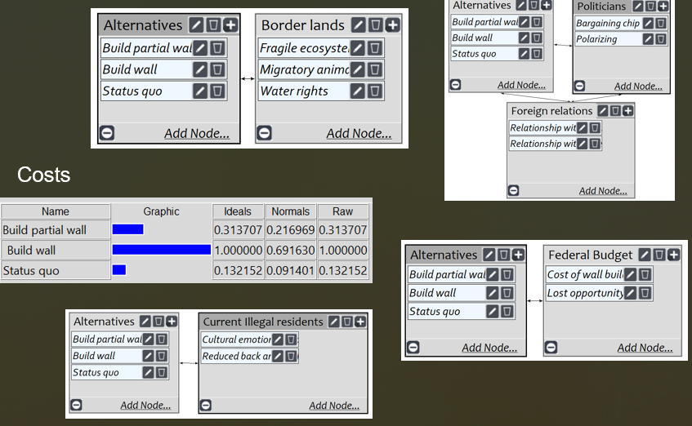
Next, we moved on to the Cost ANP subnet. The obvious node was the massive cost of constructing a wall. Allocating funding for that wall also presents a lost opportunity cost, as those funds could be allocated to more effective solutions. As previously discussed, environmental costs for a full wall are high and disruptive. Politically the wall is costly, as even arriving at a decision has incurred significant cost already in the form of political gridlock and associated government shutdowns that would be likely to continue. Getting border wall funding passed will require expenditure of massive amounts of political capital, and negatively impact relations with Mexico and other countries. Socially, having a large, visible barrier is unlikely to foster enhanced acceptance of other cultures. A summary of the Risk subnet is presented in Figure 7.
Figure 7. The Costs model in Super Decisions shows that building a full wall is significantly more costly than building a partial wall or no wall at all.

Finally, we assess the risks of the three alternatives. Here, too, we opted not to include the economic control criteria as it was less impactful. Our economic risks included wall maintenance costs, and the reduction in availability of inexpensive migrant workers. While their presence in the U.S. economy isn’t legal at present, they are present in sufficient numbers to have an economic impact nonetheless. While a full border wall may enhance security in the short term, we feel that in the long-term crime will seek other avenues and return to similar levels at a minimum, and we have included the economic impact of that crime here. Politically we considered the long-term risks of our impaired relationship with Mexico, which also has social implications. Similar to the Cost model, building a full wall was the highest risk alternative.
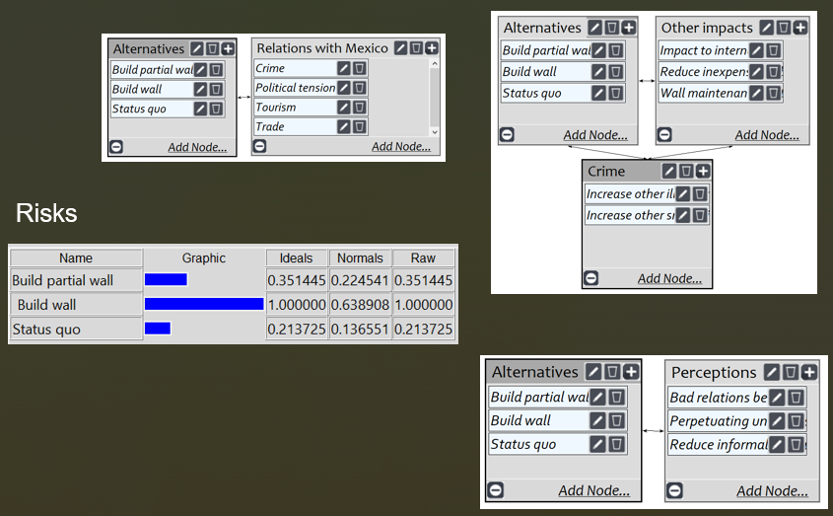
Figure 8. The Risks model in Super Decisions indicating the full wall as the highest risk alternative

The ratings process weights the preferred alternative for each strategic critera using defined scales, as shown in Figure 9, in preparation for top-level model synthesis. Figure 10 shows Strategic Criteria pairwise decisions made for the top-level AHP model, and Figure 11 indicates the Partial Wall alternative gives the best additive (long-term) and multiplicative (short-term) overall synthesis results.

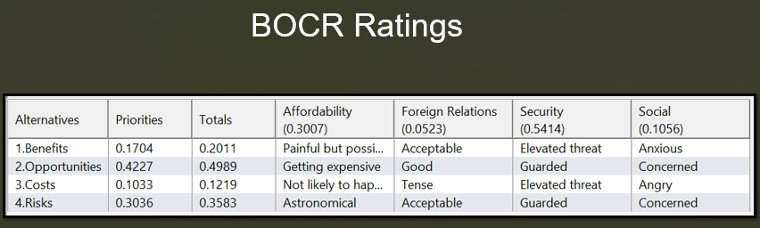
Figure 9. Building a partial wall was rated for benefits and opportunities, while building the full wall was rated for costs and risks.

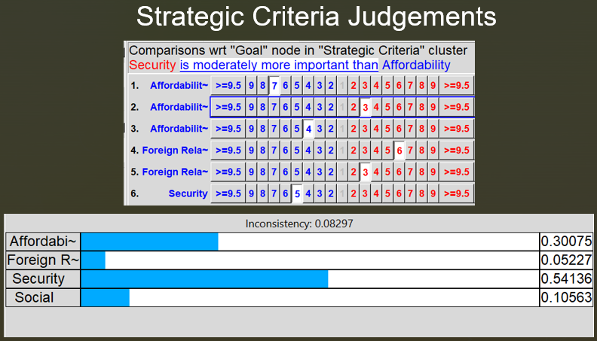
Figure 10. Pairwise comparisons of Strategic Criteria.

Total model synthesis showed that the preferred alternative was to build a partial wall. In the short-term, multiplicative model, it is clear that building the full wall was significantly hampered by the high upfront costs. The status quo priority was slightly higher in the multiplicative model vs. the additive, long-term model, presumably because the status quo represents a low up-front cost, but will likely be more costly in the long-term in the form of continued illegal immigration and associated crime and social impacts.

Sensitivity analysis at the AHP level for the BOCR criteria shows no rank reversal for benefits or opportunities. If Cost and Risk priorities increase, the Status Quo solution surpasses the Partial Wall alternative – a rank reversal. Regardless, building the full wall remains the highest cost and risk alternative. (Figure 11)
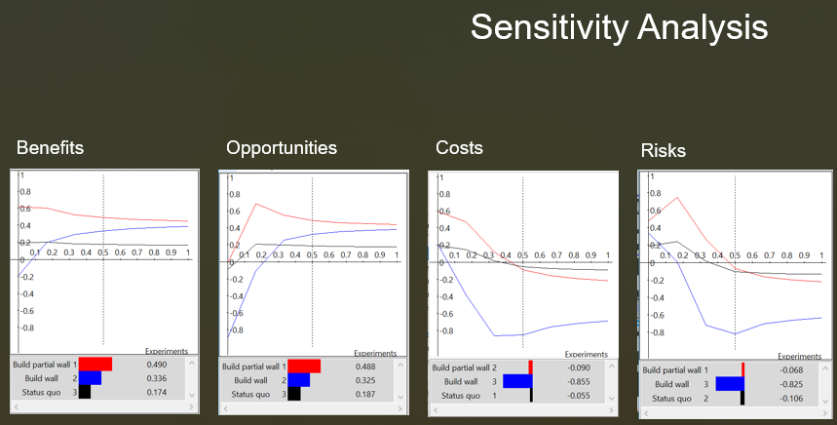
Figure 12. Sensitivity analysis shows consistency in the highest priority alternatives.

Conclusions
Based on this model, with its three limited alternatives, it is clear that the preferred alternative is to build a partial wall. This is most likely to reduce crime associated with illegal border crossing, and strengthen U.S.-Mexico relationships. Building a full wall unlikely to enhance security much more than a partial wall would, and comes at an astronomical cost politically and economically. In short, the view is not worth the climb for this alternative. While the magnitude of the current immigration problem is subject to debate, there is no doubt that the status quo presents problems in the form of illegal activity and strained relationships. While there might be better alternatives to the three presented here, if the U.S. were prompted to make an infrastructure-based decision today, our model supports a partial wall as the option most likely to balance U.S. goals of securing the country while being good stewards of tax payer dollars.

[4] Columbus’ first voyage explored Cuba’s north coast to Cayo Cruz.
[3] His second voyage explore the south coast to just above the present Isla de la Juventud (aka Pine Island).
[2] Image credit: Wikipedia ‘Antilles’.
¹ Michael E. Miller, The US-Mexico Border’s Wild Origin Story, Washington Post, January 10, 2019. ² Wikipedia, The United States – Mexico barrier. Wikimedia Foundation, Inc. last edited 19 April 2019.
³ C. Felter, Z. Laub, “Who secures the US border?,” Council on Foreign Relations, February 2019.
⁴ “Known and suspected Terrorists / Special Interest Aliens”, US Department of Homeland Security, 7 January 2019. ⁵ “Arizona mayor wants ‘lethal’ border wall wire removed…”, Associated Press, 6 February 2019.

