The Joseph M. Katz Graduate School of Business
University of Pittsburgh
International Executive MBA Program in São Paulo

Analytical Network Process Model

What new transportation mean to the international airport should the city of São Paulo choose?

Alessandro Jarzynski
Fábio Boucinhas
Mariana Castanho

Introduction 3
Background 3
The Alternatives 5
The Model 6
Results 16
Conclusion 18

Introduction
The purpose of this study is to decide which new transportation mean the city of São Paulo should adopt between the city and its international airport.

Having more than 17 million inhabitants in its metropolitan region, this city has become Latin America’s economic capital. Due to its economic importance, business tourism plays a major role in order to allow business development between locals and executives from around the world.

São Paulo is the world’s third biggest city, and currently faces a serious traffic problem. In addition to that, security is a constant concern, since urban violence is one relevant issue for local public welfare.

Given that tourism, traffic and safety are key decision factors, the city of São Paulo will consider three different options for the new transportation system between the main business area and the international airport:

- Ground Train
- Tram (or Air Train)
- Hovercraft

Background

The city of São Paulo is cut by two rivers (Pinheiros and Tietê). These rivers play a major role on the city’s complex and slow traffic. Despite extremely wide and being among the world’s longest avenues, the 6-lane roads that coast the rivers (Marginal Pinheiros and Marginal Tietê – exhibit 1) still aren’t able to provide the necessary flow on the rush hours, causing up to 100-mile traffic jams spread through the city.

Exhibit 1: Marginal Pinheiros
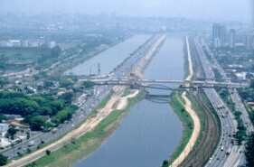

These traffic jams are responsible for a significant parcel of the urban violence in São Paulo, as criminals take advantage of the vulnerability brought by this situation.

Business tourism is a very important source of economical development for not only São Paulo, but also the entire country, as this city is the main first entry for most of the multinationals that go to Brazil.

As the traffic and violence may become an inhibitor for business development, also the need to attract more leisure tourists have lead to a joint effort between the city, state and federal administrations to study an alternative transportation mean. This decision will have to take into account several aspects, such as:

- Social welfare impact
- Environmental impact
- Political impact
- Economical impact
- Safety improvement
- Business and leisure tourism generation
- Economical feasibility

This new transportation mean will work in the route between the Berrini area, which is the main business district, and will cost the rivers until it approaches the international airport, which involve a distance of approximately 30 miles (exhibit 2).

Exhibit 2: Pinheiros River, Tietê River and the International airport
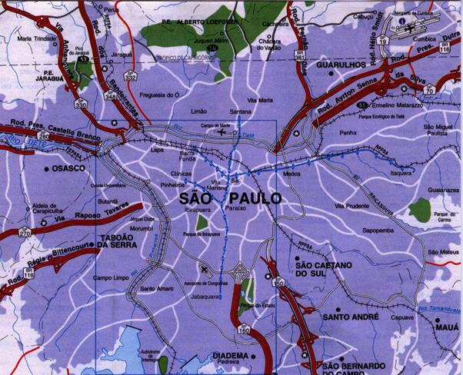
Pinheiros River
Tietê River
International Airport

The Alternatives

Each alternative has a set of characteristics that may or not be suitable for this project, and each advantage or disadvantage can be offset by that of the other alternative.
Some characteristics of each alternative are the following:

- Ground Train
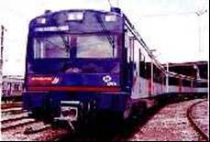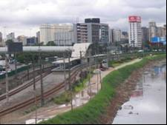
  - High Investment
  - High volume of transportation
  - Environmental change demanding
  - High maintenance cost
  - Indifferent for tourism
  - Medium Safety
  - High impact on local public welfare

- Tram (or Air Train)
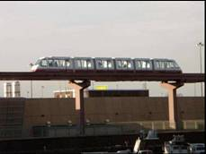
  - High Investment
  - Medium volume of transportation
  - Environmental change demanding
  - High maintenance cost
  - Medium safety
  - Attractive for tourism
  - Medium impact on local public welfare

- Hovercraft
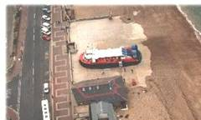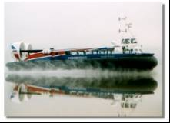
  - Medium Investment
  - Medium volume of transportation
  - Little environmental change
  - Low maintenance cost
  - Medium safety
  - Attractive for tourism
  - Medium impact on local public welfare

The Model

The model has 5 different strategic criteria that were posted as the objective of the study. The best solution in terms of transportation to the airport must take into consideration its impact in:
- Infrastructure
- Safety
- Public Welfare
- Publicity
- Traffic Improvement.
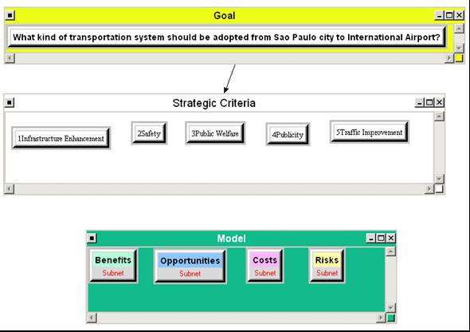

It was utilized the ratings approach in order to weight the importance of each strategic criteria as per the opportunities, benefits, cost and risk.

Publicity is the most important with 45%. This criteria is involved all political impact and reelection benefits that the new transportation mean might bring to politicians.

Traffic improvement and infrastructure were the second and third. Details are provided below:

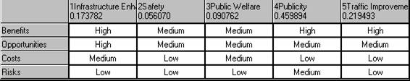

Each subnet of Benefits, Opportunities, Cost and Risk were divided into:
- Social
- Political
- Economical
- Envirnment

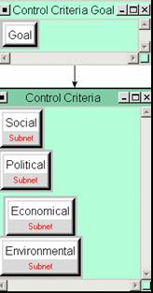

Each alternative was rated based on its relationship with each of the 16 scenarios developed and its corresponding nodes.

Benefits:

Social:
The social benefit was divided into Public Welfare and Public Interest.
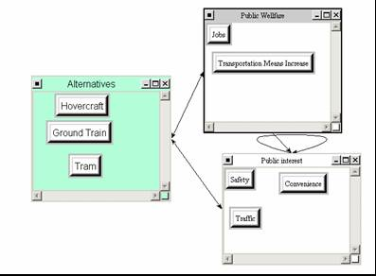

Political
The political benefit was divided into government and financial.

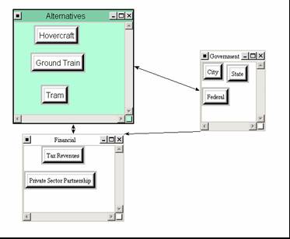

Economic
The economic benefits were divided as per its impact, whether it was to the company, which would be operating the transportation or to the society.
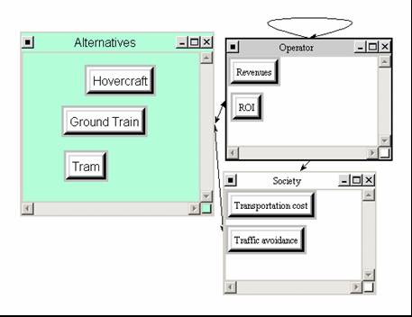

Environment
The benefit on environment was measure according to the transportation impact in preserving land, houses and forest or in reducing pollution.
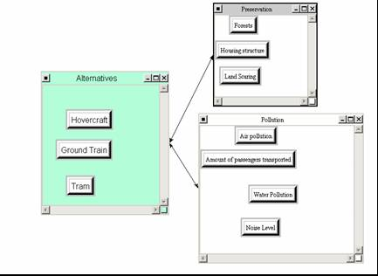

Opportunity

Social
The social opportunity was measure in term of the possibility to leverage on increasing the tourism or improving urban areas or reducing traffic in the city national airport.
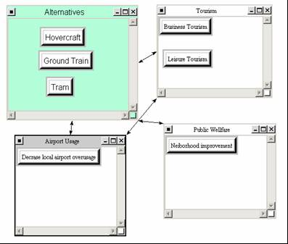

Political
The political opportunity is related to the possibility of reelection and for the party to implement similar models in other cities.
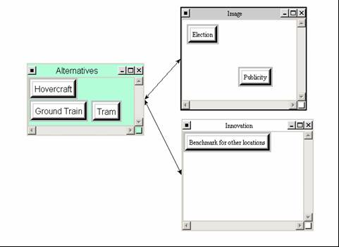

Economical
The economic opportunity related is related to the possibility of attracting new business to surrounding areas.
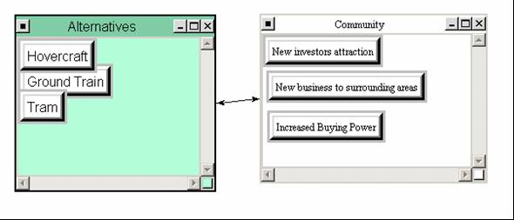

Environment
Opportunity to reduce pollution in the long term and incentives to recover affected areas, such as the river at the hovercraft alternative.

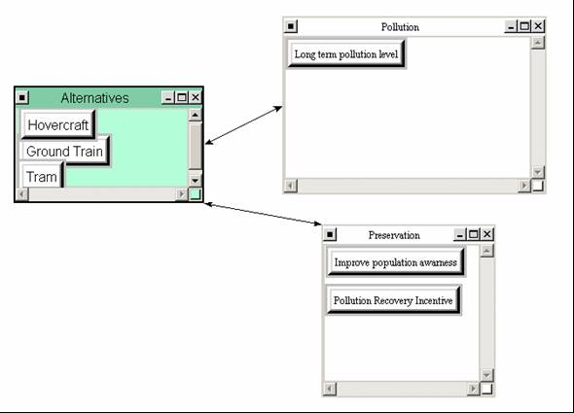

Cost

Social
The social cost of having to move families away of their home or the inconvenience of having a construction near your house and work.
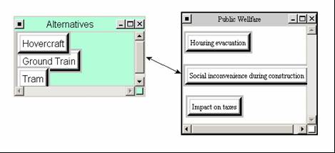

Political
The political cost is related to the population perception of public spending. , the possibility to split the cost between public and private companies and the plan to evacuate the urban areas.
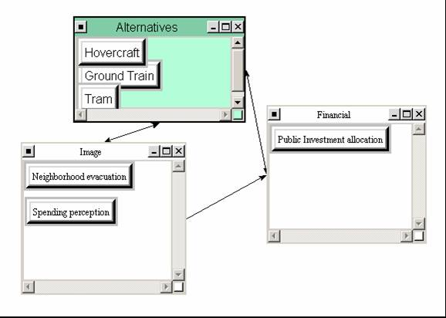

Environment
The cost related to preserve the city and disposal construction materials.
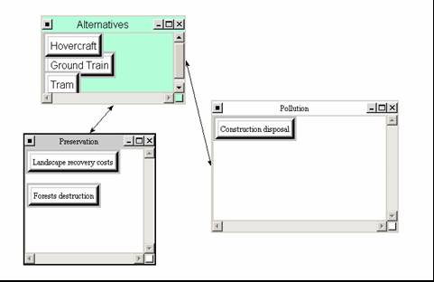

Economic
The economic cost is related to the amount invested and its returns for public and private sector. Other important factor is the total amount of money needed to maintain the transportation operating.
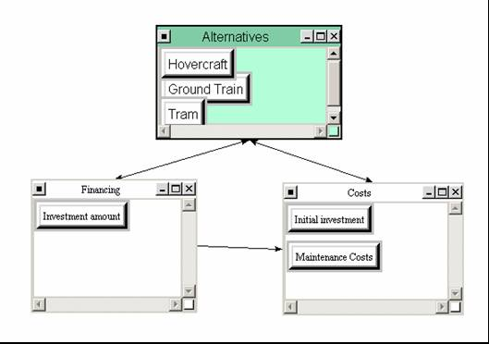

Risk

Social
The social risk is related to the project failure, or having part constructed and abandoned in the city , devaluating property and the possibilities of having accidents.
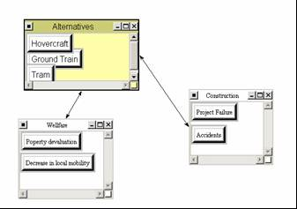

Political
The political risk is the population resistance to the project and their perception or image on the amount of money spent and the level of corruption involved in the project.
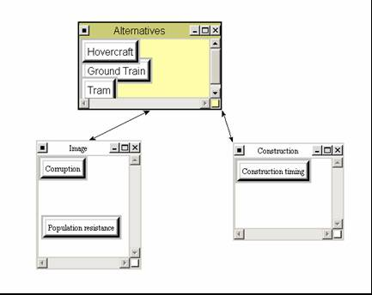

Environment
The environment risk is related to the use of misappropriate materials that can lead to accidents or increase pollution/ contamination.
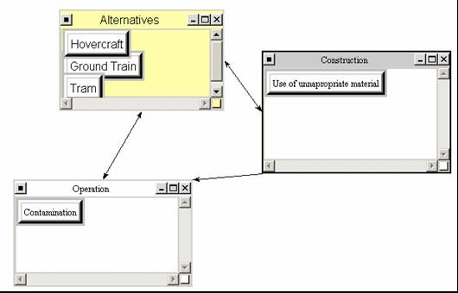

Economic
The project risk is related to the amount of demand, timing of construction and economic return of the project
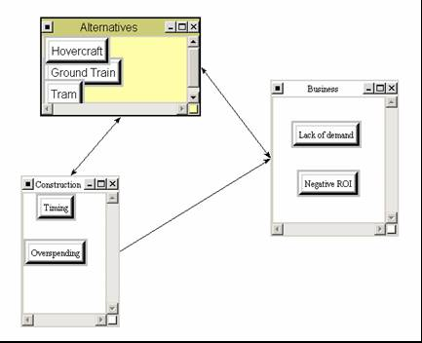

Results
As all nodes and clusters were compared based on their relationship with one another, the best solutions reached with the model was to implement the Hovercraft model with 46%, followed by the ground train with 30% and the Tram with 24%.
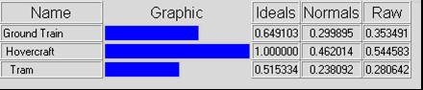

Sensitivity Analysis

The sensitivity analysis was performed taking into consideration the Benefits, Costs, Opportunities and risks as independent variables. All the analysis confirmed “Hovercraft” as the best possible decision for this problem. However, Benefits presented changes in case its priority is elevated.

In a situation where “Hovercraft” cannot be chosen as alternative any longer, the sensitivity analysis would provide further comparison between “Ground Train” and “Tram”. This could be useful since the priorities of these two are similar.

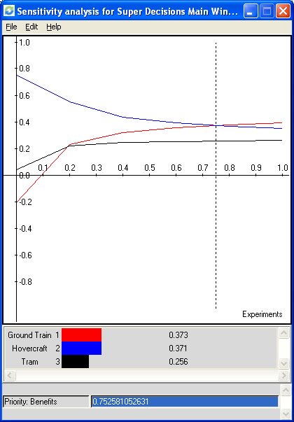

Benefits

This sensitivity analysis demonstrates that Hovercraft is the best decision until the point where we increase the priority to 0.75. After this point it changes places with Ground Train, but remains very close to it.

In the determination of the second best alternative, only if the priority is low, Tram will have an advantage over Ground Train. Otherwise, Ground Trains will keep the second place.

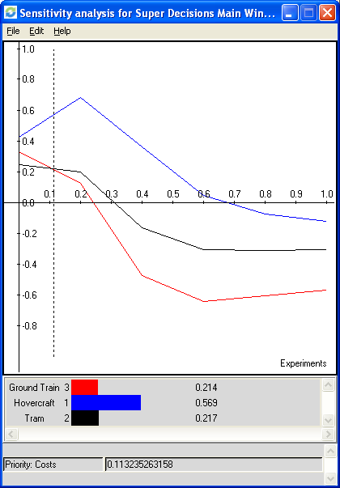

Costs

This sensitivity analysis on costs as the independent variable also demonstrated that Hovercraft is the best possible decision.

When determining the second best alternative, only when the priority is very low, Ground Train will have an advantage over Ground Train. Otherwise, Ground Trains will keep the second place.

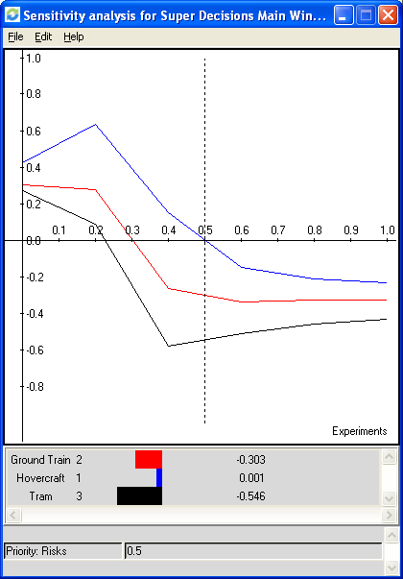

Risks

Along with costs, this can be considered one of the two most important analysis due to the nature of this problem.

This analysis demonstrated that Hovercraft is the decision that will provide the lowest exposure to risk.

Ground Train appears as the second best alternative.

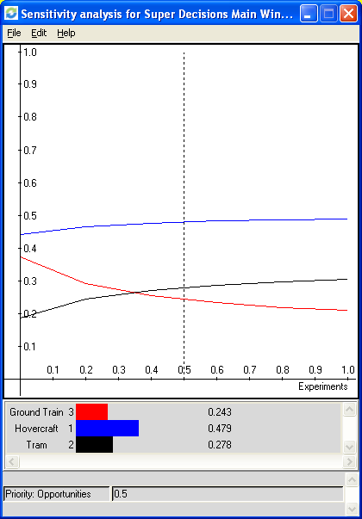

Opportunities

Finally, the sensitivity analysis on opportunities also demonstrated that Hovercraft is the best possible decision.

As a second best alternative, Tram wins as priority rises from 0.35.

Conclusion

By using the additive negative formula, the model synthesized the Hovercraft as the best decision with a 46% normalized priority, while the other two options remained technically even, in a second place.

To reach this decision, it took into consideration many variables that embrace all the stakeholders of a project of this nature, such as end users, operator, government, politicians, community, etc.

We can conclude that the choice for the Hovercraft can be taken with a considerable amount of comfort by the champions of this project. However, given the important considerations and constraints involved which are beyond the scope of the model. Items like “Funding for the project”, “How the community would respond to the project” or “What’s the influence of future election and macroeconomic developments” can change significantly this decision.

