Should U.S. Financial Reporting System Adopt IFRS?

Xiaoqian Cao
Hailu Jiang
Anqi Mu

10/17/2011

Decision Making in a Complex Environment

University of Pittsburgh
Joseph M. Katz Graduate School of Business

Table of Contents

Abstract…………………………………………………………………......................... 2

Introduction…………………………………………………………………………....... 2

Methodology….................................................................................................................. 3

Data………........................................................................................................................ 4

Analysis……...................................................................................................................... 14

Summary………………………........................................................................................ 16

Conclusion………………………………………………………………………………. 17

Future Research and Applications…................................................................................. 17

Bibliography…………………………………………………………………………….. 18

Appendices……………………………………………………………………………… 19

Abstract

For this paper we evaluated whether the United States financial reporting system should adopt International Financial Reporting Standards (IFRS). We considered the benefits, opportunities, costs, and risks of alternative decisions using economics, corporate governance, social, and technology criteria. Although more than 120 nations and reporting jurisdictions permit or require IFRS for domestic listed companies, adopting IFRS is a difficult decision that involves tons of current and future effects. Our model and decision criteria suggested that U.S should adopt the IFRS gradually.

Introduction

The International Accounting Standards Committee (IASC) was formed in June, 1973 by professional accountancy bodies in Australia, Canada, France, Germany, Ireland, Japan, Mexico, Netherlands, UK and U.S. The IASC was restructured in March, 2001, and among other things, the standard-setting body changed its name to International Accounting Standards Board (IASB) and the issued standards as IFRS. The objectives of the IASC were broad and challenging:
- To develop, in the public interest, a single set of high quality, understandable and enforceable global accounting standards that require high quality, transparent and comparable information in financial statements and other financial reporting to help participants in the world’s capital markets and other users make economic decisions;
- To promote the use and rigorous application of those standards;
- In fulfilling the objectives, to take account of, as appropriate, the special needs of small and medium-sized entities and emerging economies; and
- To bring about convergence of national accounting standards and International Accounting Standards and International Financial Reporting Standards to high quality solutions

As the business world became more global, regulators, investors, large companies and auditing firms began to realize the importance of having common standards in all areas of the financial reporting chain. In a survey conducted in late 2007 by the International Federation of Accountants (IFAC), a large majority of accounting leaders from around the world agreed that a single set of international standards is important for economic growth.

Currently, more than 120 nations and reporting jurisdictions permit or require IFRS for domestic listed companies. The European Union (EU) requires companies incorporated in its member states whose securities are listed on an EU-regulated stock exchange to prepare their consolidated financial statements in accordance with IFRS. Australia, New Zealand and Israel have essentially adopted IFRS as their national standards. Brazil started using IFRS in 2010. Canada adopted IFRS, in full, on Jan.1, 2011. Mexico will require adoption of IFRS for all listed entities starting in 2012. China and Japan is working on achieve convergence of IFRS.
Although the number of countries that require or allow the use of IFRS for the preparation of financial statements by publicly held companies has continued to increase, the acceptance of IFRS as a basis for U.S. financial reporting represents a fundamental change for the U.S. accounting profession since there are many significant differences between IFRS and U.S GAAP. For example:
- The format of financial statements including Balance Sheet, Income Statement, Statement of Cash Flow;
- IFRS allows the revaluation of assets in certain circumstances;
- Under IFRS, LIFO is not permit;
- IFRS uses a single-step method for impairment write-downs rather than the two-step method used in U.S.GAAP, making write-downs more likely;
- IFRS requires capitalization of development costs, when certain criteria are met;
- Revenue Recognition;
- Leases;
- Financial Instruments;
- Pension Plans

Thus, this decision is very important considering all the benefits, opportunities, costs, and risks. Some already changes in this system have brought some profit companies looked unprofitable on their new financial statements. In the United States, the Securities and Exchange Commission (SEC) is taking steps to determine whether to incorporate IFRS into the financial reporting system for U.S. issuers and, if so, when and how.

Methodology

During the course of this research we identified three alternative decisions for U.S. regarding IFRS:

- Adopt IFRS as soon as possible
- Adopt IFRS gradually
- Never Adopt IFRS

These alternatives are straightforward. Some countries, such as Canada, adopt IFRS fully and immediately to keep pace with other countries and save the long-term efforts with short-term costs. Some are taking the convergence process to adopt IFRS gradually trying to minimize the effects, such as China and Japan. There are also other countries that have not thought about IFRS adoption. Each alternative has advantages and disadvantages.

In our model we used strategic criteria encompassing economic, corporate governance, social and technology arenas and extended these to be control criteria within our BOCR model. We believe that these four criteria are holistic and capture the most important issues that factor in to a decision about whether to adopt IFRS. From a macroeconomic standpoint, these criteria should be the most important factors for the United States to consider when making the decision.

The economics criterion should cover all economic and financial implications of adopting IFRS. The corporate governance criterion takes the consideration of company attitude and effects of the adoption. The social criterion focuses on implications such as culture, national pride and legal system. For the technology criterion, we discussed the impact on the accounting system and the new education for accountants.

We made pairwise comparisons for the various interdependencies and elaborate on these in the next section of the report using graphics excerpted from Super Decisions.

Data
Strategic Criteria
We used economics, government corporate, social, and technology strategic criteria in our model. We also used these as control criteria consistently throughout the benefits, opportunities, costs, and risks that we identified. Further detail regarding our model is presented below.

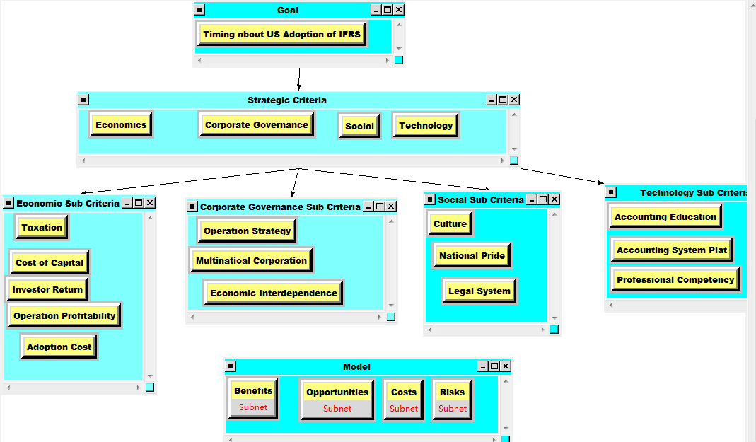
Benefits
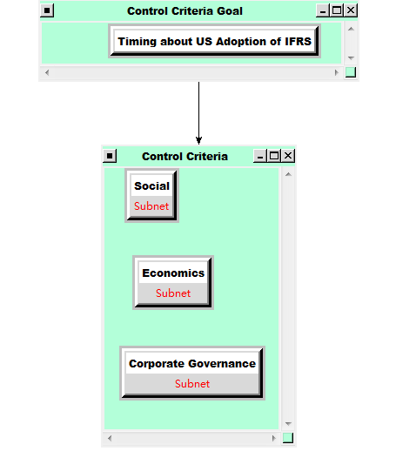

Economics Control Criteria:
The influencing factors in the economics include the following items:
- Operation Profitability: the timing of adoption IFRS will have an effect on company’s net income level
- Cost of capital: choice of equity financing or debt financing
- Investor return: dividend policy and debt investment
- Taxation: taxation base will be different under US GAAP and IFRS
- Adoption cost: the first time adoption cost will influence the choice.
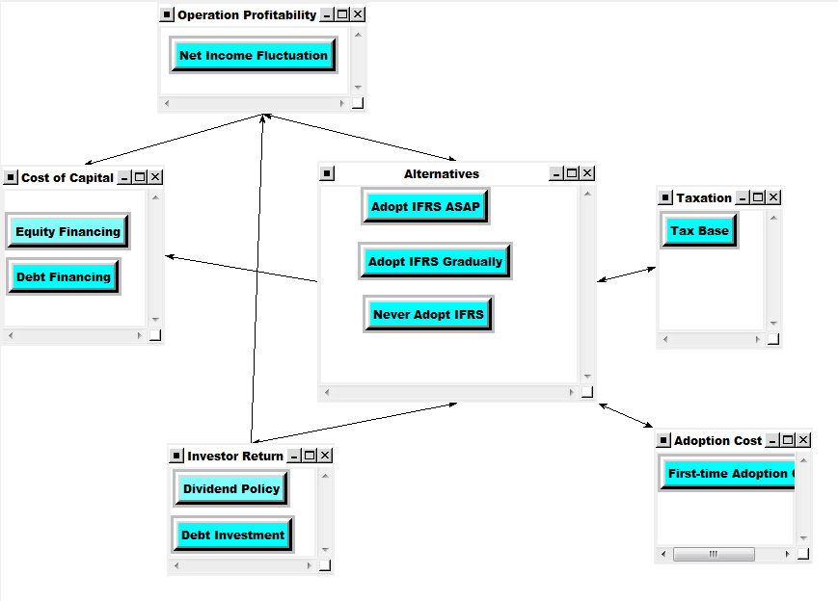
Corporate Control Criteria:
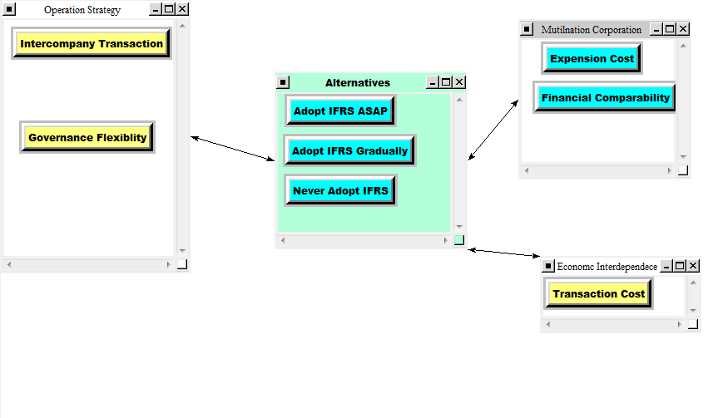
Social Control Criteria:
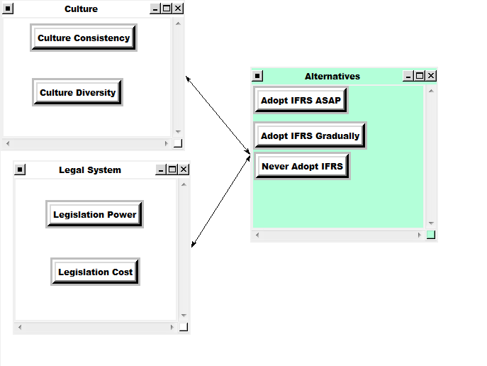
Within the economics, the priorities would be:
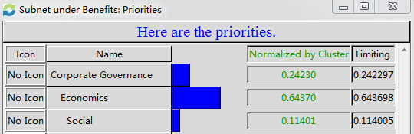

Opportunities
- Economics: Operation profitability cost of capital, investor return, taxation, and adoption cost.
- Corporate governance: Operational strategy, economic interdependence, and multinational corporations.
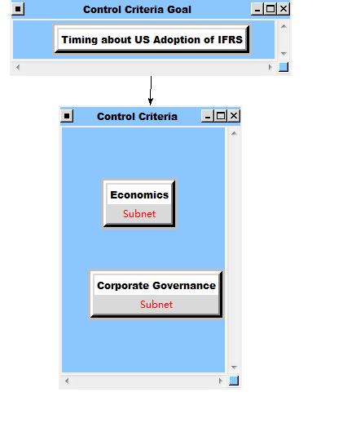
Economics control criteria:
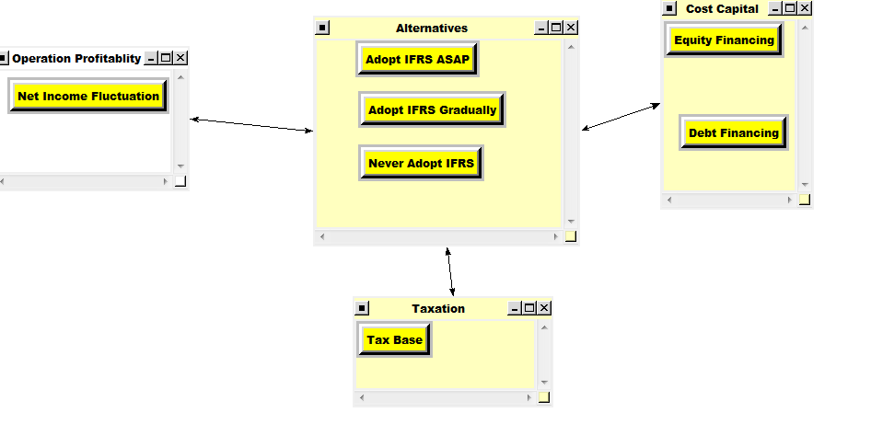
Corporate governance control criteria:
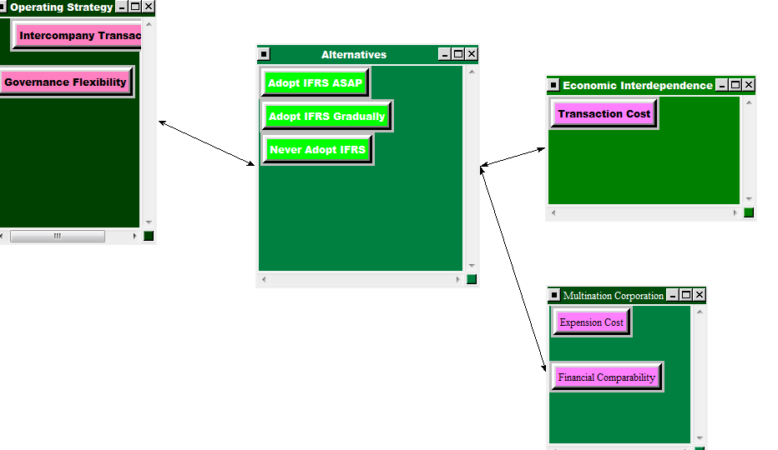
The priorities would be:
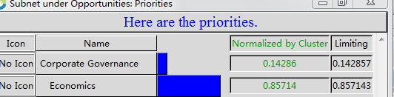
Costs
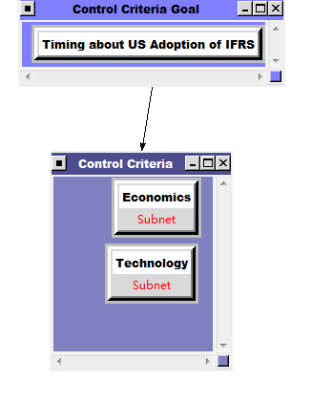
Technology control criteria:
- Accounting education: school education cost
- Accounting system plat: system upgrade cost, internal control
- Professional competency: training cost, hiring cost
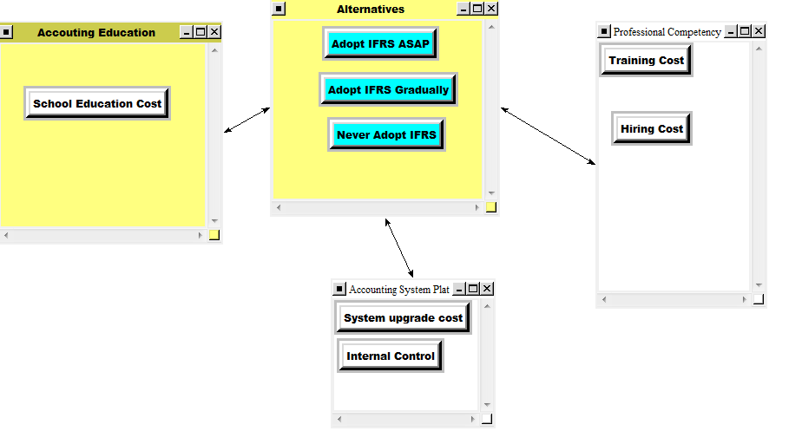
Economics control criteria:
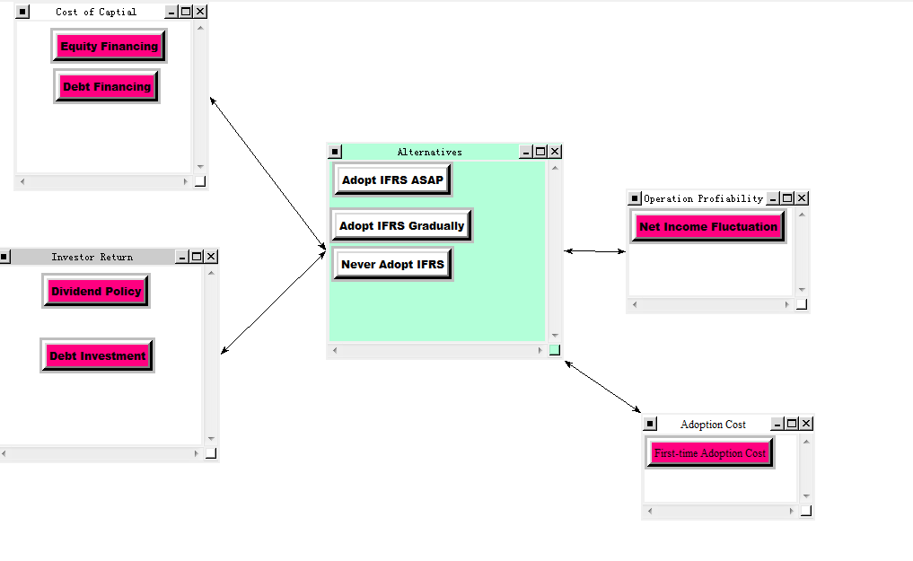
The priorities within the cost would be:
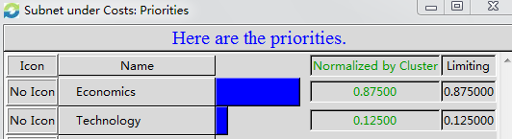
Risks
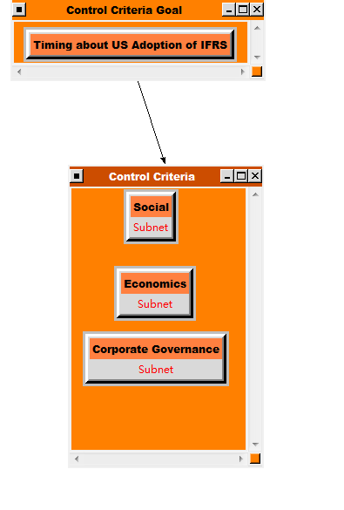

Social control criteria:
- Culture: culture consistency, culture diversity
- Legal system: legislation power, legislation cost
- National pride: emotion
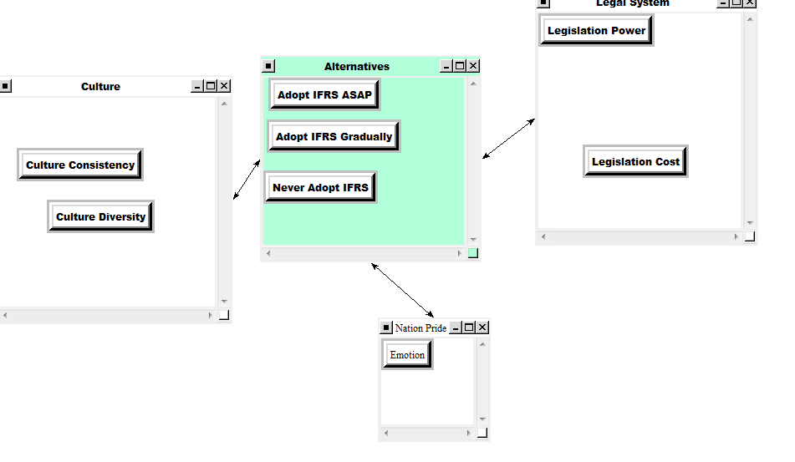
Economics control criteria:
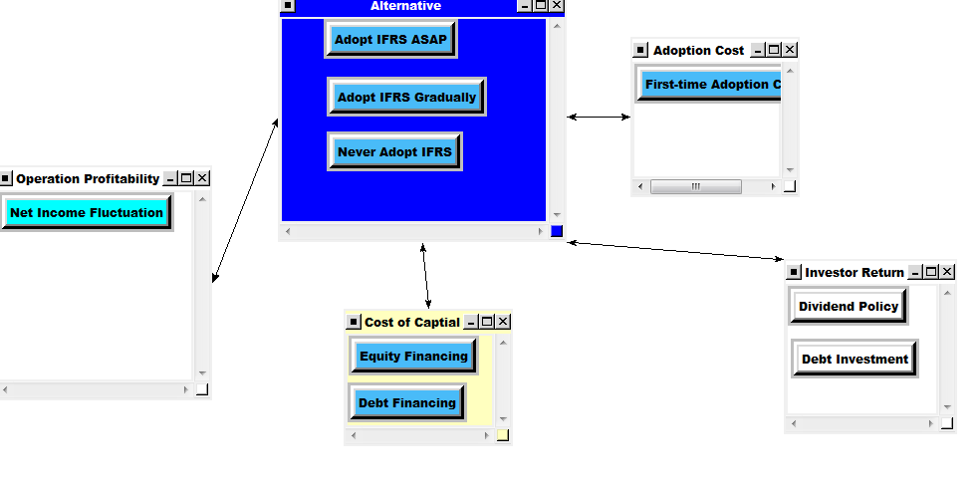
Corporate governance control criteria:
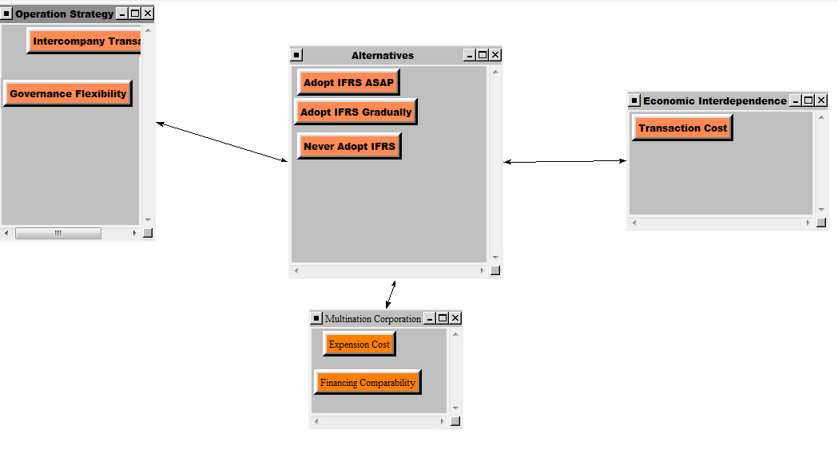
The priorities within the risk would be: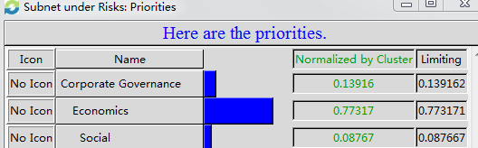
Analysis
Rating
For the rating model, we rated control criteria and factors as very high, high, medium, average, and below average. The priorities we assigned from most to least would be: opportunities, benefits, costs, and risks. Among them, the operation profitability is weighed most. The detail of rating is as follows:
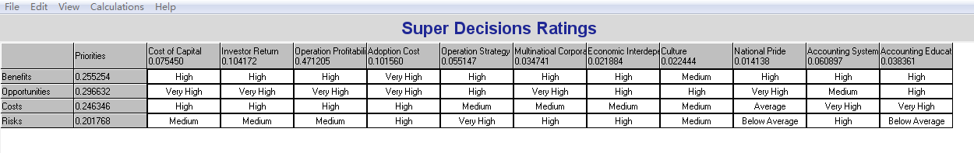
Sensitivity analysis
We performed a sensitivity analysis using benefits, opportunities, costs, and risks as independent variables. The graphs below and on the following page illustrate that US should adopt IFRS as soon as possible when benefits and opportunities are the independent variables. But US should never adopt IFRS when costs and risks are the independent variables. Thus, the best choice combined benefits, opportunities, costs, and risks would be that US should adopt IFRS gradually.

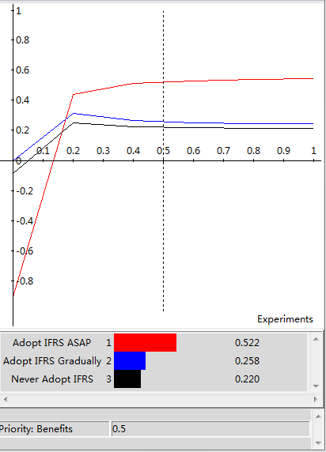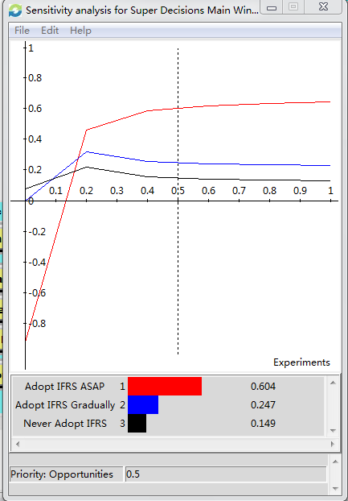

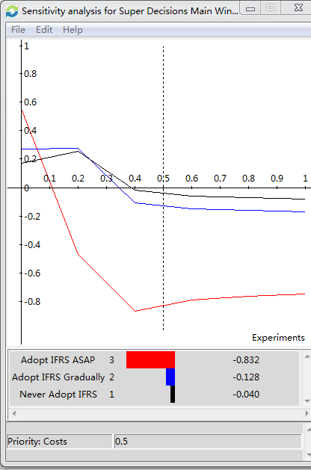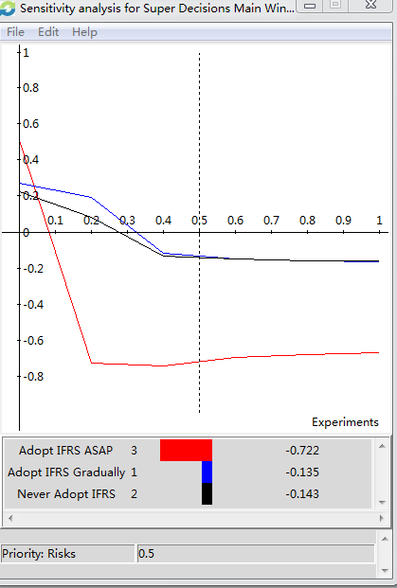

Summary

The decision whether to adopt IFRS is complex and includes a number of factors. Growing interest in the global acceptance of a single set of robust accounting standards comes from all participants in the capital markets. Many multinational companies and national regulators support it because they believe that the use of common standards in the preparation of public company financial statements will make it easier to compare the financial results of reporting entities from different countries. They believe it will help investors understand opportunities better. Large public companies with subsidiaries in multiple jurisdictions would be able to use one accounting language company-wide. Another benefit is that in a truly global economy, financial professionals, including CPAs, will be more mobile, and companies will more easily be able to respond to the human capital needs of their subsidiaries around the world. However, many people also believe that U.S. GAAP is the gold standard, and some degree of quality will be lost with full acceptance of IFRS. Another concern is that worldwide, many countries that claim to be converging to international standards may never get to 100% compliance. Most reserve the right to carve out selectively or modify standards they do not consider in their national interest, and action that could lead to incomparability.

The AICPA conducts a semi-annual IFRS Readiness Survey. In its fall 2010 survey, 54% of respondents said that the SEC should ultimately require adoption of IFRS for U.S. public companies, although most believe more convergence of accounting standards is needed first. Another 21% said IFRS should be available as an option for use by U.S. public companies. Although, year 2015 is the earliest year the SEC estimated to allow public companies to convert their financials to IFRS. Our BOCR model, however, suggested that U.S. should adopt the IFRS gradually, that means, within a long term of time.

Conclusion

United States must evaluate the pros and cons of adopting IFRS and can use a BOCR model as a useful tool to make sound decisions in a complex and tumultuous global economy. Effective decisions making must involve elements of both the heart and the mind. We cannot rely solely on intuition or “feeling” to make important decisions because this often results in the wrong decision. In professional settings we have to use analytical models and sometimes management science decision making to validate our intuition and make the most effective decisions that we can using the information and resources that we have at the time. Our analysis and analytical judgment led us to conclude that U.S. should adopt IFRS gradually. Other students and professionals might disagree with our conclusion. That is acceptable as long as they can back up their assertions with an analytical framework or tool such as Super Decisions.

That said, it is important to be aware of the influence of bias or past experiences in using a tool such as Super Decisions. Our results indicate that U.S. should adopt IFRS gradually. In terms of our team, the three of us are all master of accounting students with strong knowledge about IFRS and U.S. GAAP. Overall, bias can be an influential determinant of the results of a BOCR model in Super Decisions.

Future Research and Applications

The decision of whether to adopt IFRS will continue to be important as the conflicts debating between professionals and accountants. The SEC’s roadmap of convergence is still in doubt and some have also propose an idea of “CONDORSEMENT”-- that incorporate the two most prevalent methods of IFRS incorporation—convergence and endorsement by using a form of convergence to transition to an operating framework that draws primarily from the endorsement. Our prior research indicates that the most effective way is to adopt IFRS gradually and smooth the impacts. We believe that our BOCR model could be an important tool for other countries to consider whether to adopt IFRS and for the countries that already adopt, such as Canada to reevaluate their decision and make efforts to minimize the negative impacts.

Bibliography

Matthew G. Lamoreaux, “Beyond Convergence”, Journal of Accountancy, August 2011
IFRS.com, “International Financial Reporting Standards (IFRS)--An AICPA Background”, 2011

Tom Selling, PhD, CPA, “Top Ten Reasons Why U.S. Adoption of IFRS is a Terrible Idea”
http://accountingonion.typepad.com
David Albrecht, “Benefits and Costs to U.S. Adoption of IFRS”
http://profalbrecht.wordpress.com
Leadership.ng, “Adoption Of IFRS Will Lead To Stable Financial System – CBN”
http://leadership.ng/nga/articles
CFO.com, “SEC: Early IFRS Adoption Will Cost Firms $32M”
http://www.cfo.com/article.cfm/12625195

Appendices
