Decision Making in Complex Environment Final Project
BOCR Decision Model Project Report

Instagram was recently bought by Facebook. The objective of this model is to find out whether Instagram should have sold itself to Facebook or not.

2012
Akhil Saini, Alexandre Prati, Vinay Deshpande
Report
4/24/2012

Contents

Abstract 2
Introduction 2
Methodology 6
Alternatives 6
Strategic Criteria: 7
BOCR 9
Benefits 9
Opportunities 10
Cost 11
Risk 11
Data 12
Results 12
Ratings 14
Conclusion 15
Sensitivity Analysis 16
Appendix-1 18
Bibliography 19

Abstract
Instagram recently sold itself to Facebook for $ 1 Billion. We are preparing a decision making model to check whether they have taken the right decision. The Benefits-Opportunities-Costs-Risks model is used to determine the best option for the Instagram in the short-term and in the long-term. We considered three alternatives as follows
- YES- Sell it
- NO- Do not sell it
- Future- Consider selling in future
After performing all the comparisons and synthesis using the model we found out that selling in future is the best option for the short-term. However for the long term, not selling is the best option.

Introduction
Instagram is a photo sharing firm that launched an application for smart phones (Android and Apple) where you can post photos, "like" the pictures other users have shared, or leave comments on friends' images -- just like you can on Facebook. Instagram also has a special feature unlike Facebook. It allows users to apply filters and improve the look and feel of the picture. Instagram which started in October, 2010 had 30 million accounts by April, 2012. Facebook showcases memories -- last week's wedding, dinner, birthday, vacation -- while Instagram frames moments and allows you to filter them as per your liking -- the tulips you just passed, the sun hitting a building during your morning run, or the bizarre quote you saw on a talk show.
Unlike Facebook, you typically don't need permission to add someone to your circle. That person has an option to require permission, but most people don't bother. Under the default privacy settings, you can also browse through other people's photos without following them, just as they can do with yours.
Facebook has spent US$ 1 Billion to buy this app. The first estimate was at US$100Million and in a span of just 1 year Facebook agreed to pay $1 Billion. Facebook offered this huge amount to a company with no more than 9 employees an absolutely no revenues (Financial Times, 2012). The big question for us is why did Instagram sell itself now? And whether it should have held out?
Industry leaders have a reason to believe that Instagram has yet not matured to its potential and that it has more scope. It is just nibbling its way into the Android market and has significant growth potential there. Instagram is also said to be present in one in every ten i-phones and is the sixth most famous app in the iOS app store (Tsukayama, 2012). With the kind of growth trajectory it has it might have been able to grow to significant size in the future.
The acquisition can be well understood from the perspective of Facebook. Facebook fails to have the base that Instagram has and Photo sharing is extremely important aspect for Facebook. Facebook on an average adds 250MM (Tsukayama, 2012) photos every day to the network and had a user base of 845MM (Financial Times, 2012) users who they have to be kept within their system. It only made strategic sense for Facebook to acquire a future potential competitor.
But from the stand point of Instagram it remains an ambiguous decision to us for selling it now when there was a significant potential for growth. Why not earlier or at some stage later. If Facebook could raise its bid from 100 million to 1 billion in one year then why Instagram didn’t wait more time if it had to sell.
The acquisition of Instagram has got everybody talking about it. This has been rated as one the most valuable acquisitions. The officials of Facebook have also touted that they will not be considering such an acquisition for some time to come. Instagram was just on its way up with the cost per user very low there was not much for the company to worry about as the graph below depicts.
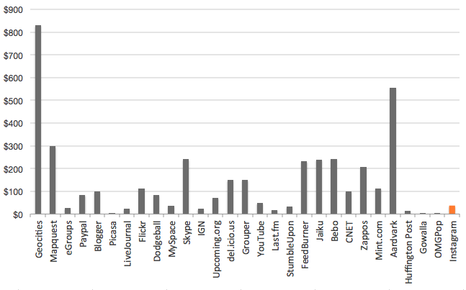
It can be argued that Instagram sold itself pretty quickly. The following graph shows that in the history of acquisitions Instagram sold itself rather in the infant stage.
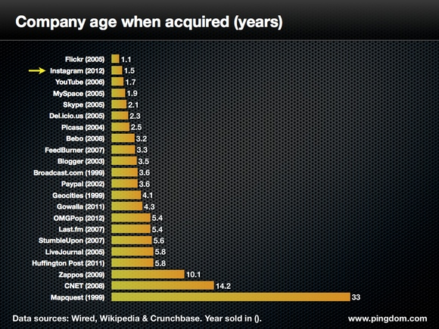
Further analysis on the acquisition suggests that the value of instagram was on a exponential curve.
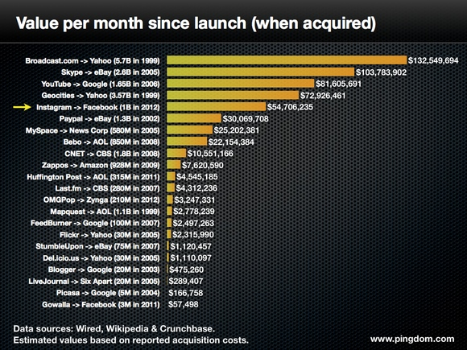
This depicts that it was one of the biggest pay offs in the acquisition of any technology start up.

Methodology
The Benefits-Opportunities-Costs-Risks model is used to determine the best option for the Instagram on the short-term and on the long-term.

Alternatives
- Instagram should sell itself to Facebook right now. Selling it right now could be the best option if Instagram realizes that in the near future technology will change very fast and it might become obsolete from market and might not be a value buy. Or if it realizes that 1Billion is the maximum price it can achieve ever from Facebook or if it realizes that it never planned to stay long in market and selling off in short time was the only motive.

- Instagram should not sell itself to Facebook and remain in business on its own and possibly compete with Facebook. This option could be best when Instagram has long term goals and vision expectations from its product and think that selling off doesn’t make sense as they could earn much more in future compared to what Facebook is offering currently. Also this option is good if Instagram has other plans like providing complementary services such as social networking and communication etc. and expanding their business from just one app to other wide range of services just like Google did by starting off as a search engine and now it has services in almost all spheres of the e-commerce.

- Instagram should consider whether to negotiate with Facebook to increase its value and wait for some more time. In this situation Instagram should be consider making threshold in terms of time and / or the number of subscribers Instagram wants to attain.

Strategic Criteria:
- Competition: - Every company wants to stay competitive in market but the question here is whether Instagram can compete with Facebook (currently or in the future) Facebook has currently 845MM users as opposed to Instagram 30 MM user. Facebook currently has wide range of services offered but not the platform for photo sharing which Instagram possesses as mention in introduction. It remains to be seen and there are indicators in the market which suggest that Instagram could have been a potential competitor for Facebook.

- Financial: - Research suggests that this is the most significant criterion when selling a company. This criterion was chosen in order to gauge whether the offered amount of 1 Billion possibly could have been more in the future or given the sale it is the best price they could have got.

- Personal: - This criterion was chosen because of the qualitative significance it carries. There could have been personal preference which affected the decision while making a choice of selling or not selling and because we are talking from the perspective of a startup company with very small number of employees there could be personal preference superseding other factors.

- Technology: - This criterion is chosen because of the dynamic technological environment where we assume that the decision to sell or not to sell a company is influenced by the fact whether the technology might get obsolete very quickly and the entrants might end up losing its competitive edge or whether the technology might boom. Also another important consideration is how long before competitors can imitate this technology.

BOCR

Benefits
 | Financial | Brand Appreciation | Will the brand value grow in future if they didn’t sell the company
 |  | Financial Growth | They have no financial benefit right now as they are not making any revenues. Generating revenue through advertisement.
 |  | Market Share | Significant market share because of the huge subscriber base.
 | Social | Brand Recognition | Whether Instagram will become an integral part of people’s life like Facebook and Twitter and whether people will start relating to Instagram as something personal
 |  | Social Awareness | This is an indicator whether Instagram will be as powerful in creating social awareness as other social networking platforms for e.g., uprising in Egypt fuelled by Facebook

Opportunities
 | Financial | Acquisition | Whether Instagram would be able to acquire competitors
 |  | Market Share | Based on the current subscriber base Instagram will continue to increase market share. Alliances with platform like Android and IOs will only increase customer reach.
 |  | Revenue | Will they be able to generate revenue in future through subscriptions and advertisements, leasing of technology
 | Diversification | Social Networking | Grow from photo sharing to social networking hub
 |  | Video Sharing | Improve technological competency by adding features like video sharing and live streaming
 |  | Communication | Ultimately become a tool of communication like Facebook and Skype

Cost
 | Economic | Operations | Costs incurred by Instagram such as variable cost for running the company such as human resource, administrative costs
 |  | Technology | Costs incurred to sustain competitive technological advantage such as R&D and setting up new technological infrastructure cost

Risk
 | Financial | Bankruptcy | As the company has no revenues it could lead to future bankruptcy
 |  | No Revenue | Existing business model cannot generate any revenue
 |  | Under-value | Company might not be offered same price of $1Billion in future
 | Technology | Imitate | Competitors might imitate the technology sooner than expected
 |  | Obsolete | Technology might become obsolete after a certain time

Data
For constructing the matrices necessary to do the analysis we used the Questionnaire method for the BOCR Ratings.

Results
Benefits:
Weights | Control Criteria | Alternatives | Ideals | Normals | Raw
0.83 | Financial | Future | 0.684393 | 0.341603 | 0.170801
 |  | No | 1.000000 | 0.499132 | 0.249566
 |  | Yes | 0.319084 | 0.159265 | 0.079633
0.17 | Social | Future | 0.572357 | 0.319618 | 0.159809
 |  | No | 1.000000 | 0.558425 | 0.279212
 |  | Yes | 0.218395 | 0.121957 | 0.060979

Opportunities:
Weights | Control Criteria | Alternatives | Ideals | Normals | Raw
0.67 | Financial | Future | 0.777176 | 0.376327 | 0.188163
 |  | No | 1.000000 | 0.484223 | 0.242112
 |  | Yes | 0.287988 | 0.139450 | 0.069725
0.33 | Diversification | Future | 0.550321 | 0.29961 | 0.148481
 |  | No | 1.000000 | 0.539614 | 0.269807
 |  | Yes | 0.302853 | 0.163424 | 0.081712

Costs:
Weights | Control Criteria | Alternatives | Ideals | Normals | Raw
1.0 | Economic | Future | 0.550321 | 0.29961 | 0.148481
 |  | No | 1.000000 | 0.539614 | 0.269807
 |  | Yes | 0.302853 | 0.163424 | 0.081712

Risks:
Weights | Control Criteria | Alternatives | Ideals | Normals | Raw
0.20 | Financial | Future | 0.567836 | 0.314841 | 0.147421
 |  | No | 1.000000 | 0.554459 | 0.277229
 |  | Yes | 0.235725 | 0.130700 | 0.065350
0.80 | Technology | Future | 0.572357 | 0.317618 | 0.159809
 |  | No | 1.000000 | 0.558525 | 0.279212
 |  | Yes | 0.218395 | 0.121957 | 0.060979

Ratings
The results of the BOCR model are weighted by rating the top alternative for each merit against the Strategic Criteria. For creating the rating we will use the following scale:

Very High | 1.00
High | 0.56
Moderate | 0.30
Low | 0.16
Very Low | 0.05

 | Priorities | Competition | Financial | Personal | Technology
Benefits | 0.110712 | Low | Moderate | Moderate | Low
Opportunities | 0.208443 | Moderate | High | High | Moderate
Costs | 0.226804 | High | Moderate | Moderate | High
Risks | 0.454041 | Very High | High | Very High | Very High

Conclusion
For short term, we see from the results graph that the best option for Instagram would be to sell itself in the future. The score for this option is .39. The second option would be to sell it right now. The score is quite close to the first option, which is .34. So there is a very close difference which makes it difficult to affirm that they didn’t do the right thing by selling it right now.
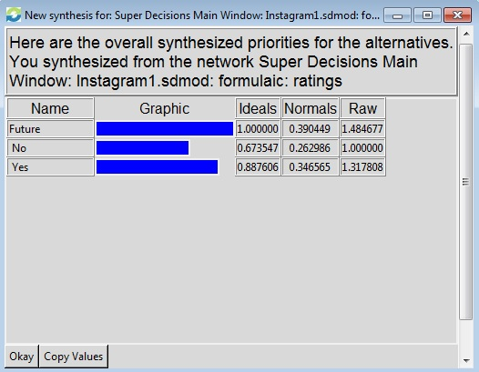
For long term, we see from the results graph that the best option for Instagram would be to sell and not compete with Facebook. The score for this option is -0.120. The second option would be to sell it in the future and demand higher price at that time.
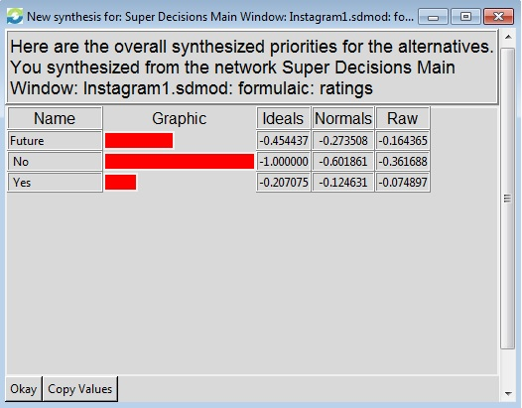

Sensitivity Analysis
From the Benefits Sensitivity analysis we notice that FUTURE would be the best option until 0.4 but after that NO become the first priority.
From Opportunities sensitivity analysis we notice that the first option would be YES is the best option until 0.15 which converts to FUTURE after 0.15 an remain the best until o.35 after which the best option is NO

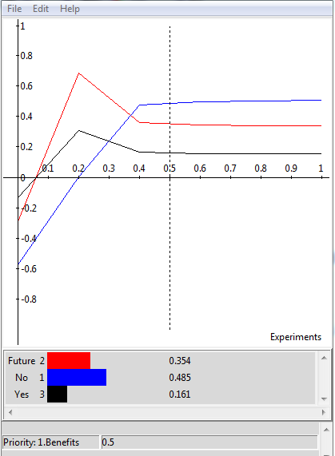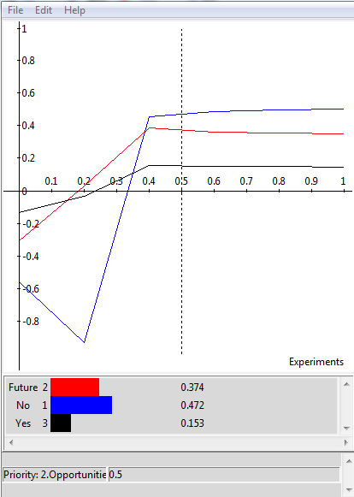

From Cost sensitivity analysis we notice that the first option would be YES no matter what.
From Risk sensitivity analysis we notice that the first option is FUTURE until 0.13, which changes to YES at 0.13 and remains the same all throughout.

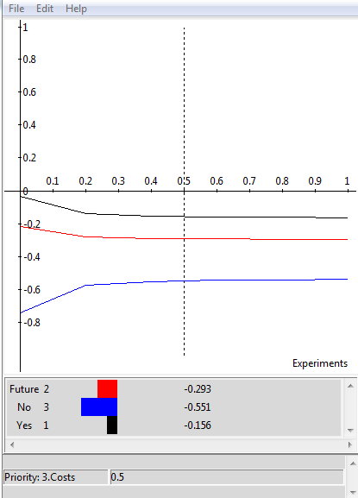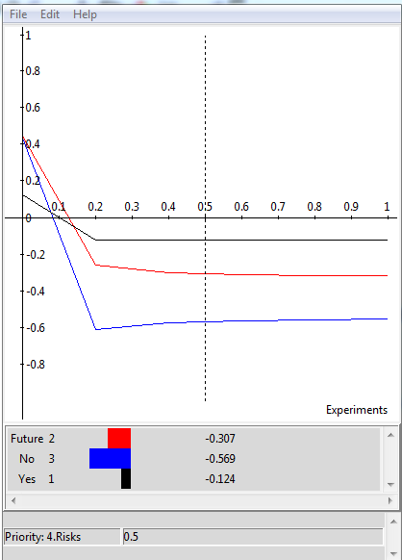

Appendix-1
The main model screen shot
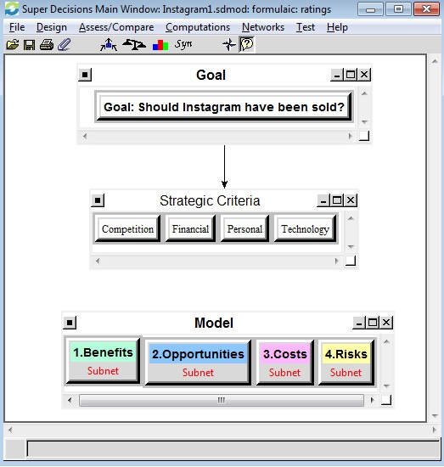
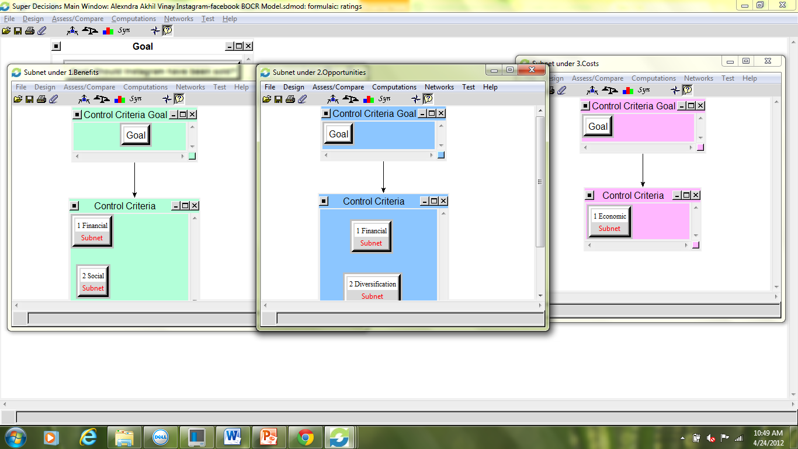

Bibliography
“Facebook buys Instagram”. Hayley Tsukayama. The Washington Post. Washington, D.C.: Apr 10, 2012. pg. A.9
"Facebook/Instagram." Financial Times 10 Apr. 2012: 14. General OneFile. Web. 24 Apr. 2012.
http://www.huffingtonpost.com/bianca-bosker/instagram-facebook_b_1423775.html
http://royal.pingdom.com/2012/04/17/instagram-and-the-fastest-biggest-payouts-in-tech-startup-history/
http://www.usatoday.com/tech/products/story/2012-04-14/instagram-app-review/54261822/1

http://www.usatoday.com/tech/products/story/2012-04-14/instagram-app-review/54261822/1
http://www.huffingtonpost.com/bianca-bosker/instagram-facebook_b_1423775.html
http://www.wired.com/epicenter/2012/04/opinion-baio-instagram-trend/
http://royal.pingdom.com/2012/04/17/instagram-and-the-fastest-biggest-payouts-in-tech-startup-history/

