L.B. Foster Disaster Recovery Solution Selection
BQOM Decision Making in a Complex Environment

Date: 4/23/2013

Edward Donehue

L.B. Foster Company: For more than a century, our L.B. Foster (LBF) has provided the materials necessary to construct and maintain major transportation, construction, utility, recreation and agriculture projects. Our products have recently contributed to the improvement of many landmark structures including the Panama Canal, Brooklyn Bridge and New Orleans flood walls. L.B. Foster operates individual business units that specialize in rail, construction and tubular products. These groups manage manufacturing, distribution and sales facilities nationwide. We also function as a distributor and service provider in strategic alliances with industry leading manufacturing and engineering firms.

Our company maintains ongoing programs that enhance product quality, improve operational processes and assure employee safety. L.B. Foster is committed to providing superior products for our customers, an entrepreneurial climate for our employees and exceptional value for our stakeholders.

L.B. Foster IT Department: Recently the L.B. Foster IT Department was charged with enhancing the Disaster Recovery capabilities for the corporate headquarters and the main remote locations. The established success criteria are; 1. Recovery Time Objective (RTO) of less than 12 hours; 2. a Recovery Point Objective (RPO) that includes the VMWare server farm, critical applications and the JD Edwards Server; 3. Lastly to complete the project by the end of 2013

Risk Assessment and Disaster Impact: The existing state of Disaster Recovery at L.B. Foster is basically a standard backup system, without Disaster Recovery or Business Continuity capabilities. The corporate headquarters in Greentree, PA is at minimal risk of damage from a disaster. Flooding and flash floods would not reach our datacenter, the western PA area is at low risk of most "Acts of God" weather related occurrences and man made/caused disasters are statistically rare. In addition, LBF has a high risk tolerance as demonstrated by the existing RTO objective of 7 days.

A major area of concern is the network design. There are multiple Single Points of Failure (SPOC) non-redundant critical network devices.

The impact of a disaster on the Greentree headquarters is extremely high. With the existing backup infrastructure and a seven day turn around on system recovery the loss of revenue, customer goodwill and the threat of punitive government measures the cost associated with a failure could ruin the company.

Super Decisions: The objective of the Super Decisions model is to determine the best possible method for Disaster Recovery. The choices include make no changes to the existing system, build a LBF second (possibly two) datacenters in our existing remote locations, purchase new servers and networking equipment and lease datacenter space and lastly lease the network equipment and datacenter space.

Glossary:

Single Point of Failure (SPOF) is a part of a system that, if it fails, will stop the entire system from working. They are undesirable in any system with a goal of high availability or reliability, be it a business practice, software application, or other industrial system.
Backup and Data Redundancy is the process of backing up, refers to the copying and archiving of computer data so it may be used to restore the original after a data loss event
Backups have two distinct purposes. The primary purpose is to recover data after its loss, be it by data deletion or corruption. The secondary purpose of backups is to recover data from an earlier time, according to a user-defined data retention policy, typically configured within a backup application for how long copies of data are required. Though backups popularly represent a simple form of disaster recovery, and should be part of a disaster recovery plan, by themselves, backups should not alone be considered disaster recovery. One reason for this is that not all backup systems or backup applications are able to reconstitute a computer system or other complex configurations such as a computer cluster, active directory servers, or a database server, by restoring only data from a backup.
Since a backup system contains at least one copy of all data worth savithat includeng, the data storage requirements can be significant. Organizing this storage space and managing the backup process can be complicated undertaking.
Disaster Recovery is the process, policies and procedures that are related to preparing for recovery or continuation of technology infrastructure which are vital to an organization after a natural or human-induced disaster. Disaster recovery is a subset of business continuity. While business continuity involves planning for keeping all aspects of a business functioning in the midst of disruptive events, disaster recovery focuses on the IT or technology systems that support business functions.
Business continuity is the activity performed by an organization to ensure that critical business functions will be available to customers, suppliers, regulators, and other entities that must have access to those functions. These activities include many daily chores such as project management, system backups, change control, and help desk. Business continuity is not something implemented at the time of a disaster; Business Continuity refers to those activities performed daily to maintain service, consistency, and recoverability.
The foundation of business continuity are the standards, program development, and supporting policies; guidelines, and procedures needed to ensure a firm to continue without stoppage, irrespective of the adverse circumstances or events. All system design, implementation, support, and maintenance must be based on this foundation in order to have any hope of achieving business continuity, disaster recovery, or in some cases, system support. Business continuity is sometimes confused with disaster recovery, but they are separate entities. Disaster recovery is a small subset of business continuity. It is also sometimes confused with Work Area Recovery (due to loss of the physical building which the business is conducted within); which is but a part of business continuity.
High Availability is a system design approach and associated service implementation that ensures a prearranged level of operational performance will be met during a contractual measurement period.

The Model:

My goal was to use the Super Decisions Model to make a decide what disaster recovery methodology to use at LBF. I used the Benefits, Opportunities, Costs and Risks model to evaluate:
- No Changes (Existing DR System)
- LBF Distributed DataCenter
- DR Service w/LBF Equipment
- DR Service w/Leased Equipment

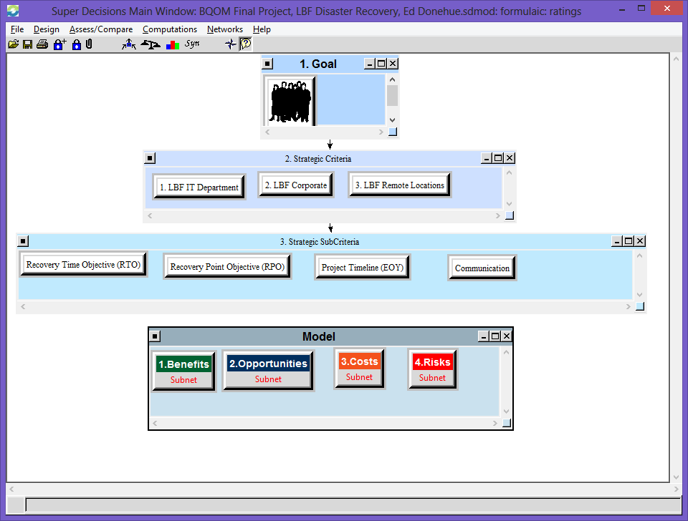
Rozann made the following observation about the model. " In your strategic criteria you have main criteria and subcriteria. And it is interesting the way you did it as you have each of the main criteria linked to the subcriteria – this is okay to do, but rare to see – it is known as a complete hierarchy where the same subcriteria are evaluated for each of the main criteria, instead of each main criterion being linked to its own special subcriteria.
Anyway, the question is: are you more interested in rating your BOCR nodes against the main criteria? Or in the subcriteria? I would think perhaps it would be better to select the subcriteria for your ratings columns instead of the main criteria as you have done. Otherwise the judgments you made to prioritize the subcriteria don’t have any effect in the model.
Another way to prioritize the main criteria instead of having a goal and linking them from the goal would be to get rid of the goal altogether and link the subcriteria back to the main criteria then make the additional judgments that would be required. This should give more reliable priorities for the main criteria. It is not that much work to do.
Still you have to decide whether you want to rate the BOCR against the main criteria or the subcriteria."

Whether I decided to use the Strategic Criteria or the Strategic Sub-Criteria the ratings do not fully inform my decision.

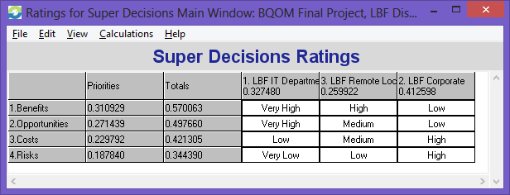

The rating indicate an anomaly however, one of the assumptions entering the decision analysis was that the LBF Corporate office would benefit from any disaster recovery solution.

The model integrates complex criteria and pair wise comparisons. The subnet for the BOCR are:

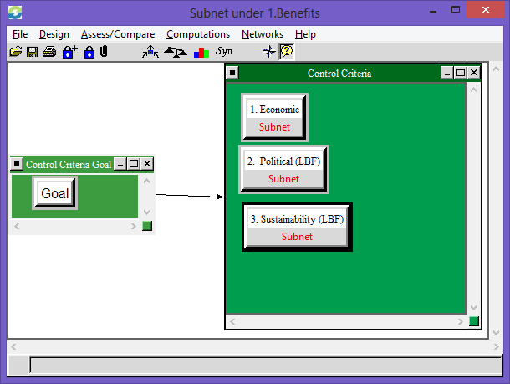

- Economic
- Political (LBF) = strictly internal L.B. Foster politics between IIT, Corporate and Remote Offices
- Sustainability = the extent to which the solution enables LBF to sustain a disaster

Under each subnet there is an array of criteria including:
Benefits |  | Opportunities |  | Costs |  | Risks
Economic |  | Economic |  | Economic |  | Economic
Capital Spending |  | Expense Spending |  | Capital Spending |  | Revenue
Energy Consumption |  | Staffing Expense |  | Energy Consumption |  | Lost Customers
Tax Benefit |  |  |  | Expense Spending |  | Lost Staffing (layoffs)
Staffing Expense |  |  |  | Staffing Expense |  | Lost Data
Expense Spending |  |  |  | Operational Cost |  | Fines
 |  |  |  | Facilities Cost
 |  |  |  | Management costs
Political |  | Political
Flexible Technology |  | Staffing Levels
Capacity Usage |  | Remote Office Service |  | Political |  | Political
Remote Office Service |  |  |  | Staffing Levels |  | Reputation
LBF DR Location |  |  |  | Remote Office Service |  | IT Department Health
 |  |  |  | Distributed IT Department |  | Security
Sustainability |  | Sustainability |  |  |  | Regulation
Data Protection |  | Geographic Redundancy
Geographic Redundancy |  | Total System Restoration
Agility |  | Replicated Network
Scalability
Total System Restoration

Final Analysis: In the end the results mirror the Disaster Recovery Industry trend. More and more companies are outsourcing their disaster protection to service providers. The synthesized criteria also disclose my bias towards an L.B. Foster distributed datacenter solution. The extra expense associated with building and maintaining data closets, servers and infrastructure would be offset by the influx of IT employees and the skills they bring (very much needed in the LBF IT department). Housing the backup solution would also have the most benefit for the remote offices providing better technology performance and developing good will with our newly absorbed remote locations.

Still the analysis is clear, the model indicates the DR Service w/Leased Equipment is the way to precede. The Benefits (Economic, Political and Sustainability) all indicate the Leased Equipment is optimal.

As I suspected the Political and Sustainability Opportunities are highest for the LBF Distributed DataCenter Solution, but the Leased Equipment option still has the highest Economic Opportunity.

For some reason the model correctly identifies the Political Costs of the LBF DataCenter as appropriately high, but incorrectly identifies the Leased Equipment option as the highest Economic Costs. In reality the Leased Equipment Costs would literally be the least expensive monetarily and likely the least expensive in practical purposes as well.

As indicated below the Leased Equipment Risks criteria indicate the Economic and Political risks are high, but the LBF Corporate Risk Tolerance is very high as well. Concidering the potential threat for L.B. Foster’s Corporate datacenter is very low means we (LBF) are comfortable with the level of risk inherent to the Leased Equipment solution.

Synthesized Criteria Priorities:
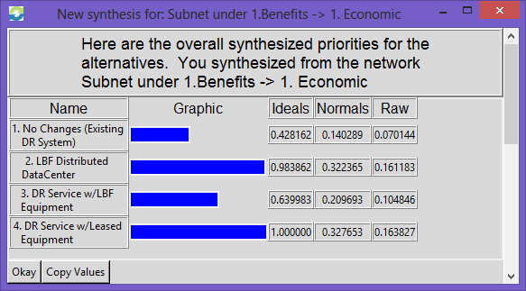 | 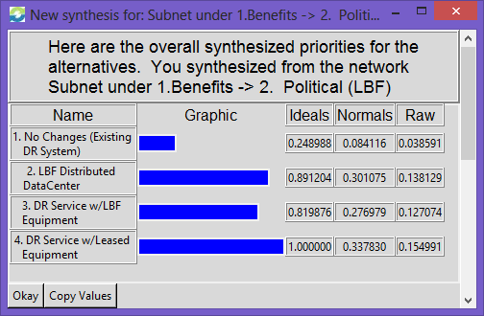
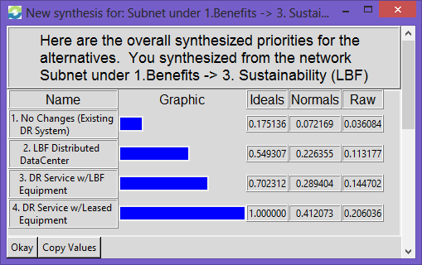 | 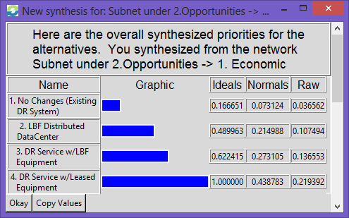
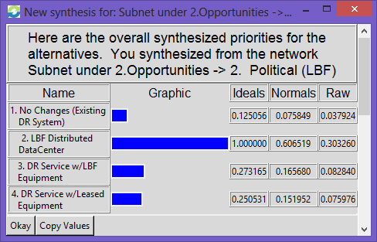 | 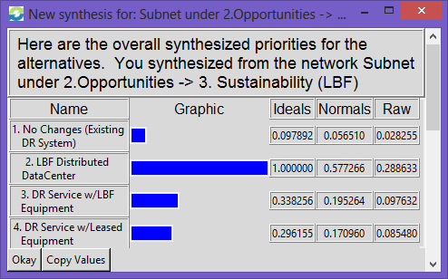
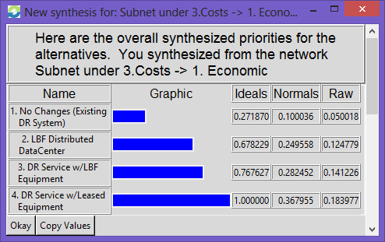 | 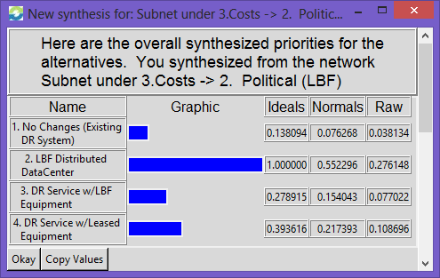
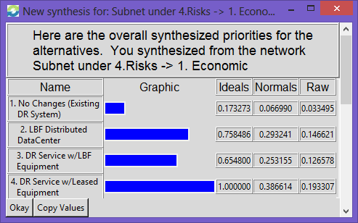 | 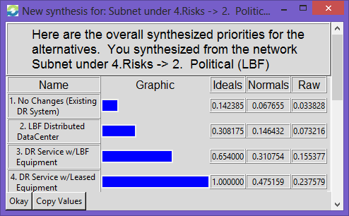

Synthesized Alternative Priorities:

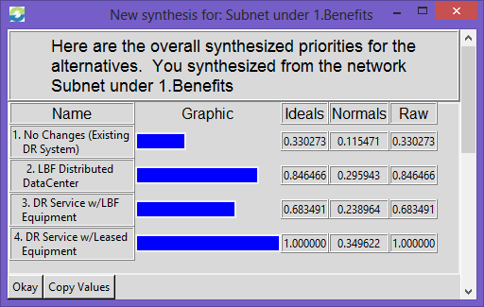

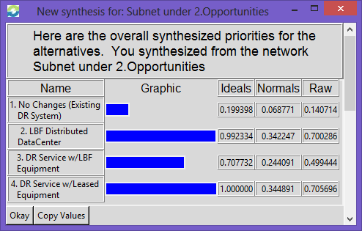

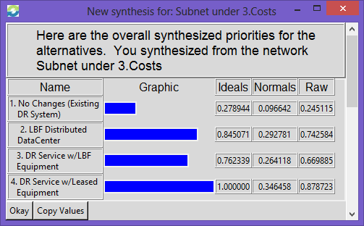

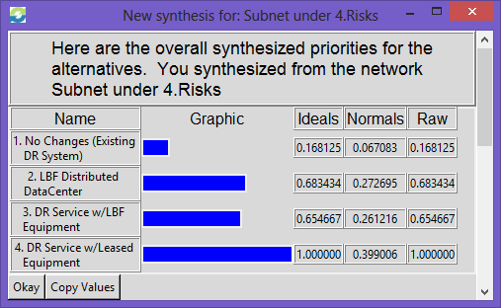

Sensitivity Analysis:
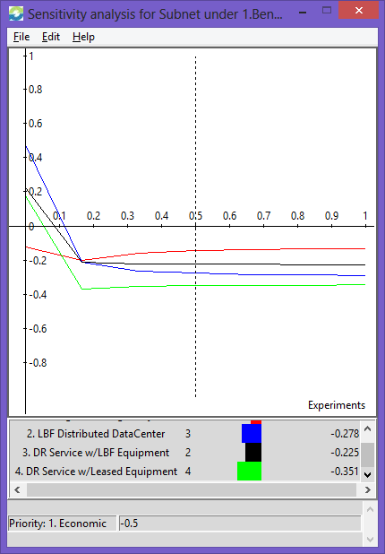 | 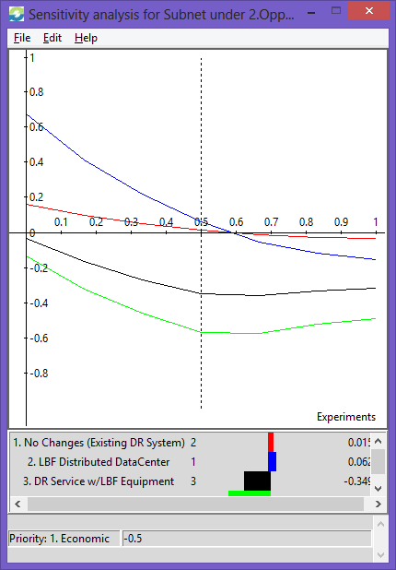
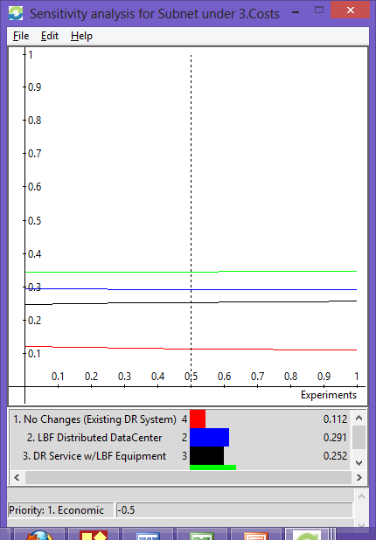 | 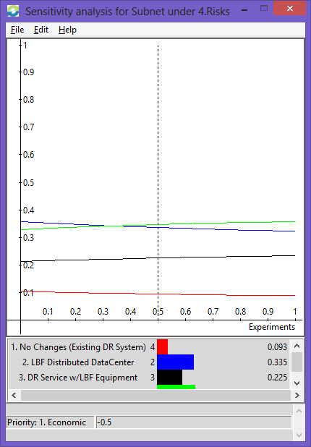

One Final Note: Ultimately the Sensitivity Analysis of the entire model (below) disclosed a bias for the Disaster Recovery solution that I personally preferred. If the project included additional participants the results likely would have been different.

