Should T-Mobile Invest in Home-based Internet Service?
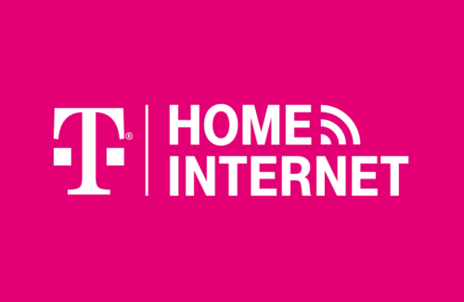
```````````````````````````````````````````````````````````````````````````````````````````````````````````````````````
FINAL PROJECT REPORT BY:
Ankita Chouhan and Ravi Patel
BQOM 2521 Decision Making in Complex Environment
`````````````````````````````````````````````````````````````````````````````````````````````````````````````````````````````````````````````

Table of Contents
ABSTRACT - 3 -
DECISION PROBLEM - 4 -
METHODOLOGY - 5 -
Alternatives - 5 -
Strategic Criteria - 5 -
Control Criteria and Sub-factors - 6 -
BOCR - MAIN NETWORK MODEL - 11 -
Benefits - 12 -
1. Economical - 12 -
2. Organizational - 13 -
3. Operational - 14 -
Overall Result of the Benefits Perspective - 14 -
Opportunities - 15 -
1. Economical - 15 -
2. Organizational - 16 -
Overall Result of the Opportunities Perspective - 16 -
Costs - 17 -
1. Financial - 17 -
2. Organizational - 18 -
Overall Result of the Cost Perspective: - 18 -
Risks - 19 -
1. Economical - 19 -
2. Organizational - 20 -
Overall Result of the Risks Perspective: - 21 -
THE RATINGS MODEL - 22 -
LONG-TERM & SHORT-TERM SOLUTIONS - 26 -
SENSITIVITY ANALYSIS - 27 -
For Benefits - 27 -
For Opportunities - 27 -
For Costs - 28 -
For Risks - 28 -
CONCLUSION - 29 -
REFERENCES - 29 -

ABSTRACT
In April 2021, T-Mobile launched its 5G-based Home Internet service. During the interview, Mike Sievert, T-Mobile CEO, mentioned how T-Mobile brings a choice to 30 million American households in rural areas and smaller markets, with T-Mobile home broadband based on 5G technology. Elon Musk’s Starlink and Verizon are also in the process of bringing the 5G Home Plan, but according to Sievert, T-Mobile will soak up a lot of opportunity by getting way ahead. This technology will disrupt the entire rural market, how they are currently operating.
There is strong competition between three major telecom providers in the United States, i.e., AT&T, Verizon, and T-Mobile. This competition intensified during the pandemic because of the work-from-home situation, where multiple markets wanted faster and better connectivity. The total addressable market for internet service providers is greater than $100 billion in 2021. However, this is only true for urban areas, people in rural areas do not have much choice. There has always been a problem with high-speed internet in rural areas because of not having enough cable or fiber connections.
From a market-share perspective, the market of rural areas has always been under-served, often has few competitive options, and there is a scope of tremendous growth in that area. This opportunity was seen by T-Mobile, which is one of the top telecommunications companies in the United States. In a decision in-line with its innovative approaches to its technology, T-Mobile decided to bring a 5G-based home internet connection with a pilot version that has been ongoing for more than a year.
T-Mobile brands itself as the “Un-Carrier”. They want to advance their brand and beat the competition in that process. This represents a high valuation of innovation. They have a decision made by the Executive Vice President of Emerging Markets, Dow Draper. They lead the group focused on market opportunities beyond mobile carrier smartphone models. They lead T-Mobile’s expansion into home broadband video and certain internet of things.

GOAL OF T-MOBILE
By Mike Sievert, T-Mobile CEO: “Our new goal is to build the world’s best 5G network, delivering innovation, speed, and value. With the New T-Mobile, you will never be forced to choose between low prices or a great network again, because with the new T-Mobile network, we’ll give you BOTH.”

DECISION PROBLEM
“Should T-Mobile invest in home-based internet service?”
The pandemic has forced many companies or industries to operate online. For instance, employees have started work-from-home, universities started offering online classes, school kids are learning online, etc. As the demand for better internet services is increasing, the opportunities for home internet services are also growing.
In the chart below, we can see T-Mobile is far behind its competitors. The reason could be because Verizon and AT&T are currently offering home-based internet services. To increase their current market share compared to their competitors, T-Mobile needs to find new ways to achieve a competitive advantage.

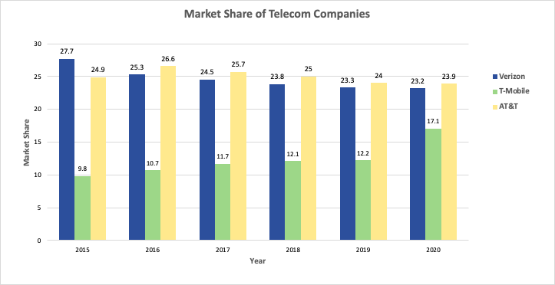
Figure: 1 (source IBIS World)

METHODOLOGY

Alternatives
- Do Not Enter into A New Market: T-Mobile will continue offering its mobile wireless services, and will not enter a new market, i.e., home-based internet services.
- Enter a New Market with Existing Technology: T-Mobile can enter a new market, i.e., providing home-based internet connection via fiber optics channels. Currently, most of the home-based i is delivered via fiber optics or cables; therefore, T-Mobile will face strong competitors and the risk of surviving the market is higher.
- Partnership with existing company: In this alternative, T-Mobile can partner with an existing company that is currently delivering home-based internet services via fiber optics. This option will create an additional source of revenue and provide growth to the company. However, the company will not get complete control over the services it would like to provide to its customers.
- Enter a new market with 5G-based technology: Rather than entering a new market with existing technology, i.e., fiber optics, the company can invest in 5G-based technology. This technology can help them broaden their horizon and deliver services in rural areas and small markets, where currently there is a shortage of fiber optics channels.

Strategic Criteria
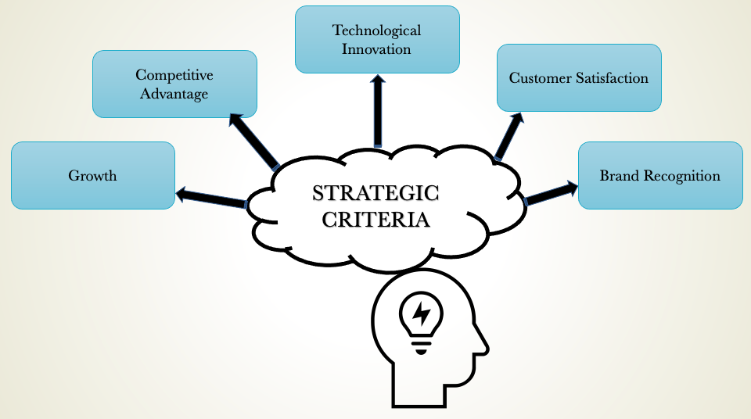
Figure 1
Table 1 below provides a detailed description of each strategic criterion that explains what is important for the decision-maker (T-Mobile)

Strategic Criteria | Description
Growth | Is there potential growth for the company if they decide to invest in home internet services? Will they be able to acquire more customers? Can they grow beyond their current geographical region?
Competitive Advantage | Many companies provide home internet services. Which alternatives will give them a maximum competitive advantage?
Technological Innovation | Technological innovation might increase T-Mobile's existing market share and broaden its network coverage.
Customer Satisfaction | T-Mobile has many loyal customers. Providing them with reliable and better network coverage might cause higher customer satisfaction for the company.
Brand Recognition | What will be the impact of its decision on the company's reputation?

Control Criteria and Sub-factors
Every alternative will be evaluated based on the BOCR (Benefits, Opportunities, Costs, and Risks) model. Below are the description of control criteria and subfactors:

BENEFITS
Economical | Organizational | Operational
- Impact on Existing Market | - Impact on Investments | - Pricing
- Impact on Market Share | - Number of Customers | - Technology Requirements
- Impact on Revenue | - Customer Reaction | - Coverage
- Economical:
- Impact on Existing Market: Every alternative has some kind of impact on the existing market. If T-Mobile decides not to enter into the new market and focuses more on the current services, it might not cause an impact on market share; however, it might create some impact on the market.
- Impact on Market Share: If T-Mobile decides to enter this new market, T-Mobile’s current wireless mobile customers are most likely to try new home internet connections. Also, if T-Mobile invests in 5G-based home internet connections, they might expand their network to rural areas.
- Impact on Revenue: Currently, T-Mobile provides mobile wireless connections and some related services. Entering into a new market will create a diversified portfolio. It will generate additional revenue for T-Mobile.
- Organizational:
- Impact on Investments: Companies might get new investors or more investment from previous investors when they see growth prospects in a new market for T-Mobile.
- Number of Customers: By providing a better connection than its competitors, might create positive network effects among users. As a result, T-Mobile might pull more customers from its competitors.
- Customer Reaction: Existing customers, who are happy with the T-Mobile customer service, are likely to try T-Mobile's home-based connection as well.
- Operational
- Pricing: Some companies have a monopoly in certain parts of the United States, especially in rural areas. T-Mobile can break this monopoly by offering competitive pricing, it will help them in acquiring more customers.
- Technology Requirement: Investment in new technology, like 5G, can disrupt the industry that provides home-based internet connection via fiber optics and cables. The investment in new technology might benefit the company to increase its existing market share.
- Coverage: The accessibility of the technology to the customer markets could be impacted. There is a balance between geographic access and the markets.
OPPORTUNITIES
Economical | Organizational
- Impact on Existing Market | - Brand Recognition
- Impact on Market Share | - Number of Customers
- Impact on Revenue | - Number of Investors

- Economical:
- Impact on Existing Market: Successful launch of home-based internet might create opportunity for future growth in a new competitive market. Also, some alternatives might cause a slight change in the company’s growth that is hard to create an impact on the market share.
- Impact on Market Share: Portfolio diversification might create opportunities for growth in market share.
- Impact on Revenue: Increase in market share will generate additional revenue for the company.
- Organizational:
- Brand Recognition: Currently, T-Mobile only offers wireless mobile connections, if they start providing home internet connections as well it will likely increase brand value.
- Number of customers: If T-Mobile provides a better home internet connection, it will increase their popularity. This positive word-of-mouth can create positive network effects, which will bring new customers for T-Mobile.
- Number of Investors: Seeing potential growth in the company new investors might attract.

COSTS
Financial | Organizational
- Partnership Cost | - Employees Requirement
- Marketing Cost | - Technological Investment
- Opportunity Cost | - Infrastructure Requirement
- Financial
- Partnership Cost: If T-Mobile decides to launch its home-based internet connection in partnership with an existing provider, T-Mobile will have to bear the partnership cost.
- Opportunity cost: Resources for this plan would limit other short-term or potential long-term projects.
- Marketing Cost: Differentiating between T-Mobile’s current product line or competitors' products for broadband internet would be necessary with this new service. If T-Mobile plans to enter into a new market, they have to bear marketing costs to promote its new service compared to its competitors.
- Organizational
- Employee Requirement: Technical employees for the infrastructure and marketing would be necessary when implementing a new approach for technology within the company.
- Technological Investment: The research and development associated with the new technology and integration of new systems into current systems would be required.
- Infrastructure Requirement: The initial cost of installation and ongoing cost of maintenance would be required resources to support broadband internet.

RISKS
Economical | Organizational
- Market Competition | Internal-Org | External-Org
- Customers Reaction | - Infrastructure Requirements | - Customers Perception
- Marketing Requirement | - Focus | - General Public Perception
- Impact of Network Traffic | - Business Relationship | - Sustainability

- Economical:
- Market Competition: Market traction with broadband internet with this technology and company have limited history to base predictions.
- Impact of Network Traffic: Traffic loads determine customer access and experiences with the services offered. If a great number of users cause a positive or a negative impact on the access to the network, then the access and/or experience could be affected.
- Customer Reaction: Initiation customer reactions have been mixed to the company’s approach to broadband internet in the past and may influence future customers’ perspectives.
- Marketing Requirement: Maintaining the messaging of competitive benefit of this model compared to other available services.
- Organizational: This control criterion is subdivided into two clusters.
  - Internal-Org
- Infrastructure Requirement: More users of the company’s communication infrastructure may lead to increased strain on hardware and software and potentially face decreased customer experience with broadband internet.
- Focus: Pursuing these alternatives would expand beyond the mobile-wireless competencies. Focusing on broadband internet might take away focus from mobile-wireless.
- Business Relationship: Managing the ongoing relationship between T-Mobile and a technological partner may limit options for future investments, conflicts in contracts, and differences in long-term goals.
  - External-Org
- Customer Perception: The current customers will have to compare use of wireless mobile services to potential new offerings.
- General Public Perception: The new technology of 5G has faced public distrust in general safety of the technology to potential abuse by the government. This has already manifested in some vandalization or even destruction of 5G cell towers in some parts of the world.
- Sustainability: The company’s commitment to sustainability is a part of its organizational targets. This includes improving use of renewable energy, reducing waste, and responsible product lifecycle.

BOCR - MAIN NETWORK MODEL
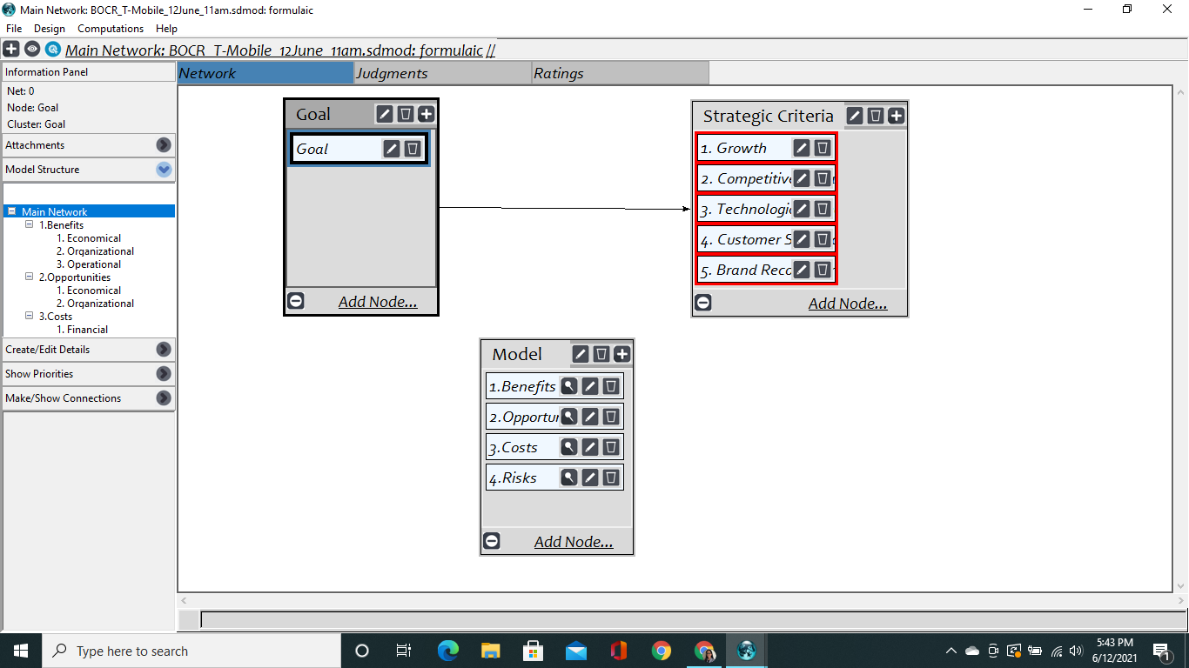

Strategic Criteria: Result
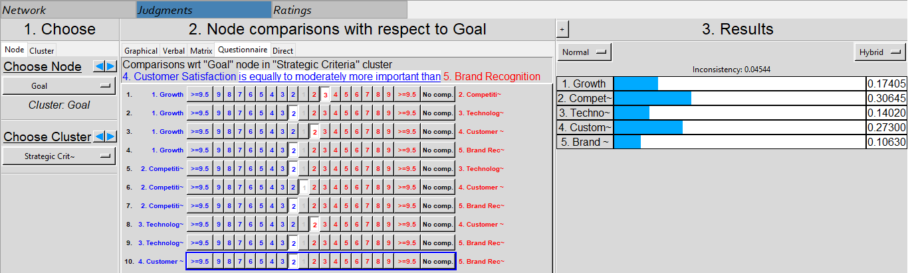
The above result was obtained by performing pairwise comparisons. Based on the above result, the weight and rank of all the strategic criteria were assigned.
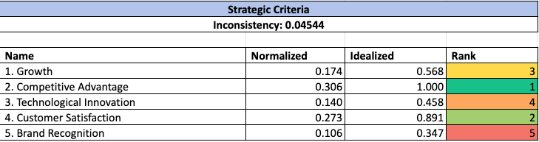

Benefits
For Benefits perspective, we have three control criteria, i.e., Economical, Organizational, and Operational, connected to the Goal.

Economical
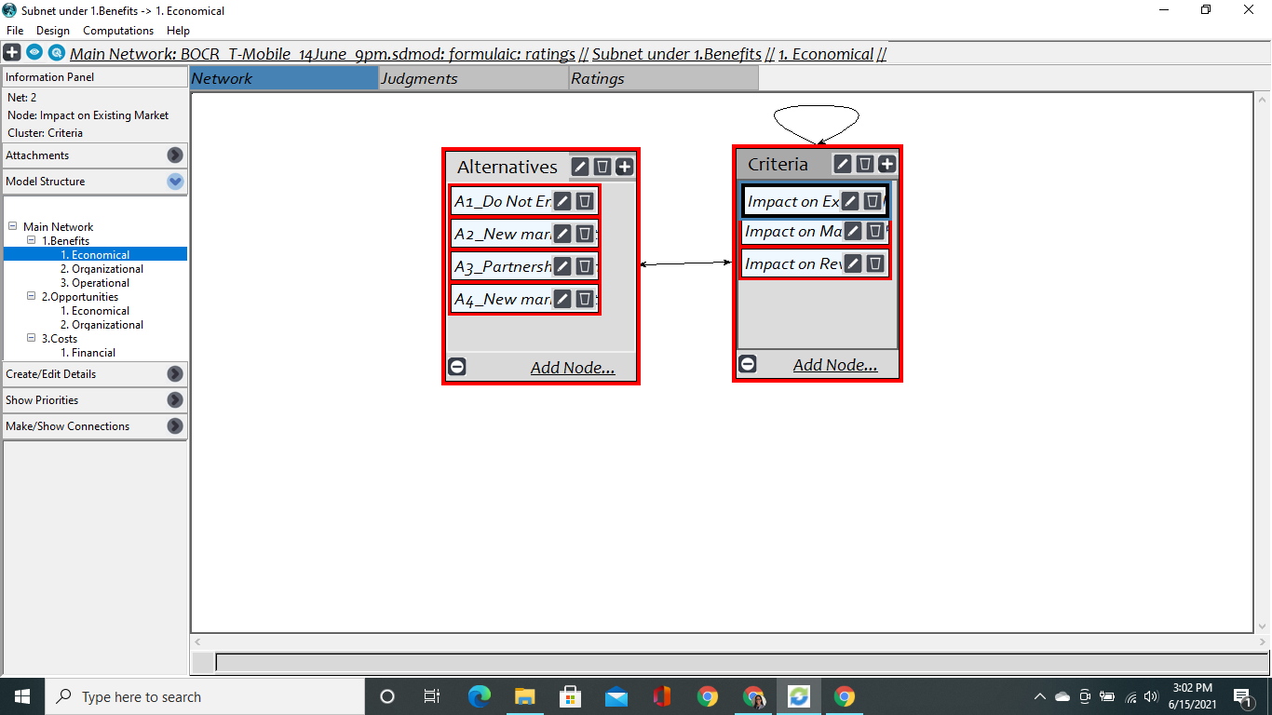

Connections: In Economical Control Criteria, Criterion - "Impact on Existing Market" is connected to "Impact on Market Share" and "Impact on Revenue" because a change in market growth might impact both - market share and revenue. Similarly, "Impact on Market Share" is connected to "Impact on Existing Market" and "Impact on Revenue."

Result of the Control Criterion Economical under Benefits Perspective:
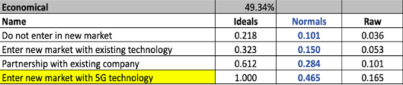

Organizational
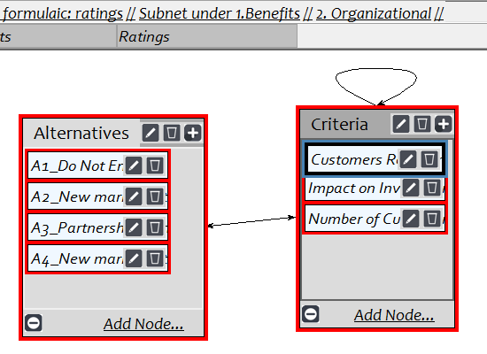

Connections: In Organizational Control Criteria, Criterion - “Customers Reaction” is connected to “Number of Customers” and “Impact on Investment” because positive or negative reactions could have an impact on many customers and investment by investors.
Result of the Control Criterion Organizational under Benefits Perspective:
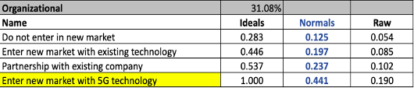

Operational
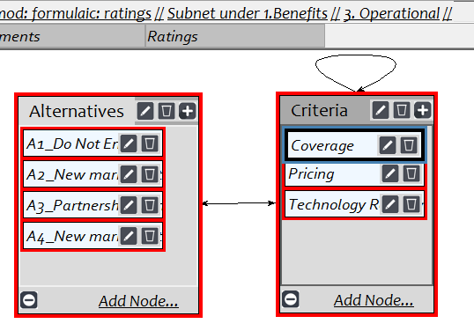
Connections: In Operational Control Criteria, Criterion - “Coverage” is connected to “Pricing” and “Technology Requirements” because having good coverage provides competitive pricing and also requires technological innovation.
Result of the Control Criterion Operational under Benefits Perspective:
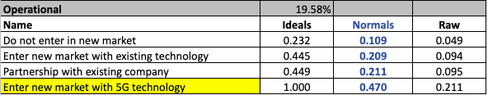

Overall Result of the Benefits Perspective
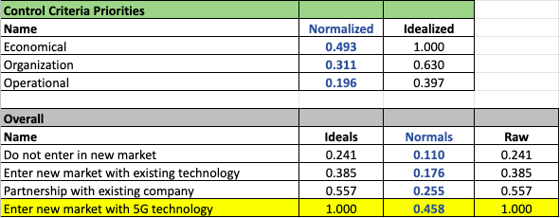
Interpretation: In the result obtained by synthesizing the Benefits perspective, we can see the best alternative for the T-Mobile is to “Enter a new market with 5G technology”. We obtained this result because all control criteria were giving the same best result, i.e., the alternative 4. It also makes sense because entering into a new market with 5G technology will provide T-Mobile maximum competitive advantage that no other home-based internet service providers offer. Additionally, with this alternative, they can expand their geographical location because they do not have to bear the limitation of the range of fiber optics or cables.

Opportunities
For Opportunities perspective, we have two control criteria, i.e., Economical and Organizational, connected to the Goal.

Economical
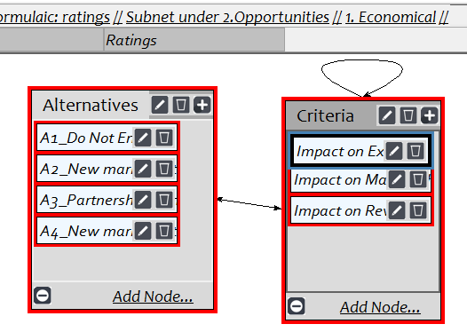
Connections: Connections inside Economical Control Criteria are identical to connections inside Economical Control Criteria of Benefits.
Result of the Control Criterion Economical under Opportunities Perspective: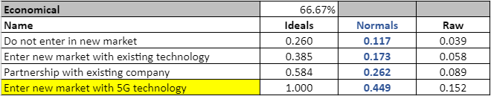

Organizational
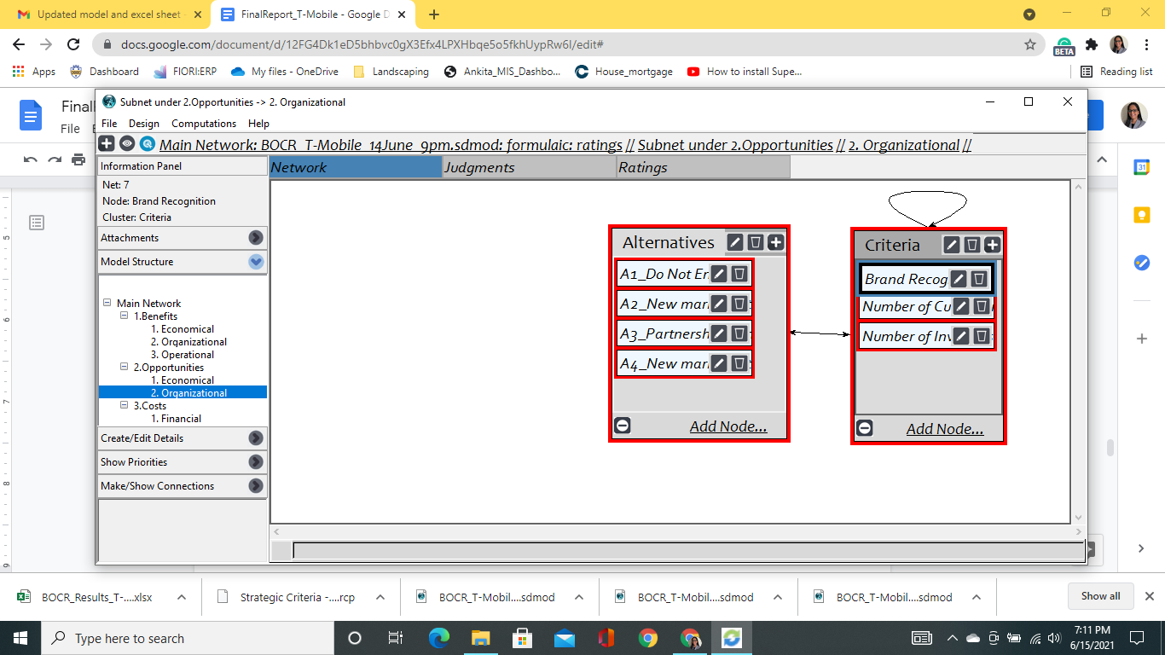
Connections: In Organizational Control Criteria, Criterion - “Brand Recognition” additionally connected to “New Customers” and “New Investors” because a good reputation can bring more customers and investors, vice versa.
Result of the Control Criterion Organizational under Opportunities Perspective:
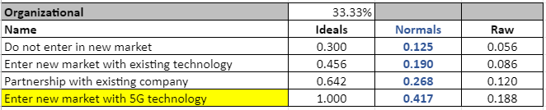

Overall Result of the Opportunities Perspective
Interpretation: In the results of the synthesis for Opportunities, the best Alternative for T-Mobile is to “Enter a new market with 5G technology”. Both control criteria find this alternative as the best option. This new technology offers the most potential chances to influence these new markets and channels that might not otherwise be possible in the other Alternatives. Additionally, we can also say with 5G there is a tremendous possibility of growth. By providing better and reliable network coverage creates a positive network effect among users. It will help T-Mobile to reach its goal of becoming the World’s best 5G network provider.

Costs
For Costs Perspective, we have two control criteria, i.e., Financial and Organizational, connected to the Goal. Every control criterion has a bidirectional connection between the alternatives and subfactors.

Financial
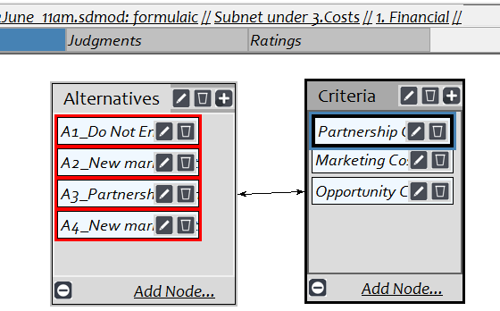
Connections: Under the Financial control criterion of the Costs perspective, Partnership, Marketing, and Opportunity costs are connected to the alternatives and vice versa.
Result of the Control Criterion Financial under Cost Perspective:
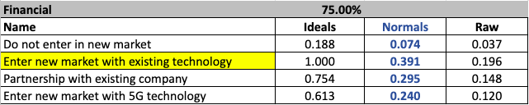

Organizational
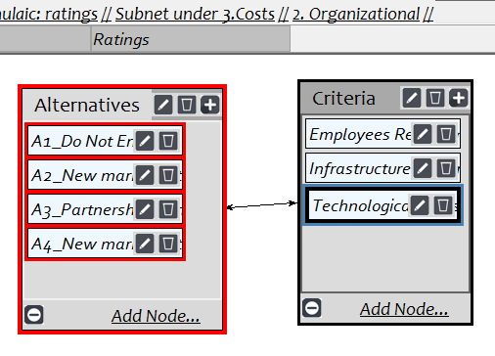
Connections: In the Organizational control criterion, Employees Reaction, Infrastructure Requirements, and Technological Requirement are connected directly to the Alternatives and vice versa with mutual impact.
Result of the Control Criterion Organizational under Cost Perspective:
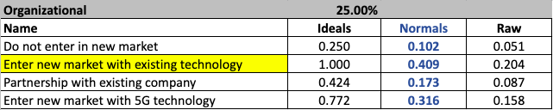

Overall Result of the Cost Perspective:
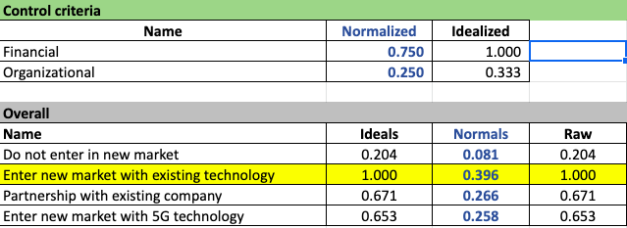

Interpretation: In the results for the synthesis of the Cost perspectives, the costliest alternative is to “Enter a new market with existing technology”. There is a 13% difference between the costliest and second-most costly options. One of the reasons Alternative 2 being the costliest is because T-Mobile has very strong competitors, i.e., AT&T and Verizon. The marketing cost, which includes promotion, advertisements, hoardings, etc., to attract customers from its competitors, and providing better prices makes this alternative the costliest. It follows the logic that minimal change and limited introduction of new technology would require the lowest financial costs and therefore makes the “Do not enter a new market” alternative the least costly option.

Risks
For Risks Perspective, we have two control criteria, i.e., Economical and Organizational, connected to the Goal. Every control criterion has a bidirectional connection between the alternatives and subfactors.

Economical
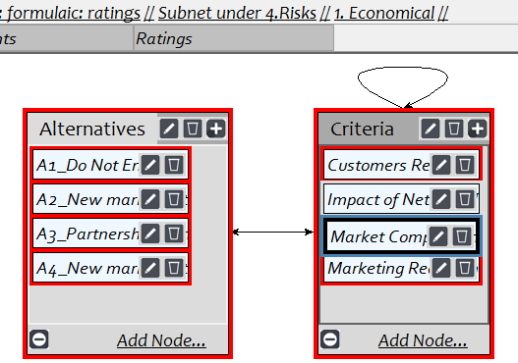
Connections: In the Economical Control Criteria, Criteria - “Market Competition” is connected to “Customers Reaction” and “Marketing Need”. The reason is tough competition might require additional marketing that might bring negative/positive reactions from customers.
Result of the Control Criterion Economical under Risks Perspective:
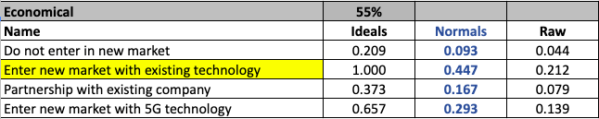

Organizational
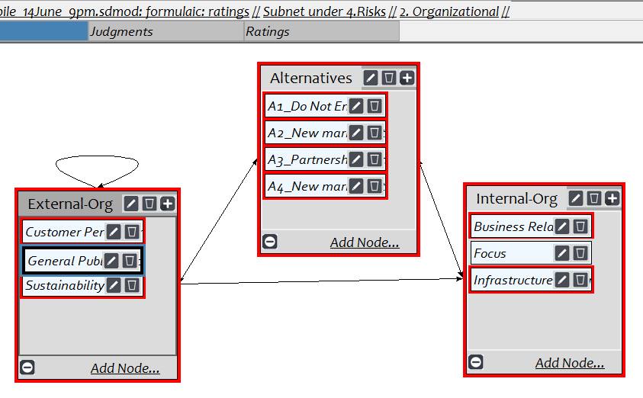
Connections: In the Organizational Control Criteria, we have three clusters - Alternatives, Internal-Org, and External-Org. They are connected in the following ways:
- There is a bidirectional connection between Alternatives and the other two clusters.
- Criterion “Public 5G Perception” from External-Org cluster is connected to the same cluster with Customer Perception and Sustainability because the possibility of protest against 5G technology can impact current customers’ perception and current sustainability practices. Also, the same criterion is connected to the Internal-Org cluster because possible protests and vandalism can cause risk of infrastructure damage and can create partnership conflicts.
Result of the Control Criterion Organizational under Risk Perspective:
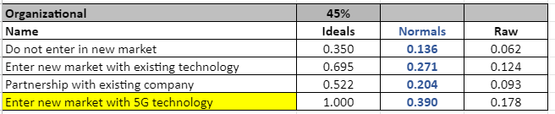

Overall Result of the Risks Perspective:
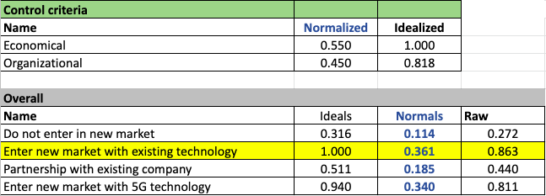
Interpretation: In the overall result of the synthesis for the Risks perspectives, the riskiest alternative identified was “Enter a new market with existing technology”. It could be because the weightage given to Economical was 55% compared to Organization, that is 45%. Since under Economical control criterion, alternative 2 is the riskiest option, we got alternative 2 in the final result. As we can see in the table above, the overall results were close between the two alternatives (A-4, 0.361 vs. A-2, 0.340) but the significant uncertainty of the perceptions of customers and the consumer public may account for the weight given to “Enter a new market with 5G technology”

Sanity Check

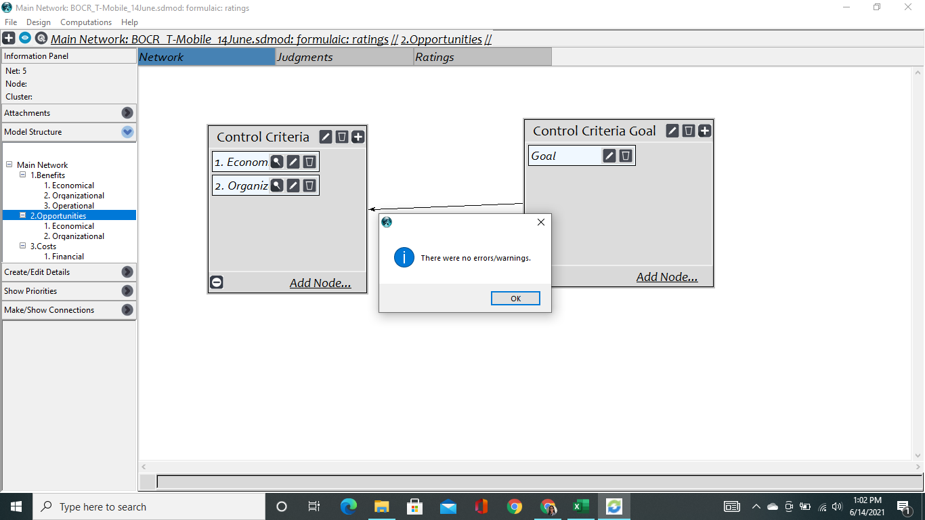

THE RATINGS MODEL
After performing all the pairwise comparisons at the bottom level networks of BOCR, we have defined the below scales of each strategic criterion.
Growth | Competitive Advantage | Technological Innovation | Customer Satisfaction | Brand Recognition
Excellent | Maximum | Not Required | Less than 3 | Very High Impact
Very Good | More than Average | Little Requirement | Between 3 to 5 | High Impact
Good | Average | More than Little | Between 5 to 7 | Medium Impact
Fair | Less than Average | Significant | Greater than 7 | Low Impact
Poor | Minimum |  |  | Very Low Impact
Very Poor |  |  |  | Neutral

We performed the below steps to create the Ratings model for the top level of the network.
Step 1: Adding Strategic Criteria as Column Names
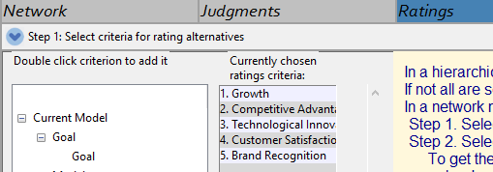
Step 2: Adding Alternatives - Benefits, Opportunities, Costs, and Risks as Rows
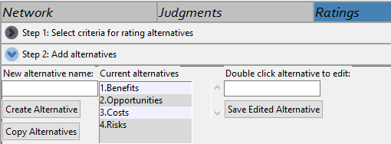
Step 3: Adding defined scales and performing pairwise comparisons for every scale
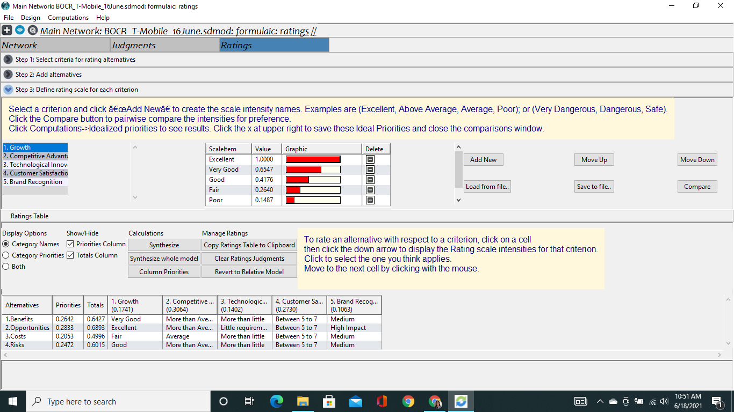
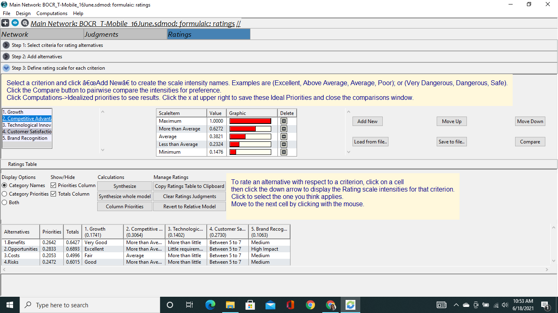
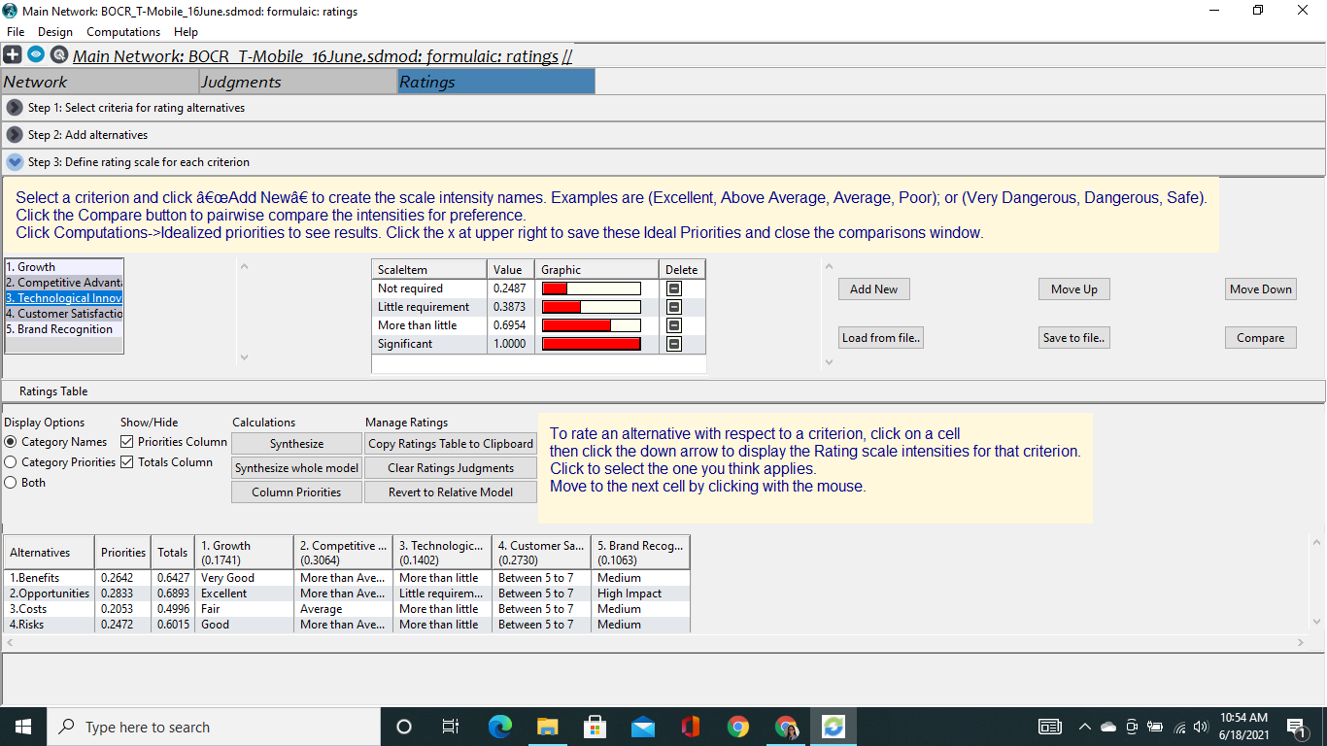
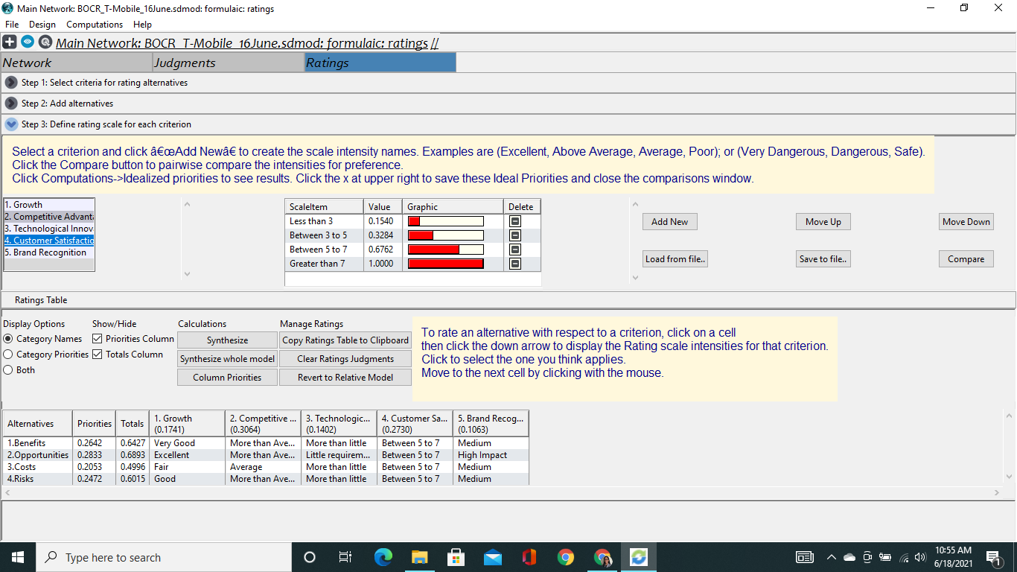
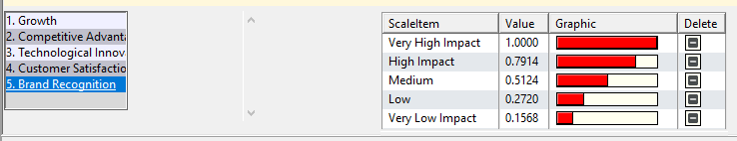
- Pairwise Comparisons: We performed pairwise comparisons for every scale that we have defined.
- Customer Satisfaction - Inverted Scale: Customer satisfaction was on a scale of 1 (extremely dissatisfied) to 10 (extremely satisfied). We created brackets, to allow for scoring in comparison brackets, and to keep the consistency of the brackets with the associated 1-10 score. The comparisons were inverted because we needed the lowest score to have minimum priority.

Step 4: Creating Rating Table

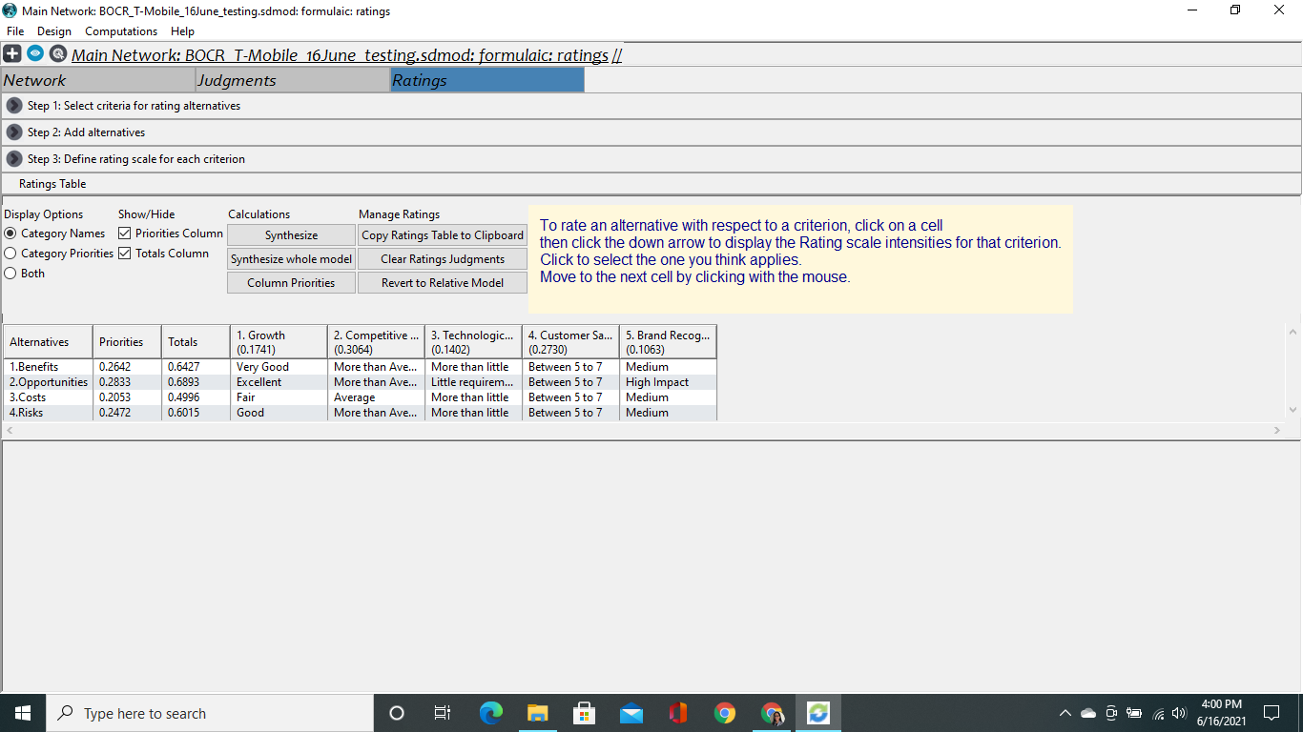
The above scale for each strategic criterion was selected, based on the overall result obtained by performing the Synthesis of every perspective. The below screenshot shows the overall result under each perspective.
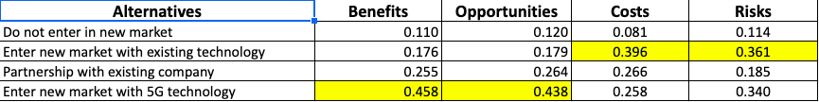

We performed the following steps to rate each strategic criterion for every perspective:
- Under the Benefits perspective, alternative 4 - Enter a new market with 5G technology provides the maximum benefit.
- This alternative will give T-Mobile very good growth because, with 5G, they will be able to target rural areas and small markets where competition is not intense.
- They will get more than average competitive advantage because of lack of competition, as mostly home-based internet connection provides internet via fiber optics or cables.
- It requires more than little technological innovation because currently, they do provide a 5G mobile wireless connection.
- Customer satisfaction is assumed to be between 5 to 7 because meeting customers' expectations would be very difficult.
- Brand Recognition might have a medium impact because creating popularity takes time.

- Under the Opportunities perspective, alternative 4 provides the maximum benefit.
- This alternative will give T-Mobile excellent growth because, with 5G, they can leverage new technology with a competitive advantage for a unique market that is under-realized.
- It requires little technological innovation because the technology is currently developed but needs to be extended in a company infrastructure like T-Mobile.
- Brand Recognition would have a very high impact because they would have a short-term novelty to rural areas that do not have many other options and over the long-term can create popularity through good service.
- From the Costs perspective, alternative 2 - Enter a new market with existing technology is the costliest option.
- The growth in this alternative is fair because of the competition. If T Mobile enters the market with existing technology, then its ability to address new customer markets would be limited.
- The competitive advantage for this alternative is average because it would offer the same technology as its competitors. The approach that T Mobile uses heavily favors innovation, which this option minimizes.
- Technological Innovation, Customer Satisfaction, and Brand Recognition would be like other alternatives.
- Under the Risks perspective, alternative 2, Enter a new market with existing technology is the riskiest option
- The growth in this alternative potentially will be good because T-Mobile’s current customers, who are happy with the services provided by them, are very likely to try their home-based connection. However, the uncertainty with customer reaction and the value that existing technology offers might influence this alternative.
- The competitive advantage is “More than Average” because the existing technology when deployed in a variety of markets would offer a competitive advantage to the other companies in the field.
- The impact on Technological Innovation, Customer Satisfaction, and Brand Recognition would be like other alternatives.

LONG-TERM & SHORT-TERM SOLUTIONS
Multiplicative: Short Term Solution
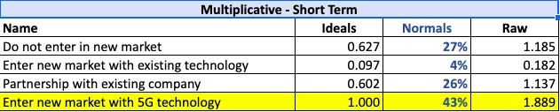
Interpretation: The short-term analysis supported that T-Mobile should Enter a new market with 5G technology. The public reaction and uncertainty are offset by the novelty of the technology and the value it offers. Furthermore, with this technology, they can target rural areas and small markets because due to the limited capacity of Fiber Optics or cables, the competition is low. Consumers will perceive an advantage in adopting T-Mobile services that will give a competitive advantage to the company.
Additive: Long Term Solution
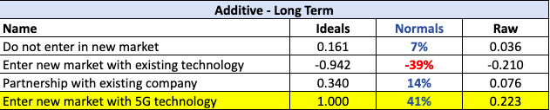
Interpretation: The long-term analysis also supports that T-Mobile should Enter a new market with 5G technology. Compared to other alternatives, alternative-4 has the highest weightage (that is 41%) because T-Mobile has a tremendous opportunity for growth with 5G technology. There are several areas where people struggle to get reliable and better network coverage because of the limited number of fiber optics or cables. With 5G technology, T-Mobile can target these areas and gain a competitive advantage. On the other hand, we can see that alternative - 2 has a negative Normals value because this option is very costly and risky too. In long-term outcomes of brand recognition can build new markets that allow T-Mobile to obtain maximum growth. It will help T-Mobile to reach its goal of becoming “The World’s best 5G Network”.

SENSITIVITY ANALYSIS

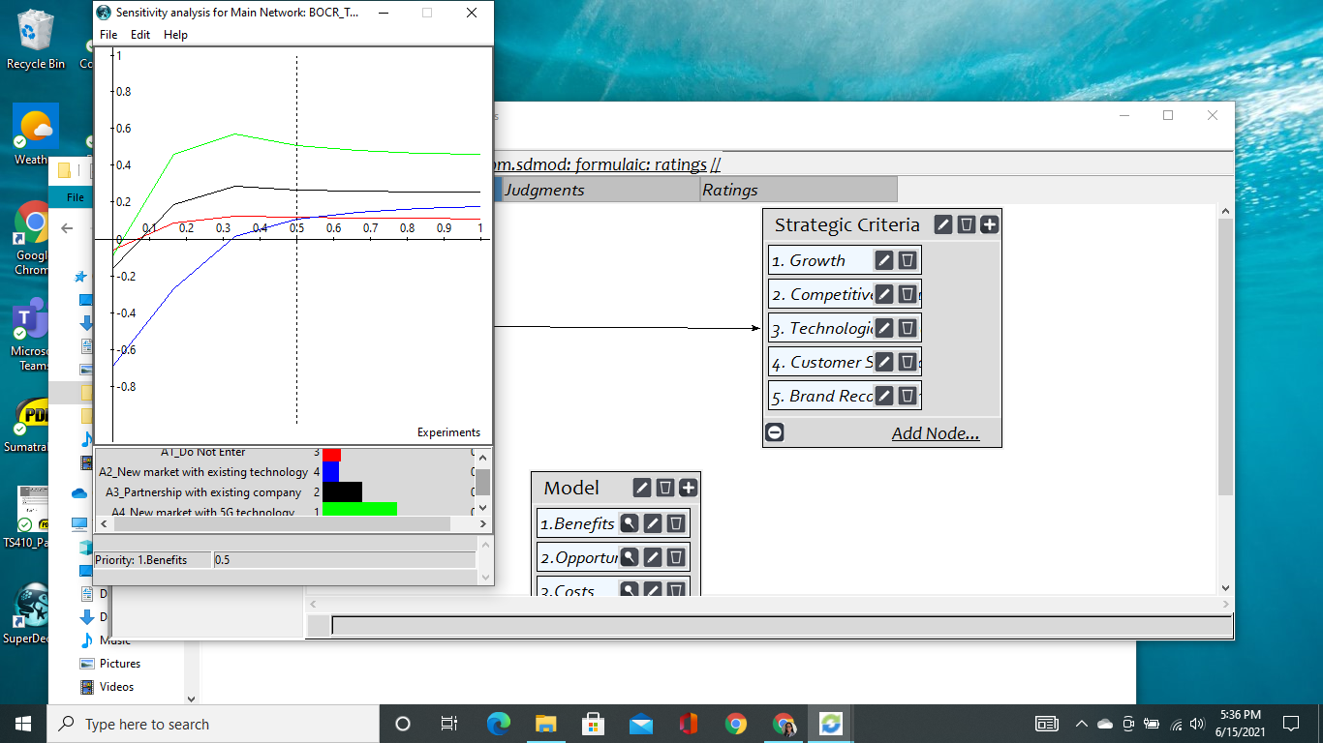
For Benefits
Interpretation: In the screenshot, we can see the result is very stable. For the short-term benefits, Alternative-4 remains the top preference even after changing the priority. However, there are two cross-over points that change the priority of the bottom two alternatives. If priority becomes more than 55%, the third-best option changes from A2 to A1 and, if the priority of Benefits becomes less than7%, the second-best option changes from A1 to A3.

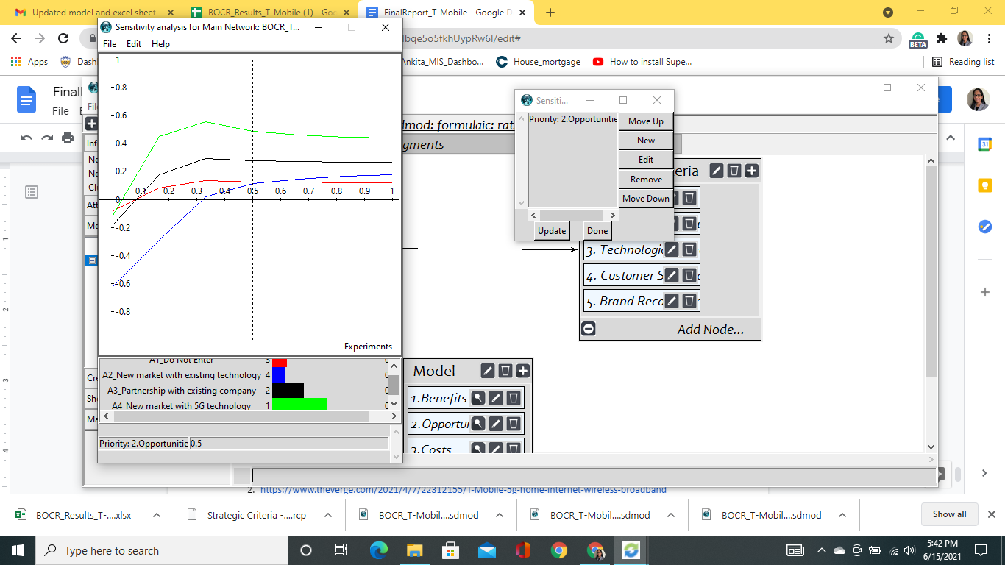
For Opportunities
Interpretation: The result of the Opportunity is very similar to the Benefit perspective. As we can see, we have a very stable result with just two cross-over points. If the priority of Opportunities becomes more than 57%, then the third-best option will change from A1 to A2 and, if priority becomes lower than 8%, the second-best option changes from A1 to A3. However, in the long-term, Alternative-4, i.e., Entering a new market with 5G technology is always beneficial even if the priority changes.

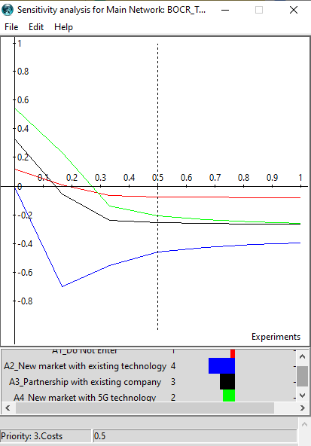
For Costs
Interpretation: Sensitivity Analysis shows that our most costly option is A2 - Entering a new market with existing technology (even after changing the priority). Now, if the priority of Cost goes down, the option to enter a new market with 5G technology (Alternative 4) becomes the best option at a point of less than 30 over the best-presented option to Not Enter the Market (Alternative-1). The option to Partner with an existing company (Alternative-3) becomes the second-best option at less than 12%. The cost in the long-term could potentially benefit most by the option of investment in the new technology.

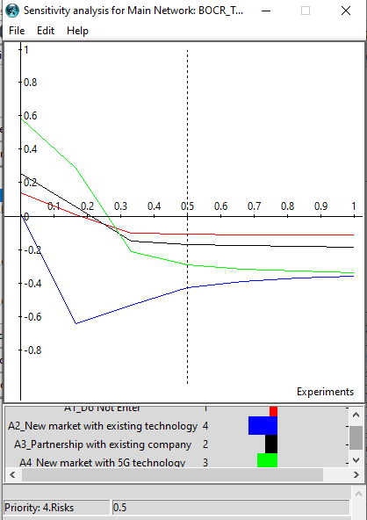
For Risks
Interpretation: As we can see in the screenshot, Alternative 2 remains the riskiest option. Alternatives 2 and 4 are very close in terms of risks at around 98% (however, there is no crossover point). Also, if the priority of the Risks goes down, the option to enter the new market with 5G technology (Alternative 4) becomes the second-best option at 29% then the best option at 27%. The option to Partner with an existing company becomes the second-best option at a point less than 23%. In the long term, the risks of partnerships may be most significant given the number of variables that could be introduced or controlled by the company.

CONCLUSION
The decision to enter a new market with various technologies is complex for a large company. The mission of T-Mobile helps identify the key factors related to this decision. The goal stated by T-Mobile’s CEO makes it clear that its main focus is to become the World’s best 5G provider. Thus, the Competitive Advantage holds the highest weightage among the other strategic criteria.
The priorities from Benefits and opportunities perspectives represented Entering a New Market with 5G technology is the best alternative. This option will give them a competitive advantage by targeting small markets and rural areas. The costliest option from the Costs perspective was to Enter a new market with existing technology. Due to the pandemic - COVID-19, almost every firm, university, school, etc., is operating from home. Thus, having reliable and better coverage is vital for every customer. Since users are already using internet services, they see very little advantage in switching their current provider and disrupt their lives. Thus, if T-Mobile wants to enter this kind of competitive environment, they are required to invest a huge amount of money into marketing, along with infrastructure costs. This option is also riskiest under the Risks perspective because surviving this market and overcoming their investment costs is very high.
There are several areas where people feel disconnected from the World because of no or poor internet coverage. Other than rural areas and small markets, there are several state parks and national parks where people like to spend their holidays but spend only a few days because of no internet coverage. With 5G technology, there is a possibility to overcome this limitation. Therefore, the alternative to Enter the New Market with 5G seems more advantageous, this is further supported by both the Short-Term and Long-Term analysis, where we got the same result.

REFERENCES
- https://www.forbes.com/sites/dwightsilverman/2021/04/19/T-Mobiles-5g-home-internet-service-looks-nice--if-you-can-get-it/?sh=29a8b3c841a9
- https://www.theverge.com/2021/4/7/22312155/T-Mobile-5g-home-internet-wireless-broadband
- https://www.ibisworld.com/industry-statistics/market-size/internet-service-providers-united-states/

