Background and Problem Definition
I’d be remised if I didn’t mention from the start that Wal-Mart is one of my favorite stores. Many share this sentiment for the mega discount retailer; after all, its slogan is “Save Money Live Better”. Given the most recent downturn in the economy, most consumers are capitalizing on every opportunity to save. The large majority of Wal-Mart stores are located in suburban areas, as bodega and local/regional grocery chains occupy the vast grocery market within city limits. In an attempt to capture some of this market share, Wal-Mart initialized campaigns to start opening stores in urban areas nationwide. One of the cities where Wal-Mart is scheduled to open 4 new locations in 2012 is Washington, D.C. The nation’s capital is also my home town, so you can imagine my excitement when I first learned of this. After calculating the savings I’d incur on gas and groceries not purchased at the local (and more expensive) markets, I read several articles on the potential (and realized) detriments to this plan. From a city government perspective, all other factors remaining constant, consumers will switch from purchasing their preferred products at the suburban Wal-Mart to purchasing at the local Wal-Mart store. In doing so, city government would incur the tax benefits otherwise incurred by other local governments. Those that oppose Wal-Mart’s entry into urban areas hold that there is an inevitable devastating economic impact associated with the proposal. That said, I thought this problem would be interesting to analyze using the BOCR/ANP model(s), both from a personal and economic sustainability perspective.
Alternatives
The alternatives in the Spirits market are listed below.
- Build Wal-Mart
- Do Not Build Wal-Mart

Criteria
After brainstorming for a bit, I came up with a few criteria that I figured would be useful to help analyze whether D.C. should allow Wal-Mart to open stores within the city limits.
- Effect on Small Business
- Profitability
- Public Opinion
Using the aforementioned strategic criteria as a guide, I began to create the BOCR model.
BOCR Model
Below is the constructed clusters and nodes mentioned above.
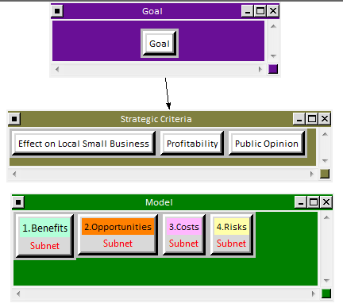

Below are the priorities for each of the criteria after the data was built into the model and pairwise comparisons were completed. The highest weighted is Profitability, followed by Effect on Local Small Business, then Public Opinion. Companies are organically in the business to maximize profits, and although governments place regulations on companies to protect social welfare, the economic downturn has seemingly forced governments more into the business of profit maximization rather than social good maximization. Unfortunately, these are the times and thus, these priorities are in line with my expectations.
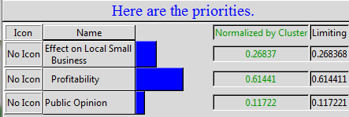
Below are the results of synthesizing each sub-network in my BOCR model.
Benefits Control Hierarchy Subnet
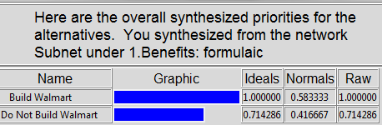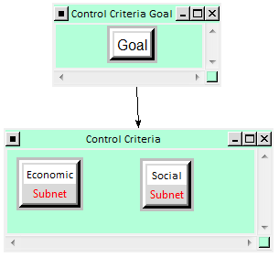

The subnet above analyzed the economic and social benefits associated with building and not building Wal-Mart stores in Washington, D.C. The pairwise comparisons results for the economic subnet were weighed at a factor of .75, whereas the results from the social subnet were weighed at a factor of .25. My interpretation of these results is that economic factors play a bigger role in the determination of the benefits associated with decision to build or not to build Wal-Mart stores. Solely, based on the benefits subnet, the recommendation would be to build the Wal-Mart in Washington, D.C.
Opportunities Control Hierarchy Subnet
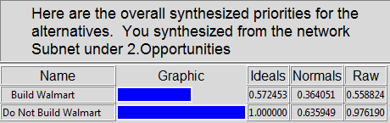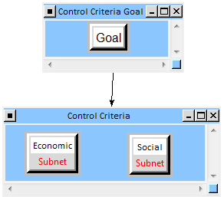
The subnet above analyzed the economic and social opportunities associated with building and not building Wal-Mart stores in Washington, D.C. The pairwise comparisons results for the economic subnet were weighed at a factor of .167, whereas the results from the social subnet were weighed at a factor of .833. My interpretation of these results is that social factors play a bigger role in the determination of the opportunities associated with decision to build or not to build Wal-Mart stores. Solely, based on the opportunities subnet, the recommendation would be not to build the Wal-Mart in Washington, D.C.

Costs Control Hierarchy Subnet
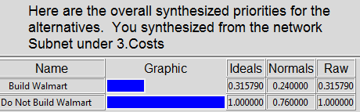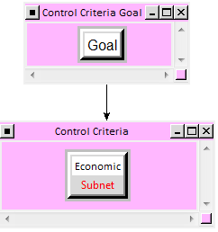
The subnet above analyzed only the economic costs associated with building and not building Wal-Mart stores in Washington, D.C. The pairwise comparisons results for the economic subnet were weighed at a factor of 1, because it is the only subnet at the second level. Solely, based on the costs subnet, the recommendation would be not to build the Wal-Mart in Washington, D.C.
Risks Control Hierarchy Subnet
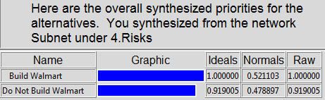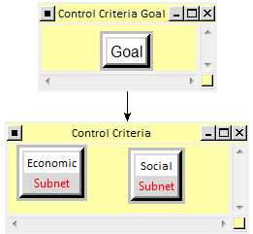
The subnet above analyzed the economic and social risks associated with building and not building Wal-Mart stores in Washington, D.C. The pairwise comparisons results for the economic subnet were weighed at a factor of .25, whereas the results from the social subnet were weighed at a factor of .75. My interpretation of these results is that social factors play a bigger role in the determination of the risks associated with decision to build or not to build Wal-Mart stores. Solely, based on the risks subnet, the recommendation would be to build the Wal-Mart in Washington, D.C.
Sensitivity Analysis: Benefits
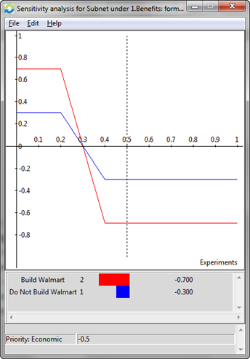
The benefits of building a Wal-Mart in Washington, D.C is constant between 0 and .2; then declines sharply between .2 and .4; and then constant again between .4 and 1. There are two points where any change in the priority values will yield no effect on the current rankings. But after .3, the decision not to build Wal-Mart is ranked higher than to do so.

Sensitivity Analysis: Opportunities
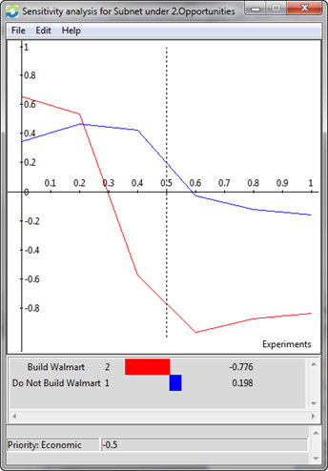
The opportunity of building a Wal-Mart in Washington, D.C is sharply decreasing from 0 to .6. After .2, the decision not to build is more favorable than to build. Between 0 and .2, it would be more opportunistic to build a Wal-Mart than to not.

Sensitivity Analysis: Costs
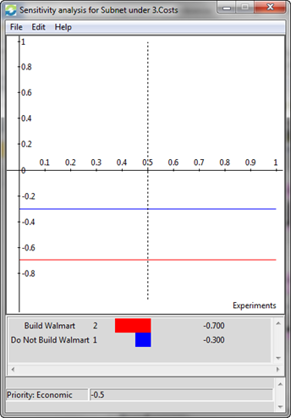
The costs of building a Wal-Mart in Washington, D.C is constant between 0 and 1. This essentially means that any change in the priority values will yield no effect on the current rankings.
Sensitivity Analysis: Risks
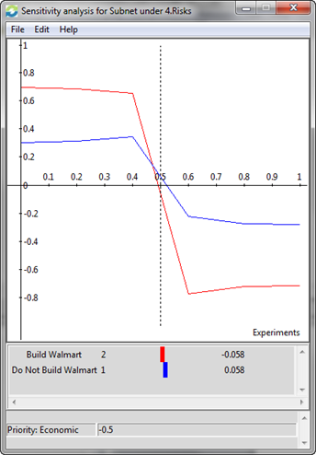
The risks of building a Wal-Mart in Washington, D.C is relatively constant between 0 and .4; then declines sharply between .4 and .6; and then relatively constant again between .6 and 1. There are two points where any change in the priority values will yield no effect on the current rankings. Between 0 and .5, it is riskier to build a Wal-Mart than not to. After .5 it is more risky not to build a Wal-Mart than to build.

Ratings Model
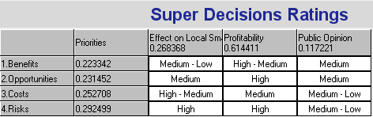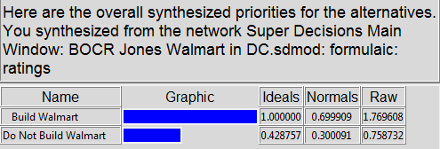
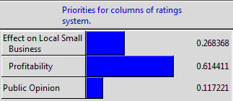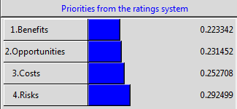
The results of the Ratings model above indicate that the Wal-Mart should be built in Washington, D.C. Moreover, the results of ratings with respect to the strategic criteria yield Profitability to be more highly rated amongst the other criteria. This is as expected given the aforementioned build decision. What seems rather odd to me is that the effect on local small business is only near 30%. I would have imagined that this number would have been larger. The priorities with respect to the BOCR model seem to quite close. Not sure if it is the norm to have Benefits/Opportunities and Costs/Risks so close in proximity one another, but it does seem intriguing. What doesn’t make much sense to me is why Profitability is my highest rated priority, along with risks. Perhaps an explanation for that is that the risks of not building the Wal-Mart far exceed the risk of building it. Let’s break ground!

Conclusion
There have been studies done in a few US cities to determine the detrimental effects of building Wal-Mart’s in urban cities. D.C., one of the notable districts in the United States, seems to think they will be able to side step the detrimental economic effects that come along with welcoming Wal-Mart with open arms. Nonetheless, the BOCR model suggests that Wal-Mart should be built. This prediction is line with what city officials have already decided. Amidst public and local business unrest, it is seen as more of asset to have the superstore located within the city limits. I am torn in that I do not want to see the possible ill-effects of economic turmoil, that has followed Wal-Mart into urban, happen to my city. On the other hand, I personally know quite a few people who this move could help. It’s pretty amazing that the BOCR model is able to aggregate the comparisons with respect to different criteria and yield a result that is consistent with real life examples.

