BQOM 2521
Yuguang Wang
M8

Background Information

Microsoft has entered the gaming industry and released its game console first generation Xbox in 2001. In this year, the 4-th generation console Xbox series X and Xbox series S will be released. The main competitor of Xbox is the PlayStation game consoles from Sony, as the game consoles of PlayStation have similar hardware and similar target users. The two companies have almost the same market share in the first two generations of the game consoles, however in the current generation PS4 is much more popular and has more market share than Xbox one. Although games like Call of Duty series and FIFA series contribute extensive of sales but these games are available on almost every platform, the exclusive games on each platform is the decisive reason for users to purchase the certain video game console. Xbox losing the competition is mainly for the reason that the exclusive games on their platform is far less than the exclusive games on PS4, for example in the top 10 best-selling games Xbox one only has 2 exclusive games which are Halo 5 and Minecraft whereas PS4 has 7 exclusive games. Therefore, in the next generation console, with still the similar hardware specs as PlayStation, Microsoft needs to make decisions to promote the new Xbox by creating more exclusive games to attract more users.

The BOCR Model

The Alternatives

- Expand current video game studio
Microsoft has its own video game studio Xbox game studio and can expand that studio to create more games.
- Schedule more 3rd party exclusive games
Microsoft can contract with more video game companies to produce more exclusive games on the new Xbox series X
- Acquire video game studios
Microsoft can acquire a small team game studio that can increase the game variety of the Xbox game environment
- Acquire a video game publisher
A video game publisher usually has a mature and large development team and standard process that can publish games by itself.

The Strategic Criteria are:

- Growth
- Compatibility with XBOX system
- Innovation
- Reputation
- Players

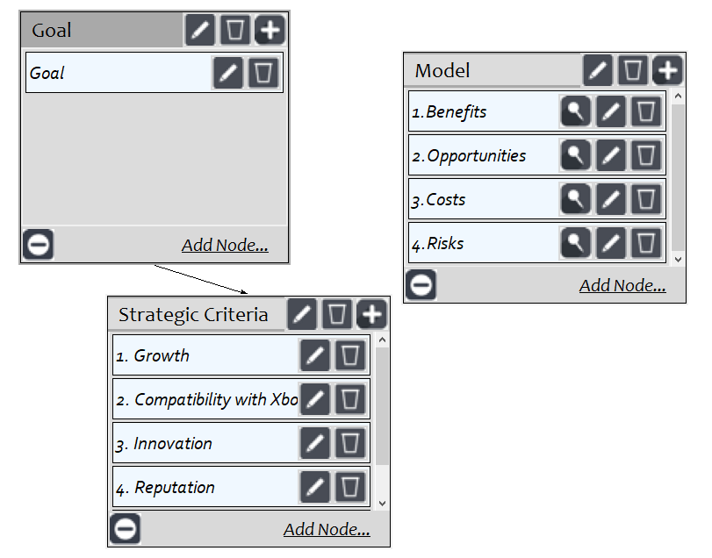

The control criteria I created for each subnetwork are:

Benefits

Economic: The profit for each alternative can bring and the cost for each alternative can save in the short run.

Operational: The performance that each alternative can improve and new technologies that each alternative can bring from the new team from each alternative when develop new video games for the new Xbox in the short run
Product: The video games that each alternative is able to create that can promote the new Xbox in the short run.

Cost
Economic: The acquisition fee and cost of game development and marketing in the short run.
Operational: The cost of collaboration in a new team for each alternative and the cost of making new marketing strategies and new branding strategies in the short run.
Product: The cost of each alternative not able to produce good games and not able to create innovations in the short run.

Opportunities
Economic: The profit for each alternative can bring and the cost for each alternative can save in the long run.
Operational: The opportunities that each alternative can improve the team management and the game performance and new technologies that each alternative can bring in the long run
Product: The opportunities that each alternative can create high quality games and bring a good reputation for Microsoft to promote the new Xbox in the long run.

Risks
Economic: The risk of high acquisition fee for low valuable companies and high development cost and marketing cost for each alternative in the long run.
Operational: The risk of not able to have good collaboration and high development difficulty and risk of difficulty to make marketing strategies for each alternative in the long run.
Product: The risk of not being able to make good video games and not being able to build a good reputation to promote the new Xbox in the long run.

The subnetwork and synthesized results

Benefits
Economic
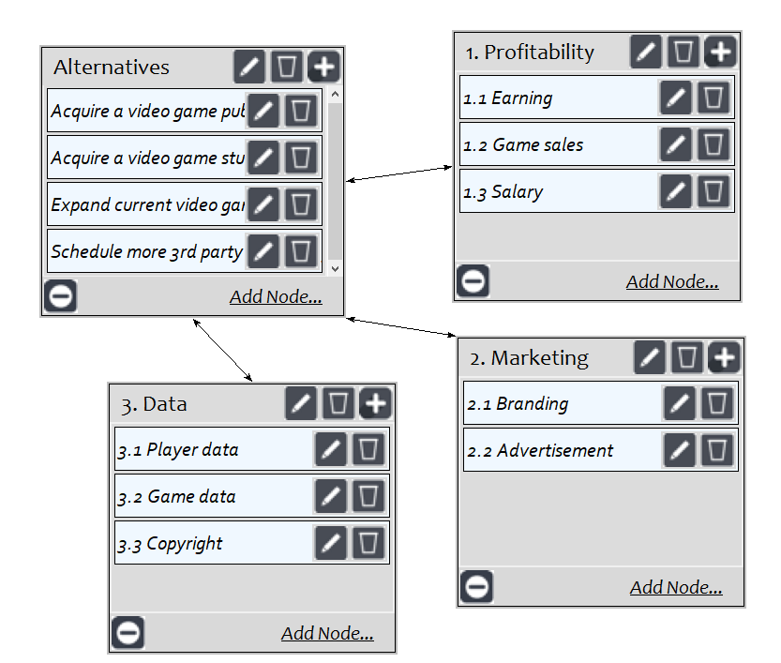

Operational
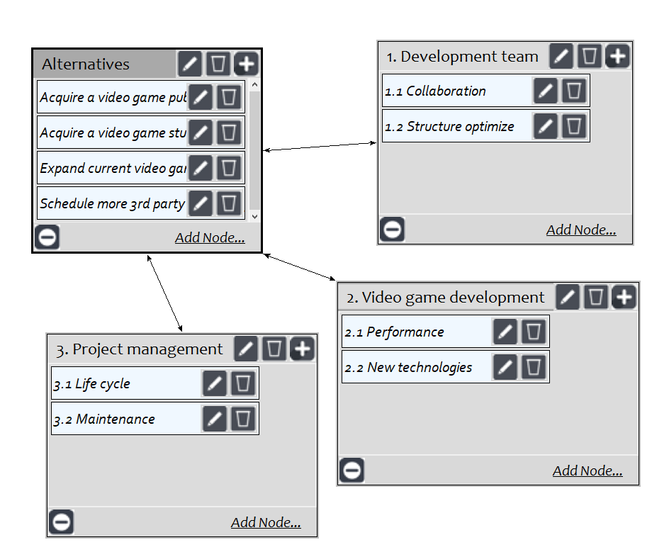

Product
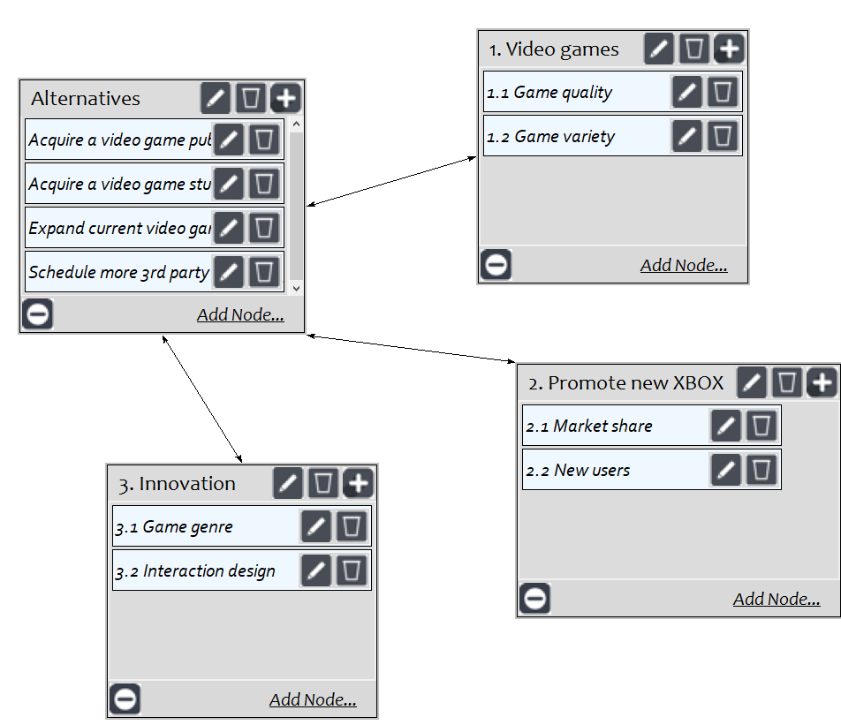

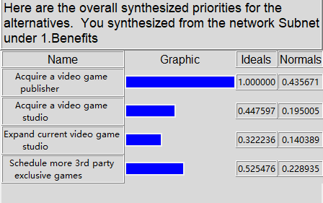
Acquiring a video game publisher has the highest value in the benefits control criteria.

Opportunities
Economic
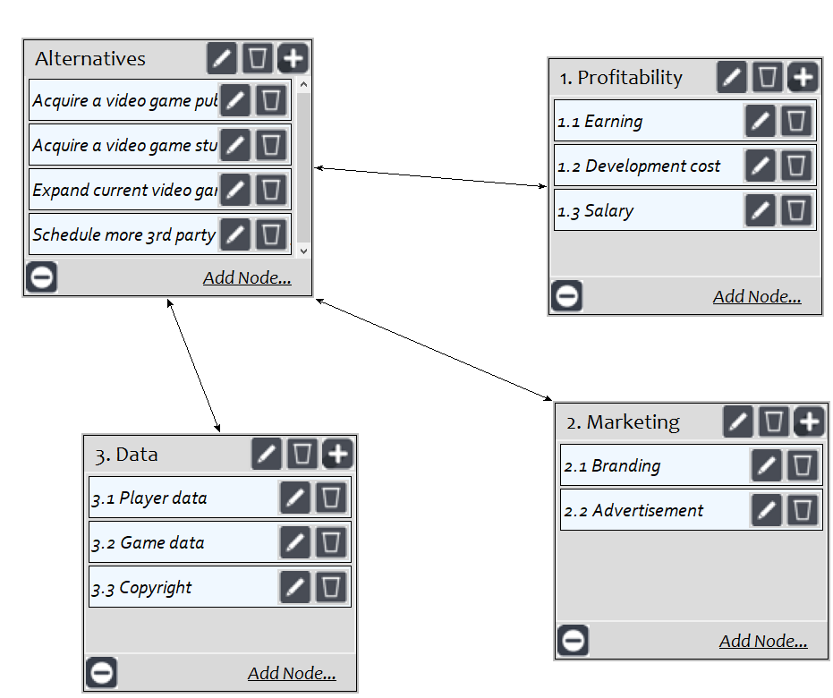

Operational

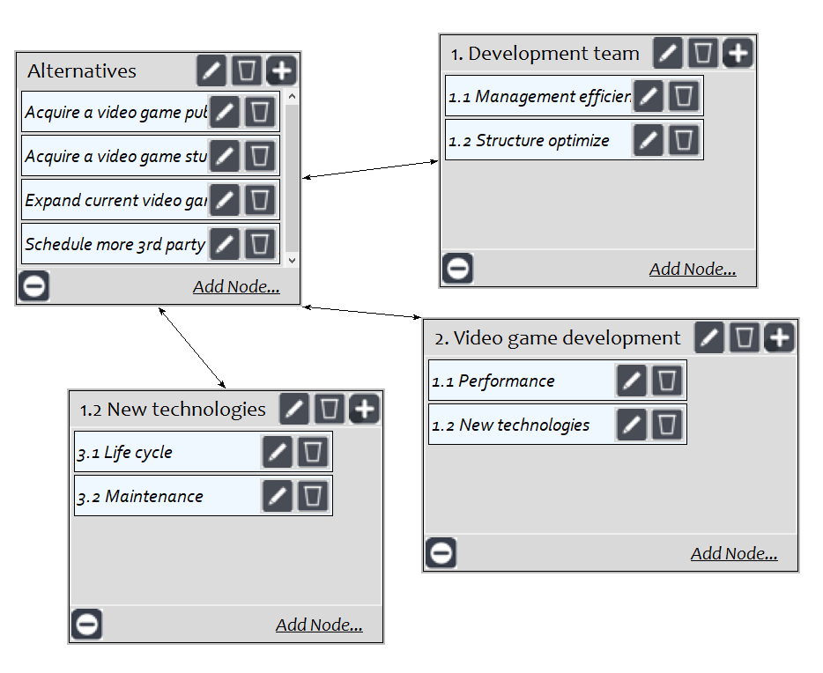
Product

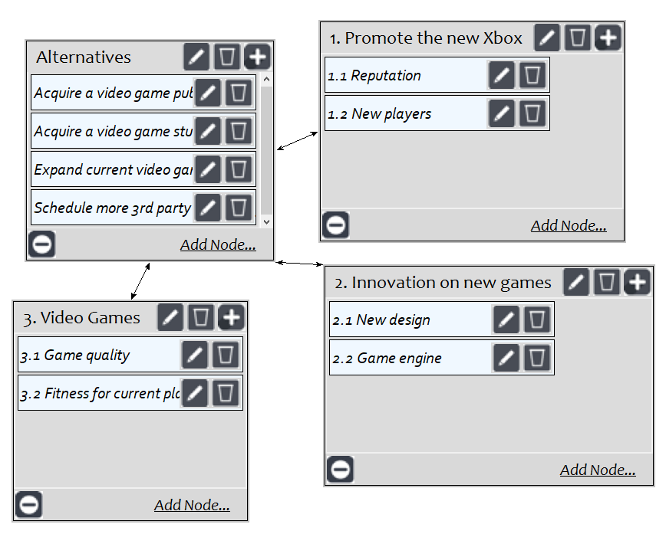
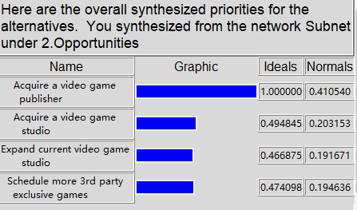
Acquiring a video game publisher has the highest value in the opportunities control criteria.

Costs
Economic
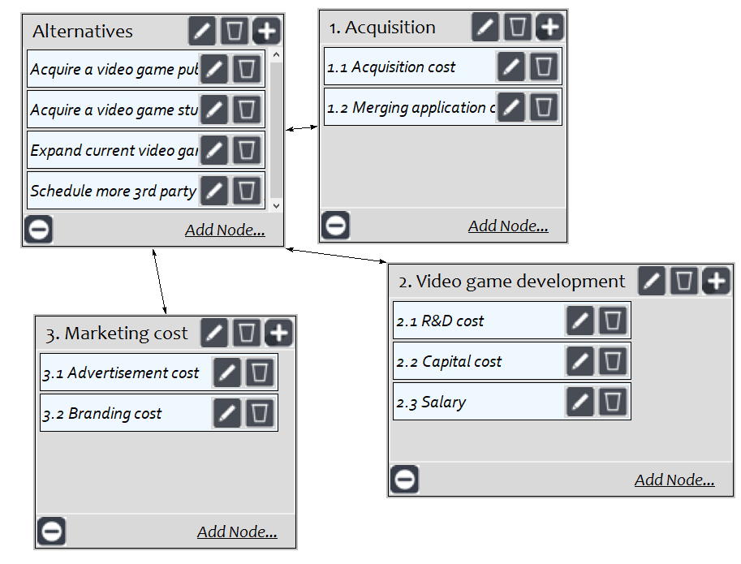
Operational
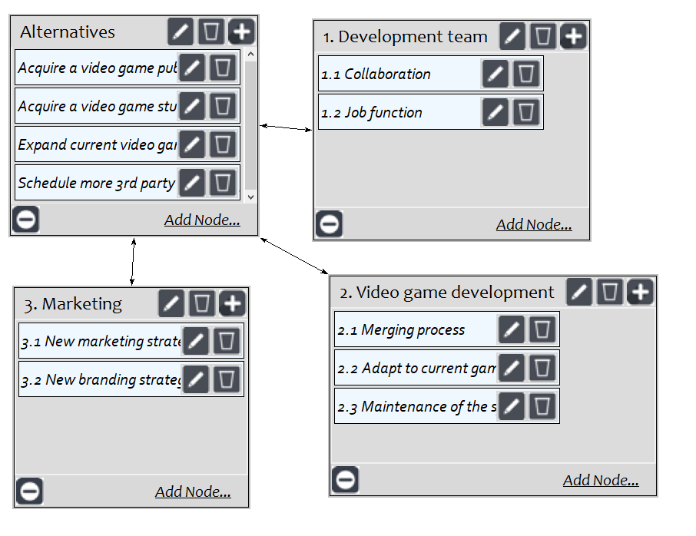
Product
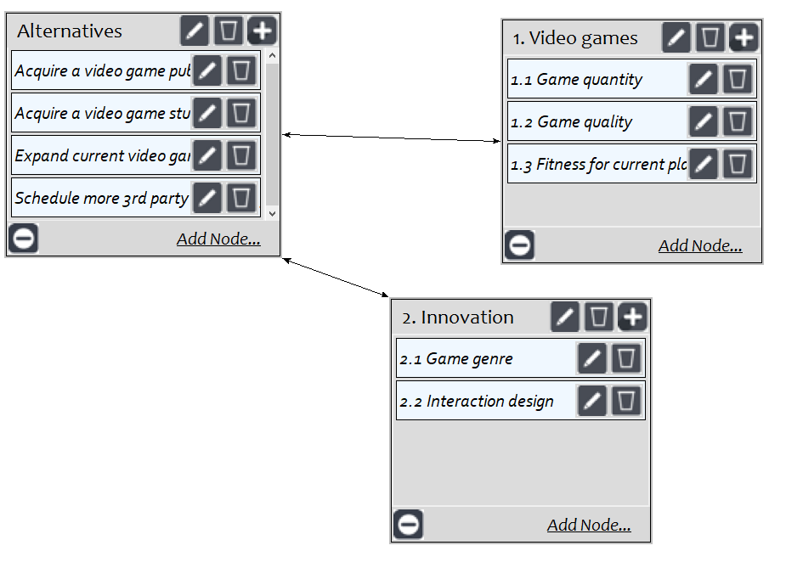

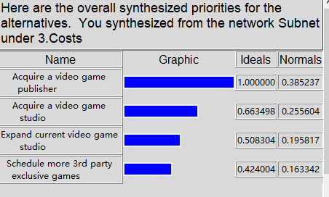
Acquiring a video game publisher has the highest value in the costs control criteria.

Risks
Economic

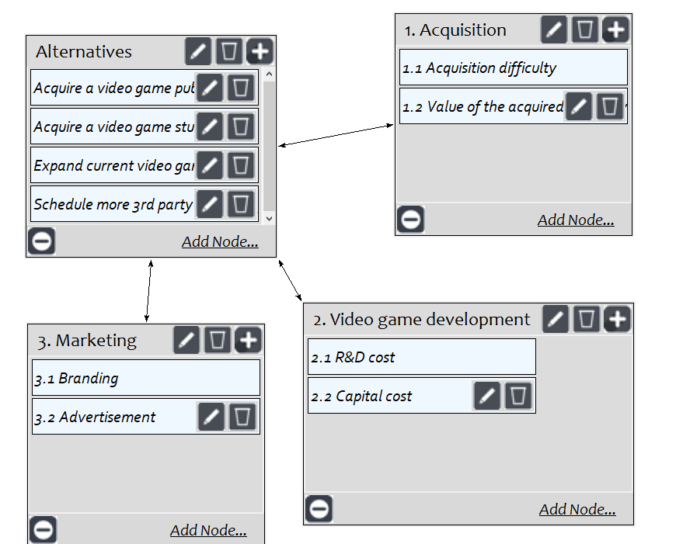
Operational
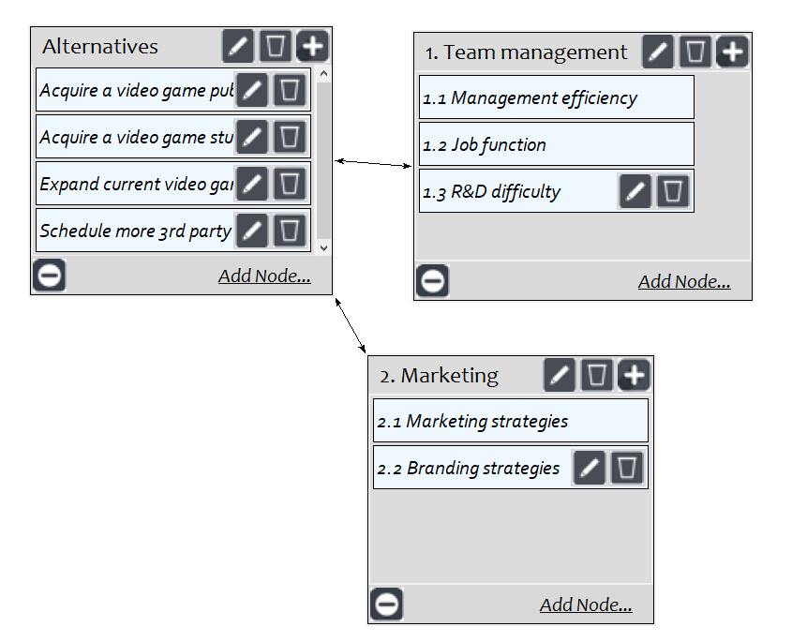
Product
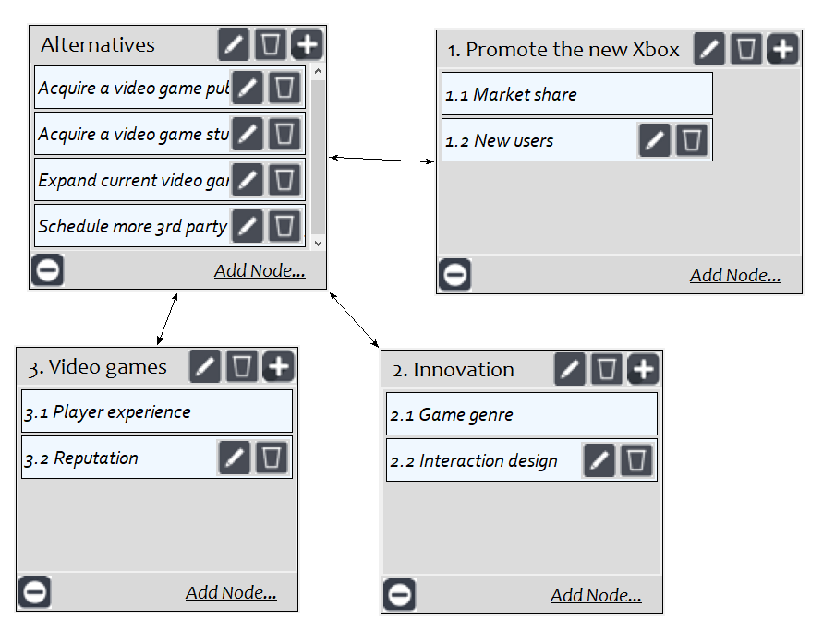

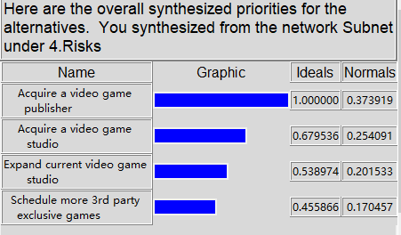
Acquiring a video game publisher has the highest value in the risks control criteria.

The rating for the control criteria and Strategic Criteria
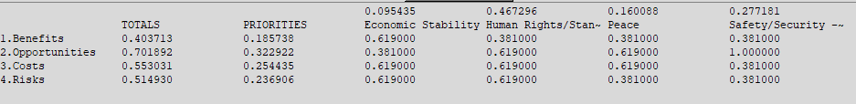

The result in the long run
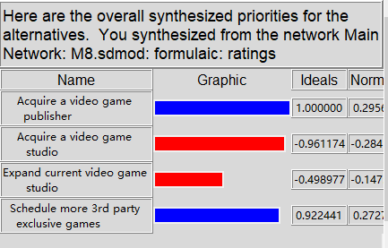
The result in the short run
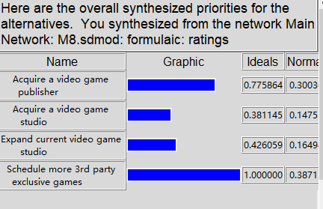

For the long run, acquiring a video game publisher has the highest value among all the alternatives. Even acquiring a video game publisher has the highest risks and costs, it also has the highest benefits and opportunities, so the result is reasonable. The result in the short run scheduling more 3rd party exclusive games has the highest value. It makes sense that if Microsoft wants to have more exclusive games and have high quality games that a video publisher can mostly satisfy that requirement, because a video publisher has more advantages in video games R&D ,although it has higher cost and higher risks in the long term. In the short term, contracting with more 3rd party video companies can provide highest quantity of exclusive games for Microsoft, even if the game quality and innovation on video games are not as good as the game publisher can bring, but it still a good decision for Microsoft to promote the new Xbox to have more market share.

Sensitivity


The Schedule more 3rd party exclusive games alternative will have the highest value if the priority of benefits changes to below 0.09

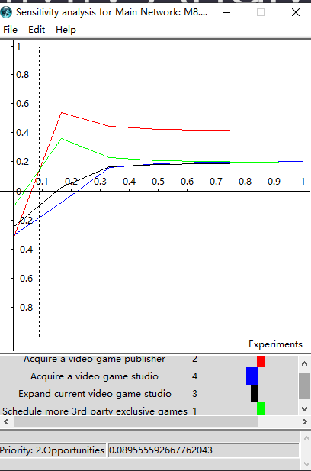
The Schedule more 3rd party exclusive games alternative will have the highest value if the priority of opportunities changes to below 0.09

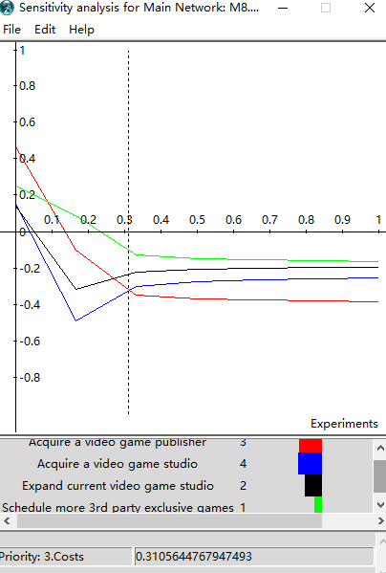

The Acquire video game studios alternative will have the lowest value if the priority of costs changes to below 0.31

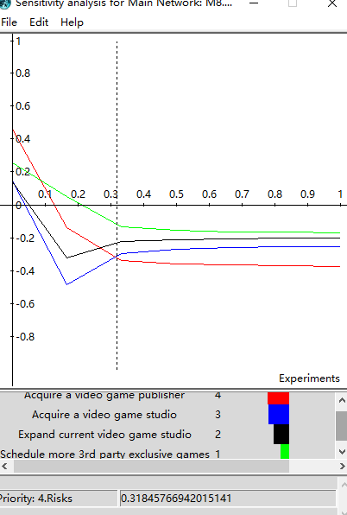

The Acquire video game studios alternative will have the lowest value if the priority of risks changes to below 0.31

