Spring 2011
Decision Making in Complex Environment
Group Project
Ed Gleeson
Gary Valkavitch
Prasad Pashte


What Strategy should Konica pursue in digital printing business?
Table of Contents
1. Executive Summary 2
2. Background 3
2.1 Industry Background 3
2.2 How should Konica Minolta adjust to changing industry demands? 3
2.3 The Decision Problem 4
3. The Model 6
3.1 Benefits 6
3.2 Opportunities 8
3.3 Costs 9
3.4 Risks 10
4. Model Results 12
5. Conclusion 19

Executive Summary
In 2009 the industry experienced an extreme decline in sales due to cyclical and structural difficulties associated with the economic downturn and society’s changing preference of consuming electronic forms of media instead of traditional print. However, digital printing business continued to grow and companies in develop more efficient production workflow to improve productivity in their traditional forms of printing. The firm Konica Minolta, which belongs to this industry, had to make a decision about investing in offering customers an automated workflow solution. Konica has 3 options: Developing a proprietary solution, acquiring EFI which is a supplier of printing software and continuing partnership with EFI.
To resolve this decision problem, a model is build using Analytical Hierarchy Process (AHP) concept. Benefits, Opportunities, Costs, and Risks are combined with five strategic criteria to arrive at the conclusion. The five strategic criteria used in our decision were economic success, employee interests, reputation, stockholder interests, and technological advancement. The benefits portion of our model contains three control criteria; Economic, Operational, and Stakeholders. The opportunities portion of our model contains the same control criteria as the benefits portion, only there are different decisions to pair-wise compare in the subnets. The costs portion of our model contains only the economic and operational considerations for control criteria, whereas Risk includes additional control criteria of stakeholders. Pairwise comparison of five strategic criteria is done before determining the priorities of the each BOCR portions of the AHP model. The priorities for the BOCR are then calculated and internally added to the Super Decisions Ratings Matrix. For final results, the whole model is synthesized from the Ratings matrix using both the additive negative and multiplicative formulas.
The result for the additive negative model shows that developing a proprietary automated workflow solution is the best alternative for Konica Minolta when considering long term goals. When using the multiplicative model, the best alternative is to continue the partnership with EFI and it is a short term decision as other two options require high capital investment.

Background

Industry Background
General Commercial Printing includes the production of the following products: advertising printing (direct mail, circulars, brochures, displays, inserts, and pamphlets), business cards, stationery, catalogs, directories, newspapers, copying/duplicating services, magazines, books, and financial/legal documents. In 2009 the industry experienced an extreme decline in sales of $20.5 billion going from an industry with over $115 billion in sales to just over $95 billion. Any major capital investments in new presses were put on hold or canceled.
The industry is challenged with both cyclical and structural difficulties associated with the economic downturn and society’s changing preference of consuming electronic forms of media instead of traditional print. The one sector of the industry that continues to grow despite the recession and changing preferences is digital printing. Digital printing is printing done on presses similar to what you would see at Kinkos, only on a larger scale. These presses can print variable documents and shorter run/on demand jobs. So while the traditional presses are efficient at producing longer run jobs (5,000 books instead of 4 or 5 for a specific customer order), the digital presses are efficient at producing jobs that are currently and expected to grow in demand in the future.
Digital printing sales have been increasing by over 5% per year for the past decade and are expected to continue to grow, while traditional longer run print sales are expected to remain flat or slightly decline. General commercial printers need to adopt this new form of production, develop more efficient production workflow, offer their services online, and improve workflow productivity in their traditional forms of printing. To do this they need to invest in digital presses and the systems that can help them improve production workflow and ecommerce capabilities.

How should Konica Minolta adjust to changing industry demands?
Konica Minolta, a major press manufacture, produces both commercial digital presses and MFPs (multi function printers, mostly used in offices.) During the recession and subsequent recovery demand for both MFPs and production digital presses has suffered. Over 70% of Konica’s revenue is from sales of production digital presses. In the current environment commercial printer business conditions have begun to improve allowing them to increase their level of capital expenditures especially in digital presses and workflow automation.
Konica’s main customer base is General Commercial Printers. In 2009 sales for this sector of the industry declined by about 16%; however, in 2010 the recovery helped them with sales increases of 2.7%. Industry profitability has also improved over the past 12 months from -1.5% to a positive 4% profit as a percent of sales. With improving conditions general commercial printers are now looking to increase their investments; however, they are not looking to increase employment levels and are instead looking to enter growing markets and increased productivity. The major growing trend is for short run on-demand jobs that are best produced on production digital presses, Konica’s major product.
This is why Konica Minolta is interested in learning more about investing in a workflow automation solution that printers can use to make their digital presses more efficient. This would enable them to increase their sales and potential profits and could potentially be a large part of the industry as more printers invest in automated workflow solutions and digital presses.

The Decision Problem
How should we invest in offering customers an automated workflow solution? At the current time Konica Minolta offers printers a variety of digital color presses to choose from. Along with the economic recovery, demand for these presses is also beginning to improve. The industry that they serve “general commercial printers” is consolidating and their demand for these presses and automated workflow solutions are increasing. Currently Konica partners with software providers like EFI that have established workflow solutions software products. Konica is trying to determine how best to capture these extra revenues by acquiring EFI, developing their own workflow software, or continue their current relationship with EFI and look for opportunities to improve efficiency.
- Develop Proprietary Solution
This would entail hiring programmers and other individuals to create an automated workflow solution. An automated workflow solution entails creating a system that helps commercial printers create their own e-commerce site where their customers can go to order printed material. Then this website has to be tied to the printers MIS systems and production workflow. The idea is that a customer can order for example business cards online and the order would be recorded on the printers MIS system and then go straight to production and finally shipping without being handled by a person. This is the direction the industry is evolving towards, but a complete workflow solution that ties together e-commerce sites, MIS systems, and production workflow will be expensive to create. We have to weigh the benefits of potential increased revenues and new market potential with the costs and risks of such a large investment.

- Acquire EFI
Electronics for Imaging or EFI is a major supplier of varying software offerings to the printing industry. They offer commercial printers software and consulting services to help them create and manage their website, MIS systems, and automated workflow solutions. Konica Minolta already partners with EFI and recommends their products to their customers. If Konica were to acquire EFI they could more rapidly enter this market but they would potentially have to pay a premium for the company due to its success and high ranking in the industry. EFI is currently not for sale; so a significant premium may be charged over current market value.

- Continue partnership with EFI
This is similar to the do nothing or continue with how you are currently operating. By continuing their partnership with EFI they are still able to offer their customers automated workflow solutions but they do not benefit from any potential additional revenues and profits. They would benefit from less costs and risks but these issues will be weighted in our BOCR model. Konica would look for ways to improve efficiencies in their business operations with RFI.

The Model
The model used in this Analytical Hierarchy Process (AHP) decision problem is shown below in Figure 1. Figure 1 shows that the Benefits, Opportunities, Costs, and Risks are combined with five strategic criteria to determine the results documented later in this section. The five strategic criteria used in our decision were economic success, employee interests, reputation, stockholder interests, and technological advancement. These five criteria are what we believed were the most important factors in the decision making process for Konica Minolta. These five criteria were then pair-wise compared and internally coded into the super decision super matrix.
Figure 1: The Konica Minolta AHP Model
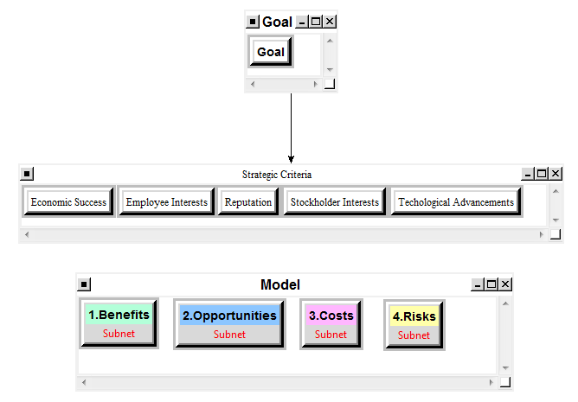
The BOCR portion of the model is not connected via a pair-wise comparison to the strategic criteria. The ideal choice for each branch of the BOCR was determined and then these decisions were manually input into the Super decisions ratings matrix. The BOCR portion of the model is explained in detail below.

Benefits
The benefits portion of our model contains three control criteria; Economic, Operational, and Stakeholders. These three criteria represent major areas of Konica Minolta’s business that will be impacted by the three potential decisions from our list of alternatives. The three control criteria are not pair-wise compared to any other clusters, but rather all have subnets due to the importance of each of these decisions. The pair-wise comparisons are made in the subnets, as shown below in Figure 2.
Figure 2: Benefits Model Including Subnets
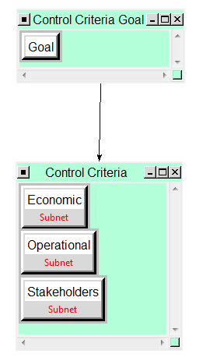
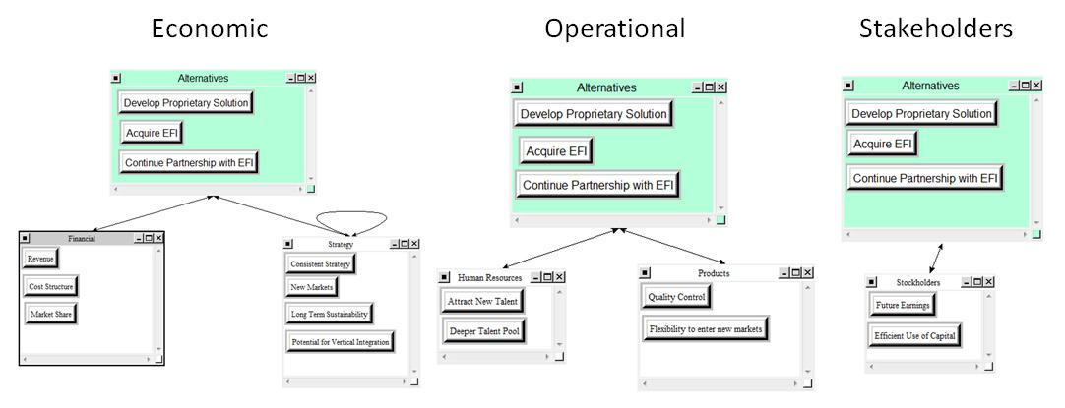
The Economic subnet had two clusters; financial and strategy. The nodes used for comparison in the Financial cluster were revenue, cost structure and market share. The nodes used for comparison in the Strategy cluster were consistent strategy, new markets, long term sustainability, and potential for vertical integration. The Operational subnet had two clusters; Human Resources and Products. The nodes used for comparison in the Human Resources cluster were the potential to attract new talent and deeper talent pool. The nodes for comparison in the Products cluster were quality control and the flexibility to enter new markets. The Stakeholders subnet had only one cluster, stockholders. In the stockholders cluster we considered the company’s potential for future earnings and the company’s efficient use of capital.

Opportunities
The opportunities portion of our model contains the same control criteria as the benefits portion, only there are different decisions to pair-wise compare in the subnets. These decisions change because we are now considering the potential opportunities and not the potential benefits that are a result of this decision. The model for the opportunities portion is shown below in Figure 3.
Figure 3: Opportunities Model Including Subnets
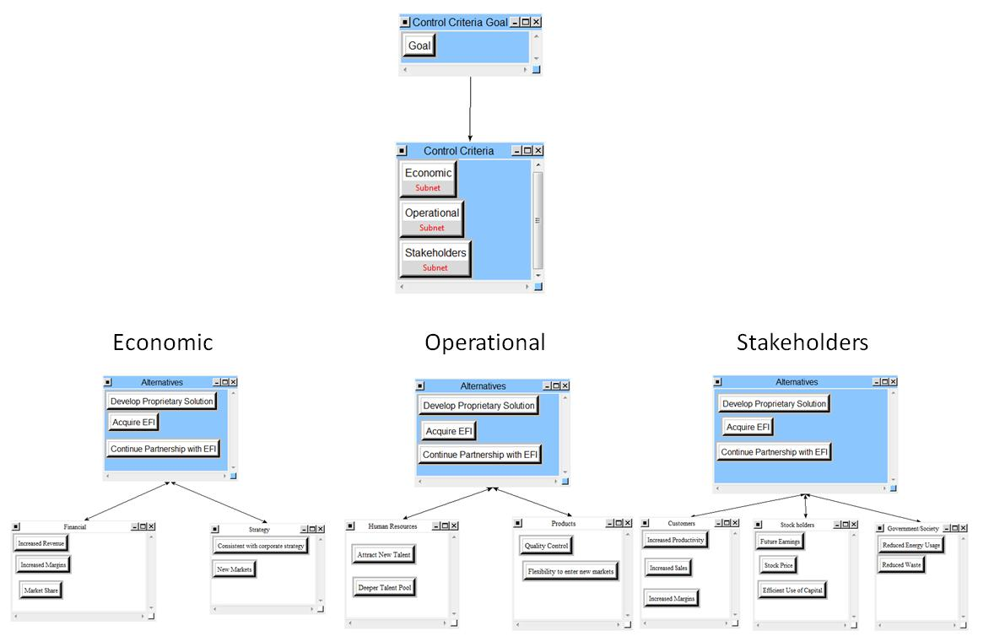
The Economic subnet has two clusters, Financial and Strategy. The nodes for comparison under the financial cluster are increased revenue, increased margins, and market share. The nodes used for comparison under the Strategy cluster are consistency with the corporate strategy and the potential for new markets. The Operational subnet has two clusters that are used for comparison, Human Resources and Products. The Human Resources cluster has two nodes used for comparisons, attract new talent and the potential for a deeper talent pool. The nodes used for comparison under the Products cluster are quality control and flexibility to enter new markets. The Stakeholders subnet has three clusters; Customers, Stock Holders, and Government/Society. The Customers cluster has three nodes used for comparisons; increased productivity, increased sales, and increased margins. The Stock Holders cluster has three nodes used for comparisons; future earnings, stock price, and the efficient use of capital. Government/Society has two nodes used for comparison; reduce energy usage and reduce waste.

Costs
The costs portion of our model contains only the economic and operational considerations for control criteria. The stakeholders are not considered for this portion of the model because there would not be any direct costs to the stakeholders but rather risks associated with the alternatives considered. These risks are covered fully in the next portion of the BOCR. This portion of the model considered the potential negative impacts associated with the costs of the alternatives considered. The model for the costs portion is shown below in Figure 4.
The economic subnet has two clusters; Financial and Management/Administrative considerations. The Financial cluster has three nodes used for comparison; capital investment costs, implementation costs, and opportunity costs. The Management/Administrative cluster has two nodes used for comparison; project management, and training. The Operational subnet has two clusters; Human Resources and Management. The Human Resources cluster has two nodes used for comparison; recruiting and training. The Management cluster has three nodes used for pair-wise comparisons; knowledge management, sales management, and software support.

Figure 4: Opportunities Model Including Subnets
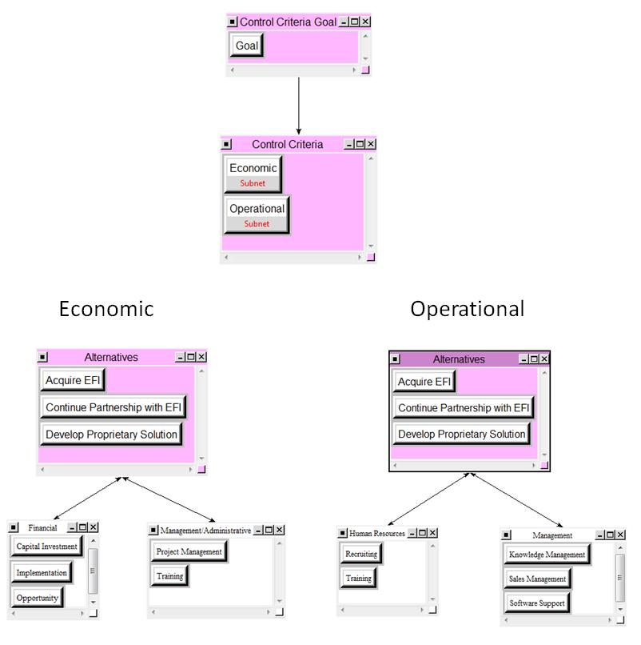

Risks
The Risks portion of our model contains economic considerations, operational considerations, and stakeholders for our control criteria. These three control criteria have subnets to look at the pair-wise comparisons. This portion of the model considers the potential risks with choosing each of the three alternatives considered for Konica Minolta.
The Economic subnet has three clusters used for pair-wise comparisons; Financial, Technological, and Reputation. The Financial cluster has three nodes used for pair-wise comparisons; capital, opportunity, and revenue. The Technological cluster has two nodes considered for the pair-wise comparisons; disruptive technology and sustainability. The
Figure 5: Opportunities Model Including Subnets

Reputation cluster has two nodes considered for pair-wise comparisons; customer relationships and supplier relationships. The Operational subnet contains two clusters; Business Practices and Human Resources. The Business Practices cluster has three nodes used for pair-wise comparisons; knowledge management, process change, and supply chain. When considering risks, the Human Resources cluster has three nodes used for pair-wise comparison; culture shift, employee retention, and hiring troubles. The Stakeholders subnet has two clusters; Financial and Customer. When considering risks, the financial cluster has two nodes used for pair-wise comparisons; employees and investors. The Customer cluster has three nodes used for pair-wise comparisons; continuing operations, customer service, and the end product.

Model Results
To obtain the AHP results, we first had to complete the pair-wise comparisons of the five strategic criteria that were chosen to be the most important to Konica Minolta. Figure 6 below shows the results of the pair-wise comparisons of the five strategic criteria. The figure on the left shows the priorities, while the figure on the right shows the ideal priorities, which normalizes these percentages by the highest priority. The inconsistency in these comparisons is 0.0522, less than the value of 0.1 which produces a consistent result. The priorities show that the economic success of the company was overwhelmingly the most important factor to be considered when making this decision. The second most important strategic criterion was Stockholder Interests, followed by Technological Advancements, Reputation, and Finally Employee Interests. Employee interests was the least prioritized strategic criteria because current operations does not focus on employee capabilities very highly. If Konica Minolta developed their own software, these priorities may see a shift to increase the employee interests.
Figure 6: Priorities for Strategic Criteria
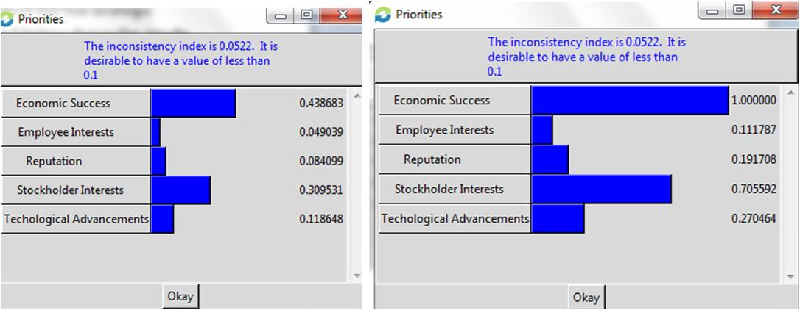
The next step was to determine the priorities for each of the BOCR potions of the AHP model. This was done by completing all of the pair-wise comparisons for all of the subnets in the BOCR portion of the model and synthesizing the results.
For the Benefits portion, developing proprietary solution was the ideal priority. Acquiring EFI was the second most beneficial choice while continuing our partnership with EFI is the least beneficial choice. Developing a proprietary solution has the potential to provide the most benefits because Konica Minolta will have the potential to enter new markets and increase their margins on purchases. For the Opportunities portion of the model, developing a proprietary solution was the best choice of the three alternatives. Acquiring EFI would be the second choice with respect to opportunities while continuing our partnership would be the least likely choice if considering opportunities only. The opportunities for future earnings and future market share are increased by acquiring EFI and increased to a greater extent if they vertically integrate and develop their own solution. For the costs portion of the model, developing a proprietary solution would be the most costly alternative followed by acquiring EFI. Continuing their partnership would be the least costly alternative. This is understandable as there is no upfront capital investment when choosing this alternative. For the Risks portion of the model, developing a proprietary solution is considered the most risky alternative followed closely by acquiring EFI. This makes sense because the strategic criteria used in this model are extremely difficult to predict, making these two choices extremely risky. Developing a proprietary solution is the most beneficial and most opportunistic alternative of the three; however, it is also the most costly and the most risky of the three possible alternatives.

Figure 7: BOCR Priorities
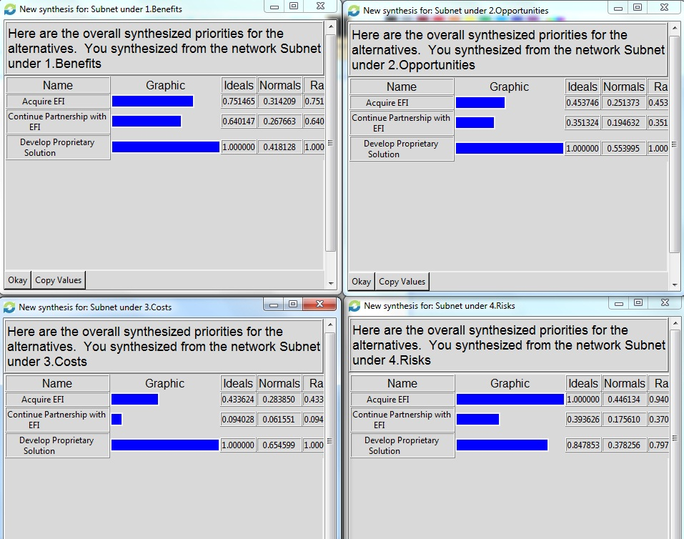
The priorities for the BOCR are then calculated and internally added to the Super Decisions Ratings Matrix. The top of the matrix consists of the five strategic criteria and their priorities while the left side of the matrix consists of the BOCR and the calculated priorities. Criteria were then chosen to compare the BOCR to the strategic criteria so that the Eigen value solution could be obtained. The criteria we chose were poor through excellent, giving us five levels to use to make all of the matrix calculations. The Super Decisions Ratings Matrix is shown below in Figure 8. The priorities in the BOCR portion of this matrix show that the opportunities are most important followed by the risks, the benefits, and finally the costs; although all were relatively close in comparison. To complete the matrix, we had to use the ideal alternative for each portion of the BOCR and then compare how that alternative would affect each of the five strategic criteria in the Ratings matrix. Because developing a proprietary solution was the ideal alternative for each level of the BOCR, this was compared to the five strategic criteria. For instance, we considered the benefits of developing a proprietary solution to provide above average benefits for Konica Minolta.
Figure 8: Super Decisions Ratings Matrix
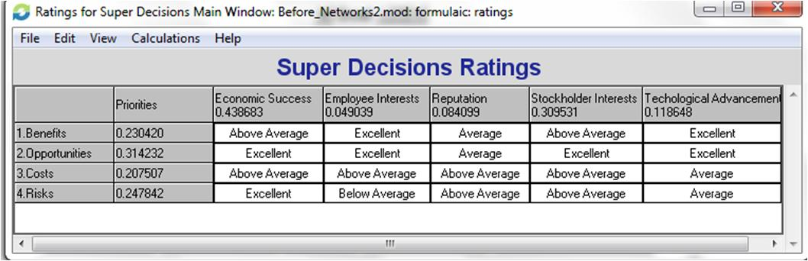
The final step to calculate the results involves synthesizing the entire model from the Ratings matrix using both the additive negative and multiplicative formulas. The results from this synthesis for both formulas are shown below in Figure 9.
This result for the additive negative model shows that developing a proprietary automated workflow solution is the alternative for Konica Minolta when considering long term goals. The second choice would be to continue their partnership with EFI with the worst decision being acquire EFI. This result makes sense because developing a proprietary solupotion provides the most opportunities, which had the highest priorities of any of the BOCR. The most interesting portion of this result is that the company should take acquiring EFI was the least desirable. The model claims that the risk is not worth the reward which is the opposite conclusion for developing a proprietary solution.
When using the multiplicative model, the best alternative would be to continue the partnership with EFI. This makes sense because the multiplicative model considers short term decisions, and the other two alternatives require a large up front capital investment.
Because Konica Minolta is financially strong and there are significant barriers to entry in this market, we would recommend using the additive negative result and focus on long term goals rather than short term goals. However, if Konica Minolta needed to think short term, continuing their partnership with EFI and focusing on improving efficiencies would be the best alternative.
Figure 9: Synthesized Additive Negative and Multiplicative Models
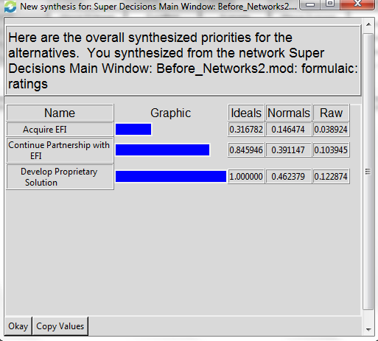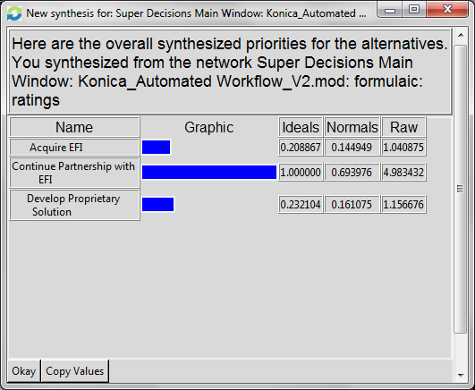
Finally we ran a sensitivity analysis on our synthesized additive negative model. We used the additive negative model because we believe Konica Minolta is more concerned with the long term implications of the decision. The sensitivity analysis shows what effect changing the priority of a merit node, for example, Benefits, will have on the synthesized priorities of the alternatives.

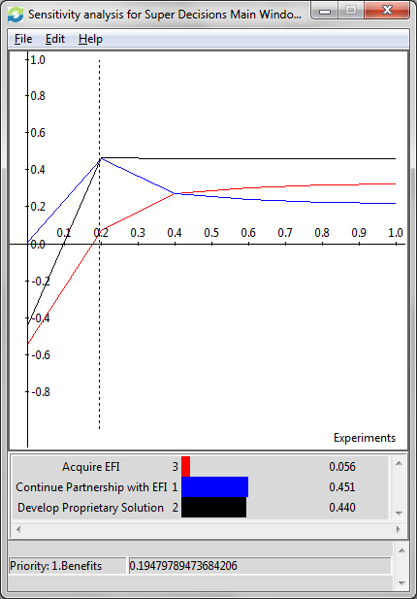
Figure 10: Sensitivity Analysis for Benefits Node (Additive Negative Model)
In our Ratings Model the Benefits Priority is .230420 and at that point Develop Proprietary Solution is the best choice. If the benefits priority was less than 0.1947, continuing our partnership with EFI would be the preferred priority. As long as the priority of benefits is greater than 0.2, developing their own proprietary automated workflow software is the best choice.

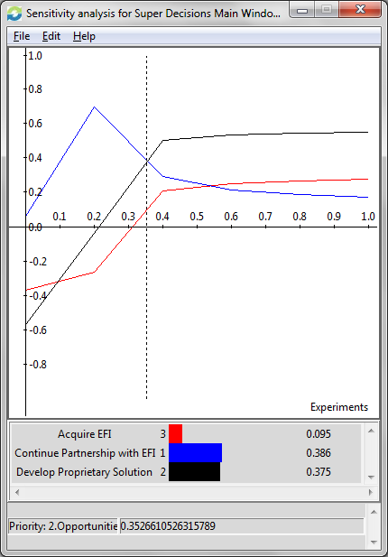
Figure 11: Sensitivity Analysis for Opportunities Node (Additive Negative Model)
In our Ratings Model the Opportunities Priority is .31432. At that point, Develop Proprietary Solution is the best choice. If Opportunities has a priority of less than .3526 the continuation of a partnership with EFI is the best choice. The best option is to develop a proprietary solution for opportunities between .35 and 1. Less than .35 continuing their partnership with EFI is their best option. One interesting finding is that at a priority of .54 and above for opportunities, Acquire EFI is a better choice than continuing partnership. As the opportunities priority increases so does the attractiveness of developing their own automated workflow solution or acquiring EFI.
Figure 12: Sensitivity Analysis for Costs Node (Additive Negative Model)
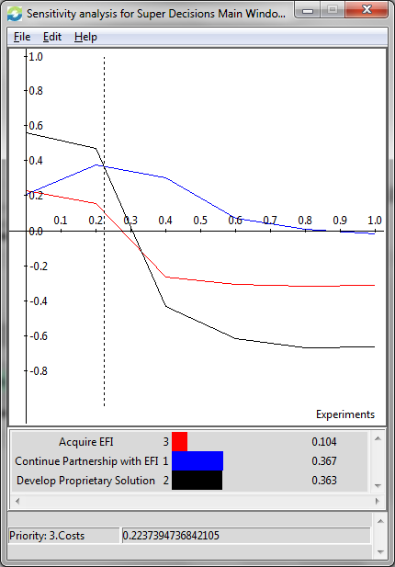
In our Ratings Model the Costs Priority is .2075 and at that point Develop Proprietary Solution is the most costly. If the Cost Priority was .22 or higher, the choice of continuing their partnership with EFI would become the alternative that Konica Minolta should choose. This makes sense because as a company becomes more concerned with costs, minimizing up front capital investment takes precedence.

Figure 13: Sensitivity Analysis for Risks Node (Additive Negative Model)
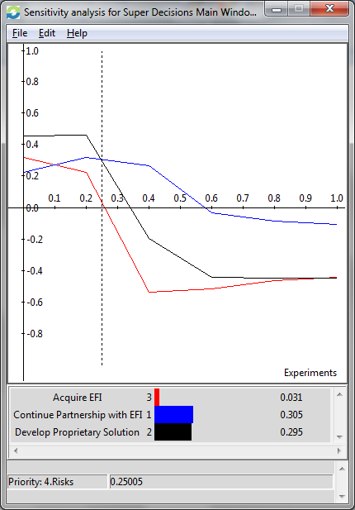
In our Ratings Model the Risks Priority is .2478 and at that point, Develop Proprietary Solution is the most risky alternative. A Priority of .25 or higher results in a new highest risks priority, which would now become to continue their partnership with EFI.

Conclusion
Based off our model’s results we recommend that Konica Minolta develop their own automated workflow solution. In the long-run, or using the additive negative model, this alternative was rated the highest. After performing sensitivity analysis on these findings we realize that if our priorities changed by as little as 5% for the benefits, opportunities, costs or risks that our choice would change to continue the partnership. The high cost of either creating their own workflow solution or acquiring EFI make our decision highly dependent on how much of an economic benefit or opportunity this investment would be. If we change our priorities and instead decide to be more cost conscious or risk adverse then we would choose not to change and just maintain our current partnership.
To improve our model in future studies we recommend researching additional companies to acquire and exploring addition markets to enter. In our first try at using the ANP model we limited our investment decision to one aspect of Konica Minolta’s business but we could expand it to additional business lines.

