Decision to Launch a New Duct Heater
Decision Making in Complex Environments
Final Report
Spring 2011

Rob Coburn
April 26th, 2011
Table of Contents
Introduction 3
Background 3
Alternatives 3
Methodology 4
Model 4
Table of BOCR Control Criteria and Sub Criteria 5
Data 9
Results 9
Synthesized Priorities for Benefits 9
Synthesized Priorities for Opportunities 9
Synthesized Priorities for Costs 10
Synthesized Priorities for Risks 10
Priorities for Strategic Criteria versus BOCR 11
Synthesized Model Using Multiplicative and Additive (Negative) Formula 11
Analysis 13
Sensitivity 13
Conclusion 18
What Did the Model Conclude? 18
How Does the Model’s Conclusion Compare to That of Traditional Methods 18
Future Research 19
Data Gathering 19

Introduction

Background
Chromalox, Inc. is a manufacturer of commercial and industrial electric heating products. It currently has several product lines including comfort and process air heaters. As a leader in its industry Chromalox has held a large market share in the comfort and process air heating markets for many years. Recently however Chromalox has begun to lose market share due to aggressive moves by its competitors with regards to new products and low pricing. Specifically, many of its competitors have begun to add products that enable them to quote bundled pricing for New Construction Projects and Waste Water Plants.
In the past few years Chromalox has seen an increasing number of HVAC bid requests that include a specific type of duct heater that uses a heating element Chromalox does not currently manufacture. This specific type of duct heater is omitted when Chromalox bids on the projects, often causing the rejection of the bid by the requestor. In the past Chromalox has not been interested in this market because of the large number of competitors and the low gross margins that come with a saturated market. However in light of the news that many of Chromalox’s competitors are starting to win bids based on bundling, Chromalox has decided to reevaluate its position of staying out of the market. In order to make a decision on how Chromalox should proceed, several alternatives were developed.

Alternatives
Chromalox developed three major alternatives. The alternatives were chosen based on their viability and previous strategies used on similar products.

Develop and Manufacture the New Duct Heater In-House
Chromalox would develop the duct heater design in-house using its current R&D capabilities. It would also manufacture the new duct heater in its Nuevo Laredo, MX facility to achieve the best cost point. The duct heaters would be made to order and sold through existing sales channels.

Buy Out New Duct Heaters from Existing Strategic Partner
Chromalox would partner with an existing customer (who also happens to be a competitor) and resell their duct heaters under the Chromalox name. The duct heaters would be made to order by the strategic partner and sold through Chromalox’s existing sales channels.

Do not Launch New Duct Heater
Chromalox would not launch the new duct heater and would continue to focus on existing products and other more profitable ventures.

Methodology

Model
Below is the BOCR model that was developed for the decision. The strategic criteria chosen were Market Attractiveness, Manufacturing Impact, Existing Product Synergies, and Financial. Based on strategic company goals, these were the most critical factors.
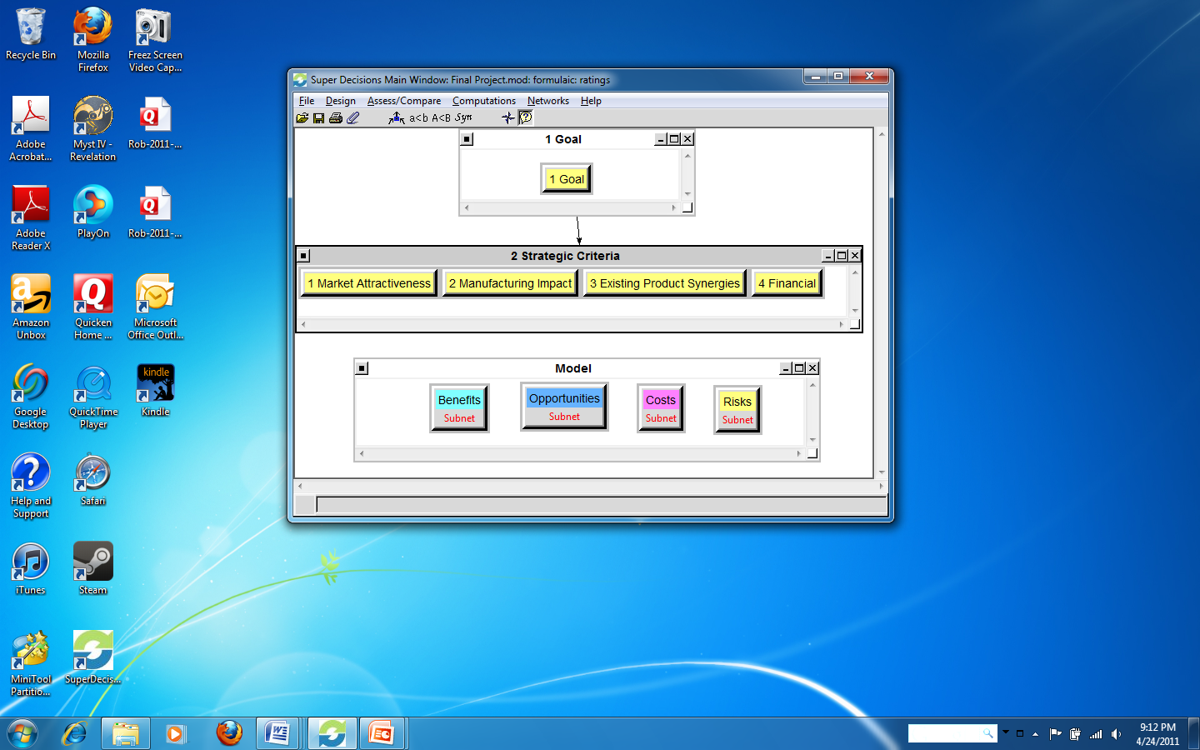

Table of BOCR Control Criteria and Sub Criteria
Each of the BOCR Control Criteria and Sub Criteria were thoughtfully selected based on what factors influence each of the alternatives. Each of the factors were organized and placed into groups which then acted as the clusters in the Super Decisions model. The model ended up being quite extensive based on the shear number of factors that can potential influence a critical business decision. As many factors were included as could be, given the time allotted to complete the project.

Benefits Control & Sub Criteria Table

 | Control Criteria | Sub Criteria
Benefits | Economic | Financial | Low Capital Equipment Cost
Benefits | Economic | Financial | Overhead Absorption
Benefits | Economic | Market | Diverse Customer Base
Benefits | Economic | Market | Large Market Size
Benefits | Economic | Market | Pull Through of Existing Products
Benefits | Operational | Engineering | Configurator Utilization
Benefits | Operational | Engineering | Existing Technologies
Benefits | Operational | Engineering | Design Simplicity
Benefits | Operational | Manufacturing | Excess Capacity Utilization
Benefits | Operational | Manufacturing | Ease of Manufacturing
Benefits | Organizational | Company Goals | Build Brand Equity
Benefits | Organizational | Company Goals | Innovation
Benefits | Organizational | Company Goals | Market Leader
Benefits | Organizational | Sales Reps | New Products
Benefits | Organizational | Sales Reps | Single Source Supplier

Opportunities Control & Sub Criteria Table

 | Control Criteria | Sub Criteria
Opportunities | Economic | Financial | Revenue Growth
Opportunities | Economic | Financial | Overhead Absorption
Opportunities | Economic | Market | Market Size
Opportunities | Economic | Market | Product Pull Through
Opportunities | Economic | Market | Value Creation
Opportunities | Operational | Engineering | Product Expertise
Opportunities | Operational | Engineering | R&D Excellence
Opportunities | Operational | Manufacturing | Excess Capacity Utilization
Opportunities | Operational | Manufacturing | Increased Efficiencies
Opportunities | Operational | Manufacturing | New Core Competencies
Opportunities | Organizational | Sales Reps | Increased Commissions
Opportunities | Organizational | Sales Reps | New Customers
Opportunities | Organizational | Strategic Partnership | Future Alliances
Opportunities | Organizational | Strategic Partnership | New Products
Opportunities | Organizational | Strategic Partnership | Knowledge Sharing

Costs Control & Sub Criteria Table

 | Control Criteria | Sub Criteria
Costs | Economic | Financial | Capital Equipment
Costs | Economic | Financial | Opportunity Costs
Costs | Economic | Sales Reps | Target List Generation
Costs | Economic | Sales Reps | Training
Costs | Operational | Product Development | Plant Resources
Costs | Operational | Product Development | Raw Material Inventory
Costs | Operational | Product Development | Training
Costs | Operational | Product Development | 3rd Party Certifications & Testing
Costs | Operational | Product Development | R&D

Risks Control & Sub Criteria Table

 | Control Criteria | Sub Criteria
Risks | Economic | Financial | Low Revenue Growth
Risks | Economic | Financial | Low Profitability
Risks | Economic | Market | Lack of Demand
Risks | Economic | Market | Substitutes
Risks | Operational | Product Development | Improper Training
Risks | Operational | Product Development | Poor Quality
Risks | Operational | Product Development | R&D Cost Overrun
Risks | Operational | Product Development | Patent Infringement
Risks | Organizational | Sales Reps | Buy In
Risks | Organizational | Sales Reps | Work vs. Reward
Risks | Organizational | Strategic Alliance | Poor Communication
Risks | Organizational | Strategic Alliance | Poor Cooperation

Data

Results
After completion of the model, the next step was to go through and perform the ratings for each of the BOCR networks to determine the priorities. The factors were then pair-wise compared against the alternatives and one another where applicable.

Synthesized Priorities for Benefits

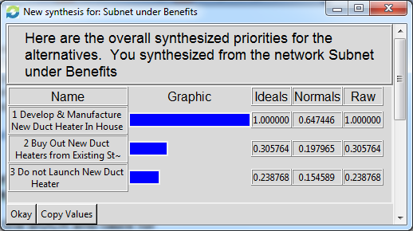

Synthesized Priorities for Opportunities

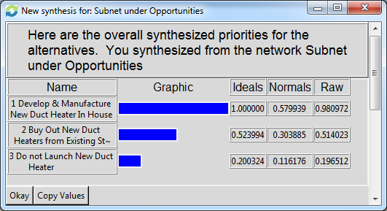

Synthesized Priorities for Costs

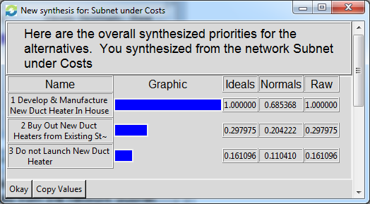

Synthesized Priorities for Risks

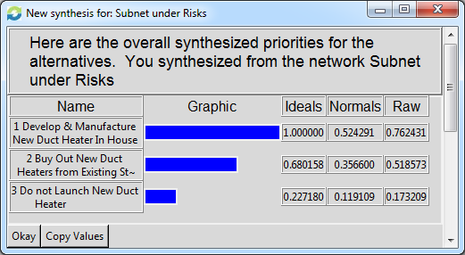

Priorities for Strategic Criteria versus BOCR
The next step in the process was to establish the priorities of the BOCR merits. This was done by developing a rating scale and applying it to the ratings formula.
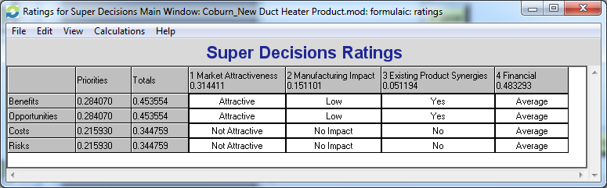

Synthesized Model Using Multiplicative and Additive (Negative) Formula
Lastly, the model was synthesized to find the overall priorities for the three alternatives using the multiplicative and additive (negative) formula. This produced the results below.
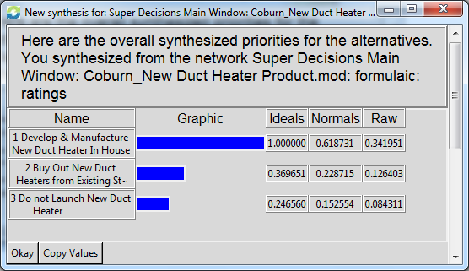

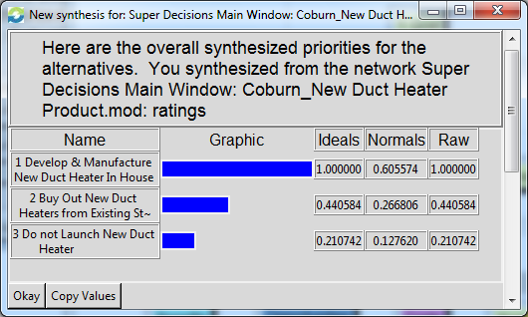

Analysis
Analysis of the data showed the model to be fairly consistent. Specifically, each of the BOCR networks produced results that were not unexpected. Throughout the 4 BOCR networks the alternative “Develop & Manufacture New Duct Heater In-House” had the highest priority. This made sense given the fact that the risk versus reward of launching any new product. The other interesting thing that came out of the analysis, was that the costs and risks were rated lower than the benefits and opportunities. This can be attributed to the fact that Chromalox’s current operational and sales strategies align well with launching the new duct heater.

Sensitivity
Analysis of the sensitivities produced some interesting results. For benefits, the alternatives were fairly consistent about a priority of 0.2.
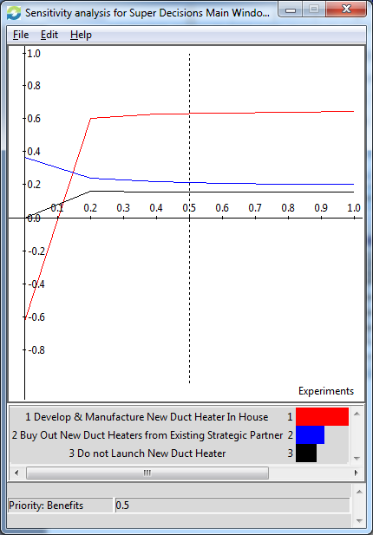
For opportunities, the case was similar to that of benefits. Again over the different values of priorities, the alternative’s rankings did not change.
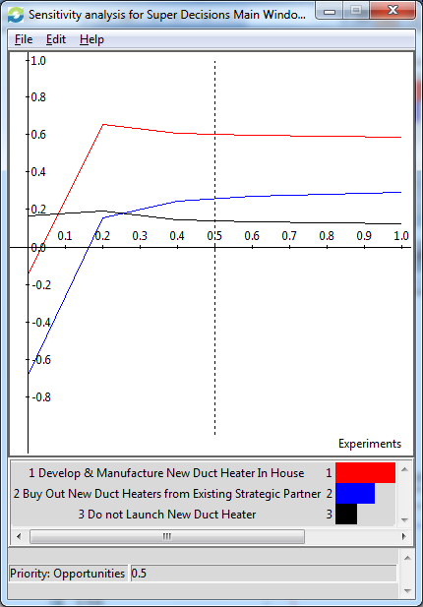
The sensitivity of the Costs network produced different results. As seed below, after reaching a priority of around 0.4, the most desirable alternative changes to “do not launch the new duct heater”. This is a little surprising considering that there is inherent risk in losing sales.
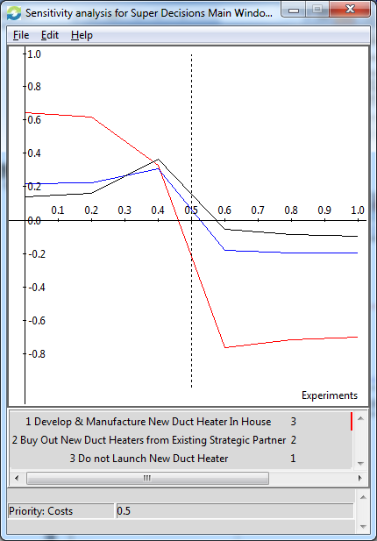
The sensitivity of risks was again similar to costs. When the priority reached a value of 0.5 the most desirable alternative became “do not launch the new duct heater”. Like the costs sensitivity analysis this could be attributed to the low priority given to the possible loss of sales do to not launching.
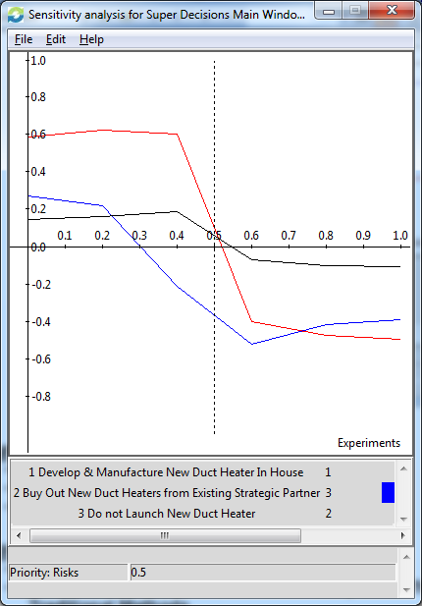

Conclusion

What Did the Model Conclude?
The model concluded that the best decision was to design and manufacture the new duct heater in house. Based on the consistency of the rankings throughout the BOCR networks, this conclusion makes sense.

How Does the Model’s Conclusion Compare to That of Traditional Methods
The interesting conclusion from this exercise was that traditional thinking may have produced a different result. In my opinion, the benefits of the market did not seem to be apparent. The profitability was not very desirable and the amount of effort required by the field sales would make it be difficult to be successful. However my initial prejudices did not take into account several factors that the model did. Specifically, the benefits to other parts of Chromalox’s business and the loss of revenue if the project was not undertaken. In a way what this exercise made me realize is that the new duct heater could be launched under a loss leader strategy. Despite the market for the product being somewhat of a dog, the increase in sales produced by bundling with other products would out-way the low profitability of the duct heater itself.

Future Research

Data Gathering
For future research I would like to gather more data for input into the model. Because this project was done on my own, I think it would be helpful to re-compare some of the different factors with input from others. There also might be additional factors I did not think of.

