Gene Patents and the Societal Impact
Rajiv Dhir, Jay Kolb, Benjamin R. Winfield, Cagatay Yanar
4/20/2010

BQOM 2521 Decision Making in Complex Environments – Spring 2010

1. Introduction

The DNA structure codes for genes. Genes form the basis of life, providing a template from which proteins are formed. These proteins in turn create an organized cascade of events leading to the existence of a “living organism”. Knowledge about the effects of DNA variations among individuals is impacting health care, with the discovery of new ways to diagnose, treat, and someday prevent the thousands of disorders that affect us. Significant federal funding has resulted in the mapping of the human genome (the Human Genome Project or HGP). Generations of biologists and researchers have been provided with detailed DNA information that will be key to understanding the structure, organization, and function of DNA in chromosomes.

All diseases have a genetic component, whether inherited or resulting from the body's response to environmental stresses like viruses or toxins. The successes of the HGP have even enabled researchers to pinpoint errors in genes, the smallest units of heredity, which cause or contribute to disease. The ultimate goal is to use this information to develop new ways to treat, cure, or even prevent the thousands of diseases that afflict humankind. In the meantime, biotechnology companies are racing ahead with commercialization by designing diagnostic tests to detect errant genes in people suspected of having particular diseases or of being at risk for developing them.

Gene tests (also called DNA-based tests), the newest and most sophisticated of the techniques used to test for genetic disorders, involve direct examination of the DNA molecule, or other molecular components (RNA/ micro-RNA). Genetic tests have conventional uses focused on screening for hereditary diseases. However these tests are becoming very critical in oncology, as our understanding of cancer is growing exponentially. Gene tests are now beginning to be used to diagnosis cancers as well provide useful information regarding therapeutic choices.

Gene testing already has dramatically improved lives. Some tests are used to clarify a diagnosis and direct a physician toward appropriate treatments, while others allow families to avoid having children with devastating diseases or identify people at high risk for conditions that may be preventable. An example is the aggressive monitoring for and removal of colon growths in those inheriting a gene for familial adenomatous polyposis; this has saved many lives.

Explorations into the function of each human gene, a major challenge, will shed light on how faulty genes play a role in disease causation. With the growing knowledge in this area, commercial efforts are shifting away from diagnostics and toward developing a new generation of therapeutics based on genes. Drug design is being revolutionized as researchers create new classes of medicines based on a rational approach, directed by the use of information on gene sequence and protein structure function, rather than the traditional trial-and-error method. Drugs targeted to specific sites in the body promise to have fewer side effects than many of today's medicines.

The potential for using genes themselves to treat disease (gene therapy) is the most exciting application of DNA science. It has captured the imaginations of the public and the biomedical community for good reason. This rapidly developing field holds great potential for treating or even curing genetic and acquired diseases, using normal genes to replace or supplement a defective gene or to bolster immunity to disease (e.g., by adding a gene that suppresses tumor growth).

While some of these tests have greatly improved and even saved lives, scientists still remain unsure of how to interpret many of them. Also, patients taking the tests face significant risks of jeopardizing their employment or insurance status,. In addition the sharing of this information can create risks that extend beyond a patient to their family members as well.

What does U.S. patent policy say about gene patenting?

1980 Diamond v. Chakrabarty:
Prior to 1980, life forms were considered a part of nature and were not patentable. Diamond v. Chakrabarty changed this with the 5 to 4 US Supreme Court decision. The Supreme Court decided that genetically engineered (modified) bacteria were patentable because they did not occur naturally in nature. In this case, Chakrabarty had modified bacteria to create an oil-dissolving bioengineered microbe.

Since then patents have been issued on whole genes whose function is known. More recently, inventors began to seek patents on sequences of DNA that were less than a whole gene. The Patent Office has developed guidelines on how to deal with these fragments since they often do not have a known function.

Some patents have been granted for fragments of DNA. That presents the problem of someone trying to patent a larger fragment or gene that contains the already patented sequence. Questions have been raised as to whether the second inventor will need to obtain a license from the first or whether he can obtain the patent without the first patent holder's permission. These types of questions are likely to arise in the near future and will most likely be resolved in courts designated to hear patent actions (create lot of litigation).

Patents have been prohibited by Congress in only a few cases where the issuance of a patent was contrary to the public interest. An example of this was the prohibition of patents on nuclear weapons. The American Medical Association had made a similar request against the patenting of medical and surgical procedures. The US Patent Office has 3 years to issue a patent, after a patent is filed. Patents are good for 20 years from filing date. Drug patents are similar; however they are applied for before clinical trials begin, so the effective life of a drug patent tends to be between seven and twelve years.

Arguments for gene patenting:
- Researchers are rewarded for their discoveries and can use monies gained from patenting to further their research.
- The investment of resources is encouraged by providing a monopoly to the inventor and prohibiting competitors from making, using, or selling the invention without a license.
- Wasteful duplication of effort is prevented.

Arguments against gene patenting:
- Patent holders are being allowed to patent a part of nature –a basic constituent of life; this allows one organism to own all or part of another organism.
- Patents could impede the development of diagnostics and therapeutics by third parties because of the costs associated with using patented research data.
- Costs increase not only for paying for patent licensing but also for determining what patents apply and who has rights to downstream products.
- Private biotechnology companies, who own certain patents, can monopolize certain gene test markets.
- Patent filings are replacing journal articles as places for public disclosure; thereby reducing the body of knowledge in the literature.

The current case that has caused a stir:

Myriad Genetics, a publicly traded company, holds the exclusive rights to perform diagnostic tests on the BRCA1 and BRCA2 genes. Mutations of these genes mutations confer a significantly increased risk of breast and ovarian cancer. Instead of a 12 percent lifetime risk of breast cancer, women who have an abnormal BRCA1 or BRCA2 gene have approximately a 60 percent risk of developing breast cancer. The increased risk of developing ovarian cancer is about 55% for women with BRCA1 mutations and about 25% for women with BRCA2 mutations. The company also holds the rights to future mutations discovered on the BRCA2 gene. University of Utah is either full or partial owner of the BRCA patents.

Currently these tests typically cost around $3500. The medical community believes that the same tests could be performed in laboratories of similar capabilities for 10% of the price charges by Myriad.

The American Civil Liberties Union, and a host of medical organization, filed a lawsuit against the US Patent and Trademark Office, Myriad Genetics, and the University of Utah Research Foundation, challenging the legality and validity of Myriad Genetics' patents for BRCA1 and BRCA2 gene mutations. The lawsuit was filed in the New York Southern District Court. The plaintiffs challenged the legality and constitutionality arguing that gene patents are illegal under patent law because genes are "products of nature. US patent law (35 U.S.C. 101) restricts patenting of "products of nature" and "physical phenomena."

Furthermore, the lawsuit claims that patenting genetic sequences hinders the free flow of information and therefore infringes the First Amendment protecting free speech.
The ACLU specifically decided to take on the USPTO in this lawsuit, because they believe the US government's issuance of "thousands of patents covering human genes" is illegal. According to ACLU's estimates, as much as 20 percent of all human genes are currently patented, including genes associated with Alzheimer's disease, muscular dystrophy, colon cancer, and asthma.

The major argument from the opponents of Myriad’s patents is that Myriad has patented an association between mutations conferring an increased risk of breast or ovarian cancer,. Myriad has patented "an idea, a scientific fact, or a piece of knowledge". This is viewed as a violation of the First Amendment because the government has issued a patent on thought or knowledge. On March 29, 2010, US District Judge Robert Sweet, in a significant ruling, has said that gene patents are invalid. The judge made the point clear when it came to gene patents, saying that they "are directed to a law of nature and were therefore improperly granted."

2. ANP Model
The Analytical Network Process is to be utilized to decide the best option related to gene patent rights and the societal impact. Three alternatives exist related to gene patenting:

Allow gene patenting: this is the status quo, where gene patents can be obtained and rights reserved to the corporation that identified the gene.
Allow Limited Gene Patenting: add tighter stipulations on the conditions of gene patents right (length of time, limit rights, etc…).

Eliminate Gene Patenting: prevent any patenting related to genetics.

In this ANP model, there are four feedback networks of control criteria, one for each of the BOCR (Benefits, Opportunities, Costs, and Risks). All four networks have subnetworks consisting of various Economic, Government, and Social components, and each component has a unique subset of nodes as shown in the following:

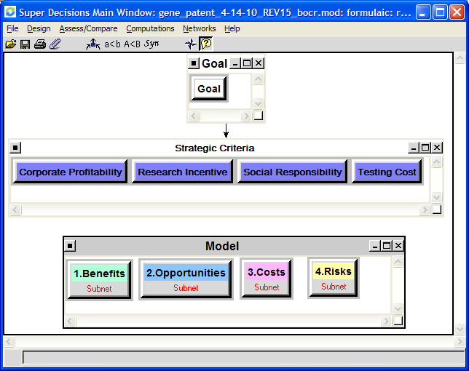

Benefits
To find the alternative that provides the most benefit related to gene patenting, three control criteria were utilized: Economic Benefits, Government Benefits, and Social Benefits, and subnets were developed for each of these criteria. The Economic benefits criteria took into consideration the sub-criteria of: Corporations, Consumer Affordability, Insurance Companies, Government, and Research and Development. The Government benefits include a sub-criteria related to Legal, and the Social benefits considered sub-criteria related to the Health of the General Public. A detailed overview of the Benefits ANP model is shown in Appendix A.

After performing pair-wise comparisons of the criteria, it was found that the alternative of Eliminating Gene Patents provided the most Benefit and that the Social sub-criteria was rated with the highest priority. The following charts show the priorities of the alternatives and the priorities of the Benefits sub-criteria:

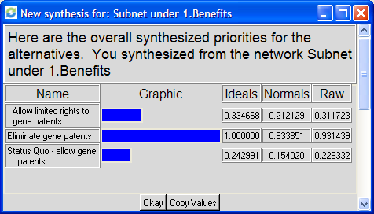

Opportunities
To find the alternative that provides the most opportunity related to gene patenting, two control criteria were utilized: Economic Opportunities and Social Opportunities, and subnets were developed for each of these criteria. The Economic opportunities criteria took into consideration the sub-criteria of: Corporations, Consumers, and Research and Development. The Social benefits considered sub-criteria related to the Health of the General Public. A detailed overview of the Opportunities ANP model is shown in Appendix B.

After performing pair-wise comparisons of the criteria, it was found that the alternative of Eliminating Gene Patents provided the most Opportunities and that the Social sub-criteria was rated with the highest priority. The following charts show the priorities of the alternatives and the priorities of the Opportunities sub-criteria:

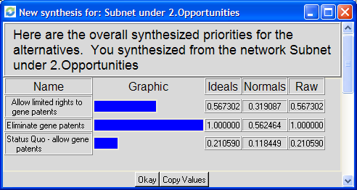

Costs
To find the alternative that provides the most cost related to gene patenting, three control criteria were utilized: Economic Costs, Government Costs, and Social Costs, and subnets were developed for each of these criteria. The Economic costs criteria took into consideration the sub-criteria of: Consumers, Insurance Companies, Government, and Research and Development. The Government costs include sub-criteria related to Legal and Regulation (by the FDA). For the Social costs, sub-criteria were developed related to the Health of the General Public and the Psycho-Social costs. The Psycho-Social impact is related to the ability to use gene testing for discrimination and the impact related to maternity/paternity decisions regarding having children. A detailed overview of the Costs ANP model is shown in Appendix C.

After performing pair-wise comparisons of the criteria, it was found that the alternative of Allowing Full Gene Patents was most costly and that the Social sub-criteria was rated with the highest priority. The following charts show the priorities of the alternatives and the priorities of the Costs sub-criteria:

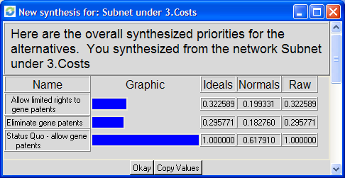

Risks
To find the alternative that provides the most risks related to gene patenting, two control criteria were utilized: Economic Risks and Social Risks, and subnets were developed for each of these criteria. The Economic risk criteria took into consideration the sub-criteria of: Corporations, Consumers, Insurance Companies, Government, and Research and Development. The Social risks considered sub-criteria related to the Consumer Safety and Psycho-Social Impacts. A detailed overview of the Risks ANP model is shown in Appendix D.

After performing pair-wise comparisons of the criteria, it was found that the alternative of Eliminating Gene Patents provided the most Risks and that the Social sub-criteria was rated with the highest priority. The following charts show the priorities of the alternatives and the priorities of the Risk sub-criteria:
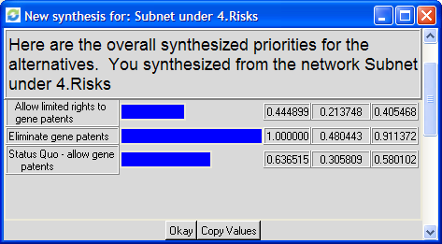

Pair-wise Comparison
Using the alternatives and the criteria described in the above sections, Table 1 on the following page identifies the priority value for each criteria.

Table 1: Criteria and Priorities

Strategic Criteria and BOCR Criteria
Ratings were produced to determine the importance of the Benefits, Opportunities, Costs and Risks associated with choosing the best gene patenting alternative. The decision-making model employed strategic criteria consisting of:

Corporate Profitability: the ability for corporations to maintain a financial success.

Research Incentive: the ability and drive to expand experiment research.

Social Responsibility: the responsibility to provide “the greater good” by improving the health of society.

Affordability: the costs associated with testing/screening for genetic health concerns.

A rating system was implemented to compare the BOCR against the strategic criteria. The BOCR were rated on a scale of Hi (1.0), Medium (0.347), and Lo (0.080). The following table summarizes these results and shows the priorities of the strategic criteria and BOCR:



The most important BOCR criteria in the model are Costs and Opportunities followed by Benefits, and Risk was viewed as the lowest criteria. These priorities show a relatively close comparison for Benefits, Opportunities, and Costs which means that these are crucial factors in determining what type of direction of future gene patents, while Risks is shown to have less influence on the decision.

Section 3: Results

Prior to the construction of the model, the authors of this paper felt that allowing limited gene patents would likely be the best decision; however, after viewing the results of the Benefits, Opportunities, Costs, and Risks model, it was clear that the elimination of gene patents was the most attractive alternative. While a complete elimination of gene patents was found to be the most risky alternative, Risk had the least weight out of the four main criteria. A domination of the Benefits, Costs and Opportunity criterion, which all carried equally heavy weight, lead to the overwhelming victory of the elimination of gene patents in the results of the model. As seen in the charts below, elimination of gene patents is equally attractive in both the long and short term.

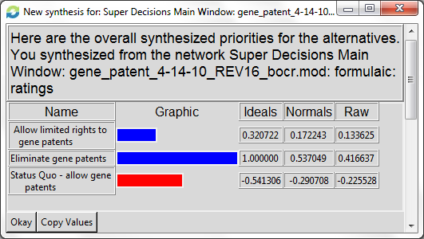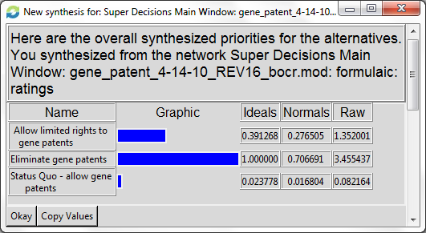

Also seen in these charts, allowing gene patents, which is the status quo, is found by the software to be the least attractive decision. Interestingly enough, allowing gene patents was found to be more attractive in the long-term, where it has a very small positive rating, than in the short term, where it is seen as an overwhelmingly negative decision. One possible explanation for this is that there is more monetary incentive for research currently, with gene patents in place. Thus, the decision to allow gene patents could hold at least some benefit in the future. However, right now tests are expensive because of monopolies due to gene patents, which impedes research and slows progress in the field of medicine.

Allowing limited gene patents was found to be a choice in both the long and the short term. It was viewed more positively in the long term than in the short term, which can be attributed to the fact that it carries with it the same incentive for research that allowing gene patents carries with it, but on a smaller scale.

Section 4: Sensitivity Analysis

The following are the results of sensitivity analyses on the four overall merits of the model.

Benefits

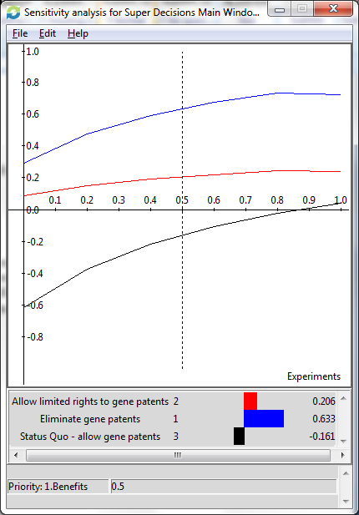

As can be seen from the above graph, regardless of how heavily the Benefits network is rated, the elimination of gene patents is still seen as the most attractive decision. Although the status quo is the least attractive decision regardless of the weight of the Benefits network, it positively correlates with the weight of the Benefits network.

Opportunities

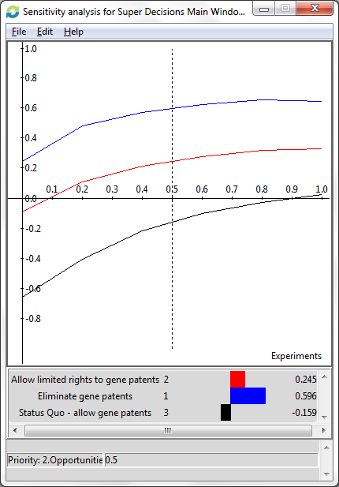

The sensitivity analysis of the Opportunities network in the model has results very similar to the sensitivity analysis of the Benefits network. The elimination of gene patents is seen as the most attractive choice, regardless of the weighting of the opportunities network. Once again, the status quo is always seen as the least attractive decision, but it becomes more attractive as the weight of the Opportunities network increases.
Costs

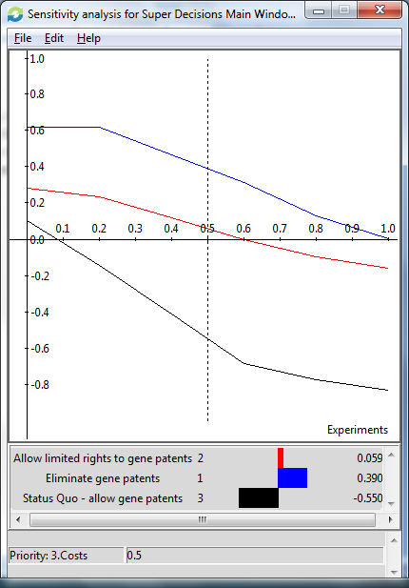

Similar to the previous analyses, the sensitivity analysis for the Costs network shows the elimination of gene patents as the most attractive decision and the status quo as the least attractive decision, regardless of the weight put on the Costs network. It appears that all of the choices generally become less attractive as weight of the Costs is increased.
Risks
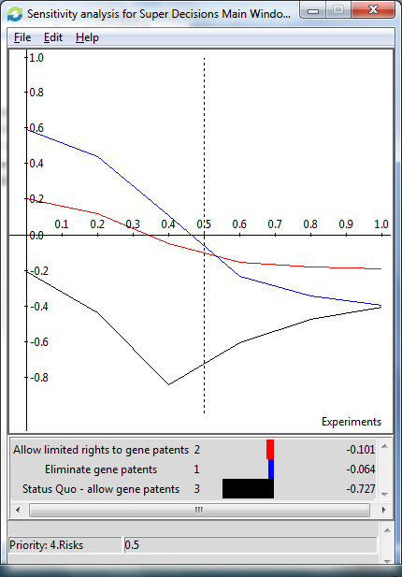

The sensitivity analysis of the Risks network is unique when compared to the other sensitivity analyses of the decision model, as the rankings of decisions change when the weight of the Risks network is modified. As weight on the Risks network increases, the decision to eliminate gene patents becomes less and less attractive, falling first below allowing limited rights to gene patents and eventually becoming about equal in attractiveness to a decision to maintain the status quo. Allowing limited rights to gene patents becomes the attractive choice when the Risk priority is over 55%.
Appendix A – Benefit Model Overview

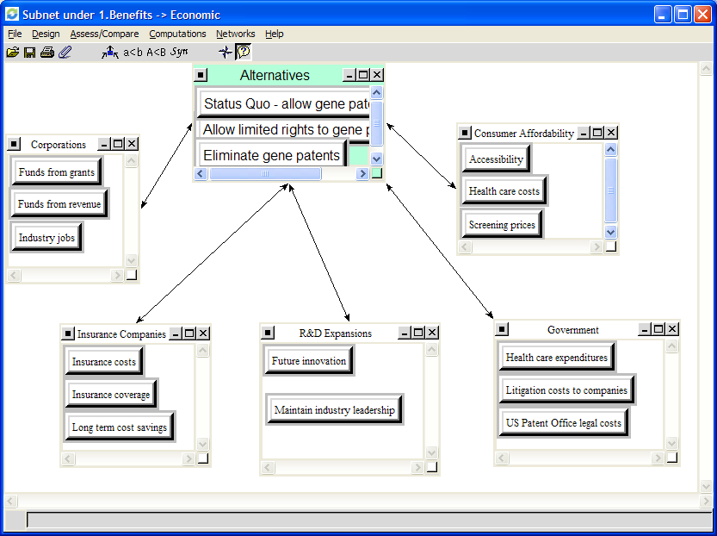

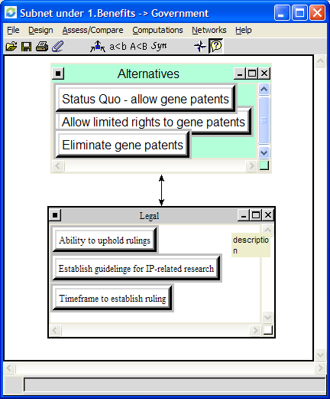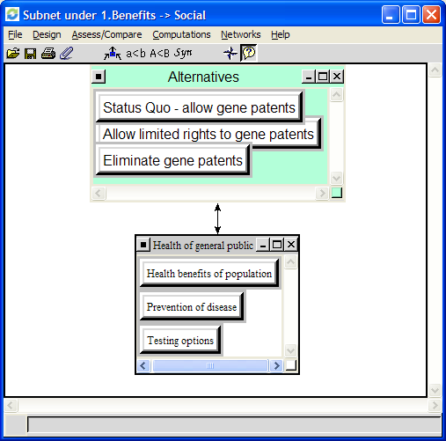
Appendix B – Opportunities Model Overview

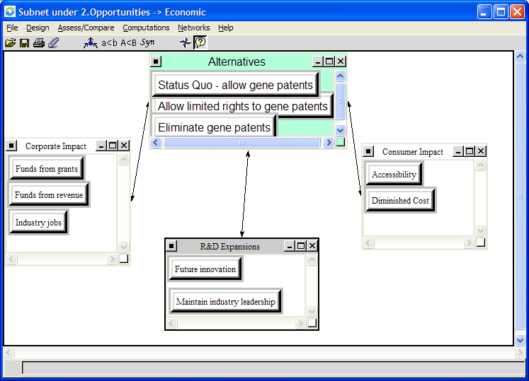
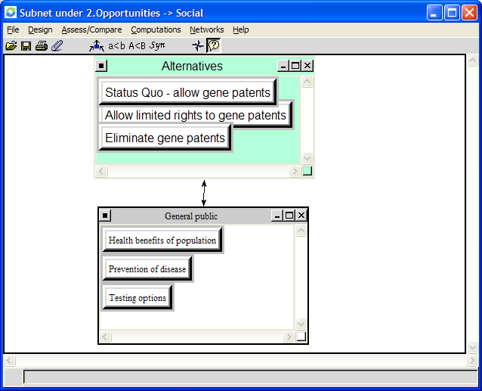
Appendix C – Costs Model Overview

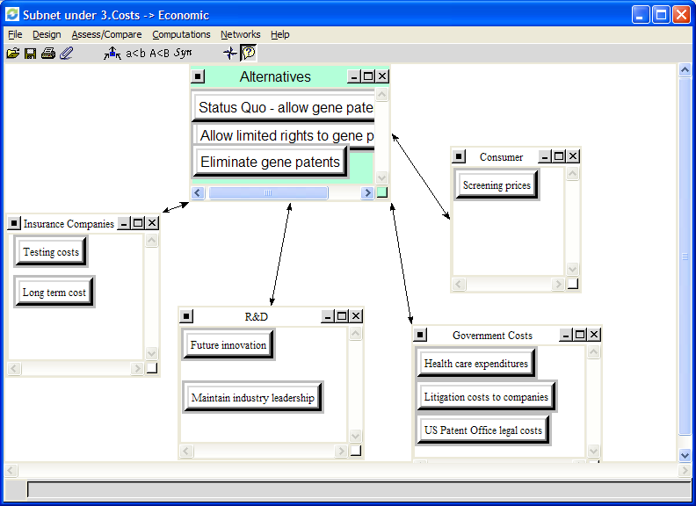

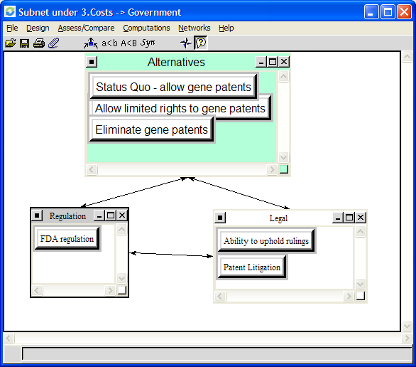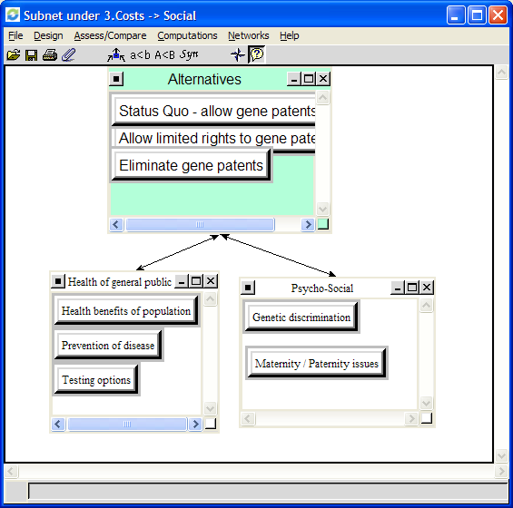

Appendix D – Risks Model Overview

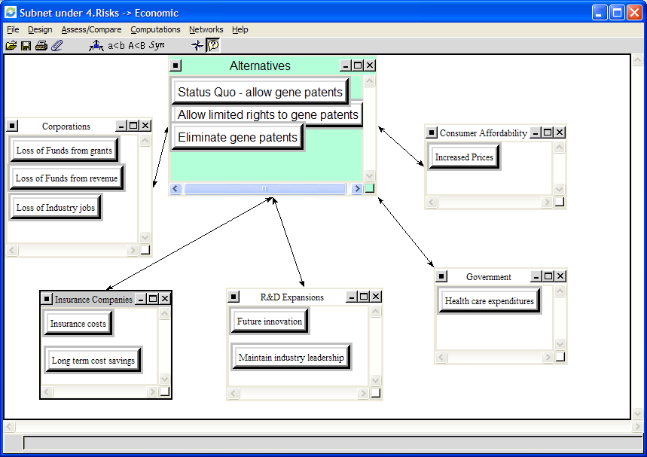

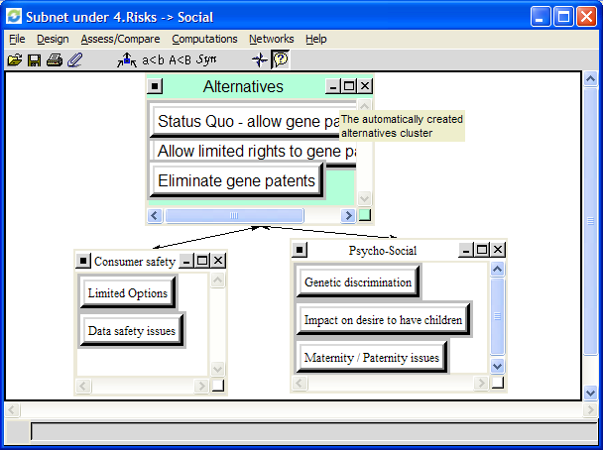

Discrimination as a Consequence of Genetic Testing. Paul R. Billings, Mel A. Kohn,t Margaret de Cuevas, Jonathan Beckwith, Joseph S. Alper, and Marvin R. Natowicz. Am. J. Hum. Genet. 50:476-482, 1992.
Genetic Testing and Insurance, http://www.cnn.com/HEALTH/bioethics/9808/genetics.part2/template.html
Gene Patenting — Is the Pendulum Swinging Back? Aaron S. Kesselheim, M.D., J.D., and Michelle M. Mello, J.D., Ph.D. The New England Journal of Medicine. April 7, 2010
Myriad's BRCA Patents Not Only Illegal, but Also Unconstitutional, ACLU Lawsuit Alleges. May 13, 2009. Turna Ray. http://www.genomeweb.com/dxpgx/myriads-brca-patents-not-only-illegal-also-unconstitutional-aclu-lawsuit-alleges

