Entrepreneurial
Decision

Decision Making in Complex Environments Final Project - April 20, 2010

Rohan Adwalpalker
Karma Edwards
Travis Wagner
EXECUTIVE SUMMARY

Entrepreneurs must beat incredible odds to achieve positive cash flow and personal satisfaction. Success in business is often based on the ability to plan well and make good decisions. Our team utilized the Super Decision Software to make the first, all-important decision: What start-up business has the most potential to achieve the multi-faceted experience of true success? By following the methods and progressive steps necessary to build hierarchies and networks, we created decision goals, clusters, nodes, criteria, subnets and sub criteria. To reach the goal of making a good decision, we chose three businesses as alternatives: 1) Consulting Firm; 2) Computer Service Business; and, 3) Nike Retail Store. From the inputs, subsequent ratings and pair-wise comparisons, we were given our answer. The Consulting Firm start-up idea garnered a top score, followed closely by the launching of a Computer Service Business, while the Nike Retail Store lagged significantly behind.

Background and Methods
According to the Small Business Association of America (SBAA), more than half of all small businesses started in the United States fail within the first four years. This makes it crucial for entrepreneurs to have a clear idea of what it entails to start and operate a specific business and what level of challenges and returns they can expect. To increase the odds of success, Gaebler Resources for Entrepreneurs (http://www.gaebler.com/Small-Business-Failure-Rates.htm) outlines four important characteristics that must be possessed or developed by any entrepreneurial hopeful. These characteristics include: An attitude of success; The stamina to sacrifice; A high tolerance for risk; and, The ability to plan.

There are an infinite number of business opportunities available and numerous criteria to evaluate them. However, for the purposes of this project, we decided to focus on three specific businesses as our final alternatives because each start-up represented one of our personal ideals for the perfect business. We also felt that all three endeavors offered variety for our model, requiring different types of inputs and possessing varying paybacks. The three business alternatives were:
- Consulting Firm: This firm would begin with just one consultant and be very knowledge intensive. It would require a great deal of networking and the establishment of credibility and trust.
- Computer Service Business: This business would also begin with just one employee and be very labor intensive. It would allow the entrepreneur a great deal of self direction and the ability to determine working hours.
- Nike Retail Store: This business would be very capital intensive. It would also require additional employees to provide customer service.

In our earliest discussions of this project, we realized that the concept of the American Dream of Rags to Riches was not a complete concept upon which to base our decision model. We believed that the meaning of successful had to include additional factors in order to accurate portray our values and beliefs. To begin building our model, we designated Best Entrepreneurial Choice as our goal and created four basic criteria to judge our alternatives: Work Life Balance; Self Direction; Financial Gain; and, Status.

We have reproduced a basic outline of the model below:

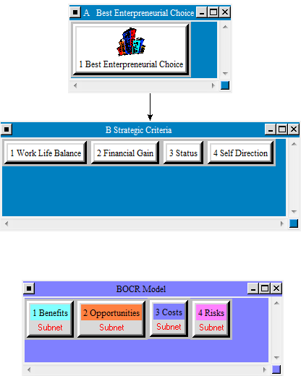

The next step was to create a Benefits, Opportunities, Costs and Risks cluster (BOCR) with subnets and sub criteria for evaluation and pair-wise comparisons. A listing of the BOCR subnets and sub criteria follows:

The Benefits Subnet

Financial Gain Sub Criteria
- Increased Disposable Income
- Material Possessions
Self Direction Sub Criteria
- Self Fulfillment
- Time Management
Status Sub Criteria
- Network Power
- Respect
Work Life Balance Sub Criteria
- Health Benefits
- Time with Family
- Philanthropy

The Opportunities Subnet
Financial Gain Sub Criteria
- Increased Disposable Income
- Material Possessions
- Comfortable Retirement
Self Direction Sub Criteria
- Self Fulfillment
- Time Management
Status Sub Criteria
- Network Power
- Respect
- Social Advancement
Work Life Balance Sub Criteria
- Health Benefits
- Time with Family
- Philanthropy

The Cost Subnet

Financial Gain Sub Criteria
- Higher Tax Bracket
- Material Possessions Maintenance and Storage
Status Sub Criteria
- Greater Professional Responsibility
- Greater Personal Responsibility
- Greater Social Responsibility
Work Life Balance Sub Criteria
- Family Expense
- Philanthropy Expense

The Risk Subnet
Financial Gain Sub Criteria
- Questionable Retirement
- Bankruptcy
- Material Repossession
Self Direction Sub Criteria
- Client Demands
- Very Long Hours
Status Sub Criteria
- Failure
- Social Decline
Work Life Balance Sub Criteria
- Family dysfunction
- Longevity Expense
- No Family Time
- Physical / Mental Health risk

Reproductions of the four BOCR subnets and Sub Criteria follow on the next two pages:

Benefits Subnet and Sub Criteria
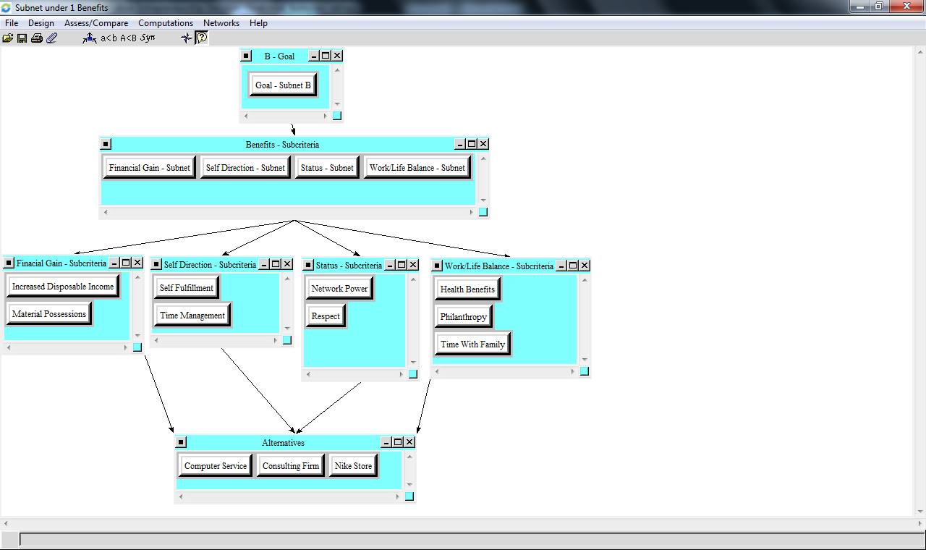

Opportunities Subnet and Sub Criteria
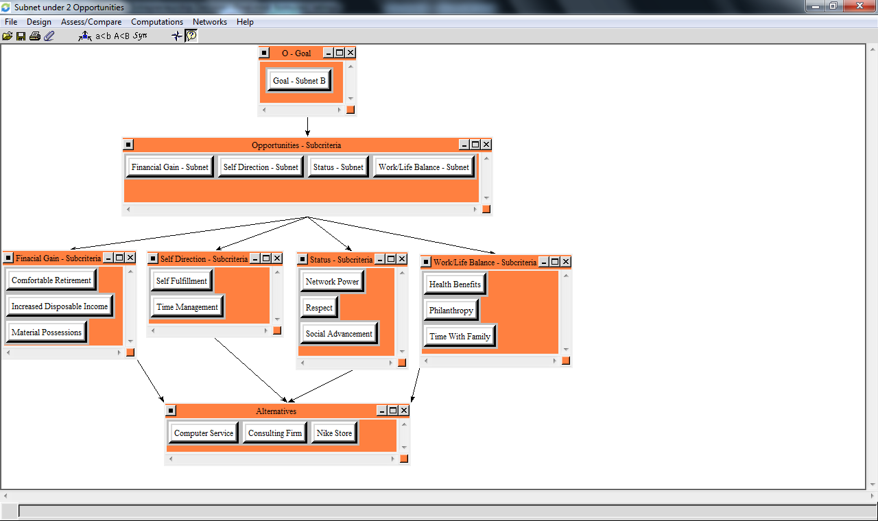
Costs Subnet and Sub Criteria
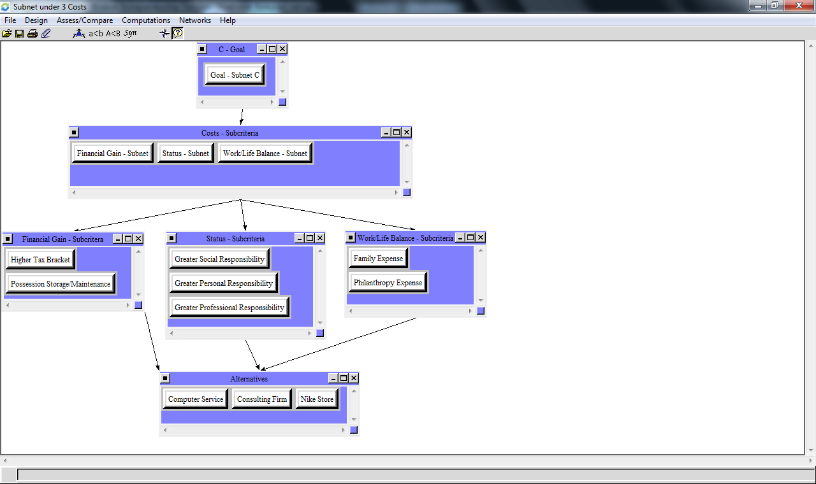

Risks Subnet and Sub Criteria
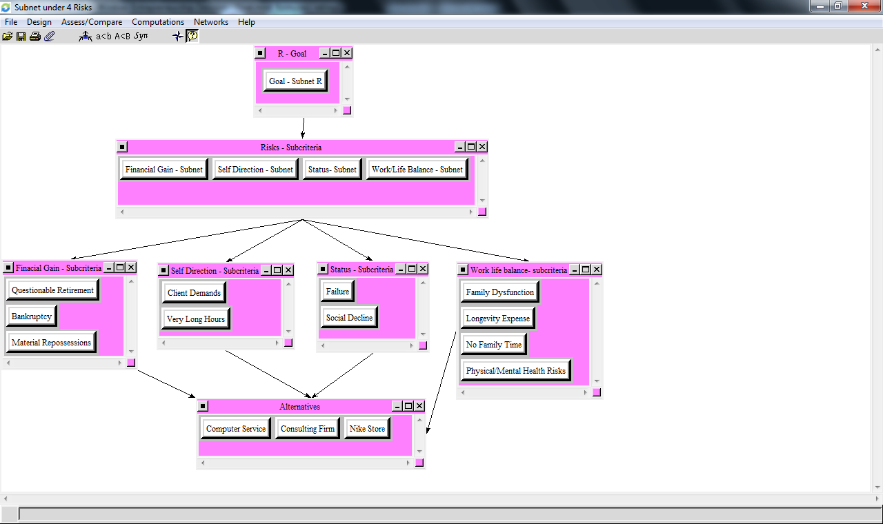
We have also reproduced several sample screenshots from our multiple pair-wise comparisons below:

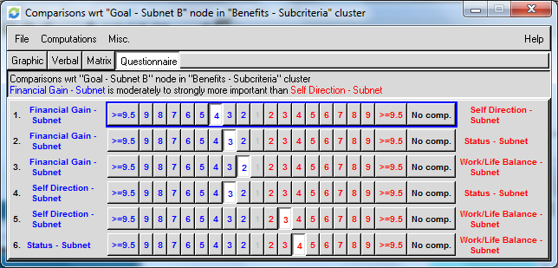
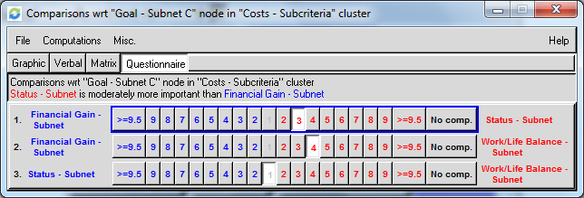
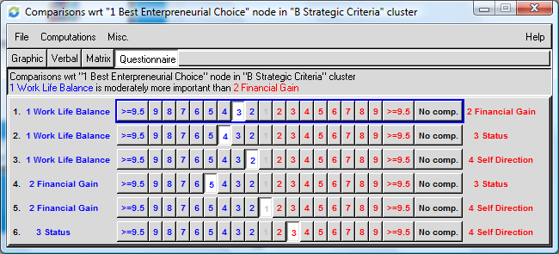
Final Decision

We synthesized results for the whole model, created the Super Decisions Ratings and then ran sensitivities for each of the BOCR subnets. Results are found below and on the following page:

Whole Model Synthesis
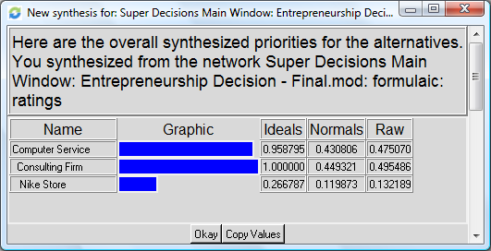

Ratings for Super Decision
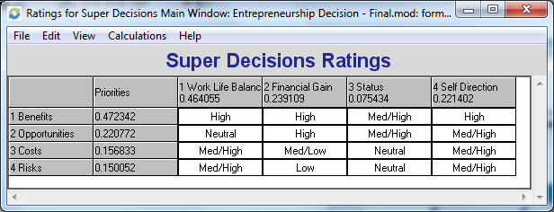

BOCR Sensitivities
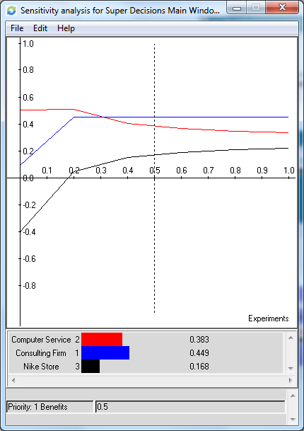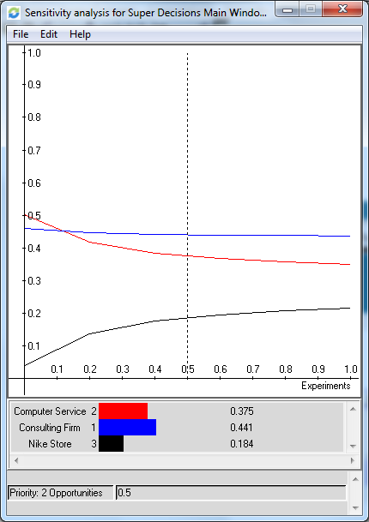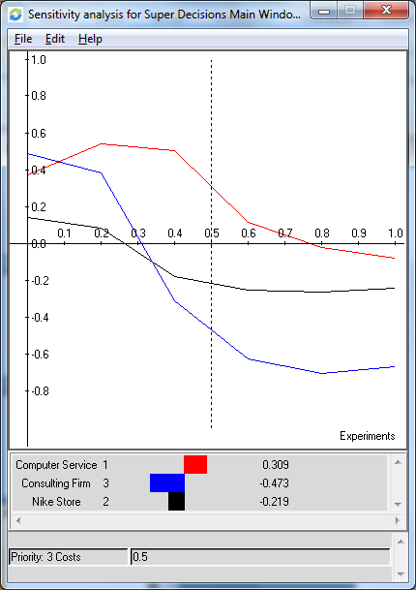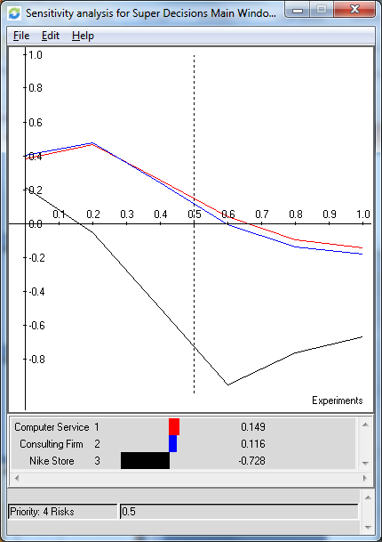

We discovered that the ratings, whole model synthesis, and sensitivities were very closely entwined. When we were building our ratings, we mistakenly placed our criteria in the left-hand column instead of the alternatives. Consequently, we were unable to produce any accurate whole model synthesis or BOCR sensitivities. Once the proper corrections were made, the information cascaded outward to the appropriate model components and we were able to continue our work.

What probably surprised us the most was that we felt forced into making certain pair-wise comparisons based on the sanity checks. Often, the numerical value recommended by the Super Decision software was not anywhere close to our intuitive choice. As the course book: Group Decision Making: Drawing Out and Reconciling Differences, described so well, “…the human mind is inherently inconsistent, good decisions need a consistent mind.”

Conclusion

Based on the results of our Entrepreneurial Decision model, we concluded that a Consulting Firm (0.449321) was the best choice for a business start-up, since it had a high rate of return and relative personal flexibility, followed closely by the Computer Service Business (0.430806) weighing in heavily due to its positive Work Life Balance factors. The Nike Retail Store (0.119873) ended up as the least desirable alternative owing to its high capital and inventory investment, burdensome overhead and required additional personnel costs. In conclusion, we felt that the Super Decision modeling helped us work together to produce a rational, consistent and defensible decision.

