BQOM 2521 – Decision Making in a Complex Environment
Katz Graduate School of Business

ANP Model for the prediction the most attractive New Market for ‘Pitt Robotics’

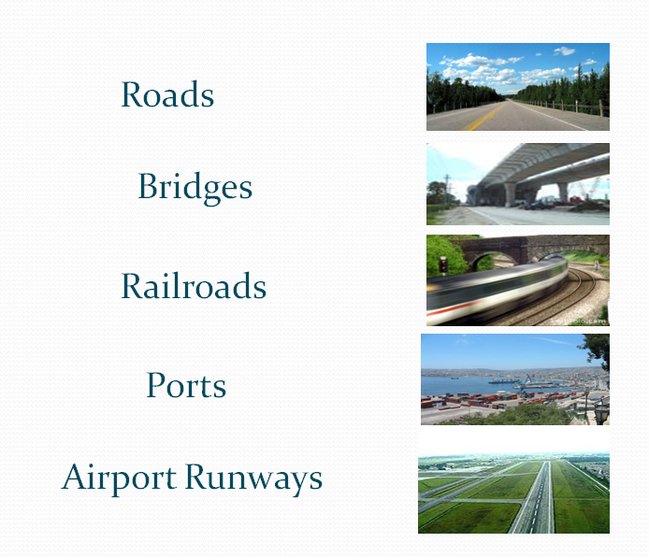

Hong-Chien Chen
Marcelo Hermosilla

Table of Contents

- Introduction
- Alternatives
- Strategic Criteria
- BOCR Model
  - Benefits
    - Benefits Subnet
  - Market
1.2 Internal Conditions
    - Sensitivity Analysis
    - Conclusions - Benefits
  - Costs
    - Costs Subnet
  - Internal conditions
1.2 Financing
    - Sensitivity Analysis
    - Conclusions - Costs
  - Opportunities
    - Opportunities Subnet
  - Market
1.2 Internal Conditions
    - Sensitivity Analysis
    - Conclusions - Opportunities
  - Risks
    - Risks Subnet
  - Market
1.2Financing
    - Sensitivity Analysis
    - Conclusions - Risks
- General Conclusions

Introduction
During the recent Project Course, we (a team of 4 MBA students) worked with a Pittsburgh based Robotic Company in developing a group of new market alternatives (applications) for the company existing technology.

Since there’s some confidentiality issues, we will call them ‘Pitt robotics’, and will discuss only general characteristics of the company.
- ‘Pitt Robotics’ market leader in Robotic pipe inspection
- High volume low cost inspection of the physical world. Digitize with very accurate resolution
- Part of their competitive advantage based on movable scanning of different surfaces (along a pathway).
- Searching to extend their technology to a different market (application).
Our Project Course Team reduced the number of possible markets from 20 to 5. Among the criteria we used: Analysis of Market Structure (Important players, Concentration ratio), description of entry barrier (regulations, Industry standards), consultations with Experts.

The purpose of this Decision Making project is to predict which of the 5 markets pre-selected should present higher possibilities of success for the company.

Alternatives
1. Railroads 2. Airports
3. Ports 4. Bridge
5. Roads.

Strategic Criteria
- The strategic criteria of this model are:
Profit s, Fit with PR, and Market Attractiveness
The following chart demonstrates the priorities of each criterion.
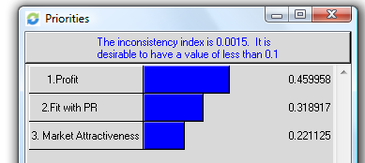

- BOCR Model

The model we chose to create was a BOCR model. This type of model focus on the main goals and strategic criteria linking to benefits, costs, opportunities, and risks. According to different criteria and BOCR analysis, we will make the best decision to choose the alternatives.

- Strategic Criteria:
The strategic Criteria of the model are: Profit, fit with PR, and attractiveness. The following chart demonstrates the priorities of each criterion.
Here are the model of BOCR and priorities of strategic criteria
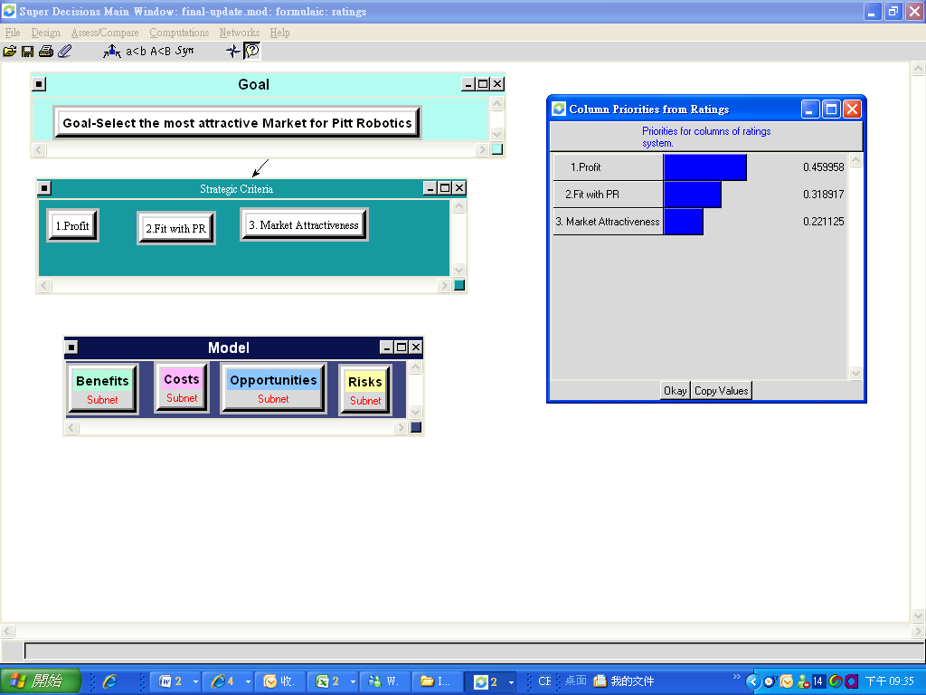

- Result of rating the BOCR using the strategic.
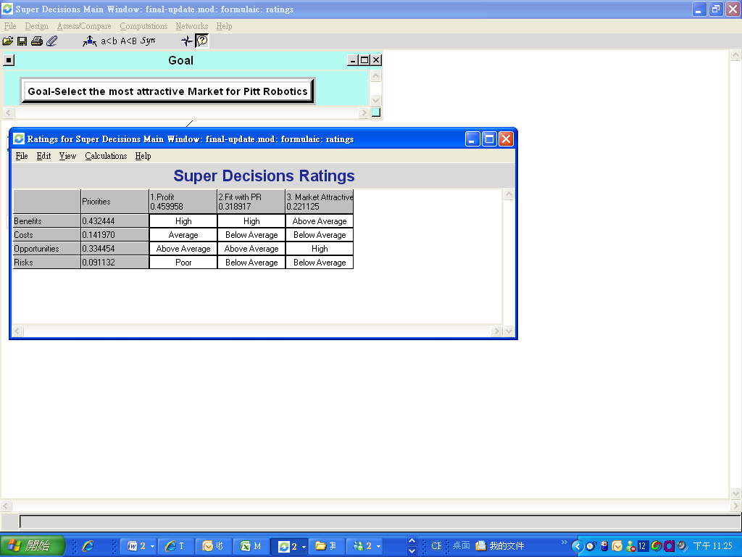
The result shows that the most important merit is benefits at 43.2% followed by Opportunities at 33.4%. This indicates that the priorities of the alternatives under benefits are weighed more heavily. Benefits at 43.2% influence the decision more than the risks at 9.1%.

- BOCR Model
Model | Criteria | Sub-Criteria
Benefits | Market  Internal conditions | size/value delivered/barrier to entry/quality
Opportunity | Internal conditions  Financing | execution costs  set up
Cost | Market  Internal conditions | volume/competition/environment  R&D/new patent
Risk | Market  Financing | entrance  financial

- Benefit
- Benefits Subnet:
Under the “Benefits” subnet, two control criteria are included, which are market and internal conditions. Each control criterion will affect benefits according to the level of sub-criteria.
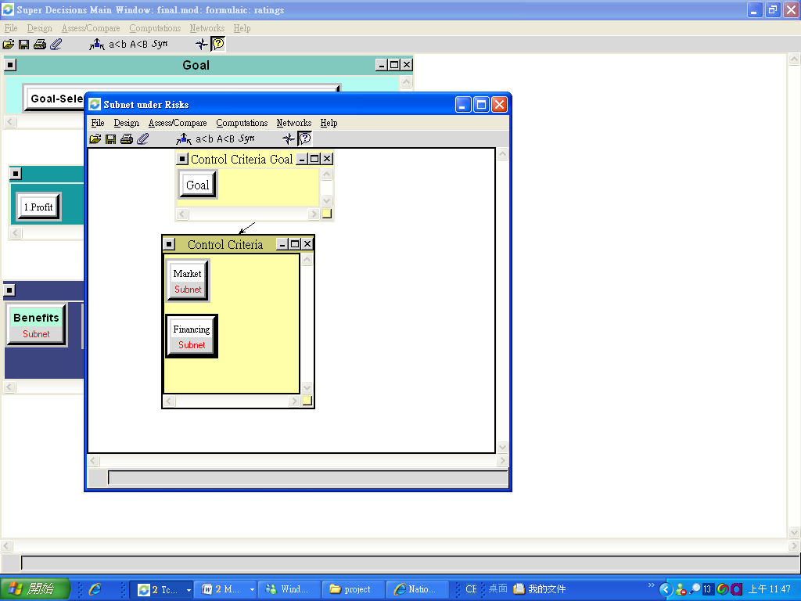

  - Market Benefit:
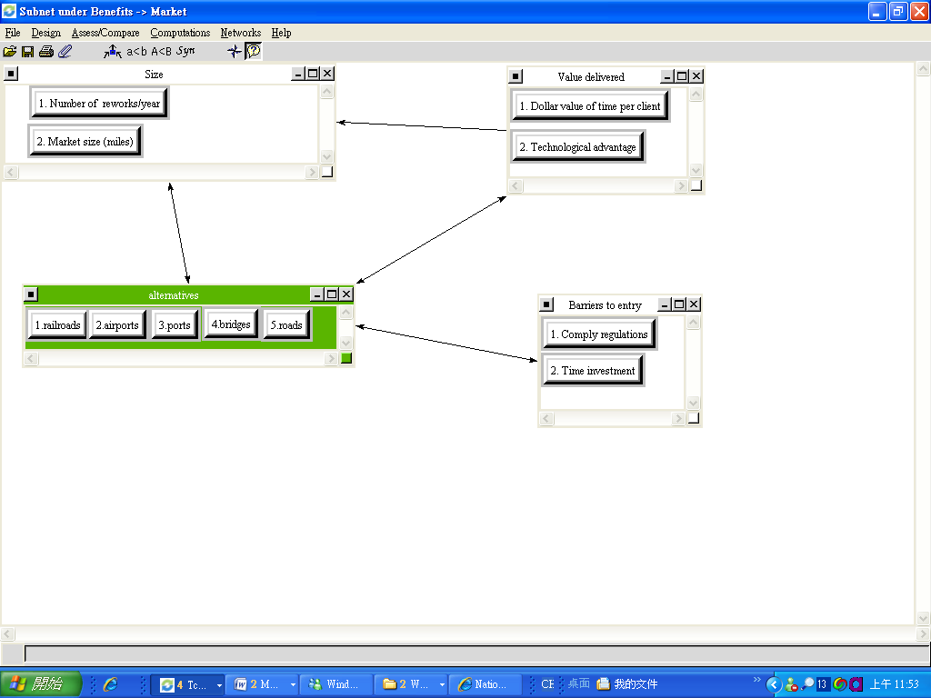
Under the criterion of market, market size, value delivered, and barrier to entry will link to alternatives with different levels.

As the chart shows above, we create the nodes which belong to size, value delivered, and barrier entry.

  - Internal Conditions Benefits:
This criterion is affected by PR’s strength that could create value to the Company. The sub-criterion is quality including PR’s quality and competitors’ quality.

- Sensitivity analysis - Benefits
In terms of “Benefits”, “Roads” is best market for PR to enter. However, as the priority of Benefit decrease till to 19.48% or lower, “Airports” will surpass “Roads” becoming the best choice for PR.
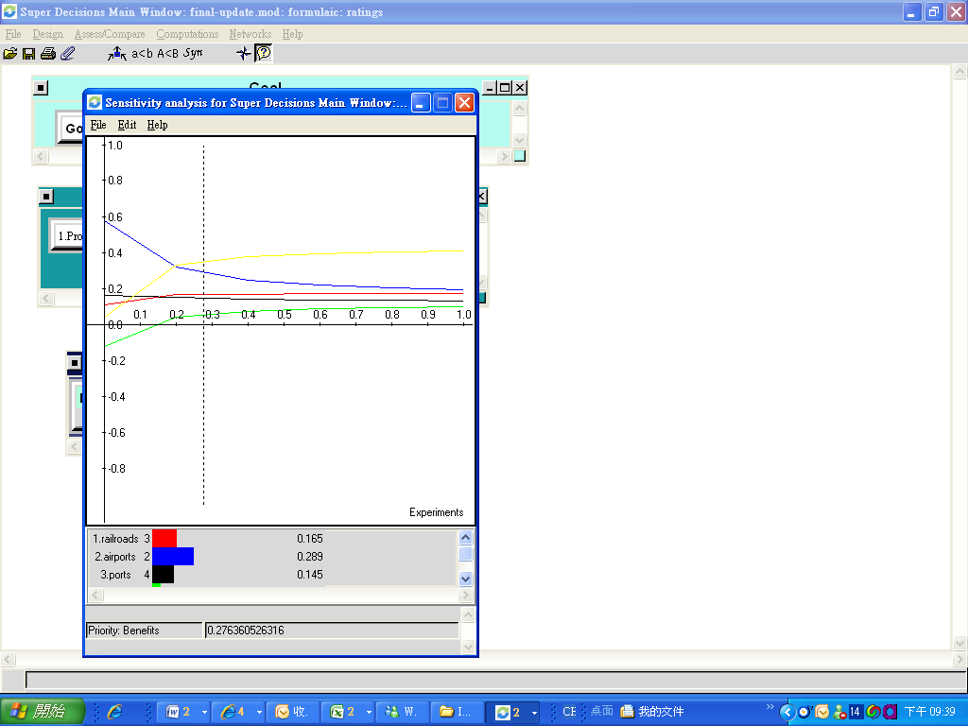

- Benefits - Conclusions
Considering the control criteria and sub-criteria, the following sheet demonstrates that under “Benefits”, entering “Roads” market will bring the highest benefits to PR.
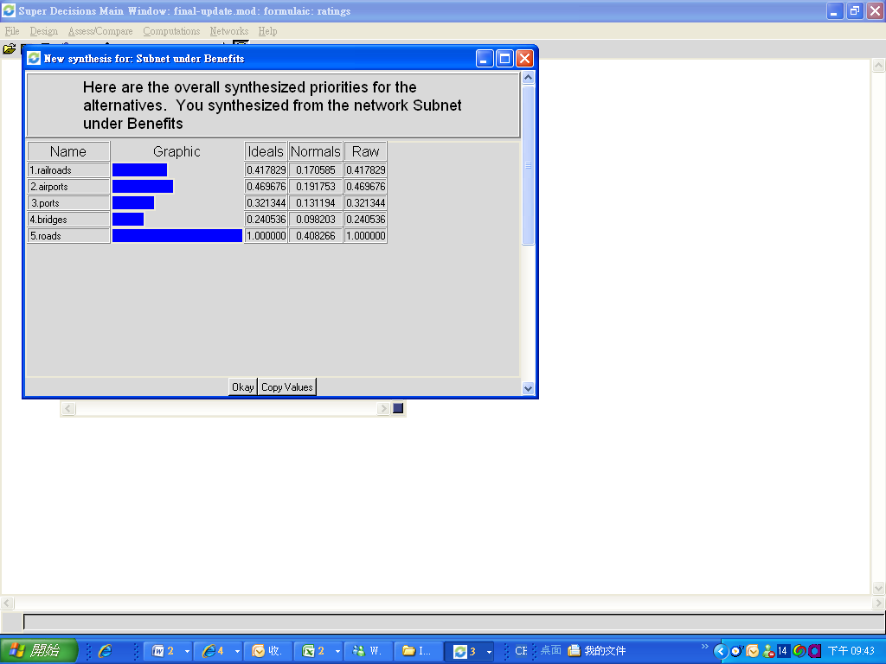

- Costs:
- Costs Subnet
Under the “Costs” subnet, two control criteria are included, which are internal conditions and financing. Each control criterion will affect costs according to the level of sub-criteria.
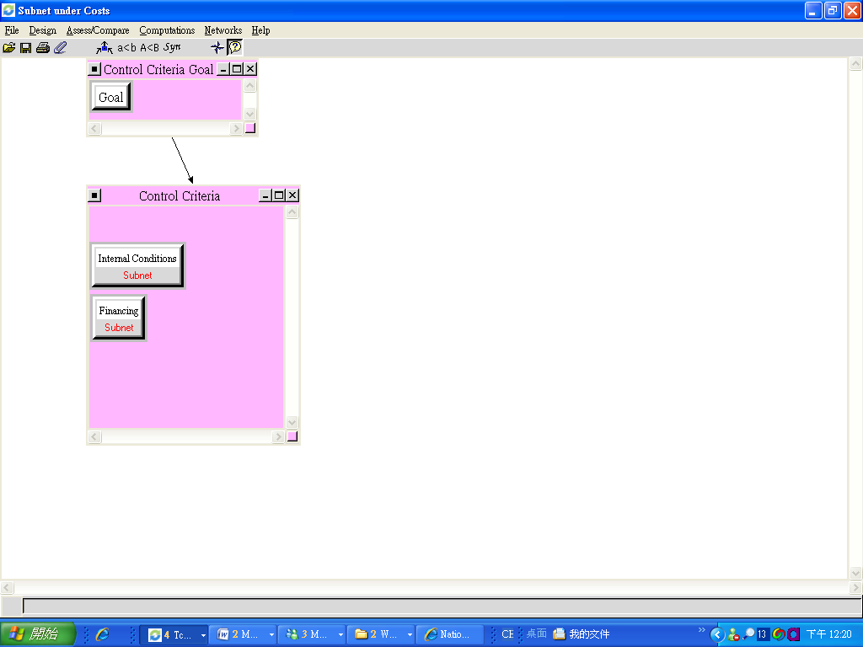

  - Internal Conditions Costs.
When PR enters a new market, cost plays an important role of profits of a company. For this industry, we identify two different costs comprising costs per mile and rework costs.
  - Financing Costs
Under the financing criterion, there are two criteria that affected costs: set up and optional. We need to concern with entrance of a big size market that probably will create higher sales or revenues. On the other hand, the higher of costs rate will reduce the total company’s profits. So profit margins will affect the decision making. The following sheet shows subnet under costs-financing and costs-internal conditions.
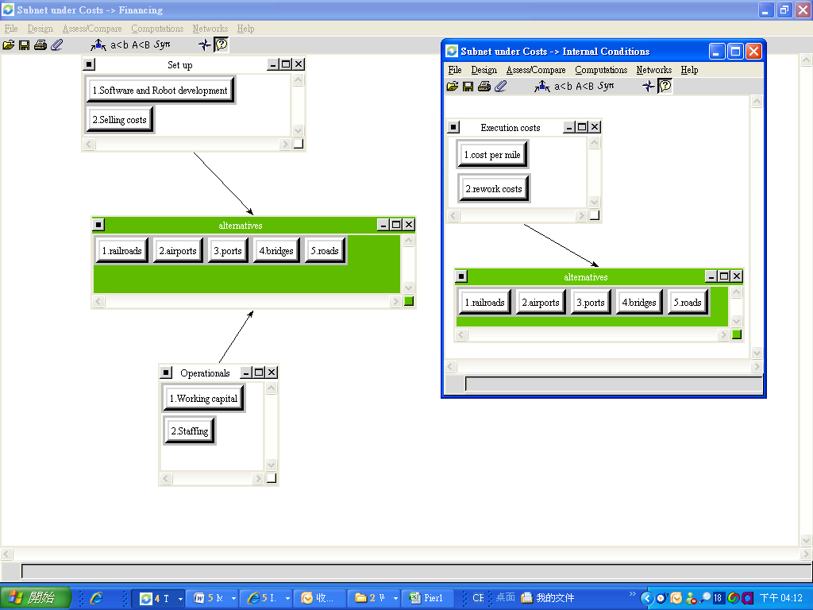
- Sensitivity analysis – Costs
“Roads” is best market for PR to enter regardless of how the priority of the Costs changes. And “Bridges” will cost at most. However, as the priority of Costs increase, the difference between “Roads” and “Railroads” will close to each other.
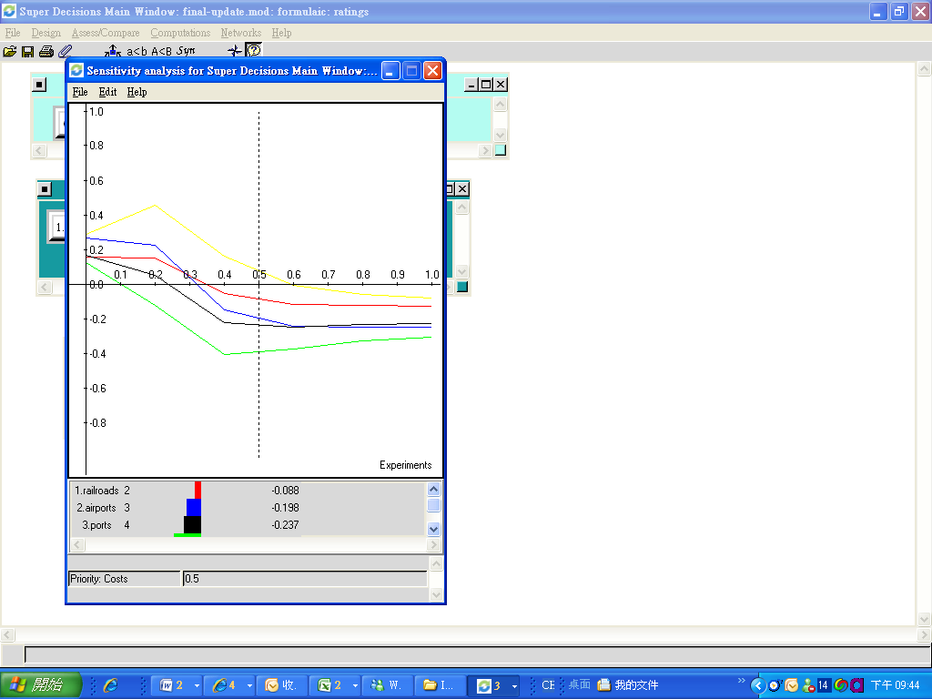

- Costs- Conclusions
Considering the control criteria and sub-criteria, the following sheet demonstrates that under “Costs”, entering “Roads” market will bring the highest costs to PR.

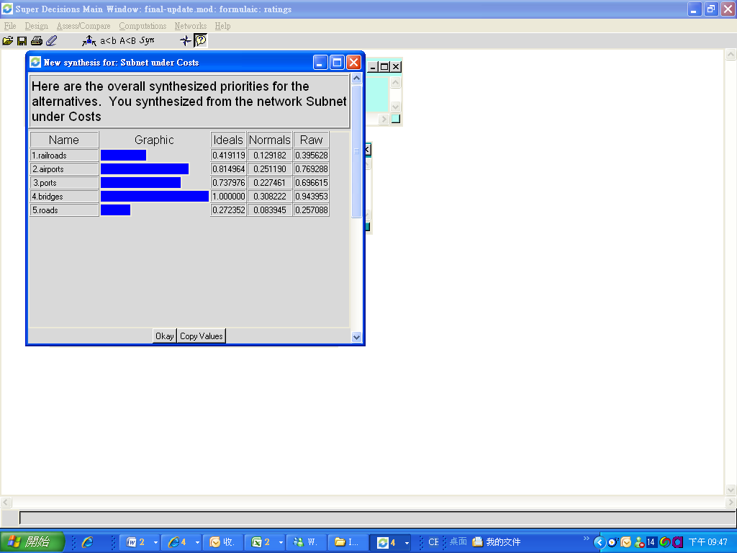
- Opportunities

1. Opportunities Subnet:
Under the “Opportunities” subnet, one control criterion is included, which is market. For PR’s opportunities, most of them are created from market so it’s reasonable to create sub-net under market of control criterion.

1.1 Market Opportunities.
Market is affected by volume, competition, and environment. Potential market size and number of clients will affect future market opportunities. Under the competition, if PR becomes the first mover or have good relationship with related companies which are already in these five markets, advantages of first movers or partnership will raise more opportunities. Environmental regulations will limit the opportunities of market.
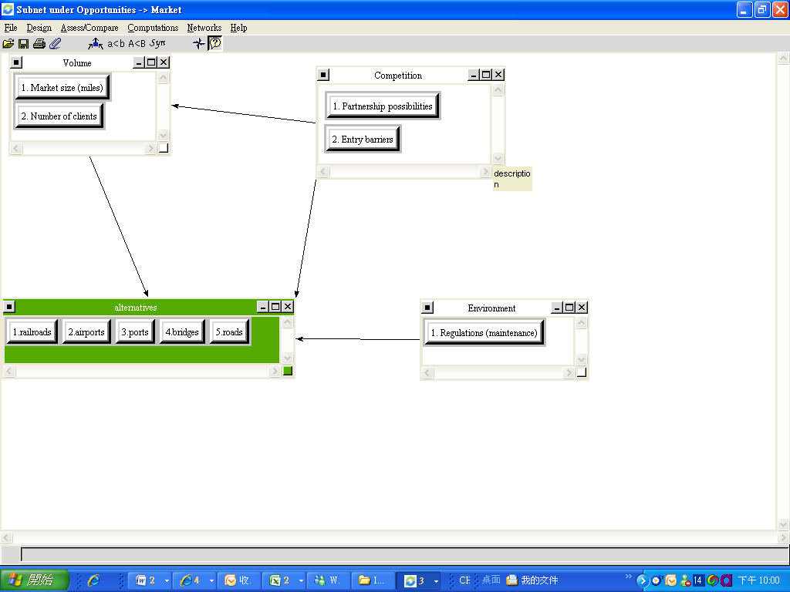
1.2 Internal Conditions Opportunities.
How to grab opportunities of future trend is key point to achieve the gold – select the most attractive market for Pitt Robotics. R & D expenses and patent development are the signs of success and competitive ability.

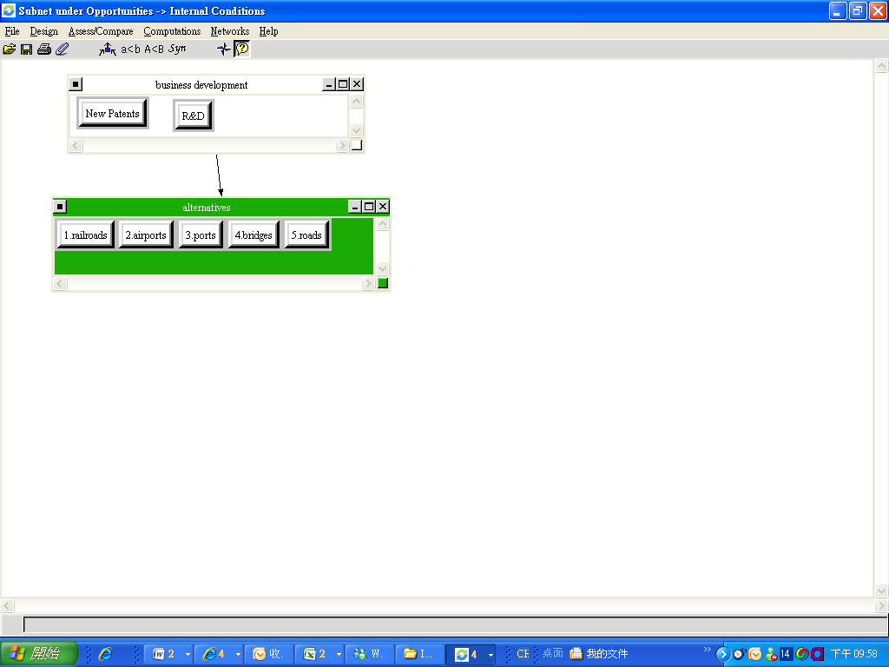

2. Sensitivity analysis – Opportunities

If the priority is more than 31.85%, “Airports” will have more opportunities for PR to create more profits.
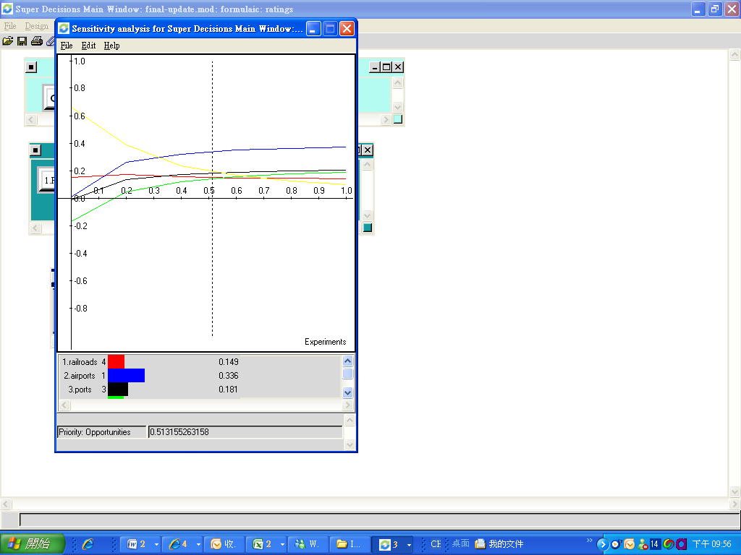

3. Benefits- Conclusions
Considering the control criteria and sub-criteria, the following sheet demonstrates that under “Opportunities”, entering “Roads” market will bring the most opportunities to PR.
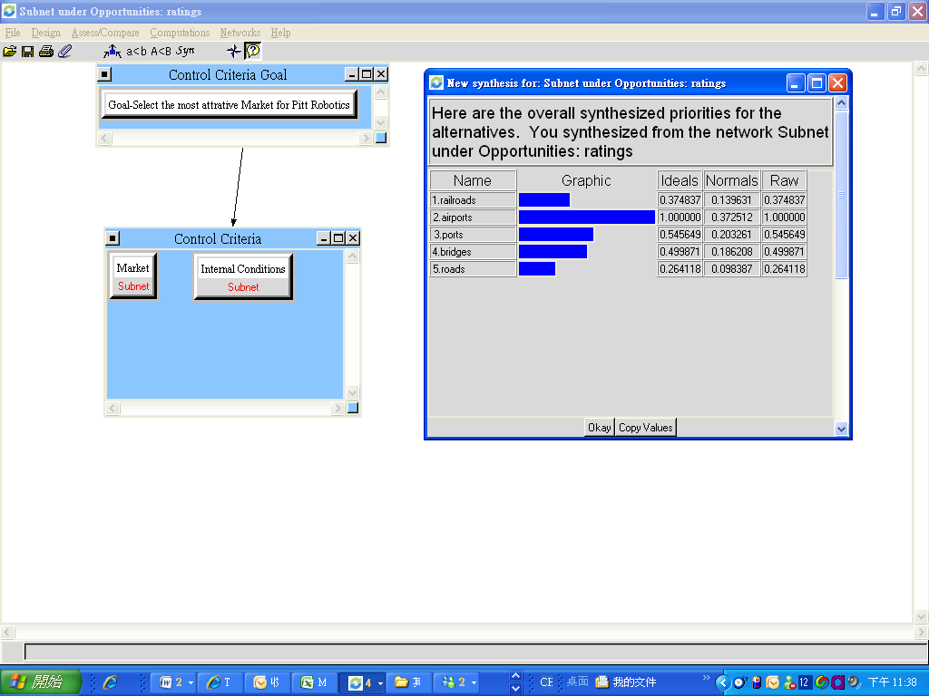

- Risks:
1. Risks Subnet:
Under the “Risks” subnet, two control criteria are included, which are market. For PR’s Risks, most of them are created from market so it’s reasonable to create sub-net under market of control criterion.
1.1 Market Risks
Market is affected by entrance and challenges. Main criteria include difficulty in comply regulations, time investment, new participants, and technological change. For example, the more profit the market is, the more participants want to get into. Severe competitions will force PR to invest more money in R&D to maintain competitive ability that will raise costs.

1.2 Financing Risks.
There are two criteria that affecting choices of alternatives. Working capital and investment required. If we predicted the investments will bring benefits or higher ROC to PR, we still need to consider if PR has enough cash on hand or has ability to finance to avoid risk of liquidity. The following sheet shows the links among each criterion. 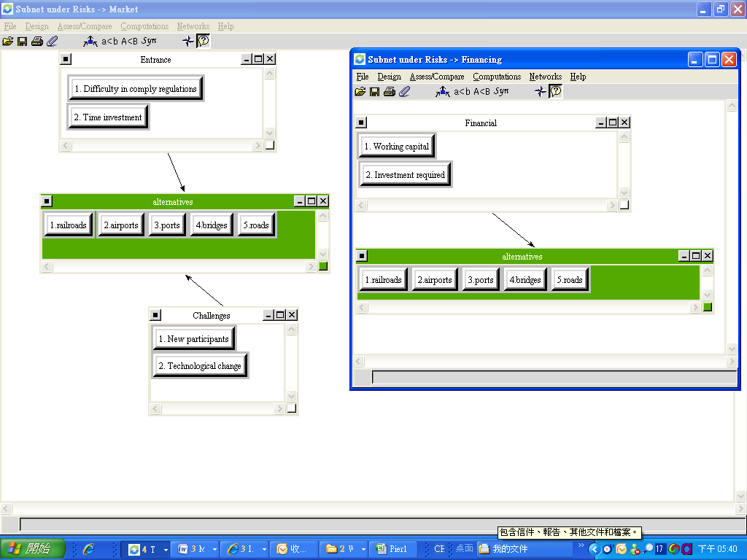

2. Sensitivity analysis – Risks
“Airports” is the riskiest market for PR to enter regardless of how the priority of the Risks changes. However, as the priority of Risks increase, the difference between “Railroads” and “Roads” will close to each other.
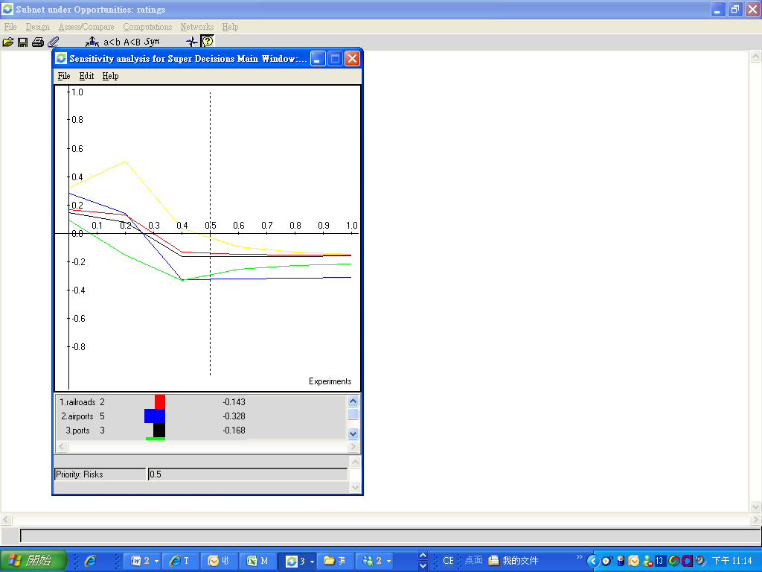

3. Risks –Conclusions
Considering the control criteria and sub-criteria, the following sheet demonstrates that under “Risks”, entering “Airports” market will be riskier than entering any other markets.
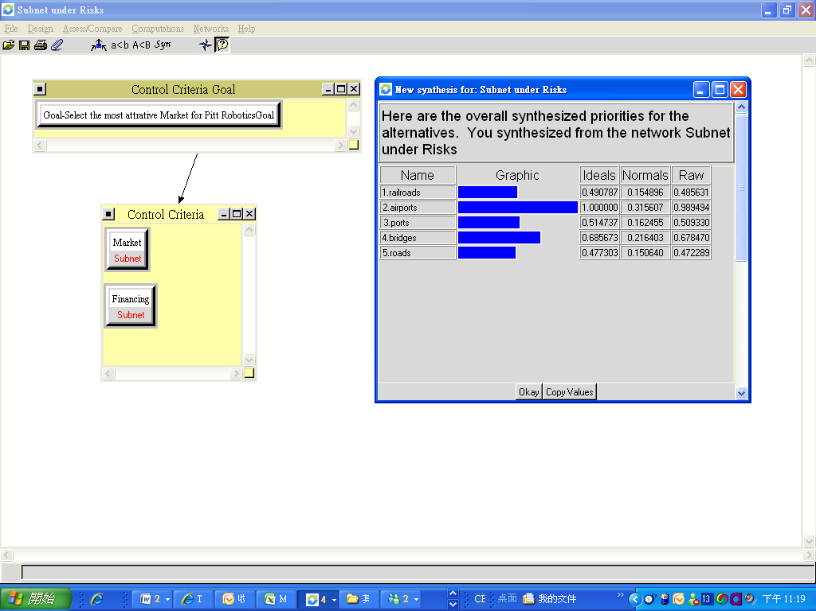

5. General Conclusions

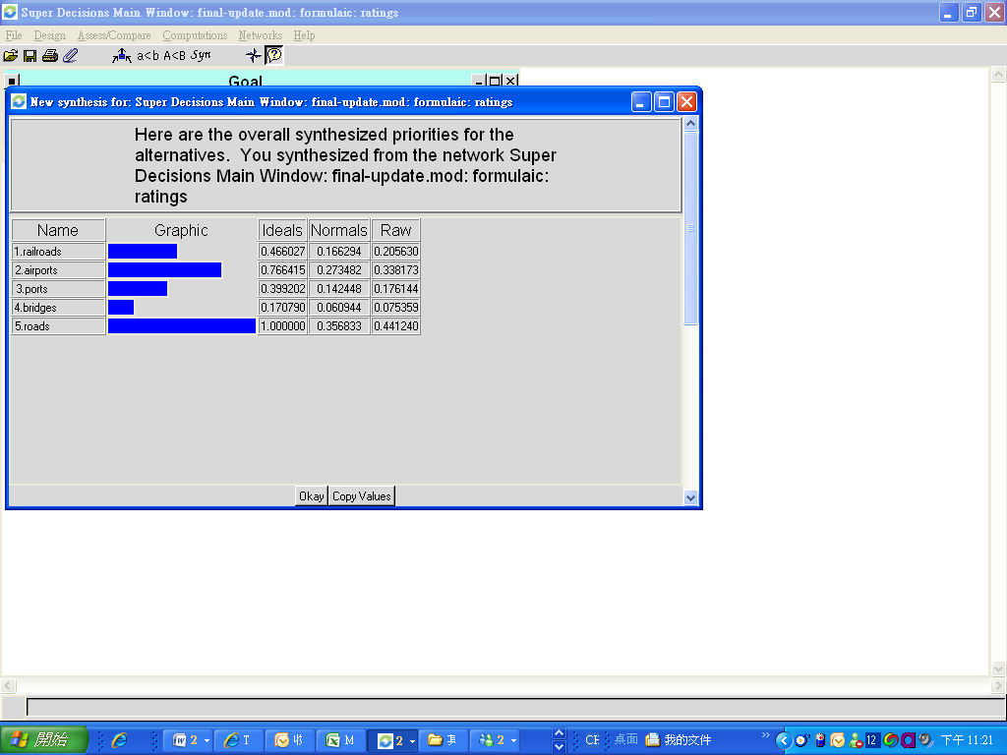
 | Benefits | Costs | Opportunities | Risks | bB+oO-cC-rR
Rating | 0.43244 | 0.14197 | 0.334454 | 0.09113
Railroads | 0.41783 | 0.395628 | 0.374837 | 0.48563 | 0.205629979
Airports | 0.46967 | 0.769288 | 1 | 0.98949 | 0.338170454
Ports | 0.32134 | 0.696615 | 0.545649 | 0.50933 | 0.176143082
Bridges | 0.24054 | 0.943953 | 0.499871 | 0.67847 | 0.07535887
Roads | 1 | 0.257088 | 0.264118 | 0.47229 | 0.441239897

To double check the raw data we have from the top-level synergy, we used the “bB+oO-cC-rR” formula to make sure the result is accurate. The b,o,c, and r are the ratings results for benefits, opportunities, costs and risks, while the B,O,C, and R is the synthesized vector for the alternatives at the control criteria level. To sum, our final result looks pretty good because the number derived from the formula matches the number from the top-level synthesis.

Based on our AHP model, “Roads” seems to become more attractive in future timeline. Even though “Airports” has higher opportunities than “Roads”, it is the “Benefit” ,”Costs” and “Risks” factors that will affect the decision of PR. From the super decision software, Roads will be the most attractive market for Pitt Robotics.

