

ANP Model for BOCR Direct Supply

BQOM 2521 – Decision Making in a Complex Environment
Katz Graduate School of Business
University of Pittsburgh

Dr. Thomas Saaty
April 25, 2005

Submitted By:
Adriano Mantesso
David Lee
Vinícius Soares
Overview:

The Direct Supply Analysis BOCR ANP model was developed to evaluate the current Cargill distribution system for a given market based on several criteria and sub-criteria (See Table 1). The distribution category alternatives analyzed were:
- Keep Agents
- Drop Agents
- Reduce Agents Scope
These alternatives were evaluated through Benefits, Opportunities, Costs and Returns frame, based on the following aspects:

Table 1: BOCR Criteria and Sub-Criteria
Benefits | Opportunities
Profits | new services
Customer Intimacy | New Products
Planning | Customized Solutions
Commission
customer base | communication flow
Volume | Increase Loyalty
Geographical coverage | Document Turnaround
decision making
Communication
Process Flow
Costs | Risks
SGA Costs | LEGAL
Information Systems | Agent Recourse
Travel expenses | Partners Recourse
Employees
customer loss | relationship development
Big Customer | Poor Relationship
Small Customer | Time to Develop
customer conflict | resistance from prod. partners
Volume | Shareholder damage
Late Payments | Reputation

Benefits:
The Benefits Criteria (See Exhibit 2) was developed to analyze the decision of reviewing the current Cargill distribution system, as follows:

PROFITS: The feeling is that the deeper the intimacy, the greater results will be for Cargill. As relationships are key in this business and even more so with the Brazilian culture, the impact on the profits will also be directly related. Intimacy exists today with current agents and will be something that will need to be developed if the decision were to shift to dropping the agents.
The impact of planning on the profits is associated with logistical and supply chain efficiencies. The better planning that we are able to do with the customers, the more likely we are to avoid unnecessary logistical costs. This is also closely related to the intimacy factor as the more intimate, the more likely we have better planning. The commission part of profits is the most critical factor of the overall analysis as this is where the real money appears. By keeping the agents, the commission values leave the company and go to the agents. Where as dropping the agents, the commission money is paid internally and becomes a cost center that is much less in value than the commission money going to the agents.

CUSTOMER BASE: The volume on the customer base is a factor as some customers may change their buying patterns and volume as a result of the alternative selected. This change could impact the overall volume, which in turn will impact the profits. The other item to be considered regarding customer base with the alternatives is the geographic coverage. The impact will be how much better or worse coverage will be attained in the vast Brazilian market. The Brazilian market is spread through out the country and regardless of the alternative; sufficient coverage will be a necessary factor, as this will impact profits.

decision making: The communication sub criteria of decision-making plays a role of making sure that messages are clear and consistent through out the communication chain. As in the game of “telephone”, the more links involved in the chain, the greater the likelihood and chances of having errors. Additionally in decision-making, the importance of processes has an impact similar to that of communication. The fewer and more simplified the processes, the better flow and ability to streamline the activities and gain quicker response for the customers.

Opportunities:
The Opportunities Criteria (See Exhibit 3) was developed to analyze the possible opportunities that could appear with changing the agent structure. Within this criterion there are some sub-criteria established to deeper analyze the opportunities associated with each of the alternatives.

NEW SERVICES:
As Cargill develops new products, there is a critical role that needs to be played involving the partnerships with the customers. This requires that there be a close relationship such that the new products are correctly sold with all the benefits to maximize the potential returns of the new products. Also the opportunities that come from customized solutions are a result of the relationships. The solutions that come from these new services take time to develop in direct coordination with the customer to meet their needs. The more direct the relationship with the customer the more likely there will be a positive and profitable service.

communication flow:
The communication flow criterion while not as critical as other criteria still plays a role in the opportunities. A result more efficient communication is the increase in customer loyalty. Communication flow needs to be natural for continued business and is unlikely to bring extra business, but the result of poor communication will definitely destroy value with the customer and loose business. Another result of good communication flow is the “turn-around” time of the documentation process. As in all import/export businesses, there is a tremendous amount of paperwork and documentation. The better the communication, the quicker and more accurate should be this part of the process.

Costs:
Within the cost network, (See Exhibit 4) we analyzed the costs associated with the various “go-to-market” strategies. Three sub-criteria were developed to further analyze the extent of costs on this distributor analysis. These criteria were as follows: SGA (Sales, General & Administrative) costs, Customer loss and Customer conflict.

sga costs:
For the SGA costs there are 3 sub criteria that were analyzed. The first is associated to the necessary information systems to conduct business. This includes both software and hardware. While there will be additional information costs associated to dropping the agents, it will not be all new as some systems and equipment already exist. A large increase in cost will be associated to the additional travel and entertainment for the customers. Today the agent covers this item and if we discontinue with the agents, Cargill will have to start to absorb that cost. The largest cost if we were to move away from the agents would come from the salaries and benefits of new employees to do the work that the agents did in the past. Some of this work would be covered by existing employees, but would also need to add more head count.

customer loss:
Another costs associated to transforming our distribution strategy will come potential customer loss. We have some customers that prefer to work directly with Cargill and others that prefer to have someone (like an agent) in between. The division is more or less divided between the large customers that want to work directly with Cargill and the smaller ones that prefer to work with a local agent. While we believe that we could lose some business, we will not likely lose any customers.

customer conflict:
Customer conflict involves two parts related to costs. The first relates to the potential volume loss and the other deals with potential customer payments delays. Some customers may shift part of their volume purchases to other suppliers if we were to change their sales contact. While the payment concern is not a large one, some may try to take advantage of the shifting situation and use it as a reason or excuse to delay payments. Alleging that the process changed and they were not aware how to act.

Risks:

The risks network (See Exhibit 5) involves three sub–criteria, but all deal with people and managing relationships. These risks are manageable, but will take time in nurturing to not have negative impacts on the business. As in most situations, some negative aspects will appear, but these seem to be limited and acceptable.

LEGAL:
The first risk and largest concern deals with the legal aspects of changing our distribution system. There could be potential recourse from both our current agents and our supply partners. There is Brazilian law that gives certain protection to supplier agents. By eliminating the agent, we would need to be prepared for handling the potential recourse by the agent. Also, the supply partner recourse could have an impact, as any change in distribution will need their approval. The risk here is that the partners may not see the same values as Cargill would in changing the agents.

relationship development:
The risks associated to the relationship development come into play if the agent structure were to change. By removing the agents, Cargill would have to take the time to develop solid relationships with the customers to be as good or even better than the current agent structure. The poor relationship will have impacts on volume and market information. The criterion of time to develop is one that should be resolvable should we remove the agents, but the longer it takes, the larger the risk to Cargill.

resistance from production partners:
The risk related to the resistance from partners is a real one that is mentioned in terms of legality, but aside from that, there are also non-legal impacts. These impacts could appear in both shareholder damage and the reputation of the company. The shareholder damage will be with the partners as the only shareholders are the partners. Some shareholders may believe that the long-standing relationship with the current agents is reason for maintaining current structure. The partners could claim that shifting the agent compromises the reputation of our traditional company.

Results

After the completion of the BOCR Networks, these rankings were determined through the creation of several criteria relevant to distribution analysis. The BOCR were evaluated based on the rankings of very high (1.00), high (0.46), moderate (0.19) and low (0.07). The distribution criteria and ranking for the BOCR were as follows:

Table 2: Distribution Priority Criteria for BOCR
 | Priorities | Engaged Employees | Enrich Communities | Shareholder Return
Benefits | 0.45 | Very High | Very High | High
Opportunities | 0.24 | High | High | Medium
Costs | 0.21 | Very High | Medium | High
Risks | 0.10 | High | Low | Medium

From the ratings system, we can extract that “Benefits” has the biggest impact for the decision and “Risks” the least.

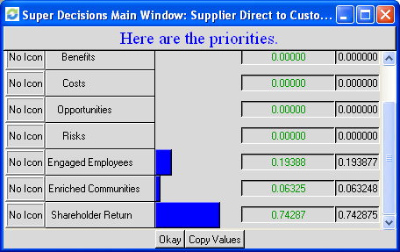

As we can see from the Priorities part, Shareholder return (0.723) has the higher weight for the decision, followed by Engaged Employees (0.194) and Enriched Communities (0.063) which seems to be aligned with Cargill perspectives.

Upon the completion of the BOCR ratings, these values were entered into the ANP model. Once the networks, sub-networks, clusters, and nodes were determined, the relationship between each cluster and node were determined and connections were drawn. Finally each cluster and node was assessed through both cluster comparisons and node comparisons.

The following information was obtained from the node and cluster comparisons for each network:

Table 3: Alternative Priorities for BOCR
Alternatives | Top Level | Benefits | Opportunities | Costs | Risks
Drop Agents | 0.748 | 0.607 | 0.626 | 0.484 | 0.564
Keep Agents | 0.021 | 0.147 | 0.144 | 0.270 | 0.184
Reduce Agents Scope | 0.229 | 0.245 | 0.229 | 0.245 | 0.255

As can be seen from Table 3, the alternative of Drop Agents resulted in the highest priority level for Benefits, Opportunities, Costs and Risks. The Benefits and Opportunities associated with this distribution category appear to be accurate (i.e. the more direct you access your customers, more profits you will make and the highest shareholder return you will make).

Under the costs criteria, the results were consistent as Dropping the agents will reduced the commission costs but it will demand some additional structure to serve those customers.

On the risks side, we also capture that Drop Agents may provide some uncertainties as the laws in Brazil provide some privileges to the agents and it is not clear until what extent this can be managed. This can be perceived by the important weight that Legal (0.593) had in the Risks sub-network attached below.

Table 4: Priorities of BOCR for Sub-Criteria
Benefits |  | Opportunities
Customer base | 0.088 | Communication flow | 0.667
Decision making | 0.194 | New services | 0.333
Profits | 0.717
Costs |  | Risks
Customer Conflict | 0.097 | Legal | 0.593
Customer Loss | 0.333 | Relationship with customers | 0.157
SGA Costs | 0.569 | Resistance from partners | 0.249

Table 4 displays the priorities for the sub-networks under the main BOCR networks. Under Benefits, the Profits criteria ranked highest among all of the benefits criteria, which is absolutely consistent to everything said at this stage. Under the Costs network the highest cost was found in the Sales, General and Administrative costs as there will be an important impact in this cost line due to the new structure needed if agents are dropped. In Opportunities, the most critical area is the chance to have a more direct communication to customers and less misunderstanding. Finally, the highest risk criterion was Legal, already mentioned and explained above.

The best interpretation of this model would be to view that “Drop Agents” option seems to be the better – as per the table below - when analyzed under the criteria selected. We do recognize that there are risks associated with this option but it seems there is a significant payoff (Benefits and Opportunities) that comes from that, at a reasonable cost. Cargill is willing to take this decision and this analysis may be used to support it even further.

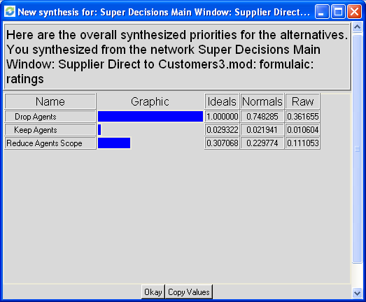

Below, you will find a summary of the model we created for this analysis and some graphs that demonstrate the sensitivity analysis.

Exhibit 1: Top level Network

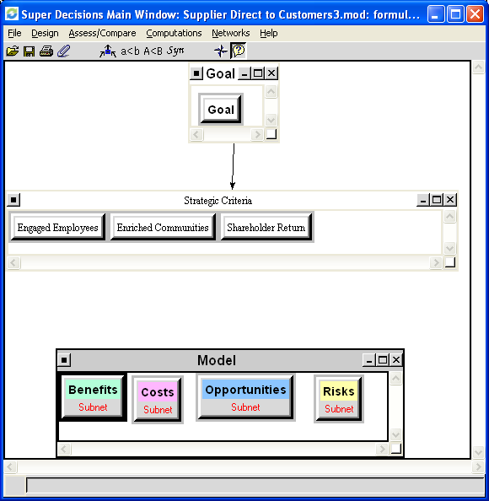

Exhibit 2: Benefits Sub-Network

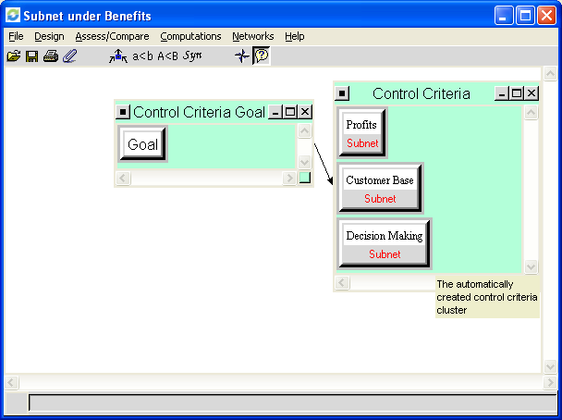

Exhibit 3: Opportunities Sub-Network

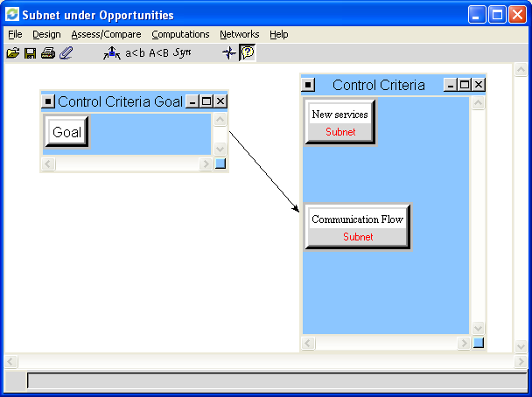

Exhibit 4: Costs Sub-Network

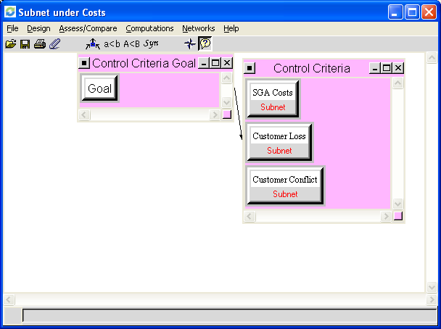

Exhibit 5: Risks Sub-Network

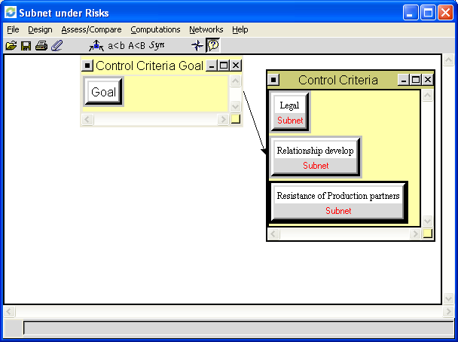

Table 6: Profits Sub-network under the Benefits Network

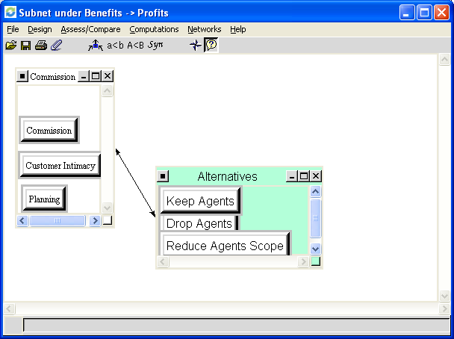

Table 7: New Services Sub-network under the Opportunities Network

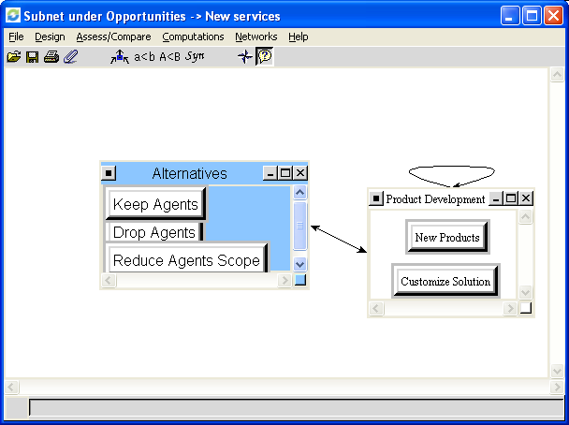

Table 8: SGA Costs Sub-network under the Costs Network

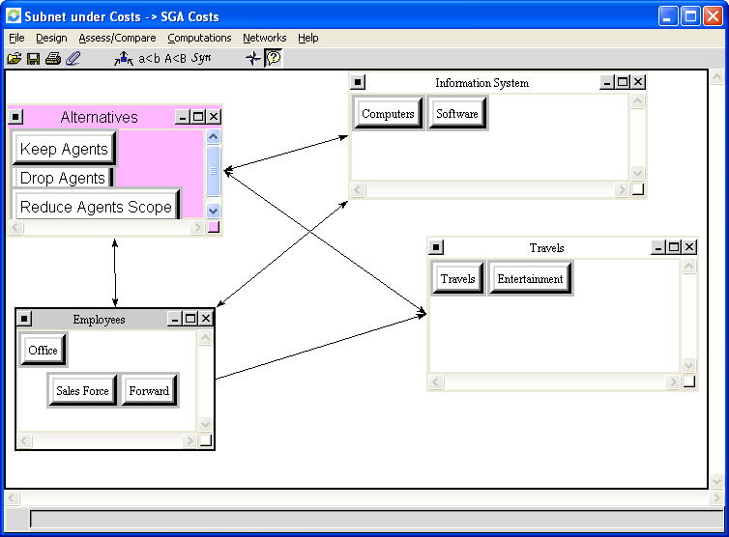

Table 9: Resistance of Production partners Sub-network under the Risks Network

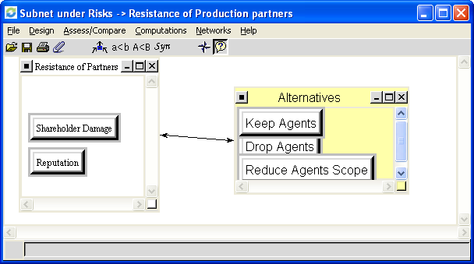

Chart 1: Sensitivity Analysis for BOCR Model - Focus Benefits

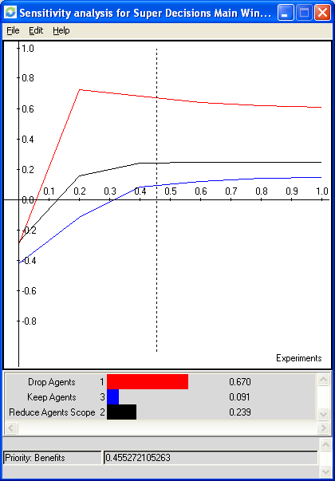

As can be seen above from the sensitivity analysis focus on Benefits, Dropping Agents has a dominant position over the other alternatives at any point of the priority range with a wide gap of advantage.

The second alternative, reducing agents scope, is also dominant over keeping the agents, letting us infer that the current position of the company (Alternative 3) is the worse one, independent of how benefits is important on our analysis.

Chart 2: Sensitivity Analysis for BOCR Model – Focus Opportunities

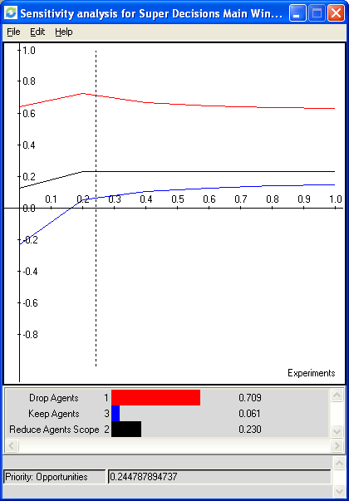

This sensitivity analysis focus on Opportunities is very similar to the previous one. Drop Agents has a dominant position over the other alternatives at any point of the priority range, however with a wider gap than the Benefits analysis.

Chart 3: Sensitivity Analysis for BOCR Model – Focus Costs

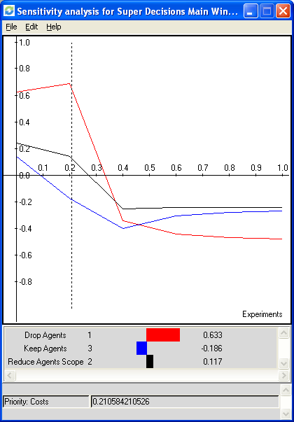

Looking to the sensitivity analysis focus on Cost, the best alternative can change depending on the importance that cost has on the analysis. In our example, where costs has a priority of 21% (the dot line on the graph) the best alternative is drop the agents. However as cost become more important on our decision and becomes higher than 38% on your priorities, the best alternative now will be “reduce agents scope”, followed by keep the agents.

Chart 4: Sensitivity Analysis for BOCR Model – Focus Risks

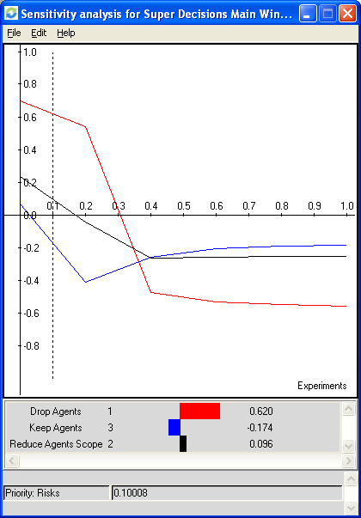

Considering the risks of each decision and its priorities comparing with benefits, opportunities and costs, there are three possible decisions as showed by this sensitivity analysis. At the current point (.10), drop agents is the best alternative however as risk priority increases this answer will change: from point .34 to point .40 reduce agents will be the best and from point .40 to 1 keep the agent will be became the best alternative.

