“Best Performing Geographic
Emerging Stock Market Cluster”

Decision Making in a Complex Environment
(BQOM 2521)

University of Pittsburgh
Katz Graduate School of Business
Ismail C. Turan
Masahiro Yamauchi

1. Decision Problem …………………………………….. P. 2
2. Goal …………………………………….. P. 2
3. Alternatives …………………………………….. P. 3
4. Strategic Criteria …………………………………….. P. 4
5. Sub Criteria …………………………………….. P. 5
6. Model Building …………………………………….. P.12
7. Subnet Control Criteria …………………………………….. P.13
8. Inner Subnet …………………………………….. P.14
9. BOCR Priorities …………………………………….. P.16
10. Decision Rating Model …………...………………………... P.19
11. BOCR Ratings and Sub Criteria Priorities ………………… P.20
12. Model Synthesis …………………………………….. P.22
13. Sensitivity Analysis …………………………………….. P.24
14. Conclusion …………………………………….. P.27

1. Decision Problems
The world has been going through a tremendous economic transformation over the last decade; an unprecedented transfer of wealth has been occurring between certain developed and developing countries. The eastern bloc economies of Eastern Europe became members of global powerhouse European Union which allowed them to obtain a definitive level of political, economic stability and higher corporate earnings. Underdeveloped countries in SE Asia fueled by China have been going through a historic economic development accompanied by high and stable GDP growth. Latin American countries such as Brazil has been on the world stage more than they ever been, on their way to become global economic powers. Situation in Middle East is no different, on top of the growing labor oriented manufacturing sector which takes advantage of low labor costs, some countries in the region enjoy the peak in commodity prices as well. As all these different geographical clusters of emerging markets evolve in several fundamental aspects, we thought that it would be interesting to observe the stock market performances of the respective regions. This study could allow us to draw a few inferences.

2. Goal
The priority question however is whether if the geographical location influences the performance of the financial markets. Followed by the question of what is the correlation of stock market returns of all these different regions; are they equally vulnerable, do they react to global developments in a similar manner or are they totally independent? Finally if there are differences that arise from the geographical location, are they efficiently reflected into financial markets thus are these financial markets efficient or are they vulnerably open to speculation which would make easier for investors to influence stock prices?

3. Alternatives
As we mentioned before, we select four alternatives. In order to analyze them specifically and circumstantially, we choose four countries in each alternative.
Eastern Europe; Russia, Czech Republic, Hungry, and Turkey
Latin America; Mexico, Brazil, Argentina, and Chile
Northern Africa/ Middle East; Morocco, Egypt, Israel, and Jordon
South East Asia; China, Taiwan, Philippines, and Indonesia
4. Strategic Criteria
For our model we picked the following four strategic criteria; Corporations, Economics, Market Climate and Politics. The reasoning for the criteria selection is as follows:
Corporations; corporations are the key players of any stock market after all only being able to trade commodities would have been major drawback for economic development and without the presence of numerous corporations trading the trade volumes would have been unrealistically low.
Economics; we can consider this criteria as seeing the big picture. Economic data is the most macro, overall yet important piece of information that influences any stock market. The announcement dates and values of certain macroeconomic indicators are highly important since they can drive the markets in different directions according to the expectations.
Market Climate; even tough U.S. economy has boasted its exports/production levels thanks to the weak dollar causing the U.S. GDP to exceed its performance in recent years and even tough increase in prices except commodity prices thus core inflation has not been a big threat to U.S. economy over the past couple of years or months, the current situation in the financial markets prove that market climate or degree of market confidence could drastically affect the performance of financial markets. Therefore we believe that this item carries a high priority.
Politics; if reaching a certain level of quality in terms of education, life standard and harvesting the positive returns of these factors on country governance thus obtaining a more stable and respectable political arena is one of the stages of development, these regions or countries could still be considered as pieces of work in progress. Therefore politics play a major role or in other words constitute a higher level of opportunity/threat factor over the performance of the markets in emerging markets in comparison to the markets in developed countries.

5. Sub Criteria
During selection of sub criteria, we try to cover all significantly important factors regarding each criterion that could influence effects on the financial markets. The summary of reasoning for each sub criterion is as follows:
Corporations:

Corporations sub criterion includes; core industry, earnings, financial health, governance reliability, international operations health, openness to innovation.

Core Industry: Industries a country is competitively involved in can tell us a lot of information about the strengths and weaknesses of a certain stock market. Core industries should maintain a high level of competitiveness and should be diversified well enough to be sustainable. For instance U.S. has managed to maintain a number of core industries competitive over the years which have made stock exchanges in this country fairly well diversified in terms having strong corporations under several diverse industrial indexes. However in some cases core industries lost their advantage such as the auto industry and we can see the adverse effects of this on the stock price performances of U.S. auto makers and how that affects the stock markets.
Earnings: The amount of revenue a corporation generates, how it manages its costs and to what degree can the CFO meet or beat the expectations of analysts’ matter a lot. This is the single most important measure that ranks company performance and it has imminent effects on the stock price. Even a handful of earnings announcements can affect the whole stock market performance during a trading day. For example strong third quarter earnings that were released by IBM recently have received the following comment from The New York Times “I.B.M.’s Quarterly Earnings Cast Light in a Darkening Economic Cloud” which emphasizes the importance of corporate earnings for the markets.
Financial Health: A corporation’s actual financial power lies beneath these metrics. These metrics could be summed up as profitability, solvency, efficiency and liquidity. This is an important diagnostic toolbox for corporations and the markets. Each sector has different set benchmarks, standards to match and markets watch this metrics continuously. Again referring to the current market turmoil, following the circulation of rumors about the solvency or liquidity of any given financial institution we have seen major sells and stock price depreciations that affected the overall stock market performance.
Governance Reliability: As much as the individuals running national economies, the men in suits that run corporations are vital for an organization’s success. Not only operationally but also financially well run corporations that have a set of ethical, procedural best practices thrive under all circumstances. Once this quality is delivered to the investors it certainly creates invisible line of security for that specific stock, index or stock market. Numerous financial publications such as Fortune praised the way JP Morgan CEO Jamie Dimon and his team have been governing JP Morgan throughout the years which created a positive buzz around the brand name. More corporations like this, more trust in the stock market would be generated.
International Operations Health: Exposure to international markets and the health of these operations are as important as domestic operations. Globalization and high speed of international information flow makes what happens abroad as important as what happens home.
Openness to Innovation: Corporations that are open to innovation certainly outperform the ones that are not as open to innovation at several areas. Stock market performance is one of them; we can observe this by comparing stock returns of Toyota and GM. In this case Toyota is the one that has been more proactively involved in innovation and the stock price performance of Toyota over the last 5 years certainly outperforms that of GM. Toyota stock has been going up where as GM stock has been going down. More companies like Toyota would make any stock market stronger and less volatile.
Economics:
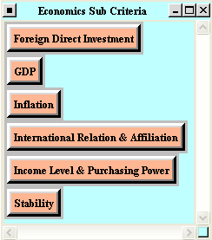
Sub criteria under the Criterion of economics are pretty straight forward and globally accepted fundamental measures of economic strength. We intended to pick measures that are viewed by markets as important and that practically generate a market curiosity such as FDI, GDP, Inflation, income level/purchasing power. The other two sub criteria that are more qualitative rather than quantitative and more open to discussion are International relations & affiliation and stability.

FDI: This metric measure the direct foreign capital flows into an economy and often viewed as an important quality by economists.
GDP: This metric measure the growth in production in an economy and developing countries are expected to have higher GDP growth rates than developed countries.
Inflation: This metric measure the incremental changes in prices in an economy. Inflation is the difference between real and nominal values.
International relations & affiliation: We believe that a country’s affiliation with other regional countries or its relations with the rest of the world plays a key role at its global integration. We can observe the positive influences of belonging to a pack of strong or regional economies and having open international relations at Eastern Europe and the countries that were involved in EU enlargement. We can draw a similar conclusion if we take NAFTA into consideration. As a national economy becomes more open and better affiliated its stock exchanges appreciate in significance they have in respective regions.
Stability: Steady and stable performance is very important for any stock market. People don’t react to bad surprises in a positive manner and unstable economies always carry higher risk.
Market Climate:
Since we view this criterion as a behavioral analysis of the stock market we intended to pick sub criteria that would help us draw a picture of a given stock markets’ current and past qualities that could provide us further insight. The sub criteria picked for this criteria are; confidence, liquidity, momentum/past performance, system development, transparency and valuation.

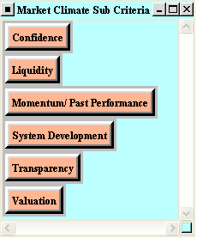

Confidence: Market confidence affects the buy/sell/hold behavior of the investors, at certain times confidence creates a domino effect over the whole market. A sudden loss of confidence can cause the stock market to plummet no matter what law makers do to prevent further damage. Confidence is hard to recover. Vice versa having strong confidence in the markets would fuel the stock markets. Therefore confidence might differ in different regions thus affecting the stock market performances.
Liquidity: Liquid markets are always better off since liquidity creates the optimal investment environment. Some of the regions might be lacking the liquidity which might affect them negatively.
Momentum/Past Performance: Even though historical data cannot dictate the future performance, the historical data is the only solid data we have on a specific market to draw inferences.
System Development: As the technology evolves trading methods change as well. Major developed stock markets are moving towards a completely electronic trading system. This change helps ease the procedures and makes the process more efficient. It would be informative to see where each region is located in terms of system development.
Transparency and valuation: The main reason the developed countries have highly efficient markets is that they have highly transparent systems which makes information flow faster and also information is reflected into the stock prices in a timely manner. It is important to see how the different regions rank in terms of transparency and valuation.
Politics:
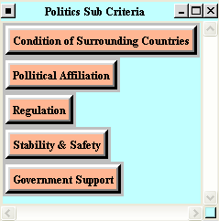
Politicians can determine the laws that run the system; they can influence the markets with their actions and announcements. Therefore it is important to see how a country is being run. The sub criteria chosen for the criteria of politics are: Condition of surrounding countries, political affiliation, regulation, stability & safety, government support. Since the sub notes under this criterion are self explanatory, we believe that having an individual section for each would be redundant.

6. Model Building
Our model is built on the control criteria explained above. All control criteria are broken down into sub criteria. Below is a screen view of the model.
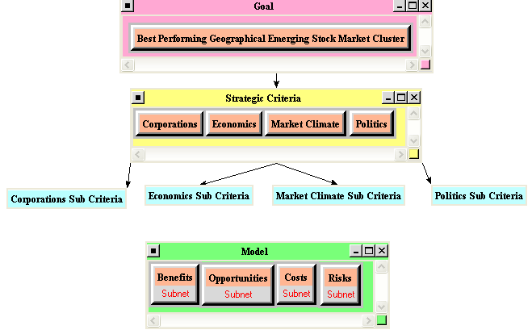

7. Subnet Control Criteria
The subnets under the benefits, opportunities, costs and risks are established based on the relevance of the strategic criteria to each BOCR criterion. Because the priority of each strategic criterion is different for BOCR, the appropriate criteria are chosen and rated. Subnet control criteria for benefits are shown below.

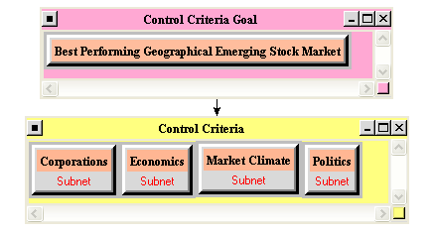

8. Inner Subnet
We intended to be very specific and hit all possible aspects for each criteria and corresponding subnet (Benefits, Opportunities, Risks and Costs). Below is an example for corporations, benefits;
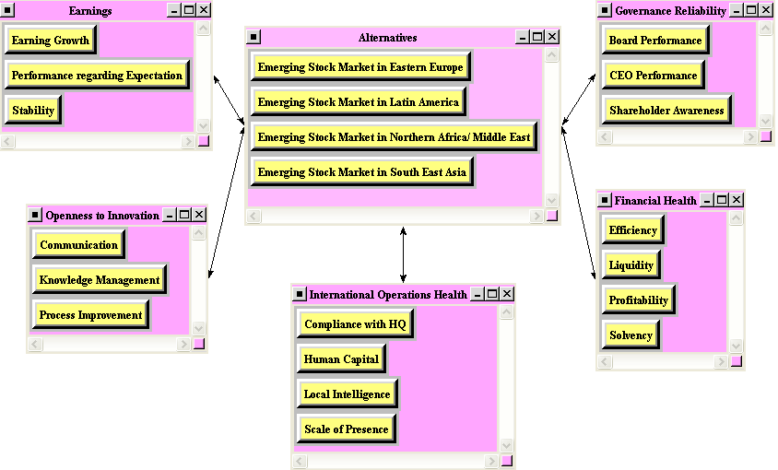

Earnings: Earnings growth, Performance regarding Expectation and Stability are picked as benefits for Earnings. Having strong growth, beating expectations and obtaining a stable growth are the beneficial aspects.
Openness to Innovation: Communication, Knowledge Management and Process Improvement. Having strong vertical, horizontal communication throughout the corporation, strong ability to manage and analyze corporate data and improving processes that help a company generate cash flows are the benefits we define.
International Operations Health: Compliance with HQ, Human Capital, Local Intelligence and Scale of Presence. Having continuous communication throughout the organization, having well educated human capital that has goals aligned with the overall company, obtaining useful local information about the countries that the corporation operates and the appropriate scale of presence in respective companies are the beneficial aspects.
Governance Reliability: Board Performance, CEO Performance and shareholder awareness. Hands on board performance that keeps an eye on the CEO and a CEO who maximizes shareholder value and shareholders who make sure management has goals aligned with the ownership are the beneficial qualities of this inner subnet.
Financial Health: Efficiency, Liquidity, Profitability and Solvency. Benefits of this subnet are self explanatory.

9. BOCR Priorities
After completing all of the comparisons for clusters and nodes, we got priorities for benefits, opportunities, costs and risks.
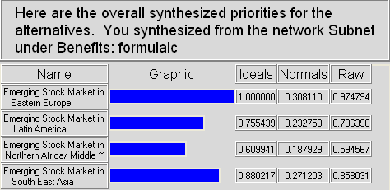
Benefits:

- Eastern Europe: 30.81%
- South East Asia: 27.12%
- Latin America: 23.28%
- Northern Africa/ME: 18.79%
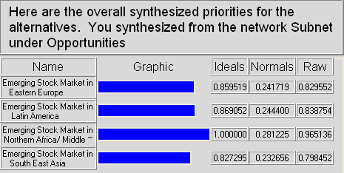
Opportunities:

- Northern Africa/ ME: 28.12%
- Latin America: 24.44%
- Eastern Europe: 24.17%
- SE Asia: 23.26%
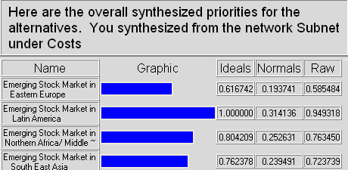
Costs:

- Latin America: 31.41%
- Northern Africa/ ME: 25.26%
- SE Asia: 23.94%
- Eastern Europe: 19.37%
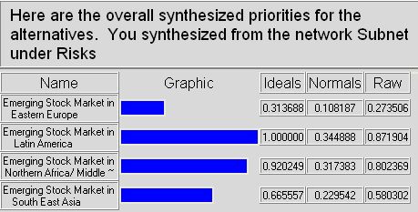
Risks:

- Latin America: 34.48%
- Northern Africa/ ME: 31.73%
- SE Asia: 22.95%
- Eastern Europe: 10.81%

We checked which strategic criterion has most important priority in the benefits, opportunities, costs and risks. As a result, market climate like efficiency of confidence/ liquidity and system development like capacity/ electronic trading is most important in the benefits. In the opportunities, corporation is most important because of the high value of earnings, international operations and financial health. In the costs and risks, economics has most important priority. In fact, a level of debt/ reserves and an economic stability largely affect to investment decisions.

10. Decision Rating Model
We created the following ratings for the sub criteria of each criterion in order to derive at the priorities.

11. BOCR Ratings and Sub Criteria Priorities
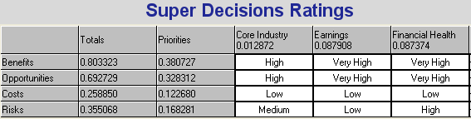
Based on the ratings as shown above, we got the following priorities for all the control criteria including sub criteria.

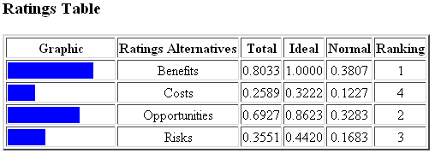

- Benefits: 38.07%
- Opportunities: 32.83%
- Risks: 16.83%
- Costs: 12.27%

Corporations | 28.22% |  | Economics | 14.95%
Core Industry | 1.29% |  | Foreign Direct Investment | 1.06%
Earnings | 8.79% |  | GDP | 3.76%
Financial Health | 8.74% |  | Income Level & Purchasing Power | 1.69%
Governance Reliability | 3.37% |  | Inflation | 2.67%
International Operations Health | 4.09% |  | International Relation & Affiliation | 0.71%
Openness to Innovation | 1.95% |  | Stability | 5.06%
Market Climates | 49.30% |  | Politics | 7.52%
Confidence | 5.35% |  | Condition of Surrounding Countries | 1.35%
Liquidity | 14.82% |  | Government Support | 2.51%
Momentum/ Past Performance | 3.68% |  | Pollitical Affiliation | 1.86%
System Development | 1.93% |  | Regulation | 0.51%
Transparency | 11.76% |  | Stability & Safety | 1.30%
Valuation | 11.76%

From the data above, we can see that market climate has the highest priority followed by corporations. In fact, market climates largely influence investors’ decision to invest into emerging stock markets. When investors find some attractive foreign companies or countries with economic high growth, they tend to refrain from actual investments unless market climate such as liquidity, confidence and transparency are positive. Moreover, since stock markets are said to lead the economic conditions, conditions of market climate is very important for making decision. Corporations also play critical parts in the decision. If the market climate is favorable and then investors find the attractive companies with high earning growth and good financial health, investors will take a forward-looking stance to invest. Actually, corporations which represent the countries and operate internationally often contribute to the countries’ economic growth. Therefore, these priorities make sense.

12. Model Synthesis
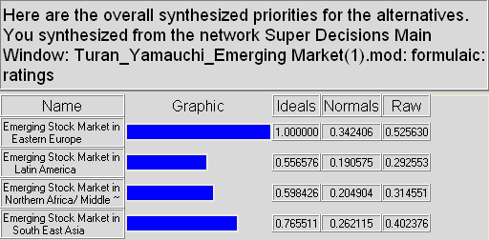
Additive Model

1) Eastern Europe: 34.24%
2) SE Asia: 26.21%
3) Northern Africa/ ME: 20.49%
4) Latin America: 19.05%
From the above results, it can be seen that Eastern Europe is the most attractive emerging market, followed by South East Asia in the long term.

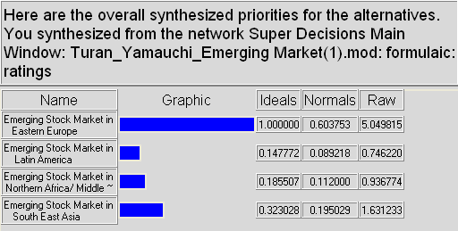
Multiplicative Model

1) Eastern Europe: 60.37%
2) SE Asia: 19.50%
3) Northern Africa/ ME: 11.20%
4) Latin America: 8.92%
In the multiplicative model, results are same as in additive model. However, Eastern Europe gets over 60%, meaning that it is the best alternative in the short term.
As a result, Eastern Europe is considered the best emerging region to invest into the stock market for the short term and for the long term. Meanwhile, all of the other alternatives have lower weights in the short term. Additionally, the multiplicative model does not give a negative rating to any of the alternatives, meaning that it still remains a viable option.

13. Sensitivity Analysis
In order to determine when different alternatives become preferable, we check sensitivity analysis by varying different weights and ratings in our model.
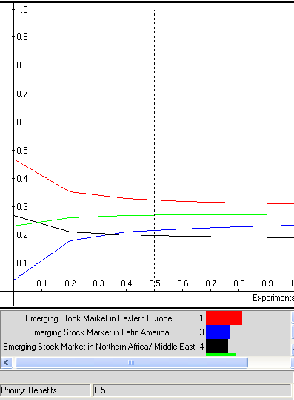
At first, we changed the weight of the benefits. When we increased the weight of the benefits, the ranking of four alternatives does not change. On the other hand, when we decreased the weight to 0.1, we found that the ranking of Latin America decreased.

Secondly, we changed the weights of opportunities, rankings for alternatives largely changed although the differences of alternatives’ priorities are very small. When the weight is 0.1, the ranking of Northern Africa/ ME is 4th. However, the weight increased to 0.9, the ranking of Northern Africa/ ME went up to 1st position. This means that if investors perceive the opportunities as the most important criteria to make the decision, they will prefer this area.
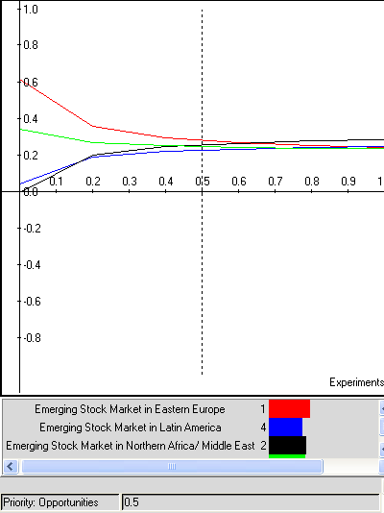

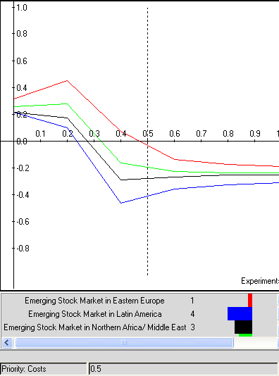
Thirdly, we did the sensitivity analysis for the cost variable. When we increased and decreased the weights of the cost from 0.1 to 0.9, the rankings did not change. But, we understand that as the weights closed to 0.9, the priority of Eastern Europe gradually decreased.

Lastly, we changed the weights of risks from 0.1 to 0.9. As same as the cost criterion, the rankings of four alternatives did not change. Additionally, in the range from 0.6 to 0.9, the ratings of Northern Africa/ ME and Latin America moderately increased while that of Eastern Europe decreased.
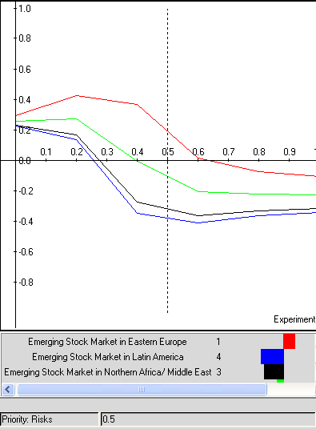

14. Conclusion
- Our model has concluded that Eastern Europe would be the best geographical emerging market cluster to invest in; however as of September 2007 Latin America is the best performer according to the actual data. Except the difference between our findings and the actual performance of Latin America, the rest of our ranking is in line with the actual performances. There are a couple reasons that could have lead to this discrepancy; we as a team are more knowledgeable about Middle East, Eastern Europe and South East Asia than Latin America due to our backgrounds and areas of interests. Therefore we might not have accurately rated Latin American Clusters or nodes. We might have undervalued some of the qualities of this region. On the other hand this discrepancy could also been caused by the inefficiency of the Latin American Market; meaning that since this market has risks large institutional investors could have been highly influencing these markets to gain from the risks. High risk always attracts higher returns, and if investors can influence the markets they can totally exploit this opportunity.
- We can conclude that different geographical clusters have differences in terms their stock market performances, we can see this through our model and we believe that the factors we included in our model lead to these differences. There always will be outliers in every theory and in our case Latin America was the outlier. Even though there was a certain ranking according to the stock market performances of the different clusters we can also conclude that they are highly correlated. The upward trend over the years along with the certain fluctuations carries similarities across the different regions.

