Topic: Should an Oil and Gas Service Company build a camp in Ohio to have a more local presence in the Utica Shale?

Background: The company I work for has a camp located in Southwestern Pennsylvania and Central Pennsylvania. These camps have been responsible for the testing and service provided to Oil and Gas companies exploring the Marcellus Shale, in addition to Michigan, West Virginia, and Virginia.

We have recently begun to service customers in the Utica Shale region, and the question being posed is whether we should build a new facility to establish a more local presence in the Utica region, or use our camp in Pennsylvania to meet the demand.

Alternatives:

- Use the combined efforts of the Southwestern Pennsylvania camps to service the Utica play.
- Build a camp in Ohio to service the Utica play.

Clusters and Nodes

- Goal Model and BOCR Nodes

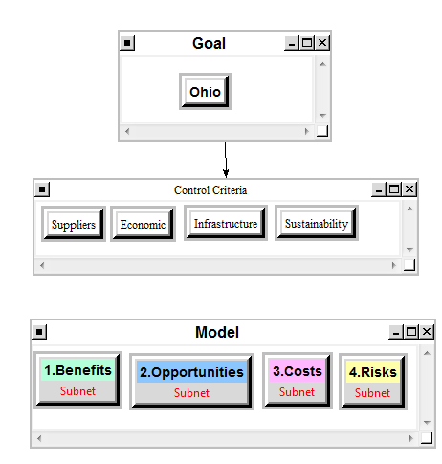

- Benefits
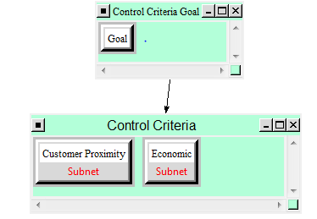

Benefits Expanded (Customer Proximity & Economic)

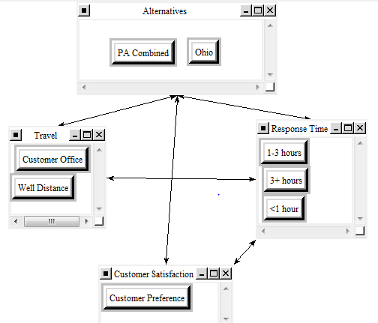

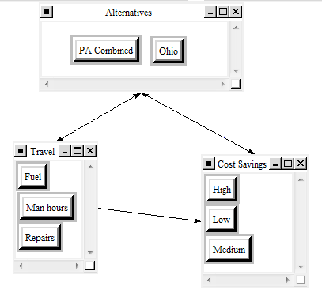
Benefit Synthesis
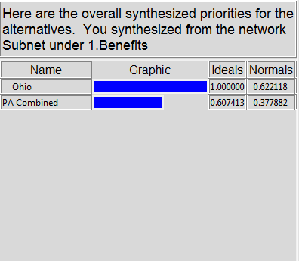
The Benefit’s synthesis show Ohio as being a very good option because of reduced cost in Man hours, Equipment repair, and travel to well locations. These are crucial savings because any revenue generated from completing jobs can be offset heavily by the aforementioned costs.

- Opportunities

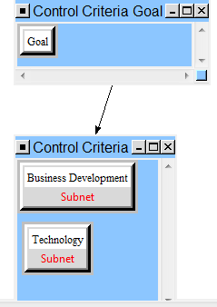

Opportunities Expanded

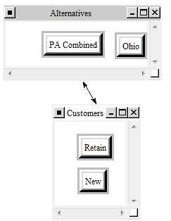

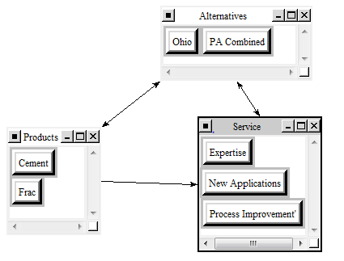

Opportunity Synthesis

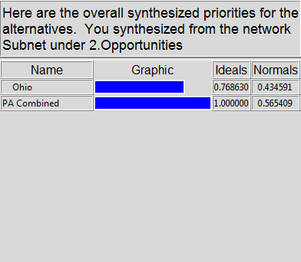

The Opportunities consist of Business Development and Technology. With new customers potentially surfacing once we establish ourselves, I chose to analyze our ability to attract new customers, as well as retain ones we currently have in the region. For the Technology aspect, I chose to analyze any new applications we might face, areas of process improvement that would be required, and the expertise that would come from knowledge of the area that would help to increase cement and frac systems for the company as a whole.

Because our Pennsylvania camps are so well established, and because there is still plenty of business in the Marcellus, PA combined came out ahead in the synthesis results.

- Costs

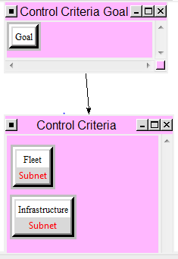

Costs Expanded

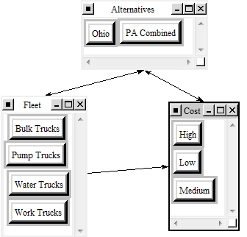
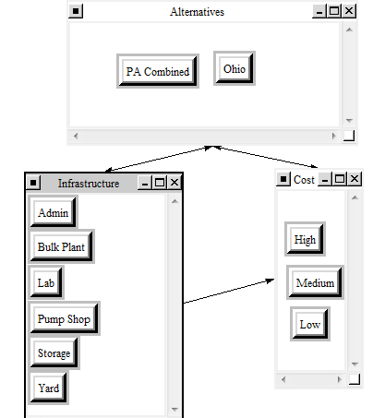

Costs Synthesis
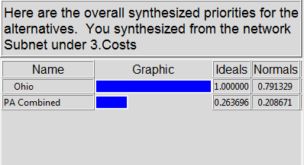

The high cost of implementing the necessary infrastructure and fleet point to the fact that Ohio is a necessarily good option.

- Risks
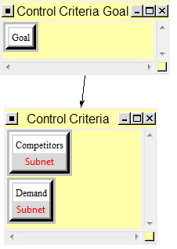
Risks Expanded

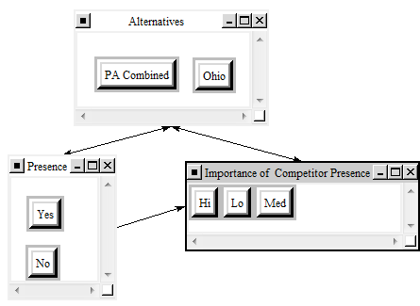

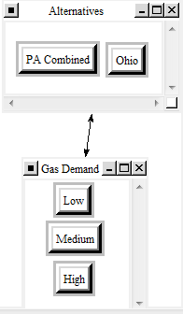

Risk Synthesis
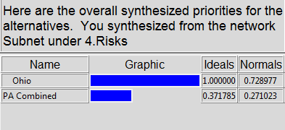

The risks for the Ohio camp are high because the chance the price of natural gas does not increase makes the camp an unviable option.

- Sensitivity Analyses

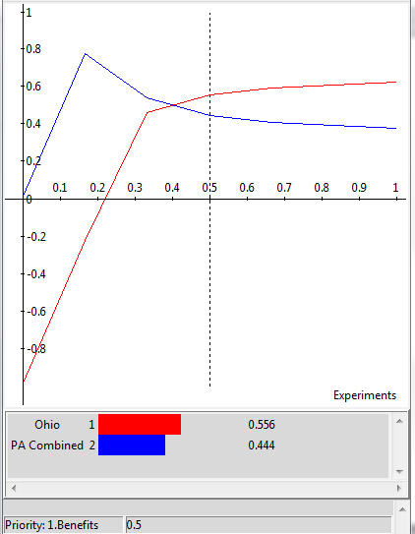
For Benefits, Ohio becomes the better option around 0.4 as the priority of Benefits increases.

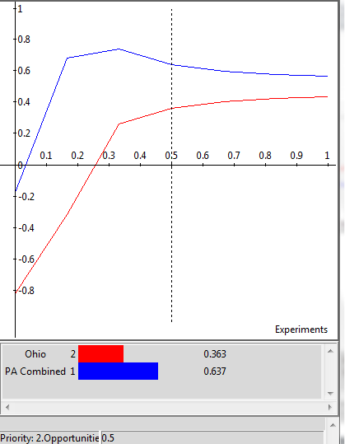
The Opportunities show PA combined as being the best option.

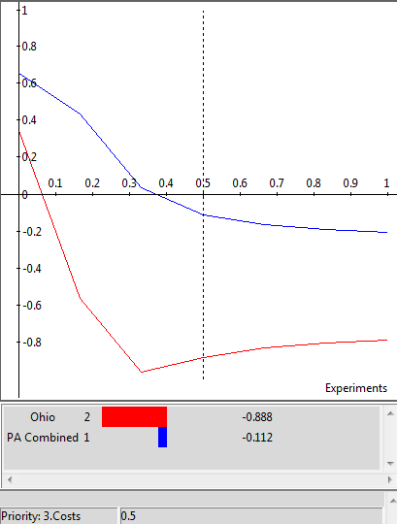
This shows Ohio as being the highest cost option, which is to be expected.

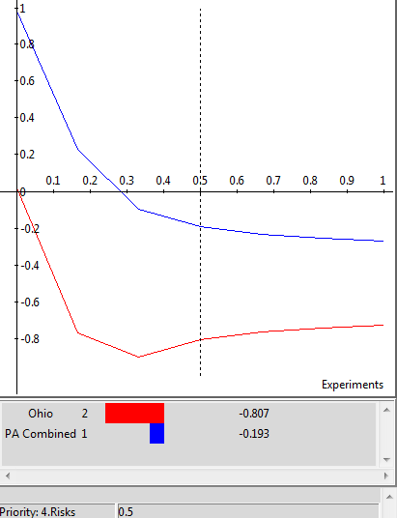
Ohio is shown as being the riskiest venture, which was also to be expected.

- Additive-Negative Synthesis

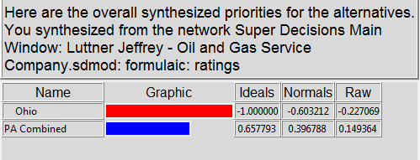

Conclusion

This final synthesis shows PA Combined being the best option for the service of the Utica shale region for the long-term. The long-term is the only synthesis that needs to be analyzed because once a camp is in place, it is expected to produce for many years. This was somewhat surprising to see because I thought the economic benefits would outweigh the costs/risks. We are currently building a camp in SE Ohio, but my limited objective analysis did most likely not take into consideration all factors.

