ANP – Project Final Report

Brazil IEMBA – Class of 2005

Group:
Benvenuto Casatti
Fabrizia Genari
Rodolfo Hrosz

May 2005

Background

The group applied the ANP methodology as a supporting tool to achieve a structured decision regarding a real business issue faced by Domaine Chandon Inc., employer of one of the group members.

Domaine Chandon is a mid sized winery in the Napa Valley in CA, producer of sparkling and still wines. The company is fully owned by the world’s leading luxury goods group LVMH.

Domaine Chandon’s sparkling wines under the brand names Chandon and Etoile lead the super-premium sparkling wine category in the US with over 50% market share.

Just recently, Domaine Chandon introduced in the US market a line of still wines (non-sparkling wines) made exclusively out of the grape varieties most used in the production of Champagne: Pinot Noir, Pinot Meunier and Chardonnay.

The introduction was a strong success as the trade and consumers accepted very well the expansion into the still wines category by Domaine Chandon, specially because this expansion was done with the specific grape varieties that Domaine Chandon knows best.

The market has also seeing other sparkling wines wineries fail dramatically when attempting the same expansion as they’ve tried this expansion with more popular grape varieties, such as Merlot and Cabernet Sauvignon, varieties that they had little no none familiarity with.

Domaine Chandon also owns vineyards planted with one of these very popular grape varieties, Cabernet Sauvignon. The quality of these grapes is superior and the grapes are currently sold to other wineries for a high price. Cabernet Sauvignon can’t be used in the sparkling wine making process for its characteristics.

Knowing that it owns superior quality Cabernet Sauvignon grapes, Domaine wants to make wine out of it, instead of continuing to sell it. Selling fruit is a non-core business for Domaine Chandon and has lower ROCE.

However, given the bad experiences had by competing sparkling wine wineries, Domaine Chandon is concerned about launching its Cabernet Sauvignon wine and jeopardizing the successful introduction of its champagne varietals still wines line by diverting from its area of expertise and diluting the concept of a “Champagne Varietals” line of wines.

Another element in the decision process is the fact that Domaine Chandon has just acquired another winery in CA named Newton Vineyeards, this winery being a well known still wines producer with the credentials to market a Cabernet Sauvignon still wine.

With all this in mind, the company faces the following strategic options:

- Continue to sell fruit;
- Introduce the Domaine Chandon Cabernet Sauvignon line extension;
- Brand X by Chandon;
- Introduce the Cabernet Sauvignon under Brand X,
- Introduce the Cabernet Sauvignon under Newton brand;
- Replant the vineyard with other grape varieties that can be used in the current product line.

The model

In order to evaluate the alternatives, an ANP model was developed with the following parts:

- Strategic criteria: defined by stakeholders such as competitors, customers, gatekeeper and shareholders.
- Alternatives: sell fruit, Domaine Chandon, Brand X by Chandon, Brand X, Newton and replant with new grapes
- Model Structure: defined in two dimensions Financial and Marketing.

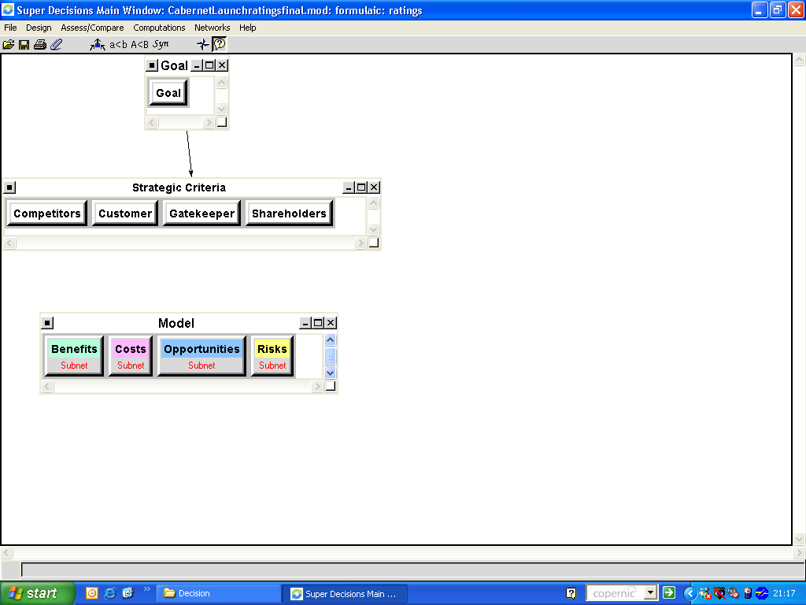

Strategic criteria

In order to evaluate the different views of the stakeholders involved in the decision, a rating table was created. The shareholders (represented by the company board) are the main influence on the decision (59.2%) because it is necessary to get their approvals to implement the best alternative. The other important stakeholders are Gatekeeper (20.1%) and customers (12.6%) who will have direct influence on the sales part of the decision. The gatekeeper is the wine critic who grades the wine that gives an indication of the quality of the wine to the customers. The customers of course are connected to the marketing aspects.
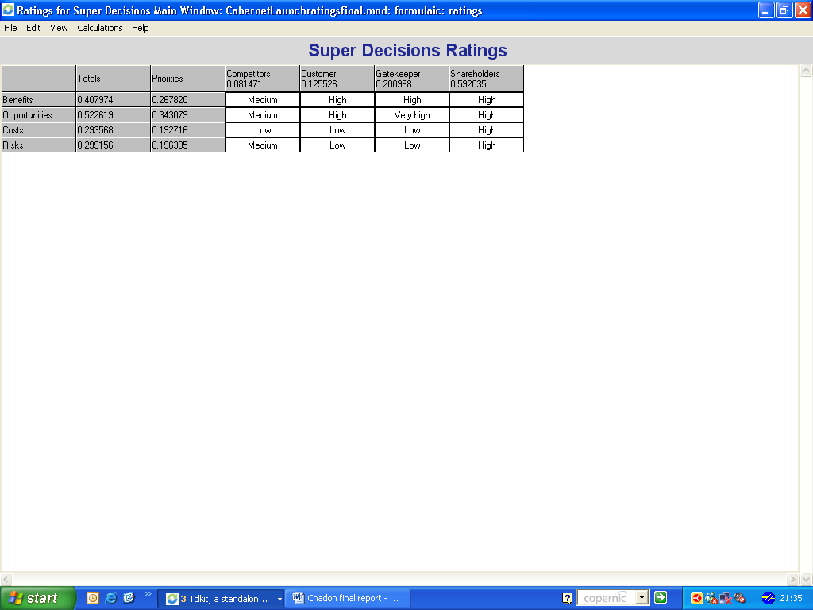

Model Structure

The criteria were divided in two segments Financial and Marketing. The financial criteria were the ROCE (Return on common’s shareholders equity) and the costs related to the redeployment of vineyard (if you choose to change the type of grape) and to the adjustments of contracts (if you don’t need to buy the total quantity of the original contracts.

The marketing criteria were market share, speed to market (how fast the alternative can generate results), brand awareness created by the alternative, the costs to build the brand and to launch the product, exports that means the possibility to export, hallo effect in the Domaine Chandon brand and brand architecture fit that means the risk that the original brand could lose.

Results

Newton that is the brand that already utilizes the Cabernet Savignon grape, is the one with greatest and fastest return, lower brand related costs, great opportunity to exports and low brand related risk. The only negative point is the cost to review the grape supply contracts.

Domaine Chandon brand is another option with strong benefits, low implementation costs but high risk to the original product segmentation. The introduction of the Cabernet Savignon grape could damage the original concept of the brand of utilizing grapes that are also used in sparkling wines.

The alternative Brand X by Chandon has positive but lower results because even tough there are positive financial and marketing results it also has higher brand building related costs.

The other options, sell fruit (the grapes itself) and redeploy vineyard (change the grape) are not economical viable and make little sense on the marketing side.

The worst option is to build a new brand from the zero. In order to achieve the marketing results it is necessary to invest a lot of money that make this option very expensive to pursue.

 |  | Criteria | Newton | Domaine  Chandon | Brand X by Ch
Benefits –  26.8% | Financial  Marketing | ROCE  Market share  Speed to market  Awareness | 42.3%  40.2%  46.7%  46.4% | 28.3%  27.5%  31.9%  28.9% | 14.3%  14.1%  11.8%  13.3%
Costs –  19.2% | Financial  Marketing | Redevelop Vineyard  Grape contract adjust  Brand building  Launch | 7.1%  63.3%  6.9%  10.2% | 7.1%  7.0%  10.9%  11.8% | 7.1%  7.0%  25.8%  32.2%
Opportunities-  34.3% | Marketing | Hallo effect  Export | 0.0%  63.7% | 75.0%  0.0% | 25.0%  10.5%
Risks – 19.6% | Marketing | Brand architecture fit | 29.5% | 48.1% | 13.1%

The final result was:

Newton | 31.7%
Domaine Chandon | 26.0%
Brand X by Chandon | 8.2%
Sell fruit | 0.4%
Replant with new grapes | -16.6%
Brand X | -17.1%

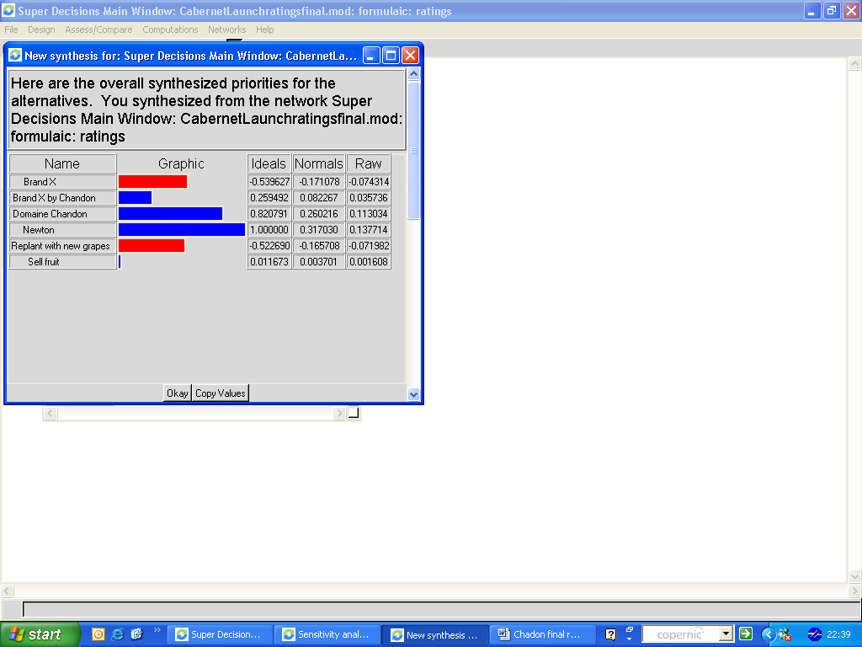

Conclusion and Sensitivity Analysis

The two best options Newton and Domaine Chandon are very close and the main difference between them is the risk on damaging the original brand. By analyzing each subnet of the model, we reached the following conclusions.

On Benefits, the change on the decision only happens if we change the importance from 26.8% to 12%. (see Sensitivity analysis: Benefits)

On Costs, the change only happens if the importance changes from 19.2% to 14.7% that means if Costs is less than 14.7% Newton will be higher than Domaine Chandon (see Sensitivity analysis: Costs)

On opportunities, the change occurs when the importance changes fron 34.3% to 27.1% (see sensitivity analysis: Opportunities)

On risks, the Newton alternative is always higher than the Domaine Chandon one.

The final result, considering the two best options, Newton and Domaine Chandon, could change if the benefits importance decreases and the opportunities and costs increases.

Sensitivity Analysis: Benefits

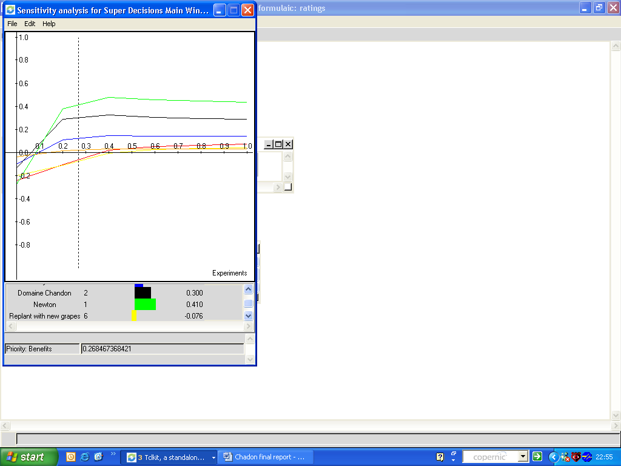

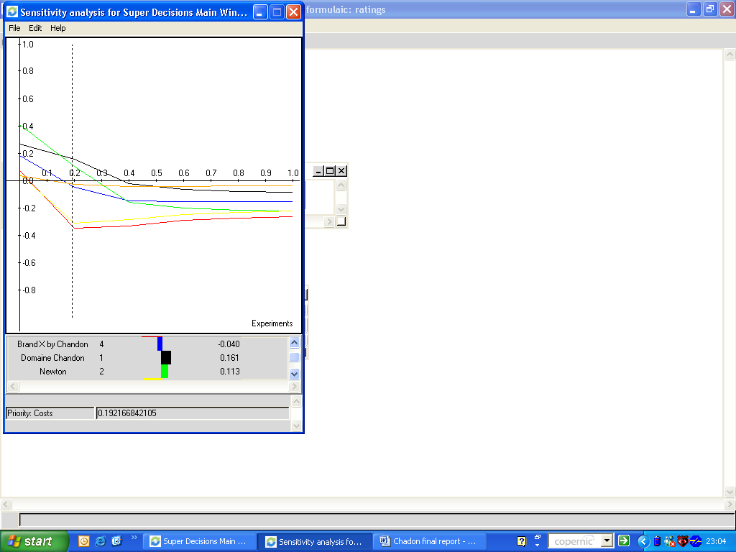
Sensitivity Analysis: Costs

Sensitivity Analysis: Opportunities

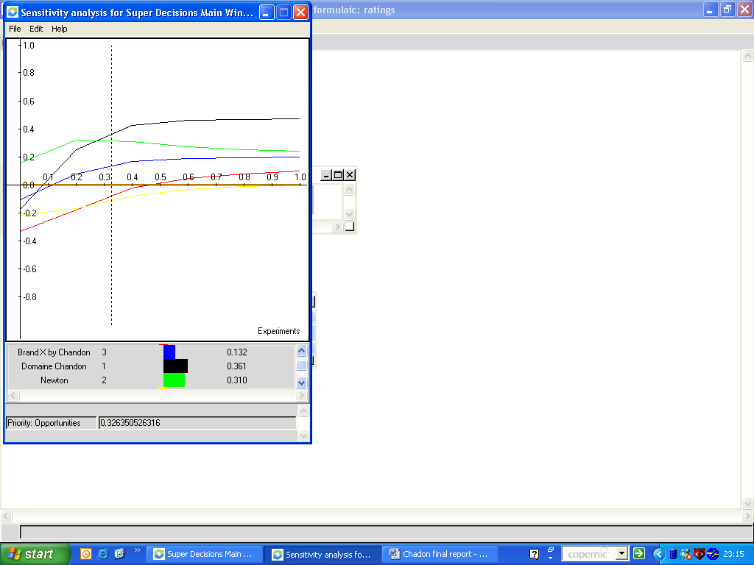

Sensitivity Analysis: Risks

