To Build a “Branch” or “Not Build” a Branch? That is the question.

BQOM 2521 Decision Making in a Complex Environment
Final Project
Spring 2013

Benjamin Pollock
BGP4@Pitt.edu

Contents: | Page #
Author’s Background | 1
Problem Introduction and Background | 1
Alternatives | 3
Methodology | 3
BOCR | 4-23
- Benefits | 4
- Opportunities | 9
- Costs | 14
- Risks | 19
Goal | 24
Sensitivity Analysis | 27
Conclusion | 32

Author’s Background:
I have several years of experience within the financial services industry. I’ve held numerous positions in finance with my current employer including capital markets, business banking, realty services and marketing analytics. Most recently I was tapped to join our SCT (Serving Customer’s Tomorrow) team to analyze how we serve our customers going forward in a significantly changed environment. The problem encompassed within this document represents a current opportunity that our company has been presented with.

Problem Introduction and Background:
The stereotypical bank branch has been around for over a hundred years. How it looks and has adapted has kept up with the current trends in architecture as well as advancements in technology. Banks used to be a simple log building or wood shack back in the late 1800’s in some parts of the world. Later, as technology grew, so did the need for banking to adopt these technologies into their business model. Banks in the late 1900s were aplenty with branches located in almost every community, municipality, township, etc. It was often hard to find a location that wasn’t served in some type by a typical brick and mortar bank branch.
The economic crash of the 2000’s forced many financial institutions to take never before seen write-offs on delinquent mortgage and other lending facilities as a result of the economic conditions. Some even put the blame of the collapse on the head of the banks. That’s for another day. However, during the process many mergers and acquisitions were taking place. Many local and small town branch banks could not operate in the current lending environment so many larger competitors who had not taken such large write-offs as a proportion of their balance sheet were taking advantage of otherwise discounted competition buyout strategies.
A few years passed before congress decided to take prompt immediate and in some circles, very hasty actions with a drastic cut of the interest rate to hovering at 0%. Accompanied with the low interest rates was the prompt and large amount of legal ramifications brought on by congress including the Durbin amendment which slashed income from transaction accounts (debit and credit cards). Many financial institutions that have a business model including the retail bank (the typical brick and mortar banks) make a large majority of their interest income from their deposit balances as well as a large portion of their fee income from the transactional activities by their customers. With the slashing of both of these revenue sources one of the key factors many banks take is to cut capital and expenditures. These activities forced the banks to rethink their business model for how they interact with customers.
Many industry experts believe the typical brick and mortar branch will always be around in some capacity to serve its customers. In what form or fashion is up for conversation in many financial circles today. However, there is a consensus that many of these branches will not be around in the amount or geographic contingencies as today. As a result, many financial institutions have turned a lot of capital resources away from the typical brick and mortar bank branches and more towards servicing customers through technology such as online banking, bill pay and credit applications as well as through consolidations such as call centers, underwriting facilities and regional or corporate headquarters.
Customers do have a tendency to utilize technology but the customer demographic that utilizes these services is not growing as rapidly as many have hoped and therefore branch strategy has become part of the business model. Many banks have started to consolidate branches. Bank of America has said it will close roughly 580 of its 5,800 branches and PNC has said it will close roughly 200 of its. For every new branch that goes up roughly two are consolidated elsewhere. For example, if one branch was located 3 miles away from peer branch of the same company, oftentimes in today’s business culture the lower performing branch would be consolidated into the other. The bank could take a huge expense save without losing much revenue as a result of customers most likely migrating to the other branch given the inconvenience of the extra three miles is not worth attriting over.
While some banks have begun massive consolidations, still others are building. During the large merger and acquisition banking climate, numerous banks began to enter new geographical markets through the purchase of another peer. As a result, their brand presence is not high in a market that has never before been entered. Brand equity is often the golden goose of a company, regardless of industry. Those with a strong brand can withstand other economic occurrences much better given a slower decline and a rapidly faster incline given market swings. This has created a push within my company to create some branches in geographic regions where our presence is not as large while still consolidating more branches in markets in which our geographic presence can be lowered due to either inactivity by the customer or opportunity and or need for capital in other areas.
Building a branch today requires much more time and consideration in the planning phase than ever before given the strict capital outflows. There are numerous meetings with every facet of a corporations hierarchy structure from distribution, technology, finance, realty services, shared services, corporate and even institutional investing. The following exercise takes place in a market of new acquisition in which the team is currently considering placing a branch in new ground. The opportunity under way is whether to build our flagship branch in the spot or not. The current geographical location was unavailable to be publically disclosed due to ongoing negotiations.

Alternatives:
There are two alternatives under consideration currently:
- Build – the company decides to go forward with a typical flagship branch on the site

- No Build – the company decides to forgo the opportunity to build
The first alternative is for the business to build the flagship branch in the location up for consideration. The alternative has been labeled “Build” subsequently.
The second alternative is for the business to not build the branch and remove itself from consideration of the leveled future development.
There were no other considerations in the space currently. The main reasoning behind not offering another branch alternative such as a smaller branch or another type of brick and mortar servicing was due to the lack of current brand presence in place. Any other form of real estate is not up for consideration given the strategic place to have the customers have their first interaction and become acclimated with the brand through a proven strategic real estate play.

Methodology:
The methodology for which to figure out the decisioning in question was made through the Analytical Network Process (ANP). Super Decisions was utilized as the model in which to either approve or disprove the decision at hand. Both the ANP process as well as Super Decisions were developed, modeled, and taught extensively by Professor Thomas Saaty.
The way in which the model was analyzed was through the BOCR model (Benefits, Opportunities, Costs, and Risks) through which each has its own network of sub criteria to determine the significance of each variable. The following explains the inner workings for how the branch decisioning model is made up.

BOCR Model Explanation:
Benefits:
The benefits were derived from several factors illustrated below:
Benefits Subnet:
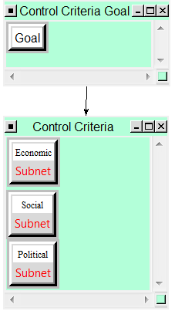

Economic Subnet:
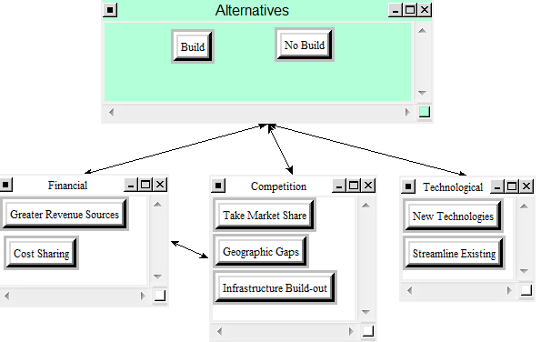
Weighted Super Matrix: Unweighted Super Matrix
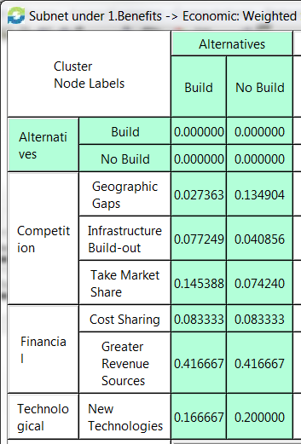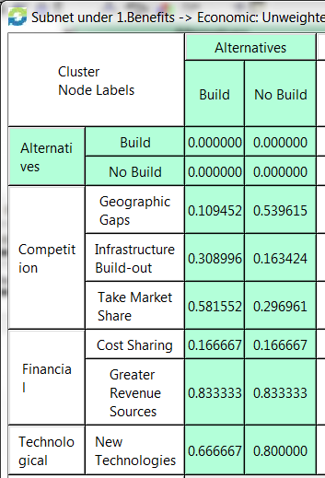

Social Subnet:
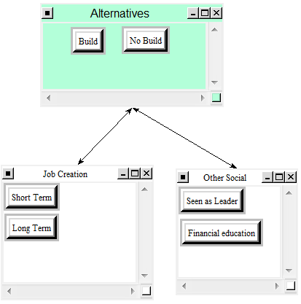
Weighted Super Matrix: Unweighted Super Matrix
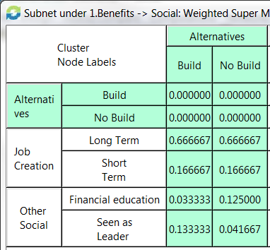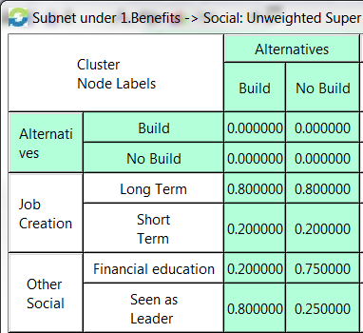

Political Subnet:
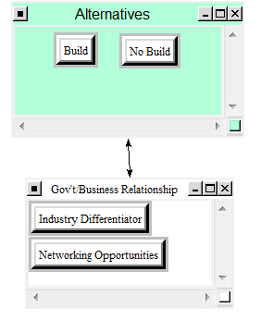
Weighted Superm Matrix: Unweighted Super Matrix
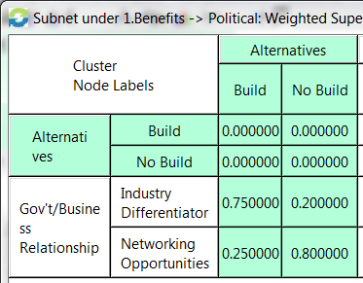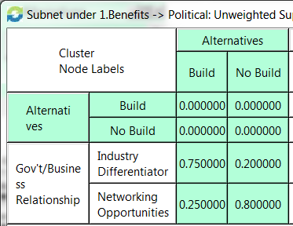

Benefits Overall Model Weights:
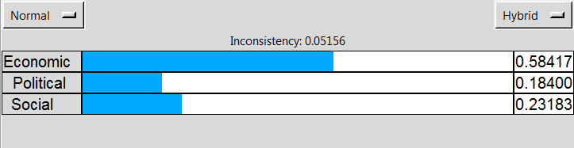
Benefits Synthesized:
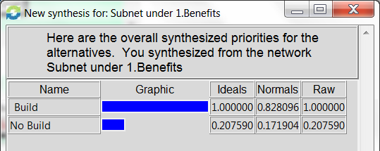
Benefits Sanity Check:
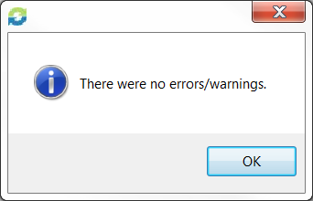

Opportunities:
The opportunities were derived from several factors illustrated below:
Opportunity Subnet:
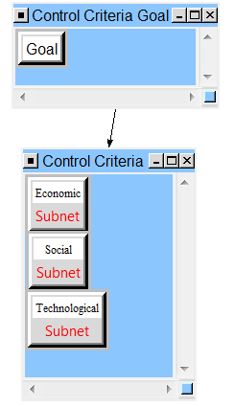

Economic Subnet:
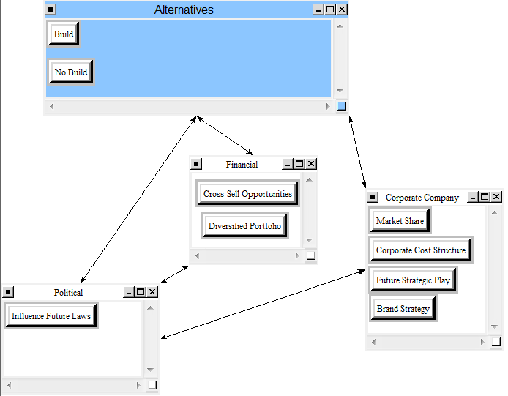
Weighted Super Matrix: Unweighted Super Matrix
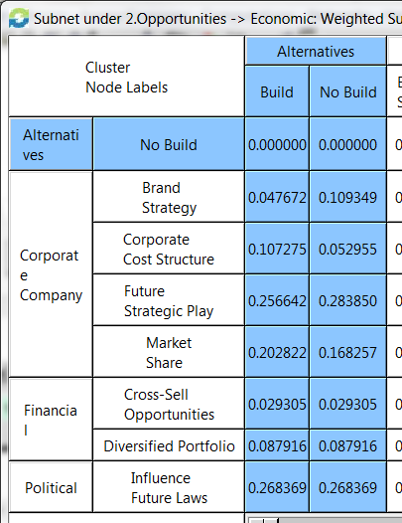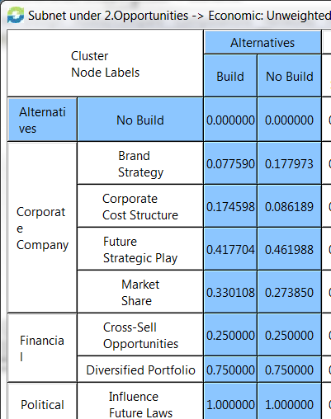
Social Subnet:
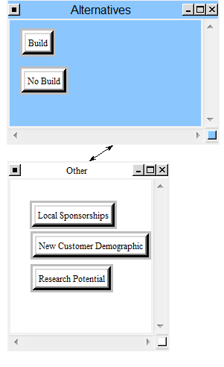
Weighted Super Matrix: Unweighted Super Matrix
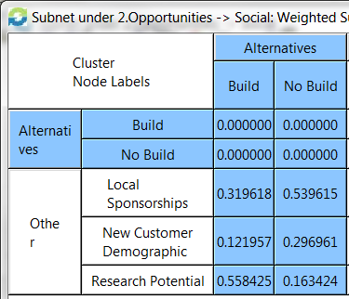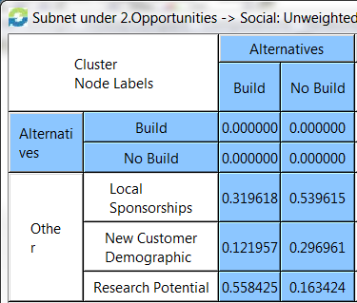

Technological Subnet:
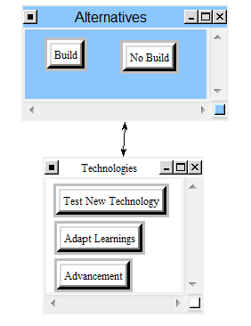
Weighted Super Matrix: Unweighted Super Matrix
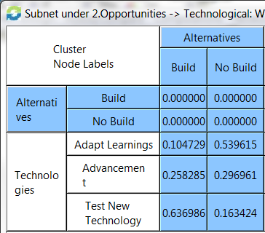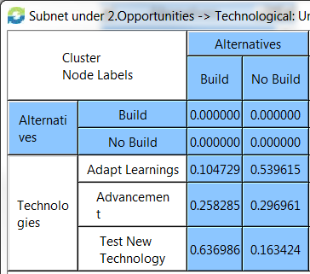

Opportunities Overall Model Weights:
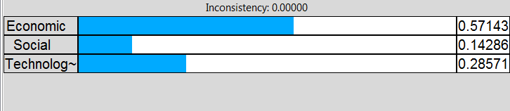
Opportunities Synthesized:
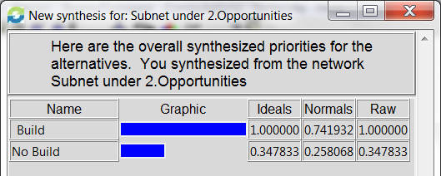
Opportunities Sanity Check:

Costs:
The costs were derived from several factors illustrated below:
Costs Subnet:
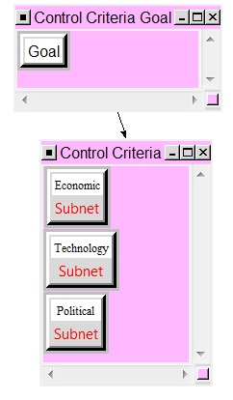

Economic Subnet:
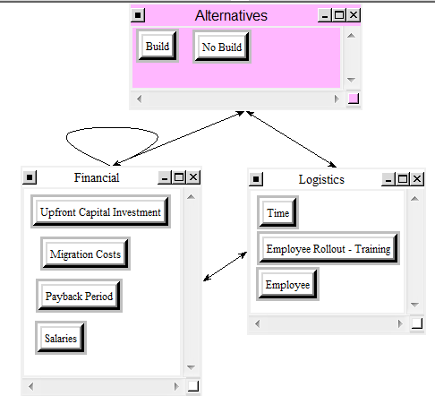
Weighted Super Matrix: Unweighted Super Matrix
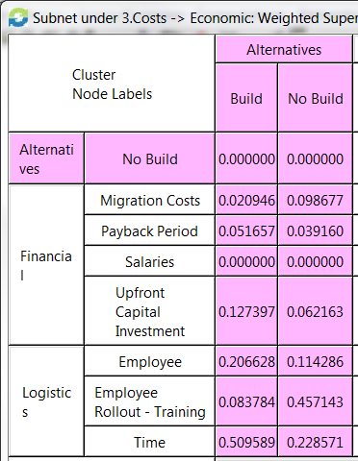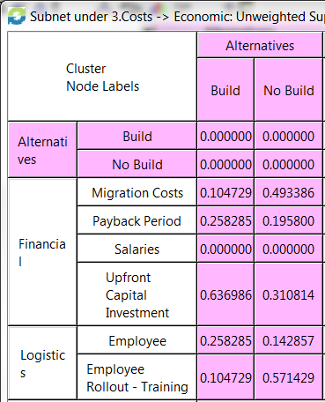

Technology Subnet:
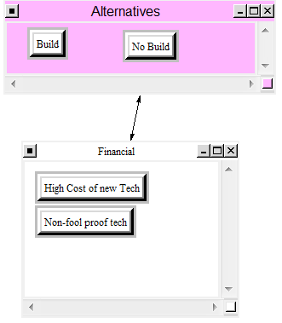
Weighted Super Matrix: Unweighted Super Matrix
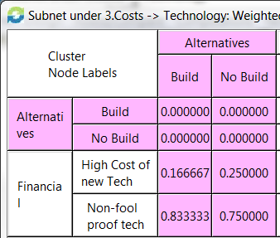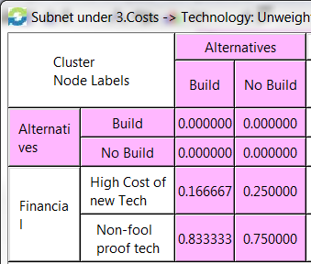

Political Subnet:
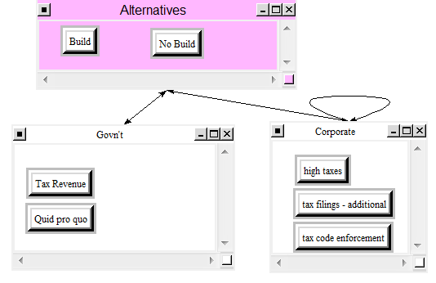
Weighted Super Matrix: Unweighted Super Matrix
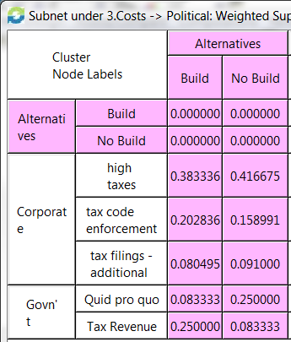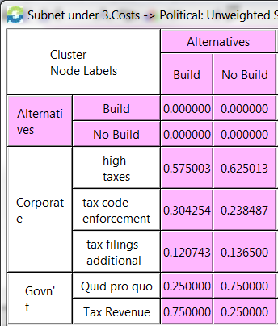

Costs Overall Model Weights:
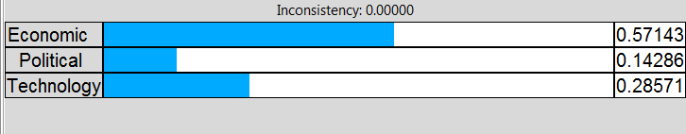
Costs Synthesized:
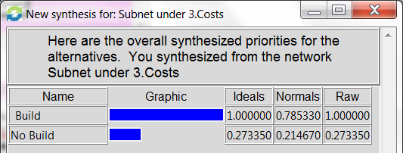
Costs Sanity Check:

Risks:
The risks were derived from several factors illustrated below:
Risk Subnet:
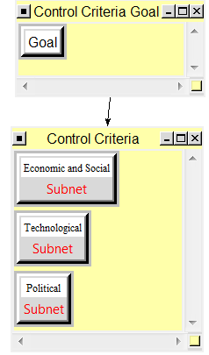

Economic and Social Subnet:
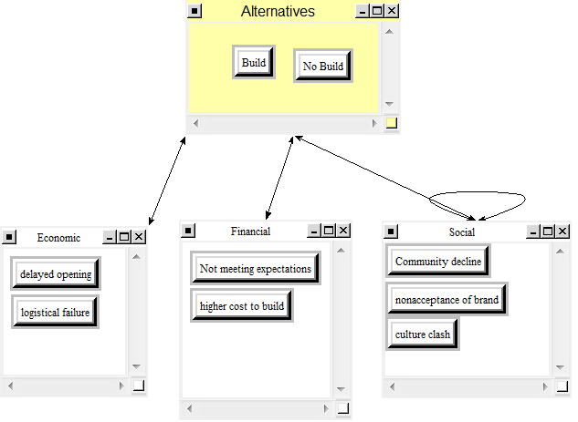
Weighted Super Matrix: Unweighted Super Matrix
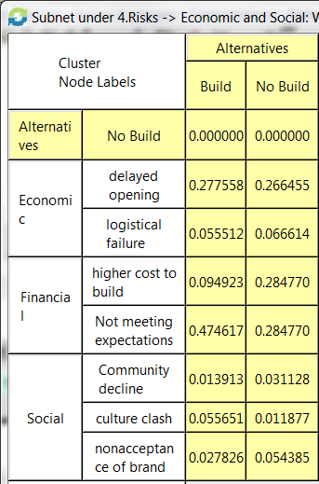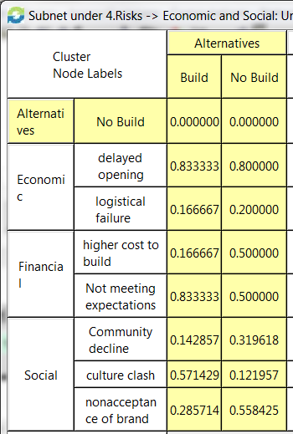

Technological Subnet:
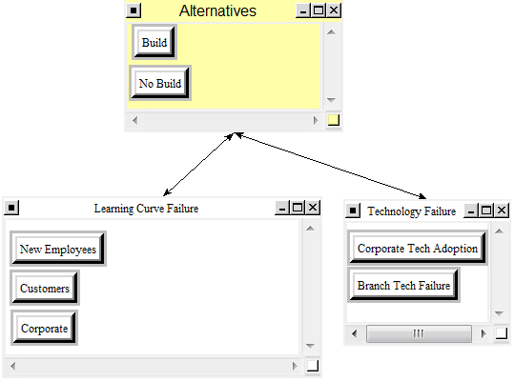
Weighted Super Matrix: Unweighted Super Matrix
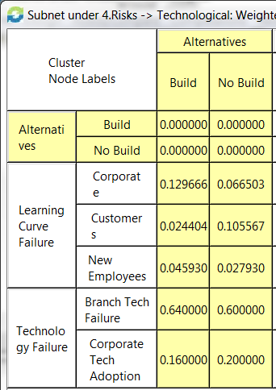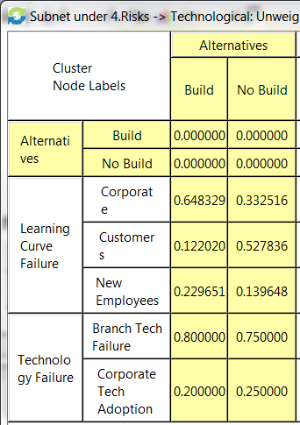

Political Subnet:
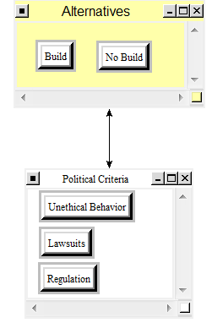
Weighted Super Matrix: Unweighted Super Matrix
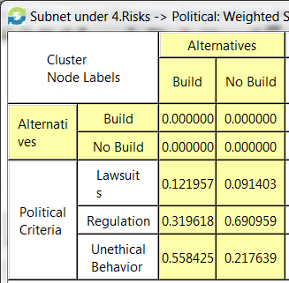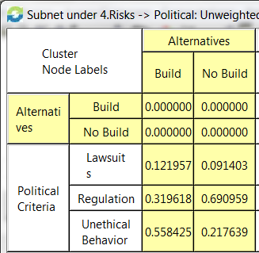

Risks Overall Model Weights:
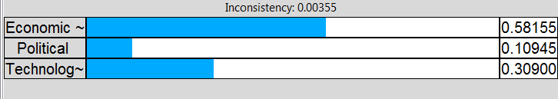
Risks Synthesized:
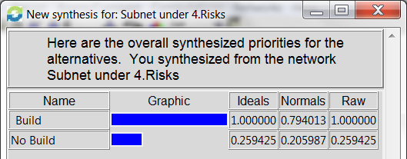
Risks Sanity Check:

Goal:
There were four additional strategic criteria added to the model displayed below:
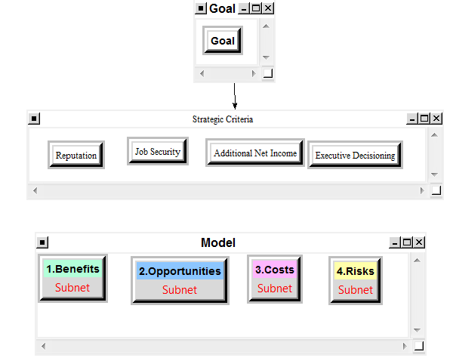
Reputation – The executive team will be the eventual party approving the branch. Their reputation among their peers can change depending upon the outcome. Generally speaking, their peers like it when branches are built.
Job Security – The executives wish to keep their jobs. A wise decision will impact the job security of the executive. By making good decisions they will keep their jobs. If they make poor decisions they will lose their jobs.
Additional Revenue – The additional revenue is a plus to the bank. However, one must be careful to consider that the additional costs do not surpass the additional revenue. Therefore, the executives are charges with driving additional profits (revenue – costs)
Executive Decisioning – This will influence the overall decision is how well the initiative is sold to committee. By doing a better job selling the branch build out or not building out a branch the pitch team can influence decisions.

Strategic Criteria Model Weights:
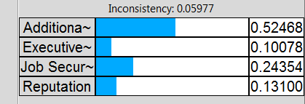

Ratings Comparison:
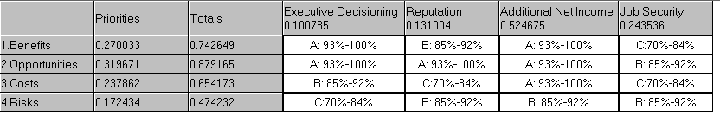

Goal Synthesized [Additive (Negative)]:
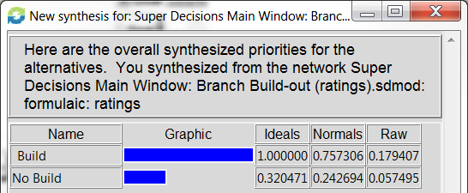
By using the Additive (Negative) formula for computation, Super Decisions suggests to “Build” the bank branch given the criteria suggested.
Goal Synthesized [Multiplicative]:
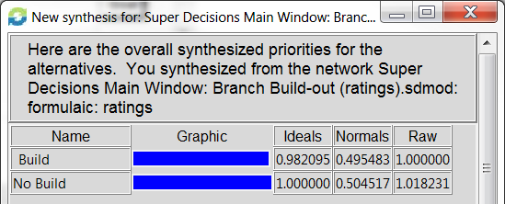
By using the multiplicative formula, Super Decisions actually recommends “No Build” of the bank branch. This is contradictory to what was foreseen above. However, the results are very close given both the ideal ratings as well as the normal ratings.

Sensitivity Analysis:
Goals:
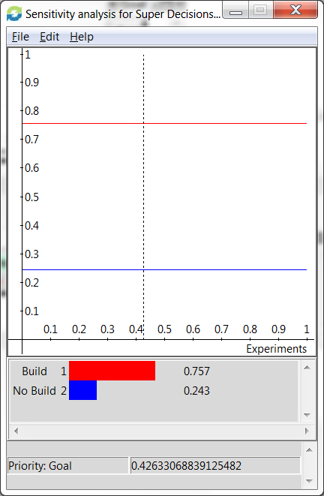
The sensitivity analysis for the overall decision is static horizontally. “Build” will always be preferable to “No Build” in the current state of the model until the comparisons are changed due to various business considerations.

Benefits:
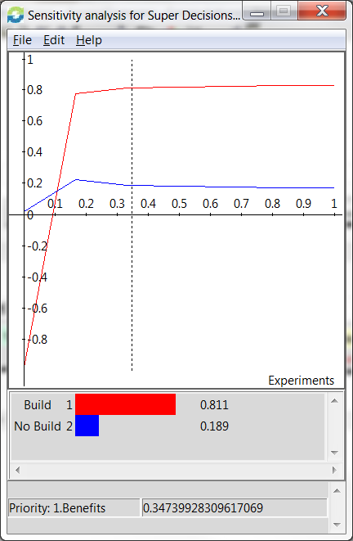
The benefits graph above shows “No Build” as the best alternative until the weighting reaches roughly 0.11 in which “Build” then takes the dominance. Both “Build” and “No Build” become rather static beyond 0.16. Build in this instance is preferred beyond 0.11.

Opportunities:
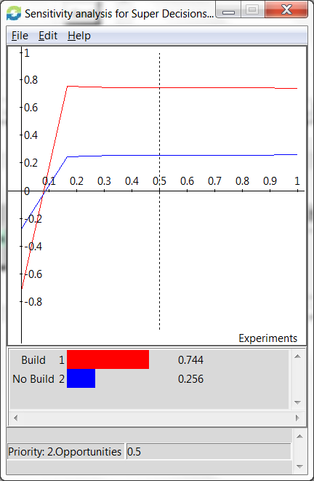
The opportunities show “No Build” as the best alternative until the weighting reaches roughly 0.07 in which “Build” then takes the dominance. Both “Build” and “No Build” become rather static beyond 0.16. Build in this instance is still mostly preferred beyond 0.07.

Costs:
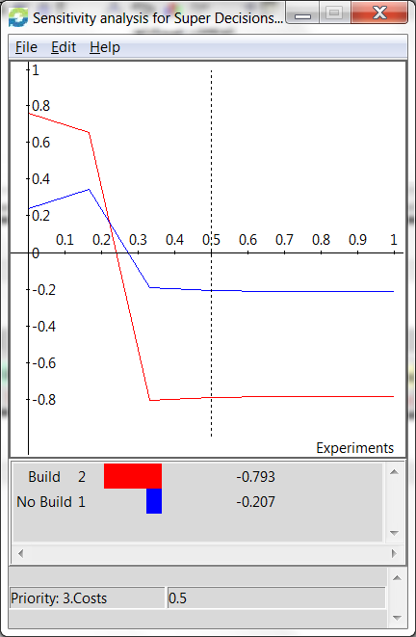
“Build” is not preferable from a cost perspective beyond 0.23 compared to “No Build”. “Build” becomes negative at 0.245 and continues thereafter becoming rather static beyond 0.32. “No Build” becomes negative at 0.28 and continues thereafter becoming rather static in similar fashion as “Build” beyond 0.32. “No Build” alternative would be more preferable when considering costs above 0.23.

Risks:
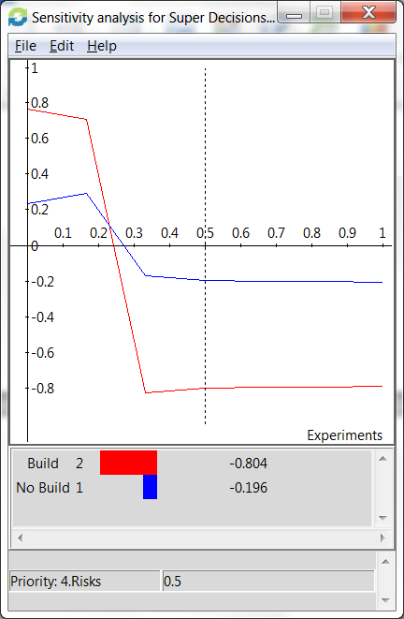
Risk is very similar to the sensitivity of the opportunities illustrated on the prior page. “Build” is not preferable from a risk perspective beyond 0.23 compared to “No Build”. “Build” becomes negative at 0.24 and continues thereafter becoming rather static beyond 0.32. “No Build” becomes negative at 0.27 and continues thereafter becoming rather static in similar fashion as “Build” beyond 0.33. “No Build” alternative would be more preferable when considering risks above 0.23.

Conclusion:
The analysis within this write-up would tend to sway towards building a branch through the additive (negative) formulization. However, the multiplicative formula would tend to sway, ever so slightly, towards not building a branch. Some would tend to think of it as a flip of the coin to make the decision. However, one would be hard pressed to make the decision based off of the flip of the coin. The ultimate decision would rely on how management is sold the initiative as well as the support in which the project has going for it.
The project was initiated due to a smaller brand presence in a market that was deemed to be ripe with opportunity by our executive leadership team. However, they were very strict to point out that the financials were of utmost importance to build the flagship branch in the area. Therefore, only the flagship branch was up for consideration. It was not considered an option for this particular geographic region to build another size branch. Therefore, only the “Build” or “No Build” option was considered.
The current status of the project is under consideration currently so therefore no particular location information was available for public disclosure given the sensitivity of the analysis. The project is in its last stage of approval for final documentation is signed and construction begins.

