Fuad Ashwash
Jennifer Stotter
Patrick Sullivan

Decision Making
Final Project
BOCR Model
Increasing Retail Banking Revenue for PNC

Goal:
For our project, we wanted to look at options for PNC Financial Services to pursue in an effort to increase retail banking revenues. Using the BOCR approach with Political, Social, and Economic control criteria, and with respect to the strategic criteria of the CFO, shareholders, and customers, we considered four decision subnets. Those alternatives included: Improving Customer Service Experience, More Mobile Banking Services, Green Buildings, and Revamping Public Image.
Model:
Our Benefits, Opportunities, Costs, and Risks for the four alternatives were broken down as follows:

Benefits
- Economic
  - Revenue Streams
  - Green Benefits
  - Non-profit Partnerships
- Social
  - Public Image
  - Investor Relations
- Political
  - Regulatory Compliance
  - Political Image
Opportunities
- Economic
  - Improved Efficiency
  - First Mover
- Social
  - Markets
  - Public Relations
- Political
  - Federal Regulations
  - Political Action Committees

Costs
- Economic
  - Cost of Implementation
  - Staffing
  - Marketing Expenses
- Social
  - Public Perception
  - Media Outlets
- Political
  - Regulatory
  - Political Relationships
  - Memberships
Risks
- Economic
  - Technology
  - Cyber Crime
  - Real Estate
- Social
  - Jobs
  - Image
  - Demographics
- Political
  - Healthcare
  - Relations with Politicians
  - Future Political Action

The criteria for each alternative under every control category had a number of node values. We proceeded to identify pertinent relationships. Although we did not feel that all of the criteria nodes applied to all of the alternatives, and vice versa, they were all important to have in the clusters for pairwise comparisons. A few sample screen shots of our model are displayed below as an illustration of our model design.
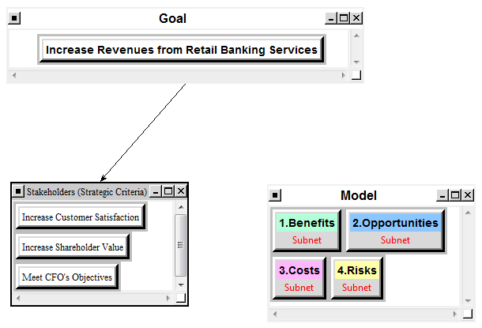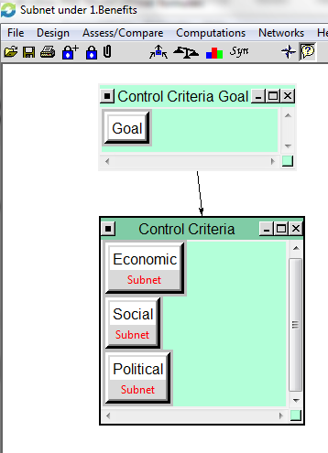
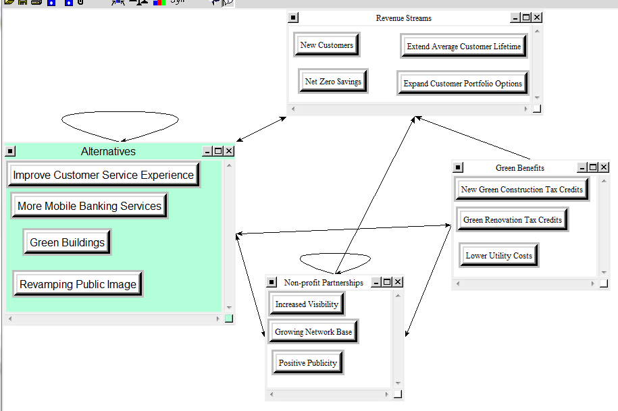

Pairwise Comparisons
After completing the initial design of the model, we completed pairwise comparisons for all of the nodes, with regard to the alternatives, within every subnets. We also rated comparisons between the clusters in the subnets. A couple of screen shots below are examples of how some of these comparisons were completed. Attention was also paid to the inconsistency levels, as it is best to keep that value under 0.1 without compromising the integrity of the comparisons.
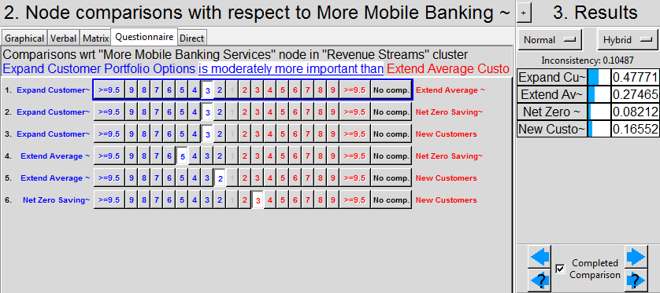
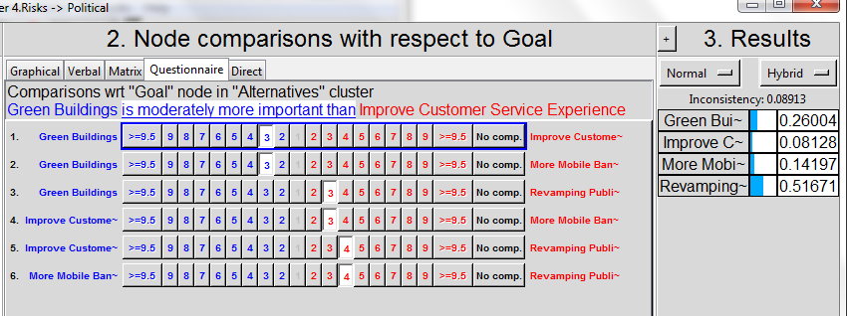
As previously stated, not every criteria was linked back to the alternatives. To gauge, we used the method of whether a reasonable question could be formed to relate the alternative to the criteria. If no such question could be formed, no link was made.
Before moving on to the next step, we checked to make sure no sink clusters or source clusters existed. We also ran the sanity check to ensure we had not missed any pairwise comparisons. In order to resolve some of the model flaws, we had to create “Super Goals” in a few of the subnets and complete the appropriate comparisons.

Priorities
After completing the pairwise comparisons, we were able to determine the priorities for our subnets. The top priorities for each decision subnet, were as follows:

Benefits: Economic
Opportunities: Economic
Costs: Economic
Risks: Economic

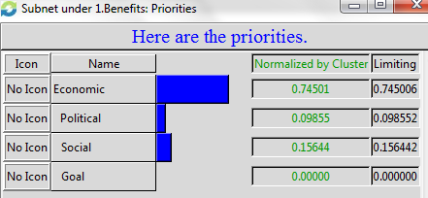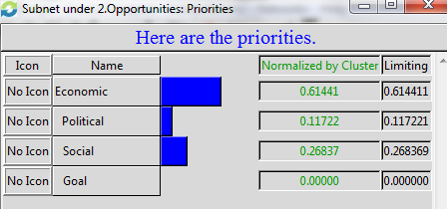
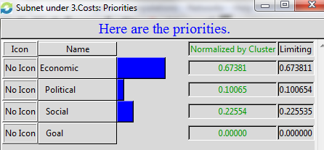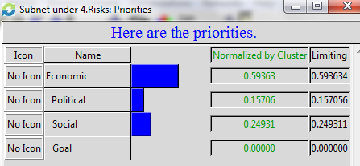
From there, we looked at the synthesized priorities under the Economic subnet for Benefits, Opportunities, Costs, and Risks. Our findings are outlined by the following screen shots:
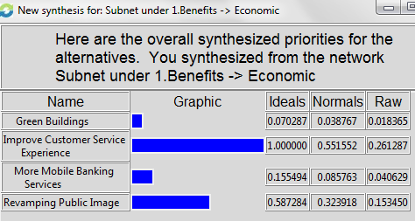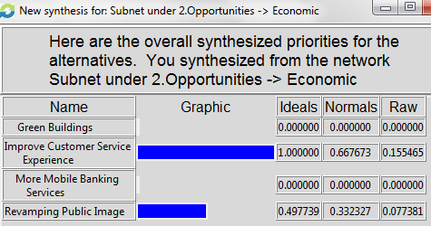
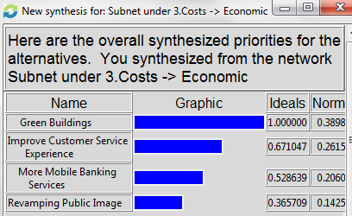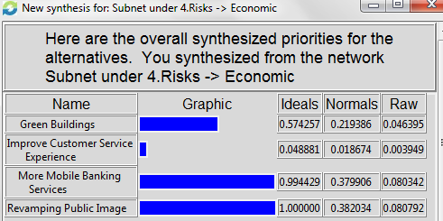
Here we see that Improve Customer Service Experience reaps the highest priority slot under Economic Benefits and Economic Opportunities. When considering Economic Costs, Green Buildings ranked the highest. Under Economic Risks, Improve Customer Service Experience was lowest, meaning it is the least risky option.
We also rated the Strategic Criteria for the BOCR model as follows:
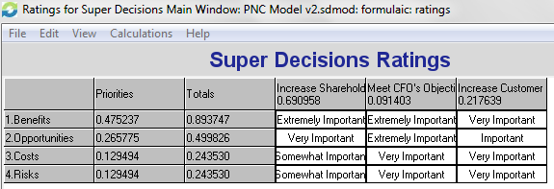
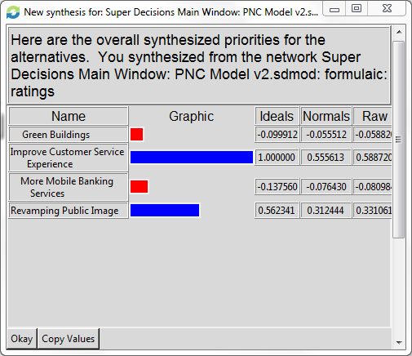

As noted above, after running a synthesis analysis of the alternatives, “Improve Customer Service Experience” is the best alternative. Next would be “Revamping Public Image.”
Sensitivity Analysis
Our next step was to run a sensitivity analysis to determine the best alternative at a given point. When synthesizing with respect to the goal, we considered sensitivity to changes in the independent variable. The four sensitivity analyses below outline changes in priorities when the main focus is on benefits, opportunities, costs, or risks.

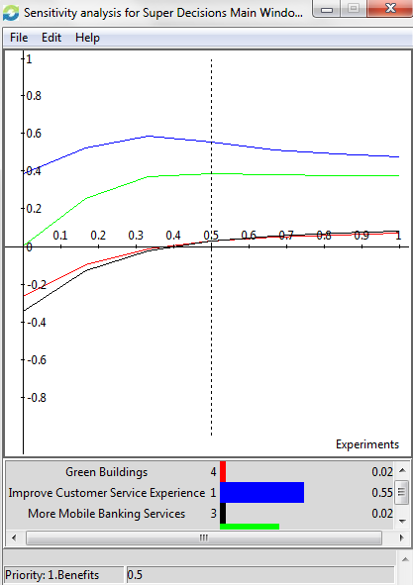
When considering priorities from the perspective of benefits, the best option for PNC to pursue is Improve Customer Service Experience, followed by Revamping Public Image. Green Buildings are slightly more desirable than More Mobile Banking Services up to about 49%, at which time the two switch roles.
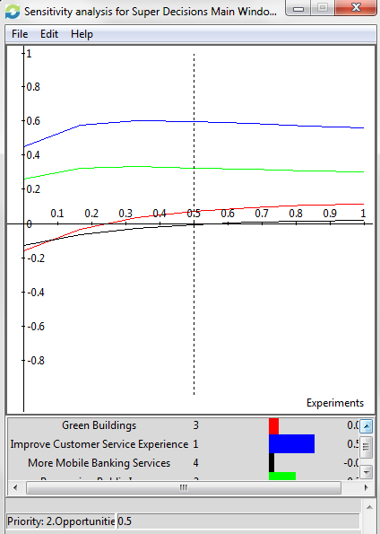
When considering priorities from the perspective of opportunities, the best option for PNC to pursue is Improve Customer Service Experience, followed by Revamping Public Image. More Mobile Banking Services are slightly more desirable than Green Buildings up to about 8%, at which time the two switch roles.

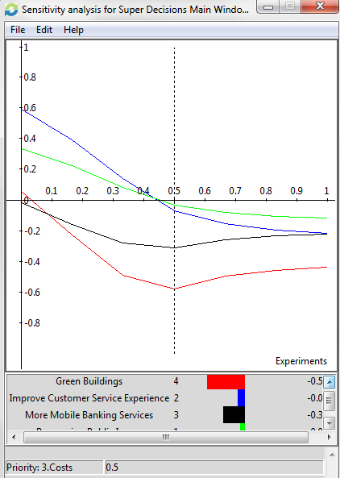
When considering priorities from the perspective of costs, the best option for PNC to pursue is Improve Customer Service Experience up to about 43%, at which time Revamping Public Image become the best priority. Green Buildings are a higher priority than More Mobile Banking Services up to about 8%, at which time the two switch roles.
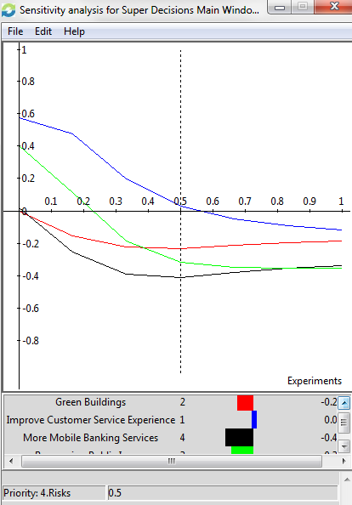
When considering priorities from the perspective of risks, the best option for PNC to pursue is still Improve Customer Service Experience. Revamping Public Image is the second best option until about 39%, at which time Green Buildings take the second tier slot for priority. More Mobile Banking Services become the third highest priority at around 84%.

Overall Results under BOCR
Using the additive negative formula (bB +oO – cC – rR) to determine the best option for the long term, we see the following:
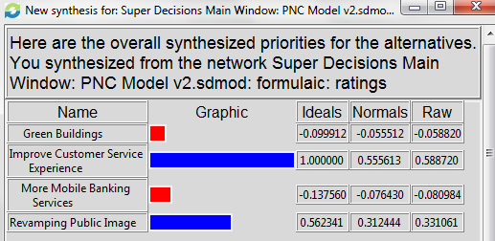
From this, we can derive that in the long term, the best option is Improve Customer Service Experience.
Conversely, using the multiplicative formula (BO/CR) to evaluate options for the short term, we find:
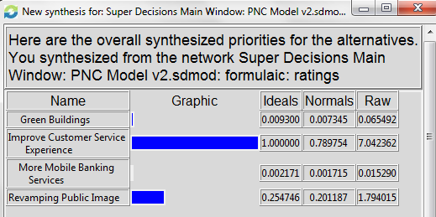
In this format, the best option is yet again Improve Customer Service Experience. Between these two tests, we see that regardless of time considerations, the preferred plan of action is to Improve Customer Service Experience in order to achieve the stated goals.
Conclusions
To conclude, according to our model, PNC should Improve Customer Service Experience first and foremost. A second alternative to be highly considered is Revamping Public Image.
For follow-up research, we recommend investigating more specific spending data for demographic groups and market locations. Additionally, the actual costs associated with things such as green building and developing new business lines should be determined. This will allow for a more accurate Return on Investment comparison, which will enhance and enrich the model.

