To Launch or Not To Launch…
An analysis of product launch scenarios

Decision Making in a Complex Environment
Spring 2013

Harry Beck
John Klune
4/22/13

Table of Contents
I. Summary Page 3
II. Background Page 3
III. Model Page 5
IV. Results Page 9
V. Sensitivity Analysis Page 16
VI. Conclusions Page 19

I. Summary
This report details the decision making process for a complex decision faced by a local company. A product had been developed with the expectation that it would be used in a project for the Department of Defense, but this did not occur due to cancelled funding. This left the product available for possible distribution through business partners either with or without an exclusive distribution contract or to not be launched at all in favor of saving the product for future use or improvement in another arena. However, the optimal decision was unclear due to competing interests and desired outcomes, some of which were objective measures (economic) and others which were mostly subjective (political). Therefore, using the SuperDecisions software and the analytic network process a complete analysis able to account for all these variables was performed. The results demonstrated that offering the product through business partners without an exclusive distributor was the most preferable option, followed by not launching the product at all. Using an exclusive contract with a business partner was the least preferable alternative in this scenario. Analysis of these results as well as a full discussion is included here.

II. Background
A. Background
The product being discussed in this paper was developed for a Department of Defense solicitation. While the company had a solution for the solicitation, there was a concern that a competitor could secure this opportunity because of a specific feature set offered. Therefore, our company developed a new product to increase the probability that it would secure the anticipated contract. While this was similar to existing products, it was a new product that offered specific features in order to attract this specific contract. Unfortunately, the funding for this Department of Defense solicitation was cancelled and the new product was never introduced to the market. The company’s existing product had strong sales with the current product portfolio.
B. Specific Problem
The aforementioned new product was predicted to be one of two potential solutions to this large Department of Defense contract, and this would have occurred without the expectation that the product would ever be released to the general market. However, once the project was cancelled, our company was left with a product that had been developed but no plans for general market release. The company was then approached by a business partner asking for exclusive rights to market the product to the general market. Our company had to then decide how to proceed.
C. Decision Specifics
In considering how to proceed with this specific product, there are several different routes for the company to pursue. The alternative strategies that the company may pursue are as follows:
Offer the product through exclusive contract with specific contingencies
The company has the choice to allow this business partner the right to market the developed product with exclusive rights, under the agreement of specific contingencies. Theoretically, there is an option to offer exclusive rights to this business partner with no contingency or fee, but this would offer minimal benefits to the company and therefore is not significant enough for consideration here. The contingency could be either flat-fee payment or guarantee of a certain sales number, but in any case would allow the company to have some benefit of guaranteed revenue to offset the risks of decreased sales when they offer it through exclusive rights.
Offer the product to all business partners for marketing without exclusive rights
The company also has the opportunity to offer the product to be marketed by any of their business partners, without any one company gaining exclusive rights to the product. Clearly, this would have substantial opportunities for increased sales given that none of their business partners have exclusive rights to the product and it would likely be available to the market more widely. However, while there are some expected economic benefits to this option there are also some political and logistical hurdles that might need to be overcome in order to satisfy all the stakeholders if this option is chosen. Fortunately, these considerations are taken into consideration in our model.
Decide to not offer the product to market
Given that the original Department of Defense opportunity that this product was developed for was cancelled, there is no impending need to offer the product to the market and our company may instead decide to retain the intellectual property of this product development for product launch at another date, continued improvement of the project prior to release, or use in another project that may have additional benefits to the company beyond what product release could offer at this point. However, all of these scenarios would need to consider the money already spent in product development as well as the lost revenue from sales of the product if they decide not to launch. On the contrary, despite extensive product development at this point there would inevitably be additional costs incurred in finalizing the product for market launch and time spent in logistical planning for working with business partners if the product is released by one of the two above options. These factors are all considered in the model presented here.

III. Model
For this decision analysis, we are using the SuperDecisions software with a full BOCR template. In this way, we will be able to analyze each of the benefits, opportunities, costs, and risks associated with each of the three alternatives to our decision as presented above. Our model was created by using three control criteria, Economic, Logistical, and Political, as shown by an example in Figure 1. Economic was an obvious control criteria choice, as any for-profit company must consider the economic ramifications of every decision, big or small. Logistics is an important criterion for us to consider as this decision is focused upon a product that our company has developed but may be marketed through one or many other business partners. The logistics of coordinating this product’s sales is of significant interest to our company’s management and employees alike. Finally, this decision carries significant political implications for the company within the larger industry marketplace. It is important to note here that the political arena considered here is not of national politics but the politics specific to the industry and marketplace. Specifically, the decision to offer the product through exclusive agreements versus widely offered has political implications given that they had already been approached by a specific business partner asking for exclusive rights. While these are not significant within a broader national political stage, the politics of a specific industry can carry as much if not more implications for a company and are therefore considered in this analysys.
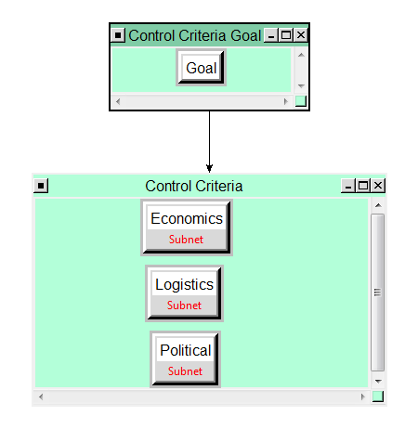
Figure 1 -- A sample of the control criteria

In addition to these control criteria, the decision is structured with three strategic criteria which more globally influence the decision making process. As such, these are some of the broader reaching goals that the company must maintain; separate from the specific considerations that are involved with each of the Subnets referred to above. The strategic criteria include Company Reputation, Revenue, and Market Share. These criteria are shown in the SuperDecisions model in Figure 2. Certainly these factors are related as market share will be proportional to revenues, but these each speak to a specific goal that the company must achieve for success.
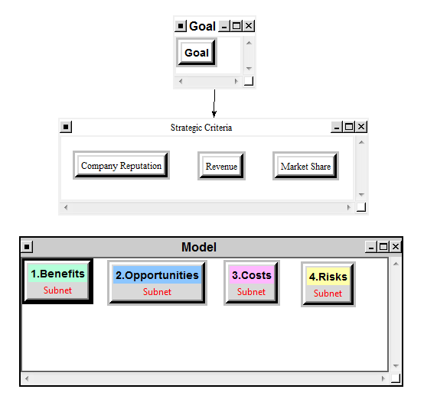
Figure 2 - Overall model as it is shown in SuperDecisions software

Within the BOCR portion of the model, each of the control criteria possess a Subnet model that are all structured similarly but modified for each subnet depending on what is reasonable for that particular Subnet. Table 1 describes the clusters and nodes that were considered for each Subnet, and as an example, Figure 3 shows an example of the Subnet under the Benefits portion of the model and the Economic control criteria. This Subnet contains all of the potential clusters and nodes that were involved in the other Subnets and shows an example of the connections that were put in place for pairwise comparisons.

Clusters | Nodes
Stakeholders | Company and Shareholders
Stakeholders | Business Partners
Company Factors | Management
Company Factors | Employees
Company Factors | Product Portfolio
External Factors | Clients/Customers
External Factors | Competition
External Factors | Government/DOD
Table 1 - A demonstration of the clusters and nodes that were used in Subnet creation and evaluation

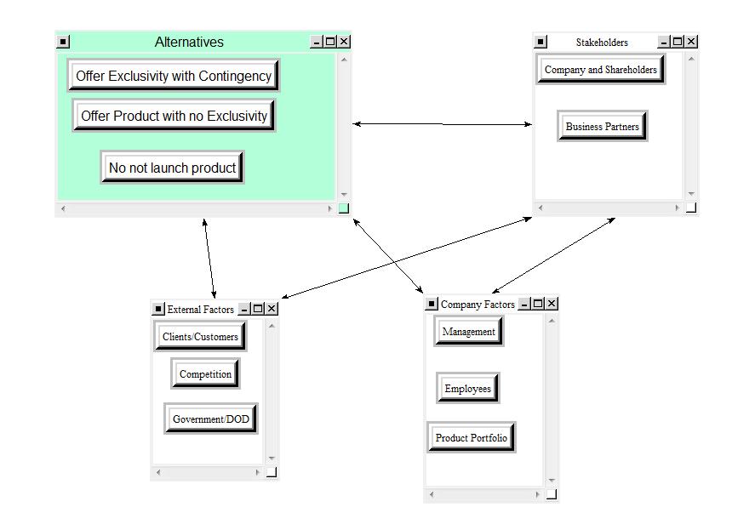
Figure 3 - Example of Subnet under Benefits --> Economic, demonstrating each of the clusters and nodes as well as the connections that were used for pairwise comparisons

For further information regarding specific clusters, nodes, and connections used in the Subnets for each BOCR node and control criteria, please refer to the model which is included in this submission. Following full creation of the model as described here, individual pairwise comparisons were performed for each of the nodes and clusters involved. Once this was complete, model results were obtained.

IV. Results
Upon completion of model building, pairwise comparisons of the Subnet models under each of the BOCR clusters was performed. The sanity check calculation was run to make sure all necessary pairwise comparisons were completed and resulted with no errors or warnings prior to results being calculated.
A. Benefits
The Benefits subnetwork including all control criteria resulted in economic benefits being of the highest priority, as expected. This is shown in Figure 4. Certainly in a business setting economic considerations are always highly prioritized and our model reflects this. The highest rated alternative under Benefits also reflects this reality, that of offering the product without any exclusivity arrangement. This is illustrated in Figure 5. This is a logical choice considering that the company would stand to have the potential for highest revenue and profits under this arrangement compared to limiting sales to one business partner or not offering the product at all. Therefore, the results from the business section are a logical conclusion in the setting of the broader question. 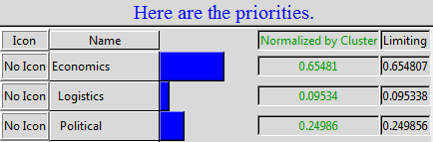
Figure 4 - The priorities under the Benefits subnet
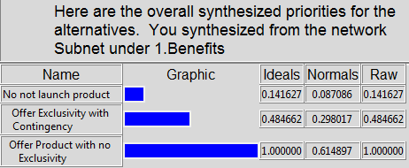
Figure 5 - The alternative rankings under the Benefits subnet

B. Opportunities
Economic priorities, again, was most important in the opportunities section. This is shown in Figure 6. It should be noted that there is no political control criteria considered in the Opportunities section as this is not a relevant consideration under these circumstances. Interestingly, while the same alternative was the top choice under opportunities, it was by a much smaller margin. This is illustrated in Figure 7. Of note, the alternative of not launching the product at all had a much higher overall result, reflecting the opportunity for further product development and use with other products as noted above.

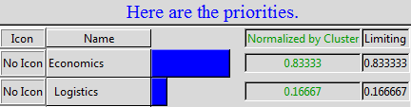
Figure 6 - The priority ranking under the Opportunities subnet
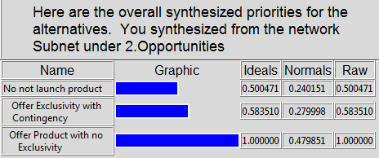
Figure 7 - The alternative rankings under the Opportunities subnet

C. Costs
The Subnet under the Costs section of our analysis is also noted to not have the Political control criteria as well, reflecting the minimal political costs involved in the decision at hand. Checking the priorities for Costs reveals again that Economics is the highest priority by the same margin as the Opportunities cluster considered above. This result is shown in Figure 8. The results of the Costs Subnet also reveal some interesting results and are shown in Figure 9. Here, offering the product with or without exclusivity arrangements revealed the same costs, both of which were significantly higher than not launching the product at all. This reflects the additional work that would need to be done by the company to bring the product to market and carry inventory specific to this product. This cost is the same for the product to be launched whether that launch occurs with one exclusive business partner marketing the product or many.
Figure 8 - The priority ranking under the Costs subnet
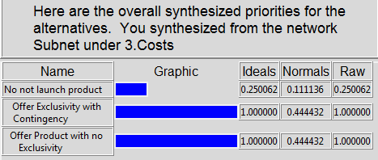
Figure 9 - The alternative rankings under the Costs subnet

D. Risks
The Risks Subnet contains all control criteria as there are certainly major risks associated in all three domains. Here, economic and political risks were equally weighted and are shown in Figure 10. It is important to remind the reader that the political risks are not of a national politics but rather the risks within the marketplace. Given that our company was approached by a specific business partner asking for exclusive rights to market a product we had developed, our decision would carry specific risks in the industry whether we chose to agree to an exclusive arrangement with this business partner or not, and this is what is reflected by the priorities here. The results of the Risks analysis demonstrates that offering the product with an exclusive arrangement carries the largest risk to the company. This result is almost assuredly a combination of the economic risk of decreased sales from an exclusive arrangement as well as the political risk of upsetting other business partners if an exclusive arrangement were to be made. This is shown in Figure 11.

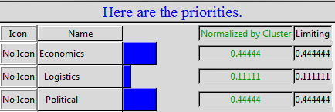
Figure 10 - The priority rankings under the Risks subnet
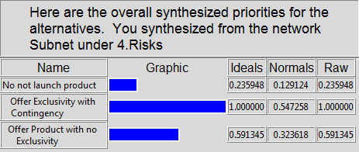
Figure 11 - The alternative rankings under the Risks subnet

E. Strategic Criteria
With each of the BOCR clusters fully analyzed and the results found to be appropriate, attention was then turned to integrating the Strategic Criteria into our model. The result of this analysis is shown in Figure 12. Pairwise comparisons of the Strategic criteria (Revenue, Market Share, Company Reputation) were performed at results demonstrated a strong need for revenue, followed by market share and company reputation taking nearly equal priorities.
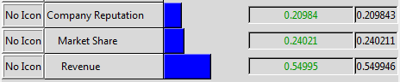
Figure 12 - Priorities of the Strategic Criteria

Once these priorities were obtained, a ratings model was created for integrating the strategic criteria with the BOCR portion of the model. In order to do this, a set of categories was created to compare the alternative choices against the strategic criteria listed. These categories as well as the numerical value given to them after comparisons are shown in Table 2. These categories were then used to input into the strategic criteria ratings scale as shown in Figure 13.

Category | Numerical Value
Significant Improvement | 1.000000
Moderate Improvement | 0.627218
No Effect | 0.299591
Moderate Decrease | 0.113470
Significant Decrease | 0.073830
Table 2 - Category rating scale used in Strategic criteria analysis

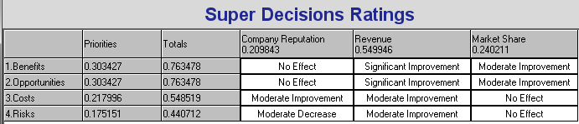
Figure 13 - Completed ratings incorporating results from BOCR analysis with stratigic criteria

F. Completed Model
With the full analysis complete, the model was calculated using both the additive and multiplicative methods. To begin, the multiplicative model, which is generally best for short term results, demonstrated that offering the product without any exclusive arrangement was the top alternative . A graphical representation of this result is shown in Figure 14.
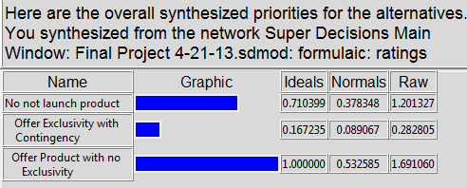
Figure 14 - Results of the model using the multiplicative method of calculation

This result is consistent with what would be expected, knowing that this option offers the greatest opportunity for increased revenue and the relative high priority that economic considerations took within our model. However, the results of the remaining two alternatives were quite surprising, with deciding to not launch the product as a second choice and launching the product with an exclusive contract to one of their business partners as the least favorable alternative. Given the importance of revenues and economics, it had been expected that this alternative would be second place as it offers more opportunity for these outcomes than not launching the product at all. To confirm these results, analysis via the additive method was performed to determine whether these results were consistent. As seen in Figure 15, this is in fact the case with the order of alternatives being the same, and in fact offering the product with exclusive contract was a negative priority under this formula.
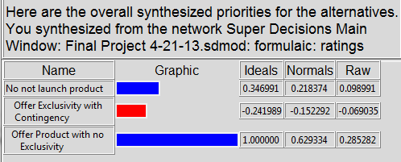
Figure 15 - Results of the model using the additive method of calculation

While this result was not expected, it can be explained and is an example of how the model and the SuperDecisions software was able to methodically consider all the factors in this decision to clearly list the alternatives in their respective priorities. The finding that offering the product with an exclusive contract would be less favorable than not launching the product at all can be explained by the significant cost it would take the company to bring the product to market and the risks that this alternative posed in terms of possible decreased revenue and political damage to our company’s relationship with other business partners. While our subjective analysis prior to launching this model would have assumed that launching the product under an exclusive contract would have been a more preferable option than not launching the product at all, this objective model has demonstrated that in fact our own priorities, when objectively and systematically analyzed, led to a different conclusion.

V. Sensitivity Analysis
Finally, a sensitivity analysis was performed to determine how this model changes as the priorities of each of the BOCR considerations change. To begin, a sensitivity analysis with respect to the Benefits node was undertaken as seen in Figure 16. As expected, launching the product with no exclusive contract is the most favorable choice across the entire spectrum. As a reminder, the Benefits node received a priority of approximately 0.30. At this point on the graph, the results are as previously reported here with not launching product a second choice. However, as benefits become a higher priority, specifically at an approximate priority of 0.334, it would become different with launching the product with an exclusive arrangement being more favorable at this point. This is likely explained by the potential economic benefit and additional revenue that would be achieved by this, as it would then have the priority to overtake the risks that are currently keeping it as the least favorable alternative to our model. These findings again are reflected in the sensitivity analysis with respect to the Opportunities node as seen in Figure 17. These results have the same pattern as the Benefits node, with the modification that the crossover requires an Opportunities priority of 0.6 for offering the product with an exclusive arrangement to be the second most favorable option. The difference in priority score needed in these two sensitivity analyses is explained by the importance of revenue in our model and the potential economic benefits from product launch.
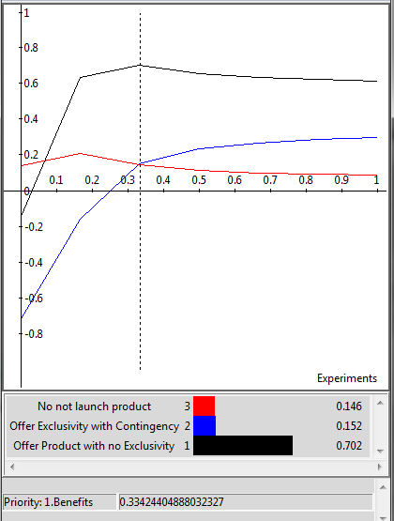
Figure 16 - Sensitivity analysis with respect to Benefits node

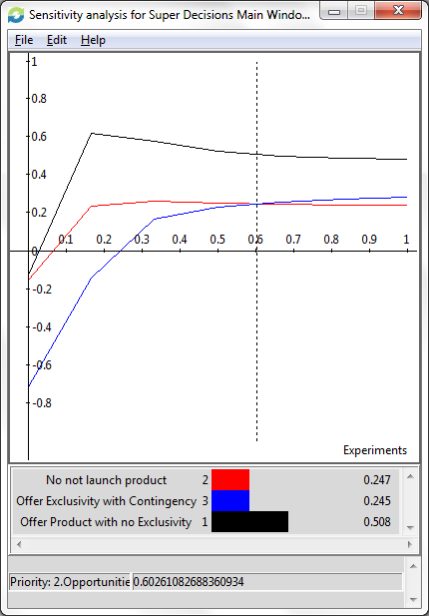
Figure 17 - Sensitivity analysis with respect to Opportunities node

In regard to sensitivity analysis for the Costs node seen in Figure 18, these results again are as expected. The least costly alternative is the alternative to not launch the product. This is reasonable as it would not incur the costs of bringing the product to market. However, there is a difference between the alternatives of offering the product with or without an exclusivity contract. As the Costs have a lower priority, the option of offering the product with an exclusive contract is less favorable, but as costs gain additional priority the options of offering the product with or without exclusivity become equal, as they are not offset by the other factors contained in this analysis. This is as expected, as the costs to our company would be the same whether the product is being launched through one company or many. The results of the sensitivity analysis for the Risks node seen in Figure 19 reflect the Costs analysis but have some important differences. Importantly, the alternative of offering the product with an exclusive arrangement is throughout the spectrum the least favorable alternative. This is likely due to the significant political risks that our company carries by making this exclusive arrangement and hurting relations with other business partners.
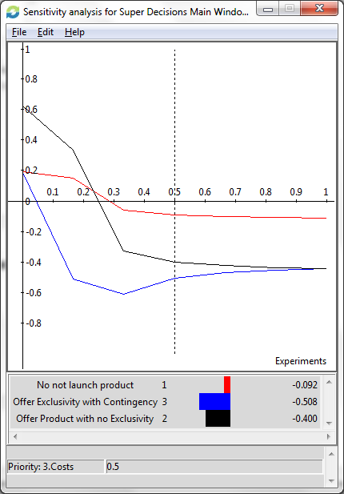
Figure 18 - Sensitivity analysis with respect to Costs node

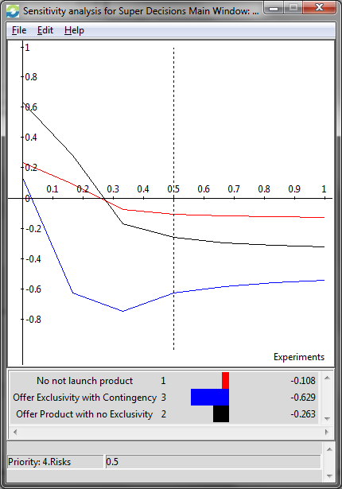
Figure 19 - Sensitivity analysis with respect to Risks node

VI. Conclusions
The model calculates that offering the product without an exclusivity contract with a specific business partner is the most preferable alternative in this decision. The importance of economic benefits was the dominant factor that led to these results. Interestingly, the alternative of not launching the product at all was the second choice followed by launching the product through an exclusive arrangement. As noted above, this was a surprising result when compared to traditional subjective decision analysis, which would likely lead to a decision to offer the product with an exclusive contract given the ability to gain revenue in this alternative. However, this objectively obtained result through the modeling software is likely due to the increased risks that the company is exposed to if they offer the product through an exclusive contract. One limitation of this model is that we do not consider here the specific strengths and weaknesses of particular business partners that might offer the partner. While some business partners may not offer a strategic advantage, others may have particular strengths or access to certain markets that may make an exclusive contract more desirable than with other partners. However, these considerations are minor in the larger scale of the decision and unlikely to significantly affect the results obtained here. Therefore, the company should decide to either offer the product or not, and if so, to offer it without an exclusive contract in order to maximize revenue.

