Decision Making Final Project

Home Depot Asian Development Strategy

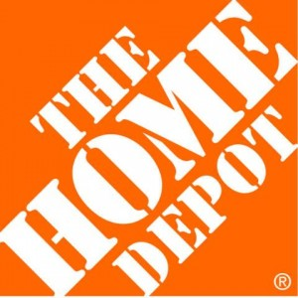

The next city in Asia Home Depot should march on after failing to grasp China mainland market

Fangjian Shang
Xiaoying Geng

Table of Contents

Introduction………………………………………………………………………….....3

Goal…………………………………………………………………………………….3

Alternatives…………………………………………………………………………….3

Modeling Process………………………………………………………………............4

Benefits………………………………………………………………………...6

Opportunities…………………………………………………………………..8

Costs…………………………………………………………………………..10

Risk…………………………………………………………………………....12

BOCR Priorities……………………………………………………………….13

Rating model….……………………………………………………………….16

Sensitivity Analysis.......................................................................................................19

Conclusion……….........................................................................................................20

Resource……………………………………………………………………………....20

Introduction/Background
The Home Depot, Inc. is the world’s largest home improvement retailer. The Home Depot stores sell a wide assortment of building materials, home improvement and lawn and garden products and provide a number of services. The Home Depot stores provide product and project knowledge to assist customers who like Do-It-Yourself ("D-I-Y") with specific product and installation questions.
During fiscal 2012, Home Depot closed all seven of its remaining big-box stores in China after years of losses. Analysts attributed the failure to the difference in culture -- DIY service approach fails to grasp the local Chinese culture. Due to the cheap labor cost, Chinese consumers prefer a do-it-for-me culture -- pay for people to do the work for them, which stunts the do-it-yourself ethos. Furthermore, apartment-based living leaves scarce demand for products like lumber.

However, because Asian market is too big to ignore, Home Depot is constantly searching for areas where it can expand into new markets to promote the profit-growth in foreign market.

Goal

The next city in Asia Home Depot should march on after failing to grasp China mainland market.

Alternatives
Learned from the lesson in China, we choose the areas with high labor cost and disposal income. During the course of this research, we narrow down alternatives to three cities for Home Depot regarding the Asian Market:

Hong Kong
Seoul
Tokyo
Don’t invest in Asia

Differences among alternatives

 | Tokyo | Seoul | Hong Kong
Income per year | 330,000 RMB | 240,000 RMB | 200,000 RMB
Rent | 36,7000 | 21,9000 | 30,000
Currency stability | medium | low | high
Interest Rate | 1.4% | 3% | 2%
Economic Growth in 2012 | downturn | 3.7% | 2%

BOCR Modeling Process

- build the networks and sub-networks for each of the BOCR models by choosing influential criteria
- Analyze and determine the best alternative for each subnet
- Choose Strategic criteria, and determine the importance of the BOCR by rating them with respect to the strategic criteria.
- Choose the best alternative by weighting the priorities of BOCR

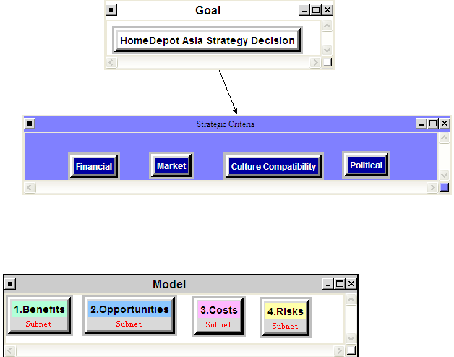
BOCR | Control Criteria | Clusters | Elements in Clusters
Benefits | Economic | Financial | Asset, disposal Income, profitability, personnel, legal
Benefits | Economic | Operational | startup time, use of management, reaction rate to market
Benefits | Social | market | customer base, brand recognition, market penetration
Benefits | Social | Political | government regulation, political support
Opportunities | Economic | financial | financing opportunities, new profit-growth spot
Opportunities | Economic | Business development | Expansion of brand recognition, global purchasing
Opportunities | Social | market | brand recognition, growth in customer base, market penetration
Costs | Economic | Financial | labor cost, shipping cost, lease, advertisement cost
Costs | Economic | Operational | startup time, use of management, reaction rate to the market
Costs | Social | Operational | startup time, reaction rate to market, use of management
Costs | Social | Market | brand recognition, competition
Risks | Economic | financial | legal cost, currency rate, loan interest rate
Risks | Economic | Sustainability | economic stability, government support
Risks | Social | culture conflicts | communication, life style
Risks | Social | localization | local competition, local management strategy

Benefits
We identify economic and social benefits as the influential factors

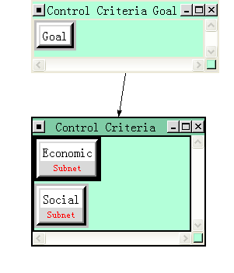
Economics Control Criteria:
Financial nodes include asset, disposal Income, profitability, personnel. Asset means the increase of the tangible or intangible asset that should be owned for new stores to make profit, such as financing lease, furniture, and laptops. Disposal income means the total personal income minus personal current taxes, which will influence the purchasing power. Personnel mean the increase of reserve of talents.
Operational nodes include startup time, use of management, and reaction rate to market.
Startup time means the time a new store need from the startup to function normally. The sooner they can start in a new country, the more opportunities they can obtain than other competitors. Use of management refers to the number of experienced management that headquarter should send to operate the new stores. Reaction rate to market reflect the new stores’ ability to meet the customers’ demand, it also reflects the quality of the management.

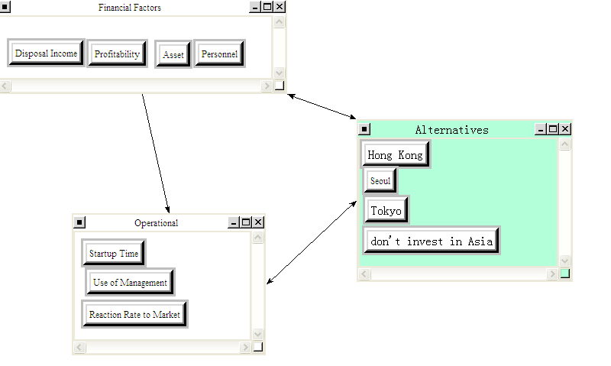

Social Control Criteria:
Market node includes customer base, brand recognition, market penetration. Customer base refers to the growth of customers and target market that a business serves. Brand recognition means the degree of widely known in those cities. Market penetration means the benefits that home depot gain part of the competitors’ customers and market share.

Political includes government regulation, political support. if the local regulation will benefit home depot’s operation. Political support means the support from department of the local government.
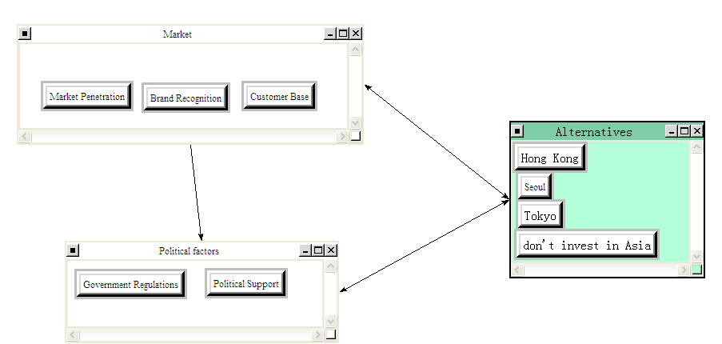

Opportunities

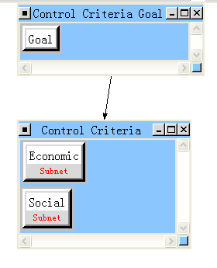
Economics Control Criteria:
Financial node includes financing opportunities, and new profit-growth, since new stores will increase home depot’s sales and profit margins and to obtain additional financing on favorable terms. Therefore, the company can obtain and manage liquidity from the positive cash flow we generate from our operating activities and our access to capital markets and invest on more items

Business development includes brand recognition, and global purchasing. The areas where home depot building new stores can expand the sources of global purchasing, which will help achieve the most favorable price.

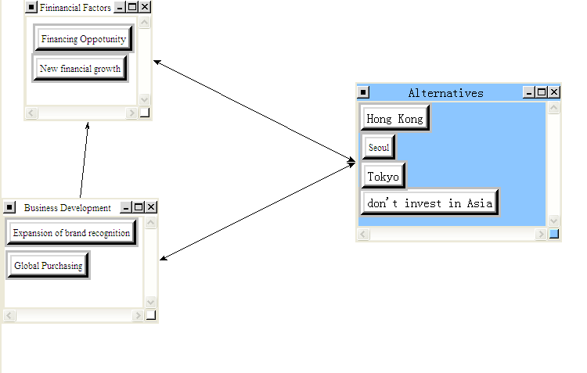

Social Control Criteria:
Market includes brand recognition, growth in customer base, and market penetration. Building new stores in foreign countries will expand the brand awareness, broaden the customer base and seize the competitors’ market.

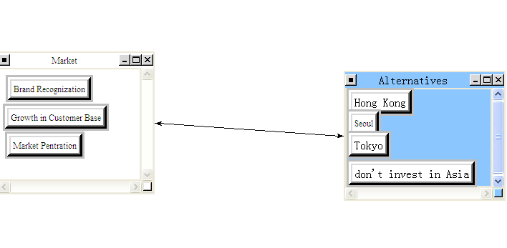
Costs

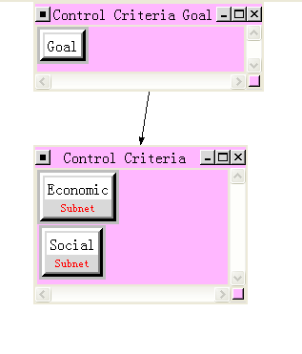
Economics Control Criteria:
Financial node includes labor cost, shipping cost, lease, since Home Depot is a retailer of home improvement and construction products and service, the cost for store opening including lease charge, labor cost will be the major issue. Meanwhile, due to the reason that they purchase products globally to achieve the most favorable price, shipment cost will also be a factor we need to consider. In Financial node, we have these criteria to compare the alternatives in order to pick up the competitive cost location.

Operational node includes startup time, use of management, reaction rate to the market, the startup time will affect their timeline to occupy the market, the sooner they can start in a new country, the more opportunities they can obtain than other competitors. The cost of utilizing of management affect their human resource cost, if they can recruit experts employees from local, the cost of using management from headquarter will be decreased. And for the reaction rate to market, it can be a good judge to calculate the cost in different countries to react to the change of market, for example, if the market has new demand for certain construction products or new decoration style, how much cost Home Depot will need to supply them in their store.

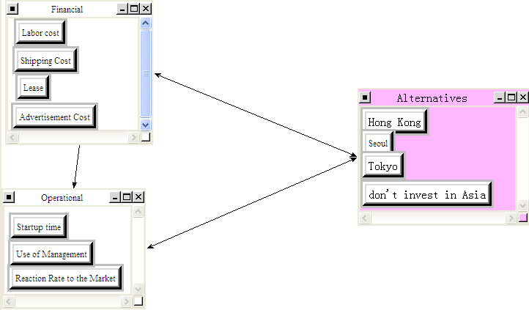

Social Control Criteria:
Operational node includes startup time, reaction rate to market, use of management, the time consuming for start up, reaction rate will have significant influence to their cost, the longer time they need, the more cost they have to afford.

Market node includes brand recognition and competition, Home Depot need to build their reputation and brand in a new country, all the marketing promotion as well as advertisement need to be considered as cost part, meanwhile, competitions with other similar companies also cost time and investment to win the market.

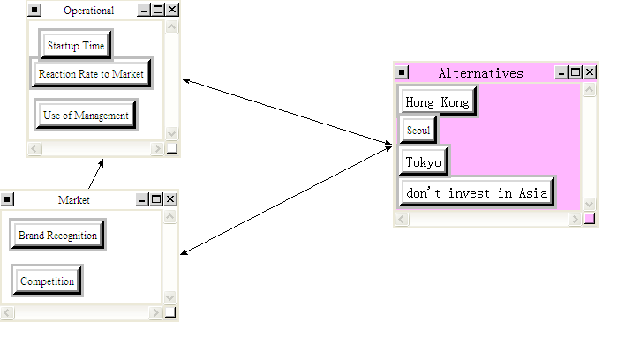
Risk
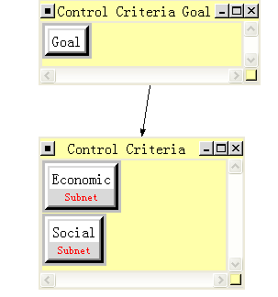

Economics Control Criteria:
Financial node includes: legal cost, currency rate, loan interest rate because Home Depot is very new in Asia, different law and market environment will bring them more risk in legal issue, the relevant cost can also be a risk. At the same time, the fluctuation of currency rate and loan interest rate are both affect their profitability in Asia, this is why we add them to risk criteria.

Sustainability node includes: economic stability, government support. From Macro economy, the economic environment and stable political support has indispensable influence to the success of one company, so these are the risk we need to evaluate in different alternatives.

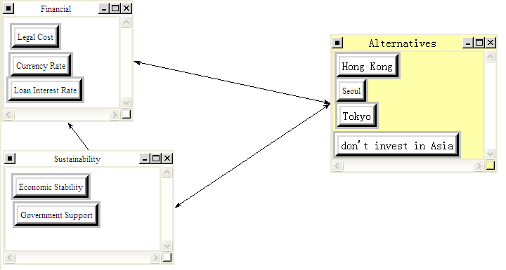

Social Control Criteria:
Culture conflicts: communication, life style
The social risk we need to emphasize most is the cultural conflicts, the different communication methods with suppliers and customers, the different life style of local residents, those can be essential risk for Home Depot.

Localization: local competition, local management strategy
We can observe the experience from most international companies, localization is the risk they need to challenge, Home Depot Asia Strategy have to consider this risk in different countries.

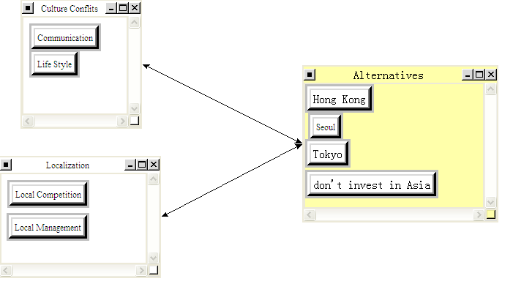

BOCR Priorities

This is a report for how alternatives fed up through the system to give us our synthesized values.

Alternative Rankings for benefits/economic
Graphic | Alternatives | Total | Normal | Ideal | Ranking
 | don't invest in Asia | 0.0270 | 0.0674 | 0.1611 | 4
 | Hong Kong | 0.0914 | 0.2280 | 0.5446 | 3
 | Seoul | 0.1146 | 0.2860 | 0.6832 | 2
 | Tokyo | 0.1677 | 0.4186 | 1.0000 | 1

Alternative Rankings for benefits/social
Graphic | Alternatives | Total | Normal | Ideal | Ranking
 | don't invest in Asia | 0.0293 | 0.0621 | 0.1301 | 4
 | Hong Kong | 0.2256 | 0.4774 | 1.0000 | 1
 | Seoul | 0.1364 | 0.2887 | 0.6046 | 2
 | Tokyo | 0.0812 | 0.1718 | 0.3599 | 3

We combine the results from the social and economic subnets for the benefits model and list the synthesis below. As we can see normalized values show that Tokyo has the highest priority at 34%.

Synthesized Result for the Benefits Model

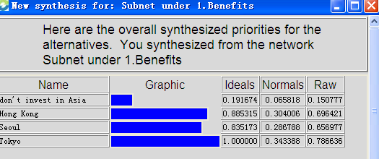

Synthesized Result for the Opportunities Model

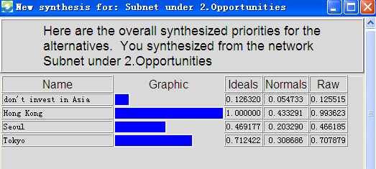

Synthesized Results for the Costs Model

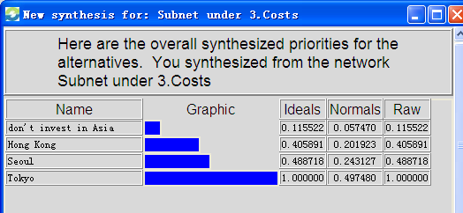

Synthesized Results for the Risks Model

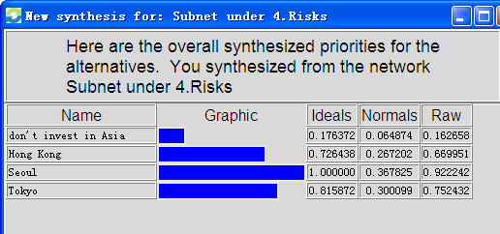

Priorities under BOCR

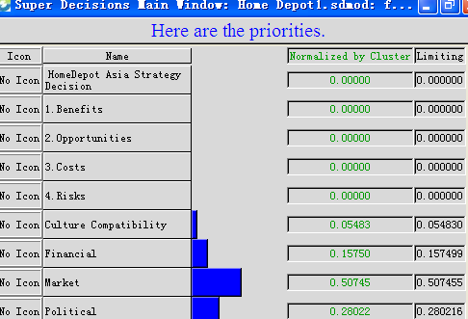

Rating Model
1. Strategic Criteria
We used Market, Financial, Political, Cultural factors as the strategic criteria in our model. We also used these as control criteria consistently throughout the benefits, opportunities, costs, and risks that we identified. Further detail regarding our model is presented below.

Market—Market is the focus of all the enterprise, Home Depot need to have detailed market evaluation and investigation before they launch to other countries. This is the essential criteria.

Financial—Financial as the main factor to calculate the profitability for enterprise should be included in criteria. The investment, cost and financing opportunities are all in this scope.

Political--In all home depot’s international operations, support from local government is critical to the Company. This support ranges from providing a good location to rent the store to insuring sufficient capital flow

Cultural—in china, home depot failed because of misreading the local culture and importing alien models that are better suited to the American countries. Therefore, to understand the life style and difference in culture of the target market will be critical.

2.Rating the benefits, opportunities, costs and risks
We rate the BOCR with respect to Market, Financial, Political, Cultural factors as shown in the table below. We thought the four strategic criteria below pretty well captured home depot’s main concerns about their new stores:
Table

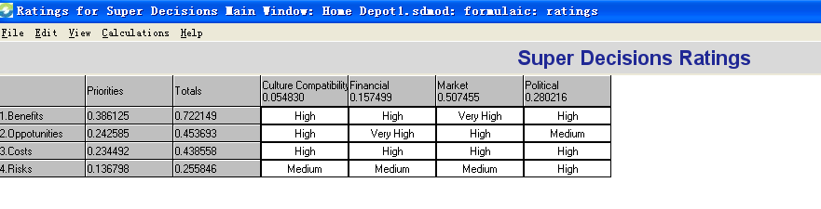

The priorities that result from the ratings of the BOCR for this decision show that the most important merit is Benefits at 31.9% followed by Opportunities at 26.4%. This means that the priorities of the alternatives under benefits are weighted more heavily. Benefits at 31.9% drive the decision more than the Risks at 19.3%.

Sanity check and Overall Synthesized Results

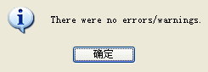

Additive formula result
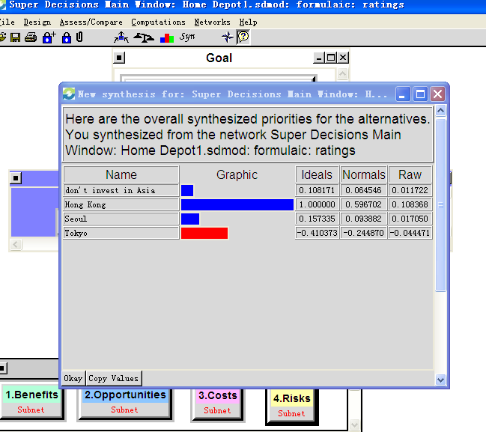

Multiplicative formula result

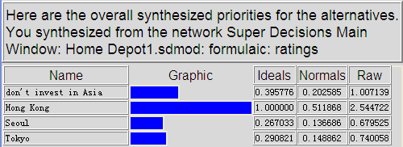

From the Additive and Multi formula, Hong Kong is the best choice for Home Depot.

As we can see, from the overall synthesized results above, home depot’s best option is to build their new store in Hong Kong.

Sensitivity Analysis Graphs

BENEFITS  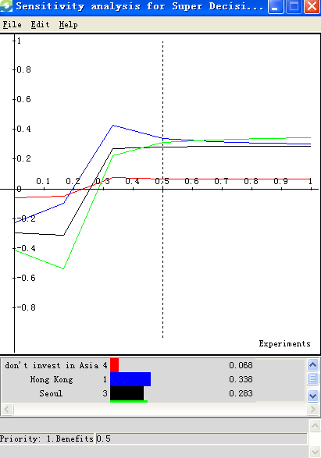 | OPPORTUNITIES  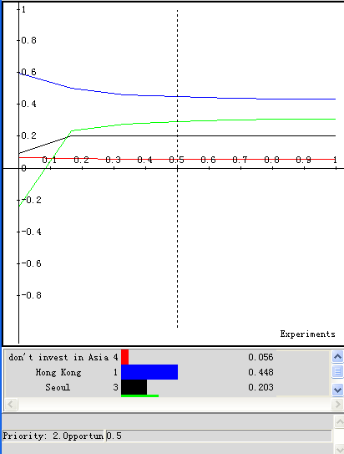
COSTS  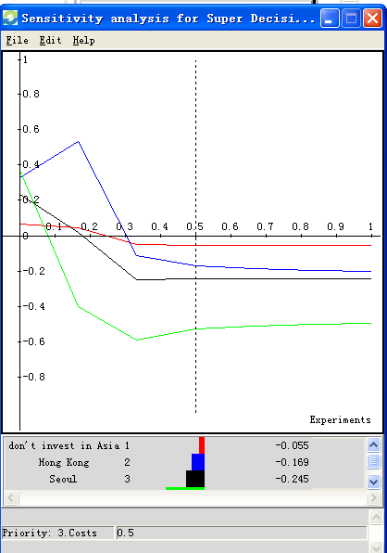 | RISKS  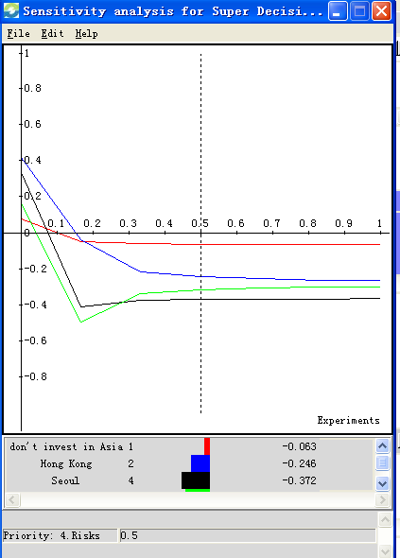

Sensitivity analysis is shown in Figure 1. In the Benefits graphs, we can find that when the priority in less than 0.5, Hong Kong is more important, however, when the priority is greater than 0.5, Tokyo is much better. Is that mean Tokyo is the best alternative? We can review the other 3 graphs, for opportunity, Hong Kong is much higher than other choices and for cost, Hong Kong is also the most favorable outcome. As the priority of risks, Hong Kong has the lowest risk than other choices. Combine all these Sensitivity analysis together, we can conclude that even Hong Kong is not the best outcome in Benefit graph, but in other three graphs, Hong Kong has more strength than other alternatives. In the strategy of Asia market, Hong Kong is the best choice.

Conclusion
In our synthesized result, we can see Hong Kong and Seoul are the top two options among all alternatives. After the comparisons of the alternatives and ratings analysis of the merits, our model shows that Hong Kong is the best choice. The main criteria for this Alternative is the market since this is the main concern for Home Depot if they plan to continue with their development in Asia. We agree with this outcome based on all the background research and competitors analysis.

Resource

- http://www.homedepot.com/?cm_mmc=SEM|THD|G|BT1|HighVolume&skwcid=TC|13614|%2Bhome%20%2Bdepot||S|b|7333208604&gclid=CJXC1qGD_7ICFVSd4AodxTEAhg
- http://www.floordaily.net/flooring-news/home_depot_looking_at_europe_asia.aspx
- http://behindthewall.nbcnews.com/_news/2011/02/08/6009194-home-depot-fails-to-convince-china-to-diy?lite
- http://investing.businessweek.com/research/stocks/financials/secfilings.asp?ticker=HD
- http://online.wsj.com/article/SB10000872396390444709004577650512492181658.html

