Selecting a Software System to Manage Clinical Trials

By: Andras Varadi

varadi@pitt.edu

Dr. Thomas Saaty

Katz Graduate School of Business

Friday, April 15, 2005

Table of Contents

Background 2
What is Lupus? 2
The Lupus Center of Excellence 2
The Decision Problem 3
Alternatives 3
Clinical Trials Management Application 3
BILAG Software System 3
Internally Developed Software System 4
Model & Result 4
The Model 4
Result 5
Conclusion 6
Possible Improvements 6
Obtained Benefits 7
Appendix 1. 8

Background

What is Lupus?
Lupus (Systemic Lupus Erythematosus or SLE) is a little known disease that occurs in over 1.5 million people in the United States. It is estimated that the disease affects many millions of people around the World. The disease was given the name lupus (Latin for wolf) because of a characteristic rash that many lupus patients exhibit. The rash on the patient’s face resembles the pattern of the markings on a wolf’s face.

The body’s immune system fights infections by causing inflammation in the affected organs. In simple terms, SLE is a disease that causes the body’s immune system to turn against itself. In people with SLE, the immune system causes inflammation in one or multiple organs without the presence of any apparent infection. The disease can involve most organs in the body such as the heart, lungs, brain, kidneys, joints, skin and blood.

The exact cause of SLE is not known. Contrary to popular belief, lupus is not an infections disease. Researchers theorize that a combination of genetic, hormonal and environmental factors contribute to the development of the disease. It is know however that SLE affects women 10 to 15 times more often then men, which is an indication that hormones are involved in the disease. Another hint at the involvement of hormones is that women with lupus mostly experience symptoms during their childbearing years (15 – 44 on average). SLE is 2 to 3 times more common in minorities, indicating that genetics also plays a factor in the development of the disease. While the role of heredity has not yet been clearly established, lupus (and other autoimmune diseases such as arthritis) appear in ‘clusters’ within families, furthering the theory of the involvement of genetic factors.

The Lupus Center of Excellence
The Lupus Center of Excellence is an organization of world-class doctors, researchers and health professionals, who are uniquely dedicated to improving the quality of life for lupus patients and for finding a cure for lupus. The Center is a part of the Department of Medicine, University of Pittsburgh.

The Lupus Center of Excellence consists of two mayor departments. The Outpatient and Clinical Research department is tasked with caring for lupus patients, as well as being a discipline leader in conducting clinical and pharmaceutical trials. In the Laboratory Research department, researchers combine data collected in the Outpatient Facility with their expertise and innovative ideas to develop new test for lupus, and potentially, novel treatments for the disease as well. The activities of the Lupus Center of Excellence are funded by a variety of sources, including but not limited to the University of Pittsburgh, NIH and the Lupus Foundation.

The Decision Problem
At any given time, the Lupus Center of Excellence is actively conducting around 20 different research projects. Each projects produces a wealth of data, the accurate analysis of which is a critical element in the success of these experiments. Without adequate data management techniques and tools, researchers are limited in their ability to interpret data and therefore are held back in their pursuit of a cure for lupus.

The need for a clinical trials management software system is evident. The Lupus Center of Excellence is currently evaluating three options for the resolution of the above-mentioned need. The selected software system will have to satisfy a wide range of requirements.

Alternatives

Clinical Trials Management Application
The Clinical Trials management Application (CTMA) was developed by the Oncology Informatics department of the University of Pittsburgh. The application was originally intended for use in the management of clinical trials in the field of cancer research. It utilizes standards of data management (specific to cancer) defined by the government.

Although the system was designed for use in cancer research, the developers have expressed an interest in utilizing their application in other areas of interest. Therefore, they are willing to adapt their application to meet the needs of lupus researchers. Furthermore, the department of Oncology Informatics supports an impressive IT infrastructure, including numerous servers and databases. The department also employs a dedicated staff of programmers and database managers.

Since both organizations are part of the same University, the department of Oncology Informatics agreed to forego any licensing fees. It will however have to be compensated for the effort of its employees as well as the reoccurring cost of application and database server hosting at its facilities.

BILAG Software System
The BILAG Software System was developed by the British Isles Lupus Assessment Group. The developers of this system are well versed in the field of lupus research. In fact, their application was specifically designed for use in lupus research.

Although this application is based on Microsoft Access, the developers still charge a rather high license fee. On top of the license fees, one must also consider the cost of obtaining Microsoft Access in order to utilize this software. The system is also limited in the number of users it can support. Therefore the systems potential for allowing expansion is limited. Although technical support seems responsive, the developer’s resources are known to be limited. As a result, it can be expected that support, future upgrades and development will also be limited.

The BILAG Software System also does not include any IT infrastructure. The data files generated by this system will have to be stored in a secured, regularly backed-up location. The security of the information contained in this software is also a cause for concern. The level of security this system provides is only as high as the capabilities of Microsoft Access allows. Dealing with confidential medical information, system security and redundancy must be considered.

Internally Developed Software System
In addition to the two alternatives described above, the Lupus Center of Excellence has the option of developing a clinical trials management system internally. The needs of the Center are quite unique. It may be more reasonable to develop a proprietary solution instead of modifying a system to fit these needs.

It is however known that software development efforts can be costly and can take a long time. The current IT staff of the Lupus Center is also inadequate for this purpose. Besides having a limited IT staff, the Center would also need to expand its IT infrastructure. Application and Database servers would have to be purchased in order to create a reasonable development environment. Depending on the skill of the developers involved, quality, security and redundancy issues would have to be closely monitored.

On the other hand, the Lupus Center could leverage its leadership position in the lupus research field to set standards for the data management of lupus clinical trials. In fact, if the software development effort was a success, the Center may even be able to commercialize a spin-off of the system, thereby gaining additional revenues to support its research activities.

Model & Result

The Model
The model used in this decision problem is pictured in Figure 1. As the illustration shows, strategic criteria were used in conjunction with a BOCR analysis to arrive at the result presented bellow. The sub-networks of the model are all individually pictured in Appendix 1 at the end of this document.

During the construction of the model, several factors were taken into considerations. Throughout the model however, Financial, Operational, HR and Technology factors were kept as the foci of the decision problem. In each category (Benefits, Costs, Opportunities and Risks) however, different elements were considered under each area of focus mentioned above. The resulting model is rather comprehensive, although probably not complete. The scope of the model had to be limited to a certain extent. Other analysts could make arguments for the exclusion or inclusion of elements based on their expertise.

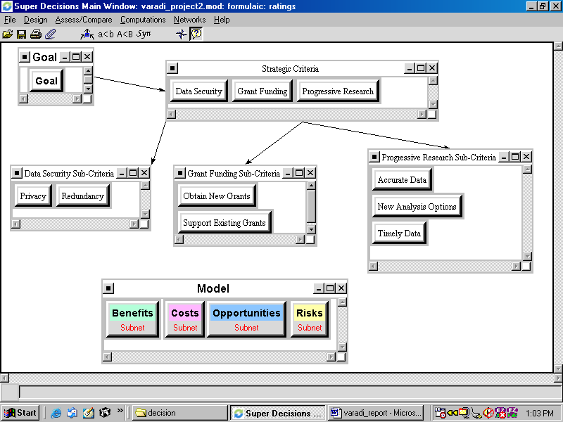
Figure 1. – The Complete Model

Result
The final result of the analysis is pictured in Figure 2. The CTMA Software System is the most strongly preferred alternative. In fact, the margin between this alternative and the two others is considerable. The result of the analysis is not a surprise. The expertise of the developers, their supporting infrastructure and their willingness to modify their application to work in lupus research presented significant benefits and opportunities. At the same time, these factors could be taken advantage of without incurring significant costs or risks. The specific technical specifications of the system were also taken into account during the analysis. For instance, the system’s compatibility with Windows and Macintosh computers was a clear advantage.

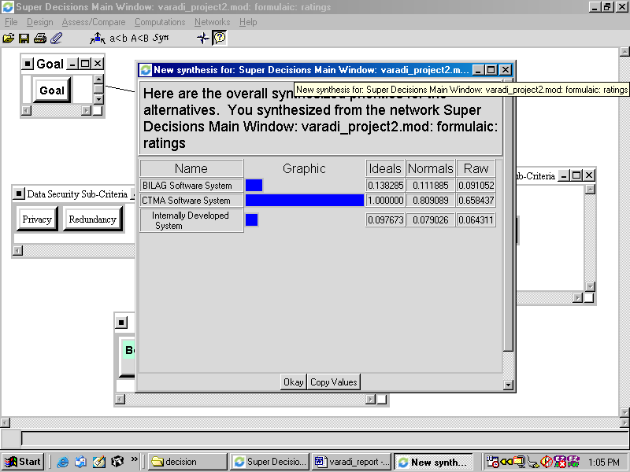
Figure 2. – The Final Result.

Conclusion

Possible Improvements
Although the model presented in this report is comprehensive and considerably accurate, it is without question that further improvements could be made. Specifically, the inconsistency of ratings may be reduced. It was sometimes difficult to reduce this inconsistency in the ratings while maintaining a sensible approach to the problem. Underlying this issue may be a problem with the interpretation of certain factors that are a part of the model. An appropriate approach to resolve this may be to reevaluate the necessity (or value) of certain nodes and clusters in the model. Once the ratings have been completed, one may remove and/or add some clusters and elements and complete the ratings once again. While this may produce a lengthier process, the results may be more reliable.

The sensitivity analysis of this model ought also be revisited. At the present time, sensitivity analysis does not yield meaningful results. The CTMA Software System alternative is so strongly preferred to the two other alternatives that the result is insensitive to changes in any of the factors.

Considering the strong preference of the CTMA alternative, one must question if rater bias played a role in producing this result. Persons completing the pair-wise comparisons will undoubtedly include their biases in their ratings. This seems unavoidable. The effects of this may be mitigated by completing the comparisons in a group, based on group consensus. This approach would utilize the expertise of several individuals and would also reduce the effect of personal biases.

Obtained Benefits
Besides obtaining the result of the analysis, the process yielded several other benefits. While the selection of a software system has been evident, the specific structured discussion of the matter has not taken place at the Lupus Center of Excellence. Using the model describe above, the discussion of the issue can take a structured format, as opposed to information discussions. The benefits and drawbacks of each system can be evaluated in a methodical way.

Besides adding structure to the discussion, with the use of the model, the costs and benefits, of each system could be quantified. Although the model most likely includes some personal bias, it still presents a quantifiable comparison of the options. As a result, instead of comparing loose, unstructured opinions, analysts now may rely on quantitative, not only qualitative information to select a software system.

Finally, the process of constructing the model prompted the discovery and consideration of factors, which previously would not have been included in the decision making process. With the use of ANP, the analyst was able to consider factors that contribute to the issue indirectly. In other words, the model allows the consideration of additional layers of factors and influences in selecting a software system to manage clinical trials.

Appendix 1.
Benefits – Operational
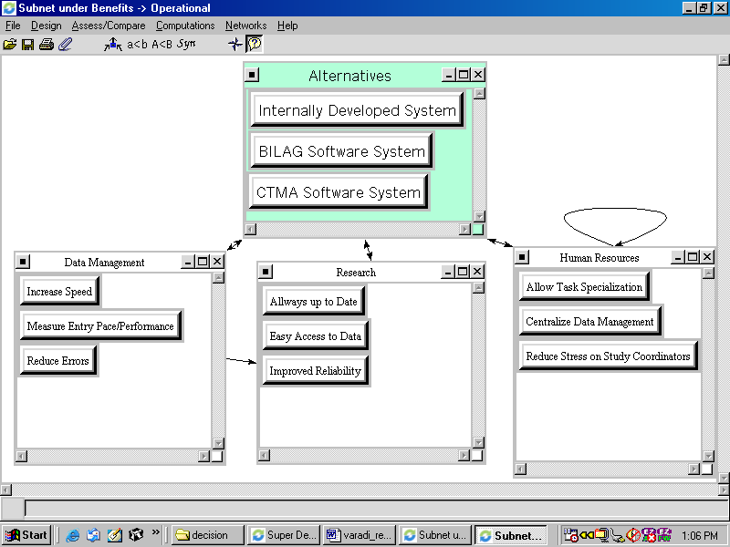

Benefits – Technology
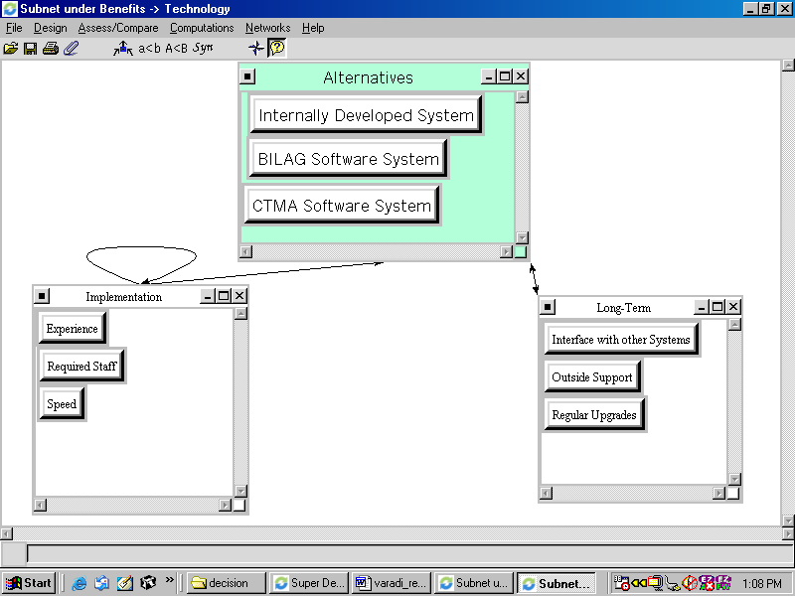

Costs – Economic
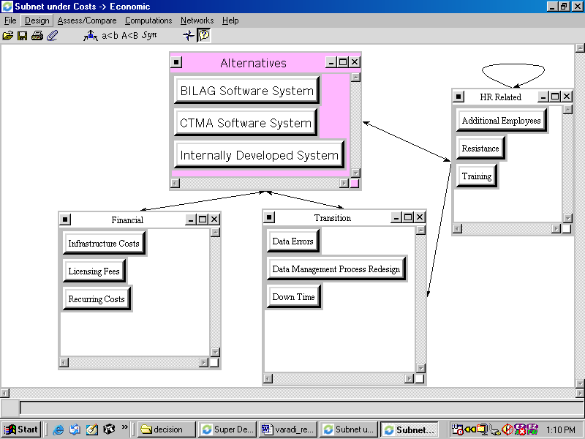

Opportunities – Economic
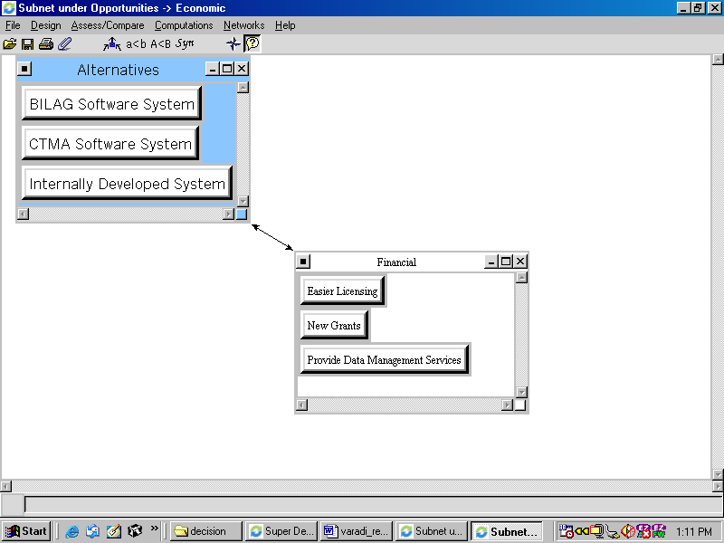

Opportunities – Operational
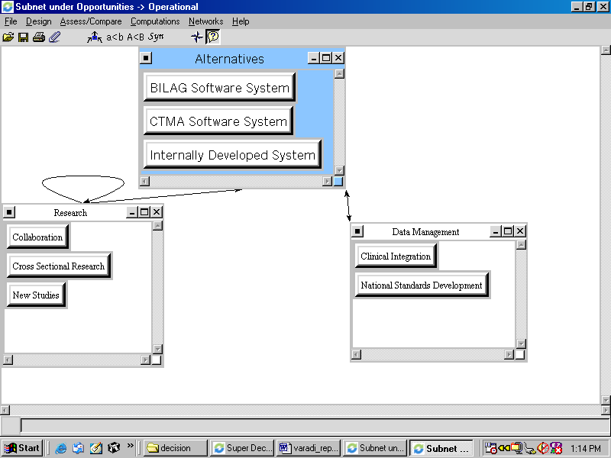

Opportunities – Technology
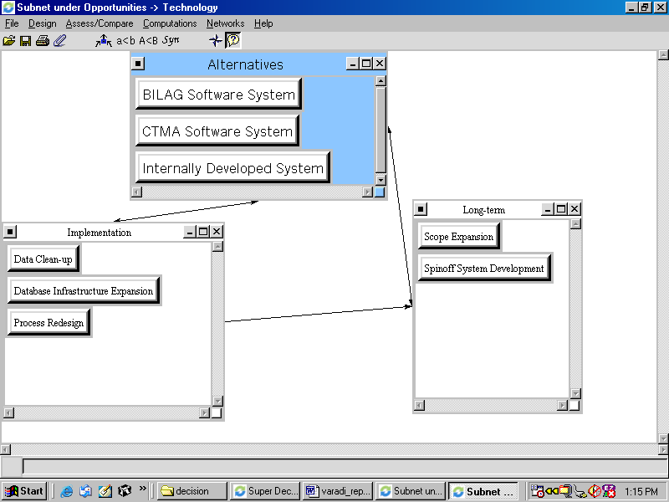

Risks – Economic
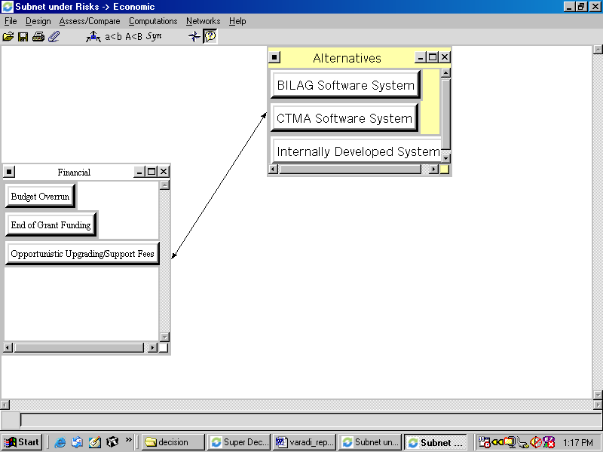

Risks –Operational
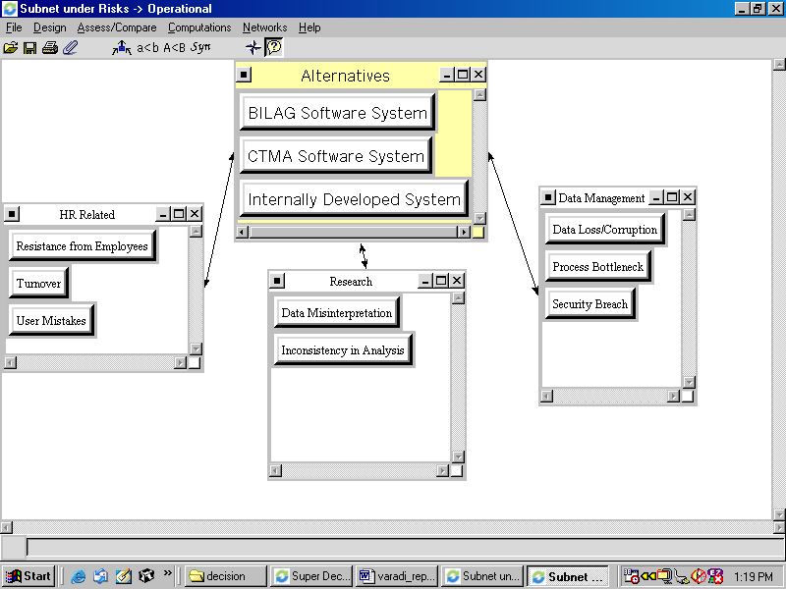

Risks – Technology
