FRANCISCO RODA
TAIS ABREU

CIMAL/IMR New Facility Location

Topic: Decision on a new facility Location for a Furniture Company (RODA GROUP)

Background: Cimal/IMR is part of the RODA Group, located in Bolivia since 1960, producing furniture to export mainly to Europe. Some of its current customers include Lowe’s, Tyndall Creek and Smith and Hawken in the US. B&Q in the UK and Carrefour and Leroy Merlin in France.
Bolivia is living a political crisis, which has forced the President to resign, and elections are to be held in 6 months. The political instability along with the continuous roadblocks has forced the company to look for alternatives. Along with these factors there are several incentives that are being considered.
The company would like to analyze the best option to locate its factory in order to achieve better-cost efficiency, lower risks, long-term sustainability and better customer satisfaction.
Cimal/IMR decided they would analyze the 4 possible options:
- Maintain the factory at Bolivia
- Move it to another location in the north of Bolivia (tax free zone)
- Move it to Arica (Chile)- Port city they use to export their goods, another tax free zone.
- Move it to Tacna (Peru)- 68 Km from the Port of Arica, another tax free zone.
In order to help this decision, Cimal/IMR Company designed the following model:

Alternatives: Decide the location for the installation of a new assembly Plant for CIMAL/IMR
Alternative 1: Existing Plant (Bolivia)
Alternative 2: Puerto Aguirre (Bolivia)
Alternative 3: Arica (Chile)
Alternative 4: Tacna (Peru)

Clusters and Nodes

Clusters/Nodes | - Criteria  - Cost Efficiency  - Customer Satisfaction  - Long Term Sustainability  - Diversify Risk  - Model: This is the top level network.  - Benefits: Benefits  - Costs: Costs  - Opportunities: Opportunities  - Risks: Risks

The Model

Ratings

To establish Ratings scales and evaluate the importance of Benefits, Costs, Risks and Opportunities of the Decision Making Model, we developed a value criteria. Cost Efficiency, Customer Satisfaction, Long Term Sustainability and diversification of Risks.
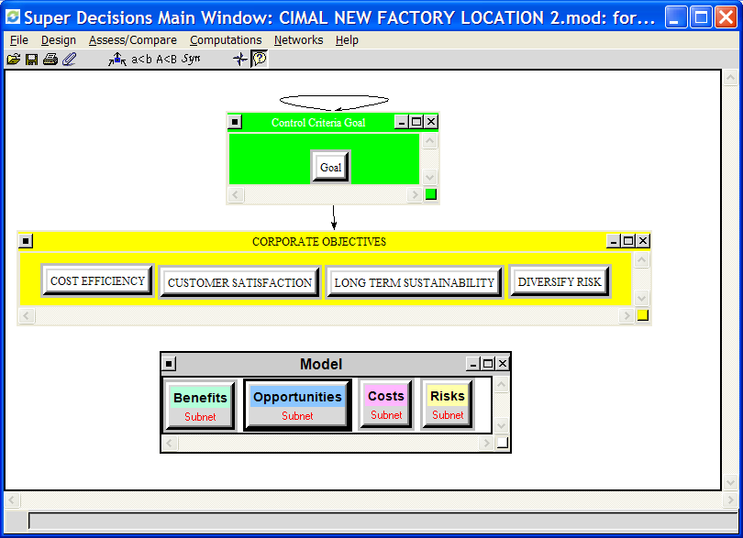

Hierarchy of Criteria for Rating Benefits, Opportunities, Costs and Risks
The four merits of BOCR were rated according to four intensities listed below along with their priorities. The outcome is summarized.

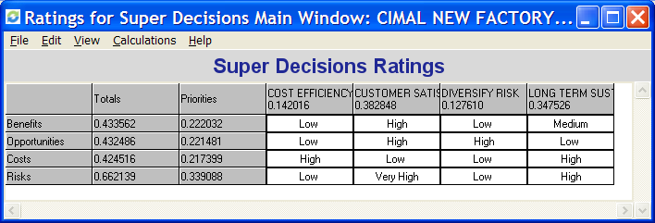
(Table 1)

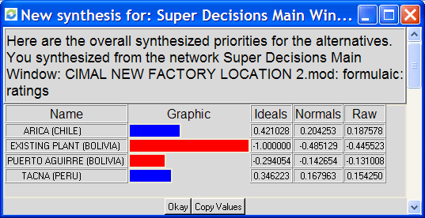

(Table 2)

Synthesized Results from Super Decision program

By using Super Decisions program, we obtained the synthesized results regarding Benefits, Opportunities, Costs, Risks and the final result of the whole model.

Report for Benefits (Table 3)

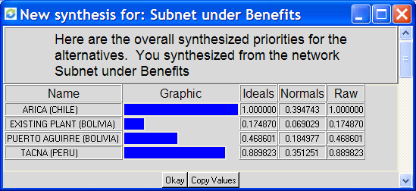

Report for Benefits => Internal Factor (Table 4)
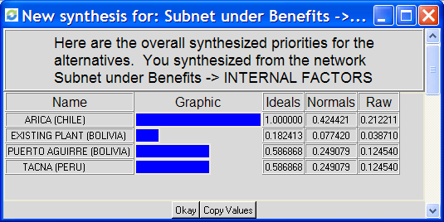

The criteria considered to define the internal benefits were Import Tax savings, training personnel and Time Zone.
Maintaining the plant in Bolivia requires a hardware tax payment of about 10% that is not required either in Chile or Peru.
Chile presents an advantage regarding training personnel because the government pays the program for employee’s development.
Chile and Peru have the advantage to ensure a delivery on time, as it is closer to Port of Arica.

Report for Benefits => External Factors (Table 5)

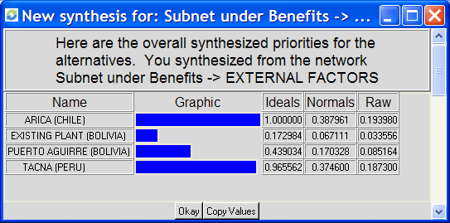

The criteria considered to define the external benefits were Container Availability and Consumer Confidence.
In Bolivia there is no container availability and it costs around U$ 1.000,00 to bring the containers, while in Peru and Chile the containers are available.
Moving the factory to Chile or Peru would also ensure a better consumer confidence, as the company would not suffer so much with the Bolivarian crisis.

Report for Opportunities (Table 6)

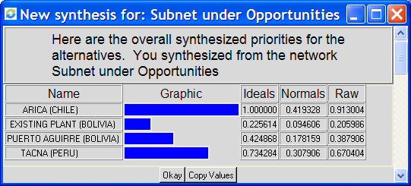

Report for Opportunities => Internal Factors (Table 7)

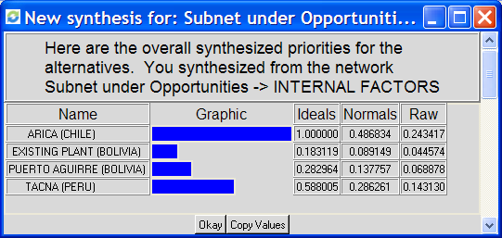

The criteria considered defining the internal Opportunities were Speed to Market, Customer Confidence and Image.
Moving the factory to Chile or Peru would ensure a better speed to market, as they would have bigger stock near to the Port of Arica to ship to Europe.
Chile and Peru would also allow the company to have a better customer confidence and image, as those countries are less risky than Bolivia.

Report for Opportunities => External Factors (Table 8)

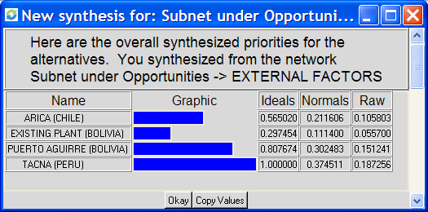
The criteria considered to define the external opportunities were Access to Funding, Access New Market and Growth Production
Chile has the advantage of the greater access to funding, however there is less possibilities of Production Growth in the future as the manpower cost is about the double of Bolivia and much more than Peru also.
Both Peru and Chile would allow the company to enter new markets and improve their credibility in the marketplace.

Report for Costs (Table 9)

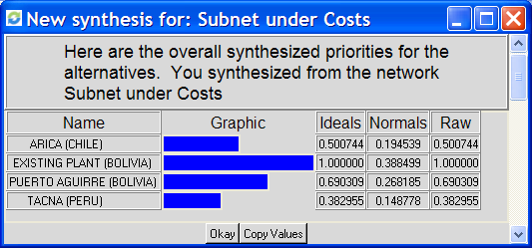

Report for Cost => Internal Factors (Table 10)

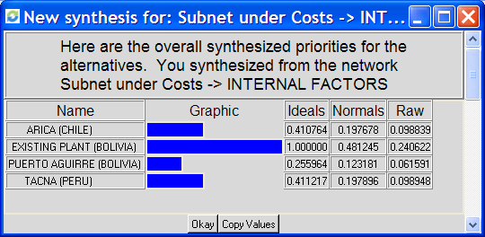

The criteria considered to define the internal costs were Sunk Cost, Cost of Transportation and Cost of Labor.

The only option that does not require investment as sunk cost is to stay in the current place. All the other 3 options present the same sunk cost.

Arica (Chile) and Tacna (Peru) presented a great advantage regarding the transportation cost, as they would transfer the goods from Bolivia to be packed at Chile and that would require only half of containers they use nowadays to transfer the final goods to the Chilean port (at Arica).
Tacna (Peru) present a lightly higher cost of transportation in comparison to Chile, as the city is about 68Km from the Port of Arica (Chile)
However Chile has a much higher manpower cost than Bolivia (almost the double) and a significant higher cost than Peru.

Report for Cost => External Factors (Table 11)

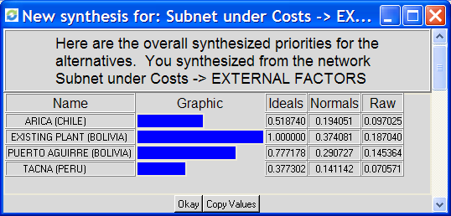

The criteria considered to define the external costs were Commission Tax, Profit tax and Lack of Productivity.

The bolivarian law requires a sales commissions and rebates of about 12,6% while either Chile or Peru present this requirement.

Arica (Chile), Tacna (Peru) and Puerto Aguirre (Bolivia) presented competitive advantage in comparison to current plant in Bolivia regarding tax, as these regions are Tax-free and nowadays, the company has to pay profit taxes to the government of about 30% in the existing plant in Bolivia.

Report for Risks (Table 12)

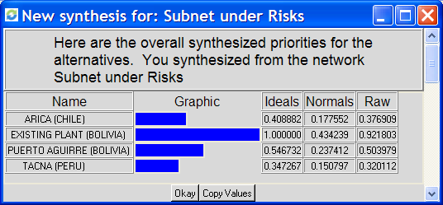

Report for Risks => Internal Factors (Table 13)

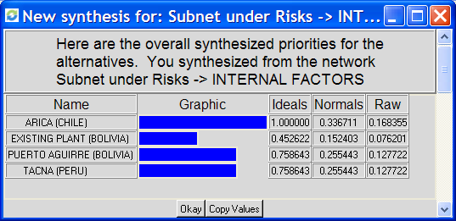

Regarding internal risks, we considered Tuff Legislation and Possible Quality Control Problem.
Chile has a really tuff legislation that is quite different from the bolivarian one.
Moving the factory to any other place (Tacna, Arica or Puerto Aguirre) also creates the risk of having quality control problems.

Report for Risks => External Factors (Table 14)

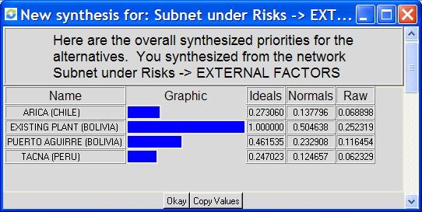

Regarding external risks, we considered Political Image, New Culture and Road Block
Maintaining the whole production in Bolivia present some risks concerning the political crisis and possible roadblocks.
Moving the factory to Chile present the risk regarding the productivity of the Chilean labor and also the different culture.

Final Result of Whole Model (Table 15)

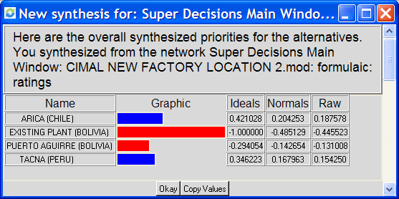

Sensitivity Analysis

From the sensitivity graph we had the following results.
- A change in the Benefit priority will not have a change in Arica being the best Alternative.
- A change in the Cost priority could change the best alternative from Arica to Tacna.
- A change in the Opportunities priority will not have a change in Arica being the best Alternative.
- A change in the Risk priority could change the best alternative from Arica to Tacna.

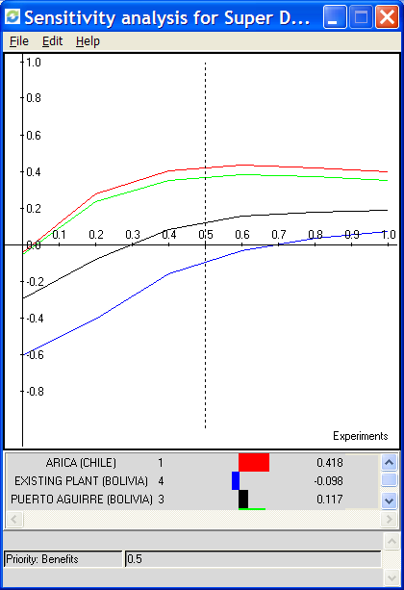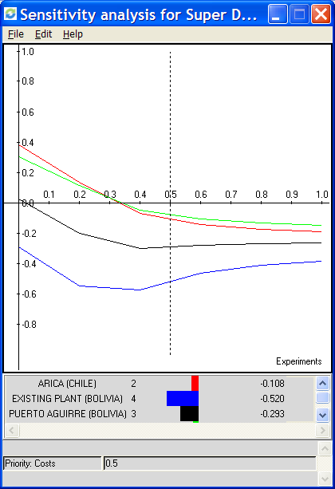
Sensitivity Analysis for Benefits Sensitivity Analysis for Costs

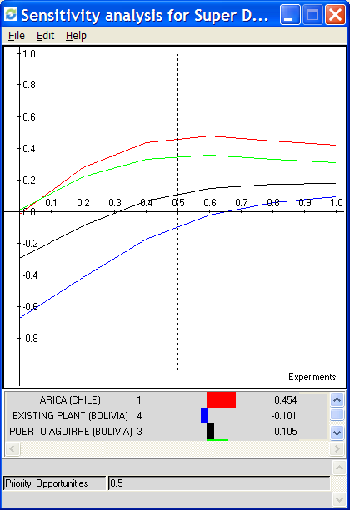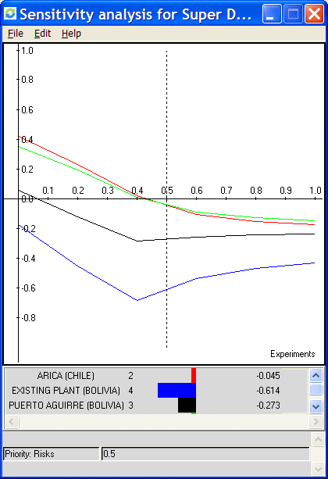

Sensitivity Analysis for Opportunities Sensitivity Analysis for Risks

Conclusion
Taking all that into consideration in the Super Decisions Tools, we realized that Arica (Chile) is the best option. The second best option would be to move the factory to Tacna (Peru). The third option would be Puerto Aguirre (North Bolivia) and the last option is to stay in the current plant.

