Disney Decision :A new theme park in Greater China (Ling-Hui, Amber, Lin SzuLun Peng)

Introduction/Background
In order to enhance operations in foreign market, Disney is constantly searching for areas where it can expand into new markets. According to the projected number of foreign visitors, Walt Disney World expects to increase the current level from 20 percent foreign visitors in domestic parks to 50 percent as well as to expand its theme park business outside the U.S. To achieve these projected numbers there needs to be an aggressive attempt to expand Disney’s presence in foreign markets, especially Greater China. However, considering the diverse social and economic backgrounds within this area, Disney needs to carefully evaluate the possible benefits and the costs and potential risks. In this model, we narrow down the alternatives to Hong Kong, Shanghai, Taiwan and no investment in Greater China. In fact, an awakening and growing middle class in these three areas is exactly the prime target audience for a Disney theme park.

Ultimate goal for Disney
Disney’s intention is to make a minimal equity investment in any operating entity and generate most of its returns through royalty, licensing, and fee income streams.

Main Model

BOCR Networks and Cluster Definitions
Under the benefits, opportunities, costs, and risks models (BOCR models), different clusters define interactions with respect to the control hierarchy established. The benefits networks indicate the alternatives that yield the most benefit and the opportunities networks indicate the alternative that offers the most opportunities, whereas the costs and risks networks indicate the alternatives that are the most costly or pose the most risk on each alternative.

The flow of the decision process is to first build the networks and sub-networks for each of the BOCR models, make the judgments and evaluate which is the best alternative in each case for this particular decision. The importance of the BOCR must then be determined by rating them with respect to the strategic criteria of the organization or decision maker. Strategic criteria are those values that must be satisfied regardless of the particular decision being made. The BOCR are not equally weighted in every decision, and to establish their priorities in this decision by rating the most important alternative (the one with the highest value which is the best under benefits and opportunities, and the worst under costs and risks) against the strategic criteria.
Decision Rating Model
We used the criteria described before to rate the BOCR with respect to competition, income level, infrastructure, international character and political support as shown in the table below.
The priorities that result from the ratings of the BOCR for this decision show that the most important merit is Benefits at 31.9% followed by Opportunities at 26.4%. This means that the priorities of the alternatives under benefits are weighted more heavily. Benefits at 31.9% drive the decision more than the Risks at 19.3%.

 | Competi-  tion  0.127 | Income  Level  0.190 | Infra-  structure  0.147 | Internat’l Character  0.323 | Political Support  0.214 | Priorities
Benefits | Strong | Very Strong | Strong | Very Strong | Very Strong | 0.319
Costs | Very Strong | Medium | Strong | Strong | Strong | 0.223
Opportunities | Very Strong | Strong | Strong | Very Strong | Medium | 0.264
Risks | Very Strong | Strong | Strong | Medium | Medium | 0.193

Figure Eight Decision Sub-networks with Clusters and Nodes for each of the BOCR

Control Criteria and Subnets of the BOCR
Each of the BOCR has control criteria whose priorities are established through pairwise comparison. The control criteria in turn have associated network sub-models that contain the alternatives of the decision and clusters of elements. Thus priorities for the alternatives are determined in each of the subnets. These are weighted by their control criterion, and these results are multiplied by the BOCR weights from the rating model and combined to give the final results. The alternatives appear in a cluster in every decision subnet, so we define them only once here. There are three locations being considered for the first Disney theme park in Greater China plus the alternative of not building at all. They are:
    - Alternatives
Don’t invest in Greater China
Hong Kong
Shanghai
Taiwan

  - Clusters in Benefits/Social Subnet
    - Alternatives
    - Market
Brand Equity: For the brand equity, we consider it as an intangible asset to Walt Disney. Brand equity represents Disney’s reputation and image in the market. Within this subnet, we will examine how much benefit each alternative can bring to Disney in terms of increasing their brand equity.
International Character: International character refers to having a diversified visitor base. The higher the diversification of the visitor base, the more it benefits Disney.
Market Competition: Market competition refers to the number of competitors with comparable scale in one market. Within the benefit cluster, we will discuss the level that Disney can be beneficial from the competition in the market of each alternative
    - Political Factors
Government Regulation: We believe a favorable local government regulation on the theme park business will definitely benefit Disney’s operation in that area and vise versa.
Political Environment: We believe a stable political environment will create a promising investment environment. Thus, the benefits will be measured base on the current political stability and potential political instability of each alternative.

Interactions between Clusters in the Benefits/Social subnet
In this subnet, we can see the interactions among clusters as well as interactions within clusters.
Market Factors: First of all, since the government regulations and political environment will affect the international character and the market competition in a market, we can see an interaction between market cluster and political factors cluster. Besides, different choice that Disney makes will affect the company itself in terms of brand equity, international character and competition in the market. Finally, the competitive ability of the company and the international character of the market may also affect Disney’s brand equity at the end. Thus, we can see another interaction within market cluster itself.
Political Factors: Besides the interaction with the market cluster, the political factors cluster also interacts with the alternative cluster because the political factors are also affected by different alternatives.
Alternatives: While each alternative affect factors in market and political clusters, those factors also have effect on Disney’s decision among alternatives in return. Thus, there are also backward interactions between the alternatives cluster and the other two clusters.

  - Nodes in the Benefits/Economic Subnet Clusters
    - Alternatives
    - Financial Factors
Gross and disposable income level: Under this factor, only the current gross and disposable income level of the area’s citizens will be considered. We assume that a higher income level in the local area will bring more business to the Disney facility and further increase Disney’s revenue.
Labor Wage: Labor refers to the current level of local labor wage. A lower labor wage will benefit Disney from reducing operating overheads.
Profitability: Profitability refers to the forecasted profits basing on the current market situation.
    - Infrastructure
Accommodation Capacity: This refers to the current accommodation capacity of that area.
Resources: The resources factor means the current construction quality and efficiency of the area.
Transportation: Transportation here means the current development of local railroads, airports, tunnels, etc. If the area is already well-developed, Disney can benefit from an instant resource of transportation system for customers.

Alternative Rankings from the Benefits/Economic Subnet
Graphic | Alternatives | Total | Normal | Ideal | Ranking
 | Don't invest in Greater China | 0.0273 | 0.0579 | 0.1242 | 4
 | Hong Kong | 0.2201 | 0.4662 | 1.0000 | 1
 | Shanghai | 0.1379 | 0.2922 | 0.6267 | 2
 | Taiwan | 0.0867 | 0.1837 | 0.3940 | 3

Alternative Rankings from the Benefits/Social Subnet
Graphic | Alternatives | Total | Normal | Ideal | Ranking
 | Don't invest in Greater China | 0.0045 | 0.0099 | 0.0219 | 4
 | Hong Kong | 0.2059 | 0.4521 | 1.0000 | 1
 | Shanghai | 0.1556 | 0.3417 | 0.7558 | 2
 | Taiwan | 0.0894 | 0.1963 | 0.4342 | 3

Combining the outcomes from the social and economic decision subnets for the benefits model produces the results shown below. The normalized values (in bold) show that Hong Kong offers the most benefits, and by a significant amount, at 46.4%.

Synthesized Result for the Benefits Model
Graphic | Alternatives | Total | Normal | Ideal | Ranking
 | Don't invest in Greater China | 0.107 | 0.050 | 0.107 | 4
 | Hong Kong | 1.0000 | 0.464 | 1.000 | 1
 | Shanghai | 0.648 | 0.301 | 0.648 | 2
 | Taiwan | 0.401 | 0.186 | 0.401 | 3

In the opportunities, costs and risks models, the decision subnets are built based on the same logic as that of the benefits subnets. The details of their clusters and nodes are similar to that of benefits and will not be shown here. A general idea of what they are can be obtained from the figure above showing the decision sub-networks. The results for each of the control criteria for opportunities, costs and risks are given below.

We show only the final synthesized results for Opportunities, Costs, and Risks.

Synthesized Result for the Opportunities Model
Graphic | Alternatives | Total | Normal | Ideal | Ranking
 | Don't invest in Greater China | 0.019 | 0.010 | 0.019 | 4
 | Hong Kong | 0.428 | 0.224 | 0.428 | 3
 | Shanghai | 1.000 | 0.524 | 1.000 | 1
 | Taiwan | 0.462 | 0.242 | 0.462 | 2

Synthesized Results for the Costs Model
Graphic | Alternatives | Total | Normal | Ideal | Ranking
 | Don't invest in Greater China | 0.104 | 0.040 | 0.105 | 4
 | Hong Kong | 0.610 | 0.233 | 0.617 | 3
 | Shanghai | 0.989 | 0.378 | 1.000 | 1
 | Taiwan | 0.912 | 0.349 | 0.922 | 2

Synthesized Results for the Risks Model
Graphic | Alternatives | Total | Normal | Ideal | Ranking
 | Don't invest in Greater China | 0.116 | 0.051 | 0.118 | 4
 | Hong Kong | 0.425 | 0.188 | 0.434 | 3
 | Shanghai | 0.981 | 0.434 | 1.000 | 1
 | Taiwan | 0.736 | 0.326 | 0.751 | 2

Decision Rating Model
The final step in the decision is to determine the strategic criteria that are more or less the same for the organization or individual in making any decision and use them to rate the BOCR with respect to competition, income level, infrastructure, international character and political support as shown in the table below. We thought the five strategic criteria below pretty well captured Disney’s main corporate concerns about their theme parks:

Strategic Criteria
Competition – Successful theme parks in the area of the Disney Facility may be viewed both positively and negatively. Other theme parks aready in the areas represent competition for Disney; however, competitors may also bring more people to the area to visit both facilities at the same time.
Income Level– Gross and disposable income levels of the area’s citizens may also affect the success of the park. Consider Tokyo Disney Land for example. Approximately 95% of its visitors are local Japanese; thus, the high average income level of Japanese does appear to contribute to the tremendous success of Disney in Japan.
Infrastructure– Infrastructure in the area of the park and the regional support are also important. Visitors should be able to access the park easily. The transportation system should be well established or enhanced while the park is being constructed. A good area should have the infrastructure to support a park efficiently. Besides, the region should also contribute to extending the time visitors are able to spend at the Disney facilities. For example, a stock of hotel rooms to support park visitors is important and rooms at a variety of price levels, all the way from economy to luxury, should be available when the park opens.
International Character – Disney is looking for “international character” for any theme park it builds in Greater China. A diversified visitor base will reduce the risks of problems in one country having an adverse effect on the flow of international visitors.
Political Support – In all Disney’s international operations, support from local government is critical to the Disney Company. This support ranges from providing a good location to build the theme park to insuring sufficient capital flow.

The priorities that result from the ratings of the BOCR for this decision show that the most important merit is Benefits at 31.9% followed by Opportunities at 26.4%. This means that the priorities of the alternatives under benefits are weighted more heavily. Benefits at 31.9% drive the decision more than the Risks at 19.3%.

 | Competi-  tion  0.127 | Income  Level  0.190 | Infra-  structure  0.147 | Internat’l Character  0.323 | Political Support  0.214 | Priorities
Benefits | Strong | Very Strong | Strong | Very Strong | Very Strong | 0.319
Costs | Very Strong | Medium | Strong | Strong | Strong | 0.223
Opportunities | Very Strong | Strong | Strong | Very Strong | Medium | 0.264
Risks | Very Strong | Strong | Strong | Medium | Medium | 0.193

BOCR Model: Overall Synthesized Results
Graphic | Alternatives | Total | Normal | Ideal | Ranking
 | Don't invest in Greater China | -0.006 | -0.017 | -0.030 | 3
 | Hong Kong | 0.214 | 0.567 | 1.000 | 1
 | Shanghai | 0.061 | 0.161 | 0.284 | 2
 | Taiwan | -0.096 | -0.255 | -0.449 | 4

As we can see, from the overall synthesized results above, Disney’s best option is to build their new theme park in Hong Kong.
Sensitivity analysis is shown in Figure Error! Main Document Only.. When the importance of Benefits is greater than 0.05, investing in Hong Kong is the best choice. At a priority of less than about 0.35 for Opportunities, Hong Kong is the best choice, but above that the choice shifts to Shanghai. One might interpret this as meaning that there are great opportunities in Shanghai, but it is also risky as can be seen from the Risks sensitivity graph. As the priority of Costs increases beyond about 0.38, the best choice shifts from investing in Hong Kong to not investing at all. As the importance of Risk increases the preferred alternative is to not to invest as all in Greater China, but since the priority is negative, below the x-axis, this is not a particularly good alternative, though it is the least negative. When risk is less than about 0.50, the preferred alternative is to invest in Hong Kong.

Sensitivity Analysis Graphs
BENEFITS  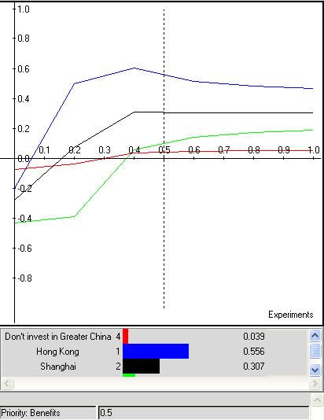 | OPPORTUNITIES  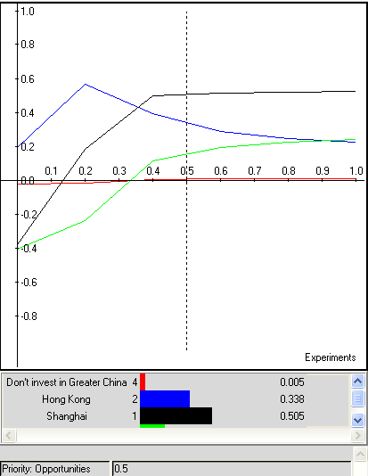
COSTS  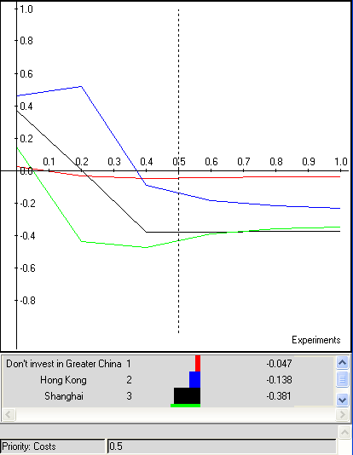 | RISKS  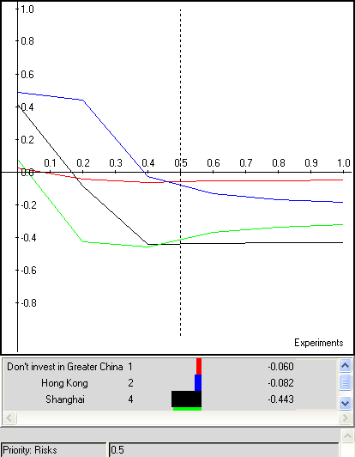
Figure Error! Main Document Only.. Sensitivity Graphs for the BOCR.

Conclusion
In our synthesized result, we can see Hong Kong and Shanghai are the top two options among all alternatives. With a population of more than 1.29 billion people, China is the most heavily peopled area in the world. With the significant purchasing power and promising business environment of Chinese market, we are not surprised at this conclusion. However, there is an interesting situation within these two options. If we see the rank under each subnet separately, we can find Hong Kong is the top choice under Benefit and Cost subnets while Shanghai ranks as the first one under Opportunity and Risk subnets. According to the foreign theme park investment projects of Disney, we can see a conservative culture in the company. In Tokyo Disneyland project, Disney contracted and cooperated with Japanese company by charging management fee, loyalty and license fee, etc., but not sharing the most operation and revenue risk. In other words, even the Tokyo Disney has launched into Japanese market with huge success; Disney is still constrained by the contract and receives a limited amount of benefits. Thus, in the Euro Disney project, the management team of Disney vowed to not repeat the same mistake in Tokyo project and tried to get the largest ownership as they can; however, the inefficient work projects and culture clashes caused unexpected expenses. Therefore, considering Disney as a company resumes to a risk adverse attitude toward their overseas investment, it is reasonable for them to choose Hong Kong as the first site to get into the Greater Chinese market. Although Hong Kong is the most costly option with relatively lower potentiality of future market than Shanghai, the high benefit and low risk seem more attractive and promising to Disney. However, if Disney be willing to sustain a higher risk level, the first optimal site will be Shanghai. (Shown in the sensitivity analysis of opportunities and risks)

