Hiring for the American Workforce
A Foreign or Domestic issue?

Caryn Burgh
Shih-Yi James Chien
Peiying Lisa Hsu

[Pick the date]

October 17, 2011

Table of Contents
Abstract 1
Introduction 3
Methodology 3
Data 5
Analysis 9
Summary 13
Conclusion 13
Bibliography 14

Abstract
Many people from other countries come to America in search of a better life and better opportunities. There are unique educational and work endeavors that are not available in all parts of the world. However, the problem arises when all of these great minds come together in pursuit of the same job offerings. Should we educate international students and then not allow them to pursue jobs within that training environment they were given? Should we try and support American citizens with job placements even though the economy needs anyone and everyone working? These are the questions we sought to answer using the decision making model.

Introduction
For many years the United States has stood as a beacon to the rest of the world for its many unique opportunities across all spectrums of life. There are many freedoms granted to people living in this country that attracts those from outside its borders. One of the particularly bigger draws is the educational system which can help prepare students for profitable jobs that will allow them better lives than those they are living in their home nations. These students graduate right alongside American citizens and are generally presented with the same job opportunities as domestic workers.
In this time of economic turmoil, jobs often can be few and far between. There are less skilled positions for more overqualified workers and with so many people looking for work, the question is raised about who should be first in line for those open positions. Should more experienced workers be hired at a slightly greater cost? Or should recent graduates be allowed the chance to train for a career while being paid less? More importantly, however, is the question should those workers be American or foreign citizens?
While the economy is suffering, it would at first appear to make sense to hire more American citizens for jobs than immigrants. Apart from providing a sense of nationalism, healing the economy from within our borders seems like a logical decision. However, studies show this actually has the opposite effect. Foreign citizens comprise over half of today’s scientists and engineers as well as make up about 15% of the overall total workforce in the United States. When both immigrants and native-born employees work alongside each other, they actually help create more job opportunities for others (Immigration Policy Center).
Americans have an incredible sense of pride however, and many believe that no matter what, preference should be given to domestic employees first. Because of this emotional and ethical component it is necessary to include various types of criteria when attempting to make a decision on this important topic. That is why using the decision making software is the best option to help choose if the US should grant more H-1B visas, keep the status quo, or lower the number of visas given.

Methodology
The optimal type of network and model to use with solving this particular problem was the BOCR model using strategic criteria to help assess each of the three alternatives. The five strategic criteria were economic prosperity, possibility to implement, political attractiveness, ethical issues and security. These were chosen based on the issues that most often appeared in articles and research about the topic. The criteria are important to both sides of the topic overall.
Each part of the BOCR model had a sub network based on three main areas of importance. These were economic, political and social influences. Each of these then had more specific nodes that the decision making software would be using to make a final synthesized result. First, the Benefit sub network comprised of two economic indicators, which were competiveness and GDP. It also had two political nodes under political power for local employees and local employers. Finally, the social component consisted of a common interest node based off global perspective.
Next, the Opportunity sub network had three nodes under its globalization factor (economic). These were access to international resources, ability to attract talents with skills and increase diversity and simulation. Political position has two nodes under it for international and “inside the US”. Finally, for the social factors, diversity and communication amoung communities were the two nodes under common interest.
Third, was the formulation for the Cost sub network. Employers (economic) was made up of wage costs and visa application fees. Policy implementation costs and policy promotional costs made up the government node of the politics component while a parties lobby cost made up the node under political parties. Two nodes covered common interest under the social component and these were unemployment benefits and communication costs.
Finally, the Risk sub network was built. Here, the economic component consists of two nodes. The economic indicator has a sub node of unemployment rate and globalization has a sub node of dependency on foreign labors and markets. Political power consisted of two nodes, public and financial support. Finally, the social component had three nodes under social security. These were the crime rate, conflicts among different communities and illegal immigrants.
Once the actual model was built and all the different layers and sub networks had been created, the next step was to establish connections between everything. After all the connections had been determined, the comparisons were made in order to determine the different priorities. What is important to note is that many of these comparisons could not be made based on actual numerical values. They were rated on their importance based off of the investigative research done on the topic. Certain criteria were more valuable to different groups than others and this would be reflected in the comparisons.
After much manipulation of the connections and comparisons, finally a synthesized model could be attempted. The model did correctly calculate the results based on two formulas we wanted to investigate. The multiplicative formula, which shows the best decision for a short term solution, and the additive (negative) formula which is also what we can use to do a sensitivity analysis. Results are listed in Figure 7 below and the best alternative was actually increasing the number of H-1B visas granted to immigrant workers.
The sensitivity analysis was then performed after the model was synthesized with the additive formula to help understand which alternative would make the best decision depending on whether the benefits, opportunities, costs, or risks were the most important factor. Interestingly enough, the best chosen alternative remained to increase foreign workers except when risks became over a 50% priority. Overall, the model not only reflected consistency when the sanity check ran, but it also followed the aforementioned studies from the Immigration Policy Center that suggest more immigrant workers should be allowed into the American workforce.

Data

Figure 1 – Top layer of model

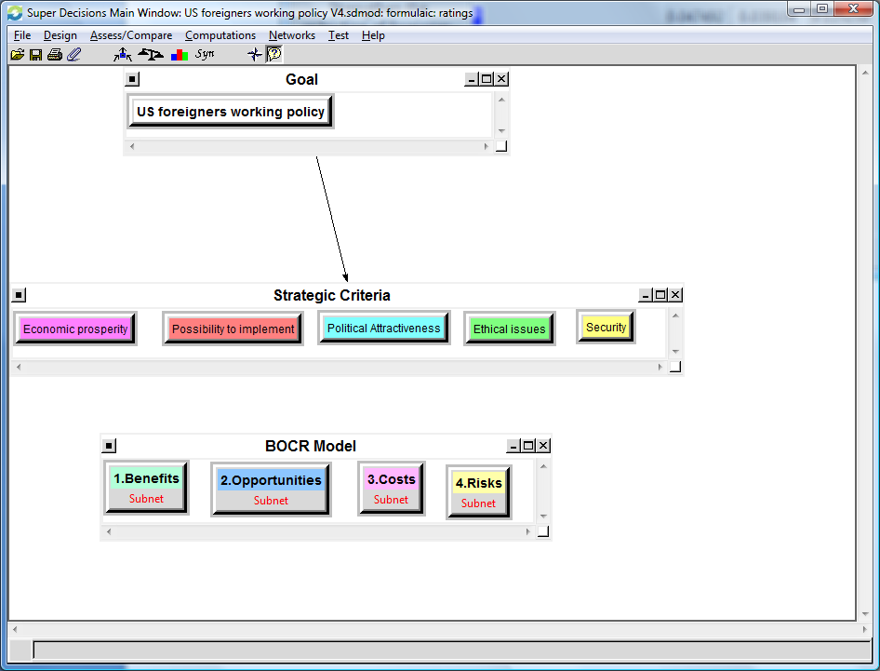

Figure 2 – Benefits sub network
Economic Political
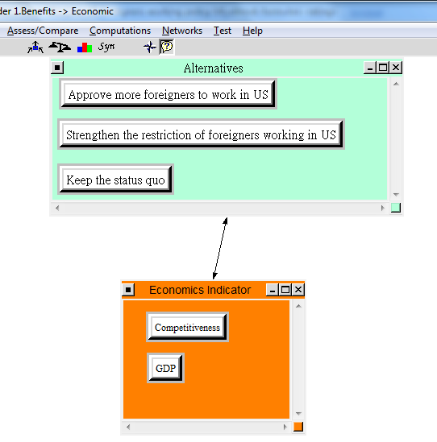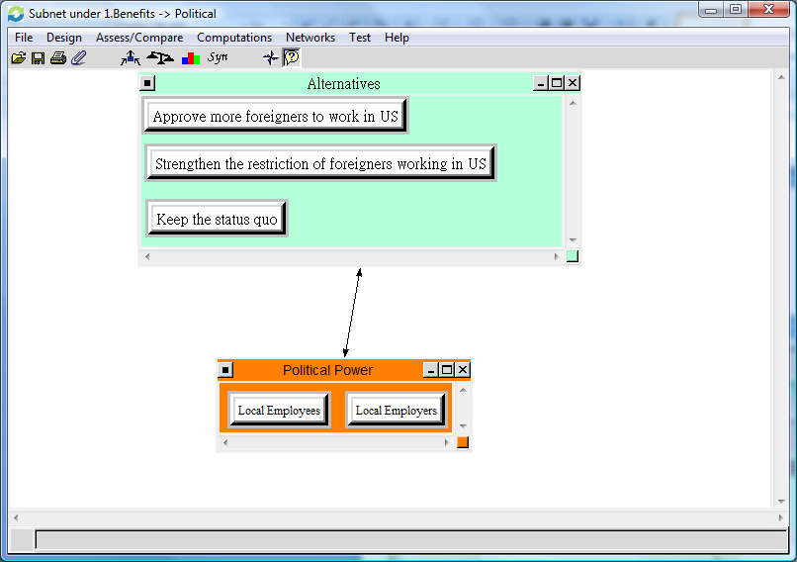

Social
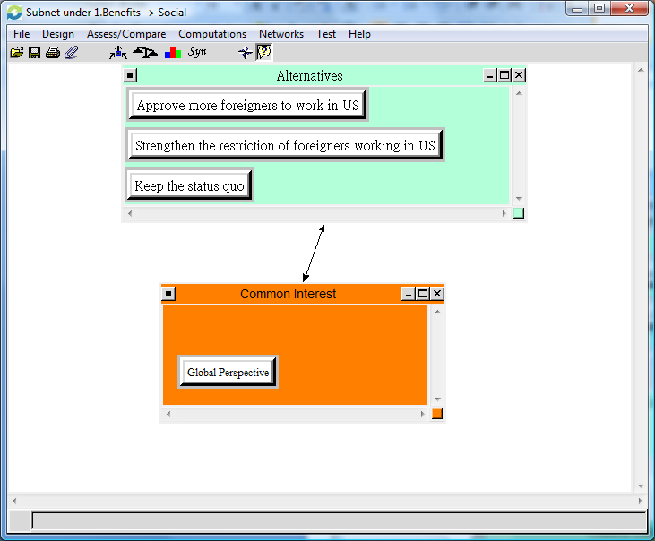

Figure 3 – Opportunities sub network
Economic Political
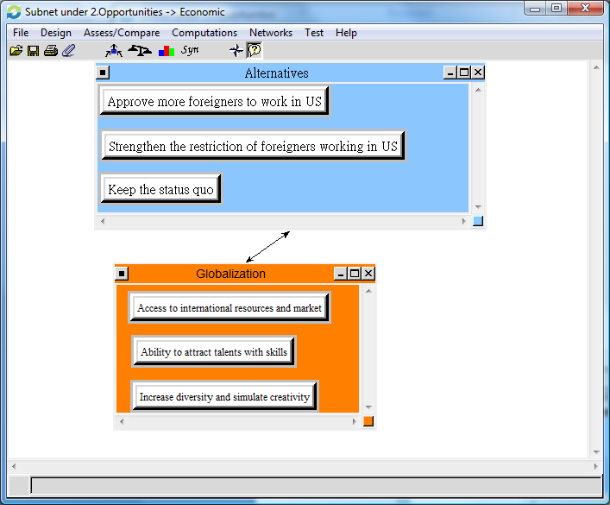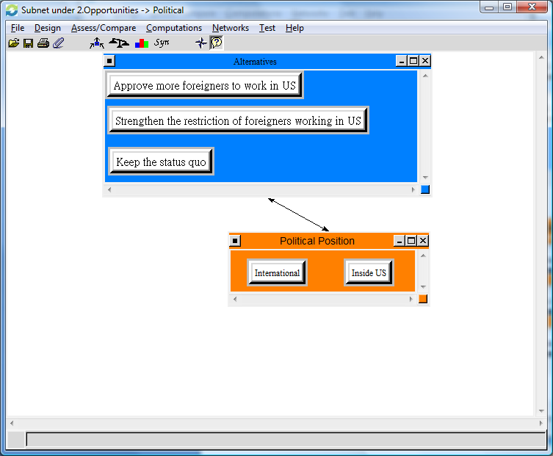
Social
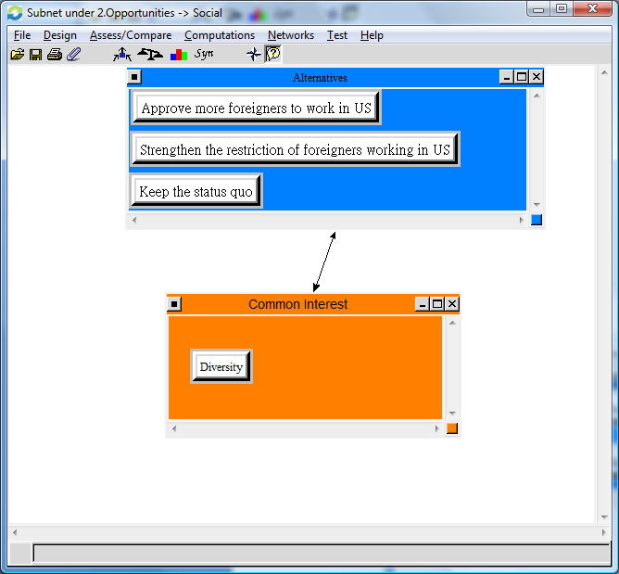
Figure 4 – Cost sub network
Economic Political
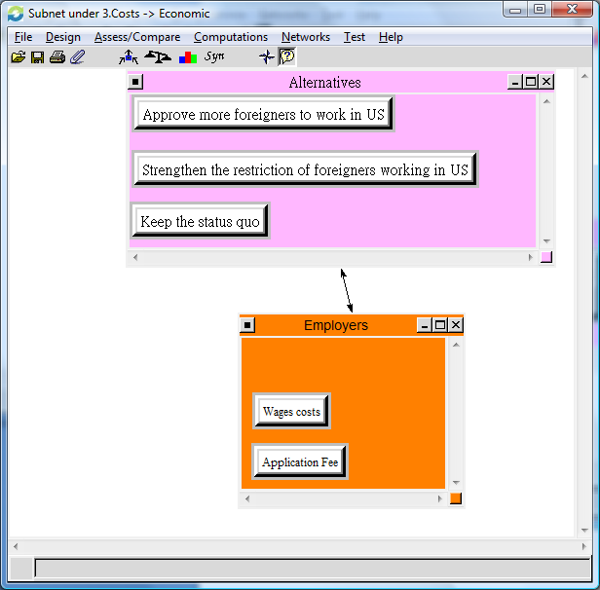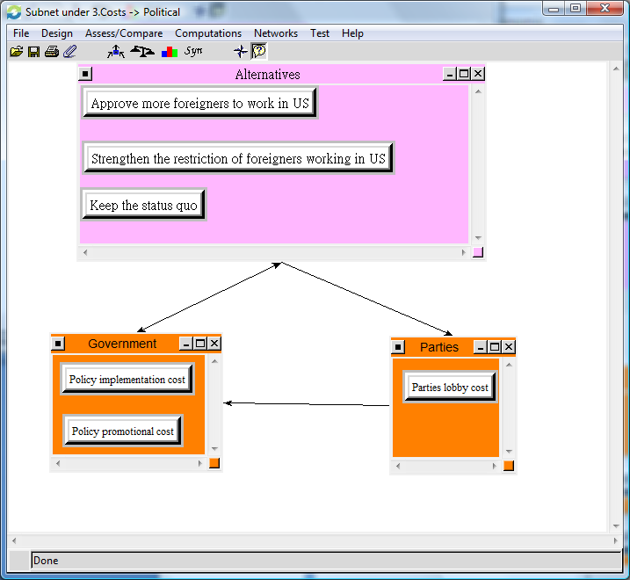
Social
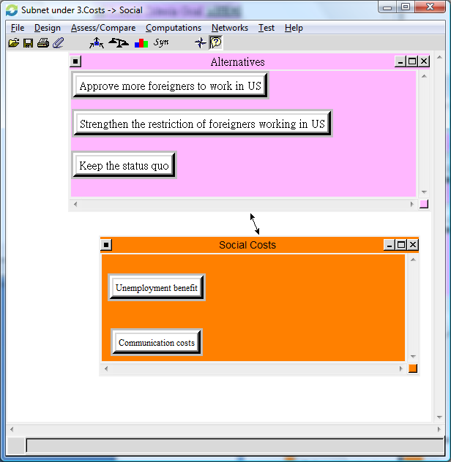

Figure 5 – Risks sub network
Economic Polticial
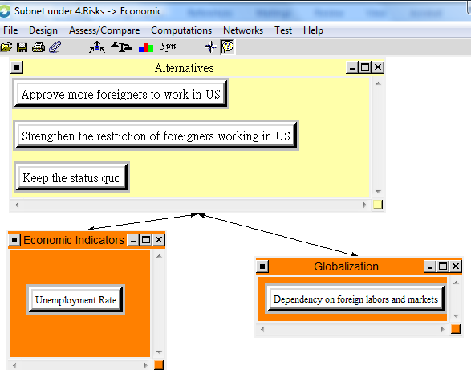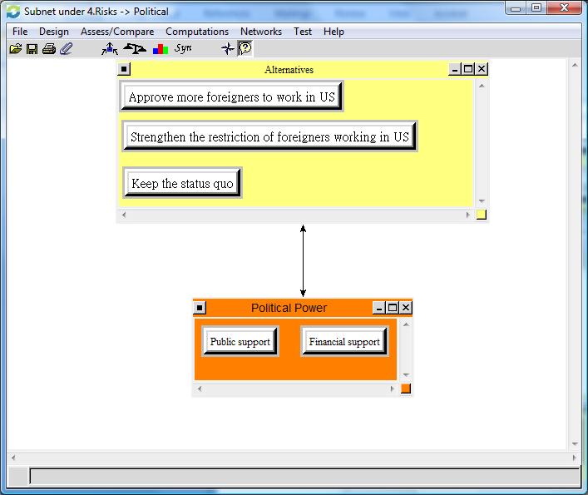
Social
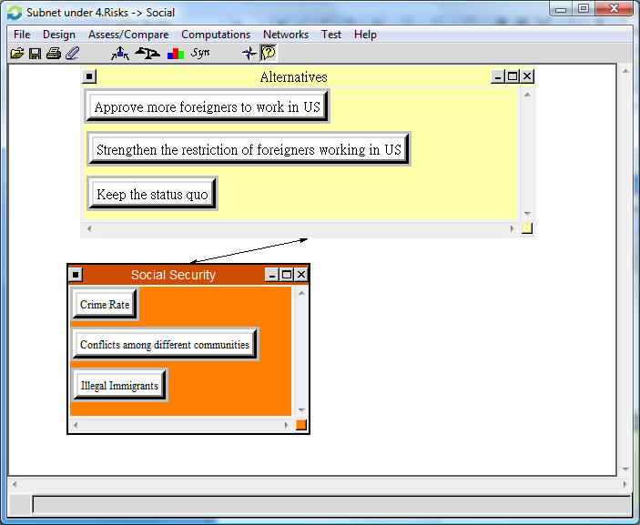

Figure 6 – Sensitivity analysis
Benefits Opportunities
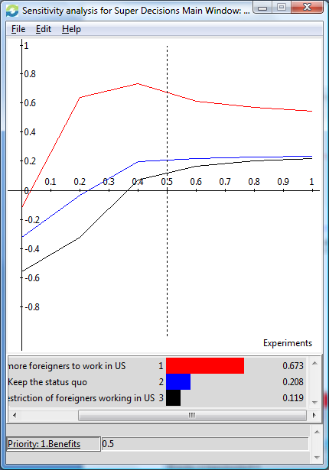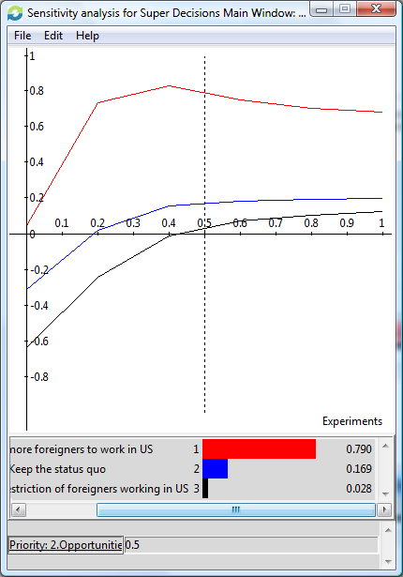

Costs Risks
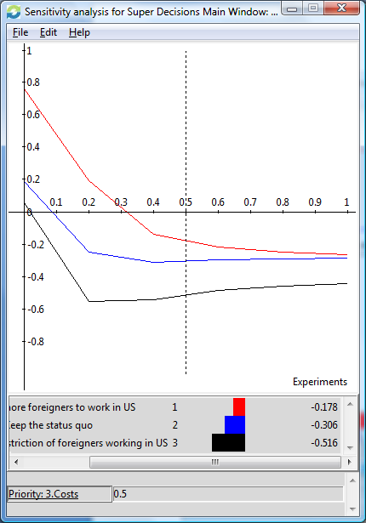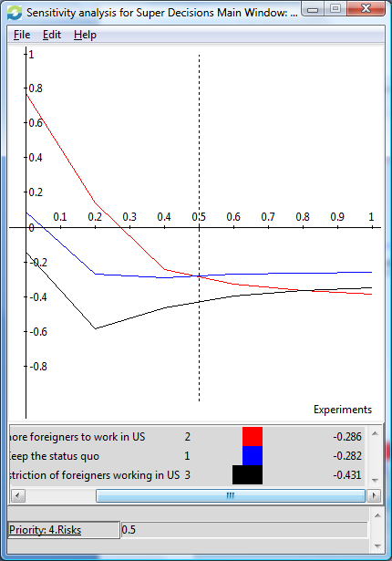

Analysis
After sythesizing the model according to the additive formula, you can see from the results in Figure 7 that the best alternative is to actually increase more forgein work visas. Figure 8 shows the results using the multiplicative formula (the best short term solution) which still shows overwhelmingly that approving more H-1B visas is the best decision. Figures 9-12 show the priorities for each of the sub networks to show which criteria affect the decision model.
Once we established which was the best alternative for the problem, we then did a sensitivity anaylsis to see if the decision would change based on the priorities of the benefits, opportunities, costs, and risks. These results are shown in Figure 6. For the benefits, opportunities, and costs graphs, it is obvious to see that the best alternative remains increasing forgein workers no matter which priority they are given. However, once if risks has a priority greater than 50%, keeping the status quo becomes the best option followed second by increasing H-1B visas and then finally (unless risks is greater than 80%), placing restrictions on immigrant workers.

Figure 7 – Sythesized

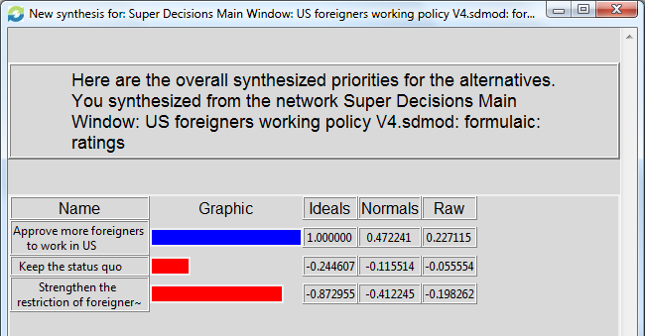

Figure 8 – Sythesized using the multiplicative formula

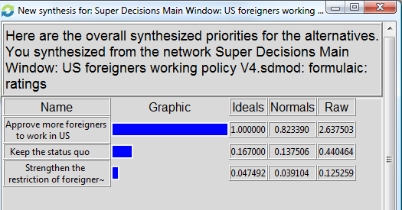

Figure 9 – Benefit priorities
Economic Political 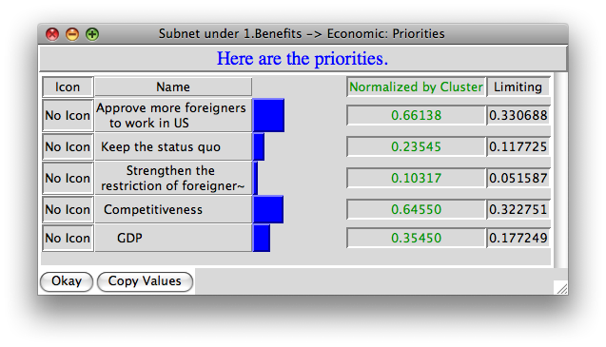 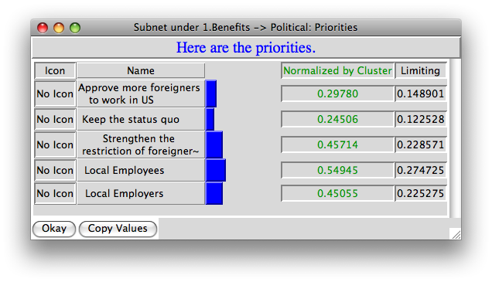
Social
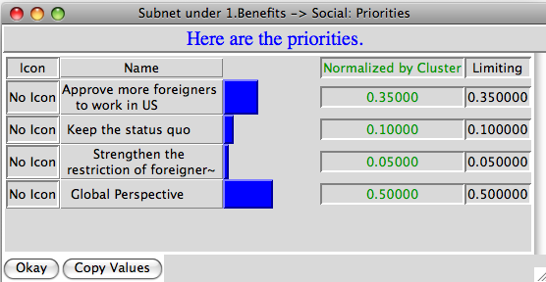

Figure 10 – Opportunity priorities
Economic Political
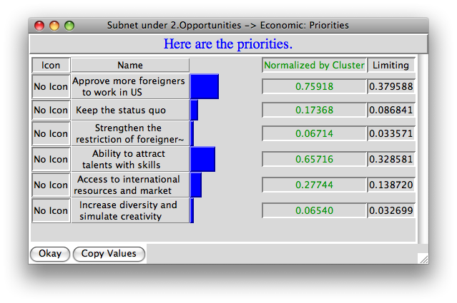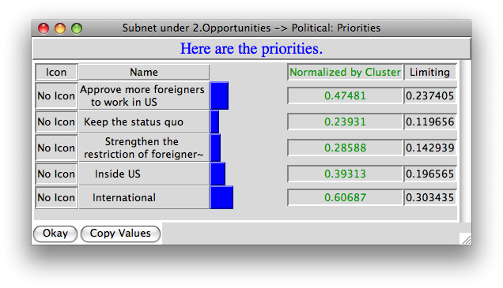
Social
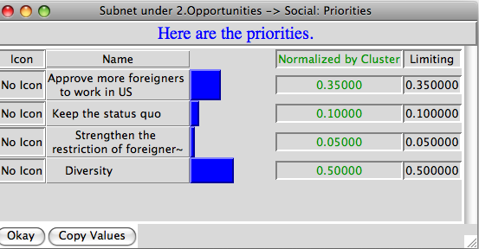

Figure 11 - Cost priorities
Economic Political
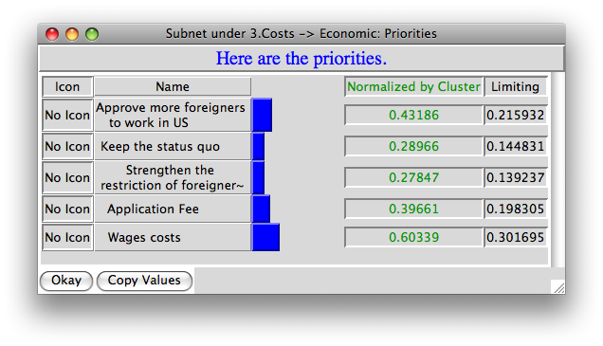 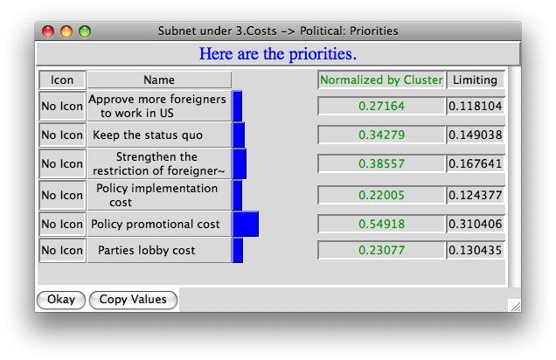 Social
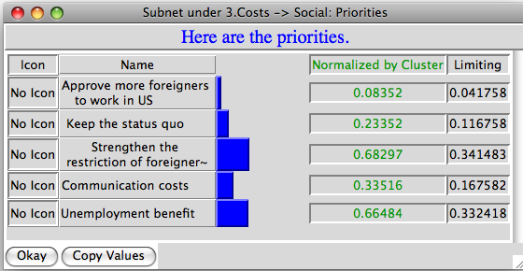
Figure 12 – Risk priorities
Economic Political 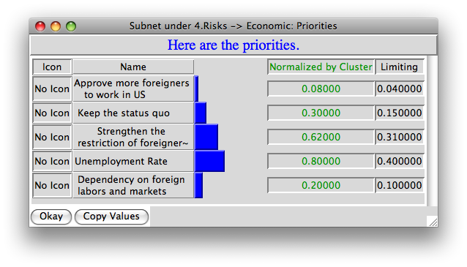 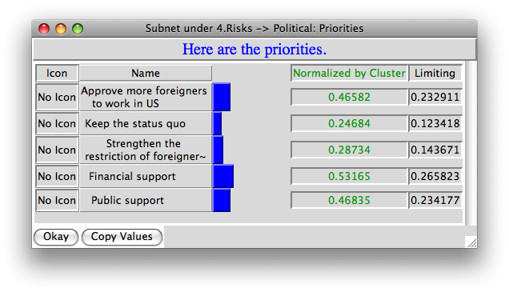
Social
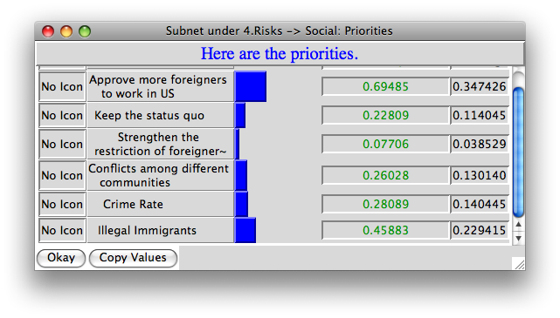

Summary
A significant problem facing the American economy today is whether to hire more forgein workers or try to promote domestic workers in already existing positions. While studies done have already shown that it is better to hire immigrant employees to work alongside American citizens, there are still issues of nationalism and political policy that complicate the issue. Because of this, it is best to use the decision making software in order to combine and evaluate all of these different criteria together in order to calculate which decision is the best alternative among increasing forgein workers, keeping the status quo, or decreasing immigrant employee numbers.
After doing research to determine which were the best strategic criteria to use for the model, the BOCR network was built with each sub network to help make comparisions between all of the various connections. Again, research helped determine how different nodes compared to one another. Once all of these connections were built and compared, the model was sythesized based on two formulas, additive and multipicaltive. In each case, the best alternative turned out to be increasing the number of forgein workers in America.
To solidify this result, we also performed a sensitivity analysis on the model making each of the benefits, opportunities, costs and risks a priority. The best decision still remained to increase the number of immigrant workers except when risks was a priority. In this unusal case, the best alternative would actually be to keep the status quo when risks was greater then 50% of a priority.

Conclusion
Overall, the best decision for the American workforce would currently be to increase the amount of immigrant workers, and therefore H-1B visas that are granted each year. This parallels findings by the Immigrant Policy Center that show that forgein workers actually help create more jobs in general when hired by companies. This is because they are often highly skilled in technical areas which leads to more patents and products that need to be supported by other workers. This is iturn opens the door for both more domestic and forgein workers. The cycle can then keep continuing on. While American nationalism and policies are in strong support of hiring domestic employees first, the working population needs to understand that by first increasing the amount of H-1B visas hired, we can then continue to create more jobs and finally start to strengthen our economy once again.

Bibliography

Center, I. P. (2011, march 30). The U.S. Economy Still Needs Highly Skilled Foreign Workers . Retrieved October 10, 2011, from Immigration Policy Center: http://www.immigrationpolicy.org/just-facts/us-economy-still-needs-highly-skilled-foreign-workers
Fan, C. V., & Batalova, J. (2007, August). US in Focus. Retrieved October 10, 2011, from Migration Information Source: http://www.migrationinformation.org/USFocus/display.cfm?ID=638
Kerr, W. R., & Lincoln , W. F. (2008). The Supply Side of Innovation: H1-B Visa Reforms and US Ethnic Invention. Harvard Business School.
National Foundation for American Policy. (2008). H-1B Visas and Job Creation. NFAP Policy Brief.

