DECISION MAKING IN COMPLEX ENVIRONMENTS WITH THE ANALYTIC NETWORK PROCESS (ANP)

Green Supply Chain Design by
Integrating LCA and BOCR Analysis

Final Project

Orrin COOPER
Antonella PETRILLO

October 2011

Index

1 Background 3
2 Introduction 3
3 Directive 2002/95/EC and Directive 2002/96/EC: RoHS & WEEE 4
4 Conceptual model and theory 5
4.1 Analytic Network Process – ANP: Theoretical background 5
4.2 Research Conceptual Model 7
5 The case study: TV & AUDIO VIDEO supply chain 9
5.1 Collection and aggregation of information 9
5.2 ANP/BOCR model 10
5.2.1 Alternatives 11
5.2.2 Criteria 11
5.2.3 BOCR Network 12
6 CONCLUSIONS AND RESULTS 20

Enclosed Files
- Cooper_Petrillo_BOCR_Green Supply Chain.docx
- Cooper_Petrillo_BOCR_Green Supply Chain.mod
- Cooper_Petrillo_BOCR_Green Supply Chain.pptx

Green Supply Chain Design by Integrating LCA and BOCR Analysis

Background
The rising interest in embedding environmental practices into operations management over the last few years has reshaped supply chain management research and practice into a new landscape. Changes range from eco-product design, such as the effective use of materials by minimizing waste and reducing the usage of hazardous and virgin materials, to eco-logistics and sustainable product return. The local optimization of environmental factors is no longer adequate in addressing the larger issue. Considerations must be made with respect to the entire supply chain from the production, consumption, customer service to the post-disposal disposition of products. This focus has led to the revolution of Green Supply Chain Management (GSCM). Confronted with the rising environmental concerns and requirements from the public, more companies are incorporating environmental performance measures as a part of their basic corporate social responsibilities.
Sustainability concepts - which usually refer to three pillars i.e. economic, environmental and social ones - are new paradigms in this industrial sector. The aim of the present work is to propose a systematic approach a firm may use to evaluate its own supply chain environmental performances. The approach integrates index methods for Environmental Performance Evaluation (EPE) and Life Cycle Assessment (LCA) with a multi-criteria model based on the Analytic Network Process (ANP) and BOCR Analysis (Benefits, Opportunities, Costs and Risks). A key aspect of the model is the consideration of environmental directives such as the Waste Electrical and Electronic Equipment (WEEE) and the Restriction of the use of certain Hazardous Substances (RoHS).

Keywords: ANP, BOCR Analysis, Green Supply Chain, WEEE, EPE.

Introduction
The consideration of environmental issues has a tremendous impact on the development and operations of a supply chain. However, green supply chain management is an emerging research area, thus there are limited conceptual models on this important subject; and in particular models that consider the effect of environmental directives (ED) on greening a supply chain. In consideration of the significance of ED on the performance of a supply chain, this work develops conceptual model for the successful greening of a supply chain that also take in consideration environmental directives such as Waste Electrical and Electronic Equipment (WEEE) and Restriction of the use of certain Hazardous Substances (RoHS). Various similar terminologies have emerged to describe GSCM. Some authors (Handfield et al., 2005) state that environmental supply chain management consists of the purchasing function’s involvement in activities that include reduction, recycling, reuse and the substitution of materials. More widely they define GSCM as the formal system that integrates strategic, functional and operational procedures and processes for employee training and for monitoring, and summarising and reporting environmental supply chain management information to stakeholders of the firm.
It is also important to note that a very important aspect of a GSCM is the integration in the operational procedures and processes of Reverse Supply Chain Management (RSCM). The main goal of RSCM is to accommodate two-way material flows across supply chain in order to provide products with opportunities for reuse and recycling (Kocabasoglu et al., 2007). According to the US Council of Logistics Management (Sarkis, 2001), RSCM should encompass two flows. The first one is a divergent flow, known as an open-loop system, using traditional SCM skills; the other is a convergent flow, or a closed-loop system, which is a backward linkage processing all end-of-life products from end-customers to the original suppliers. The basic driving forces behind RSCM are the increasing pressure from the public for eco-friendly products, the potential financial returns from reuse, recycling, and recovering materials, and the requirements from environmental regulations such as the Waste Electrical and Electronic Equipment (WEEE) (Lysons and Gillingham, 2003; Eckerth, 2004). While reverse logistics in and of itself is becoming increasingly important in the context of analyzing the waste accumulation on the downstream supply chain (Prahinski and Kocabasoglu, 2006, Sundarakani et al., 2010; Hua et al., 2011). RCSM is a really a sub-set of GSCM. Although GSCM enables the maximization of the value of residual assets, attention should be drawn to the challenges which arise from managing the reverse supply chain activities, inter-firm relationships, and/or cross-functional supply chain activities.
The present work proposes a multi-criteria based approach for supporting environmental sustainability analysis of the entire supply chain. The approach is based on the integration of Environmental Performance Evaluation (EPE) with a multi-criteria tool based on the well known Analytic Network Process (ANP) methodology and a BOCR Analysis (Benefits, Opportunities, Costs and Risks). The aims of our work is to develop the ANP/BOCR model through the definition of EPE to identify significant factors on environmental aspects; in this way, the ANP/BOCR model could supply valuable information about critical factors/area throughout the whole supply chain in order to reduce environmental impact. This study focuses on the typical cathode ray tube of computers (and televisions) industry supply chain.
The paper is organized as follows: in section 3, a brief review about the policies and legislations on Waste Electrical and Electronic Equipment is described; section 4, the theory and conceptual model and theory is explained. Then, in section 5, the proposed approach is applied in a specific case study. Finally in section 6 conclusions and results are analyzed.

Directive 2002/95/EC and Directive 2002/96/EC: RoHS & WEEE
The useful life of consumer electronic products is relatively short, and decreasing as a result of rapid changes in equipment features and capabilities (Kang and Schoenung, 2004). The growing importance of Information and Communications Technology (ICT) to the world economy has brought about a surge in demand for electronic equipment (Macauley et al., 2001). Waste from electrical and electronic equipment, EEE (WEEE) is one of the highest priority streams in waste management because of its major challenges. WEEE has also become an issue of concern to solid waste management professionals (Musson et al., 2000). Challenges faced by WEEE management are not only consequences of growing quantities of waste but also the complexity of WEEE; it is one of the most complex waste streams because of the wide variety of products from mechanical devices to highly integrated systems and the accelerating technological innovations (Yla-Mella et al., 2004). As a result of the variety of product models, size changes, compatibility issues, etc., the recovery of WEEE is very challenging (Kumar et al., 2005).
In the last two decades, there has been an increase in the number of environmental policies and legislations focusing on the product development process with an effort to reduce the harmful environmental impacts resulting from the products throughout their entire lifecycle; from product design to manufacturing to consumption and then the eventual end-of-life (EoL) management.
These policies and legislation are almost all based on the principles of extended producer and entire supply chain responsibility. This concept has become an established principle of environmental policy in many countries. This approach integrates sustainable development principles into international trade based on an international environmental law principle known as the “Polluter Pays Principle” (Kibert, 2004).
In particular the European Union (EU) sets up the green product regulations. On of the most profound examples is the establishment in 2002, of two environmental directives: directive 2002/95/EC on restriction of the use of certain hazardous substances (RoHS) in electrical and electronic equipment (European Parliament, 2003b); and directive 2002/96/EC on waste electrical and electronic equipment (WEEE), respectively (European Parliament, 2003a). Directive WEEE introduces the producers’ responsibilities, such as increasing the recycling and recovery rate of waste from electric and electronic equipment. Directive RoHS is a legal requirement that bans the use of Lead, Mercury, Cadmium, Hexavalent Chromium (Chromium VI), Polybrominated Biphenyl (PBB), and Polybrominated Diphenyl Ether (PBDE).
The aims of these two directives are not merely limiting the use of harmful substances, but also permeating into the recovery rate of at least 70–80% at the end of their useful life for electrical and electronic equipment in the EU market. This includes products such as PCs, laptops, printers, scanners and other related products.
From this point of view, sustaining a green supply chain requires a joint collaboration between suppliers including ODM (Original Design Manufacturers)/OEM (Original Equipment Manufacturers) and brand companies. In addition, the way manufacturing networks are organized would need to take product recovery into consideration (Francas and Minner, 2009). Reverse logistics also need to be carefully designed and embedded in the supply chain network (Srivastava, 2008).

Conceptual model and theory
While our understanding of a green supply chain has been expanded there is still a great deal of latitude in how it is defined. Currently, there is an imbalanced scenario within the research, which when considered together provides synergies and contradictions at the same time. Four categories of imbalances have been identified in this review, namely (1) complexity and conflict, (2) uncertainty and investment, (3) antecedent and decision and (4) attribute and performance.
The green supply chain could be viewed as a system, interlocking with elements or sub-systems (suppliers and customers), that aims to minimize wastes in the supply chain. Practices and changes within the sub-system(s) will have direct and indirect effects on the subsequent sub-system(s).
It is very difficult for a company to guarantee a complete environmental Directive compliant component and manufacturing flow due to limited capabilities and influence within the entire supply chain. The alternative strategy is to combine the operational strategy of the whole product supply chain to ensure the overall capabilities match the environmental requests, some examples include: new green products design and development, environmental performance assessment, green purchasing, eco-friendly materials, green SCM, environmental information management system, and end-of-life products recycling
From this point of view the aim of our work is to develop a strategic decision framework for GSCM. This approach highlights the components and elements for GSCM and how they serve as a foundation for the decision framework. Next, we analyze the theoretical background of Analytic Network Process and its application in the conceptual model.

Analytic Network Process – ANP: Theoretical background
The Analytic Network Process (ANP) is the successor of the popular Analytic Hierarchy Process (AHP) model developed by Saaty (1980). The AHP is a Multi-Criteria Decision Making (MCDM) tool at the core of which lies a method for converting subjective assessments of relative importance to a set of overall scores or weights. The AHP is a top-down decision model and, therefore, the criteria and alternatives are assumed independent. However, bias could occur when the criteria and subcriteria are correlated with each other. Twenty five years after the publication of pioneering work in the field of AHP, Saaty (1980, 1996) developed the ANP model, which could handle this situation of inner dependence among elements in a network.
Details on the Analytic Network Process (ANP) model can be found in Saaty (1999); the fundamentals are summarized here for completeness. The ANP model consists of the control hierarchies, clusters, elements, interrelationship between elements, and interrelationship between clusters. The modeling process is better understood by dividing it into several steps which are described as follows:

Step 1: Pairwise comparison and relative weight estimation. Pairwise comparisons of the elements in each level are conducted with respect to their relative importance towards their control criterion based on the principle of AHP. Saaty (1980) suggested a scale of 1-9 when comparing two components (see Table 1).

Table 1: Semantics scale of Saaty

Intensity of importance a_{ij} | Definition | Explanation
1 | Equal Importance | Two activities contribute equally to the objective
3 | Moderate importance | Experience and judgment slightly favor one activity over another
5 | Strong importance | Experience and judgment strongly favor one activity over another
7 | Very strong or demonstrated importance | An activity is favored very strongly over another; its dominance demonstrated in practice
9 | Extreme importance | The evidence favoring one activity over another is of the highest possible order of affirmation
2,4,6,8 | For compromise between the above values | Sometimes one needs to interpolate a compromise judgment numerically because there is no good word to describe it

The result of the comparison is the so-called dominance coefficient aij that represents the relative importance of the component on row (i) over the component on column (j), i.e., aij=wi / wj. The pairwise comparisons can be represented in the form of a matrix (Saaty, 2007). The score of 1 represents equal importance of two components and 9 represents extreme importance of the component i over the component j.
After all pairwise comparison is completed the priority weight vector (w) is computed as the unique solution of Aw = λ_{max}w, where λ_{max} is the largest eigenvalue of matrix A. Matrix A is defined as:

Step 2: Consistency index estimation. To more accurately represent judgments the comparisons need not be entirely consistent. However, if a set of comparisons are too inconsistent one could just as well have used random entries and the information from the comparisons would not be useful. In order to provide a balance the consistency index (CI) of the derived weights could then be calculated by: CI = (λmax−n) n−1. In general, if CI is less than 0.10, one may be satisfied with the judgments that were derived (Saaty, 2005).

Step 3: Formation of the initial supermatrix. Elements in ANP are the entities in the system that interact with each other. The determination of relative weights mentioned above is based on pairwise comparison as in standard AHP. The weights are then put into the supermatrix that represents the interrelationships of elements in the system. The general form of the supermatrix is described in Figure 1 where CN denotes the N^{th} cluster, e_{Nn} denotes the nth element in the N^{th} cluster, and W_{ij} is a block matrix consisting of priority weight vectors (w) of the influence of the elements in the i^{th} cluster with respect to the j^{th} cluster.

Figure 1: Supermatrix form

Step 4: Formation of weighted supermatrix. The initial or “unweighted” supermatrix consists of several eigenvectors each of which sums to one. The clusters in the initial supermatrix must be weighted and transformed to a matrix in which each of its columns sums to unity.

Step 5: Calculation of global priority vectors and weights. In the final step, the weighted supermatrix is raised to limiting power to get the global priority vectors as in Equation (1):

$\lim_{n→∞}{{\left(W\right)}^{n}}$ (1)

Research Conceptual Model
Approaches for analyzing the environmental sustainability of a supply chain could be classified into two main types: top-down models based on global level analysis and bottom-up models based on performance of individual companies in a supply chain. The first type is essentially based on a Life Cycle Analysis (LCA) approach which allows one to measure sustainability from a system perspective. On the other hand, bottom-up models such as climate change, related fossil energy use, or ISO 14000 guidelines are focused on measuring the environmental performances of a single company (Gerbens-Leenes et al, 2003). Environmental indicators in this category represent an effective approach for managing the supply chain (SC) sustainability level (Tsoulfas and Pappis, 2008). Index methods based on a predefined set of environmental indicators are usually simple and easy to use tools which provide relevant information for Green Supply Chain Management (Henri and Journeault, 2008).
The importance of collaboration and supplier partnership as a value-added strategy is discussed in great detail by Vachon and Klassen (2008). From a more operational point of view, several papers consider an analysis of a parameter which could mainly affect the Environmental Performance Evaluation (EPE) process.
From this point of view the aim of our model is to integrate different techniques: first, index categories are evaluated in order to define a reference model as an environmental reporting system; then, a multi-criteria model, based on Analytic Network Process (ANP), is developed which reflects the priorities of the influences on the supply chain environmental sustainability level. The primary focus is to assess strategic and/or operational alternatives which could improve the environmental sustainability level of a supply chain. The result is a prioritized set of potential alternatives.

The conceptual model developed is presented in Figure 2.

Figure 2: Conceptual model developed

The design of an effective measuring method is carried out with the aim is to integrate information derived from operational fields with global level effects. As reported in literature review, the effectiveness of a reporting system is heavily influenced by the specific structure of a supply chain. This preliminary activity represents a focal analysis as it supplies information about processes and procedures at each level of the SC.

According to ISO 14031 (ISO, 1999), three main subcategories are proposed in order to evaluate sustainability of supply chain: the Operational and Management Performance Indicators (OPI - Operational Performance Indicator and MPI - Management Performance Indicator respectively, ECI - Environmental Condition Indicators). The first category refers to aspects regarding facilities and equipment such as energy flows, waste and emissions, etc. The second is focused on the management’s efforts to influence process environmental performances and the last provides information about the condition of the environment which may be useful for the implementation of environmental performance evaluation within an organization. These indicators are fundamental for the development of the BOCR multi-criteria decision support system as they point out critical intervention areas for SC environmental sustainability assessment.

The case study: TV & AUDIO VIDEO supply chain
The proposed model is applied in a full scale case study regarding a TV & AUDIO VIDEO production supply chain (Figure 3). Usually, this sector is a resource intensive sector; thus, TV & AUDIO VIDEO manufacturers and processors are under ongoing pressure to maximise efficiency in all areas of production. Supply chain management in this context is a complicated due to the particular nature of the product: bulky, fragile, and difficult to deliver intact while meeting stringent requirements for high quality and safety.
The supply chain structure is quite linear; it consists of a company which produces TV & AUDIO VIDEO, with a low number of first-tier suppliers and several intermediate customers (i.e. the final product is an intermediate material for different applications). A schema is proposed in Figure 4 which highlights the main parameters usually influencing its environmental sustainability level.

Figure 3. The TV & AUDIO VIDEO supply chain schema

The proposed model has been applied to evaluate the SC environmental sustainability level and areas where intervention must have priority. Whenever possible the SC structure has been analyzed by applying the metrics system from the EPE process.

Collection and aggregation of information
To collect the information we used the database made available by the company and with information from managers in the areas of interest (see Table 3, 4, 5 and 6). This data is used to provide the weightings in the model which is explained in greater detail below.

Table 3. Consumption data

Description | Unit/total
Production | 66,273.31ton
Electric Energy | 53.499,67 MWh
Cogeneration Electric Energy | 71.395,00 MWh
Thermic Electric Energy | 80.319,38 MWh
Natural Gas Consumption | 10.896.127,84 Nm³
Water Consumption | 1,892,000.0 m3
CO₂ emissions Consumption per unit | 1.3 Ton per ton produced
Auxiliary materials (sodium hydroxide for the production of demineralized water) | 855.700 kg
Raw materials | 80.000 kg

Table 4. Waste data

Description | Unit/total
Hazardous Waste | 8,800 kg
Other wastes | 665,135 kg
Waste | 5,469,336 kg

Table 5. Packaging data

Description | Unit/total
Paper and carton packaging | 3674816 kg
Plastic packaging | 57644.5 kg
Wood packaging | 1282278 kg
Iron packaging | 8900 kg

Table 6. LCA data

Description | Unit/total
Acidification | 6.55 g SO₂/kg products
GWP 100 | 0.855 kg CO₂ eq/kg product
Ecotoxitcity | 14.2 cgPb eq/kg product

ANP/BOCR model
In this section we will analyze ANP/BOCR Model and its elements.

The process of developing an ANP/BOCR model follows these practical steps:
- Structure the problem with respect to its goal;
- Create the benefits, opportunities, costs and risks networks;
- Establish control criteria to evaluate the benefit, opportunities, costs, and risks;
- Define the decision subnets for each control criteria;
- Complete the pairwise comparison on cluster elements;
- Evaluate the rating model to combine the benefits, opportunities, costs, and risks;
- Synthesize/Combine the model with respect to the strategic criteria;
- Perform sensitivity analysis to test the stability of the results.

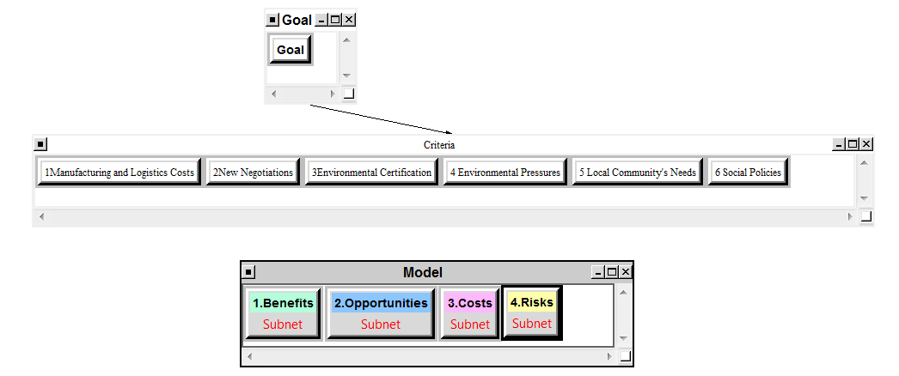
Figure 4. ANP/BOCR Model

The ANP model has been developed by a specific software tool, Super Decisions Software for Decision-Making®.

5.2.1 Alternatives
The alternatives cluster is represented by (A1) Installation of emission abatement, (A2) Installation of evaporative towers to recycle water, (A3) Installation of solar panels, (A4) Reuse packaging and (A5) Reuse of second hand materials.

5.2.2 Criteria
The criteria are described below:

- Manufacturing and Logistics Costs: These encompass the costs throughout the entire supply chain.
- New Negotiations: Changes that come about because of negotiations from other members of the supply chain, e.g. Walmart demanding a 25% reduction in packaging.
- Environmental Certification: The need to satisfy the requirements for ISO certification and of Legislation, e.g. catalytic converters.
- Environmental Pressures: Similar to environmental certification but for issues that have not been mandated, e.g. fracking chemicals.
- Local Community Needs: Requests from the community that are not mandated by law, e.g. noise pollution.
- Social Pressures: When a group or organization push for change within the supply chain. This is especially important for market share considerations, e.g. (coffee and deforestation).

5.2.3 BOCR Network
The strategic criteria and clusters are described below:

- Benefits
Economic
- Advantages: Activities can build value through sustainable methods.
- Sustainable Targets: The evaluation and implementation of actions to reduce environmental impacts.
Social
- Society: Social benefits achieved from the development of sustainability level.
- Individual: Evaluation of actions to improve health care and reduce environmental damage.
Environmental
- EPE (MPI-ECI-OPI): Assessment of the status of environmental performance measures .
- Opportunities
Economic
- Process: Processes associated with planning, scheduling, and coordinating supply chain activities. The effectiveness of an organization in managing assets to support demand satisfaction.
Social
- Resources: Processes associated with the development of territory and Human Resources e.g. life long learning.
- Environmental
- Law: Identification and quantification of energy and resource use and environmental releases to air, water, and land according to European or National decrees.

- Costs
Economic
- Infrastructure: Activities that require economic investment to ensure a green supply chains.
Social
- Human Resources: Activities that require economic investment to ensure safeguard of employees, citizen, etc.
Environmental
- Joint Venture: Agreements with suppliers that define the levels of “sustainability” or resource upside available within state.

- Risks
Economic
- Profitability: Evaluation of the ability to earn a profit.
Social
- Social Risk: Loss of competitiveness.
Environmental
- Environmental Risks: Actual or potential threat of adverse effects arising out of the organization's activities.
- LCA – Analysis of inventory: Qualitative and quantitative characterization and assessment of the consequences on the environment.

Here below, in Table 7, is show the general model for Decision Network and BOCR Analysis.

Table 7: Decision Network for BOCR Analysis
BENEFITS
Model | Control Criteria | Clusters | Elements
Benefits | Economic | Advantages | Company’s value increase  Costs saving  Profitable green  Relation benefits
Benefits | Economic | Sustainable Targets | Optimize use of resources  Optimize use of raw materials  Reduce waste  Reduce use of auxiliary materials  Reduce packaging  Optimize release of emissions
Benefits | Social | Society | Damage Prevention  Improvement local community’s relationship
Benefits | Social | Individual | Health care  Damage Reduction  Improvement employees’ relationship
Benefits | Environmental | EPE - MPI | Implementation of policies and programs  Conformity  Financial performance  Employees performance  Management and planning  Purchases and investments  Health and safety  Community relations
Benefits | Environmental | EPE - ECI | Air  Water  Land  Flora  Fauna  Humans  Natural heritage and culture
Benefits | Environmental | EPE - OPI | Materials  Energy  Services to support the operation of the organization  Products to support the operation of the organization  Design  Installation  Operation  Maintenance  Land use  Transportation  Products supplied by the organization  Services provided by the organization  Waste  Emissions

OPPORTUNITIES
Model | Control Criteria | Clusters | Elements
Opportunities | Economic | Process | Improvement of production process  Customers’ satisfaction  Improvement stakeholders’ relationship  Improvement bank’s relationship  Adaptability – Be Creative  Development of environmental economic and social culture
Opportunities | Social | Resources | Promotion of territorial identity  Develop new professional skills  Stimulate the establishment of quality products
Opportunities | Environmental | Law | New sustainable regional planning  European/National Policies enforcement  Sustainable production methods

COSTS
Model | Control Criteria | Clusters | Elements
Costs | Economic | Infrastructure | Increase in infrastructure costs  Increase counseling costs
Costs | Social | Human Resources | Training costs  Health care survey costs
Costs | Environmental | Joint Venture | Partner skills

RISKS
Model | Control Criteria | Clusters | Elements
Risks | Economic | Profitability | Net profit Margin  Standardization
Risks | Social | Social Risks | Legal Penalties  Paternalism  Stigma
Risks | Environmental | Environmental Risks | Data Collection  Implementation of failure  Introduction of indirect Problems
Risks | Environmental | LCA – Analysis of inventory | Global warming potential - GWP  Ozone  Consumption of non-renewable resources  Acidification  Eutrophication  Photochemical smog  Ecotoxicity

ALTERNATIVES
Model
ALTERNATIVES | ALL NETWORKS | - A1  - A2  - A3  - ….  - An

Here below in Table 8, is show our specific model for Decision Network and BOCR Analysis

Table 8. Decision Network for BOCR Analysis

BENEFITS
Model | Control Criteria | Clusters | Elements
Benefits | Economic | Advantages | Company’s value increase  Costs saving  Profitable green  Relation benefits
Benefits | Economic | Sustainable Targets | Optimize use of resources  Optimize use of raw materials  Reduce waste  Reduce use of auxiliary materials  Reduce packaging  Optimize release of emissions
Benefits | Social | Society | Damage Prevention  Improvement local community’s relationship
Benefits | Social | Individual | Health care  Damage Reduction  Improvement employees’ relationship
Benefits | Environmental | EPE - MPI | MPI - N° of green initiative  MPI – N° of green investments
Benefits | Environmental | EPE - ECI | ECI – C02  ECI –Natural Gas  ECI – Waste  ECI – Water  ECI – Electricity  ECI – Emissions
Benefits | Environmental | EPE-OPI | OPI –Auxiliary Materials  OPI – Total Energy  OPI – Raw Materials  OPI – Packaging  OPI - Cogeneration

OPPORTUNITIES
Model | Control Criteria | Clusters | Elements
Opportunities | Economic | Process | Improvement of production process  Customers’ satisfaction  Improvement stakeholders’ relationship  Improvement bank’s relationship  Adaptability – Be Creative  Development of environmental economic and social culture
Opportunities | Social | Resources | Promotion of territorial identity  Develop new professional skills  Stimulate the establishment of quality products
Opportunities | Environmental | Law | New sustainable regional planning  European Policies enforcement  Sustainable production methods

COSTS
Model | Control Criteria | Clusters | Elements
Costs | Economic | Infrastructure | Increase in infrastructure costs  Increase counseling costs
Costs | Social | Human Resources | Training costs  Health care survey costs
Costs | Environmental | Joint Venture | Partner skills

RISKS
Model | Control Criteria | Clusters | Elements
Risks | Economic | Profitability | Net profit Margin  Standardization
Risks | Social | Social Risks | Legal Penalties  Paternalism  Stigma
Risks | Environmental | Environmental Risks | Data Collection  Implementation of failure  Introduction of indirect Problems
Risks | Environmental | LCA – Analysis of inventory | Acidification  Global warning protection  Ecotoxitcity

ALTERNATIVES
Model
ALTERNATIVES | ALL NETWORKS | - Installation of emission abatement  - Installation of evaporative towers to allow recycling of water  - Installation of solar panel  - Reuse packaging  - Reuse of second hand materials

These criteria were ranked according to the BOCR. The control criteria are used to generate the weights of the BOCR with a ratings model (Figure 5). The following figures (Figure 6, 7 and 8) depict the local priority and overall synthesis according additive and multiplicative formulas.

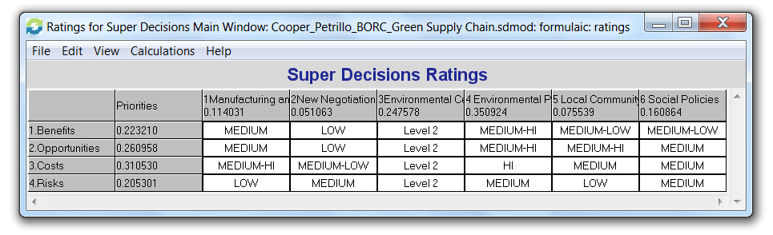

Figure 5. ANP/BOCR Model

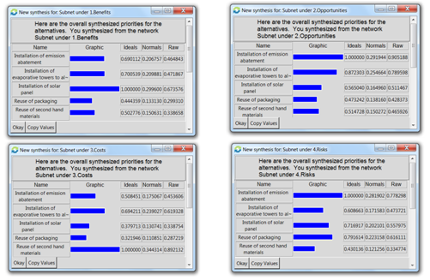
Figure 6. Local Priorities

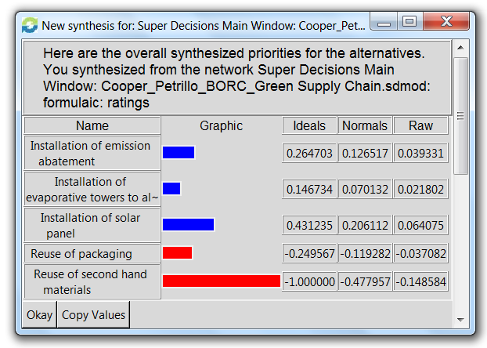
Figure 7. Global Priority – Additive Formula

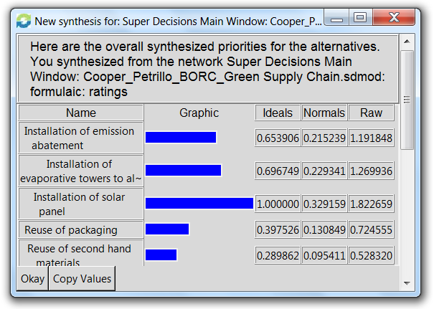
Figure 8. Global Priority – Multiplicative Formula

To test the stability of our decision we used the sensitivity analysis (Figure 9) tool to test the robustness of the decision with respect to changes in the weighting of the benefits, opportunities, costs and risks. The following graphs summarize the results:

The graphs below show that for:
- Benefits, Costs as the independent variable the optimum solution is the installation of solar panel;
- Opportunities as the independent variable the optimum solution is the installation of emission abatement;
- Risks as the independent variable the optimum solution is reuse of second hand materials.
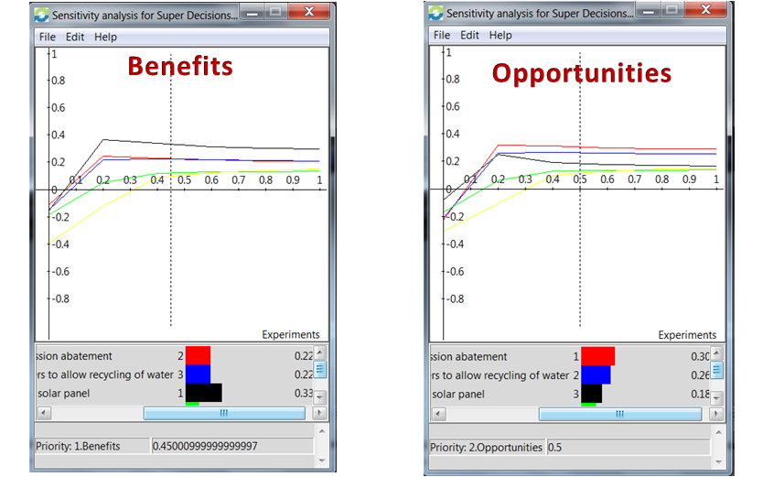

Figure 9. Sensitive Analysis

CONCLUSIONS AND RESULTS
The model is an integrated approach to evaluate the environmental sustainability of a supply chain. The proposed approach involves the evaluation of the entire supply chain: the environmental performance of a product or a producer depends not only on its production process, but the whole life cycle has to be evaluated starting from the first supplier to distribution to the final customer and final recovery activities. The approach integrates index methods for Environmental Performance Evaluation (EPE) with a complex multi-criteria model, the Analytic Network Process (ANP). This proposed approach aims to optimize the development of the ANP model through a previous definition of EPE to identify significant factors of environmental aspects; in this way, the ANP model supplies effective information about critical factors/areas in the entire supply chain in order to optimize the sustainability level. The model has been tested in a real supply chain regarding the TV & AUDIO VIDEO production. This supply chain is characterized by a simple structure as a company heavily influences SC performance; moreover, environmental sustainability issues are relevant in this SC. Results obtained have highlighted different capabilities. Further developments could be oriented in applying the approach to several industrial fields where SC structure complexity arises.

References:
Eckerth, G., 2004. Supply chain management in take back of WEEE. In: Proceedings of the Electronics Goes Green, Berlin, Germany, 6–8 September 2004, pp. 241–244.

European Parliament,2003a.Directive2002/96/EC on Waste Electrical and Electronic Equipment (WEEE), (Online) /http://europa.eu.int/eur-lex/lex/Lex UriServ/LexUriServ.do?uri=CELEX:32002L0095:EN:HTMLS (accessed in10 May, 2005).

European Parliament,2003b.Directive2002/95/EC on the Restriction of the Use of Certain Hazardous Substances in Electrical and Electronic Equipment,(Online), /http://europa.eu.int/eur-lex/lex/LexUriServ/LexUriServ.do?uri=CELEX:32002 L0095:EN:HTMLS (accessed in10May2005).

Francas, D., Minner, S., 2009. Manufacturing network configuration in supply chains with product recovery. OMEGA 37 (4), 757–769.

Gerbens-Leenes PW, Moll HC, Schoot Uiterkamp AJM, (2003), Design and development of a measuring method for environmental sustainability in food production systems, Ecological Economics, Vol.46, pp.231-248.

Handfield, R., Sroufe, R., Walton, S., 2005. Integrating environmental management and supply chain strategy. Business Strategy and the Environment 14, 1–19.

Henri J, Journeault M, (2008), Environmental performance indicators: An empirical study of Canadian manufacturing firms, Journal of Environmental Management, Vol. 87, pp. 165–176.

Hua, G., Cheng, T.C.E., Wang, S., 2011. Managing carbon footprints in inventory management. International Journal of Production Economics 132 (2), 178–185.

ISO, (1999). Environmental performance evaluation e guidelines- ISO 14031. Geneva: International Standard Organization.

Kang H-Y, Schoenung JM. Used consumer electronics: a comparative analysis of material recycling technologies. In: 2004 IEEE international symposium on electronics and the environment; 2004.

Kibert NC. Extended producer responsibility: a tool for achieving sustainable development. J Land Use Environ Law 2004;19:503–23. http://www.law.fsu.edu/journals/landuse/vol19 2/kibert.pdf.

Kocabasoglu, C., Prahinski, C., Klassen, R.D., 2007. Linking forward and reverse supply chain investments: the role of business uncertainty. Journal of Opera- tions Management 25, 1141–1160.

Koh, S.C.L., Gunasekaran, A., Tseng, C.S. (2011). Cross-tier ripple and indirect effects of directives WEEE and RoHS on greening a supply chain. Int. J.ProductionEconomics (article in press).

Kumar V, Bee DJ, Shirodkar PS, Tumkor S, Bettig BP, Sutherland JW. Towards sustainable product and material flow cycles: identifying barriers to achieving product multi-use and zero waste. In: Proceedings of IMECE 2005. 2005 ASME international mechanical engineering congress and exposition; 2005.

Lysons, K., Gillingham, M., 2003. Purchasing and Supply Chain Management, 6th ed. Prentice-Hall, Harlow.

Macauley M, Palmer K, Shih J-S, Cline S, Holsinger H. Modeling the costs and environmental benefits of disposal options for end-of-life electronic equipment: the case of used computer monitors. Resources for the Future. Discussion Paper, 10–27 June, 2001.

Musson SE, JangY-C, Townsend TG, Chung I-H. Characterization of lead leachability from cathode ray tubes using the toxicity characterization leaching procedure. Environ Sci Technol 2000;34:4376–81.

Prahinski, C., Kocabasoglu, C., 2006. Empirical research opportunities in reverse supply chain. OMEGA 34 (6), 519–534.

Sarkis, J., 2001. Greener Manufacturing and Operation. Greenleaf Publishing, Sheffield.

Saaty, T.L., 1980. The Analytic Hierarchy Process. John Wiley, New York.

Saaty, T.L., 1996. The Analytic Network Process. RWS Publications, Pittsburgh, PA.

Saaty, T.L., 1999. Fundamentals of the analytic network process. Proc of International Symposium on Analytical Hierarchy Process, Kobe, Japan.

Saaty, T.L., 2005. Theory and Applications of the Analytic network Process: decision making with benefits, opportunities, costs, and risks. RWS Publications, (Pittsburg ,USA).

Saaty T. L., Peniwati K., 2007. Group Decision Making: Drawing out and Reconciling Differences. RWS Publications, (Pittsburg , USA).

Srivastava, S.K., 2008. Network design for reverse logistics. OMEGA 36 (4), 535–548.

Sundarakani, B., de Souza, R., Goh, M., Wagner, S.M., Manikandan, S., 2010. Modelling carbon footprints across the supply chain. International Journal Production Economics 128 (1), 43–50.

Tsoulfas T, Pappis CP, (2008), A model for supply chains environmental performance analysis and decision making Journal of Cleaner Production, Vol. 16, pp. 1647–1657.

Vachon S, Mao Z, (2008), Linking supply chain strength to sustainable development: a country-level analysis, Journal of Cleaner Production, Vol. 16, pp.1552–1560.

Vereecke A, Muylle S, (2005), Competitive Success Through Supply Chain Management in The Glass Industry, GLASS PROCESSING DAYS. Available at www.gpd.fi

Yla-Mella Y, Pongracz E, Keiski RL. Recovery of waste electrical and electronic Equipment (WEEE) in Finland. In: Pongracz E, editor. Proceedings of the waste minimization and resource use optimization conference, June 10, 2004, Oulu, Finland. p. 83–92. http://www.oulu.fi/resopt/wasmin/ylamella.pdf.

