Making Decisions in Complex Environments
“What should PPG do with its ERP system?”
Justin M Ritter
PPG Industries – Programmer / Analyst
10/15/2012


Preface
PPG Industries is a Fortune 200 company that manufactures coatings, specialty products and materials. PPG operates globally and is separated into 12 business units that focus on different markets. With the complexity of running many businesses under one umbrella, the systems footprint is also large and fragmented. Today, PPG coatings division in North America runs on an old mainframe system for its ERP (Enterprise Resource Planning) that has been around for over 30 years. This ERP system handles order placement, invoicing, inventory tracking, manufacturing, and many other aspects of the operation. Five years ago, the company took a look at its landscape to evaluate a business case for replacing its old ERP systems for coatings with a newer one. This decision would result in a capital transaction in the tens of millions of dollars. So, what should PPG do with its ERP system?
Alternatives
The three choices were to either: upgrade to a new system, postpone the upgrade for another five years, or to never upgrade the system.
- Upgrade to a new ERP
Upgrading to a new ERP system is not an easy or cheap task. It requires capital and people to carry out a multi-year project which could impact day to day operations. This use of capital also impacts other investments in other regions and new products. When the project is complete though, it offers potential headcount savings, productivity gains, technological advances, and better customer integrations that could put PPG ahead of its competitors.
- Never upgrade to a new ERP
Never upgrading to a new ERP is the cheapest short-term option there is. However, with the increasing chance that the hardware and software will go out of support, this could lead to a potential disaster down the road. Customer interactions and integrations are also impacted as the old system has many limitations that affect all types of services. Status quo is also the easiest to do since it requires no decision or changes at all which many of the employees prefer.
- Postpone upgrading for five years
Postponing the upgrade for five years has the benefits of saving the capital, but still perpetuates all the issues that come along with the older systems. Putting off this decision may be the right decision given the criticality of recovering from the recession and uncertainty in the markets that PPG operates in.
The Model
To assist with this difficult decision, an Analytical Hierarchy Process (AHP) model was put together to weigh the benefits, opportunities, costs, and risks of the three alternatives discussed above. To weigh these options, strategic criteria was put together to help give weights to the benefits, opportunities, costs, and risks by pair wise comparing the strategic criteria’s importance to the goal of making a decision about the old ERP systems. The strategic criteria are: business performance, innovation, internal interest, market share, and shareholder value. All of these are critical pieces of the corporate strategy and blueprint that PPG revises every year in its annual filing. The model can be seen below.

Figure 1: The AHP Model
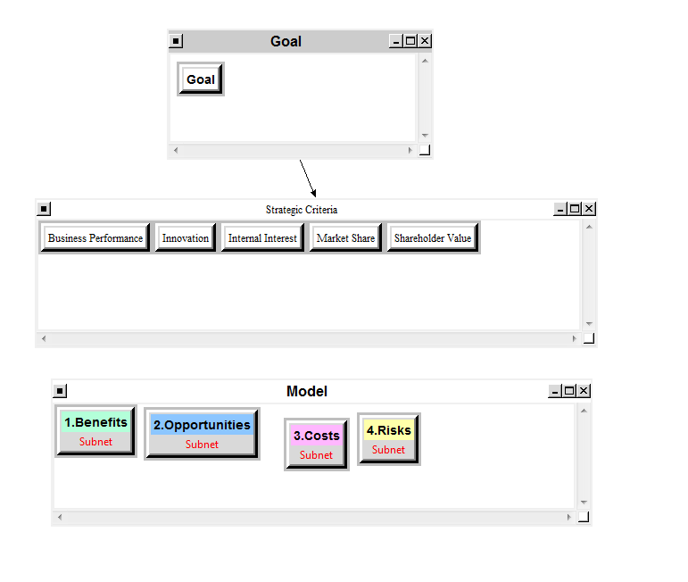
The benefits, opportunities, costs, and risks are not connected directly to the strategic criteria. Ratings are used to give individual weights from the strategic criteria and the model nodes listed above. These will be covered after the subnets are discussed for the model.

Benefits
The benefits portion of the model has four control criteria: operational, economical, customers, and technological. Each one of these control criteria contain an Analytical Network Model (ANP) to model which of the three alternatives should be chosen for the benefits and respective control criteria by comparing factors with each other and the alternatives.
Figure 2: Benefits Model
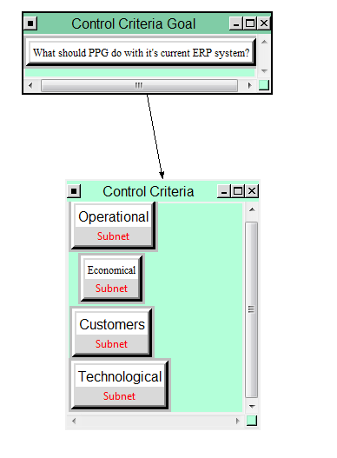
Figure 2.A: Benefits Model – Operational Subnet
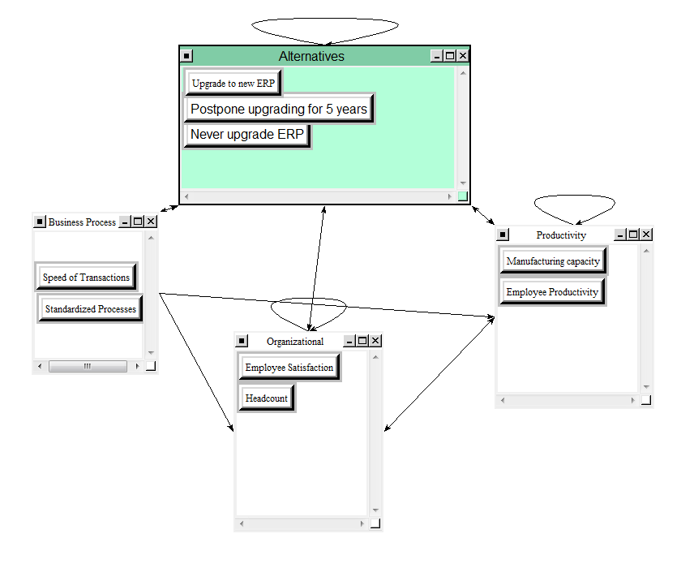

Figure 2.B: Benefits Model – Economical Subnet
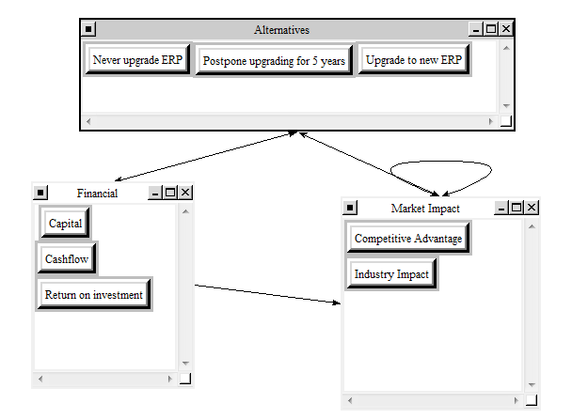
Figure 2.C: Benefits Model – Customers Subnet
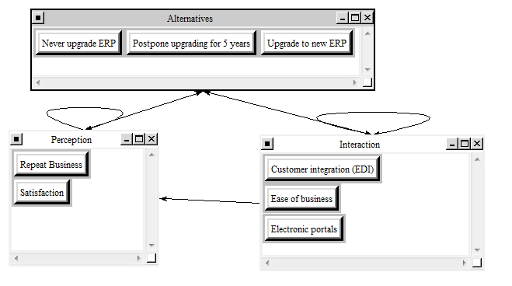
Figure 2.D: Benefits Model – Technological Subnet
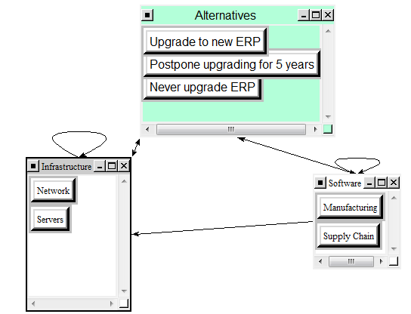
As seen above, the operational subnet contains three main clusters that affect the alternatives: business processes, organizational, and productivity. These are all aspects of the company’s operations that play into the core systems upgrade. There are potential headcount savings that can be realized with a newer system along with capacity gains and transaction quickness. The economical subnet contains financial and market impact aspects; there is a return on investment as well as advantages that could help PPG beat its competitors. The customers subnet contain aspects of customer perception and customer interaction which are impacted by an ERP upgrade. New systems enable ease of business, customer satisfaction, and the immediate use of new features such as electronic ordering portals. The last subnet is technological which contains aspects in both infrastructure and software. There are benefits with a simplier network and server footprint along with various application improvements, two of which being for manufacturing and supply chain.
Opportunities
The opportunities portion of the model has two control criteria: economical and customers. Operational and technological are not on the opportunities model as they are realized immediately through the benefits model.
Figure 3: Opportunities Model
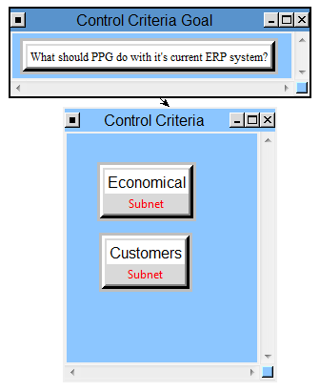
Figure 3.A: Opportunities Model – Economical Subnet
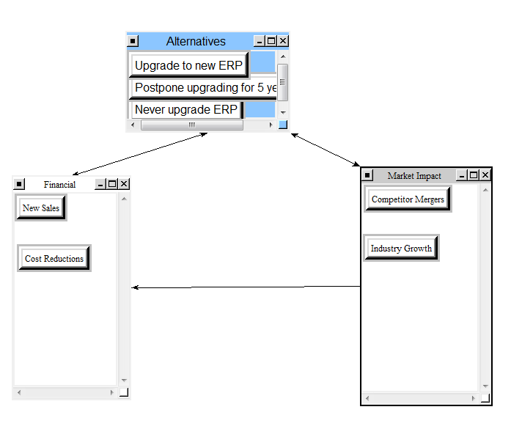
Figure 3.B: Opportunities Model – Customers Subnet
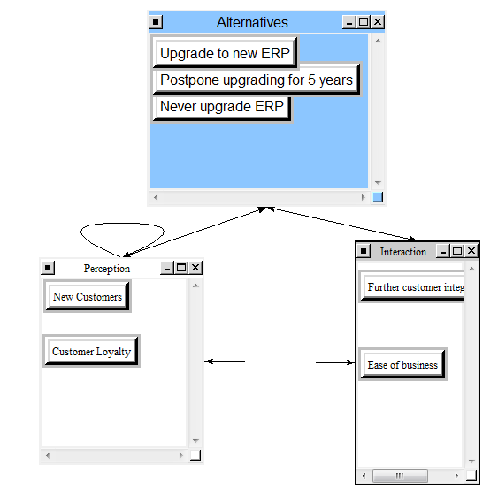
In the figures above, the two subnets for the opportunities model help determine what alternatives has the best long term positive impact. The economical subnet contains again financial and market impact aspects. There are potentially new sales that could be generated as a result of a new system along with cost reductions that go with that. Having a new system also makes mergers easier and could enable the overall industry to grow in capacity. For the customers subnet, the customers’ perception and interaction play into the choices as individual clusters. New customers and customer loyalty can be affected by this system upgrade along with long term ease of business and rich integration with their systems.
Costs
The costs model has two control criteria: economical and technological. Operational and customers are not on the costs model as customers do not pay forward for new systems directly and day to day operations will remain the same regardless of the systems.
Figure 4: Costs Model
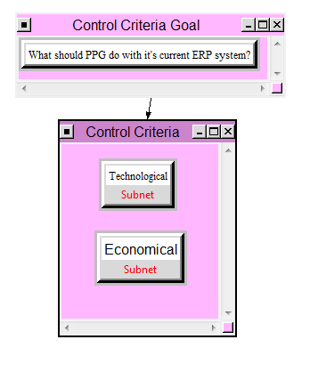
Figure 4.A: Costs Model – Technological Subnet
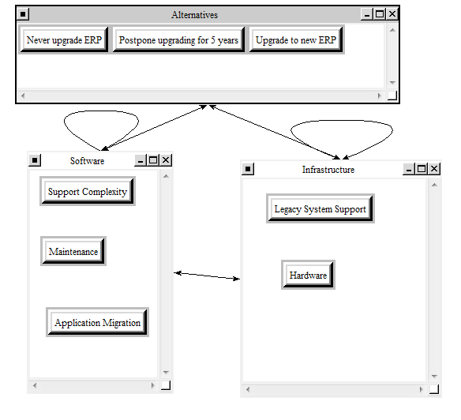

Figure 4.B: Costs Model – Economical Subnet
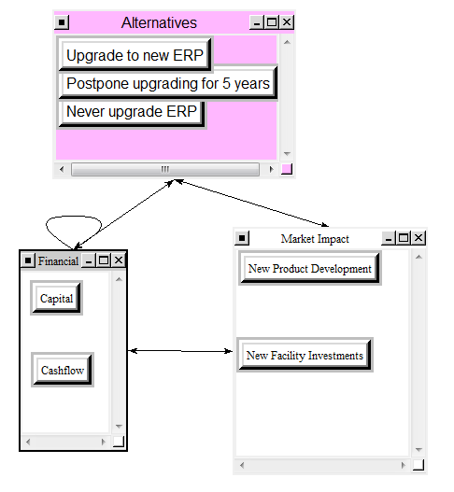
The technological subnet contains aspects of software and infrastructure again but is looking explicitly at support costs, out of support systems, and migration of new systems which requires a lot of effort. Old software and legacy systems can cost technological advances and functionality that can impact the business. In the economical subnet, financial and market impact clusters are aspects that affect the possible choices of what to do with the existing ERP system. There are hard dollars behind a system upgrade along with potential impacts of PPG’s expansion into new regions with new facilities and products. These are directly related with the financial reasons as all research requires funding and time.
Risks
The risks model has two control criteria: customers and technological. Operational and economical are not on the risks model as operations should again not be directly affected by the systems that support them and the economical negative impacts are realized immediately through the costs model.

Figure 5: Risks Model
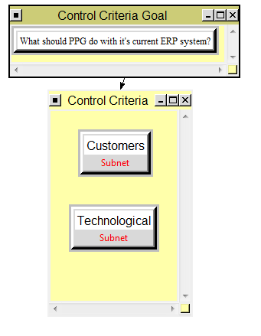
Figure 5.A: Risks Model – Customers Subnet
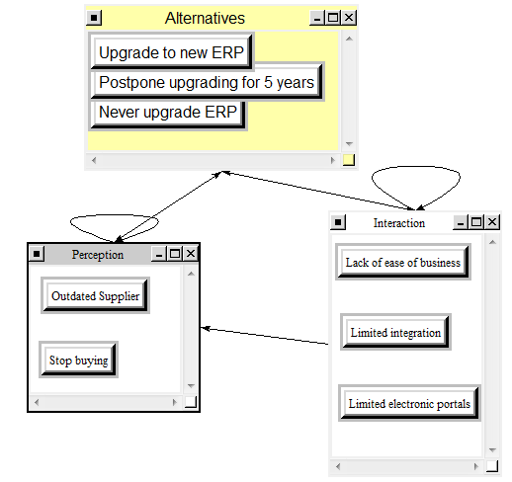
Figure 5.B: Risks Model – Technological Subnet
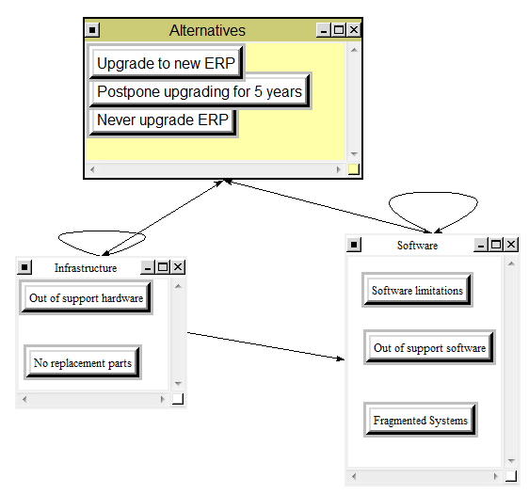
From above, the customers subnet contains perception and interaction clusters, but this time they contain more long term impacts. Customers could eventually stop buying or believe PPG is an outdated supplier. Along with this, lack of integration and clunky business interactions could negatively impact customer interaction. The technological subnet contains infrastructure and software aspects. The infrastructure cluster contain issues along out of support hardware of an older system along with replacement parts not existing for older hardware. The software cluster has issues around out of support applications, system fragmentation which again drive complexity, and limitations down the road with future software upgrades.
Model Results
The first step in using the outer most AHP model was to assign priorities of each strategic criteria to the goal of making the decision by comparing them. The normalized and ideal priorities are below.
Figure 6: Normalized and Ideal Priorities of the Strategic Criteria
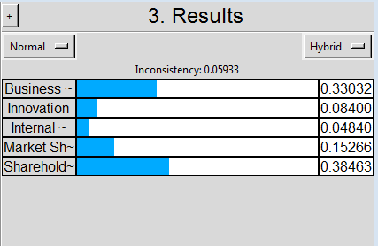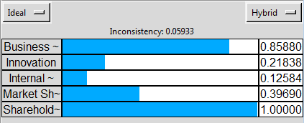
With PPG having an unprecedented dividend payout and business performance history, it’s no surprise that these are the most important factors with this decision and any others that the company makes. These align well with the overall corporate strategy that is communicated every year to shareholders and employees.
The second step was to make the connections and comparisions between all the subnets within the benefits, opportunities, costs, and risks models that make up the outer AHP. Connections were made if the starting node had an impact on the ending node which would affect the rest of the network. The priorities of the alternatives from each one of the four models are listed below.
Figure 7: BOCR Priorities
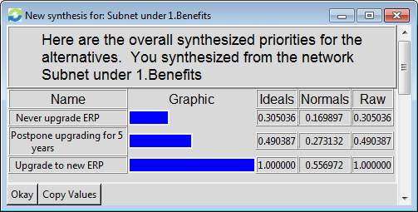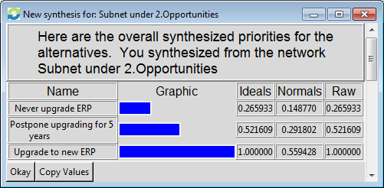
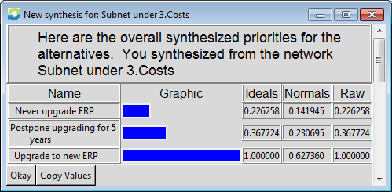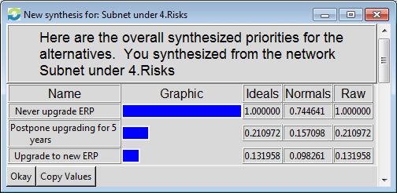
These priorities are rolled up to the outer AHP model which contains the strategic criteria and their respective priorities. To relate the two and calculate which of the three alternatives should be chosen, ratings must be used give each of the strategic criteria a priority with respect to each model (BOCR).
For business performance, the rating categories were: drastically improve results, improve results, keep results same, and decrease results. For innovation, the rating categories were: Increases innovation, keeps innovation same, and decreases innovation. Internal innovation had the following categories: everyone buys in, most buy in, mixed feelings, and no one buys in. For market share, the ratings were: gain market share, no impact to market share, and hurt market share. Lastly, for shareholder value, the categories were: drastically increase shareholder value, increase shareholder value, no impact to shareholder value, and decrease shareholder value. The ratings for each of the strategic criteria in relation to the benefits, opportunities, costs and risks are listed below.
Figure 8: BOCR Ratings Matrix
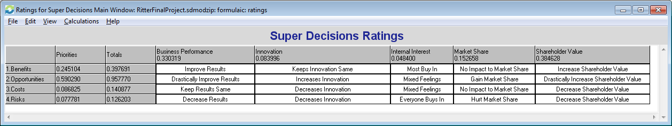
With these final ratings, the entire model can be synthesized and a choice can be selected out of the three alternatives. Results from the additive (negative) formula and the multiplicative formula are listed below.
Figure 9: Additive (Negative) Overall Synthesis
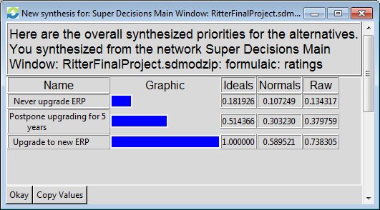
Figure 10: Multiplicative Overall Synthesis
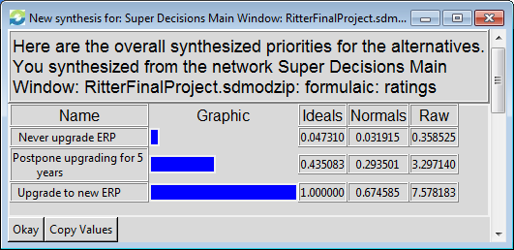
Both results show that the upgrade to the new ERP is the preferred alternative according to this model and its inner workings. For the additive (negative) results, none of the options are negative which makes sense given the fact that the business can continue to run on the older systems without a major negative impact according to any of the five strategic criteria. The multiplicative results have a stronger stance on the upgrading which implies a better short-term result as opposed to the long-term result that the additive (negative) formula offers. In both cases again, postponing the upgrade is much more favorable than never upgrading as the impact is nominal as compared to the strategic criteria. These results highlight the need to upgrade the system over not upgrading with the priority being on doing the upgrade now as opposed to postponing it. It appears to be a worthwhile investment!
Sensitivity Analysis
Sensitivity analysis can only be run on the additive (negative) formula results. Looking above, our opportunities model was prioritized by ratings with respect to strategic criteria at almost 60%. If the priority of opportunities were to change, how would it affect the decision of selecting an alternative?
Figure 11: Sensitivity Analysis for Opportunities
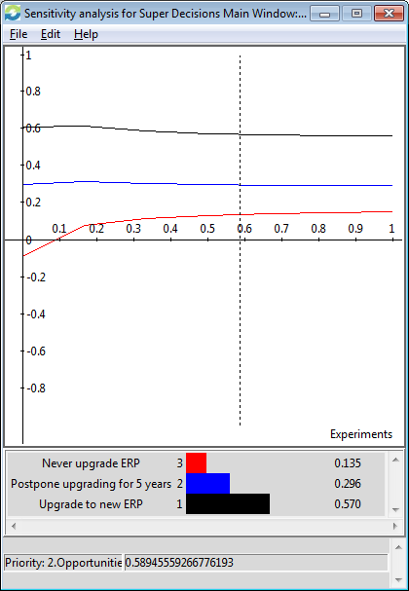
The figure above shows that no matter what priority is given to the opportunities node, the order of choices is maintained in the overall model. What is interesting is that very close to 10% or lower priority for opportunities, never upgrading the ERP systems has a negative impact given the strategic criteria.
Looking at the immediate costs model which only had 14% priority as compared to the other three model, we can see that its weight drastically impacts the decision made by the model. The sensitivity analysis is below.
Figure 12: Sensitivity Analysis for Costs
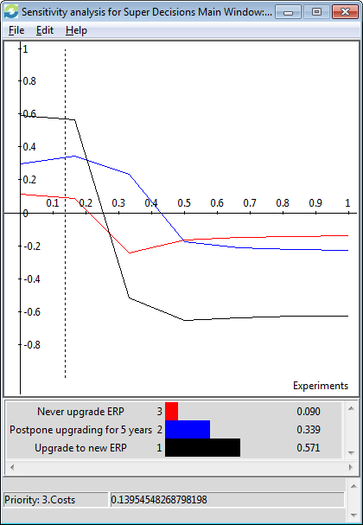
The more costly that the upgrade becomes, the less preferred the choice is to actually do the upgrade. At about 20% priority, postponing the upgrade becomes a better choice as the costs put the upgrade below it. Furthermore, at 27% priority, never upgrading becomes more favorable than doing the upgrade. Lastly, at about 50% priority, never upgrading the ERP system becomes the most favorable by a slight margin over postponing the upgrades.
Conclusion
The model claims that upgrading the core ERP systems for the coatings division of PPG Industries to be the best option in both the short-term and long-term according to the key strategic criteria that aligns well with the strategic direction of the company. To tie this into the current world, PPG just divested the chemicals division to put itself in a stronger cash position. This cash from the sold business is to invest heavily in the core coatings businesses that make up PPG. An upgrade of the core ERP system has tremendous impact on the potential of those businesses and makes sense to do if the priority is there for these business units. Regardless of the costs, upwards to a priority of almost 50%, the upgrade or eventual upgrade of the core ERP systems makes sense to do for the company’s future. PPG should upgrade its core ERP systems.
To improve the model, further breakout could be done for each of the BOCR subnets and their subnets. There are potentially some relationships and impacts that are not captured by this simplified version of the real world problem. Researching what other businesses have received as benefits as opposed to costs would be helpful as well as ERP implementations are an area of heavy focus due to their impact and large price tag. The last thing that could be added was the potential impact to competitors specifically and the other business units within the company as there is some cross business unit activity that occurs.

