Choosing the Best Reward or Recognition To Raise Employee Morale Within A Company
Analytical Network Process Model
Ashley Rudy and Greg Spelar
4/23/2013

The Analytical Network Decision model identifies the best approach to raising employee morale. The BOCR model and ratings model are used to identify the best alternative: Intrinsic Events, External Events, and Profile-Raising Events. The strategic criteria of raising an employee’s morale consisted of Independence, Shared Governance, Recognition, and Self-Actualization. These are ranked and weighed heavily on the BOCR model. In the BOCR results, the multiplicative and additive models provided two difficult results. The sensitivity analysis is also conducted to identify what areas could affect the overall results.

Table of Contents
- Introduction………………………………………………………………………………………….……2
- Assumptions………………………………………………………………………………………………..2
- Model………………………………………………………………………………………….………...…..3
- Data & Analysis……………………………………………………………………………………...…17
- Further Research & Application……………………………………………………….……..….25
- Summary………………………………………………………………………………………………..…26
- Conclusions………………………………………………………………………………….......……..26
- References………………………………………………………………………………..………….……26

- Introduction
This group applied the ANP methodology to determine an appropriate allocation of resources for companies seeking to increase employee morale through the use non-financial means.
Many companies are under increasing pressure to increase the morale of its employees with growing constraints on compensation. Increased levels of employee morale has been shown to increase productivity and An increasingly popular method of improving morale has been to provide employees with events designed to increase communication and enjoyment in the workplace. In addition, many companies take up sponsorship of events, charities, and causes believed to be important to its employees.
The three alternatives examined in this model and examples of such are as follows:
- Intrinsic Events – Rewards benefiting the individual employee, such as flex-time, work from home, opportunities to work in different operational areas.
- External Events – Company picnics, motivational speakers, tickets to sporting events, competitions, special training opportunities, junkets for high performing employees.
- Profile-Raising Events – Sponsorship of foundations, matching employee donations to charities, naming rights to charitable events
The model takes the following stakeholders into consideration: The managers who are responsible for making the decision and responsible for the outcomes, the employees who will be determining the outcomes, the community, and the industry in which the company operates.
Our strategic criteria examine the determinants of employee morale and the potential impact of each of the presented alternatives.
- Independence – Being empowered to conduct one’s job without micromanagement.
- Self-actualization - Increase employee's ability to achieve their potential. Providing learning and educational opportunities as well as advancements.
- Shared governance - Having the ability to contribute to making a decision. To be listened to and hear from.
- Recognition - Praise or acknowledgement of exceptional work

- Assumptions
Our model includes the following assumptions:
The company in question has over 5,000 employees working in a central location.
The work performed by the majority of the employees is not physically taxing.
The demographics of the company’s employees match national averages.
- Model
Table 1 depicts the criteria used to evaluate the alternatives in a Benefits, Opportunities, Costs, and Risks (BOCR) model. We define each of the criteria below.
Table 1: BOCR Criteria and Sub-criteria
Benefits | Opportunities
Operational | Operational
Product Development | Talent Pool
Employee Retention | Process Improvement
Profitability
Social | Social
Employee Value | Communication
Communication | New Markets
Productivity | Competitiveness
Time | Knowledge Sharing
Community Relationship
Industry Reputation
Costs | Risks
Operational | Economic
Output | Legal Issues
Manager time | Market Expansion
Financial
Social | Social
Industry Reputation | Talent Pool
Shareholder Support | Community Relationship
 | Employee Value
 | Communication
 | Productivity
 | Time

Figure 1: Benefits
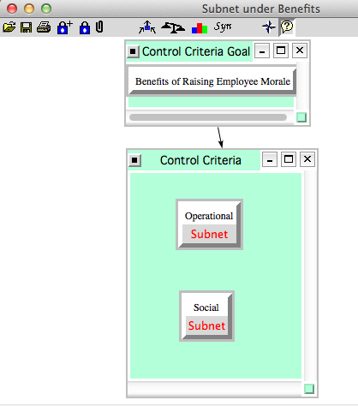

Figure 2: Operational Benefits
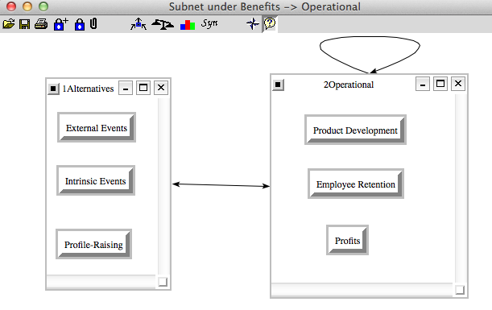
Product Development: This node examines the impact of each alternative on the company’s ability to bring new products to market. Intrinsic rewards have a moderate effect on this node as improved collaboration among employees would increase quality and time to market. External events, such as skill-building and focus groups, would have the strongest impact on this node. Profile-raising events would have a minimal impact on product development due to a lack of focus on this criterion.
Employee Retention: This node examines each alternative’s impact on a company’s ability to retain employees, particularly top performers.
Profits: This node encompasses the impact of each alternative on profitability. We expect that a more motivated pool of employees will generate higher returns than an unmotivated one.
Social: This subnet is comprised of the social benefits of increased morale in the workforce. Included is another sub-network depicting underlying factors of employee’s value to the company.

Figure 3: Social Benefits
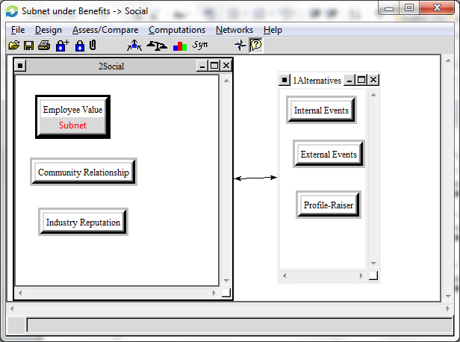
Employee Value: This node examines criteria which make up the underlying value of an employee’s contribution to the company

Figure 4: Employee Value’s Social Benefits
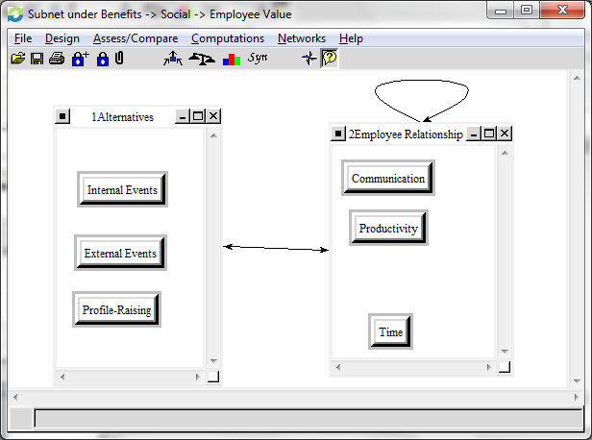
Communication: This node compares the benefit of each alternative’s impact with regards to improving the flow of ideas between employees and departments.
Productivity: This node compares the positive impacts of each alternative on an employee’s output and quality of work.
Time: This node compares the value of each alternative with respect to an employee’s time. Intrinsic events may include granting an employee flex-time, while external events typically involve consuming an employee’s time outside of work.
Community Relationship: This node represents the view of the community in which the company is physically located. A community relationship can contributes to an employee’s sense of involvement.
Industry Reputation: This node represents each alternative’s impact on how company is viewed in comparison to its peers. This node is of particular importance because of its impact on future business considerations for customers and competitors.

Figure 5: Opportunities
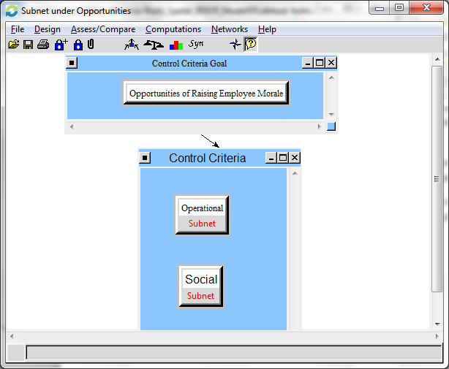

Figure 6: Operational Subnet
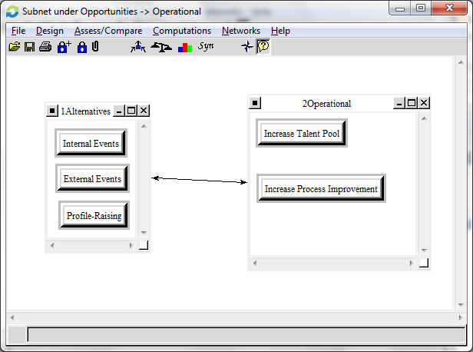
Talent Pool: This node evaluates each alternative’s effect on the current and potential employees of the company. This node is of particular importance given the costs associated with acquiring talent.
Process Improvement: This node compares the possibility of each alternative will increase increase communication and motivation among employees, and result in efficiency gains among existing processes.

Figure 7: Social Opportunities
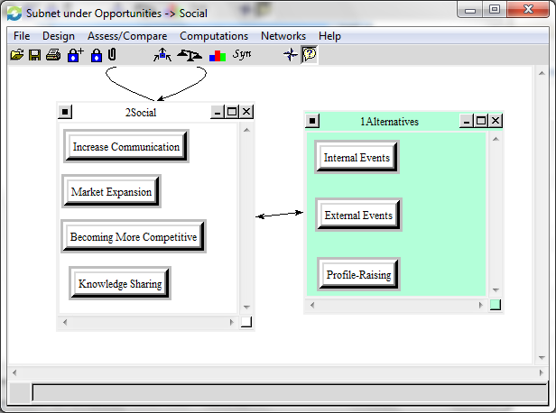
Communication: This node compares each alternative’s impact on communication in the firm and the potential benefits that this additional communication may bring.
New Markets: This node captures the potential of additional business opportunities being discovered through the use of each alternative.
Competitiveness: This node weighs each alternative’s potential for increasing the competitiveness of the firm through higher levels of motivation.
Knowledge Sharing: This node compares each alternative’s potential for increasing employees’ general knowledge of the company and the interactions of various business units.

Figure 8: Costs
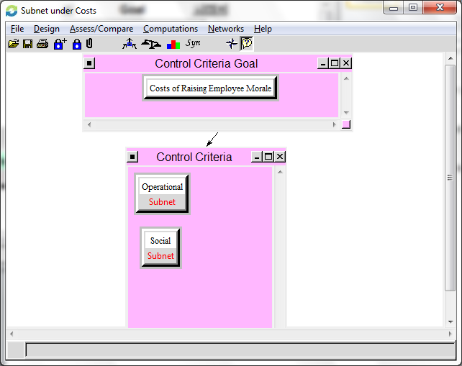
Figure 9: Operational Costs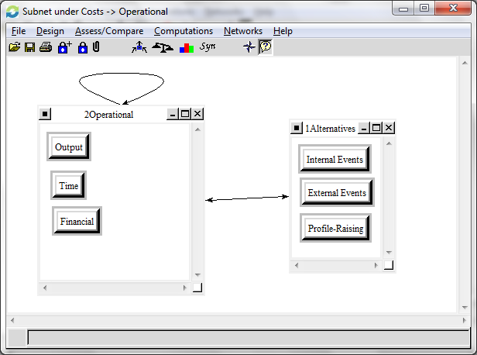
Employee Output: This node accounts for the opportunity cost of employees spending time at morale-increasing events rather than working on their job for each alternative.
Time: This node accounts for the opportunity cost of the time managers spend planning events and determining appropriate rewards for each alternative.
Financial: This node captures the direct outflow of funds required by each of the three alternatives.

Figure 10: Social Costs
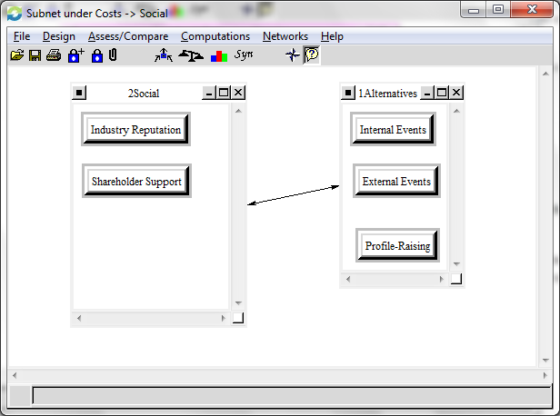
Industry Reputation: This node captures the downside cost of devoting resources for each alternative as interpreted by the company’s customers and competitors.
Shareholder Support: This node captures the cost of shareholders reacting to the use of resources for morale-improving purposes for each alternative. Intrinsic events typically require fewer cash outlays than external events, while profile-raising events typically double as marketing efforts.

Figure 11: Risks
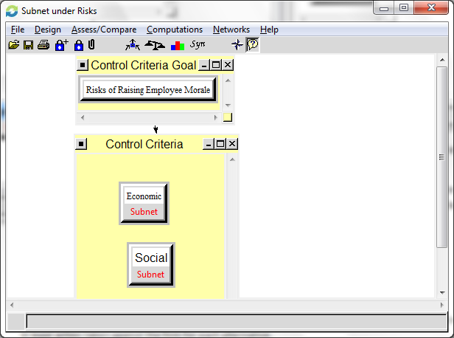

Figure 12: Economic Risks
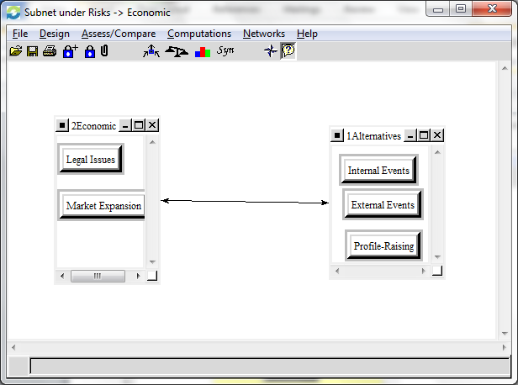
Legal Issues: This node captures the risk of litigation occurring for unintended consequences that result in legal action taken against the firm for each alternative.
Market Expansion: This node captures the risk of each alternative negatively impacting the company’s ability to expand into new markets.

Figure 13: Social Risks
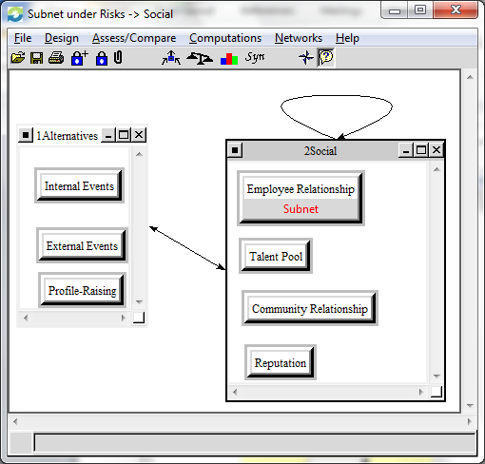
Employee Value: This subnet captures the risk to the below criteria
Communication: This node compares the risk of each alternative’s impact on disrupting the flow of ideas between employees and departments.
Productivity: This node compares the risks of each alternative on an employee’s output and quality of work.
Time: This node compares the value of each alternative with respect to an employee’s time. Intrinsic events may include granting an employee flex-time, while external events typically involve consuming an employee’s time outside of work.
Talent Pool: This node captures the risk for each type of event in regards to negatively impacting the retention of current employees and cost of acquiring future talent.
Community Relationship: This node captures the risk of each type of event potentially damaging the company’s reputation with the surrounding community.
- Data & Analysis
This section will cover the meaning behind each section of the model and the overall results of the goal in the BOCR model.
In our Benefits Results displayed below, the Alternative, Intrinsic Events, had the highest priority with the External Events as the 2nd priority and the Profile-Raising as the last alternative of the three. This conclusion makes sense because the company will see stronger benefits of raising employee morale by intrinsic events. By incorporating events that involve self-actualization and independence, this will improve the morale of an employee. The 2nd priorities focus more on teamwork and recognition. While the 3rd priority focuses on the company’s reputation, sometimes based on the employee’s charity of interest, which does not always motivate employee.
It is important to note that from a manager’s perspective, profits were weighted more heavily than product development and employee retention. Profits were more in favor of External Events. The reasoning behind this is External Events such as training increases the productivity and efficiency of an employee, which ultimately improves profits for a company.
Figure 14: Benefits Subnet Results
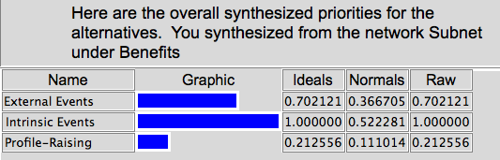
In the Opportunities Results, the Intrinsic Events were the highest priority, the External Events as the 2nd highest priority, and the Profile-Raising as the last priority. This makes sense because there are more opportunities available for intrinsic events of raising employee morale than profile-raising or external events. In Process Improvement, Intrinsic Events were more important than the other two alternatives because they are more effective at motivating an employee internally, which may ultimately improve their performance level. The 2nd priority, External Events, ranks higher than Profile-Raising because from an Opportunistic view, it is more effective in Communication, Knowledge Sharing, and Market Expansion. By having company picnics or training provides opportunities to share knowledge between employees or improve communication amongst employees and management.

Figure 15: Opportunities Subnet Results
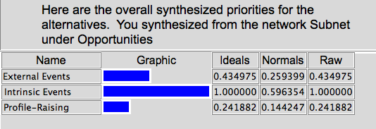
In the Cost Results, the External Events were the highest priority, the Profile-Raising as the 2nd highest priority, and the Intrinsic Events as the last priority. External Events are the highest cost because Output and Time are most affected from an operational view. Holding External Events such as training and having motivational speakers will take away the employee’s time and directly affect the output of the company.
Profile-Raising was ranked higher than Intrinsic Events because of the social criteria. The cost that comes with improving employee morale socially may involve its reputation and also shareholder support. Profile-Raising comes at a higher cost than Intrinsic Events because it has a higher influence on the industry, shareholders, and community, and takes more resources.
Figure 15: Cost Subnet Results
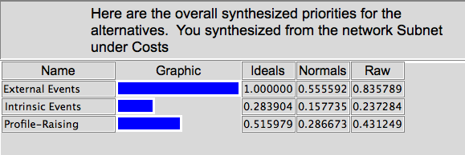
In the Risks Results display below, the Intrinsic Events were the highest priority, the External Events as the 2nd highest priority, and the Profile-Raising as the last priority. When raising the employee’s morale, there may be legal risks such as an employee’s rights being violated, equal employee opportunity, or conflict of interest in sponsorships and charitable donations. These are more apparent in External Events and Profile-Raising. For example, a company has to offer training to all the employees in the department, not just a select group. Employees may feel excluded because of their gender or race and may cause them to take legal action. This also can be applied when companies provide advancement opportunities to specific employees.
From the Social Risk aspect, Employee Value is the higher risk for Intrinsic Events because it has a stronger influence. Giving an employee their independence and flexibility to work whenever they want may have setbacks. The company is taking a chance by trusting their employees to complete their work efficiently and not slacking off when working from home.
Companies also risk their talent pool more so in Intrinsic and External Events. When increasing employee morale, if they do not provide the right opportunities to employee’s satisfaction, this will limit the interest of potential star employees. If a potential employee is aware that the company provides limited advancement or has dissatisfied employees, then they will choose to work at other companies where employees are treated better.
Figure 16: Risks Subnet Results
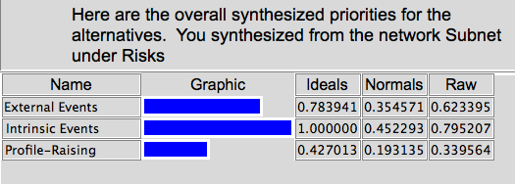
The overall results were weighted by the Ratings. With the Strategic Criteria of Independence, Self-Actualization, Shared Governance, and Recognition, the ratings weighed heavily in favor towards Benefits as being the highest priority. Second highest was Opportunities, Costs as 3rd highest priority, and Risks as the last priority. When raising employee morale, all four strategic criteria rated high for benefits because they are all important values to employees.
Independence was rated as medium for opportunities, costs, and risks. It is an important value but independence is not a high opportunity, cost, or risk for raising employee morale. Self-Actualization is high for benefits and opportunities because without it, raising employee morale would be difficult to achieve. On the other hand, cost and risk are not as affected therefore received low ratings. Shared Governance was considered high for benefits, opportunities, and costs. Employees taking part in making decisions is important for them to feel valued, but may come at a cost when there are conflicts in making the best decision. Lastly, Recognition was rated as an important benefit but provided limited opportunities for the goal. Costs and Risks were unaffected by Recognition and therefore received low ratings.

Before the strategic criteria were included, we synthesized the current model in the additive formula for long term. In the figure below, Internal Events was clearly the highest priority, with External Events as 2nd priority and Profile-Raising closely in 3rd.
Figure 17: BOCR Results using the Additive (Negative) formula
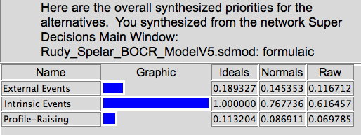

Next, the BOCR model was synthesized based on the multiplicative formula for the short term. In Figure 18, once again Internal Events was the highest priority, with External Events in 2nd and Profile-Raising in 3rd.
Figure 18: BOCR Results using the Multiplicative formula
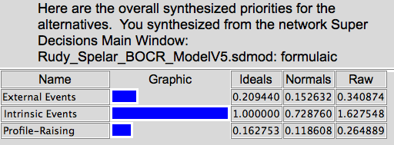

The long-term and short-term gave the same best alternative with Intrinsic Events as highest priority. Moving back to the Additive formula, we then added the strategic criteria to further analyze our alternatives. Our results are shown in Table 2 below.

Table 2: Strategic Criteria Ratings and Priorities
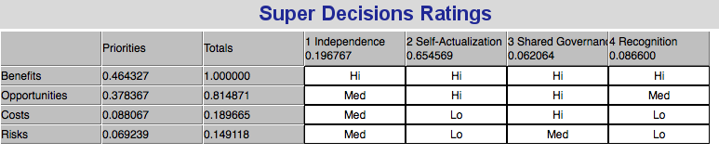
Therefore, with Benefits as the highest priority of the Ratings, the best choice to raise employee morale was Intrinsic Events. This is due to Intrinsic Events providing opportunities to become more independent and increase self-actualization through flex-time and rotational assignments. By trusting the employee and giving them the opportunity to work in areas of interest to them increases their motivation and satisfaction in the company.
The overall second highest priority, which also ranked second in Benefits, was External Events. This was due to not impacting as strongly on Independence or Self-Actualization. Shared Governance and Recognition are more noticeable factors in company picnics and competitions but they are not as important to employees. Employees want to give their opinion and want to be recognized but if they do not feel fulfilled in their accomplishments, then they may not become completely motivated to succeed in their positions.
The last priority was Profile-Raising Events. This received the lowest ranking because most employees are not satisfied with their company donating money to their charities of preference. The company is pleasing the employee through recognition, which is not as strongly valued as the other strategic criteria. Sponsorships and involvement of charities increases opportunities of hiring star employees and improves its reputation but it does not satisfy the employee morale in the long run.
Figure 19: BOCR Model Results
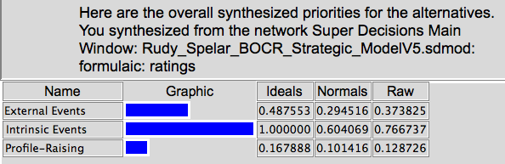
Sensitivity Analysis
The Sensitivity Analysis for Benefits, shown in Figure 6, concluded with Intrinsic Events being the best Benefit from 0 to 1. At no other point do the other two alternatives cross over to become the better choice. External Events was the 2nd highest priority from the 0 to 1 range and Profile-Raising in 3rd.
Figure 20: Benefits Sensitivity Analysis
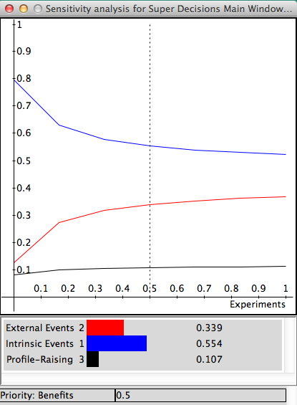
The Sensitivity Analysis for Opportunities, shown in Figure 21, concluded with once again Intrinsic Events being the best Opportunity from 0 to 1. External Events was the 2nd highest priority from the 0 to 1 range and Profile-Raising in 3rd.

Figure 21: Opportunities Sensitivity Analysis
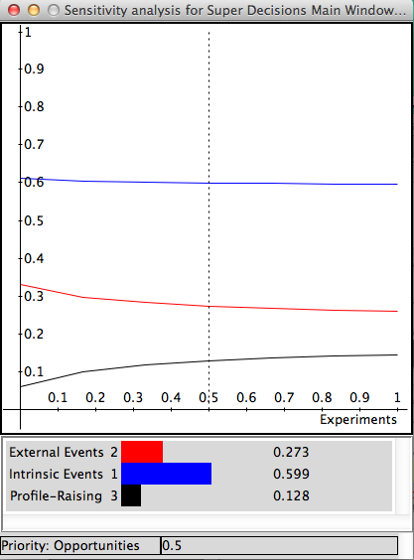

The Sensitivity Analysis for Costs, shown in Figure 22, concluded with Intrinsic Events being the best Cost alternative from the range of 0 through 1. From 0 to 0.22 has the 2nd highest priority, then from 0.23 to 1, Profile-Raising becomes the 2nd highest priority.

Figure 22: Costs Sensitivity Analysis
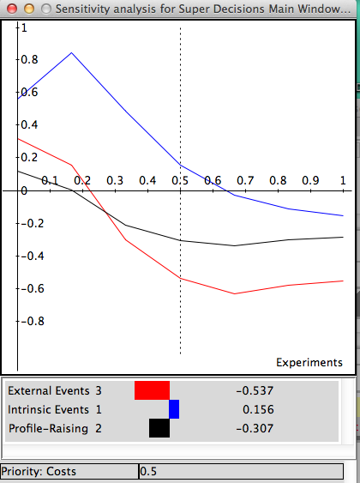
The Sensitivity Analysis for Risks, shown in Figure 23, concluded with Intrinsic Events being the best Risk from 0 to 0.47. At 0.47 to 1, Profile-Raising was the better Risk. From 0 to 0.32 has the 2nd highest priority, then from 0.32 to 1, Profile-Raising becomes the 2nd highest priority.

Figure 23: Risks Sensitivity Analysis
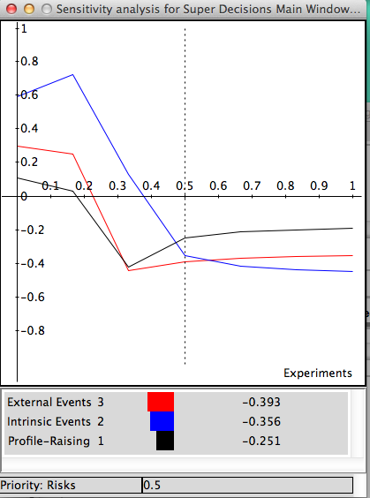

- Further Research and Application
Further research should include taking employee surveys to gather their interests in specific reward or recognition they would prefer or are comfortable with. Then in addition another BOCR model could be conducted reviewing what the best specific reward or recognition should be. It would be difficult to satisfy everyone but if most of the employees were satisfy then the goal was reached.
Since Intrinsic Events was the highest priority for most of the BOCR components and in the sensitivity analysis, it would be a good idea to look into individual Intrinsic Events and analyze more specific options. We will get a stronger understanding of what specific Intrinsic Event employees prefer.
- Summary
Analyzing what the best option was for raising employee morale was looked at from the perspectives of the employee, management, community, and industry. Even though management has the ultimate decision of what was the best option to take, they have to heavily weigh the employee’s interests or they will not achieve their goal. This will impact the company negatively by performance and profit. By focusing on the employee’s needs in a nonmonetary way will satisfy them and motivate them to become more successful and improve their performance. When employees see that their work matters to the company, they feel more valued and will continue to contribute. Raising employee morale heavily impacts the company’s performance and success.
- Conclusion
The final conclusion is that for an employee to enjoy working for a company they need to have opportunities to learn and achieve self-fulfillment. They have to have some level of independence or else their performance will deteriorate. They have to feel that they are making a difference in the company. They will increase their value by having the drive to improve their performance, efficiency, and creativity. This will positively impact the company’s success, reputation, and value and is an area that management should focus on. Raising employee morale can be obtained in various ways through nonfinancial ways.
- References

Guold, Tim. “Retention in 2013: What do employees really want?” HRMorning.com. n.p. 16 February 2013. http://www.hrmorning.com/retention-in-2013-what-do-todays-employees-really-want-the-long-view/. 16 April 2013.
“Rebuilding Morale.” MindTools. n.p., n.d., http://www.mindtools.com/pages/article/morale.htm.
20 April 2013.
Thompson, Boyce. “20 Ways to Improve Company Morale.” Multifamily Executive 2009. n.p.15 October 2009. http://www.multifamilyexecutive.com/human-resources/20-ways-to-improve-company-morale.aspx 20 April 2013.

