Define the Best Location for ABAP Factory Implementation

Topic:
Define a place to implement an ABAP (SAP programming) Development Factory to support Brazil SAP Consolidation Project and also the future Brazil’s SAP maintenances.

Introduction
An ABAP factory model should be defined to support Brazil SAP Consolidation project. This project has a huge timeline and also budget restrictions. The resources allocation is a key success factor for this project.

Background
Monsanto Brazil has today a local vendor that already provides ABAP development and maintenance for the current installation. The Monsanto Company has a contract with India and also have US resources option. For this special project that has more than 40.000 hours forecasted for development and also some budget restrictions, the alternative considering Benefits, costs, opportunities and risks should be carefully evaluated.

Alternatives : Have the ABAP Development and Maintenance Factory implemented in
Alternative 1: Brazil
Alternative 2: US
Alternative 3: India.

Clusters and Nodes

Clusters/Nodes | - Criteria  - Delivery on Time  - Financial  - Knowledge Transfer  - Quality  - Model: This is the top level network.  - Benefits: Benefits  - Costs: Costs and Investments Involved  - Opportunities: Opportunities  - Risks: Risks  - Select Location:  - Goal: Define Best Location for ABAP Factory (India, USA or Brasil):

Benefits Network
Clusters/Nodes | - Control: Manage the project considering the communication, methodology and time zone aspects  - Financial: Financial aspects considering new products, savings using templates and supporting another regions  - Technical: Technical Requirements considers the General and Local requirements like government requirements, and also the technical aspects by itself.

Costs Network
Clusters/Nodes | - Financial: Financial criteria considers the training, sunk investments and the fee that vendor will be charging  - Image: Image criteria considers the customer confidence and the internal credibility

Opportunities Network
Clusters/Nodes | - Economic: The economic criteria consider network opportunities, partnership and resource optimization.  - Technological: Technological criteria considers the network, skills enhancement and partnership opportunities

Risks Network
Clusters/Nodes | - Competitors Reaction: Competitors reaction will evaluate how quick the competitors can react and copy the model.  - Cultural Conflicts: cultural conflicts will evaluate the communication, work style and language impacts.

Alternative Rankings
Graphic | Alternatives | Total | Normal | Ideal | Ranking
 | Brazil | 0.1415 | 0.4602 | 1.0000 | 1
 | Índia | 0.0310 | 0.1008 | 0.2191 | 2
 | USA | -0.1350 | -0.4390 | -0.9540 | 3

The Model

Ratings

To establish Ratings scales and evaluate the importance of Benefits, Costs, Risks and Opportunities of the Decision Making Model, we developed a value criteria. The four criteria in our model are delivery on time, financial, knowledge Transfer and quality. (Figure 1)
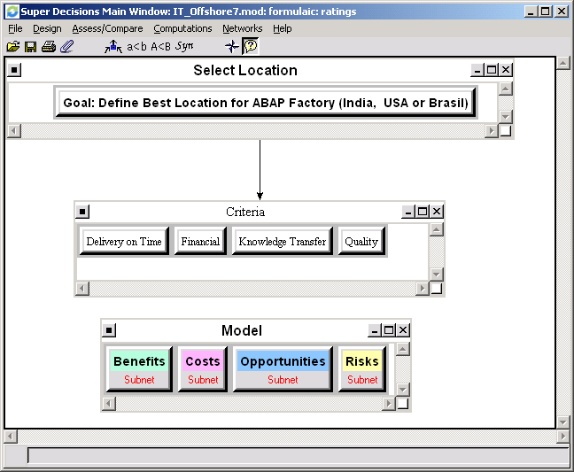
(Figure 1)

Hierarchy of Criteria for Rating Benefits, Opportunities, Costs and Risks
The four merits of BOCR were rated according to five intensities listed below along with their priorities. The outcome is summarized in Table 1 and Table 2.

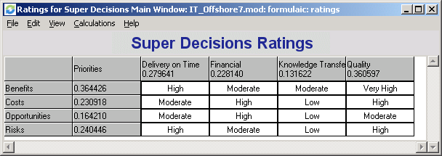
(Table 1)

Graphic | Ratings Alternatives | Total | Ideal | Normal | Ranking
 | Benefits | 0.5749 | 1.0000 | 0.3644 | 1
 | Costs | 0.3643 | 0.6336 | 0.2309 | 3
 | Opportunities | 0.2591 | 0.4506 | 0.1642 | 4
 | Risks | 0.3793 | 0.6598 | 0.2404 | 2
(Table 2)

Synthesized Results from Super Decision program

By using Super Decisions program, we obtained the synthesized results regarding Benefits, Opportunities, Costs, Risks and the final result of the whole model. The results are illustrated from Tables above FROM 3 to table 6.

Report for Benefits (Table 3)
Graphic | Alternatives | Total | Normal | Ideal | Ranking
 | Brazil | 0.7378 | 0.3612 | 0.9018 | 2
 | India | 0.8181 | 0.4005 | 1.0000 | 1
 | USA | 0.4867 | 0.2383 | 0.5949 | 3

Report for Benefits->Control
Graphic | Alternatives | Total | Normal | Ideal | Ranking
 | Brazil | 0.2970 | 0.5940 | 1.0000 | 1
 | India | 0.1151 | 0.2301 | 0.3874 | 2
 | USA | 0.0880 | 0.1759 | 0.2962 | 3

Report for Benefits->Financial
Graphic | Alternatives | Total | Normal | Ideal | Ranking
 | Brazil | 0.1653 | 0.3305 | 0.9013 | 2
 | India | 0.1833 | 0.3667 | 1.0000 | 1
 | USA | 0.1514 | 0.3028 | 0.8258 | 3

Report for Benefits->Technical
Graphic | Alternatives | Total | Normal | Ideal | Ranking
 | Brazil | 0.1338 | 0.2676 | 0.5439 | 2
 | India | 0.2460 | 0.4919 | 1.0000 | 1
 | USA | 0.1202 | 0.2405 | 0.4888 | 3

Report for Costs (Table 4)
Graphic | Alternatives | Total | Normal | Ideal | Ranking
 | Brazil | 0.5529 | 0.2281 | 0.5830 | 3
 | India | 0.9224 | 0.3806 | 0.9727 | 2
 | USA | 0.9483 | 0.3913 | 1.0000 | 1

Report for Costs->Financial
Graphic | Alternatives | Total | Normal | Ideal | Ranking
 | Brazil | 0.0950 | 0.1899 | 0.4447 | 3
 | India | 0.1915 | 0.3829 | 0.8965 | 2
 | USA | 0.2136 | 0.4271 | 1.0000 | 1

Report for Costs->Image
Graphic | Alternatives | Total | Normal | Ideal | Ranking
 | Brazil | 0.1643 | 0.3286 | 0.8775 | 2
 | Índia | 0.1872 | 0.3745 | 1.0000 | 1
 | USA | 0.1485 | 0.2970 | 0.7930 | 3

Report for Opportunities (Table 5)
Graphic | Alternatives | Total | Normal | Ideal | Ranking
 | Brazil | 0.5119 | 0.2688 | 0.5652 | 2
 | Índia | 0.9057 | 0.4755 | 1.0000 | 1
 | USA | 0.4870 | 0.2557 | 0.5377 | 3

Report for Opportunities->Economic
Graphic | Alternatives | Total | Normal | Ideal | Ranking
 | Brazil | 0.2330 | 0.4660 | 1.0000 | 1
 | India | 0.1671 | 0.3342 | 0.7172 | 2
 | USA | 0.0999 | 0.1998 | 0.4289 | 3

Report for Opportunities->Technological
Graphic | Alternatives | Total | Normal | Ideal | Ranking
 | Brazil | 0.0751 | 0.1501 | 0.2678 | 3
 | India | 0.2803 | 0.5605 | 1.0000 | 1
 | USA | 0.1447 | 0.2893 | 0.5161 | 2

Report for Risks (Table 6)
Graphic | Alternatives | Total | Normal | Ideal | Ranking
 | Brazil | 0.3484 | 0.1821 | 0.4130 | 3
 | India | 0.8437 | 0.4410 | 1.0000 | 1
 | USA | 0.7209 | 0.3768 | 0.8545 | 2

Report for Risks->Competitors Reaction
Graphic | Alternatives | Total | Normal | Ideal | Ranking
 | Brazil | 0.3125 | 0.6250 | 1.0000 | 1
 | India | 0.0682 | 0.1365 | 0.2184 | 3
 | USA | 0.1192 | 0.2385 | 0.3816 | 2

Report for Risks->Cultural Conflicts
Graphic | Alternatives | Total | Normal | Ideal | Ranking
 | Brazil | 0.0466 | 0.0932 | 0.1856 | 3
 | India | 0.2511 | 0.5022 | 1.0000 | 1
 | USA | 0.2023 | 0.4046 | 0.8058 | 2

Final Result of Whole Model (Table 7)

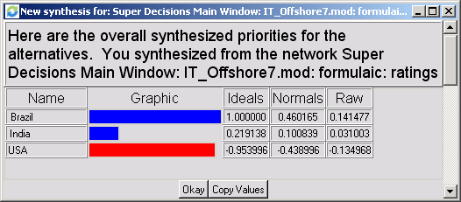
(Table 7)

Sensitivity Analysis

From the sensitivity graph for each of the BOCR node, we had the following results.
- If the changes in the priority of Benefits increases best alternative could change to India
- The increase of Cost priority will not change the final outcome of Brazil decision it will be always the best option. It has the lowest cost.
- The increase of Opportunities priority will not change the India as the best alternative
- The increase of Risks priority will not change the final outcome of Brazil decision it will be always the best option in terms of Low Risk.

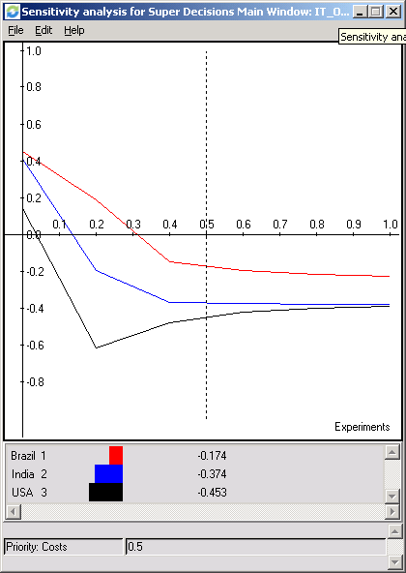
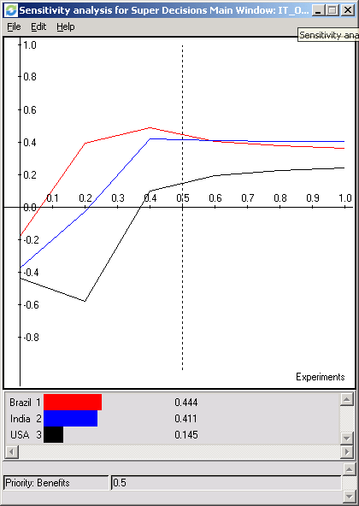
Sensitivity Analysis for Benefits Sensitivity Analysis for Costs

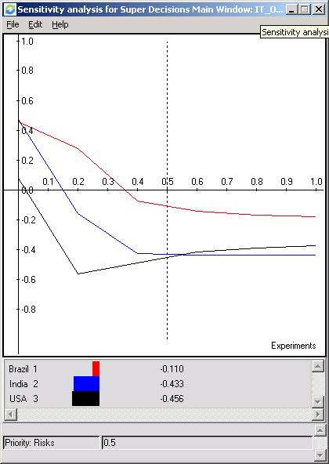
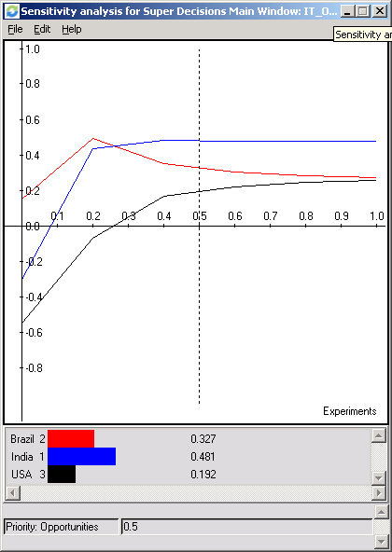

Sensitivity Analysis for Opportunities Sensitivity Analysis for Risks

Conclusion

The model results clearly support the alternative implement the ABAP Factory in Brazil, considering:
Benefits -> High control that Brazil can provide considering the communication (same language and culture) and time zone positive aspects (no differences between the Business Analysts and Programmers.

Costs --> Brazil has a low cost comparing with US and India. A low sunk cost will be needed considering that there is already a infrastructure implemented in Brazil.
Opportunity --> Although India has the higher opportunity, the model shows that the weight of this factor doesn’t interfere in the final decision.
Risks --> There is lower risk for Brazil comparing with the US and India. Mainly considering the Cultural Conflicts.

