Best strategy to deal with the refugees

Group:
- Bernhard Leibel
- Vitali Lebsack
Course: BQOM2521 Decision making in complex environments
Date: 19.04.2016

Abstract

Germany is currently facing one of the biggest challenges since over two decades. These are closely intertwined with the fate of Syria and its civil war that is raging since 2011. In 2015 over one million refugees from Syria and other hot spots of the world arrived in Germany on their long search for shelter. And there are eleven million Syrian people more on the run – many of them also heading for Germany and other European countries. In this paper we share the view with the German government and try to find the best strategy to deal with the huge number of refugees still on their way to Germany. We have to decide which of four strategies would be the best for the German people that we serve, the entry countries (that are the first European point of contact for the refugees) and for Europe as a whole. In doing so, we must take into account a lot of different external and internal factors. To handle this complex decision making situation we use the Analytic Hierarchy Process (ANP) developed by Thomas L. Saaty and the Super Decisions software tool that implements the use of the ANP approach. We create a complex BOCR (benefits, opportunities, costs and risks) model which incorporates all the information that is crucial for this decision. Our analysis shows that the best strategy to deal with the huge amount of refugees would be to force a European solution. This would be both the best short-term and the best long-term solution. Furthermore our analysis shows that this decision outcome is relatively stable even when changing some of the parameters.

Introduction

The initial event for the big getaway was the Arab spring in 2011when young people in some Arabic countries like Tunisia, Egypt or Syria tried to start a revolution against the totalitarian regimes in their countries. In Syria this movement had serious consequences even until today. The country is facing a severe civil war that is lasting since over five years and took a lot of lives. Most of the big cities throughout the country are destroyed and more that the half of Syria’s population is on the run (12 million people – four million have already left the country, the other eight million people are on the run within Syria). One of the consequences of this chaotic situation is the rise of a terroristic organization that calls itself ISIS (Islamic State in Iraq and Syria). Fully utilizing the chaos in Syria and the disruption of Iraq and under the false pretenses of religion they have occupied a relatively big part of Syria and Iraq and are terrorizing the people who live there. In addition to that a lot of clouded young Muslims from Europe went to Syria and Iraq to fight for ISIS. But ISIS does not limit its terror to the occupied countries. They committed several terroristic attacks in Turkey and Europe. Some of the most severe attacks happened throughout the last six months when young ISIS fighters smuggled themselves in into big European cities like Paris and Brussels and killed hundreds of innocent people before killing themselves. This leads to fear among the European population that more terroristic attacks are still to come and that ISIS could use refugees as a Trojan horse so send even more terrorists to Europe.
Because the terror and war are far more severe in Syria than in Europe, millions of Syrian refugees are heading to Europe and hope to find shelter there. Most of them are dreaming of a peaceful life in Sweden or Germany. In their desperate situation many of them pay criminal traffickers who exploit these people by taking a lot of money from them, putting them on small, crammed boats and sending these boats across the Mediterranean Sea. Many of the refugees drowned on their way to Europe because the crammed boats became instable in the rough Sea. And those who arrive in the European entry countries like Greece or Italy are put into crowded reception camps where they have to wait for a long time because Europe is unable to cope with these masses of people. Unrests are a daily occurrence in these camps.
Two years ago some refugees found a route through Turkey over the Balkan and Austria. Since then over one million people used this route to reach their destinations in Europe. All the countries on this way could not handle the masses of people so the biggest part of the refugees coming through this route have not been registered or even checked for security issues. Many of them even had no passes. Furthermore there are rumors that a lot of the refugees have destroyed their passes with intent so no one could check whether they are from Syria, Afghanistan or another country hoping that they will be granted asylum when they pretended to be refugees from Syria. Some rumors even say that a lot of these people moving to Europe have faked passports. These rumors alarmed a lot of people especially in Germany where the most of the immigrants arrived. During the year of 2015 over one million refugees came over the Balkan route to Germany (this number is more than 1% of the German population). On some days more than 10,000 unregistered and unchecked people passed the German boarders. Many German volunteers welcomed the refugees, gave them something to eat and to drink, some things for the basic needs etc. But there are a lot of people in Germany that are fearful because of the masses of refugees, the terrorist attacks and the Muslim religion of the arriving refugees that differs from the mostly Christian religions in Germany. They argue that our social system will break down when too many people move to Germany and that the Muslim religion and its believes does not fit into the German lifestyle and the way of thinking and conflicts with the most important cornerstones of the German “culture” like gender equality, freedom of speech, religious freedom etc.
Unfortunately lately there have been some incidents that seem to confirm those skeptics. One of these incidents happened on New Year's Eve 2015/2016 in Cologne where hundreds of young, drunk males (many of them indeed unfortunately happened to be Muslim refugees) gathered near the central railway station and harassed young women who were just passing by (some of them even say they have been raped). The German police that was present did nothing to safe the women because there were too few police men around. This was a big scandal in the beginning of 2016 and divided the German people even further into the ones that still want to help the refugees and those who are afraid of them. A lot of controversial discussions are going on in Germany right now and lead to surprising election results. Just some weeks ago there have been elections in some of the German “states” where a new party called AfD (Alternative für Deutschland) gained a significant part of the votes. Four years ago this party did not even exist and now they get nearly 25% of the votes in Sachsen-Anhalt and over 15% of the votes in Baden-Württemberg (one of the biggest “states” in Germany). Why are they getting so much attention? The reason is that they say they are against the European Union and against letting Muslim refugees in. The parties of the current German government (SPD and CDU/CSU) had significant losses in these elections. Some people say the reason is the bad strategy (or even a lack of a strategy) regarding the refugees coming to Germany. 2017 will be the big election year in Germany where the new German government will be elected.
But not only Germany is divided. Even Europe seems to be divided too. Somehow surprised by the masses of refugees that are coming to Europe over the Balkan route some countries like Hungary started to build fences to prevent the refugees to move through their country. Other countries like Poland refuse to welcome refugees at all. Some other countries set a maximum limit of refugees that they can accept a year e.g. Austria said they only can give asylum to 37,500 people a year which is extremely small compared to the one million people arrived in Germany during 2015.
How did the German government react to the masses of refugees? First of all they said that Germany is a country that has an increased responsibility concerning persecuted people due to the holocaust during the 3rd Reich. Because of this history and our constitution we have to help people that are in need and all refugees are welcome. But they could not initiate anything to handle the huge amount of refugees coming to Germany. They tried to find a solution with other European countries but could not reach agreements fast enough. So they led the European Union into a deal with Turkey. This deal says that Turkey will take back refugees that are not accepted in the European Union and bring them back to where they come from. On the other hand Turkey will check refugees coming to Turkey on their way to Europe for security and whether they have a chance of getting asylum in Europe and send them directly to Germany and other European countries. For this service Turkey will get three billion Euros and the European Union will restart the dialogue of Turkey joining the European Union. These dialogues have been stopped some years ago because of the precarious circumstances regarding human rights, freedom of speech and other issues that were observed in Turkey. So many people view this agreement as a farce.
In this paper we try to find out whether this deal with Turkey is the best strategy for the German government to deal with the masses of refugees or whether there are other, even better strategies to cope with this situation. So the decision maker in this case is the German government facing a very complex situation with a lot of different internal and external factors that have to be considered. The goal is to find a solution that ideally fits all stakeholders (the refugees, the European entry countries that are overstrained with this situation, the German people that are divided, Europe as a whole and Turkey). We try to reach this goal by using the ANP approach, designing a complex BOCR model, feeding it with all data and judgements that are available, synthesizing the results and hopefully getting the answer to the question “What is the best strategy for the German government to deal with the refugees?”
First of all we will describe the methodology of our approach, the assumptions we made, the alternatives we considered and the control and the strategic criteria that we put into our model. This will be done in a top down manner, starting from the top level network and going down into the decision networks that are on the 3rd level.
The analysis of the results will be done the other way round. We will start at the bottom (the 3rd level decision networks) moving up and synthesizing the results until we reach the 1st level of our BOCR model. On the way up we will describe and interpret the results of each of the networks. At the end of the analysis section we talk about our findings regarding a sensitivity analysis of the results obtained through the model before we briefly sum up our findings and draw a conclusion.

Methodology and Data

Our goal designing the network was to keep the model as simple as possible yet avoid neglecting the most important parameters. We strongly believe that only by keeping the model as simple as possible we can avoid major mistakes. Therefore we had to carefully tailor all parts of our BOCR model that we will describe in this section. But before describing the structure of our network we need to lay out the alternatives we considered, our control criteria, our strategic criteria and the main assumptions we made.

The following list contains the alternatives we considered for our decision and some assumptions we made for these alternatives:

- Force European solution:
  - Although the German government already tried to reach a European solution we strongly believe that this alternative is worth trying harder. Our assumption is that the European countries can reach an agreement about which European country can take how many refugees per year and by doing this demonstrate the strength and unity of the European Union. Allocating the refugees to different countries will divide the big number of people into smaller numbers that could be handled by the European countries. Because of this, better checks of the refugees could be done regarding their background (security) and whether they have a chance of getting asylum in the EU. Demonstrating the unity of the EU will furthermore have a positive effect on the European citizens who have lost their fate in the union over the last few years (and especially on the German people who believe they only have to pay for Europe without having any advantage – see financial crisis and Greece). We also assume that even reaching such a complex agreement, Germany as one of the economically most stable countries of the union will have to bear the biggest burden – means to take more refugees that the other European countries and even pay the other countries for taking refugees. This is the downside of this alternative. Another downside is that it would take a lot of time to reach such an agreement within the European Unity and one cannot say for sure that this approach can be successful.
- Let everybody in:
  - This alternative has been practiced throughout the year 2015 when big numbers of refugees arrived in Germany. They were all welcomed and brought to reception camps. They only were checked for illnesses but not who they are, where they come from and whether they could be dangerous (terrorist background?) or not. We assume that this can only be an emergency alternative when no other alternative seems to be advantageous. This alternative bears the biggest security risk and could lead to social unrest from the German people but also from the refugees who would have to wait a long time for asylum, housing etc.
- Let nobody in:
  - This would be the approach that some European countries like Poland already practice. The German government could say that they won’t let more refugees come to Germany because we already have welcomed over one million refugees. This alternative would contradict the German and the European constitution. On the other side the German government already breached the Schengen contract by accepting all the refugees throughout the year 2015 because these are exceptional circumstances. So why not breaching contracts again in order to save the German population from bigger conflicts?
- Turkey deal (do nothing):
  - Like the alternative “force European solution” this would be a middle ground between the alternatives “Let everybody in” and “Let nobody in”. Both of these solutions will lead to a selection of refugees (internally [by the EU] or externally [by Turkey]) that will be allowed to enter the European Unity. Other “refugees” will be refused. The refugees that are allowed to enter will be better off than if every “refugee” would be allowed to enter because this will reduce the competition they will face later on when searching for a job in Germany etc. In contrast to the European solution the Turkey deal has several disadvantages. First of all Turkey by far does not meet European standards in terms of gender equality, freedom of speech, freedom of religion etc. even getting worse over the last few years. So offering Turkey to join the European Union is clearly a bad decision. Furthermore we would let this slightly “dubious” country (some rumors say that Turkey is financing ISIS by buying cheap oil from them + Turkey currently has a “war” against the Kurds) decide which refugees are allowed to come to Europe and which must stay out. This is another ethical dilemma. But could this solution also have advantages?

As we can see there is no ideal solution to this complex problem. All alternatives obviously have downsides. It is hard to tell which solution may be the best strategy for the German government to deal with the refugees and to reach a consensus that fits best for the German people, the refugees and Europe. Deciding about the best from these alternatives we use the following control criteria:

- Demographic:
  - Like many other developed countries of the world Germany is facing demographic issues that cannot be solved internally. The German population overages. More and more elder people have to be supported by fewer younger people. And the birth rates are further decreasing. Young refugees entering Germany could be a solution to this problem. So there could be demographic opportunities for Germany in accepting a big number of refugees.
- Economic:
  - Improving the demographic situation could also lead to an improvement of the economic situation when the young refugees will find a job and hence contribute to the growth of the German economy. On the other side we do not know what education the refugees have or what they are capable of. Because Germany is a very developed country, a lot of processes are automated (especially in manufacturing) and so most of the jobs require high education. If most of the refugees do not have such an education or/and are not capable or willing in gaining such an education, this could lead to a big rise of unemployed people and could cause a breakdown of the social system in Germany.
- Security:
  - There are some security issues that must be taken into account – especially after the terroristic attacks in Paris and Brussels. Germany has to be very careful not to be infiltrated by terrorists that will spread across Europe and terrorize the European citizens. Another factor regarding security is the security for the refugees. Some German people are angry about what is happening in the world (the Muslim terrorist attacks, some other incidents in Germany etc.), they are frustrated and many of them are not well educated, maybe have lost their job and are unemployed. These people are unsatisfied with their situation and this lack of satisfaction can make them see the refugees as a threat and maybe attack them (there already were such incidents). So making this decision we also have to take the security of the people into account, that come to Germany in order to find shelter.
- Social:
  - Furthermore we have to take social costs and risks into account e.g. the possibility of social unrests from the German people (when they feel disadvantaged compared to the refugees) or the refugees (when they realize that Germany is not able to cope with the big number of refugees and that Germany might not be the paradise they were dreaming of). On the other hand we have to consider social benefits and opportunities e.g. some of the refugees could help filling the gaps Germany has in nursing, home care and other important social fields.
- Cultural:
  - There could be several cultural opportunities but at the same time also risks. The refugees will surely bring more diversity to Germany enriching the German culture with new points of view, new ideas, food etc. But there is also a potential risk of a cultural clash between the mostly Christian German people and the mostly Muslim refugees.

Not all of these control criteria could be equally well applied to the four BORC merits so we have tailored each 2nd level BORC network to the most important control criteria – see description of the 2nd level networks below.

Making such a complex decision the German government in addition to the control criteria has to keep several things in mind. We modelled these things as our strategic criteria and divided them into three categories. First, the temporality of the solution. The longer it takes to get a solution the worse it is because we do not know how to manage the refugees that arrive in the meantime. We cannot just say stop to the refugees and they will stop coming to Europe until we agreed upon a strategy. This is not realistic. The other two bigger strategic criteria are ethical and political. We chose to have those as strategic criteria instead of adding them to the control criteria because we felt that these two are even more abstract and hence more intangible than our control criteria (social, economic, cultural, security and demographic). We further subdivided the political and ethical strategic criteria into the following sub-criteria:

- Elections 2017:
  - Making any decision the German government has to keep in mind that there will be elections in 2017. So they must avoid decisions which will lead to losing votes from the German people, like they did in the more local elections this year.
- Reputation in the world:
  - Another important factor for the German government should be a good reputation in the world. It has a relatively good reputation and must avoid losing it because a good reputation means more influence.
- Unity of European Union:
  - The current trend towards a disruption of the European Unity must be stopped otherwise the European Unity will have no future. The European Unity is very important for all countries it consists of because it brings stability and power (economically and diplomatically).
- Unity of the German population:
  - The unity of the German population should be one of the major concerns of the German government to prevent social unrest and political and economic instability within the country.
- Criminal trafficking:
  - Whatever decision the German government will make it must take into account the implications that the decision has for the criminal trafficking on the Mediterranean Sea etc. The goal should be to make a decision that will not favor criminal trafficking because as a consequence of criminal trafficking people (refugees) will die e.g. when crammed boats sink into the sea etc.
- Freedom of opinion:
  - This is one of the main points of the German and European constitution and one must take into account with whom one can do deals and what kind of deals on can make without breaching agreements.
- Gender equality:
  - This is another important strategic criterion because it was a long way to reach a certain degree of gender equality in Germany and we are unfortunately still not there where we want to be. We should prevent influences that would lead to a setback. So we must estimate whether and how the assimilation of mostly Muslim refugees will influence this goal (see incidents in Cologne on New Year’s Eve).
- Human rights:
  - The human rights debate is one of the most important things to keep in mind while making such a decision. The German and the European constitution grant help to those who are persecuted. We must avoid decisions that contradict this important concept. Refugees are persecuted and threatened people who have the right to live and to be happy like every one of us. We must help them somehow. The second point here is the development of Turkey through the last years. They do not accept the Kurds and are fighting them, rumors say they torture people in their prisons etc. This runs contrary to the European constitution. Take thin into account when making deals with such countries!

Now that we have described our assumptions, the alternatives we consider and our control and strategic criteria we need to examine the structure of our network. We will use the top down approach beginning at the highest level of the network and going further down to the 3rd level of our BOCR model where our decision networks reside.
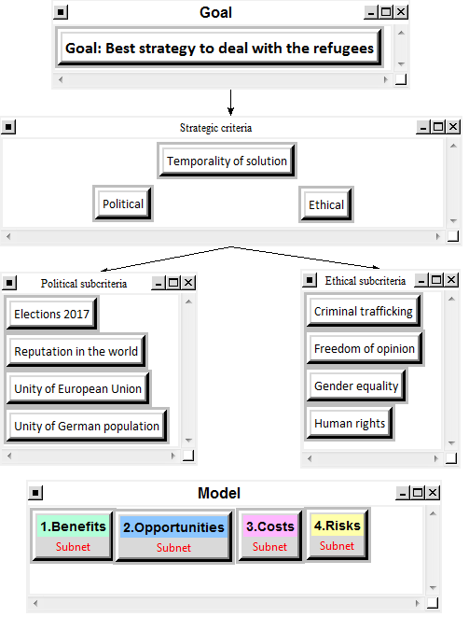
Figure 1: Top level network of BOCR model with strategic criteria

As figure 1 shows our goal is to find the best strategy for how to deal with the refugees. The goal is connected to our strategic criteria. We have three main strategic criteria. The temporality of the solution does not have any sub-criteria but the political and ethical strategic criteria are further subdivided in the sub-criteria described in the section above. So the sub-criteria clusters are connected to the strategic criteria cluster, respectively to the correct strategic criterion inside the strategic criteria cluster. At the bottom we have the BOCR (benefits, opportunities, costs and risks) cluster which has no visible connection to the goal or the strategic criteria. The connection is made through rating the BOCR merits against the strategic criteria – described later on in this document.
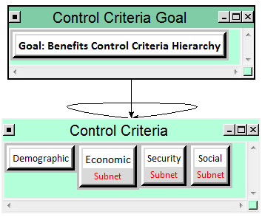
Figure 2: The benefits network

Figure 2 shows our 2nd level network for the benefits. Here we can see that our control criteria for the benefits are economic, security, social and demographic. All these control criteria (except demographic) have subnetworks that will be described later on in this document. The demographic criterion does not have a subnetwork because its priority is too low and the subnetwork wouldn’t make any difference for the synthesis of the results. As we can see from figure 3 the demographic criterion only accounts for nearly 5% of the result. It is only effective in the long run, will be more effective in the opportunities network and cannot get high priorities for immediate benefits. All the other criteria have much more impact and should have a subnetwork. As one can see from figure 3 we felt that the economic benefits should have the highest priority but Security is almost as important as the economic criterion because we as the German government have to make sure that our nation is safe and can thrive.

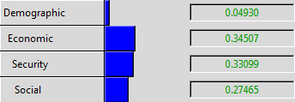
Figure 3: Priorities within the benefits control criteria network

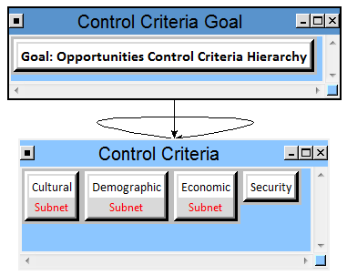
Figure 4: The opportunities network

Figure 4 shows our opportunities network. The opportunities that we see are cultural, demographic, economic and security. Because security is rather a short-term concern and the other control criteria already account for more than 80% we did not make a subnetwork for this criterion. The other three were more important for us as one can see from figure 5. The most important opportunities are the ones that are economic and demographic as described above.

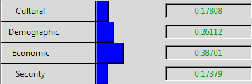
Figure 5: Priorities within the opportunities control criteria network

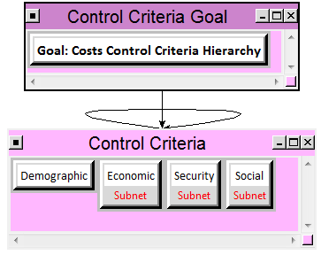
Figure 6: The costs network

The costs have the same control criteria as the benefits – compare figures 2 and 6. And like for the benefits the demographic control criteria does not have a sub-network because it accounts only for 8% of the decision – see figure 7. The most important costs are the social ones because the German people have to pay for the refugees as long as they have not been granted asylum and hence cannot work and pay taxes. So the refugees are at first a burden for the social welfare system. Another important cost criterion is security because we did not check most of the refugees that entered Germany in 2015, we do not know who they are and when we let more people in not checking them the security costs will go up because we have to place more police officers on the streets to prevent such incidents like in Cologne on New Year’s Eve.

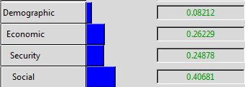
Figure 7: Priorities within the costs control criteria network

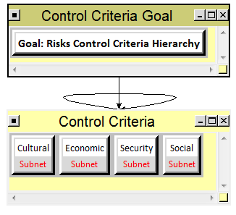
Figure 8: The risks network

In the risks network – see figure 8 – we have four sub-networks because we felt that all four control criteria are very important in terms of risks. Figure 9 shows the priorities derived from our pairwise comparisons for the control criteria. Somehow the priority of the cultural control criteria seems to be 0%. We have no explanation for that and couldn’t find a problem within the structure or within the comparisons. As figure 10 shows the cultural control criteria shouldn’t be 0%. We assume that there must be a bug in the Super Decisions software.

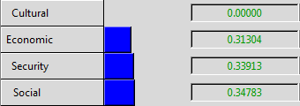
Figure 9: Priorities within the risks control criteria network

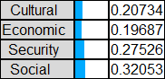
Figure 10: Pairwise comparisons for the risks control criteria

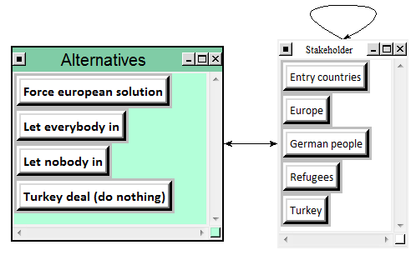
Figure 11: Decision network level 3

As we can see from figures 2 to 8 we have tailored each network to best fit our decision context and our understanding of the problem. Because of the good tailoring, our carefully selected control criteria and the relatively big amount of strategic criteria there was no need to create a complex decision network in the 3rd level because the complexity of the circumstances is already described by the levels above. Figure 11 shows the decision network that we used throughout the 3rd level of our model. In each of the single decision networks we thought about which of the stakeholders influences whom and slightly modified the connections. We put all stakeholders into one cluster because we needed to make pairwise comparisons when making connections between the stakeholders. If we would have spread the stakeholders over several clusters we would have not be able to make those comparisons. As one can see all alternatives reside inside each of the 3rd level decision networks.

Analysis and Synthesis
Analysis of the data and the synthesis of the results will be done bottom up, beginning at the lowest levels of the network synthesizing up to the top level. We begin our analysis inside the decision network for economic benefits.

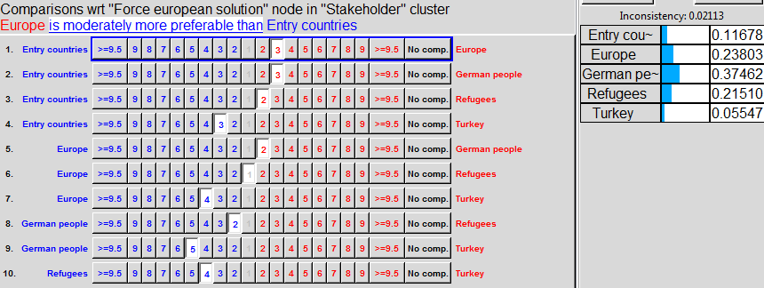
Figure 12: Economic benefits comparison “Who will benefit economically most from a European solution?”

The result of this comparison (figure 12) highlights that actually Germany is the most attractive target for refugees and therefore Germany is having the biggest cost in organizing the travel, housing, alimentation, medical supply, security etc. If the European community decides an equal delivery and equal conditions for refugees in all EU countries, Germany’s charge is going to be effectively reduced. The second winner of this alternative is nearly equal the refugees and the European Community, because a better delivery of refugees improves their job chances and will push their economic situation. The reason for Europe as a second winner is the implication of the European spirit and the European constitution in our “Stakeholder Europe”. As Germany belongs to the economically stronger countries in Europe and actually carries the biggest charge, the equalization of charges inside the community implies means of economic self-protection, similar to the support of Greece during the European debts crisis, so either the European solution or the Turkey deal would be the best solution for the German people in economic terms – see figure 13.

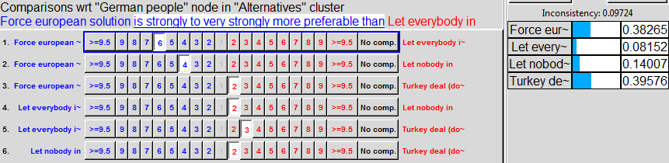
Figure 13: Economic benefits comparison “Which alternative benefits the German people most regarding economics?”

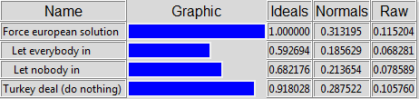
Figure 14: Synthesis result for economic benefits

Both solutions, the European and the Turkey deal, help to reduce costs rapidly – see figure 14. As the Turkey solution reduces the total number of refugees in sending back not accepted people, this solution is cost reducing and hence economically good for Germany. The result is driven by the assumption that the costs of the service Turkey is providing to Germany (and the EU) are inferior to costs generated by illegally migrating people.

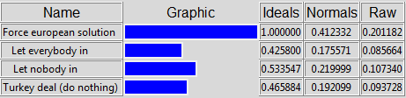
Figure 15: Synthesis result for security benefits

The main reason for this result (figure 15) is the better ratio of helping and security staff above number of refugees the more European countries help coping with the refugees. Better delivery enables much better security measures and helps to avoid panic and crime. The turkey deal cannot really improve security since the number of illegals migrating as refugee disguised people is difficult to fix. The second best solution in terms of security benefits for Germany would be to stop all people from entering Germany – which is no surprise.

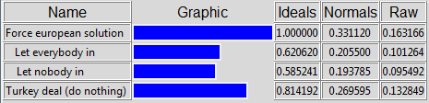
Figure 16: Synthesis result for social benefits

The leading idea during this decision (figure 16) is the definition of “social” as taking into account equal delivery of opportunities between social groups such as working population, retired persons, minorities and disabled persons. The best possibility to reach a good delivery rate of refugees is the European solution. The turkey deal is on place two, because it implies that most of the arriving refugees come to Germany leading to a high density of refugees and an increase of social gaps in the German population. Currently the Turkey deal is helping to reduce the total number of refugees and to keep the social situation stable in relation to “let everybody in”.

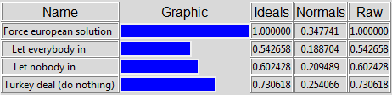
Figure 17: Synthesis result for benefits

Figure 17 shows the synthesized result for benefits that includes all partial results discussed above. All in all the result is driven by social and economic benefits comparisons. When we talk about benefits in the current emergency situation in Germany, it’s more taking a choice of the smallest evil. Real benefits do only exist for refugees and unfortunately for criminal trade. Every single decision has an aspect of avoiding the evil and pushing the good related to our values.

The next analysis step is the one for the opportunities.

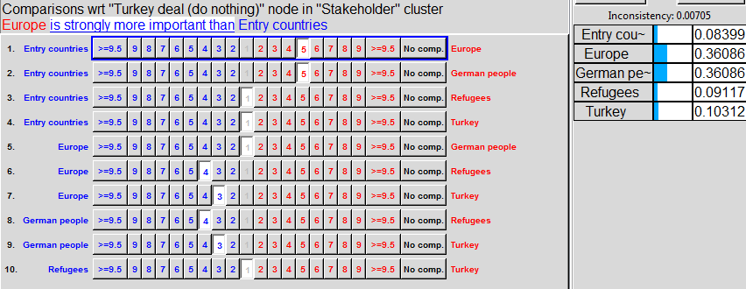
Figure 18: Demographic opportunities “Which stakeholder will have the greatest demographic opportunities when the decision would be ‘stay with the Turkey deal’?”

Figure 18 shows a small part of all the comparisons that needed to be made. In particular is shows answers to the question “Which stakeholder will have the greatest demographic opportunities when the decision would be ‘stay with the Turkey deal’?” Here we can see that Europe and the German people will have the most opportunities from this alternative. The reason behind this rating is that the Turkey deal will filter some of the refugees out that have no chance of staying in the EU and still lets enough people in who can help reduce the demographic imbalance now and in the future. We see a similar result for the alternative “force European solution” – not shown in this document.

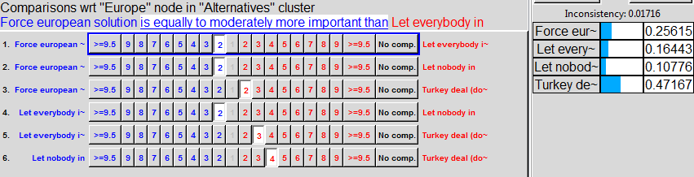
Figure 19: Demographic opportunities “Which alternative will have the best opportunities for Europe?”

Figure 19 shows that the best demographic opportunities for Europe can be reached with the Turkey deal. Because Turkey is not part of the EU they can dismiss any refugee they want. For the European solution it would be much more difficult to filter refugees out that do not fit into the scheme of the people Europe needs. This may sound cruel but this is the nature of the Turkey deal. This barbarous calculus will be diminished using the strategic criteria “Human rights” in the rating at the top level network.

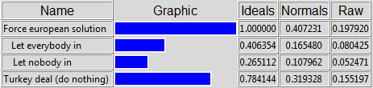
Figure 20: Synthesis result for demographic opportunities

The most optimistic approach to the refugee situation in Germany (figure 20) is the vision of a multicultural Germany with a good structure of population. This is the main reason for our favorite solution. In fact, Germany needs migration, because the actual development shows, that many families only have between zero and two children what is not sufficient for the creation of a functional social system.

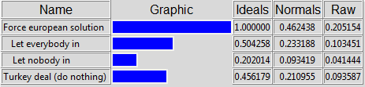
Figure 21: Synthesis result for cultural opportunities

Concerning culture, we tried to include “religion” in our decision. This makes the word “culture” very difficult to handle, because the mix of culture is a good target on one side and nurturing the own culture on the other side. We decided with the approach, that one side needs the other, because the diversity is being driven by competitive behavior. The more diversity we get, the more cultural identity will be created by each of our cultures. So it is not surprising that the European solution and “Let everybody” in are the winner in this case – see figure 21.

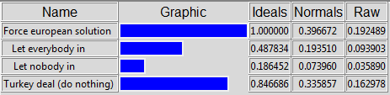
Figure 22: Synthesis result for economic opportunities

This result (figure 22) depends on the above discussed demographic approach.

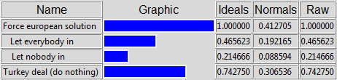
Figure 23: Synthesis result for opportunities

The overall synthesis for opportunities (figure 23) shows that the European solution again is the winner followed by the turkey deal (which is not really a solution). The Turkey deal could only collect points in being the smaller mistake in relation to the other two extreme solutions.

After analysis of the opportunities we now look at the costs.

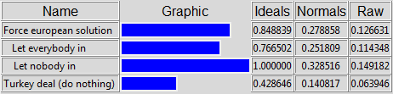
Figure 24: Synthesis result for economic costs

Sad but true. Economic thinking reduced to just money cannot help making a better world – see figure 24. This would imply that the German government would stop refugees from coming to Germany at all.

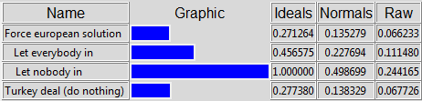
Figure 25: Synthesis result for security costs

The cheapest solution is not always the best – see figure 25. Again, the Turkey deal is only the smaller evil. This result implies the assumption that “illegal migrants” are more dangerous than “legal refugees”. This cannot be proven.

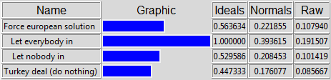
Figure 26: Synthesis result for social costs

If Germany manages the migration of refugees without the help of the European Community, social gaps will increase – see figure 26. The turkey deal is the winner in this case and implies the advantage of reduction of criminality.

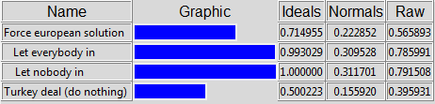
Figure 27: Synthesis result for costs

The complete costs are going to be maximum for both extreme solutions – see figure 27. As we are in the European Community, in the long run national challenges are European ones. If a problem is really important, it cannot be one nation’s problem. Sooner or later Europe is responsible for all kind of costs each nation has to carry. The good result of the Turkey driven by security thinking.

And last but not least the analysis of the risks:

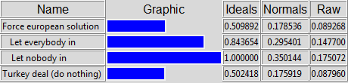
Figure 28: Synthesis result for cultural risks

These results (see figure 28) are driven by the same motivations as cultural opportunities above. Again, the two extreme solutions give the worst results. Important for cultural diversity is a good mix of cultures. This balance can be disturbed in both cases, if Germany won’t get enough migrating young people or if too many Germans will have Syrian roots.

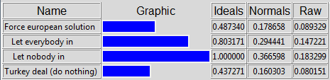
Figure 29: Synthesis result for economic risks

The vision that “let nobody in” will be as expensive or more than “let everybody in” is based on the long run thinking and the responsibilities of Germany and Europe in the world community. Certainly both extreme solutions imply economic disadvantage in Europe – see figure 29.

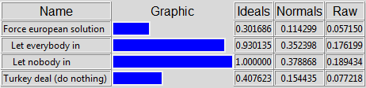
Figure 30: Synthesis result for security risks

Looking at the circumstances in refugee camps and housings in Germany, both extreme solutions rise the security risk in Germany and Europe. The Turkey deal is not really better than the European solution (see figure 30) it is just driven by fear of terrorism.

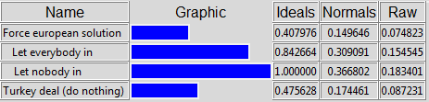
Figure 31: Synthesis result for social risks

Figure 31 shows the same approach as for social opportunities.

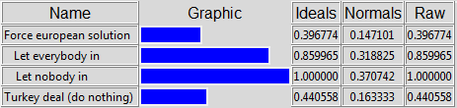
Figure 32: Synthesis result for risks

Both extreme solutions have a high risk impact (see figure 32). The unequal mix of cultures and social groups and the concentration of too many people of different cultures and religions will result in economic, social, cultural and security risk.

Now we have synthesized all decision networks up to the 2nd level and have the best results for benefits, opportunities, costs and risks. These results must now be synthesized to get the overall result of the decision network. Before we can do this, we have to rate the strategic criteria by making pairwise comparisons – see figure 33 for some of the pairwise comparisons we made.

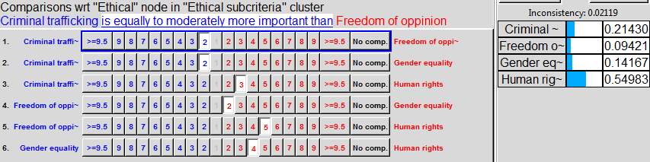
Figure 33: Pairwise comparison for the ethical strategic sub-criteria

Figure 33 (pairwise comparison of the ethical strategic sub-criteria) shows clearly that while deciding the fate of refugees and German people the German government must first of all take into account the most important point of the German and the European constitution – the human rights! The second priority should be stopping criminal trafficking because people die when the criminals won’t be stopped. This point is related to the human rights somehow.

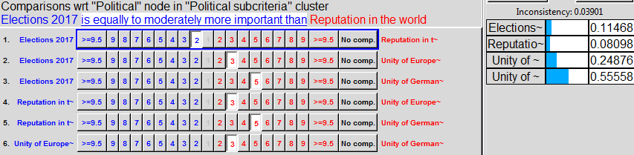
Figure 34: Pairwise comparison for the political strategic sub-criteria

Figure 34 shows our pairwise comparison of the political strategic sub-criteria. The unity of Europe seems to be the most important point maybe because when Europe is united, so will the German people too. The second most important point is the unity of the German people to preserve social unrest. It looks like we do not care much about the reputation in the world (maybe because we have a relatively good reputation at the moment). The elections 2017 are still a point but shouldn’t be that important because we are deciding the fate of people and people are (or at least should be) more important than politics and elections.

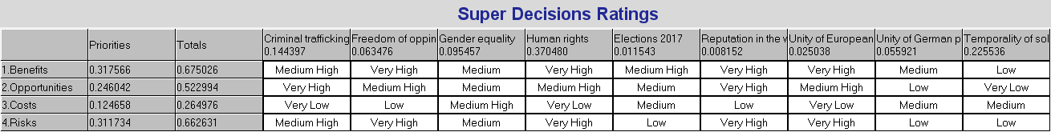
Figure 35: Ratings of the BOCR alternatives against the strategic criteria
Figure 35 shows the ratings of the strategic criteria against the BOCR merits. Here we can see that we rated the benefits for freedom of opinion as very high, also very high rated are the human rights regarding the benefits. The other elements are rated accordingly and should be self-explanatory.

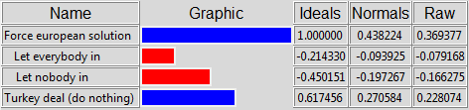
Figure 36: Decision network synthesis result for the additive (negative) formula => the best long-term alternative

Figure 36 shows the overall BOCR network result for the additive (negative) formula. This is the best long-term result. As we can see (and have expected somehow) the European solution is the best alternative even considering that it would take longer to reach a common ground with all other European countries.
Somewhat surprising is that the Turkey deal is our second best alternative. This is due to the relatively low costs (in terms of money) and a substantial gain of security compared to the worst alternative to let everybody in.
As hindsight we can conclude that the strategy of the German government to let everybody in (in 2015) was a bad decision. As foresight we may conclude that the Turkey deal may be a temporal solution until the European solution has been developed – we hope so.

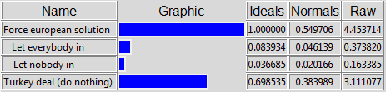
Figure 37: Decision network synthesis result for the multiplicative formula => the best short-term alternative

The multiplicative formula (short-term solution – see figure 37) shows similar results as the additive formula. But compared to figure 36 the Turkey deal is even more attractive in the short term. This supports our conclusion that the Turkey deal may be just a short-term interim solution. To let everybody in is the worst decision even in the short-term.

To ensure the stability of the outcome of our analysis, we conducted sensitivity analysis for the BOCR merits.

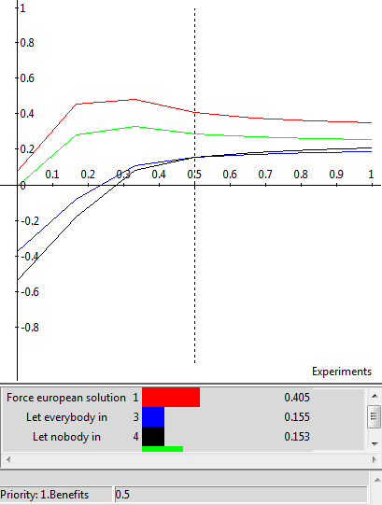
Figure 38: Sensitivity analysis with respect to benefits

The rank remains mostly the same regardless of the priorities of benefits – see figure 38. As the priority of benefits increases over 0.6 there is a priority inversion for the alternatives “Let everybody in” and “Let nobody in”. Not to let anybody in gets more preferable. But the best solution in terms of benefits is always the European solution.

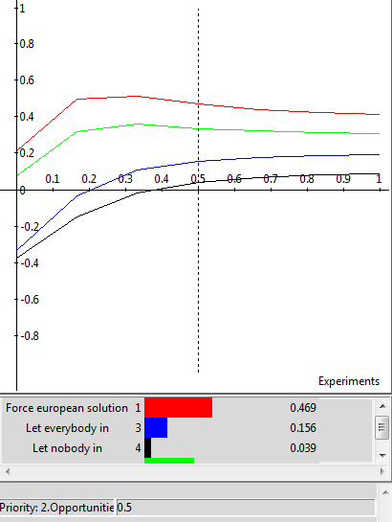
Figure 39: Sensitivity analysis with respect to opportunities

As figure 39 shows the rank remains the same regardless of the priorities of Opportunities.
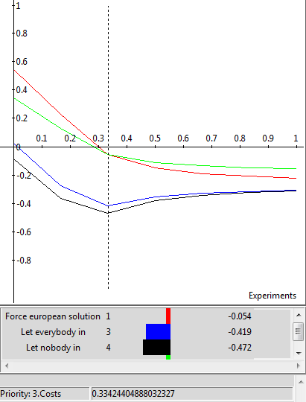
Figure 40: Sensitivity analysis with respect to costs

The Turkey deal becomes the more preferred alternative as the priority of costs increases over 0.334. It’s like we said in the analysis, the Turkey deal can be the cheaper one but it doesn’t make it right anyways.

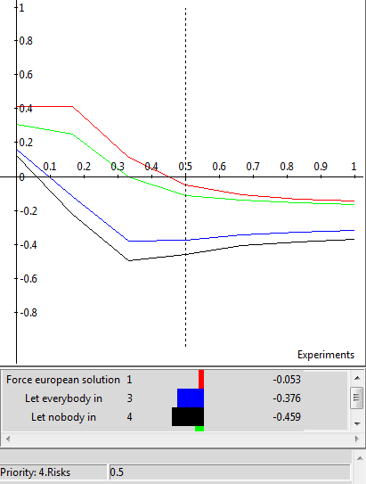
Figure 41: Sensitivity analysis with respect to risks

Figure 41 shows that the rank remains the same regardless of the priorities of Risks. The European solution is always the best solution regarding the risks although the Turkey deal becomes nearly as good as the European solution the more the priority of risks reaches 0.9 or higher.

We also conducted a sensitivity analysis for the 2nd level BOCR networks but there were no other findings than those described above. Our sensitivity analysis indicates that the final ranks of the alternatives might change from European solution to Turkey deal when costs are getting more important. The outcome is relatively stable and the German government should choose the European solution because it is the best alternative in the short- and in the long-run.

Summary and Conclusion

To find the best strategy for dealing with the refugees from the standpoint of the German government we build a complex ANP BOCR model. Our alternatives were to force a European solution, to exclude the refugees from coming to Germany, to let everybody come to Germany as they like or the status quo – the Turkey deal. After examining the various benefits, costs, opportunities and risks regarding to control criteria like economic, security, social, demographic and cultural we found out that the European solution would be the best alternative for the short- and for the long-term. The Turkey deal gets more attractive as the costs become more important. Because of this analysis we advise the German government to take the status quo (the Turkey deal) as a short-term temporarily solution and try to force a European solution for the refugees. This will be best for all stakeholders and will ensure a strategy for the future in case a tragedy like this happens again and millions of people need a shelter.
Some points that need further attention and examination are:
- The 0% priority for the cultural control criteria in the risks network. We should find out whether this is software bug in the Super Decisions software or an issue with our model.
- The different results of the Super Decisions model and our Excel sheet – see Appendix. Why are there differences?

References
- https://www.bundesregierung.de/Webs/Breg/DE/Themen/Fluechtlings-Asylpolitik/4-FAQ/_node.html?id=GlossarEntry1671930
- https://www.bundesregierung.de/Content/EN/Reiseberichte/2016/2016-03-16-europaeischer-rat-maerz.html?nn=709674
- http://www.bamf.de/SharedDocs/Anlagen/DE/Publikationen/Flyer/flyer-schluesselzahlen-asyl-halbjahr-2015.pdf?__blob=publicationFile
- http://www.tagesanzeiger.ch/ausland/europa/EU-verpasst-bescheidene-Ziele/story/16331547
- https://en.wikipedia.org/wiki/Syrian_Civil_War
- http://de.statista.com/statistik/daten/studie/1239/umfrage/aktuelle-arbeitslosenquote-in-deutschland-monatsdurchschnittswerte/
- http://de.statista.com/statistik/daten/studie/1223/umfrage/arbeitslosenzahl-in-deutschland-jahresdurchschnittswerte/
- https://www.amnesty.org/en/what-we-do/people-on-the-move/
- http://www.welt.de/politik/deutschland/article146452109/Die-Fluechtlingskrise-aus-der-Perspektive-des-Jahres-2017.html
- http://www.handelsblatt.com/politik/deutschland/fluechtlinge-in-deutschland-bayern-bereitet-sich-auf-moegliche-grenzschliessung-vor/13025054.html
- http://www.handelsblatt.com/politik/deutschland/gastbeitrag-von-dagmar-woehrl-fuenf-schritte-zur-loesung-der-fluechtlingsfrage/11678706.html
- http://www.lpb-bw.de/fluechtlingsproblematik.html
- http://info.kopp-verlag.de/hintergruende/geostrategie/michael-morris/das-fluechtlingsdrama-laeuft-nach-plan-auf-dem-weg-in-die-neue-weltordnung.html
- http://info.kopp-verlag.de/hintergruende/deutschland/peter-harth/deutschlands-fluechtlingsproblem-das-schweigen-ueber-die-importierte-gewalt.html
- http://www.zeit.de/politik/ausland/2016-01/fluechtlingspolitik-oesterreich-reinhold-mitterlehner-beschraenkung
- http://www.focus.de/politik/deutschland/asylpolitik-im-vergleich-so-gehen-andere-laender-mit-fluechtlingen-um_id_4866879.html
- http://www.zeit.de/politik/ausland/2016-03/eu-gipfel-tuerkei-abkommen-fluechtlinge-angela-merkel

Appendix
Figure 42: Bottom-up synthesis for the decision making network from Excel sheet

With the synthesis in the Excel sheet we get the same result but not quite the same numbers. We couldn’t find out what the problem was.

