Decision Making in a Complex Environment
BQOM 2521

Final Report: Municipal Park Upgrades
Benefits, Opportunities, Costs, & Risks

Submitted to: Dr. Elena Rokou

Submitted by:
Stephen Kralik

Table of Contents

Background ……………….………………………………………………………….………… 3
Decision Point, Perspective, Alternatives ……………………………………………………… 3
Strategic Criterion…………………..…………………………………………...……………… 4
Control Criterion…………………..…………………………………………..…………...…… 5
Benefits…………...………..……………………….……………….…………...…… 5
Opportunities …...………..………………….…..………………….…………...…… 8
Costs………………..……………………………………………….…………...…… 10
Risks……………....………..….;;………………………………….…………....…… 12
Model Summary ………….……………………………….………….……………….......…… 14
Final Results ………………..………………………………………………….…..…......……..14
Priorities……...…………….……………………………………….……….…...…… 17
Synthesized Results ………………………………………….………………..........… 18
Sensitivity Analyses…………………………….;………..….………………......…… 19
Works Cited ………………..………………………………………………….…..…......……..24

Background:
Recently, the township that I live in sent out a notice to all residents in the local community requesting their input on a list of potential upgrades to the local park. The municipal park is currently is a scenic, local park, but lacks the allure of more modern parks. Currently, the park contains crushed stone walking trails, a dog park, pond, ball fields, tennis, volleyball, pavilions, etc.; however, it lacks some of the modernized amenities that some of the larger parks have. The township, in general, is supposed to be a peaceful, suburban setting that is further away from the city but still within reach. According to the township, part of their mission statement is to create recreation areas while fostering safe and orderly development and long-term future growth of the community (www.penntwp.org). The current municipal park would benefit from some smaller upgrades, like paving the walking trails, and would not necessarily bring in extra crowds or offset the home-style feel. Alternatively, adding an amphitheater and wedding gazebo, may increase foot traffic and transform the park into something it was not originally intended to be. The latter would affect the community and especially the nearby neighborhoods that use the park regularly for its low-key walking trails and other relaxing activities.

Decision Point, Perspective, Alternatives

The township is currently considering all the above stated projects and is currently asking for input on their suggested modifications. The main decision point that will be addressed is whether the township should update the municipal park. The perspective in which the decision point will be addressed is that of the township officials. There are several alternatives that the municipality can consider. The first is to upgrade the park with their initial proposed changes. These changes include adding in an amphitheater next to the pond. This space could then be rented or potentially leased for personal events. Additionally, the gravel walking trails would be paved, and a wedding gazebo would be built that could also be rented to weddings and other special events. The next alternative is to upgrade the park, but with only non-invasive upgrades. This approach would be a happy medium between not upgrading the park at all and upgrading the park with all the proposed changes. Some of the minimally invasive upgrades would include those that maintain the peace and serenity of the current park, such as paving the walking trail, adding the nature pavilion, and adding the exercise stations that surround the park. These changes would not greatly increase the foot traffic of the park by drawing in visitors from other communities; however, those living in the area could enjoy the community more. The last alternative is to not upgrade the park at all. Not upgrading would result in no changes to the current park. The park would therefore remain a peaceful place; however, it would not have as many events and activities, and may not be quite as enjoyable for the everyday park goer.

Strategic Criterion

The first strategic criterion that will be addressed is community development. This includes how the proposed changes will contribute to the development of the current community. The second strategic criterion is the surrounding neighborhoods. Adding additions to a current park can have ripple effects on the surrounding areas. The next is the township impact, such as the stores and any increased traffic, followed by political impact, as updating a park would help to increase a candidate’s platform on their political campaign. The last strategic criterion is security. This is because adding additions to a park that could potentially bring in additional visitors, not only to the community park, but also into the surrounding area and may lead to the need for additional police presence or surveillance.

Control Criteria

The control criteria are comprised of the benefits, opportunities, costs, and risks.

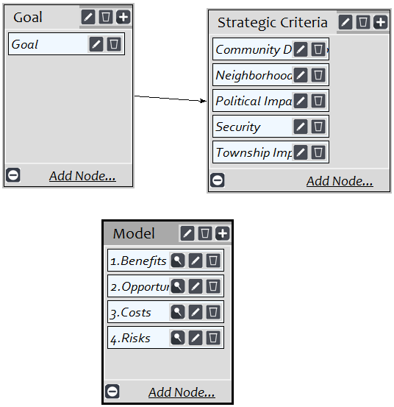

Benefits

For benefits, one of the subnetworks include the economic impacts. These include home value, Jobs, and Revenue for the residents and businesses in the community. Increasing home value can be influenced by the modifications to the park, so long as they are those that make people want to live close to the park. Additionally, adding modifications would create jobs for those that are tasked with completing the modifications, and call for the need for additional park maintenance workers. Lastly, the upgrades could result in a higher local revenue provided by more local businesses, drawing in more customers that are now funneling through the area.

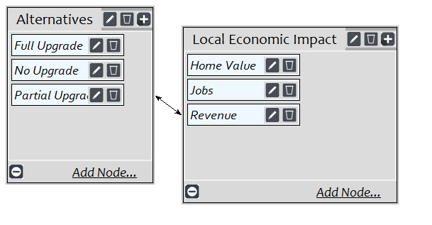

For the political subnetwork, the benefits include community relations and maintaining a relatively low-crime environment. Community relations can be boosted by leveraging the park upgrades as a political accomplishment for those in which the politician wants to represent. Additionally, the politicians would be highly affected by the increase or decrease in crime that the additional foot-traffic at the park may bring.
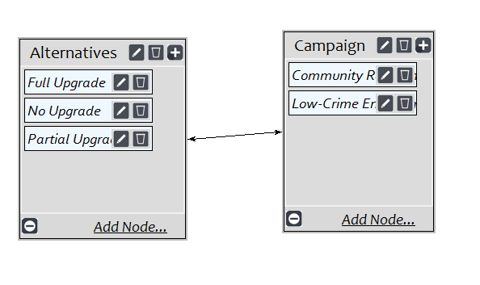
Lastly, there is the social subnetwork for benefits. These include mental health, physical fitness, and community satisfaction. These options provide more opportunities for people to enjoy outdoor gatherings, more activities for the local community, and healthy alternatives. This could be for both those who regularly enjoy indoor exercise, and those who wish to be more active.
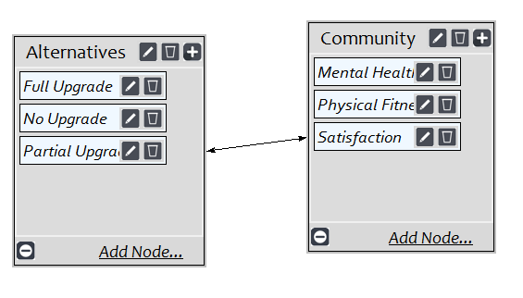

Opportunities

For the opportunities control criteria, the first subnetwork includes the economic opportunities. These include housing development because of more developers wanting to build desirable homes close to a popular community park and local gross domestic product from sustained increased revenue that is a result of more people visiting the area.
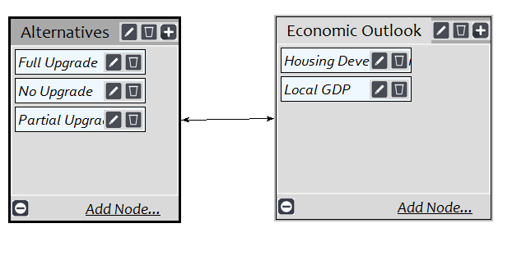
The next subnetwork is political, which includes political accomplishments and reelection. This is the opportunity for politicians to stay relevant by supporting a park that residents are excited to visit. How a politician handles project and dissects what the needs of the community are with ultimately assist with reelection opportunities.
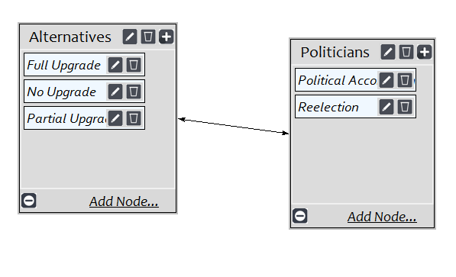
The last subnetwork includes the social opportunities. These include childhood development, higher quality recreation in the area, and improved wellness.
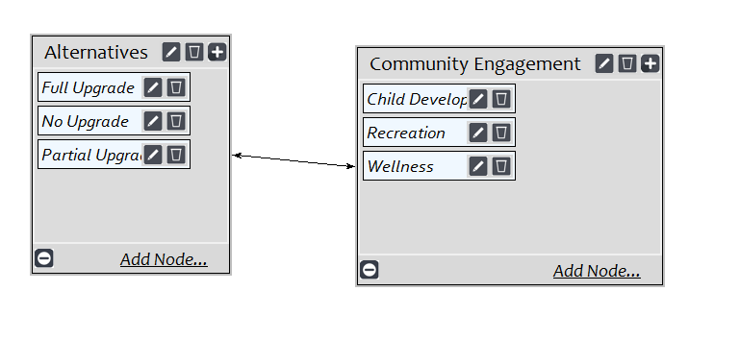

Costs

For the cost control criteria, the first subnetwork is the financial costs. The risks include the restricted COVID budgeting constraints. Also, an associated opportunity cost as a dollar spent on this park upgrade is a dollar not spent on an upgrade that could potentially add more value to the township officials.
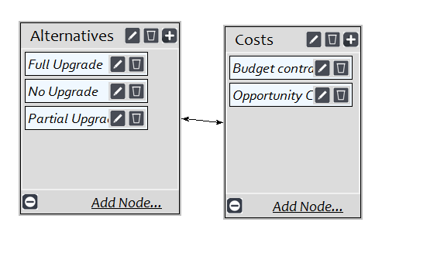
The next subnetwork is political. This includes job loss and taxes. If the project is unsuccessful, this could result in the hired or elected officials losing office, which could greatly impact the community. Currently, the township is lower than the state average in terms of cost of living by county (www.bestplaces.net). If taxes were to increase and living in the local community becomes less desirable, this could affect the local politicians’ chances of being reelected.
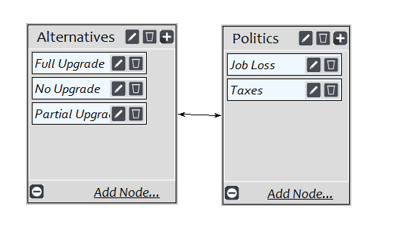
The last subnetwork is social, including taxpayer distrust and traffic congestion. Individuals could find that the upgrades to the park did not meet their expectations. This could lead to distention and distrust as to how the taxpayers’ money is being spent. Additionally, a very large cost would be increased traffic congestion through the area, while the benefits of the increased congestion may outweigh the costs, traffic congestion may result in parking lot expansions or even change of traffic patterns that would have an affect on the community and its residents.
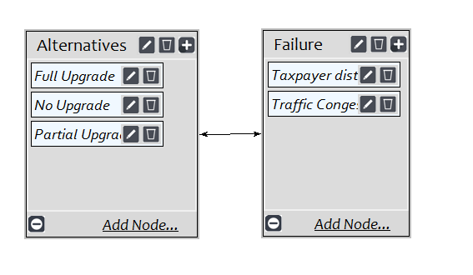

Risks:

Lastly, there is the risks control criteria. The first subnetwork is financial. These include the potential increased maintenance costs of the proposed upgrades and a longer-term opportunity cost. If the park were to run over budget or find that maintaining the upgrades proves to be costly, taxes could be raised in the local community, which could in-turn, make the surrounding neighborhoods less desirable. Additionally, longer-term opportunity costs may arise since we are unable to know how long the COVID-19 budgetary constraints will last.

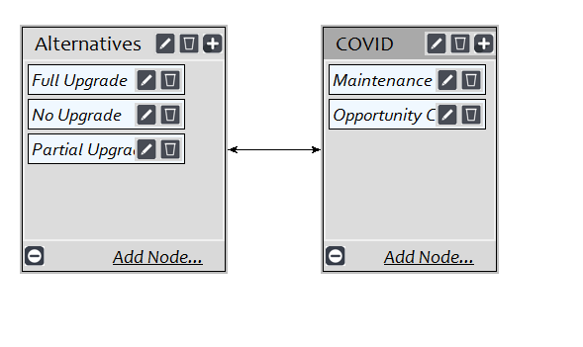
The next subnetwork includes political risks, such as changing community dynamics which is a potential drawback from transforming the park into something that does not align with the community image and fluctuating crime levels due to more people being drawn to the park, and thus creating divisiveness on the direction in the community.
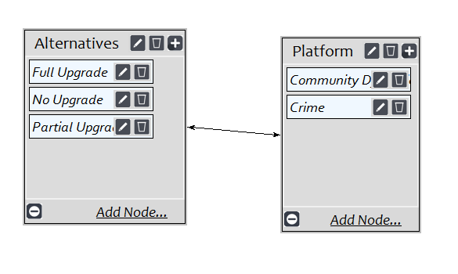
There is also the social subnetwork. This includes changes to the community dynamics. If more people are visiting the park, there is the risk of the changing dynamics in a negative way and thus decreasing the park image. Larger additions would lead to a larger gathering of people. The park may become viewed as a commercialized park and not a low-key scenic area.
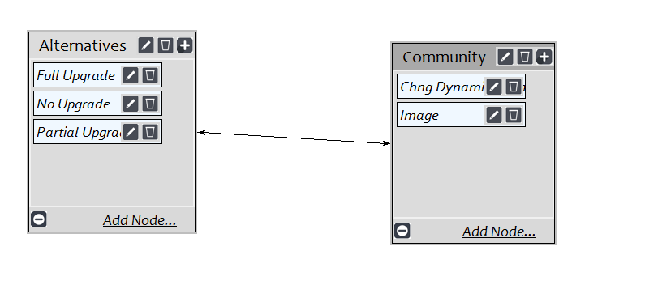

Model Summary

To summarize the structure of the model, the main decision analyzed was regarding whether the township should update the local park to include an array of upgrades that include those that would please the local community while still maintaining the current peaceful atmosphere, all the way to those that would bring in visitors from other townships. The alternatives addressed included upgrading the park with all the proposed changes, upgrading the park with only the minimally invasive changes, or not upgrading the park at all and leaving the park as is. The strategic criteria were then ranked from most important to least important, and included community development, the surrounding neighborhoods, the township impacts, political impact, and security. From there, the subnetworks of the control criteria were analyzed to look at the benefits, opportunities, costs, and risks of each.
Should the township proceed with upgrades to the park?

Risks
Costs
Opportunities
Benefits

Political
Social
Financial

Social
Political
Financial
Social
Political
Economic

Economic
Social
Political
Community Dynamics
Community Dynamics
Maintenance Costs
Taxpayer Distrust
Job Loss
Budget Constraints
Childhood Development
Political Accomplishments
Housing Development
Mental Health
Community Relations
Home Value
Image
Crime
Opportunity Costs
Traffic
Taxes
Opportunity Costs
Recreation
Reelection
Local GDO
Physical Fitness
Low-crime Environment
Jobs
Wellness
Community Satisfaction
Revenue

Final Results

Looking at the individual profiles of the Benefits, Opportunities, Costs, and Risks, we can clearly see that Economic and Financial were the sub-networks with the top priority in all cases. This is followed by social, and political is last as can be viewed below.

Benefits are highly influenced by economic impact, and a Full upgrade of the proposed park plans is recommended with a priority of 0.637

Opportunities are also highly influenced by economic impact which resulted in a full upgrade priority of 0.627

Costs associated with the no upgrade option received higher priority than the other alternatives, since the financial cost of not upgrading is more costly in the short term than upgrading (fully or partially)

Risks are strongly influenced by the financials and outweigh both the political and social risks associated with transforming the park. Therefore, the full upgrade option received top priority at 0.743

This result is expected, given that 88.9% of individuals living in the township own their own homes (www.census.gov). Additionally, only 2.1% of the population in the township are currently unemployed. (https://statisticalatlas.com). All this coupled with the current low cost of living help to reinforce the top two sub-networks.

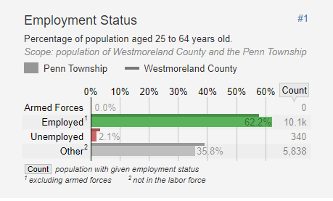
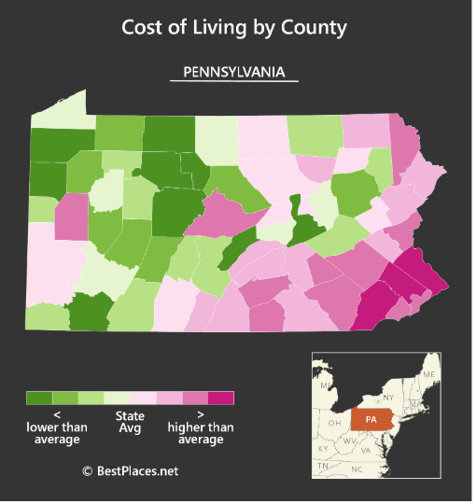

Priorities:

Next, we look at the priorities for the benefits, opportunities, costs, and risks as they compare to their respective alternatives which are rated against their strategic criteria.

For the benefits row, in respect to A1: Full Upgrade, we see the strategic criterion community development rates very highly followed by the surrounding neighborhood. However, political impact, security, and township impact are minimal. Benefits are the third most beneficial to the decision maker because they provide outstanding benefits to the community development and security.
Opportunities is the second highest priority especially for community development and township impact because the upgrades could provide substantial long-term improvements.
Costs is the lowest priority and evaluates the costs of the alternative A3: No Upgrade to the control criterion. Not upgrading the park would result in no additional community development and have no effect on the surrounding neighborhoods. Everything would maintain status quo and the community would see no improvements. With no improvements, there would be no additional revenue coming in not only for the township, which is the purpose of the “opportunity cost” sub-network, where not upgrading would have a much higher opportunity cost than spending money for the park upgrades.
Lastly, the risks of A1: Full Upgrade has high political impact and security, due to all the new improvements potentially increasing the rate of crime and negatively changing the dynamics of the community. The township is currently rated in the top two of the safest places to live in Pennsylvania (www.cbslocal.com). Adding improvements that are meant to draw in larger crowds drastically poses a risk to changing this data for the worse.
In summary of the top-level ratings, the Opportunities and Risks are the most important by the township officials, with a Full Upgrade in mind. While the Benefits and Costs are slightly less important when considering a Full Upgrade or No Upgrade, respectively.

Synthesized Results

Long-term synthesized results:
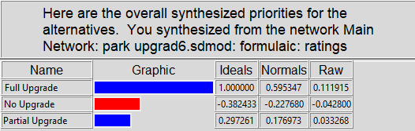

Short-term synthesized results:
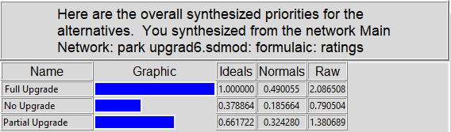

Sensitivity Analyses

Benefits
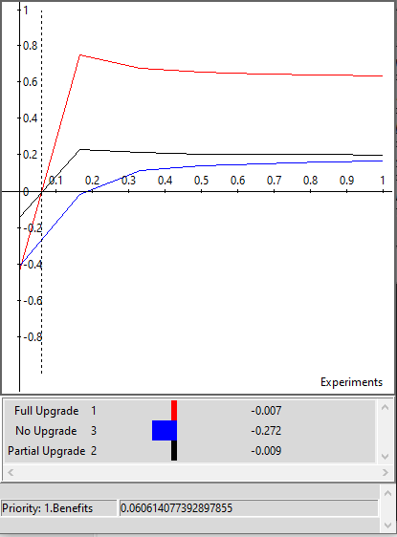

The sensitivity analysis for benefits shows that as the priority for benefits remains now, A2: Partial Upgrades is the best option, however, as more importance is placed on benefits, the A1: Full Upgrade is clearly the best option at the 5% level and remains the best option thereafter.

Opportunities
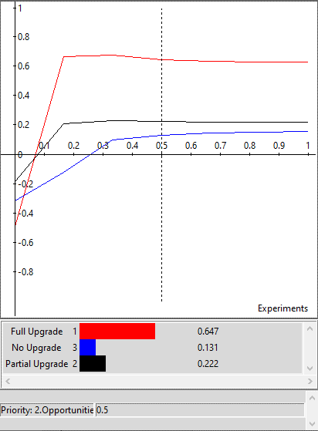

Similarly to the benefits sensitivity analysis, at low levels of priority for opportunity, A2: Partial Upgrade is the best option, but after about 7.5%, the Full Upgrade is overwhelmingly the best options for all levels thereafter.

Costs
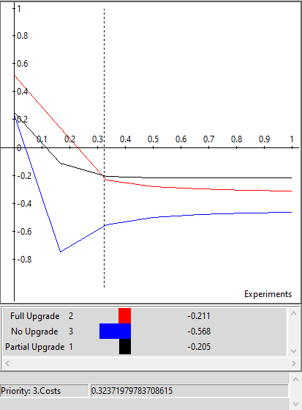

As costs become more significant, the partial upgrade becomes the better option to the township officials. This can be seen just past the 30% level. This is most likely expected because the partial upgrade is the minimally invasive option.

Risks
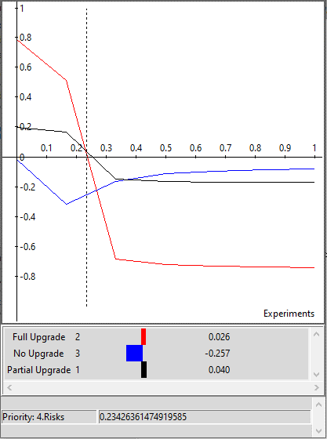

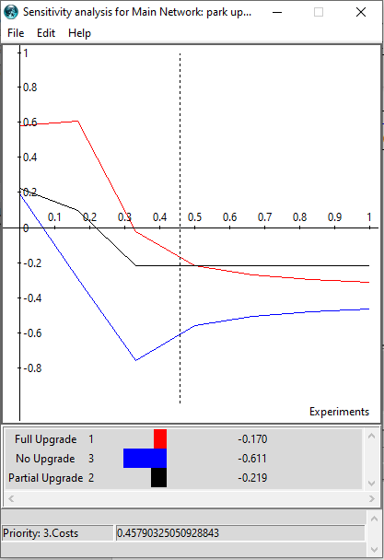
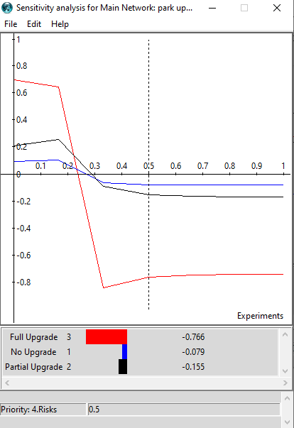
As risk becomes a higher priority, the Full Upgrade option becomes much less desirable very quickly, and the partial upgrade becomes the best option at about 23%. As the priority for risk increases, or put another way, the township’s tolerance for risk decreases significantly, then the No Upgrade option becomes the most appropriate.

To conclude this analysis, it makes most sense to complete a full upgrade of the park. There was a heavy weighting on the economical and financial facotors which were highly influencial to this decision. The full upgrade option not only had the best benefits and opportunites such as potential increase in jobs and local GDP, but it also was the riskiest since it could change the dynamics of the community adversely and increase park maintenance costs. Not upgrading was the costliest, however, because of the strong opportunity cost associated with forgoing the economical and financial benefits. Opportunities and Risks were the highest weights in the ratings model because they ranked highly in community develoment and township or Political Impact and Security respectively. Both long-term and short-term results indicate to Fully Upgrade the park, however, the short-term has less variance between the priorities in each alternative. Lastly, the sensitivity analysis points out that if benefits or opportunties are of any priority above approximately 7.5%, then a Fully Upgrade is the best alternative. For costs and risks, as the decision maker becomes more cost-sensitive and more risk averse, there is a rank reversal between Full Upgrade and Partial Upgrade in the costs analysis and two rank reversals depending on risk tolerance in the Risk analyses.

Works Cited:
“About " Penn Township, Westmoreland County, PA.” Penn Township, Westmoreland County, PA, 8 May 2019, penntwp.org/about/).
“Best Places in PA.” Best Places to Live in Penn Township (Westmoreland Cnty), Pennsylvania, www.bestplaces.net/city/pennsylvania/penn_township_(westmoreland_cnty).
Bureau, US Census. Census.gov, www.census.gov/.
CBS Pittsburgh. “Study: 2 Western Pa. Communities Ranked Safest In The State.” CBS Pittsburgh, CBS Pittsburgh, 12 Feb. 2020, pittsburgh.cbslocal.com/2020/02/12/study-two-western-pa-communities-ranked-safest-in-the-state/.
“Employment Status in the Penn Township, Westmoreland County, Pennsylvania (Township).” The Demographic Statistical Atlas of the United States - Statistical Atlas, statisticalatlas.com/county-subdivision/Pennsylvania/Westmoreland-County/Penn-Township/Employment-Status.

