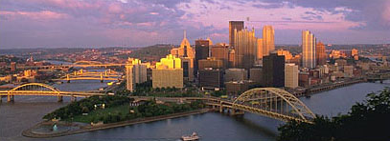

What Should the City of Pittsburgh do with Regard to the Pittsburgh Penguins’ Mellon Arena?



Analytical Network Process Model

Decision Making in a Complex Environment
Final Project

David Dunsavage

Brian Marflak

October 14, 2002

Table of Contents

Introduction…………………………………………………………………... 3

- Background …………………………………………………………………… 3

- Model …………………………………………………………………………... 4

- Results ………………………………………………………………………. ..12

- Sensitivity ……………………………………………………………………. 15

- Conclusions ………………………………………………………………….. 19

- References ………………………………………………………………….. 20

I. Introduction

The purpose of this study is to determine what the city of Pittsburgh should do with regard to the Pittsburgh Penguins’ Mellon Arena. The Penguins current arena is the oldest arena (40 years) of all the teams in the National Hockey League (NHL). The commissioner of the NHL, Gary Bettman, states that the Penguins badly need a new arena because their current arena lacks the large number of club seats and luxury boxes that produce substantial revenue in the NHL newer arenas [Reference 1]. This study, using the Analytical Network Process (ANP) will determine the best decision for the city of Pittsburgh should make between the following alternatives:

- Build New Arena
- Refurbish Existing Arena
- Keep Existing Arena

II. Background

This has become an issue in Pittsburgh because of the potential threat that the Penguins would have to leave the city because of poor revenues. And recently in Pittsburgh with the building of new stadiums for the Steelers and the Pirates, the Penguins feel that they should also have a new venue in which to play.

The Penguins hired HOK Sport Inc. to study the options with regard to the arena situation [Reference 2]. This study was to evaluate both the construction of a new arena and the renovation of the current arena. The results of this study have shown that the cost of renovating Mellon Arena would be of similar cost to building a new arena (greater than 200 million). Also, if Mellon Arena were to be renovated, the Penguins would have no place to play during the renovation. Therefore, the study deems renovation to not be a viable option [Reference 7].

Clearly, the biggest hurdle to the construction of a new arena is cost. The cost for a new arena for the Penguins is anticipated to be $270 million. This includes: hard and soft construction costs of the facility, site acquisition, relocation, demolition, offsite public improvements (roads, parking lots, and utilities), project soft costs and project contingencies [Reference 3]. The main issues with regard to costs are public funding (taxes) and state funding.

Another issue with regard to the Mellon Arena is the historical value. Some historians claim that the arena was an integral part of the city’s renaissance and meets the necessary criteria for historic status designation. The arena’s retractable dome, which is cited as Pittsburgh’s technical contribution to the World, is the only structure of its kind in North America [Reference 4]. Although, state lawmakers feel that historic status should not be recognized for Mellon Arena [Reference 6].

The owner of the Pittsburgh Penguins (Mario Lemieux) stated that the Penguins can’t survive long in Pittsburgh without a new arena. The owner said that the team is financially strapped, and a new arena would allow the team to increase revenues. Lemieux has stated that he would never personally move the team out of Pittsburgh, but without a new arena, he may be forced to sell the team and the new owners may wish to move the team to another market [Reference 5].

III. Model

The goal was to take the information discussed in the previous sections and use it to develop a Superdecisions ANP model. The purpose of this section is to describe the model. Figure 1 shows a schematic of the overall model.

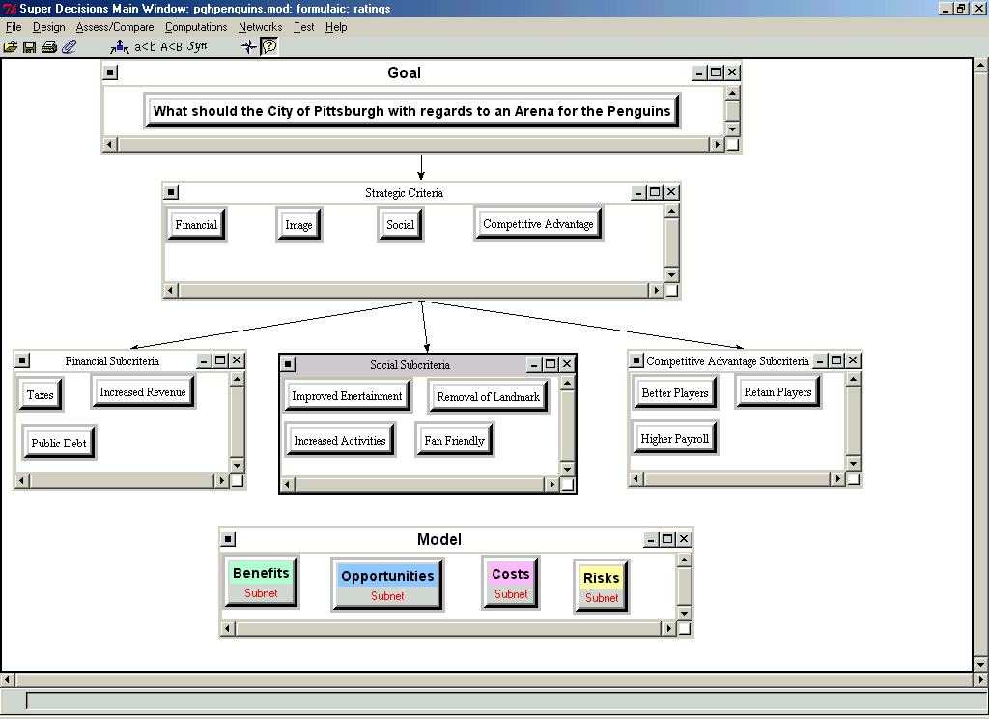
Figure 1: Schematic of Overall Superdecisions ANP Model

The goal of the model was to determine what the city of Pittsburgh should to with regard to an Arena for the Penguins. Strategic Criteria and Sub-Criteria are shown in Figure 1. These criteria are compared using the ratings model.

The Benefits, Opportunities, Costs, and Risks (BOCR) are created and each have subnets. The Benefits Subnet is shown in Figure 2.

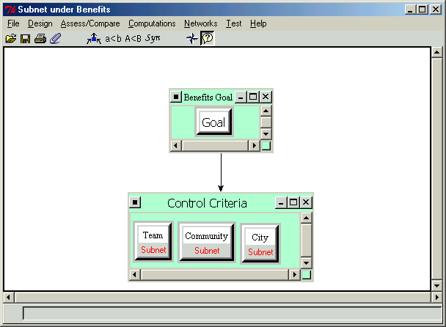
Figure 2: Benefits Subnet

As shown in Figure 2, Control Criteria were set up as Team, Community, and City Benefits.

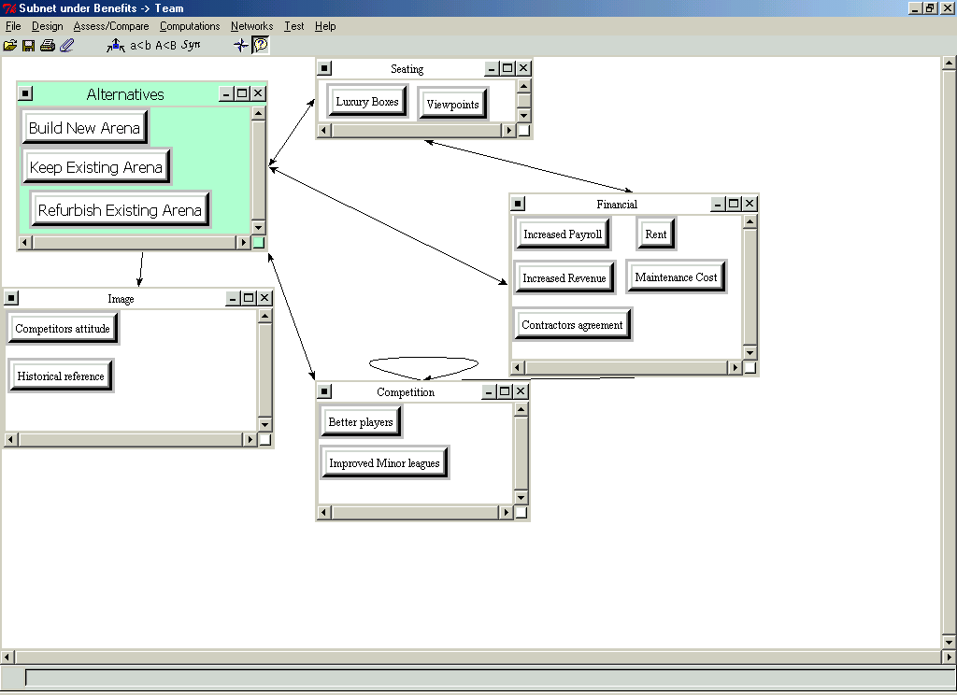
Figure 3: Team Benefits Subnet

Figure 3 shows the team benefits subnet. As can be seen, many benefits were incorporated into the model with regard to the arena.
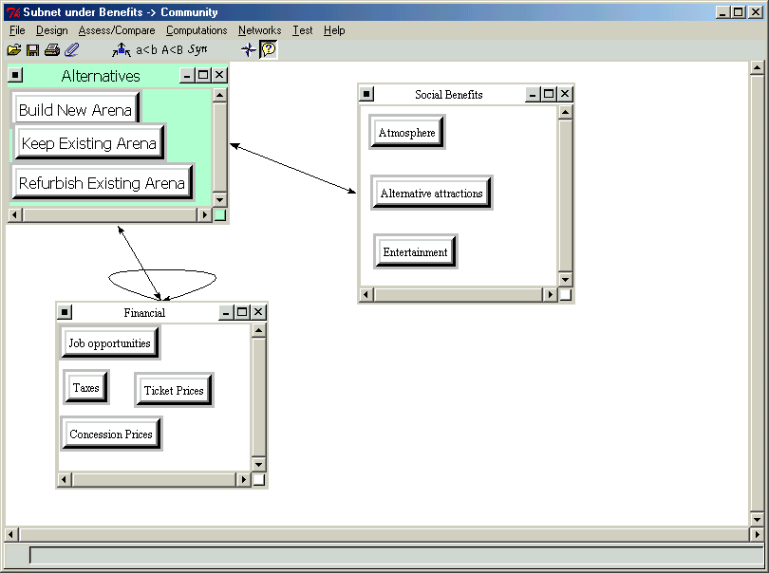
Figure 4: Community Benefits Subnet

Figure 4 shows the community benefits, which include: Job Opportunities, Entertainment, and Atmosphere.

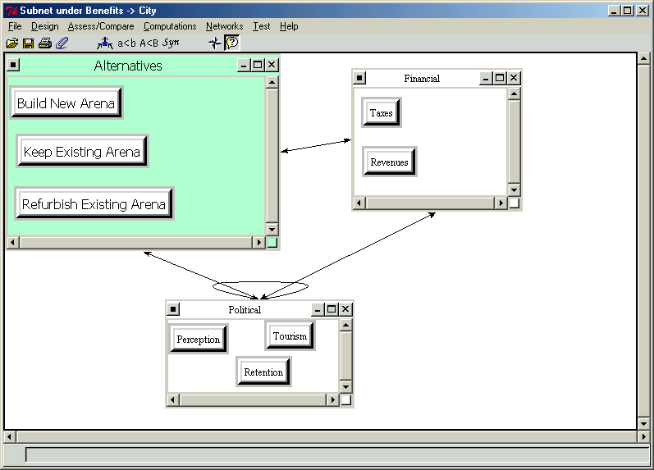
Figure 5: City Benefits Subnet

The city benefits are many and include city perception, increased revenues, tourism, and resident retention.
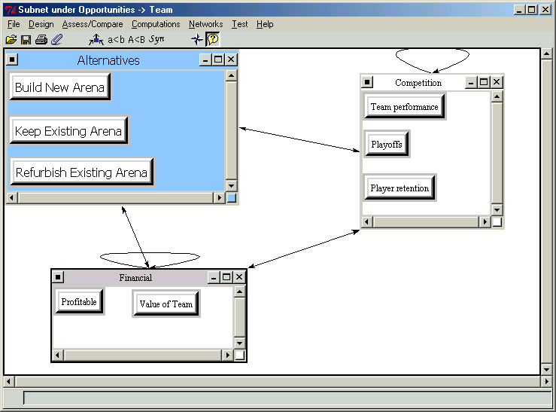
Figure 6: Team Opportunities Subnet

In terms of opportunities, team opportunities are that the team could be profitable and of greater value, as well opportunities for the team to improve (playoffs, player retention).

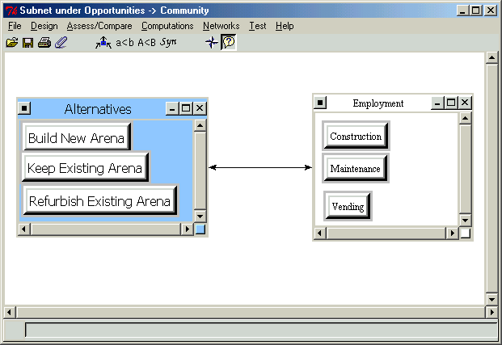
Figure 7: Community Opportunities Subnet

The opportunities for the community are under the category of employment and can be in various categories.
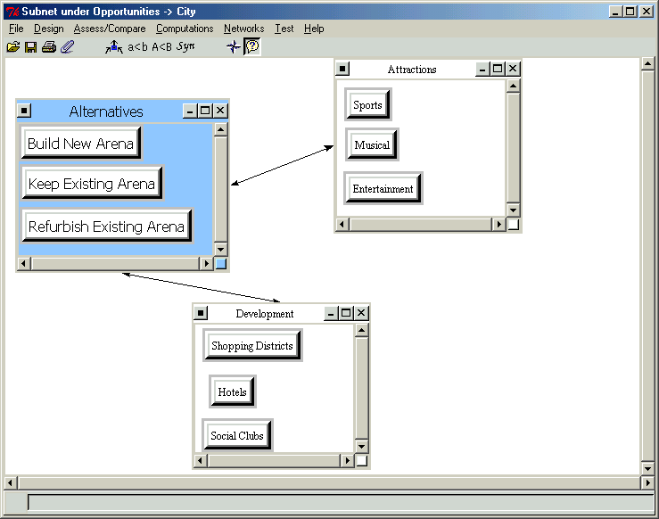
Figure 8: City Opportunities Subnet

The opportunities for the city deal with increased revenues in terms of shopping districts, hotels, and social clubs, as well as entertainment.

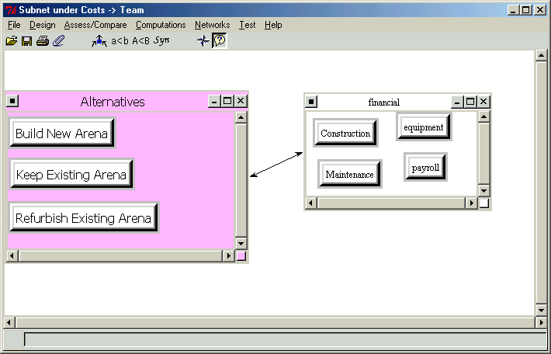
Figure 9: Team Costs Subnet

The costs for the team are shown in Figure 9, and consist of construction (for New Arena or Renovation), maintenance (for Maintaining Existing Arena), and other costs associated with the team.
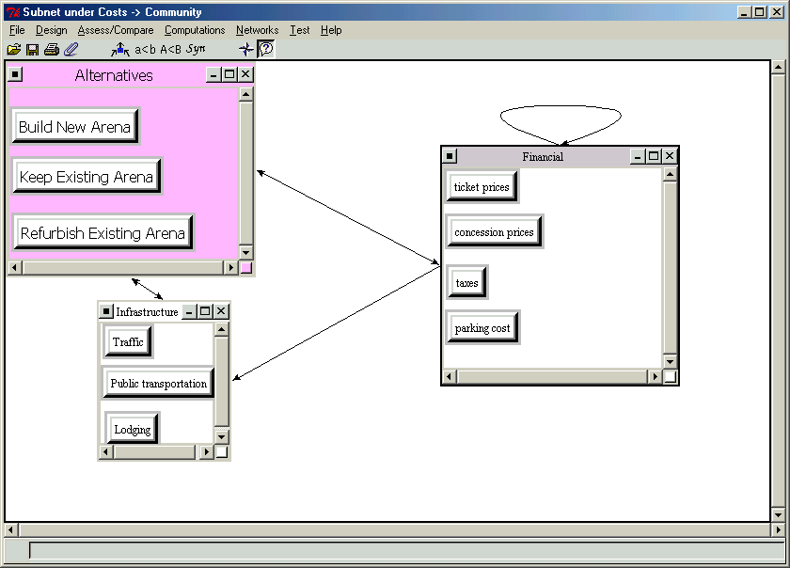
Figure 10: Community Costs Subnet

The cost for the community is most importantly in Taxes. In terms of a new arena, some of the costs would be placed on the taxpayers, which plays a major role in the model.

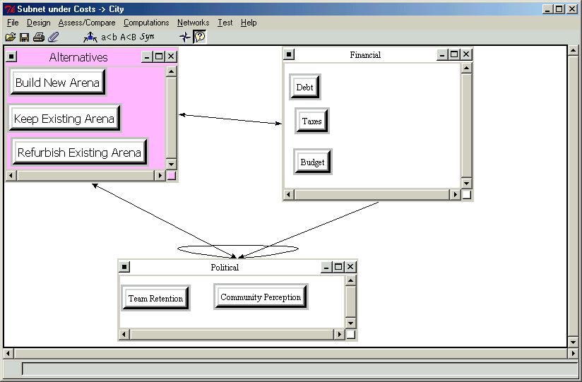
Figure 11: City Costs Subnet

City costs are also substantial in the areas listed in Figure 11.
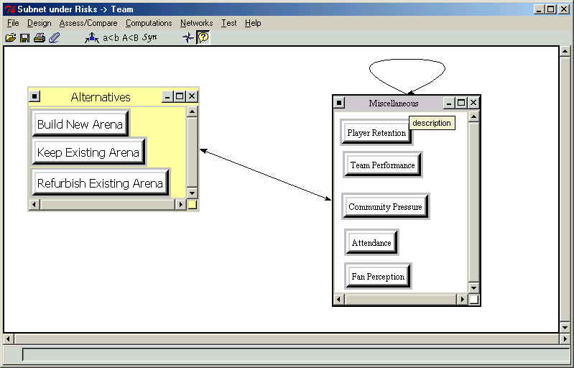
Figure 12: Team Risks Subnet

Team risks are in the areas of the performance of the team, attendance, fan perception, and community pressure. The network is shown in Figure 12.

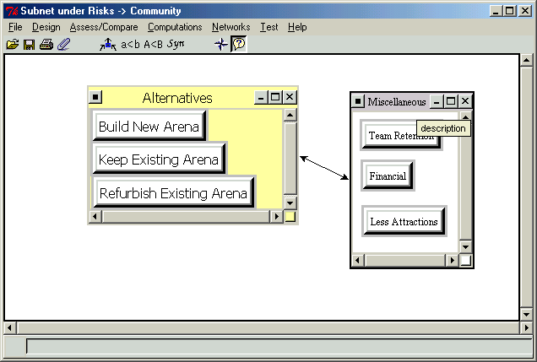
Figure 13: Community Risks Subnet

Community risk is most importantly financial as well as the retention of the team.
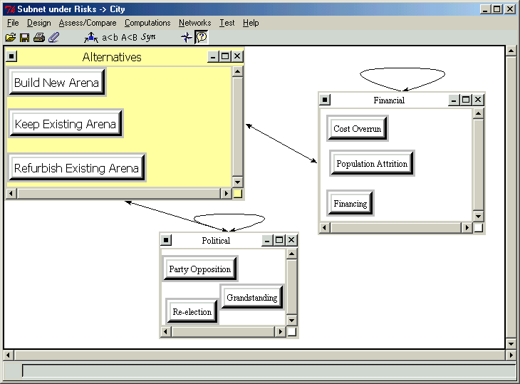
Figure 14: City Risks Subnet

City risks were quantified in terms of financial and political, in which financial were deemed most important.

Pairwise comparisons were made for all of the subnets for Team, Community, and City. The model was synthesized, and the results of the analysis are presented in the next section.

IV. Results

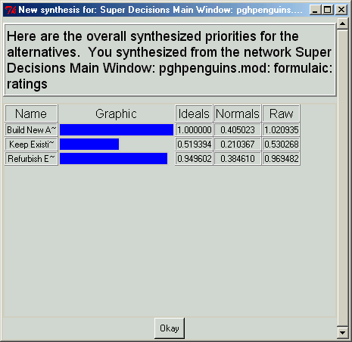
Figure 15: Multiplicative Formula Results

From the synthesis of the model, Figure 15 details that Building a new arena would be the optimal solution to the City of Pittsburgh’s issue with the Penguins. Refurbishing the existing arena is fairly close in the multiplicative model, however, a new arena is an approximately 5% better solution. Because of possible human error within the pairwise comparison, either of these options could be selected because of the small difference between the two.
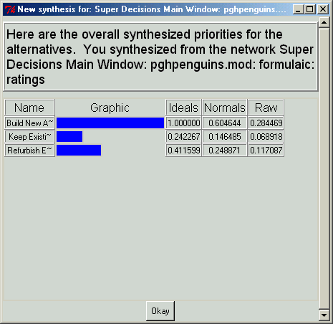
Figure 16: Subtractive Formula Results

Unlike the multiplicative model, the subtractive formula clearly shows that building a new arena is the best option for the city of Pittsburgh. Although refurbishing the existing arena again is second in the decision, the approximately 40% difference between the two clearly shows that there should be no consideration except building a new arena
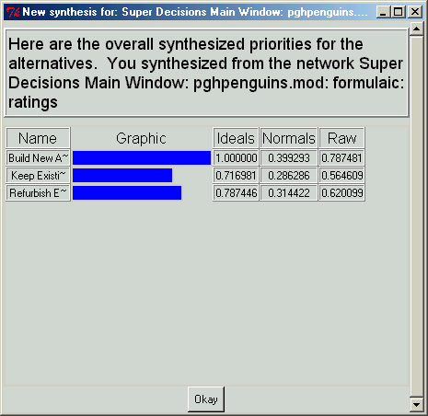
Figure 17: Additive Formula Results

Finally, in Figure 17, the additive formula was synthesized and this synthesis yielded similar results to the others, but, keeping the existing arena was a closer choice than the previous formulas. Building a new arena is still the choice that Pittsburgh should follow because of the approximately 20% difference between the nearest choice.

In conclusion, although some of the percentages between the choices was narrow, the obvious choice between all of the formula results shows that Building a new Arena would be in the best interest of the city of Pittsburgh. After review of the results, a recommendation to the city would be to proceed with funding and start the project of providing a new arena to the Penguins.

V. Sensitivity

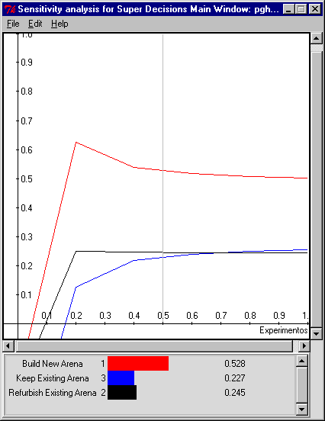
Figure 18: Sensitivity Analysis Model

As shown in the Sensitivity analysis of the model, Figure 18, the sensitivity displays that Building a new arena is the avenue that the city of Pittsburgh should follow for the Penguins. The option of ‘building a new arena’ is twice the factor as either ‘keep the existing arena’ or ‘refurbish the existing arena’ according to the sensitivity analysis.

When looking at each of the models BOCR, the sensitivity analysis shows the following information concerning Benefits as shown in the attached Figure 19. Building a new arena still obtains the highest rating as compared to the other options, however, ‘keep the existing arena’ has the second highest rating as opposed to the third in the overall model. The benefits sensitivity also shows that the building a new arena option diminishes as the benefits increase, where it increases when you keep the existing arena.

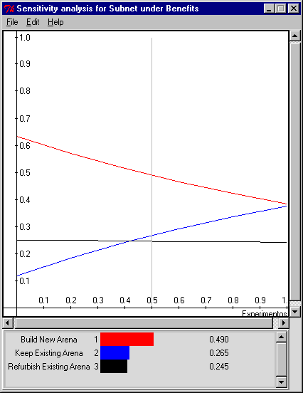
Figure 19: Sensitivity Analysis Benefits

For the opportunities portion of the model, the sensitivity analysis is shown in Figure 20.
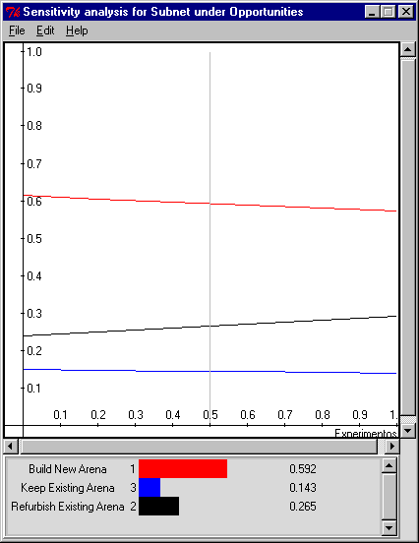
Figure 20: Sensitivity Analysis Opportunities

The sensitivity analysis for the opportunities again shows that building a new arena has the highest rating of all of the options. The sensitivity analysis also shows that all three options are consistent throughout the entire opportunities range.

The costs sensitivity analysis is shown in figure 21.

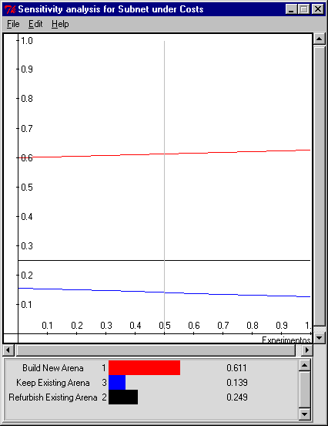
Figure 21: Sensitivity Analysis Costs

As with the opportunities sensitivity analysis, the costs sensitivity analysis again has building a new arena as the highest rated and all three options do not change drastically as costs change.

Finally, shown in figure 22 is the Risks sensitivity analysis.

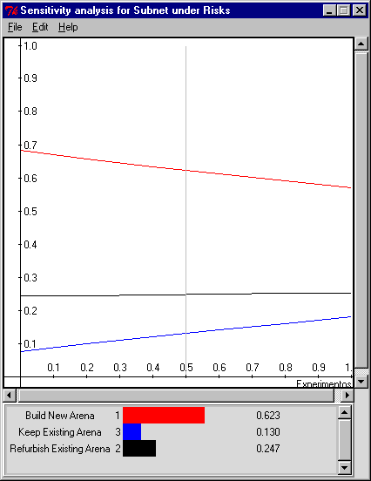
Figure 22: Sensitivity Analysis Risks

The sensitivity analysis for risks shows that building a new arena is the highest rated in the risks analysis and all of the sensitivity analysis. Building a new arena decreases as the risks increase which is similar to the benefits analysis.

In conclusion, the sensitivity analysis clearly indicates that building a new arena is the best option. It also details that building a new arena has the best benefit, however, it is adversely affected by the risks involved with building a new arena.

VII. Conclusions

The model presented herein used explicit research parameters to construct an ANP model to determine what the city of Pittsburgh should do with regard to the Pittsburgh Penguins’ Mellon Arena with the following alternatives:

- Build New Arena
- Refurbish Existing Arena
- Keep Existing Arena

The results of the synthesized ANP model show that for the Multiplicative, Subtractive, and Additive formulas, building a new arena is the most viable option for this city. The recommendation of this analysis is that the city of Pittsburgh should build a new arena for the Pittsburgh Penguins.

VII. References

- “Bettman Says Penguins Need New Arena,” Sportsline.com wire reports, Feb. 3, 2001.
- “Kansas City Firm Hired to Study Penguins Arena Options,” J. Mandak, The Associated Press, May 19, 2001.
- “SEA Releases Development and Financing Plan for a New Arena,” July 31, 2002
http://www.pgh-sea.com/Welcome/newarena/body_newarena.html
- “Historic Status Sought for Mellon Arena,” July 9, 2001.
http://html.thepittsburghchannel.com/pit/sports/penguins/stories/penguins-86283120010709-080720.html
- “Penguins Make Pitch for New Arena,” June 14, 2001.
http://www.thepittsburghchannel.com/News/818556/detail.html
- “Historic Landmark Status Unlikely For Igloo,” October 9, 2002
http://www.thepittsburghchannel.com/penguins/1600255/detail.html
- Allegheny Institute Report #02-308, “Private Financing for a New Penguins Arena,” July 2002. http://www.alleghenyinstitute.org/reports/02_08.pdf

