Decision Making in Complex Environments: The Relationship between Turkey and the EU
2010
Mirko Daum and Anna-Maria Hartnagel

13.04.2010
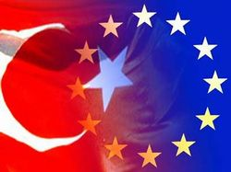
Table of Contents
1. Introduction and Problem Definition 3
2. Model Development: ANP Model 4
2.1. Alternatives 5
2.2. Strategic Criteria 7
3. BOCR 8
3.1. Benefits 9
3.1.1. The Subnets 9
3.1.2. Synthesized Results 12
3.2. Opportunities 13
3.2.1. The Subnets 13
3.2.2. Synthesized Results 16
3.3. Costs 17
3.3.1. The Subnets 17
3.3.2. Synthesized Results 20
3.4. Risks 21
3.4.1. The Subnets 21
3.4.2. Synthesized Results 24
4. Rating Model 25
5. Analysis of Result 26
5.1. Additive Method (negative) 26
5.2. Multiplicative Method 27
6. Sensivitiy Analysis 28
6.1. Benefits 28
6.2. Opportunities 29
6.3. Costs 30
6.4. Risks 31
7. Conclusion 32
8. Appendix 33

Introduction and Problem Definition

For about two decades now, the most controversial debate being discussed among EU members is the question concerning the most appropriate relationship between Turkey and the European Union. In the meanwhile, the “Turkey question” has also been picked out as a central theme of various elections within the EU members and has also been spread to non-EU countries. Moreover, opinion polls show how deeply split the European public is over this issue, as are governments and parliaments across the continent.
Historically, the EU established a Customs Union with Turkey in 1995 which covers certain trade agreements and entails alignment by Turkey with certain EU policies. Officially, Turkey became a candidate country for EU membership after the Helsinki European Council of December 1999. However, the start of fiery discussions was triggered by a meeting of the European Council in December 2002. There, it was resolves that the EU would open accession negotiations with Turkey if the latter would fulfill the Copenhagen political criteria until the European Council in December 2004. Although not all criteria were met, the EU symbolically opened membership talks with Turkey in October 2005(so-called screening process). However, a number of stumbling blocks remain on Ankara's road to EU accession, in particular concerning the non-recognition of Cyprus, freedom of expression, corruption, violence against women, and the rights of the Kurdish minority.
New developments like the international convergence between Iran and Turkey could place an additional burden upon the relationship between Ankara and Brussels. Furthermore it can be seen that in certain countries (Netherlands, Hungary etc.) right party leaders have taken over the power in their countries and heat up the debate against further expansion of the European Union. One other fact has also risen the antipathy against Turkey and other Islamic nations which is the increase in Honor killings within the EU, most of the time exclusively committed by people with an Islamic background.
The mentioned events have contributed to heating up the debate on how to weight the underlying political, economic, and sociocultural criteria in order to come to a conclusion concerning which kind of relationship with Turkey is the best. Some members of the European Union want to reject the admission of Turkey as they fear certain economic costs, while other countries anticipate cultural and political conflicts arising from Turkey´s entry into the EU. On the other hand, there are major economic as well as political benefits and opportunities which cannot be ignored. But until now there has been no agreement upon a final decision.
This model therefore aims to help the decision makers of the EU (government heads of the member states) which option with regard to the relationship between Turkey and the EU are the best for all concerned parties.

Model Development: ANP Model

For this final project, we used the Analytical Network Process model that has four feedback sub-networks of control criteria: Benefits, Opportunities, Costs and Risks (BOCR). Each of these criteria has a set of its own sub-networks which contain control criteria and subcriteria that are specifically defined for each aspect of the analysis (a set of control criteria for Benefits, a separate set of criteria for Cost etc.). All strategic criteria, control criteria as well as subcriteria were determined through the research of appropriate literature and personal knowledge that appeared to have importance for determining the outcomes and policy making decision. Most of the information was taken from the website of the European Commission and the prior model of Goebl and Wurst. In addition to the BOCR cluster, there are two clusters, containing the goal and the strategic criteria, respectively. As described before, the goal of this decision model is to determine the best relationship between the EU and Turkey, weighing the BOCR against the strategic criteria on hand.

In order to accomplish the goal, we first build a goal node, networks and sub-networks for each of the BOCR models as well as strategic criteria (see figure 1).
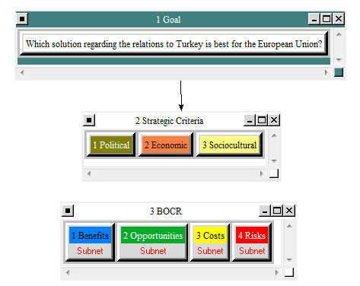
Figure 1: Overview ANP model at the top-level
In a next step, we made judgments and evaluated which was the best alternative for each control criteria of the BOCR regarding the particular decision by synthesizing the judgments. The importance of the BOCR’s sub results must then be determined by rating them with respect to the identified strategic criteria. Strategic criteria are those values that must be satisfied regardless of the particular decision being made.

Alternatives

For the purpose of the decision described above, three alternatives were identified which reflect different potential types of relationships between the EU and Turkey. This included the following alternatives:

- Admission of Turkey as a fully accepted member of the EU: This option represents the most fundamental shift in the relationship implying drastic economic, political, and sociocultural consequences for each of the parties involved (Turkey and each member country of the EU). But a full membership for Turkey could overtax the EU's capacities because adapting structures, balancing economic interests and aligning "political cultures" requires considerable patience and sensitivity. Full membership for Turkey would constitute the most far-reaching enlargement in the EU's history. In addition, it will be hard to convince all EU member states to agree to Turkey´s accession in the EU since especially Austria and Cyprus stated their disfavor.

- Rejection of Turkey as a fully accepted member of the EU: The second option equals maintaining the current status of Turkey with trade agreements and the like. Some argue that the EU should create a close and comprehensive bond between Europe and its neighbors. This can be done successfully on the EU's border with Turkey. On the other hand, a rejection might be regarded as an insult or at least as a major backlash for Turkey which could endanger current connections between Turkey and the EU. It could further increase support for Turkish nationalist, trying to stop Turkey´s democratization. Additionally, it could also trigger an alienation of Turkey from the West, leading to closer relationships with their neighbors in the Middle East, Russia, and Asia.

- Offer Turkey a special partnership (privileged partnership): The report of the European Commision of 2004 that lists special regulations that would apply to Turkey (most notably regarding the free movement of labor) shows that the EU's offer of membership would only lead to second-class status for Turkey. A privileged partnership instead of an underprivileged membership is the better — and more honest — option for both sides. A privileged partnership would also save Europe from "overstretch" and tie Turkey even closer to the West. This partnership could consists of institutional cooperation, an expansion of the already existing customs union, and a membership in European foreign, security and defense policy structures on an equal basis. Additionally, there might be further obligations towards Turkey such as the requirement to abolish human rights violations or the endorsement of further democratization. However, these additional requirements have to be specified only after the basic decision towards the type of relationship has been made.
Concerning the alternative for a failure of negotiations this options might be the only one that would not rebuff Turkey and preserve the chance for real European politcal integration. However, officially offering a special partnership might anger Turkey and deteriorate the existing bonds.

Strategic Criteria

In general, strategic criteria are those values that must be satisfied regardless of the particular decision being made. Since the BOCR are not equally weighted in every decision, and to establish their priorities in this decision, the most important alternative (the one with the highest value which is the best under benefits and opportunities, and the worst under costs and risks) is rated against the strategic criteria. It is a way of finding out what the most important merit is in this particular decision.
In particular, we identified the following strategic criteria:
- Political: This criterion reflects the EU´s request for a stable institution that guarantees democracy, the rule of law, human rights and respect for and protection of minorities. In addition, a stable and friendly relationship with neighbor states is desired. The military force of a country is also of importance. On the other side, the admission of a new member will complicate the decision making process within the EU. The political aspect was weighted as of minor importance because we feel that economic as well as sociocultural aspects are considered more crucial by the various governments of European countries.

- Economic: The granting of an EU membership is also related to a functioning market economy, as well as the ability to cope with the pressure of competition and the market forces at work inside the Union. Besides the trade-related aspects, other aspects such as unemployment rate, wages, infrastructure and necessary subsidies for e.g. agriculture are also essential. Moreover, there might be a higher competition within the EU countries because of new and cheaper products from Turkey, and an overload of capacity for the existing EU members as a consequence of expected further immigration. Furthermore, the global influence of the EU might increase with the admission of an additional member.

- Sociocultural: Another crucial point are sociocultural attitudes regarding the general value system, discrimination of women, and xenophobia. Moreover, influences such as demographics of the population and the intention to drive and implement reforms to democratize the country are noted. This criterion covers negative effects resulting from the clash of two completely different cultures and value systems. Further conflicts and a loss of identity for the European people might depict a negative scenario. On the other hand, dealing with a new culture can broaden the Europeans´ horizon. The sociocultural criterion is weighted as the most important one as it creates extended fears and negative anticipation throughout the existing members of the EU. The conflicts might even occur more vigorously on a subliminal level. There is a lot of skepticism towards the compatibility of the oriental and occidental value systems.

BOCR

To follow the complex and multidimensional connections and dependencies within the various positive as well as negative aspects related to this subject, we used the BOCR concept. Under the BOCR models, different clusters define interactions with respect to the control hierarchy established. The benefits networks indicate the alternatives that yield the most benefit and the opportunities networks indicate the alternative that offers the most opportunities, whereas the costs and risks networks indicate the alternatives that are the most costly or pose the most risk on each alternative. In general, all nodes of the BOCR cluster contain subnets that again contain three subnets for political, economic, and sociocultural influences. Each of these subnets contains criteria to evaluate the three alternatives. The subnet Opportunities, for example, looks as follows:

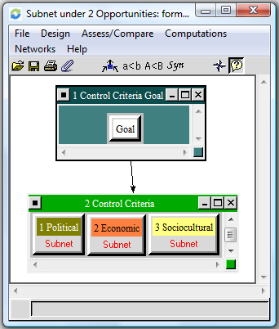
Figure 2: Subnets under Opportunities

Benefits

The Subnets

The benefits are divided into political, economic, and sociocultural benefits which in turn contain another subset with control criteria and the alternatives.
Regarding the political benefits, the three alternatives at hand are influenced by the reputation that the EU would gain if they affiliate Turkey or reject Turkey after decades of negotiations. Additionally certain political figures will win the support of Turks who currently live in the EU. An admission of Turkey would also promote further democratization in Turkey. Turkey could also be of strategic importance to the Middle East and a close alliance against Teheran. In order for Turkey to become a member, they need to find a solution to the issues concerning the Kurdish minority and the division of Cyprus. Both might lead to an acceptance and opening of Turkey in exchange for the EU membership.
In the case that Turkey’s membership will be rejected, the points described before would either rest at the status quo or could even get worse. It is very likely that a rejection would anger the Turkish government and population, leading to an alienation from, not only the EU, but also the West in general.
A partnership would lead to benefits somewhere in the middle of the other two decisions.
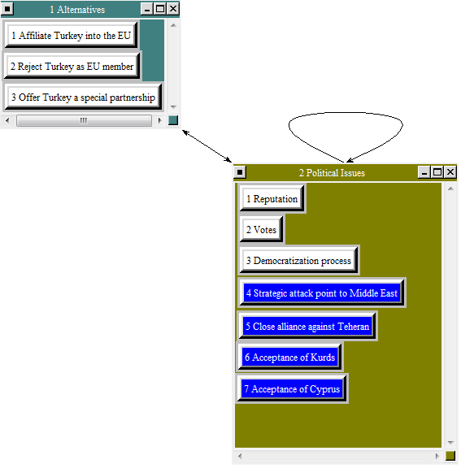
Figure 3: Political subnet under Benefits

Under economic benefits, the different possible relationships with Turkey are influenced by direct and indirect impacts. We also included the time aspect as some of the impacts are only short-term; others will add more benefit in the long run. The direct impacts include an improvement of trade due to reduced trade barriers and new customers and products if Turkey becomes an EU-affiliate. The European trade balance would also improve because many people living in the EU travel to Turkey for their vacation and thus import Turkish services. If Turkey becomes a member, money spent in Turkey would remain within the EU. Indirect impacts of Turkey´s economic involvement are its ongoing economic growth together with its decreasing unemployment rate, which increases wages and thus increases private consumption. Additionally the conservative approach of Turkish banks and the government´s goal to reduce public debt, led to a lower impact of the recent financial crisis and an improvement of Turkey´s credit rating. These aspects increase the likelihood of an EU membership since Turkey proves stable enough to not need financial support or future bailouts. This would also help to stabilize the Euro currency.
If Turkey becomes either a member or a special partner of the EU, the European Union will benefit from the Turkish economy, while a rejection of Turkey might provoke Turkey to close its market for other European countries which could have an especially severe impact on the oil supply.
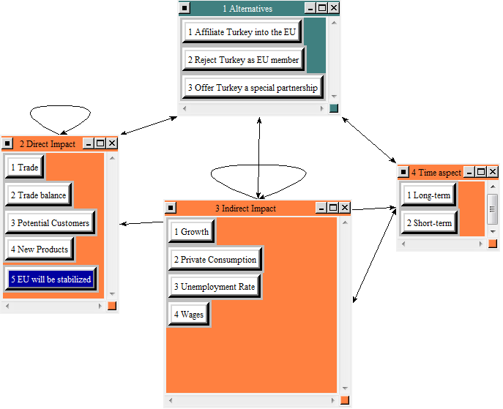
Figure 4: Economic Subnet under Benefits

Sociocultural benefits concern demographics and the democratization process as well as the general acceptance of Muslims in general and enhance the cultural horizon. The EU inhabitants could become more open-minded and abandon prejudices.
Turkey has already shown its will to fulfill the admission requirements by introducing reforms and improving its democracy. If Turkey becomes either a member or a special partner of the EU, these intentions will tie Turkey to the EU while its reform process will go on. Moreover, the mentioned options would probably be linked to further reforms and enforcement to decrease forced marriages and honor killings. Once implement and practiced in Turkey, the Turkish living in other EU member states are more likely to adapt these reforms and attitudes. The demographic aspect means that Turkey has a high birth rate and thus has a strong base of young people, whereas in Europe the birth rate is very low and elder people outnumber the younger ones. Only Turkey´s admission would balance this structure.
If Turkey is rejected, it might stop its reforms and get demoralized or even worse, reverse the achieved changes since the population is upset and nationalists are gaining the mastery.

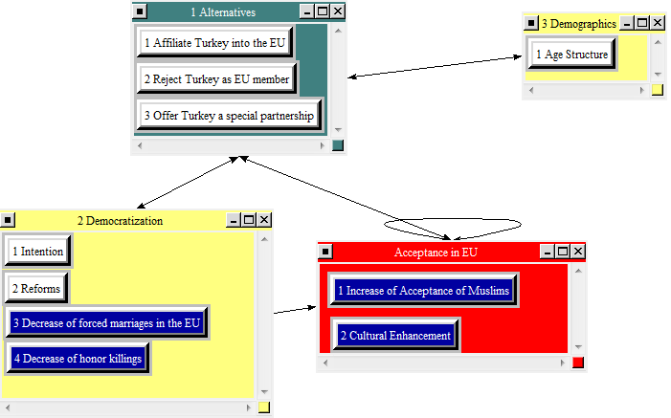

Figure 5: Socicultural Subnet under Benefits

Synthesized Results

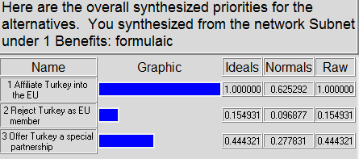
Figure 6: Synthezised Results under Benefits
Overall, “Affiliate turkey into the EU” is the best alternative found in the Benefits subnet node with 62.5%, followed by “Offer Turkey a special partnership” with 27.8% while “Reject Turkey as a member has only 9.7%. This is quite understandable because the rejection of Turkey´s application could have a negative repercussion on the existing relationship between Turkey and the other EU countries.

Opportunities

The Subnets

Similarly to the benefits node, the opportunities node contains political, economic, and sociocultural subnets.
A major political criterion for the Turkey issue is the geopolitical aspect. The admission of Turkey would also benefit the EU in terms of a lower dependency on Russian Oil, because of safe access to and influence over the Nabucco pipeline/oil fields in the Caucasus, which would give the EU more room for expressing their opinion. This access would otherwise not be possible. Turkey’s admission would make Turkey an ally for the EU and, in adding its military force, it would contribute to defend and strengthen the EU. Regarding Europe’s Middle East politics, Turkey could be a stabilizing factor and a bridge to Islamic nations because it would be a balance as a huge Islamic country in Europe. Islamic countries are more likely to listen to Turkey than to any other EU member state. These factors would increase the size of the EU and thus its political power. It could even help the EU to become less dependent on the United States. Additionally, a membership opens up the opportunities for an acceptance of Cyprus and the opening of its seaports and airports, an acceptance of the genocide in Armenia and the abundance of minority prosecution within Turkey. It might also help to overcome the long-lasting battle with the PKK. These would be beneficial for both, other EU members and the Turkish population, in the future.
Of course this scenario of higher global influence and the fulfillment of the external factors are not realistic if Turkey is rejected or offered a partnership as this partnership will mainly focus on the economic field.
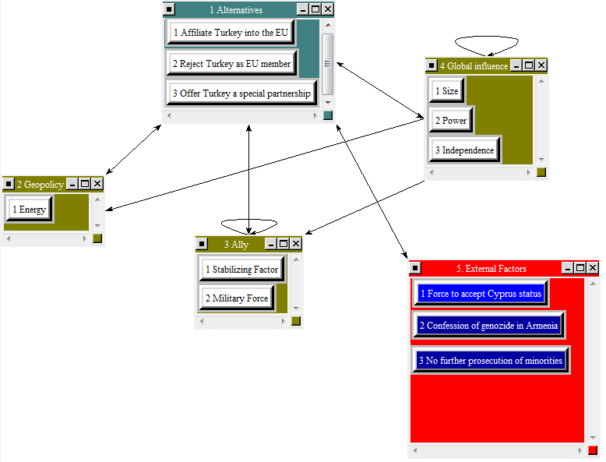
Figure 7: Political Subnet under Opportunities

Regarding economic opportunities, the access to the Caucasian oil fields would still only be possible if Turkey is affiliated so that a shortage of oil and therefore an upsurge in prices can be prevented. Turkey’s admission would open new markets for the other European countries where they could invest and find ways of cheaper production than back home. Moreover, the global influence scenario could become true in case of an admission as well as in the case of a special partnership. If Turkey were an EU member, the migration of Turkish asylum seekers might decrease as the Turkish living standard, political system, and stability would adapt to the European one so that the Turkish people could stay in their own country. This would mean a lower economic burden for Europe. All these opportunities result from an affiliation as well as from the partnership, while a rejection would not allow this.
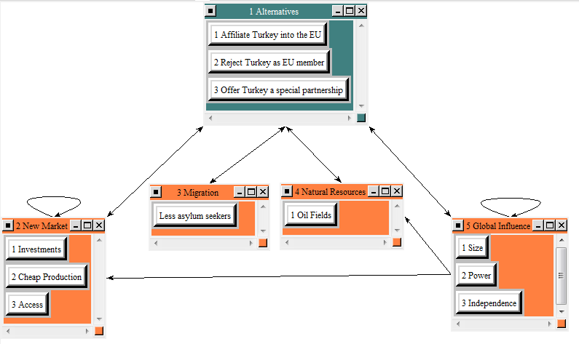
Figure 8: Economic subnet under Opportunities

Sociocultural aspects include a better integration of Turks living in Europe and the introduction of a new culture. (The culture is already present in Europe but it is not freely accepted as the Turks still are a minority). With Turkey’s entry into the EU, the European Union could be seen as “rescuer” of Turkey as it has helped to improve the Turkish democracy, living standard, and its awareness for development. Thus the Turkish migration into the EU might slow down. In addition, an affiliation will probably require Turkey to improve its freedom of speech and equal rights, which in turn will improve the living conditions in Turkey. Moreover, polygamy in Turkey will be obliterated since it is not accepted within the EU. These opportunities will not appear if Turkey is rejected as member or if the EU offers a special partnership.
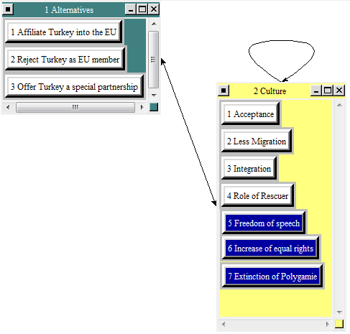
Figure 9: Sociocultural Subnet under Opportunities

Synthesized Results
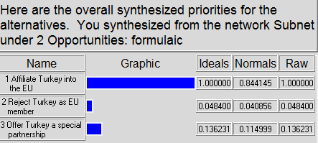
Figure 10: Synthesized results under Opportunities

Under the Opportunities subnet, “Affiliate Turkey into the EU” is the best choice at 84.4%, followed by “Offer Turkey a special partnership” at 11.5%, and “reject Turkey” is last with 4.1%.

Costs

The Subnets

After discussing the positive aspects, we will now focus on the negative sides towards determining the goal. Similar to the subnets under benefits and opportunities, the costs subnet consists of three subnets facing political, economic, and sociocultural criteria.
The political subnet deals with the influence on European politics, with different types of human rights violation and with other external factors. The dominating position of Turkey (because of its size) as a potential member of the EU, especially relating to its comparatively poor economic standard, negatively affects the weight of votes of the other EU members and it also results in a more complicated decision making process. The violation of human rights within Turkey is of particular importance for the EU. The acceptance of Turkey as an adequate member of the EU will bring these issues on the agenda and this will result in financial burden as regards to guarantees of fair trials for political prisoners of Turkey and might also have demoralizing effects towards existing EU countries concerning the handling of torture. In addition, the EU would have to solve the existing issue concerning the recognition of Cyprus and the genocide in Armenia. Moreover, the additional subsidies and financial aids for Turkey would burden the EU member state in a time that is already marked by the financial distress of the existing member states such as Greece. Another cost could occur with the affiliation of Turkey as an EU member regarding the new border of the EU. The extension of the borders could lead to new issues refugees or direct military threads.
Political costs will negatively affect the EU almost exclusively in the case of affiliation.
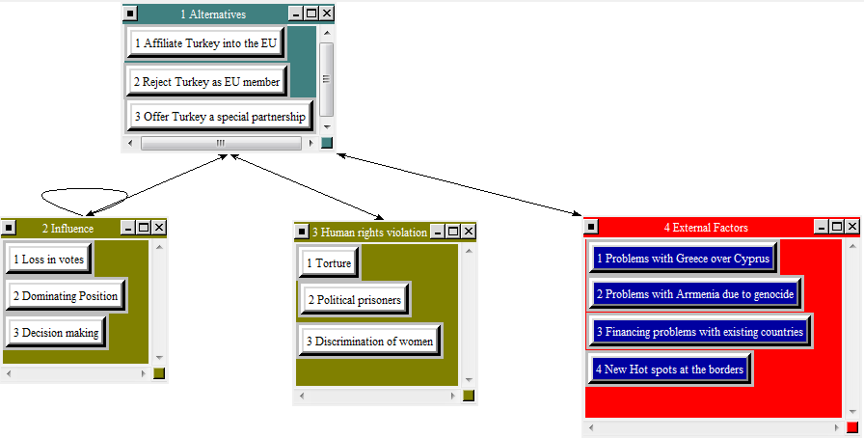
Figure 11: Political Subnet under Costs
Economic costs occur in the form of monetary payments as well as competition costs. For some costs the time aspect is of major importance. Therefore, we deal with short term (up to 5 years) and long term (more than 5 years) effects. If Turkey is either admitted or offered a special partnership, subventions for agriculture will be the most expensive upcoming payments for the EU. The strong rural sector of the Turkish economy constitutes a claim for extended subventions, in both the short term and the long term. Turkish companies will appear as new competitors potentially offering cheaper products to EU consumers because of cheaper labor costs. The labor market of EU countries might suffer from this, too. The effect of competition costs however is more short-term related. To some minor extent all these costs will also occur if Turkey is offered a special partnership.
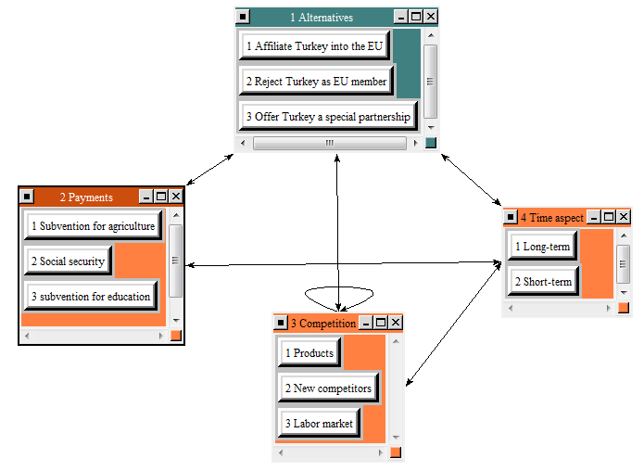
Figure 12: Economic subnet under Costs

Sociocultural costs refer to human rights violation and also to various issues connected with the aspect of identity as well as other EU internal factors. The identity of Europe is defined by its culture, value system, and history and, to some minor extent, also by its geography. Culture and history strongly influence the underlying value system of Europe which has been originally shaped by the Jewish-Christian occidental culture. The affiliation of Turkey would bring in a new and strong culture which is related to an Islamic worldview. Cultural differences would also carry weight with regards to a special partnership. The EU would also have to deal with human rights violation in Turkey, initiating reforms that abolish those methods. In addition, the affiliation of Turkey might further alienate EU-opponents which would lead to a lower acceptance of the whole movement. The EU citizens might also turn away from the EU movement caused by a fear of Islamic religion (associated with terrorism, headscarves and discrimination of women). Furthermore, an additional member state could just overstretch the EU system, slowing down and complicate decisions.
Therefore the rejection of Turkey would be the most cost-saving alternative.

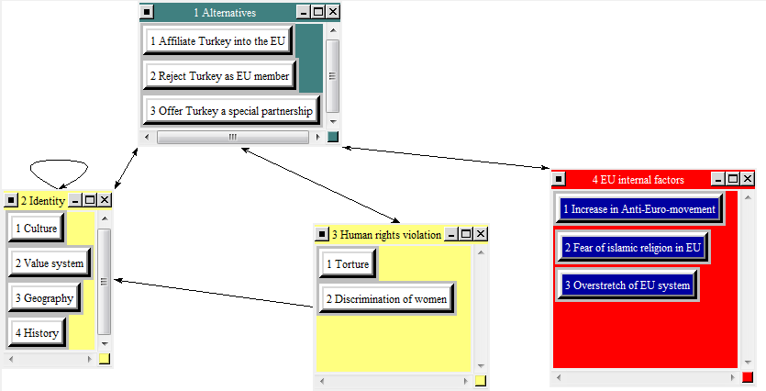
Figure 13: Sociocultural Subnet under Costs

Synthesized Results

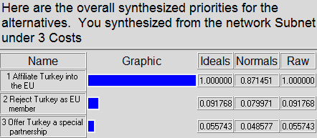
Figure 14: Synthesized Results under Costs
The synthesis can be seen as a reverse rating, showing the most expensive alternative as its first choice. Therefore “Affiliate Turkey” is the most expensive choice showing up at 87.1%. “Reject Turkey” and “Offer special partnership” are rated with 8% and 4.9%, respectively.

Risks

The Subnets

The risks involved again cover political, economic, and sociocultural aspects.
Political risks refer to the negative impact on the system of the EU itself. They also take into consideration the relationship between the EU and its neighboring countries. The instability of the political system (mainly caused by the strong influence of the military and terrorist attacks by the PKK) within Turkey might be transferred to the EU. Besides, the degree of freedom of action might get limited through the admission of Turkey. Different political attitudes as well as the existence of an additional member might complicate the process of decision making within the EU. Furthermore, minorities such as Kurds are persecuted or discriminated in Turkey. With reference to the neighboring countries of the EU, other Islamic countries could see the admission of Turkey as a bridge which could forward the expansion of Islam, but this might also bear further terrorism. However, further terrorism might not be completely prevented by either rejecting Turkey as an EU member or offering a special partnership. On the other hand, the relationship between the EU and other Islamic countries could worsen as there are ongoing conflicts between Turkey and theses countries. The admission of Turkey would import these conflicts into the EU. The positive relationship between the EU and Israel might also suffer from an intensified relationship with Turkey. Additionally, the affiliation of Turkey might lead other neighboring countries to claim membership. In particular poorer and geographically insignificant countries might be seen as potential candidates. Moreover, a closer relationship to Turkey and the safe access to oil fields in the Caucasus may strain or deteriorate the existing relationship between Russia and the EU.
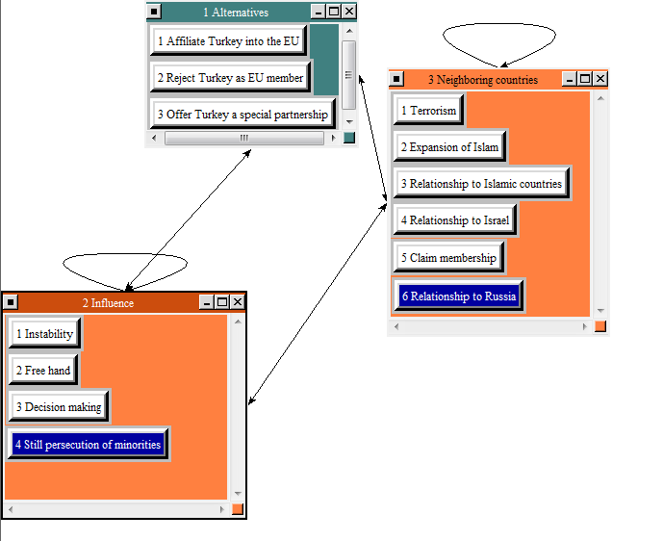
Figure 15: Political Subnet under Risks
Regarding economic risks, major factors are: expected rise in social security costs because of higher unemployment rates (former asylum seekers might claim financial support) and the outflow of cash from existing EU countries as a consequence of outsourcing activities. In addition, the agricultural subsidies for Turkey as a member of the EU will be too burdensome for the existing member state and might also cause another discussion about the accurate distribution of subsidies among the member states. Moreover, the EU currency could devalue because of political crisis within Turkey or at its borders or because of investors´ belief that a true integration of Turkey is possible. There might also arise various capacity problems. The potential migration of Turkish people to EU countries and higher birth rates of the immigrants might, for example, require the construction of new houses as well as religious centers and extra capacities in schools and other educational institutions. Capacity risks are short-term as well as long-term related. Financial risks are predominantly short-term risks. It becomes clear that, regarding the economic risks, the rejection of Turkey would be, in any case, the least risky alternative. The difference between full admission and a special status of Turkey is not regarded as substantial.
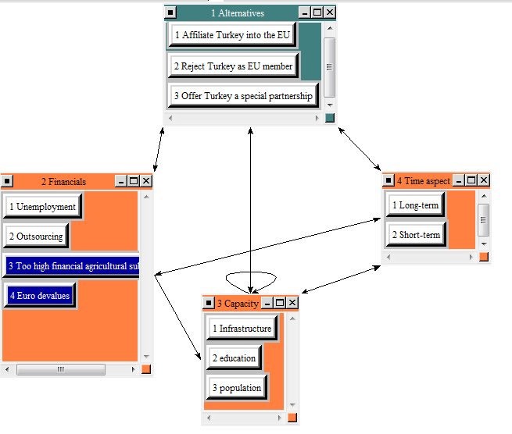
Figure 16: Economic Subnet under Risks
Relating to the sociocultural risks, the demographic aspect – as mentioned above – also plays a major role. Further risks cover again the issue of identity. Specifically, the construction of further mosques might be perceived as foreign bodies in the predominantly Christian shaped society of Europe. The potential conflicts especially refer to the affiliation of Turkey into the EU. The feeling of injustice deriving from social security claims of the Turkish immigrants as well as the different value system throughout Europe might increase xenophobia towards the Turkish people. On the other hand, the immigrants might decide to further separate themselves from the surrounding society as to protect their Islamic beliefs. Furthermore, an affiliation of Turkey might reduce their efforts with regards to a true integration into the EU and its Western culture, because once you become a member it is rather unlikely to be thrown out again. This might also lead to a slower implementation (if at all) with regards to the ban of forced marriages. If Turkey becomes an EU member, the geographical expansion might also lead to a higher exposure of terroristic attacks which would in turn influence and threat the living of the EU citizens. The risk of further separation, however, might also occur if Turkey is rejected. Efforts towards better integration of asylum seekers and Turkish immigrants throughout Europe should therefore be communicated as major issues independent from the result of this debate itself.
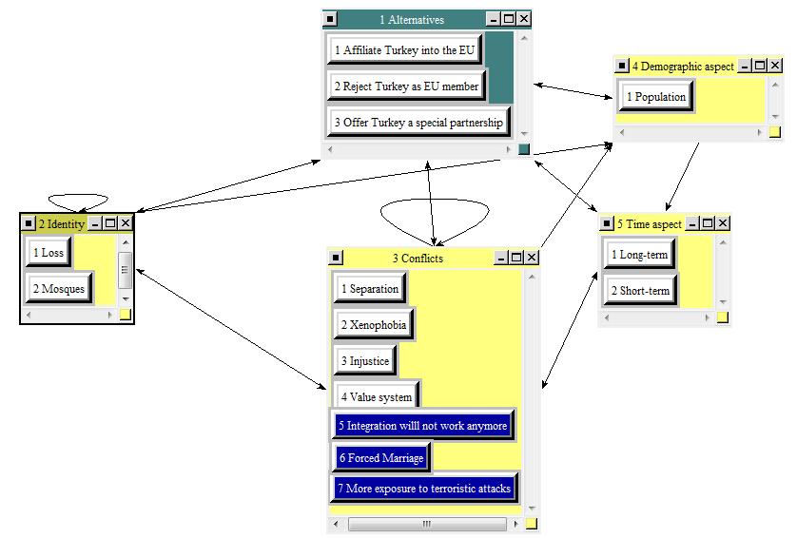
Figure 17: Sociocultural subnet under Risks

Synthesized Results

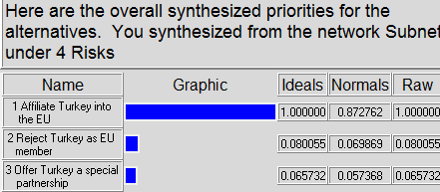
Figure 18: Synthesized Results under Risks
The subnet under risks shows similar results as compared to the one under costs. The “Affiliation of Turkey” bears the highest risks with 87.3%, followed by “Reject Turkey” with 7% and “Partnership” with 5.7%.

Rating Model

We implemented a ratings system to compare the results of each BOCR node against our three strategic criteria in order to develop the weights for the “driving” alternative for each BOCR node. The Ratings Matrix with the control criteria (political, economic, sociocultural) and the BOCR as the dependent variables appears as follows:
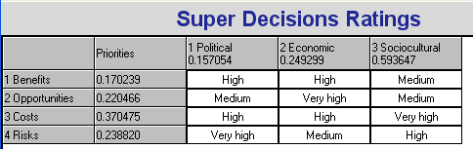
Figure 19: Decision Rating to develop BOCR Weight
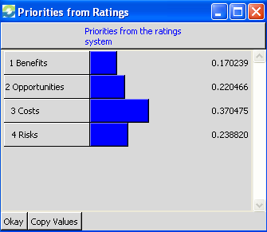
Figure 20: Priorities for the Ratings System
As seen above, both Costs and Risks together make up 61% of the totals. Benefits and Opportunities represent 17% and 22% respectively. Therefore it becomes clear that we see the negative aspects of this debate as the limiting factors towards a full integration of Turkey into the EU which is mainly caused by the high rating of the sociocultural strategic criteria.

Analysis of Result

Additive Method (negative)

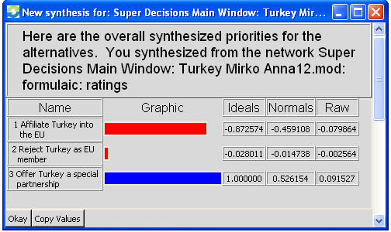
Figure 21: Synthesis for the (negative) Additive Model
Overall, “Offer Turkey a special partnership” came in as the best solution. This alternative ranked only as number two in benefits and opportunities with a huge gap to the first place, but created the least amount of costs and risks. This result demonstrates that the overall costs and risks are of greatest importance whereas benefits and opportunities are only weighted as being of minor importance (see figure 20). The second best solution is “Reject Turkey as EU member”. The reason for this ranking can be seen in high costs and risks savings outweighing the benefits and opportunities. According to our model, “Affiliate Turkey into the EU” is the least attractive solution.

Multiplicative Method

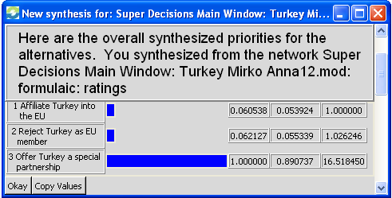
Figure 22: Synthesis of Multiplicative Method
In general, the multiplicative method multiplies benefits and opportunities and divides the result by the product of costs and risks.
Similar to the additive model, “Offer Turkey a special partnership” is again the best choice with 89.1% for the multiplicative method. “Rejecting Turkey as EU member” ranks second with 5.5%, while “Affiliating Turkey into the EU” with 5.4%. The special partnership is therefore a compromise between the other two possibilities – offered alone it wouldn’t be a favorable choice – but compared to the other alternatives it is the best to choose.

Sensivitiy Analysis

Benefits

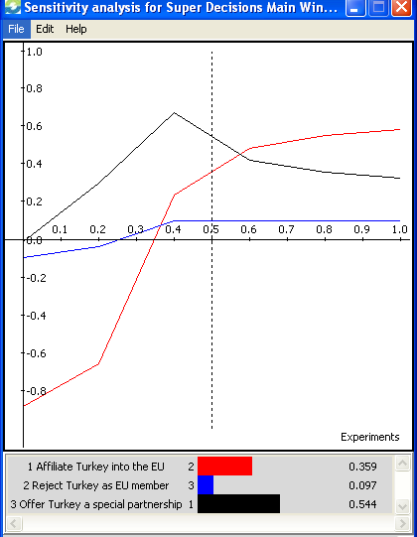
Figure 23: Sensitivity Analysis for Benefits
The special partnership is the best choice until a weighting of benefits of about 57%. With weights higher than 57%, alternative 1 “The admission of Turkey”, gets the best rating.

Opportunities
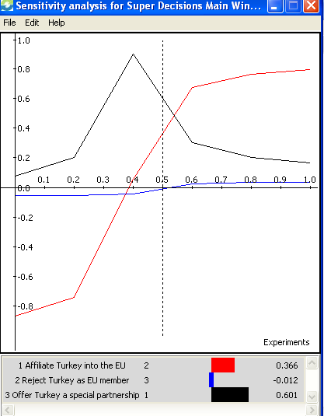
Figure 24: Sensitivity Analysis for Opportunities
The sensitivity graph regarding opportunities shows a similar trend as compared with benefits. Up to a weighting of opportunities of about 54%, alternative 3, the special partnership, is the best choice. With weights higher than 54%, alternative 1, the admission of Turkey, gets the best rating.

Costs
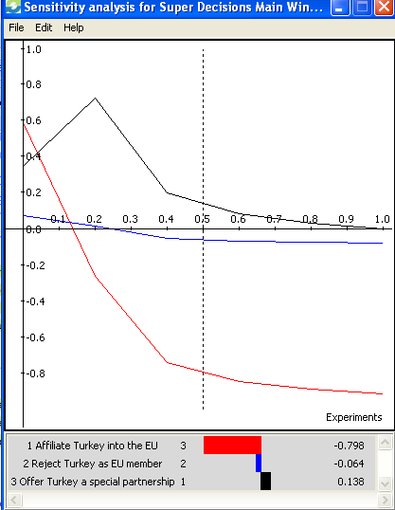
Figure 25: Sensitivity Analysis for Costs
With respect to costs, as long as we weight the costs more than approximately 4%, alternative 3, the special partnership, will be the primary choice. As we decrease the weighting under 4%, the order of the given alternatives will switch to alternative 1. It is also interesting to see that the higher the weighting of costs alternative 3 and alternative 2 are getting closer to each other.

Risks

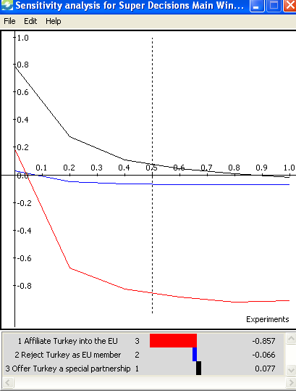

Figure 26: Sensitivity Analysis for Risks
A change in the weighting of risks does not change the alternative chosen: “Offer Turkey a special partnership” will always be the highest rating. When increasing the weight of risks, alternative 2 again narrows alternative 3.

Conclusion

After running through the model, it was not surprising to discover that “Offer Turkey a special partnership” was the top choice followed by “Reject Turkey as EU member”. Since sociocultural aspects outweighed the political and economic criteria, cost and risks got higher priorities. Therefore, these alternatives were the top choices based on the fact that the costs and risks of fully accepting Turkey as a member of the EU outweighed the benefits and opportunities of this alternative. These two top alternatives are expected to offer the best results for the European Union as a whole, for each of its existing members and Turkey itself. Offering Turkey a special partnership would also allow both parties to not publicly lose their face by finally ending the long lasting negotiations.
It is interesting to see that the final recommendation resulting from this model did not change, although we adjusted the model including recent events and developments. However, we expect further heated and tedious negotiations among the EU members as well as with Turkey regarding that question. We are eager to hear about the outcome.

Appendix
Copenhagen Criteria:
The so-called " Copenhagen criteria ", set out in December 1993 by the European Council in Copenhagen, require a candidate country to have:
- stable institutions that guarantee democracy, the rule of law, human rights and respect for and protection of minorities;
- a functioning market economy, as well as the ability to cope with the pressure of competition and the market forces at work inside the Union;
- the ability to assume the obligations of membership, in particular adherence to the objectives of political, economic and monetary union.
In 1995 the Madrid European Council further clarified that a candidate country must also be able to put the EU rules and procedures into effect. Accession also requires the candidate country to have created the conditions for its integration by adapting its administrative structures. While it is important for EU legislation to be transposed into national legislation, it is even more important for the legislation to be implemented and enforced effectively through the appropriate administrative and judicial structures. This is a prerequisite of the mutual trust needed for EU membership.
In addition, the EU must be able to integrate new members: it needs to ensure that its institutions and decision-making processes remain effective and accountable; it needs to be in a position, as it enlarges, to continue developing and implementing common policies in all areas; and it needs to be in a position to continue financing its policies in a sustainable manner.

See appendix for detailed description of the Copenhagen criteria.
http://ec.europa.eu/enlargement/candidate-countries/turkey/eu_turkey_relations_en.htm [as of 13.04.10]
http://ec.europa.eu/enlargement/the-policy/conditions-for-enlargement/index_en.htm [as of 13.04.10]

