ANWR

Arctic National Wildlife Refuge

Justin Emanuel

Pete Cefalu

Introduction to the ANWR situation
ANWR-Arctic National Wildlife Refuge covers 19 million acres on the Northern coast
of Alaska. The entire refuge lies nort of the Arctic Circle and 1,300 miles south of the North Pole. The Coastal Plain area comprising 1.5 million acres on the northern edge of ANWR, is bordered on the north by the Beaufort Sea, on the east by the U.S. Canadian border and on the west by the Canning River. The consensus of the geologic community is that the Coastal Plain of ANWR represents the highest petroleum potential onshore area yet to be explored in North America. If explored, it is estimated that it will take 15 years or more before oil and gas will reach the market.
This coastal plain area, also known as area 1002, was originally protected in 1960 by President Eisenhower. Twenty years later President Carter signed the Alaska National Interest Conservation Act. This legislation was important as it created a majority of the National Parks in Alaska and expanded ANWR to its current size. A compromise was reached to pass the legislation, in return for designating a majority of the area-protected land; area 1002 was left unprotected and thus open for exploration.
Each administration since has had its own opinion regarding the land and what should be done with it. The Reagan Administration was ready to drill but was derailed by the Exxon Valdez catastrophe. The first Bush Administration likewise was unsuccessful. The Clinton Administration designated the area for protection and it has been since.
The second Bush Administration, in response to ongoing Middle East violence and recent terrorists attacks, namely 9/11, sees drilling in ANWR as vital not only for economic but national security reasons. Several environmental groups consider ANWR a great American natural treasure and one of the last places on the earth where an intact expanse of arctic and sub-arctic lands remain protected. They feel the habitat, the wildlife, and the culture need to be protected from the exploration of gas and oil.
The following Super Decisions model was composed as a way of coming to a decision regarding the use of this land. This model incorporates pair-wise comparisons of benefits, costs, opportunities and risks associated with drilling or not drilling. By making these comparisons and choosing the answers that best represent the use of this land we were able to come to a plausible conclusion on whether or not this land should be further explored.

Overview of the Model

Outline for ANWR model
- The ANWR Model sub-networks were set up as follows:
- Benefits, Costs, Risks and Opportunities sub-networks all contain the following alternatives:
- Economic alternatives follow:
- Do Not Drill For Oil
- Drill For Oil
- Political alternatives follow:
- Do Not Drill For Oil
- Drill For Oil
- Social alternatives follow:
- Do Not Drill For Oil
- Drill For Oil

Main structure of Top-level network Overview

Alternatives | - Do Not Drill For Oil (Open ANWR for oil and gas drilling)  - Drill For Oil (Do not open ANWR for oil and gas drilling)
Network Type: | Formulaic
Formula: | $NormalNet(Benefits)*$SmartAlt(Benefits) + $NormalNet(Opportunities)*$SmartAlt(Opportunities) + $NormalNet(Costs)*(1-$SmartAlt(Costs)) + $NormalNet(Risks)*(1-$SmartAlt(Risks))
Clusters/Nodes | - 2Criteria: These criteria are used to evaluate the merits of the ANWR situation.  - Amount of oil: This will take into account the amount of oil that is available in the ANWR area. For example, if the amount of oil is very low, outcome of this criteria would lean towards not drilling for oil.  - General public opinion: This criteria takes into account the general public opinion. This includes local, national and international.  - International Politics: International relations with OPEC nations and the outcome of the drilling situation.  - Goal: The Goal in this model is to Drill or Not Drill for oil.  - Drill or Do Not Drill:  - Model: This is the top-level network.  - Benefits:  - Costs:  - Opportunities:  - Risks:

Ratings for the BOCR

Priorities derived for the ratings

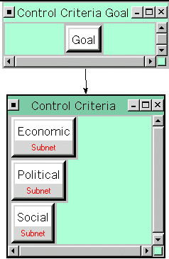
Main structure of Benefits network

This network is a sub-network of the top-level network. What follows a brief recap of the Benefits network.

Alternative(s) under it: | - Do Not Drill For Oil  - Drill For Oil
Clusters/Nodes | - Control Criteria: The automatically created control criteria cluster  - Economic  - Political  - Social

Main structure of Benefits/Economic network

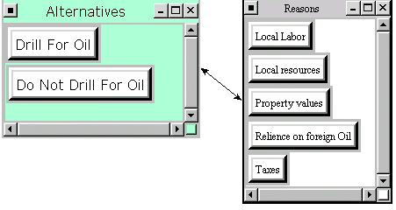
This network is a sub-network of Benefits. Following is a brief recap of this network.

Alternative(s) in it: | - Do Not Drill For Oil  - Drill For Oil
Clusters/Nodes | - Local Labor: Local work force and Local Jobs  - Local resources: Use of local raw materials that will boost other local industries in Alaska  - Property values: The effects of ANWR on the nearby property values  - Relience on foreign Oil: USA able to use our own oil instead of relying on the Middle East and other nations  - Taxes: What effect will this have on taxes

Political Main structure of Benefits/Political network

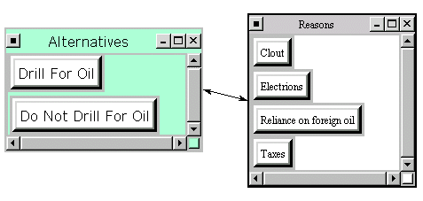

This network is a sub-network of Political Benefits. Following is a brief description of this network.

Alternatives: | - Do Not Drill For Oil  - Drill For Oil
Clusters/Nodes | - Alternatives:  - Do Not Drill For Oil:  - Drill For Oil:  - Reasons for Choosing an alternative:  - Clout: Political Power resulting from drilling or not drilling for oil.  - Elections: effect drilling or not drilling will have on democratic and republican elections  - Reliance on foreign oil: How drilling or not drilling will effect the US and the use of forign oil.  - Taxes: What will the effect be on taxes?

Social Main structure of Benefits->Social network

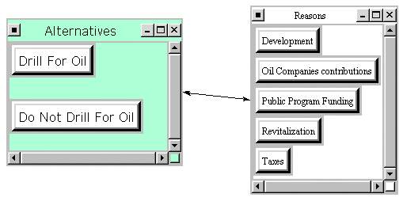

This network is a sub-network of Benefits. What follows a brief recap of this network.

Alternative(s) in it: | - Do Not Drill For Oil  - Drill For Oil
Clusters/Nodes | - Alternatives: The automatically created alternatives cluster  - Do Not Drill For Oil:  - Drill For Oil:  - Reasons:  - Development: Development of socialization locally  - Oil Companies contributions: Effect of oil companies contributing funding  - Public Program Funding: Public funding provide to help residents succeed  - Revitalization: re-stimulate the local social atmosphere  - Taxes: Effect on taxes

Main structure of Costs network
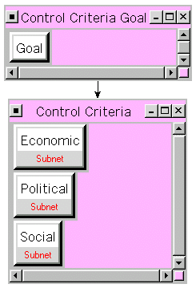

Alternatives | - Do Not Drill For Oil  - Drill For Oil
Clusters/Nodes | - Control Criteria: The automatically created control criteria cluster  - Economic"Economic:  - Political"Political:  - Social"Social:  - Control Criteria Goal: The automatically created control criteria goal cluster

Economic Main structure of Costs/Economic network
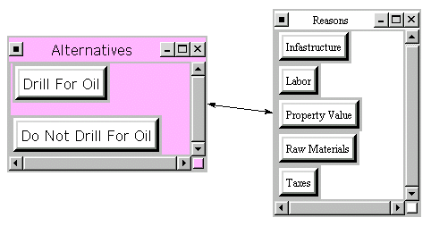

This network is a sub-network of Costs. What follows a brief recap of this network.

Alternatives | - Do Not Drill For Oil  - Drill For Oil
Clusters/Nodes | - Alternatives:  - Do Not Drill For Oil:  - Drill For Oil:  - Reasons: description  - Infrastructure: Cost of roads and railways to access the area  - Labor: Cost of labor needed to build and run new facility  - Property Value: What will happen to property value of nearby residents and businesses  - Raw Materials: Cost of raw materials needed  - Taxes: what is the effect on taxes

Political Main structure of Costs/Political network
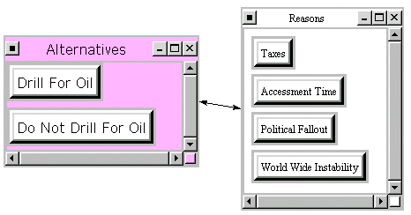

This network is a sub-network of Costs. What follows a brief recap of this network.

Alternatives: | - Do Not Drill For Oil  - Drill For Oil
Clusters/Nodes | - Alternatives:  - Do Not Drill For Oil:  - Drill For Oil:  - Reasons:  - Assessment Time: The time it takes to access the situation  - Political Fallout: What will cause political fallout  - Taxes: What is the cost of new taxes  - World Wide Instability: cost of causing world wide stability

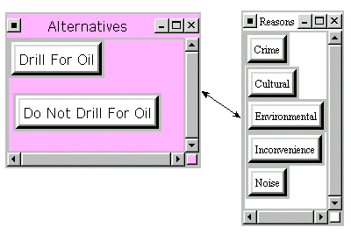
Social Main structure of Costs/Social network

This network is a sub-network of Costs. What follows a brief recap of this network.

Alternatives: | - Do Not Drill For Oil  - Drill For Oil
Clusters/Nodes | - Alternatives:  - Do Not Drill For Oil:  - Drill For Oil:  - Reasons:  - Crime: Crime rate  - Cultural: Historical cultural issues  - Environmental: effects on the environment  - Inconvenience: Inconvenience to inhabitants  - Noise: Noise pollution

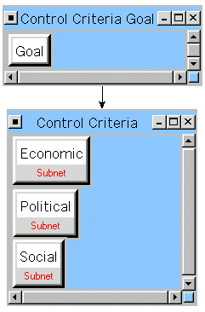
Main structure of Opportunities network

This network is a sub-network of the Top-Level network. What follows a brief recap of this network.

Alternatives | - Do Not Drill For Oil  - Drill For Oil
Clusters/Nodes | - Control Criteria: The automatically created control criteria cluster  - Economic"Economic:  - Political"Political:  - Social"Social:

Economic Main structure of Opportunities/Economic network
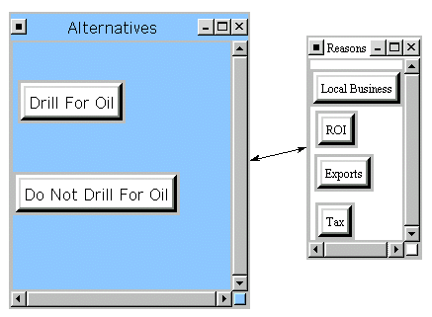

This network is a sub-network of Opportunities. What follows a brief recap of this network.

Alternatives in it: | - Do Not Drill For Oil  - Drill For Oil
Clusters/Nodes | - Alternatives:  - Do Not Drill For Oil:  - Drill For Oil:  - Reasons:  - Exports: value of exports  - Local Business: Use of local businesses  - ROI: Return on investment  - Tax: New tax rate

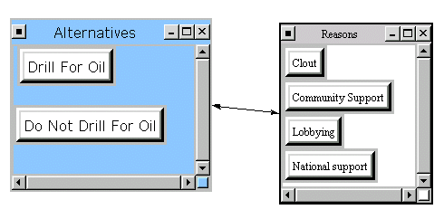
Political Main structure of Opportunities/Political network

This network is a sub-network of Opportunities. What follows a brief recap of this network.

.
Alternative(s) in it: | - Do Not Drill For Oil  - Drill For Oil
Clusters/Nodes | - Alternatives:  - Do Not Drill For Oil:  - Drill For Oil:  - Reasons:  - Clout: Political power  - Community Support: Support received locally  - Lobbying: lobbying for votes  - National support: Support received nationally

Social Main structure of Opportunities/Social network
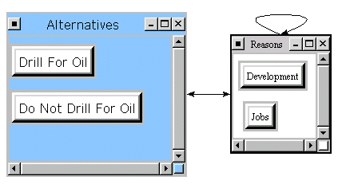

This network is a sub-network of Opportunities. What follows a brief recap of this network.

Alternatives: | - Do Not Drill For Oil  - Drill For Oil
Clusters/Nodes | - Alternatives:  - Do Not Drill For Oil:  - Drill For Oil:  - Reasons:  - Development: Development of surrounding areas  - Jobs: Jobs created locally

Main structure of Risks network
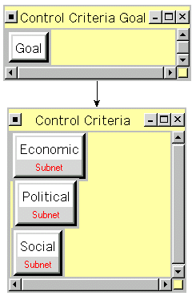

This network is a sub-network of top-level network. What follows a brief recap of this network.

Alternatives | - Do Not Drill For Oil  - Drill For Oil
Clusters/Nodes | - Control Criteria:  - Economic"Economic:  - Political"Political:  - Social"Social:

Economic Main structure of Risks/Economic network

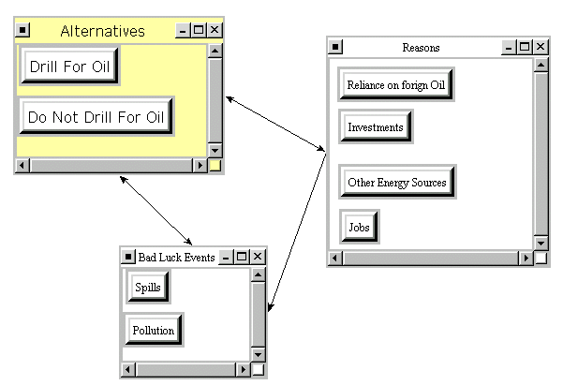

This network is a sub-network of Risks. What follows a brief recap of this network.

Alternative(s) in it: | - Do Not Drill For Oil  - Drill For Oil
Clusters/Nodes | - Alternatives:  - Do Not Drill For Oil:  - Drill For Oil:  - Bad Luck Events:  - Pollution: Pollution created  - Spills: Oil Spills  - Reasons: description  - Investments: Investing in US companies  - Jobs: Jobs created  - Other Energy Sources: Wind, Solar, gas, etc.  - Reliance on foreign Oil: US oil Vs. Foreign oil

Political Main structure of Risks/Political network
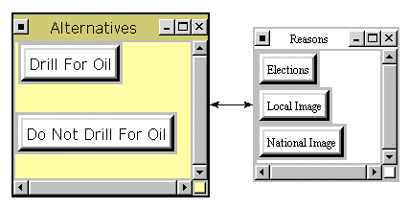

This network is a sub-network of Risks. What follows a brief recap of this network.

Alternative(s) in it: | - Do Not Drill For Oil  - Drill For Oil
Clusters/Nodes | - Alternatives:  - Do Not Drill For Oil:  - Drill For Oil:  - Reasons:  - Elections: Election outcomes  - Local Image: Local image created  - National Image: Portrayed national image

Social"Main structure of Risks->Social network
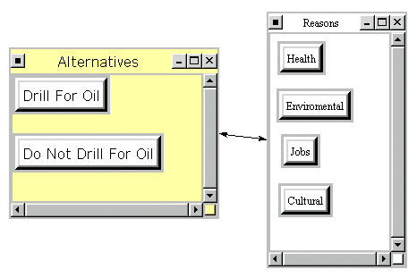

This network is a sub-network of Risks. What follows a brief recap of this network.

Alternative(s) in it: | - Do Not Drill For Oil  - Drill For Oil
Clusters/Nodes | - Alternatives:  - Do Not Drill For Oil:  - Drill For Oil:  - Reasons:  - Cultural: Cultural effects  - Environmental: Effects on environment  - Health: Effects on health  - Jobs: Jobs created

Report for toplevel
This is a report for how alternatives fed up through the system to give us our synthesized values.

Alternative Rankings
Graphic | Alternatives | Total | Normal | Ideal | Ranking
 | Do Not Drill For Oil | 0.2508 | 0.2235 | 0.2878 | 2
 | Drill For Oil | 0.8715 | 0.7765 | 1.0000 | 1

How the alternatives fed forward

Do Not Drill For Oil | Total Priority | Rank
Benefits | 0.3376 | 2
Costs | 0.3122 | 2
Opportunities | 0.1975 | 2
Risks | 1.0000 | 1

Drill For Oil | Total Priority | Rank
Benefits | 1.0000 | 1
Costs | 1.0000 | 1
Opportunities | 1.0000 | 1
Risks | 0.5524 | 2
- Ratings Information
- This network had sub-networks. So the ratings system's values is used to set the values of $TotalRat(Node_With_Sub-network), $NormalRat, and $IdealRat, used in any formula given.

Ratings Table
Graphic | Ratings Alternatives | Total | Ideal | Normal | Ranking
 | Benefits | 0.8595 | 1.0000 | 0.4252 | 1
 | Costs | 0.0947 | 0.1102 | 0.0469 | 4
 | Opportunities | 0.7684 | 0.8940 | 0.3801 | 2
 | Risks | 0.2989 | 0.3478 | 0.1479 | 3

Report for Benefits
This is a report for how alternatives fed up through the system to give us our synthesized values..

Alternative Rankings
Graphic | Alternatives | Total | Normal | Ideal | Ranking
 | Do Not Drill For Oil | 0.3376 | 0.2524 | 0.3376 | 2
 | Drill For Oil | 1.0000 | 0.7476 | 1.0000 | 1

How the alternatives fed forward

Do Not Drill For Oil | Total Priority | Rank
Economic"Economic | 0.1175 | 2
Political"Political | 0.1560 | 2
Social"Social | 0.1124 | 2

Drill For Oil | Total Priority | Rank
Economic"Economic | 0.3825 | 1
Political"Political | 0.3440 | 1
Social"Social | 0.3876 | 1

- Economic Report for Benefits/Economic
This is a report for how alternatives fed up through the system to give us our synthesized values.

Alternative Rankings
Graphic | Alternatives | Total | Normal | Ideal | Ranking
 | Do Not Drill For Oil | 0.1175 | 0.2351 | 0.3073 | 2
 | Drill For Oil | 0.3825 | 0.7649 | 1.0000 | 1

Political"Report for Benefits->Political
This is a report for how alternatives fed up through the system to give us our synthesized values. Return to main menu.

Alternative Rankings
Graphic | Alternatives | Total | Normal | Ideal | Ranking
 | Do Not Drill For Oil | 0.1560 | 0.3121 | 0.4537 | 2
 | Drill For Oil | 0.3440 | 0.6879 | 1.0000 | 1

Social Report for Benefits/Social
This is a report for how alternatives fed up through the system to give us our synthesized values.

Alternative Rankings
Graphic | Alternatives | Total | Normal | Ideal | Ranking
 | Do Not Drill For Oil | 0.1124 | 0.2248 | 0.2900 | 2
 | Drill For Oil | 0.3876 | 0.7752 | 1.0000 | 1

Report for Costs
This is a report for how alternatives fed up through the system to give us our synthesized values.

Alternative Rankings
Graphic | Alternatives | Total | Normal | Ideal | Ranking
 | Do Not Drill For Oil | 0.3122 | 0.2379 | 0.3122 | 2
 | Drill For Oil | 1.0000 | 0.7621 | 1.0000 | 1

How the alternatives fed forward

Do Not Drill For Oil | Total Priority | Rank
Economic"Economic | 0.0734 | 2
Political"Political | 0.0711 | 2
Social"Social | 0.2017 | 2

Drill For Oil | Total Priority | Rank
Economic"Economic | 0.4266 | 1
Political"Political | 0.4289 | 1
Social"Social | 0.2983 | 1

- Economic Report for Costs/Economic
This is a report for how alternatives fed up through the system to give us our synthesized values.

Alternative Rankings
Graphic | Alternatives | Total | Normal | Ideal | Ranking
 | Do Not Drill For Oil | 0.0734 | 0.1468 | 0.1721 | 2
 | Drill For Oil | 0.4266 | 0.8532 | 1.0000 | 1

Political Report for Costs/Political
This is a report for how alternatives fed up through the system to give us our synthesized values.

Alternative Rankings
Graphic | Alternatives | Total | Normal | Ideal | Ranking
 | Do Not Drill For Oil | 0.0711 | 0.1421 | 0.1656 | 2
 | Drill For Oil | 0.4289 | 0.8579 | 1.0000 | 1

Social Report for Costs/Social
This is a report for how alternatives fed up through the system to give us our synthesized values.

Alternative Rankings
Graphic | Alternatives | Total | Normal | Ideal | Ranking
 | Do Not Drill For Oil | 0.2017 | 0.4033 | 0.6760 | 2
 | Drill For Oil | 0.2983 | 0.5967 | 1.0000 | 1

Report for Opportunities
This is a report for how alternatives fed up through the system to give us our synthesized values..

Alternative Rankings
Graphic | Alternatives | Total | Normal | Ideal | Ranking
 | Do Not Drill For Oil | 0.1975 | 0.1649 | 0.1975 | 2
 | Drill For Oil | 1.0000 | 0.8351 | 1.0000 | 1

How the alternatives fed forward

Do Not Drill For Oil | Total Priority | Rank
Economic"Economic | 0.0707 | 2
Political"Political | 0.1312 | 2
Social"Social | 0.0542 | 2

Drill For Oil | Total Priority | Rank
Economic"Economic | 0.4293 | 1
Political"Political | 0.3688 | 1
Social"Social | 0.2792 | 1

- Economic Report for Opportunities/Economic
This is a report for how alternatives fed up through the system to give us our synthesized values.

Alternative Rankings
Graphic | Alternatives | Total | Normal | Ideal | Ranking
 | Do Not Drill For Oil | 0.0707 | 0.1414 | 0.1647 | 2
 | Drill For Oil | 0.4293 | 0.8586 | 1.0000 | 1

Political Report for Opportunities/Political
This is a report for how alternatives fed up through the system to give us our synthesized values.

Alternative Rankings
Graphic | Alternatives | Total | Normal | Ideal | Ranking
 | Do Not Drill For Oil | 0.1312 | 0.2624 | 0.3557 | 2
 | Drill For Oil | 0.3688 | 0.7376 | 1.0000 | 1

Social Report for Opportunities/Social
This is a report for how alternatives fed up through the system to give us our synthesized values.

Alternative Rankings
Graphic | Alternatives | Total | Normal | Ideal | Ranking
 | Do Not Drill For Oil | 0.0542 | 0.1625 | 0.1940 | 2
 | Drill For Oil | 0.2792 | 0.8375 | 1.0000 | 1

Report for Risks
This is a report for how alternatives fed up through the system to give us our synthesized values.

Alternative Rankings
Graphic | Alternatives | Total | Normal | Ideal | Ranking
 | Do Not Drill For Oil | 1.0000 | 0.6442 | 1.0000 | 1
 | Drill For Oil | 0.5524 | 0.3558 | 0.5524 | 2

How the alternatives fed forward

Do Not Drill For Oil | Total Priority | Rank
Economic"Economic | 0.3195 | 1
Political"Political | 0.2787 | 1
Social"Social | 0.3234 | 1

Drill For Oil | Total Priority | Rank
Economic"Economic | 0.1590 | 2
Political"Political | 0.2213 | 2
Social"Social | 0.1766 | 2

- Economic Report for Risks/Economic
This is a report for how alternatives fed up through the system to give us our synthesized values.

Alternative Rankings
Graphic | Alternatives | Total | Normal | Ideal | Ranking
 | Do Not Drill For Oil | 0.3195 | 0.6676 | 1.0000 | 1
 | Drill For Oil | 0.1590 | 0.3324 | 0.4978 | 2

Political Report for Risks/Political
This is a report for how alternatives fed up through the system to give us our synthesized values.

Alternative Rankings
Graphic | Alternatives | Total | Normal | Ideal | Ranking
 | Do Not Drill For Oil | 0.2787 | 0.5574 | 1.0000 | 1
 | Drill For Oil | 0.2213 | 0.4426 | 0.7941 | 2

Social Report for Risks/Social
This is a report for how alternatives fed up through the system to give us our synthesized values.

Alternative Rankings
Graphic | Alternatives | Total | Normal | Ideal | Ranking
 | Do Not Drill For Oil | 0.3234 | 0.6468 | 1.0000 | 1
 | Drill For Oil | 0.1766 | 0.3532 | 0.5461 | 2

Conclusion

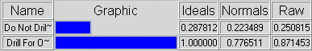
In summary, exploring for oil and gas seems to be a better alternative for ANWR. Our model indicates that ANWR should be opened to oil and gas exploration by 77.65%.

In a recent poll conducted, native Alaskans support opening ANWR to oil and gas exploration. The poll results are show below. The question asked was “Do you believe oil and gas exploration should or should not be allowed within the ANWR Coastal Plain?”

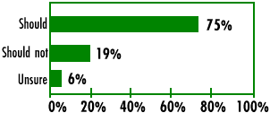

This outcome is consistent with our findings and appears to be with all geographic subgroups in Alaska (See below).

RED = support for opening ANWR
BLUE = Does not support opening ANWR

