Decision making in a Complex Environment
April 22, 2008

How to Provide Technical Services to a Companies Customer Base

James D. Longinotti

Background

Many companies today have large world wide service organizations. In many cases these organizations are designed as profit centers within the company. This means that not only are they charged with repairing, updating and providing preventative maintenance to products around the world but they must also contribute to the companies over all profits.
The operation of these departments involves spares location, logistics support, technical support, field service representatives, and depot repair facilities. The services that this organization can provide must be marketed to the customer base; this can be in the form of service agreements or service products. A key portion of the service revenue comes from new and renewed service contracts but there are also specific service products that can be marketed and sold to those who have chosen to not to purchase service contracts. If a customer chooses to provide their own service then they may require special tools for repairing and calibrating the equipment. The service organization can make these available to that even if a customer chooses to provide their own service some revenue can be obtained via the sale of tools, calibration kits, and training on how to perform the calibration.
In order to maximize profits decisions must also be made about where to locate field service representatives and spares. Should the field service representative be given an automobile or will the company reimburse them for mileage. If the field service representative is placed in the wrong location then a large sum of money will end up being spent on airfare to get them where they need to go. Where ever the service representative is located spares must be available either on the field service representative, on site, or be shipped to the location of failure.
In order to combat some of these issues many companies have developed different models for structuring their service organization. Just a few of the many possibilities are listed below and studied in this paper. Options 2 and 3 below involve using a third part service organization like GE, MIRA, or one of the many others available to provide the field service function using support from the company producing the product.
- Do not outsource the service function
  - The logistics, support, depot, and field forces all are operated and owned by the parent company.
- Outsource the entire service function
  - The logistics, support, and depot functions are operated and owned by the parent company however the field service function is outsourced.
- Outsource the service function in hard to reach locations.
  - The logistics, support, and depot functions along with some of the field service function are operated and owned by the parent company however some of the field service function is outsourced. This is the case in hard to reach locations where there are smaller numbers of products to be serviced.

The Model
The goal of this paper is to address the question: How should companies deploy service? How and where should companies get their field support representatives to the location of failure in the most profitable way while maximizing benefits and opportunities and minimizing costs and risks. The general model is given below:
How Should Companies Deploy Service

Benefits | Opportunities
Costs | Risks

Figure 1 – BOCR Model

The Alternatives:
- Do not outsource the service function
- Outsource the entire service function
- Outsource the service function in hard to reach locations

A view of the ANP:
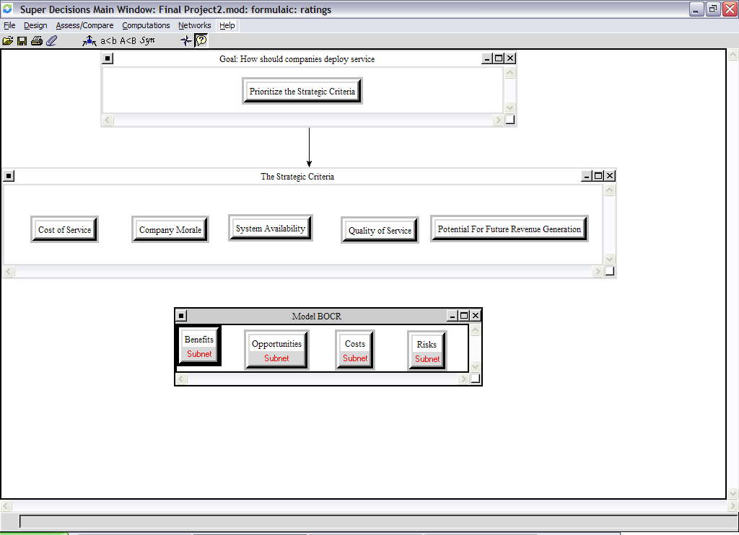
The Benefits Node – Includes subnets for Customer Satisfaction and Financial.
The Customer Satisfaction subnet is shown below: it includes clusters for System Availability and Quality os Service.
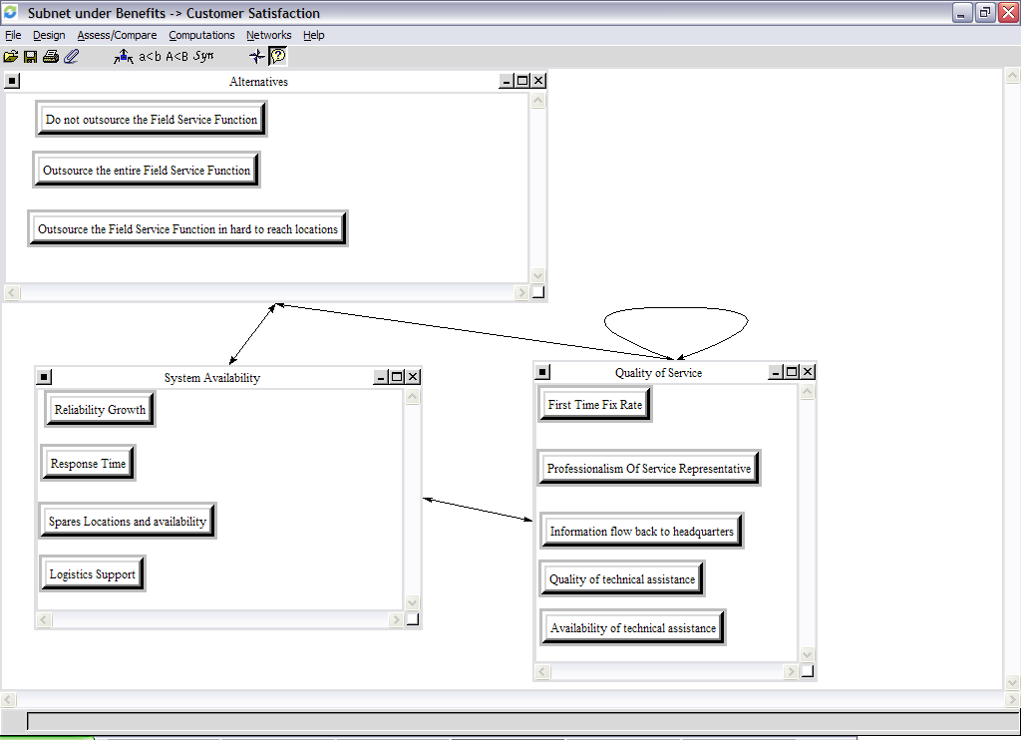

System Availability | Quality of Service
Reliability Growth | First Time Fix Rate
Response Time | Professionalism of Service Representative
Spares Location and Availability | Information Flow back to headquarters
Logistics Support | Quality of Technical Assistance
 | Availability of Technical assistance

The System Availability cluster includes nodes:
Reliability Growth: Indicates the potential for the systems reliability to improve based on feedback from field failures. Trends are analyzed and fixed through design modification
Response Time: Refers to the amount of time between the service call and the service technician arriving on site.
Spares Location: and Availability Refers to spares being where they are supposed to be when they are supposed to be so that system availability is maximized.
Logistics Support: Refers to the support organization in the parent company that maintains and delivers spares to the failure location.
The Quality of Service cluster includes nodes:
First Time Fix Rate: Is the rate that issues are resolved in one service visit only. No return visits are required.
Professionalism of the Service Representative: Indicates the attention and patience of the representative in dealing with the customer. Experience has shown that in house representatives typically score better in this category.
Information Flow back to Headquarters: This is important and can greatly effect the reliability growth of the product since this information is what allows a company to trend the data for failures.
Quality of Technical Assistance: This is important especially when outsourcing the field service function to those that are not familiar with the product.
Availability of Technical Assistance: How long does a rep have to wait to get help, and will they be available 24 hours a day, 7 days a week?
The Financial subnet is shown below, it includes the clusters: Service Revenue, Logistics Costs, Field Costs, Depot Costs, Transportation Costs
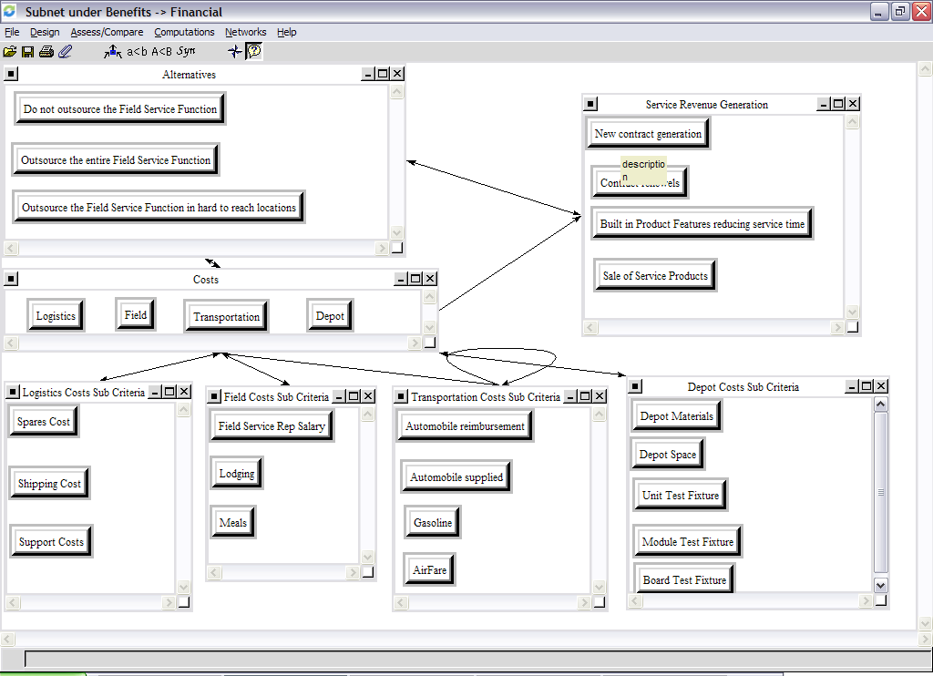
Logistics Costs | Field Costs | Transportation Costs | Depot Costs | Service Revenue Generation
Spares Costs | Field Rep Salary | Automobile Reimbursement | Depot Space | New Contract
Shipping Costs | Lodging | Automobile Supplied | Unit Test Fixture | Contract Renewal
Support Costs | Meals | Gasoline | Module Fixture | Built In Product Features
 |  | Air Fare | Board Fixture | Sale of Service Product

The Logistics Costs Cluster: This cluster contains the costs associated with getting spares on site to the location of failure. This includes the cost of the spare, the cost to ship it, and the cost of supporting the spares inventory (support costs). The support cost also includes the people required to establish inventory levels and maintain the inventory.
The Field Costs Cluster: This cluster contains the costs associated with repairing and maintaining product in the field. It includes the field rep salary, as well as their lodging and meals.
The Transportation Costs Cluster: This cluster contains the cost of the getting the field rep to the location of failure. This cluster includes airfare and carfare and gasoline. It looks at the relationship between automobile reimbursement and automobile supplied.
The Depot Costs Cluster: This cluster contains the costs associated with repairing failed Field Replaceable Units (FRUs) in the field. The primary drivers of this are the test equipment required to trouble shoot to the unit module and board as well as the cost of space required for the people and equipment.
Service Revenue Generation: This cluster deals with the way a service organization can generate revenue. The major drivers for this cluster are new service contracts, contract renewals, the sale of service products, and the incorporation of design features that reduce the number of failures and the time required to repair them.
The Opportunities Node – Includes subnets for Customer Satisfaction and Financial
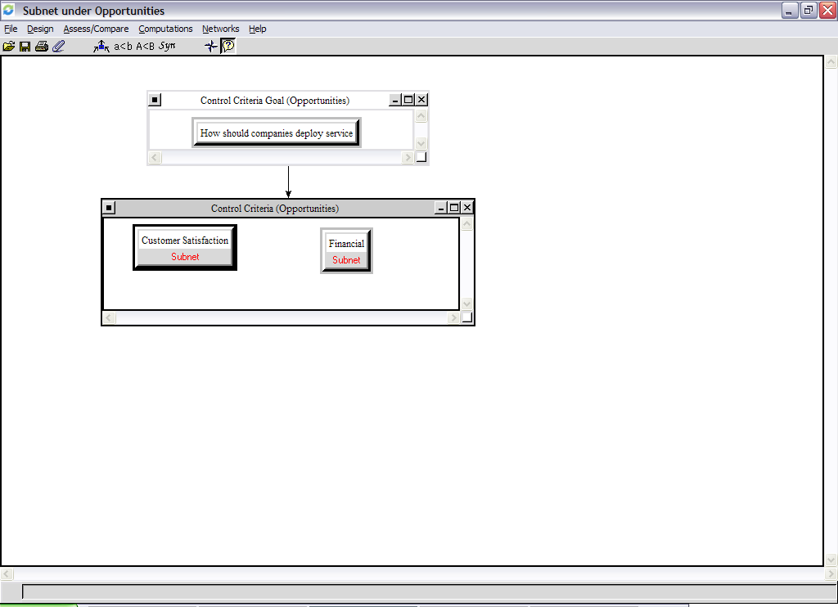
The subnets under Opportunities contain the same subnets as the benefits node Customer Satisfaction, and Financial. The clusters and nodes are shown again here the node descriptions are as described above.

Customer Satisfaction Subnet: includes clusters for System Availability and Quality of Service
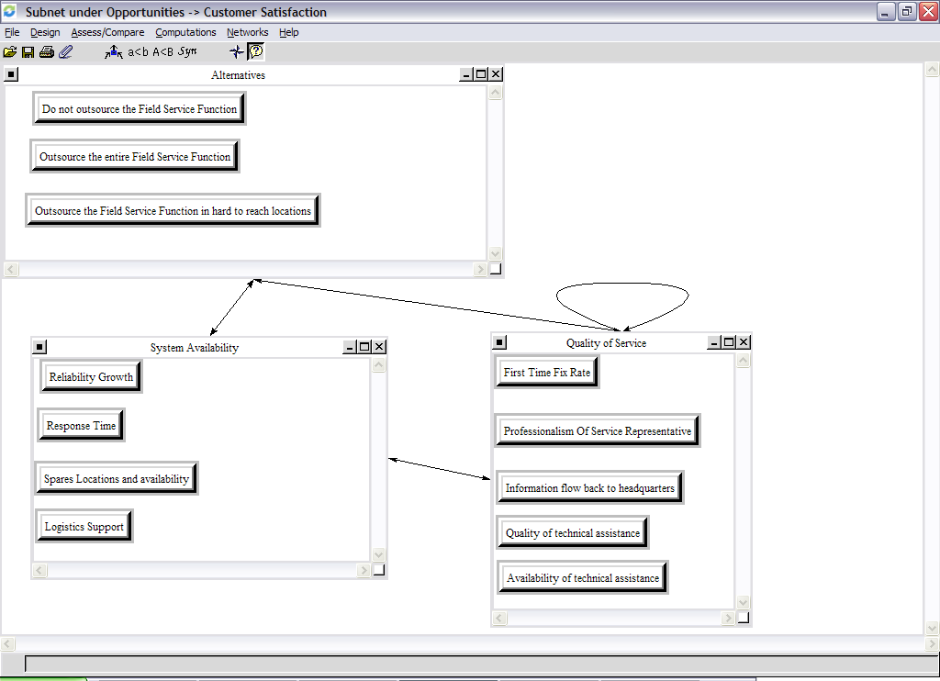
System Availability | Quality of Service
Reliability Growth | First Time Fix Rate
Response Time | Professionalism of Service Representative
Spares Location and Availability | Information Flow back to headquarters
Logistics Support | Quality of Technical Assistance
 | Availability of Technical assistance

These nodes have already been described under the Benefits Node

Financial Subnet: includes clusters for Service Revenue, Logistics, Field, Transportation, and Depot costs.
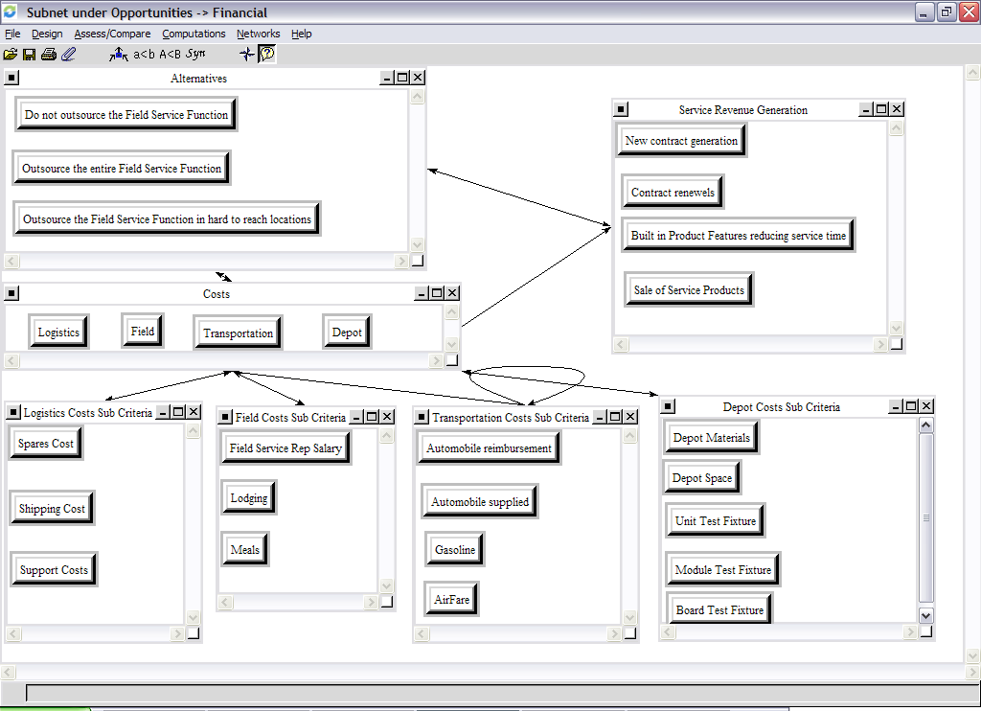
Logistics Costs | Field Costs | Transportation Costs | Depot Costs | Service Revenue Generation
Spares Costs | Field Rep Salary | Automobile Reimbursement | Depot Space | New Contract
Shipping Costs | Lodging | Automobile Supplied | Unit Test Fixture | Contract Renewal
Support Costs | Meals | Gasoline | Module Fixture | Built In Product Features
 |  | Air Fare | Board Fixture | Sale of Service Product

The Costs Node – Includes subnets for Salaries and Financial. In the costs node the worst alternatives get the highest priority. The questions that are asked are based on which are most costly.
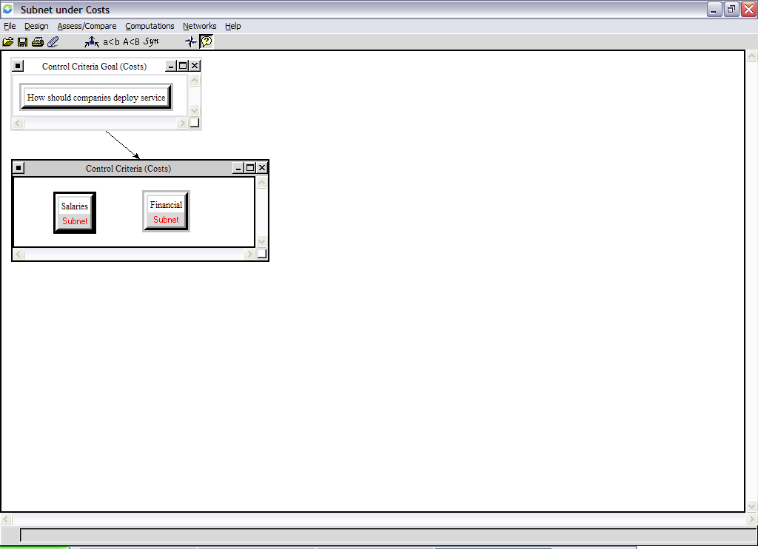
Salaries Subnet - The salaries subnet is shown below. It incorporates clusters for the salaries of the field, support, and depot staff.
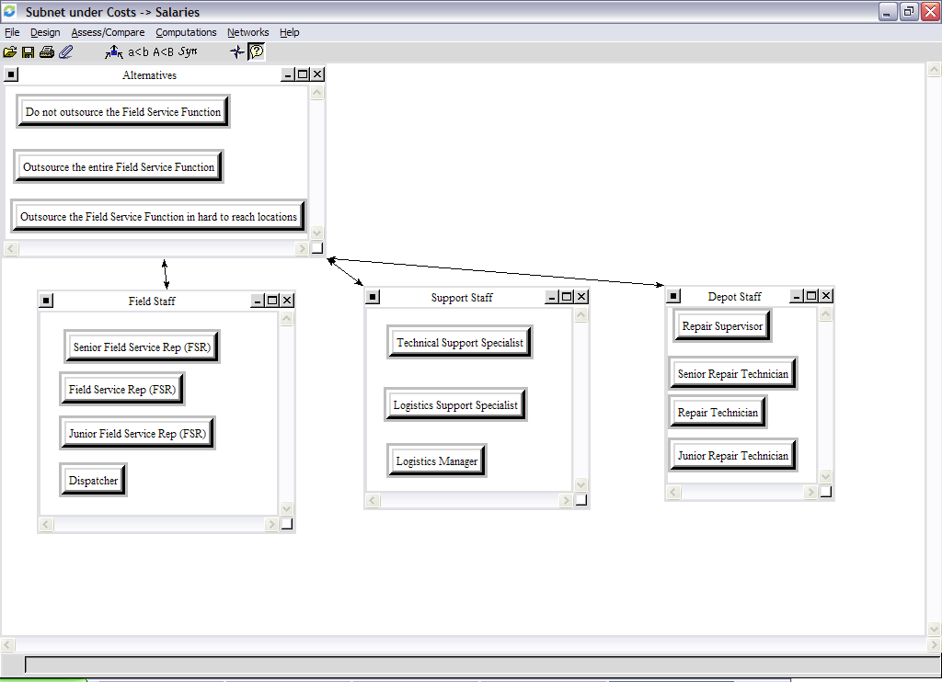

Field Staff | Support Staff | Depot Staff
Junior Field Service Representative | Technical Support Specialist | Junior Repair Technician
Field Service Representative | Logistics Support Specialist | Repair Technician
Senior Field Service Representative | Logistics Manager | Senior Repair Technician
Dispatcher |  | Repair Supervisor

Field Staff
The field staff in a typical service organization is broken into three levels based on experience and seniority. They are responsible for field repairs and maintenance as well as service contract sales. The lowest level is a junior field service rep having between 0 – 2 years of field experience, a field rep typically has between 2 – 5 years of experience and a Senior Rep has > 5 years of experience.
Support Staff
The support staff is normally broken down into technical support and logistics support. The logistics support personnel handle spares inventory world wide. They control the depot inventory as well as the field inventory and the flow of inventory between the depot and field. The technical support specialist is responsible for assisting the Field Service Engineer troubleshoot problems in the field. These employees report to a Logistics Manager.
Depot Staff
The depot staff is responsible for repairing failed field replaceable units returned from the field. They are broken up into similar levels as the Field Staff.

Financial Subnet – The financial subnet is shown below. It incorporates clusters for field, transportation, logistics, and depot costs and is shown below.
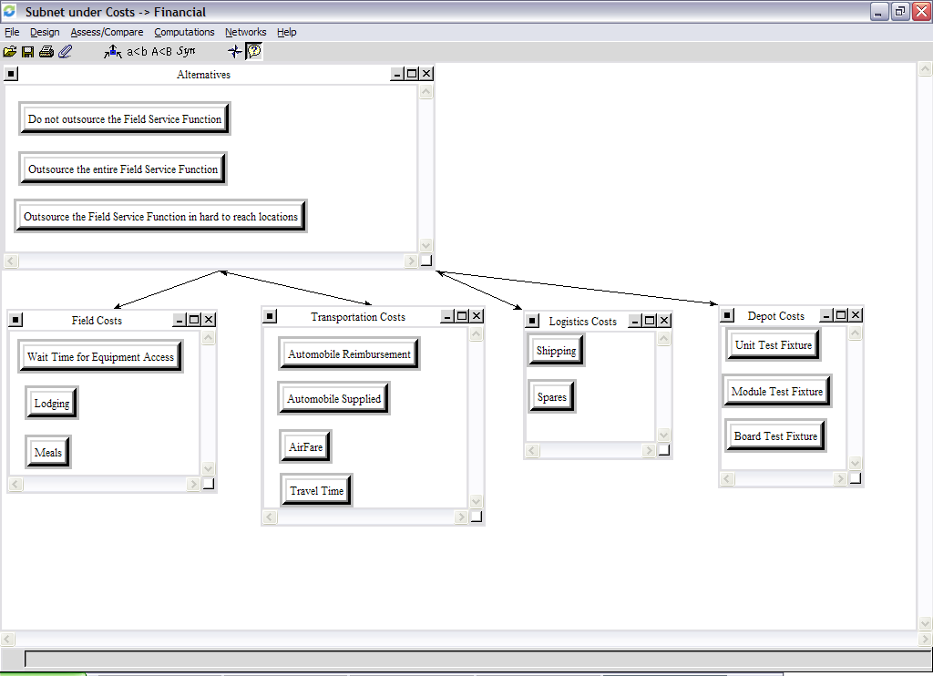

Field Costs | Transportation Costs | Logistics Costs | Depot Costs
Wait time | Automobile Reimbursement | Shipping | Unit Fixture
Lodging | Automobile Supplied | Spares | Module Fixture
Meals | Airfare |  | Board Fixture
 | Travel Time

Field Costs – The primary costs associated with the field are travel expenses like lodging and meals. The other cost considered is the time that the field rep will have to wait before he is permitted to service the equipment. If the product requires service but is not down hard the customer may choose to continue using it until they have completed their backlog, especially if they have customers waiting.
Transportation Costs – The primary transportation costs are carfare and airfare there is also a relationship between reimbursement for a personnel car or supplying a car.
Logistics Costs – These costs pertain to the cost of the spare and the cost of getting it where it needs to go.
Depot Cost – The primary depot costs are for the fixture needed to isolate the fault within the failed Field Replaceable Unit (FRU). This is done at different levels. The top level is the unit, it is the highest priority, below the unit is the module, and below the module is the board. Board refers to a printed circuit board.
The Risks Node – Includes subnets for Customer Satisfaction and Financial. In the risks node the worst alternatives get the highest priority. The questions that are asked are based on which are most risky.
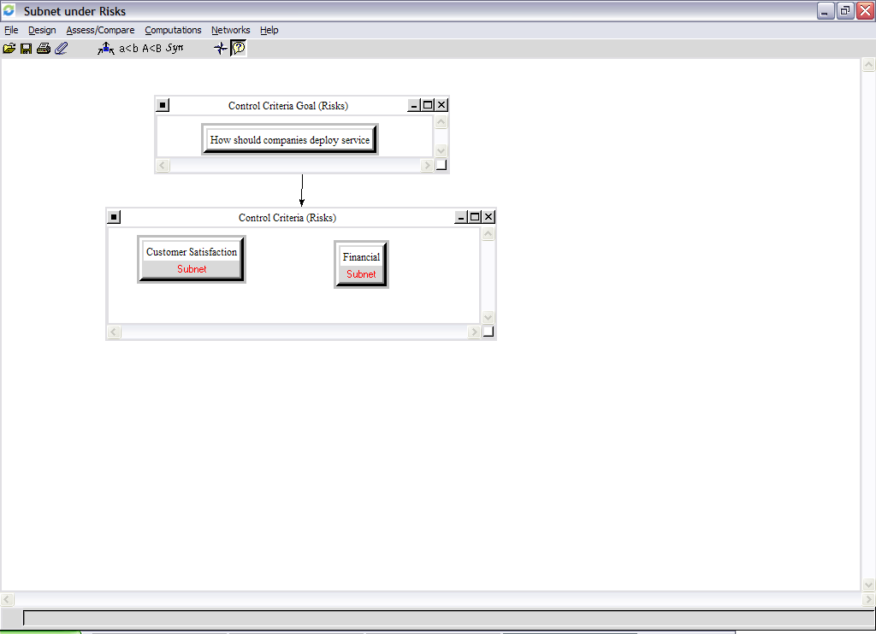

Customer Satisfaction Subnet – The subnet is shown below. It incorporates system availability and quality of service clusters as shown below.
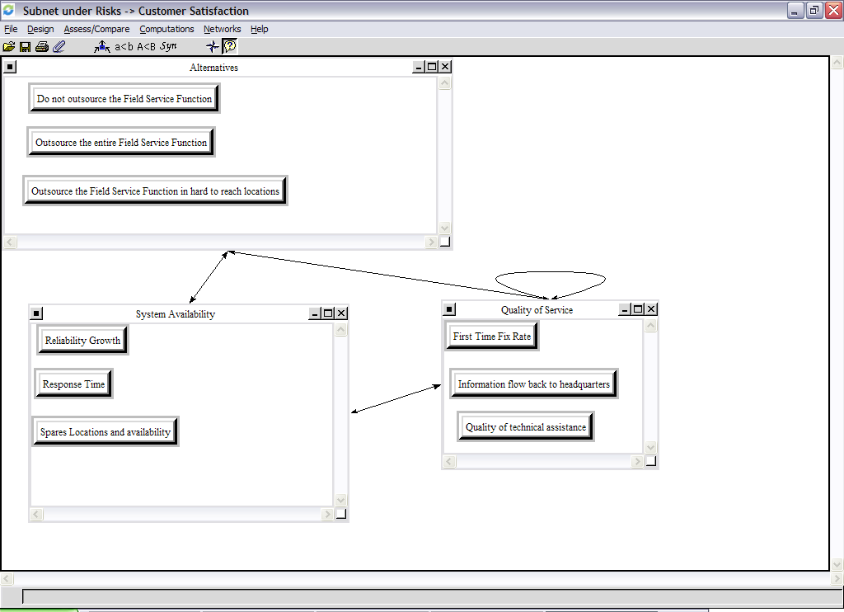
System Availability | Quality of Service
Reliability Growth | Information Flow back to Headquarters
Response Time | Quality of Technical Assistance
Spares Location and Availability

These nodes have already been defined under the benefits node.

Financial Subnet – Includes clusters for Service Revenue and Costs and is shown below.
Logistics Costs | Field Costs | Transportation Costs | Depot Costs | Service Revenue Generation
Spares Costs | Field Rep Salary | Automobile Reimbursement | Depot Space | New Contract
Shipping Costs | Lodging | Automobile Supplied | Unit Test Fixture | Contract Renewal
Support Costs | Meals | Gasoline | Module Fixture | Built In Product Features
 |  | Air Fare | Board Fixture | Sale of Service Product

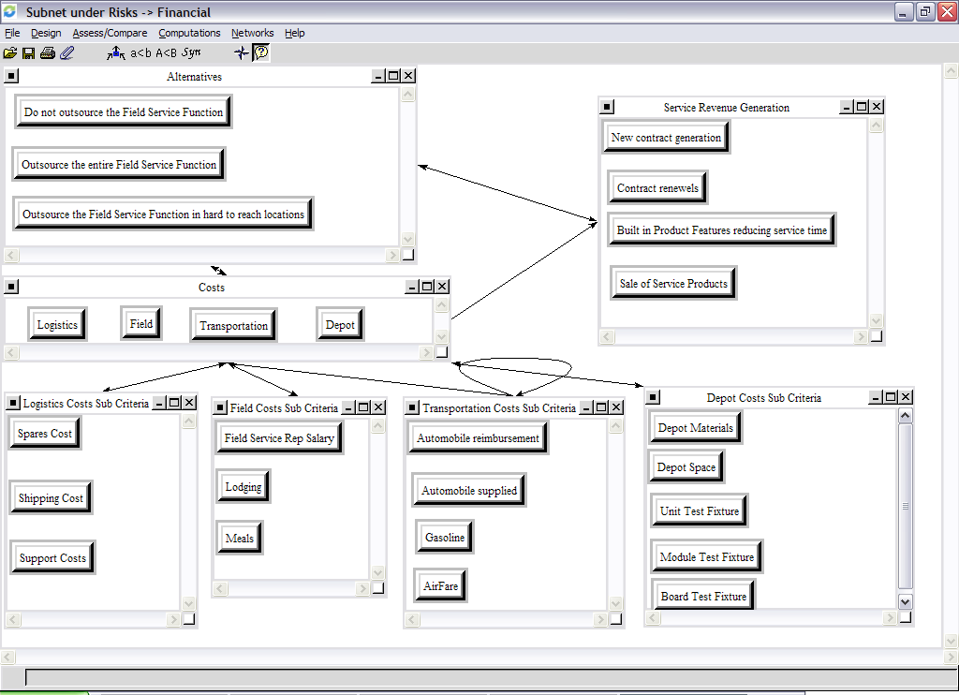

The clusters and nodes in the financial subnet have already been identified and described in the benefits node.

The Strategic Criteria

How are the Benefits, Opportunities, Costs, and Risks prioritized in the model? The BOCR model that I employed uses Strategic Criteria to prioritize these nodes. Categories were generated for each of the criteria and the categories were rated using pair wise comparisons.
The criteria and their categories are shown below:
Cost of Service | Company Morale | System Availability | Quality of Service | Potential For Future Revenue Generation
Low | Low | Low | Low | Low
Medium | Medium | Medium | Medium | Medium
High | High | High | High | High
Very High | Very High | Very High | Very High | Very High

The pair wise comparisons for the criteria and their ratings are shown below along with the priorities of the Benefits, Opportunities, Costs, and Risks:
 | Priorities | Cost of Service 0.278516 | Company Morale 0.037545 | System Availability 0.442611 | Quality of Service 0.092964 | Potential For Future Revenue Generation 0.148365
Benefits | 0.346132 | High | Medium | Very High | Very High | High
Opportunities | 0.246556 | High | Medium | Medium | Very High | Very High
Costs | 0.229592 | Very High | High | Medium | Medium | Medium
Risks | 0.17772 | Low | Medium | High | Medium | Medium

You can see from the table above that the Benefits received the highest priority followed by Opportunities, Costs, and Risks. These results can be used to formulate the final results using two methods additive (negative) and multiplicative.
In the additive (negative) method I used the following equation: bB + oO –c C – rR
In the multiplicative method I used the following equation: BO / CR
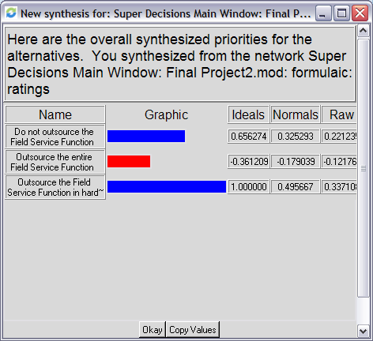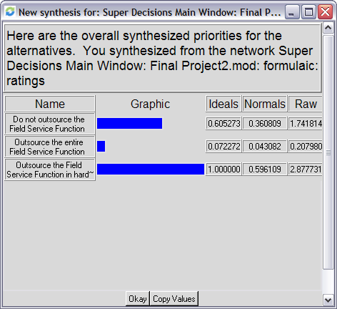
Additive (negative) from Super Decisions Multiplicative from Super Decisions
As a verification of these two methods the equations above were used to calculate the same values by hand in a spread sheet. It can be seen that the manual calculation matches that of the Super Decisions program. The parameters of these equations and the results are shown in the charts below:
 | Benefits | Opportunities | Costs | Risks | BO / CR | bB + oO - cC - rR
BOCR priorities | 0.3461 | 0.2466 | 0.2296 | 0.1777
Do not out source the service function | 0.7930 | 0.8206 | 0.7000 | 0.5337 | 1.7418 | 0.2212
Out source the entire service function | 0.4069 | 0.4100 | 0.8722 | 0.9197 | 0.2080 | -0.1218
Out source the service function in hard to reach locations | 0.9565 | 0.9443 | 0.5253 | 0.5975 | 2.8777 | 0.3371

Sensitivity Analysis
Please see appendix A for the sensitivity analysis

Conclusion
It can be seen that the results of these hand calculations matches the output from the Super Decisions software. The data used in the spread sheet is the raw data from Super decisions. It can be seen that in using both the additive and multiplicative methods to synthesize the results the alternative that is the best solution to the problem of “how should companies deploy service “ is to out source the service function in hard to reach locations. The benefits node had the highest priority followed by opportunities, costs and risks. There are many drivers to this question however the overwhelming driver is customer satisfaction.
This makes sense and is what many companies do today. Outsourcing the field service function in hard to reach locations can reduce costs like transportation and can keep customer satisfaction high by providing the outsourcing company with high quality technical and logistics support functionality.
Appendix A – Sensitivity Analysis
In my sensitivity analysis, I used parameter type 0, and network 0 because I wanted to see the relationship of the alternatives with respect to the BOCR priorities. I did a separate analysis for each of: benefits, opportunities, costs, and risks.
Modify the benefits priority holding others constant
As the benefits priority starts low the Alternative of outsourcing the entire field service organization is attractive, however once the benefits priority is raised outsourcing the field service function in hard to reach locations becomes the preferred alternative. This can be seen from the illustrations below.
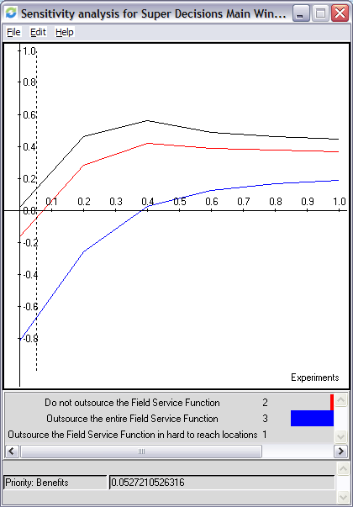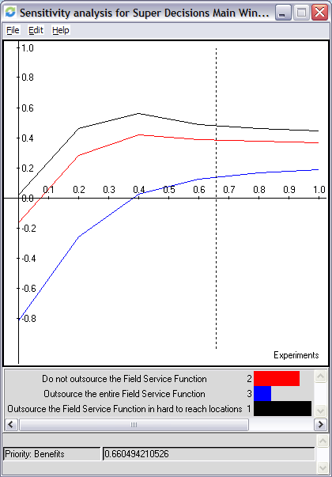

Modify the opportunities priority holding others constant
As the opportunities priority starts low the Alternative of outsourcing the entire field service organization is attractive, however once the benefits priority is raised outsourcing the field service function in hard to reach locations becomes the preferred alternative. This can be seen from the illustrations below and is similar to the benefits priority.
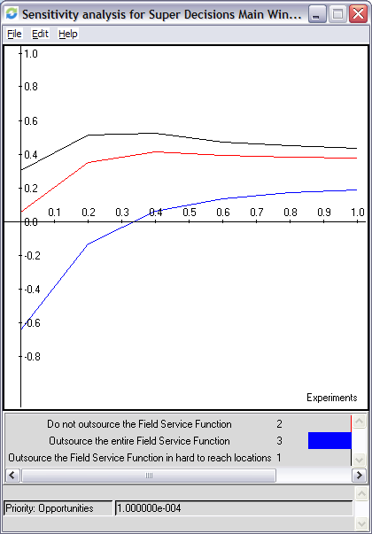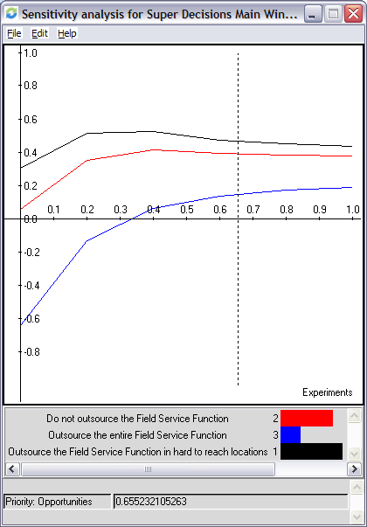

Modify the costs priority holding others constant
As the costs priority starts low the Alternative of outsourcing the entire field service organization is attractive, even as the priority is increased outsourcing the entire field service organization remains the most attractive alternative. This indicates tht outsourcing the entire field service organization could be costly. This can be seen from the illustrations below.

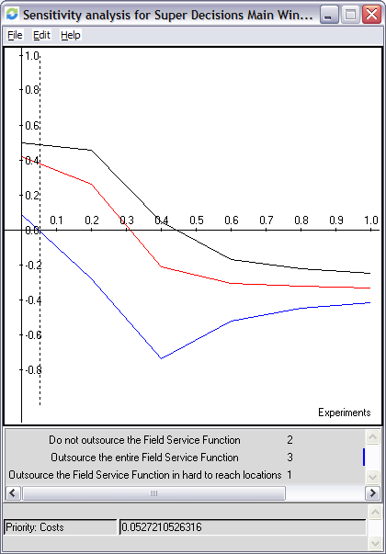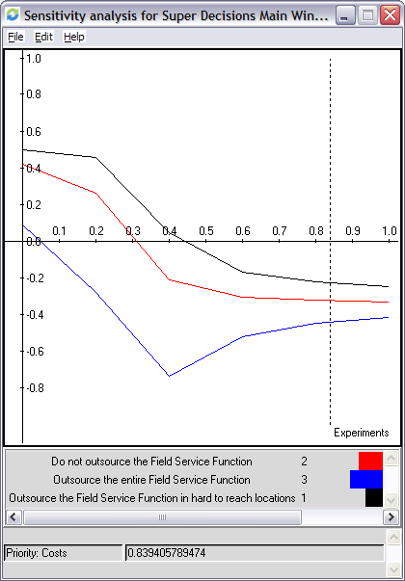

Modify the risks priority holding the others constant
As the risks priority starts low the Alternative of outsourcing the entire field service organization is attractive, even as the priority is increased outsourcing the entire field service organization remains the most attractive alternative. This indicates that outsourcing the entire field service organization could be risky. This can be seen from the illustrations below.
