UNIVERSITY OF PITTSBURGH
Katz Graduate School of Business

BQOM 2521
Decision Making in a Complex Environment
Fall 2008

Final Project
Topic: Best Career after Graduation
-The ANP Model-
October 6, 2008

Team Members

Pundhisa Aneknidhi
Duangporn Siribanpitak

Table of Contents
Page
Overview 3
Alternatives 3
The Model 3
1. Ratings 3 NETWORK ANALYSIS 5
2. BOCR Network 5
Benefits 5
Costs 6
Opportunities 7
Risks 8
Results 11
Sensitivity Analysis 11
Benefits Sensitivity 11
Costs Sensitivity 12
Opportunities Sensitivity 12
Risks Sensitivity 12
Conclusion 12
Appendix 13

Overview
The Best Career after Graduation Decision model was developed to evaluate potential career choices. We chose this topic because we both are not certain what we should do after completing our degree at Katz in order to gain maximized benefits in the future.
The alternatives for our career are:
(1) Marketing Field in the US
(2) Marketing Field in Thailand
(3) IT Field in the US
(4) IT Field in Thailand
(5) Accounting Field in the US and
(6) Accounting Field in Thailand
We determined that working in Marketing Field is our current concentration at Katz. It will be challenging for us while IT Field is our past work experience when we were in Thailand. It will be easy for us to find a job in this field in the US. However, Accounting Field is the major for our undergraduate degree. We always studied hard and got good grades. Also, we had some internship experience in this field. Since we will be obtaining our MBAs, we felt that there would be a good chance if we could switch jobs. We would be able to get a “better” job based on our specific criteria.

The alternatives were evaluated based on the followings:

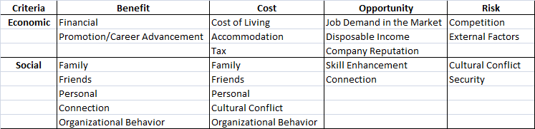

The Model
1. RATINGS:
Overview of our entire model is shown in Exhibit 1 in the Appendix. The model has 4 different strategic criteria. The strategic criteria are used to prioritize the BOCR as we recognize that in any decision there are multiple considerations that need to be taken into account.
1) Financial
2) Personal Satisfaction
3) Respect
4) Work-Life Balance

The results of the pair-wise comparisons between the criteria are shown below;
Subjective Value in Evaluating Merits

1.Financial: 0.44
3.Respect: 0.11

4.Work-Life Balance: 0.22

2.Personal Satisfaction: 0.22

A set of ratings for the overall significance of the Benefits, Opportunities, Costs, and Risks of the decision was developed. The strategic criteria are considered as Economic and Social. Ratings were given and prioritized with respect to the overall goals for each of the strategic criteria individually. The assessment criteria used to determine the priorities of the BOCR merits are shown below figure.

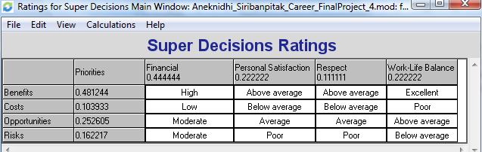

The priorities for ratings are below:

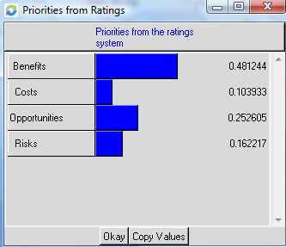

As indicated above, 3 factors (Benefits, Opportunities, and Risks) show high priorities. We satisfied with this output in that the input was carefully thought out.
The benefits are high almost across the board considering the best-case scenario for each alternative. Benefits could bring high financial reward, above average personal satisfaction, above average in regards to respect, and excellent work-life balance – all in the case that the chosen alternative leads to success in both personal and work life. Costs for all alternatives relate to below average one’s personal satisfaction, poor (inadequate) work-life balance, below average one’s respect and low finances. Considering Opportunities, financial reward would be moderate, respect average, personal satisfaction average and work-life balance above average. Risks have a moderate financial factor, possibility of poor respect, Poor personal satisfaction, and below average work-life balance.

NETWORKS ANALYSIS:
2. BOCR Network
The overall BOCR network is illustrated in a tree hierarchy format in figure below. The top level is a cluster that contains the Goal node. This cluster is connected to the second-level clusters that contain the BOCR nodes: Benefits, Opportunities, Costs and Risks.

Each subnet of Benefits, Opportunities, Cost and Risk were divided into:
- Economic
- Social

Benefits
Opportunities
Costs
Risks
Economic
Social
GOAL
Economic

Social
Economic

Social
Economic
Social

Benefits:
See Exhibit 2-4 in the Appendix. The Benefits Criteria was developed to analyze the potential benefits the six alternatives.

Economic Benefits:
FINANCIAL BENEFITS: The financial benefits of each alternative can be divided into two groups: monetary and non-monetary. Some examples for monetary benefits are wages, salaries, and bonus. For non-monetary benefits, some companies may offer recognition awards, number of vacation leaves, and any other kinds of welfare. We understand that working in IT Field in the US will give us the highest financial benefits while working in Accounting Field in Thailand may give us the lowest financial benefits compared to any other option we have. For non-monetary benefits, apart from IT Field in the US, we think there is no significant difference among other jobs.

PROMOTION/CAREER ADVANCEMENT: The promotion or career advancement consists of promotion evaluation method, incentive, and the percentage of annual salary increase. For IT Field, the promotion evaluation method is based on employee’s performance whereas Accounting Field is normally based on the level of seniority. The examples of incentive are commission and special pay when employees achieve some targets. We perceive that working in Marketing Field will get the highest incentive and finally gain the promotion. Moreover, in terms of growth in salary, we also think that Marketing Field gains the fastest growth in salary.

Social Benefits:
FAMILY: Family encompassed factors that would benefit one’s family, including time available for family and money to support, and proximity to them, as determined by career decisions. Working in Accounting Field in Thailand would allow more time for family, but would benefit low-to-moderately as far as money to support. Ideally, working in Marketing or IT Field would increase the monetary benefits but slightly decrease the benefits for time. Working in the US would definitely make us stay far away from our home country.

FRIENDS: Friends encompassed factors that would benefit the relations ship with one’s friends, including time available to spend with friends and earning the social acceptance from friends, as determined by career decisions. Working in IT Field in the US should gain the most respect, followed by Marketing Field in the US. The time benefit is similar to the family time benefit, with working in Accounting Field in Thailand allowing the most free-time to spend with friends.

PERSONAL: The personal cluster included standard of living, leisure time, and lifestyles. We determined that Accounting Field in the US would make us have the highest standard of living and Marketing Field in Thailand would make us have the lowest standard of living. Accounting Field in Thailand would have much leisure time, followed by Accounting Field in the US. In terms of lifestyles, if we work in Accounting Field in the US, we can do several free-time activities such as outdoor sports or travelling.
CONNECTION: This means the relationship with colleagues, supply chains, and community. Working in Marketing Field in Thailand makes us have a good relationship with colleagues because most of the job scopes tend to rely on team commitment. Moreover, for marketing jobs, we have to keep contact with the supply chains and also community.

ORGANIZATIONAL BEHAVIOR: We have three sub-criteria in this point. They are management style, team-oriented, and job mobility. We determined than IT Field has to rely on team in order to finish any assigned projects. Moreover, IT Field in the US generates many frequent business travels so we can get a chance to travel to several places.

Costs:
See Exhibit 5-7 in the Appendix. The costs network analyzes the costs associated with a career decision.

Economic Costs:
COST OF LIVING: The economic costs involved in deciding on a career choice are expenses for food, housing, healthcare, and clothing. When working in the US, you will incur the most costs for food, housing, and healthcare. In Thailand, the costs for these items are much cheaper. For clothing expenditures, working in Marketing field tends to have the highest costs of apparels in order to attract customers and make a good image of your company.

ACCOMMODATION: The sub-criteria network evaluates the costs associated with commute and home visit. If we work in IT Field in Thailand, we will make several trips to clients’ sites and this will affect our personal spending for commute (transportation) if we cannot reimburse this expense from our company. On the other hand, working in the US inevitably generates costs for home visit to Thailand.

TAX: We consider tax expenses in three types: income tax, sales tax, and real estate tax. IT Field in the US results in the highest income tax payments because we can earn the highest salaries. Moreover, working in the US, we have to pay higher levels of sales tax and real estate tax than when we work in Thailand.

Social Costs:
FAMILY: Money to support, time for family, and proximity to them were used to rate the cost of alternatives in relation to family. In regards to money to support, there was a high cost to work in Thailand, due to limited level of incomes since we think that working in the US with our MBA degree will lead to a better salary. Although, in regards to time and proximity, there was a low cost to work in Thailand and a high cost for working in the US due to the amount of time we spend to contact our families.

FRIENDS: Social acceptance and time for friends were used to rate the cost of alternatives in relation to friends. In regards to time, there was a low cost to work in Accounting Field due to predictable work hours and a high cost for working in IT Field due to the amount of time available after work. In regards to social acceptance, there was a low cost associated with working in the US, as we felt that Thai people may give their higher respect to working abroad.

PERSONAL: Personal costs involved include standard of living, leisure time, and lifestyles. In working in Thailand, standard of living and lifestyles would be big costs. In working in IT Field, leisure time would be a high cost. In contrast, working in Accounting Field would generate a low cost for leisure time.

CULTURAL CONFLICT: This cost can incur because of these reasons; different personal values or different work-related opinions. Working in Marketing Field tends to have a high cost for different individual values because the work has to be based on subjective individual opinions. Working in IT Field, especially as an IT consultant, will have a high cost for different work-related opinions since it is quite hard for IT team to agree on the same solution for each client.

ORGANIZATIONAL BEHAVIOR: We have three sub-criteria in this aspect. They are management style, team-oriented, and job mobility. We determined than working in Thailand generates a high cost for management style since most Thai people respect seniority even in the workplace. Moreover, working in IT Field leads to high costs for team-oriented and job mobility because it relies on the team performance and frequent business travels.

Opportunities:
See Exhibit 8-10 in the Appendix. The Opportunities Criteria was developed to analyze the possible opportunities that would come out of each alternative.

Economic Opportunities:
JOB DEMAND IN THE MARKET: The different job demands in the market which affect each alternative depend on the number and variety of jobs available. The alternative that has the highest number of jobs available in the market is working in Accounting Field in the US. On the contrary, in terms of job varieties in the market, marketing jobs will offer the highest opportunities.

DISPOSABLE INCOME: Each alternative comes with financial opportunities for disposable income. Specifically, disposable income means the amount of after-tax income that is available to divide into spending, investing, and personal savings. If we work in IT Field in the US, we have a high chance of getting all three of these opportunities. However, if we work in Accounting Field in Thailand, we will have a low chance of getting these opportunities because of the relatively low salaries.

COMPANY REPUTATION: There are two opportunities in regards to company reputation: job security and resume built-up. If we work in Accounting Field, we will get a high opportunity for the job security. This job has certain criteria for promotion evaluation method. Normally, it will be based on the number of years we work in that company so this can imply high job security. In terms of resume built-up opportunity, working in Marketing Field in the US may make us have the best work experience in our resume.

Social Opportunities:
SKILL ENHANCEMENT: Language improvement, interpersonal skills, communication skills, and computer skills were used to analyze the skill enhancement criteria. Obviously, working in the US will help us to develop our English language skills. In our review, we found that working in Marketing Field would have the highest likeliness of improving interpersonal skills and communication skills because of the nature of work which is dealing with people. On the other hand, working in IT Field would significantly enhance our computer skills.

CONNECTION: Again, this means the relationship with colleagues, supply chains, and community. Working in Accounting Field creates a good opportunity for us to make a relationship with colleagues. For marketing and IT jobs, we have to keep contact with the supply chains and also community. Therefore, we can have a good opportunity when we want to change the jobs because they can help us to find jobs or be our references.

Risks:
See Exhibit 11-13 in the Appendix. The risks network shows potential risks associated with a career choice.

Economic Risks:
COMPETITION: The alternatives include such issues as the potential risks associated with different forms of competition depending on which alternatives are chosen. Working in IT Field may face with high risks of market-wide competition while working in Marketing Field especially in the US may face with high risks of company-wide competition. In our view, working in Accounting Field is secure and has fairly no risk on this kind of competition.

EXTERNAL FACTORS: Each career alternative comes with a different level of risk. In this aspect, we have economic stability and political influence as the sub-criteria. Economic stability results from low inflation rate, strong currency appreciation/depreciation, stable interest rate, and good economic cycle. The career alternative that comes with the most risk of economic stability is working in Marketing Field especially in the US. The market is always changing. By working in Accounting Field, we have a low risk of economic stability. However, Accounting jobs tend to have the highest risk in terms of political influence because it will reflect on incorrectness of accounts recording when there is a change in laws or accounting rules.

Social Risks:
CULTURAL CONFLICT: The alternatives include risk to different personal values and different work-related opinions. In regards to different individual values, there was a low risk to working in Accounting Field because most of accounting works are based on objective opinions and specific accounting rules without personal feelings. In regards to work-related opinions, there was the lowest risk to work in the US since American organizational culture tends to have more open society and is diverse. This means we can show our work-related opinions freely. In Thailand, sometimes we have to keep quiet because we still respect to the seniority.

SECURITY: The alternatives include risk to life security and property security in different degrees. There is the highest risk to work in IT Field in regards to both life security and property security due to high competition and many threats from computer crime. In terms to life security, we determined that there was a low risk associated with working in Accounting Field whereas in terms of property security, working in Marketing Field may have the lowest risk.

Benefits(+)
From Benefits point of view, Marketing Field in the US is the highest priority while IT Field in the US is the second highest.
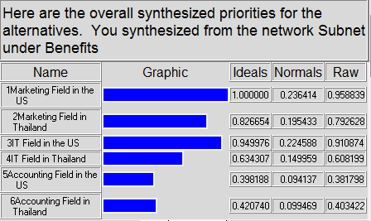
Costs(-)
From Costs point of view, IT Field in the US is the worst. The second worst is Marketing Field in the US.
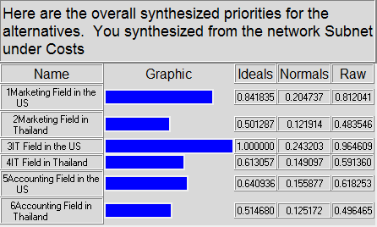

Opportunites(+)
From Opportunities point of view, IT Field in the US is significantly higher than other 5 choices.
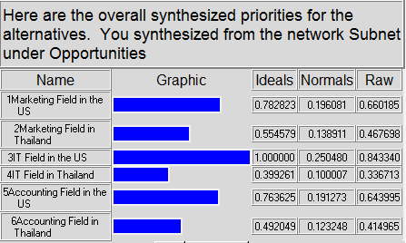
Risks(-)
From Risks perspective, Marketing in the US is the highest, but IT Field in Thailand (the second) looks almost the same.
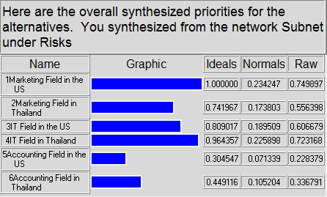

Results
Once the networks, sub-networks, clusters, and nodes were created, the relationship between each was determined and connections were made. The node comparisons were really the important factors in determining the best alternative. After we did the cluster and node comparisons, below is the result for the overall model.

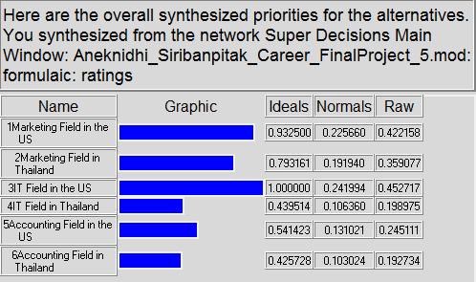

As shown in the table directly above, the alternative of IT Field in the US resulted in the highest priority level for the overall model. The second and the third are working in Marketing Field in the US and Thailand, respectively. The rating appears to be accurate, because the lower the cost and risk associated with our alternatives, the more benefits and opportunities are found. According to the model, the best choice is IT Field in the US after graduating with a degree from Katz.

The results of this model were based on our personal criteria in regards to making a career decision. Social and economic factors were found to have major influence on this decision. The best interpretation of this model would be that working in IT Field in the US would lead to more personal satisfaction, a good work-life balance, acceptable financial rewards and increased gain in respect. Working in Accounting Field as our previous job, even though stable financially is not worth the personal dissatisfactions. Working in Marketing Field could bring high yields, but it is not worth the risk to the social and economic criteria discussed previously.

Sensitivity Analysis
See Exhibit 14-17 in the Appendix.
The sensitivity analysis will consider the individual variables which are the Benefits, Costs, Opportunities and Risks. The results from analyzing the sensitivity graphs for each of the BOCR nodes are as follows:

Benefits Sensitivity
- As the priority of Benefits increases above about 54%, the best option changes from IT Field in the US to Marketing Field in the US. Furthermore, Marketing Field in Thailand is always the third-ranked career.

Costs Sensitivity
- As the priority of Costs increases above around 12%, Marketing Field in Thailand will be the best option after we graduate.

Opportunities Sensitivity
- The changes in the priority of Opportunities will not change the final outcome for the best career we should choose. IT Field in the US is always the best choice. Also, Marketing Field in the US is still the second option.

Risks Sensitivity
- As the priority of Risks increases above about 30%, Accounting Field in the US becomes the best career for us after graduation. However, if the priority of Risk increases above about 51%, Accouting Field in Thailand becomes the second-ranked career.

Conclusion
We use the ANP model to define the best career choice after graduation. The result is that IT Field in the US is the most suitable job for us in terms of benefits, costs, opportunities, and risks. This is under the Additive negative formula (bB+oO-cC-rR) which is generally best for long-term results. See Exhibit 18 in the Appendix. Moreover, when we change to Multiplicative formula (BO/CR) which is equivalent to marginal cost/benefit analysis and generally best for short-term results, the most suitable job for us is Accounting Field in the US. See Exhibit 19 in the Appendix.

Appendix
Exhibit 1 Top Level Network

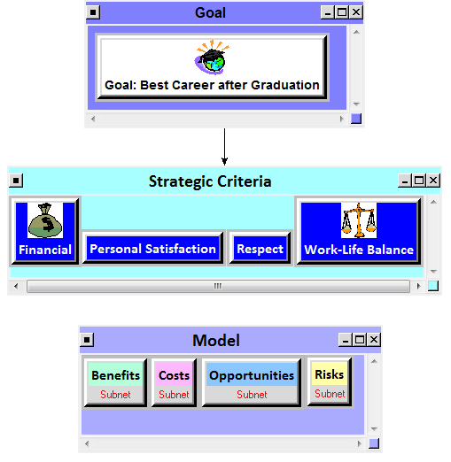

Exhibit 2 Benefits Sub-Network

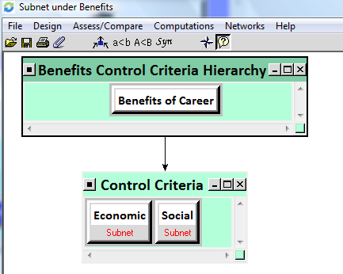
Exhibit 3 Economic Benefits Sub-Network

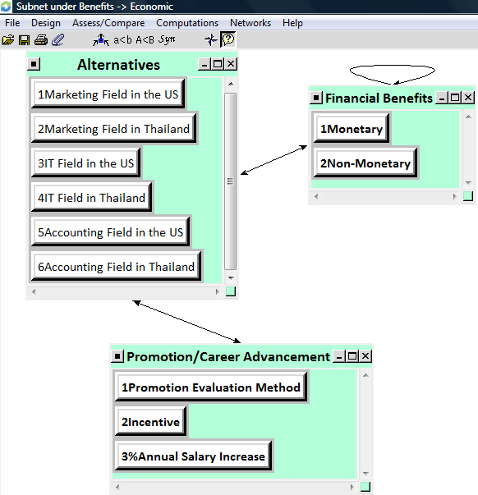

Exhibit 4 Social Benefits Sub-Network

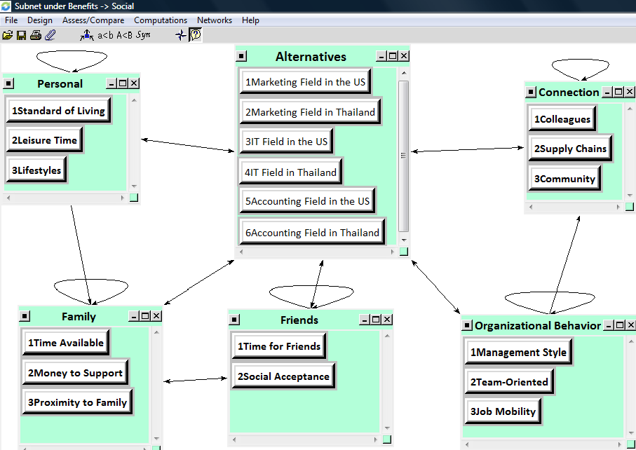
Exhibit 5 Costs Sub-Network

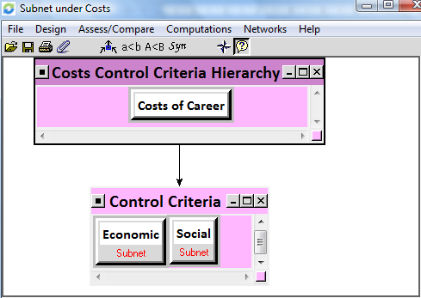

Exhibit 6 Economic Costs Sub-Network

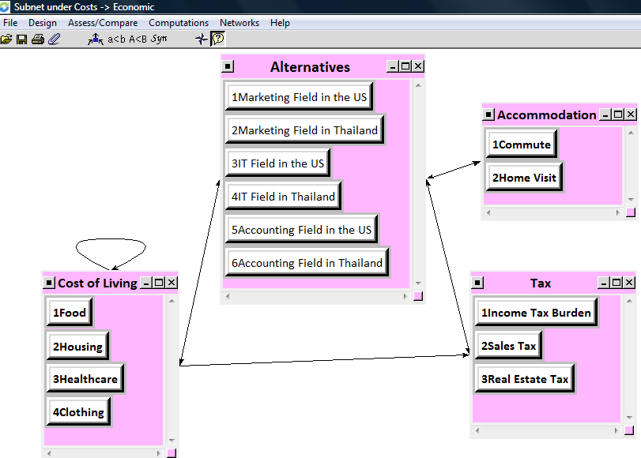
Exhibit 7 Social Costs Sub-Network

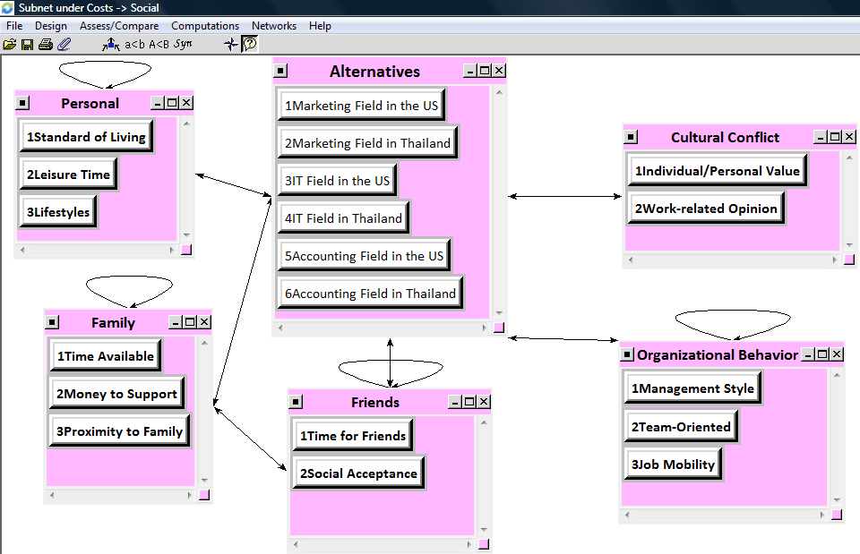

Exhibit 8 Opportunities Sub-Network

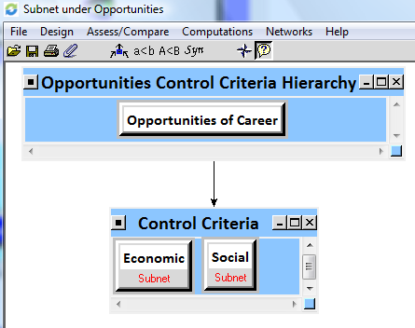

Exhibit 9 Economic Opportunities Sub-Network

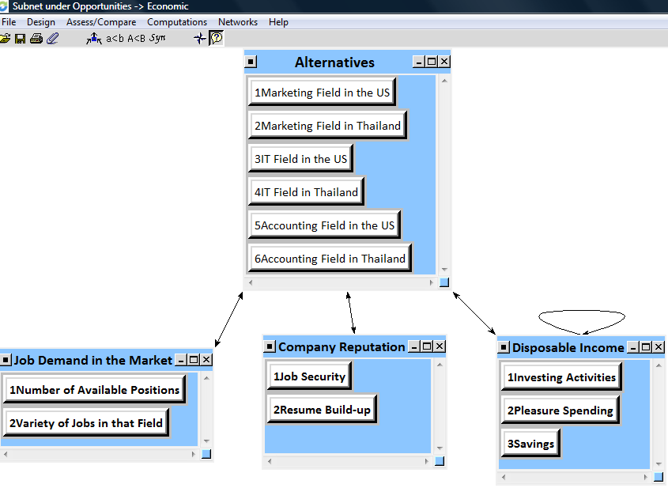
Exhibit 10 Social Opportunities Sub-Network

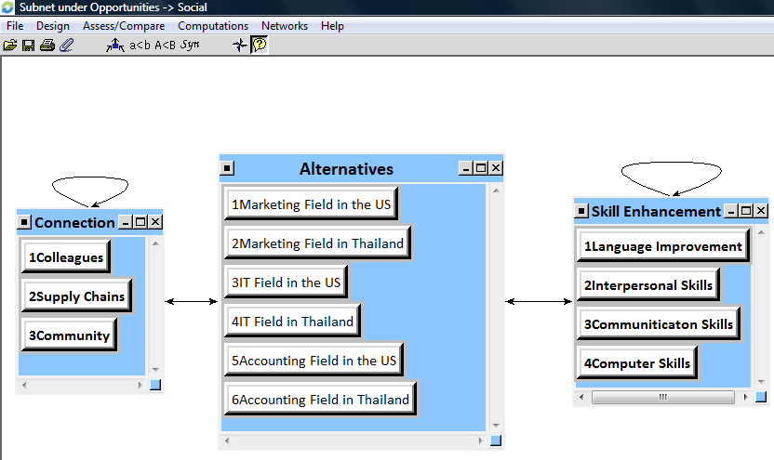

Exhibit 11 Risks Sub-Network

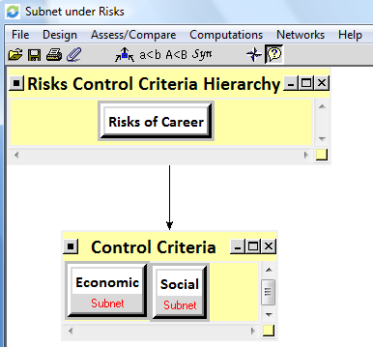

Exhibit 12 Economic Risks Sub-Network

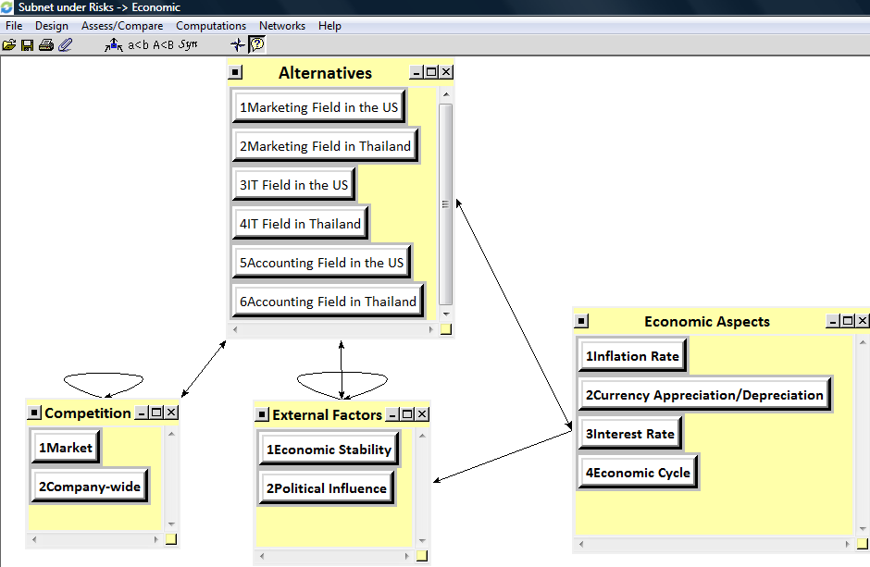

Exhibit 13 Social Risks Sub-Network

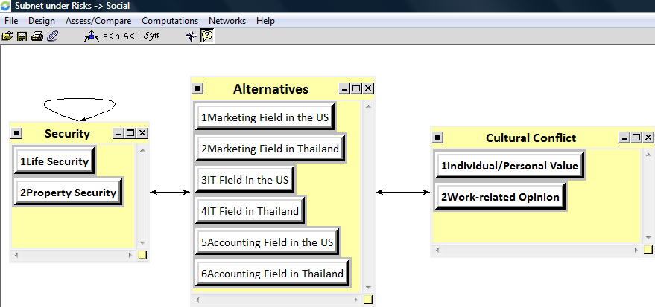

Exhibit 14 Benefits Sensitivity

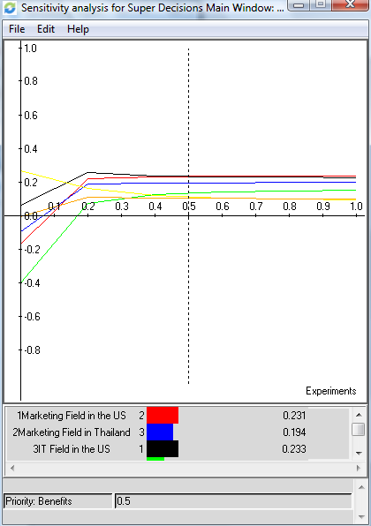
Exhibit 15 Costs Sensitivity
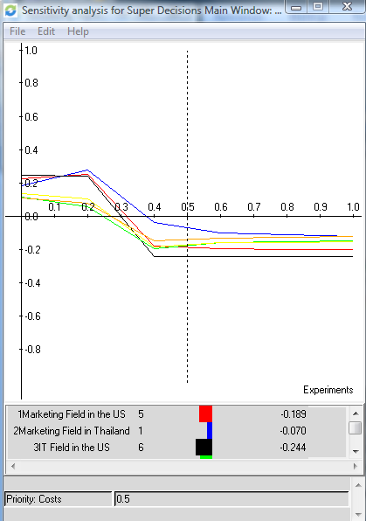

Exhibit 16 Opportunities Sensitivity
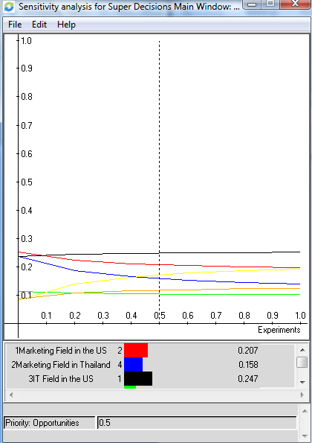

Exhibit 17 Risks Sensitivity

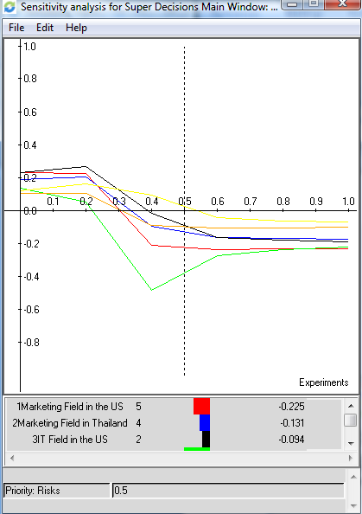

Exhibit 18 Overall Synthesis of the Priorities of the Alternatives with the total formula bB+oO-cC-rR

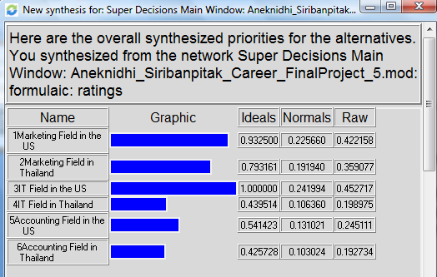

Exhibit 19 Overall Synthesis of the Priorities of the Alternatives with the Marginal Formulas BO/CR

