Best Movie to Produce
Decision Making in a Complex Environment: Spring 2013
Final Project

Staci Gratton - SDG28@pitt.edu
Deborah Lauro – DFL5@pitt.edu

Table of Contents:

Decision……………………………….………………………2
Alternatives……………………………………………………3
Strategic Criteria…..………………………………………….5
Benefits…………………………………………………..…..13
Costs………………………………………………………….14
Opportunities………………………….……………………..15
Risks…………………………………………………………..16
Ratings Model…………………….………………………….17
Overall Super Decisions Results……..………...………….19
Sensitivity Charts……………….…………………………….20

Decision:

The decision in question for this project is from the perspective of a movie producer. The next venture for this particular producer will be to create a movie based on a best-selling piece of literature. A model has been developed in order to determine which of the proposed books will yield the most positive outcome for the producer and the film industry as a whole.

Alternatives:

The literatures we choose to analyze (and excerpts regarding the plots) are:

- The Giver (A classic novel highly praised for its literary achievements):
  - “The Giver is a dystopian children's novel by Lois Lowry. It is set in a society which is at first presented as a utopian society and gradually appears more and more dystopian. The novel follows a boy named Jonas through the twelfth year of his life. The society has eliminated pain and strife by converting to "Sameness," a plan that has also eradicated emotional depth from their lives.”
- Batman …The Remake (A well-established comic book with a large fan base of all ages):
  - “The Batman saga takes place primarily in the fictional municipality of Gotham City, a city overrun with crime, graft, and corruption. Its citizens live in perpetual fear from the vast number of criminals, gangs and common thugs. In an effort to combat the crime, billionaire philanthropist Bruce Wayne creates the costumed persona of the Batman to prey on the superstitious and cowardly criminals' fears.”
- Divergent (A novel with a target audience of teenagers and young adults):
  - “In Beatrice Prior's dystopian Chicago, society is divided into five factions, each dedicated to the cultivation of a particular virtue—Candor (the honest), Abnegation (the selfless), Dauntless (the brave), Amity (the peaceful), and Erudite (the intelligent). On an appointed day of every year, all sixteen-year-olds must select the faction to which they will devote the rest of their lives. For Beatrice, the decision is between staying with her family and being who she really is—she can't have both. So she makes a choice that surprises everyone, including herself. During the highly competitive initiation that follows, Beatrice renames herself Tris and struggles to determine who her friends really are. But Tris also has a secret, one she's kept hidden from everyone because she's been warned it can mean death. And as she discovers a growing conflict that threatens to unravel her seemingly perfect society, she also learns that her secret might help her save those she loves… or it might destroy her.”

Strategic Criteria:

The following strategic criterion was used to determine the overall successfulness of each of the proposed novels/soon-to-be movies:

- Fan Base: A large and dedicated fan base is essential in making a movie a success. If the perspective literature has a large following, it is likely that the movie will follow suit.

- Entertainment Value: Who doesn’t love to be entertained? Successful books and movies need to thrill audiences and keep their attention from beginning to end.

- Affordability: Movie making is a business, so it is crucial that revenues exceed expenditures.

- Marketability: The movie must be fit to sell. A creative and engaging plot is necessary in reaching substantial interest and “buzz” in the industry.

BOCR Model
Each of the subnets Benefits, Opportunities, Costs and Risks were further analyzed according to the Economic and Social impact. The detail behind each is shown below:

Benefits:
Overall synthesized results for Benefits: Batman would be the most beneficial movie to produce.
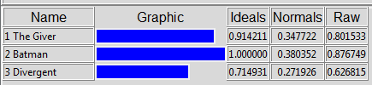

Benefits Economic Subnet Benefits Social Subnet
Highest Economic Benefit: Batman Highest Social Benefit: The Giver
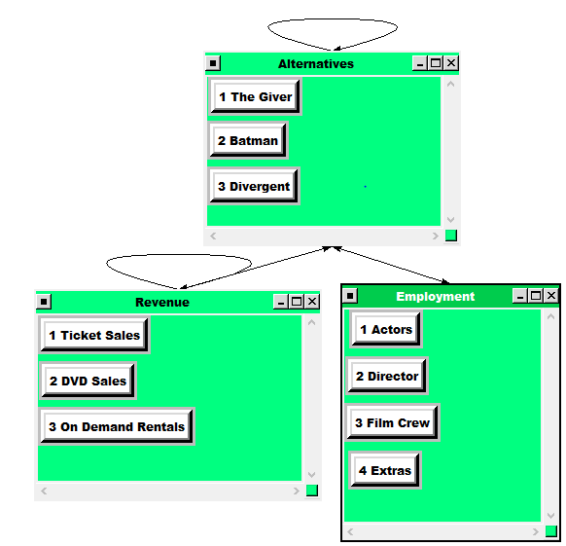
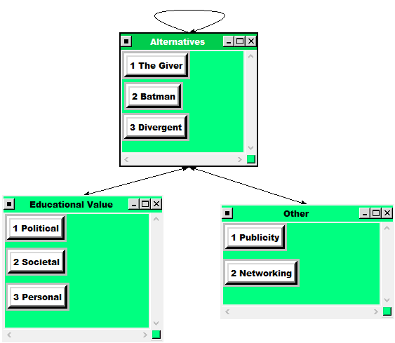

Costs:

Overall synthesized results for Costs: Batman would be the most costly movie to produce.

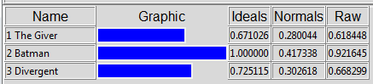

Costs Economic Costs Social
Highest Economic Cost: Batman Highest Social Cost: The Giver
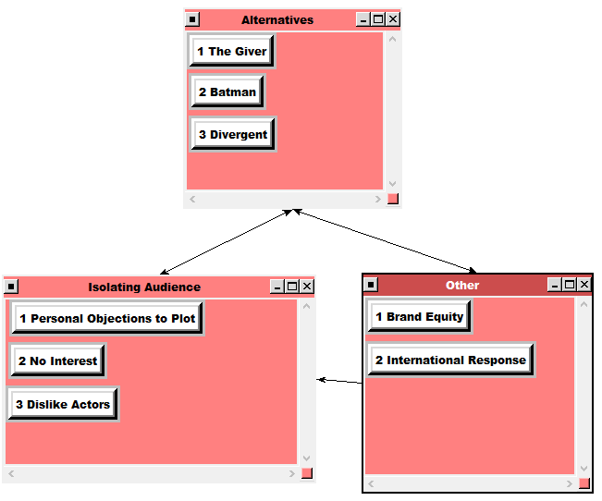
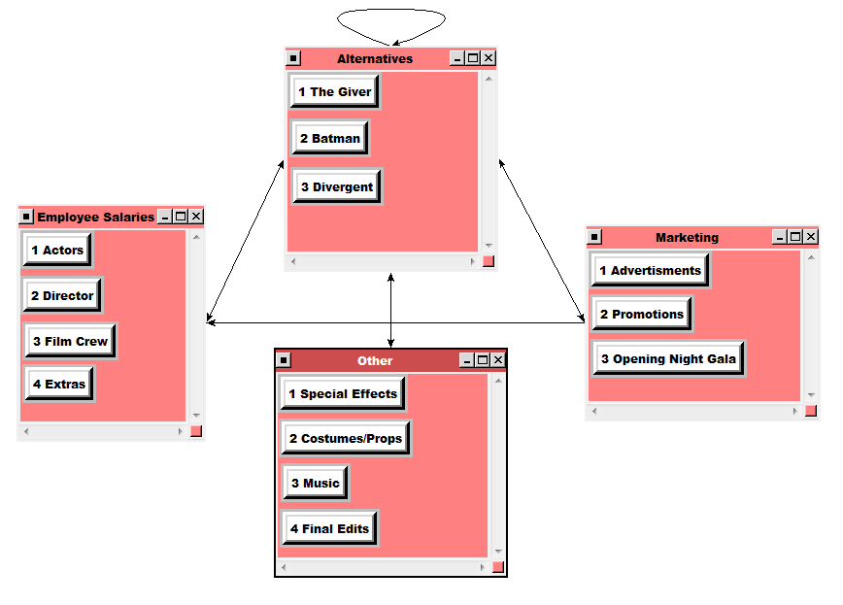

Opportunities:

Overall synthesized results for Opportunities: Divergent would have the most opportunities.

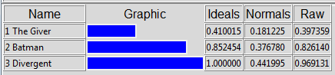

Opportunities Economic Opportunities Social
Highest Economic Opportunity: Divergent Highest Social Opportunity: The Giver

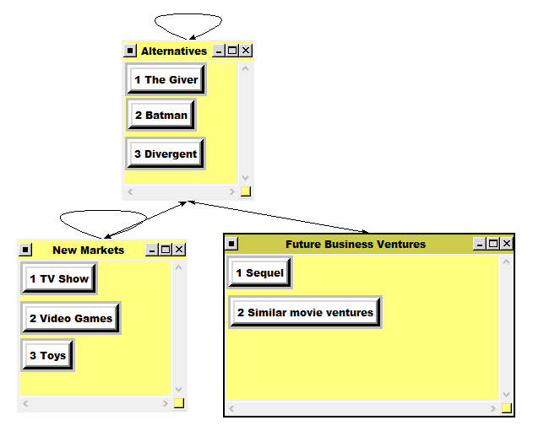
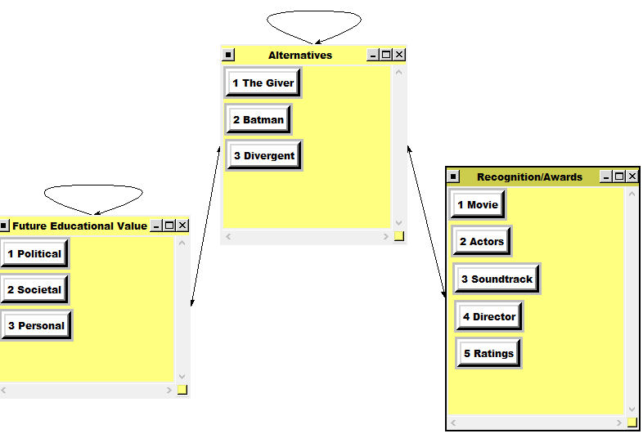

Risks:

Overall synthesized results for Risks: Divergent would have the highest level of risk.

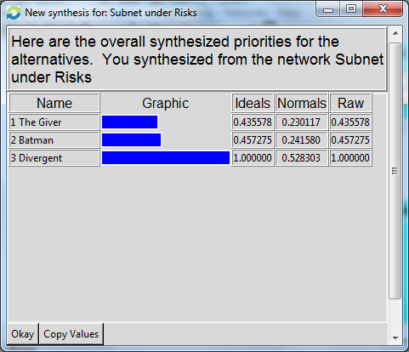

Risks Economic Risks Social
Highest Economic Risk: Divergent Highest Social Risk: Divergent

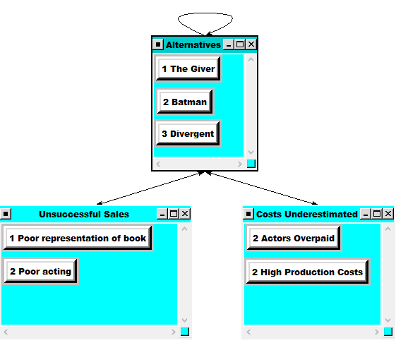
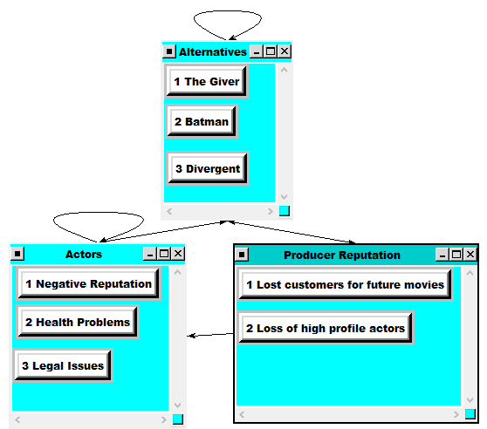

Ratings Model:

In order to determine the priorities of the Benefits, Costs, Opportunities, and Risks, we used a ratings model that compared the highest ranked alternatives for each of the BCOR categories against our Strategic Criteria. The chart can be viewed below. From this model, it was determined that the Benefits held the highest priority for this particular decision. It is also interesting to note that the Entertainment Value is our most important Strategic Criteria, followed by the Marketability as second most important.
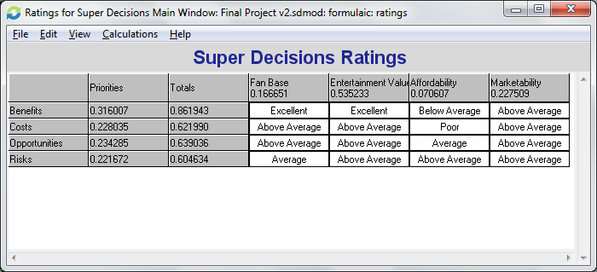

Overall Super Decision Results:

Additive / Negative Formula Results – Long Term
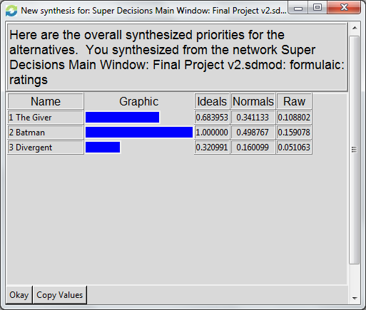

Multiplicative Formula Results – Short Term
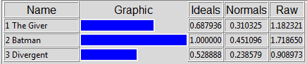

As can be seen from the synthesized results, the overall highest ranked alternative for our combined BCOR model was Batman, followed by the Giver, and lastly Divergent. Both the Additive/Negative and Multiplicative Results revealed the same order of ranked alternatives.

According to our Super Decision results, Batman would be the best piece of literature to produce and turn into a movie. Therefore, as producers, it would be in our best interest to create a Batman Remake.

Sensitivity Charts:

Benefits:
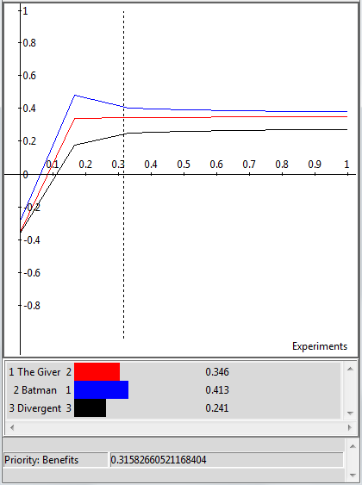
This sensitivity chart shows that our Benefits model is highly consistent. Regardless of the priority value for Benefits, Batman would still be the best alternative.

Costs:
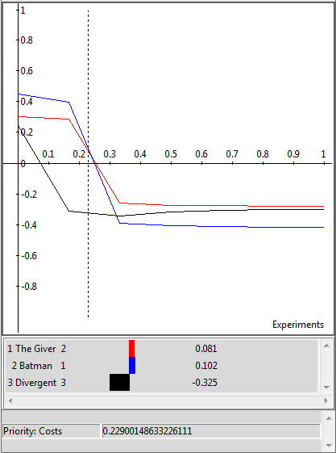
Had the priority of Costs been valued above 0.245 (just slightly more than our determined value of 0.228), then The Giver would have been chosen as the best alternative.

Opportunities:
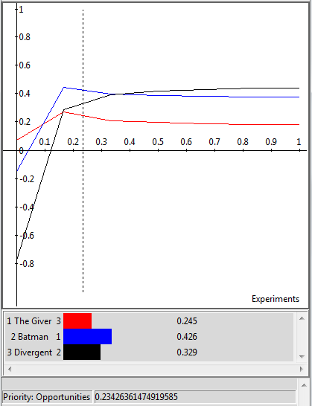
Had our Opportunities been valued at a priority below 0.0922, The Giver would have been the best alternative; however, had it been valued at a priority above 0.371, Divergent would have been the best alternative.

Risks:
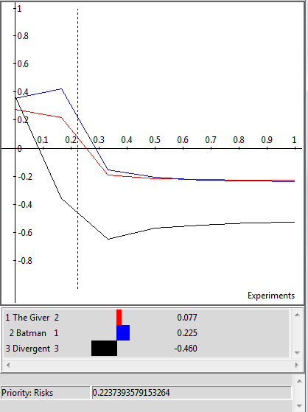
If our Risks priority had been valued at above 0.618, The Giver would have been chosen as our best alternative for this decision.

Wikipedia Editors. “The Giver.” Wikipedia.org. Wikipedia Foundation, Inc. 19 April 2013 <http://en.wikipedia.org/wiki/The_Giver>.
Wikipedia Editors. “Batman (Comic Book).” Wikipedia.org. Wikipedia Foundation, Inc. 15 April 2013 <http://en.wikipedia.org/wiki/Batman_(comic_book)>.
“Divergent.” Goodreads.com. < http://www.goodreads.com/book/show/13335037-divergent>.

