Scott Cottier and Andrew Scott
Decision Making in a Complex Environment
Final Project – Power Plant
ABSTRACT
This paper will discuss the decision making process of converting a coal fired power plant into a natural gas fired power plant, a co-fired power plant, or to shut the plant down. The model examines the four options by using a benefits, opportunities, costs, and risk model. Within these categories three main criteria are looked at, political, economic and social. The research for this was conducted by reading various articles from trusted sources, personal experiences, and general knowledge based on the fuel types. Through the model, it was discovered that the best option for a company with this decision is to have a co-fired power plant, which will allow the company flexibility as many of the aspects that were examined in the model have a great deal of risk involved long term.

Introduction
In today’s world, with the rising cost of coal and government regulations, many companies are currently deciding to convert their power plants to natural gas or closing them permanently. The reason that many companies have to consider these options today is because natural gas prices are decreasing due to the increased supply of natural gas. Also, the government is currently putting in stricter policies for particulate discharge and CO2 released to the environment. Both of these regulations are specifically designed to affect the coal fired generation power plants of the United States. Although these regulations will create a cleaner environment for the world to live in, the cost of electricity will rise. This issue is currently in the forefront today, because many companies are deciding to shutter power plants and lay hundreds of people off each time a plant is shut down. The overall effect the shutdown has is not only economical for the company, but also impacts the local community as well as the people who live around the plant. Whereas today, we also see many companies trying to develop new technology to convert these plants from coal fired generation to either co-fired or natural gas plants. Many companies see quite a bit of risk making the full conversion to natural gas, as the prices could quickly increase in the future and leave the company with no flexibility. With the co-fired power plant, not only will the company be left with the flexibility of switching to either fuel in the future, but it will also be able to utilize much of the technology that currently exists in the plant. The downfall of a cogeneration plant is that it may not always be economical competitive in the power market as other technologies emerge. Also, the current technology is new and unproven. Many companies do not want to be the test subjects of this new technology for the price tag that is associated with it. This paper will take all of these aspects and examine what is the best decision for the utility companies to make based on the above information.
Methodology
Before we could setup a model, it needed to be determined what the overall outcomes for the research and model would be. We determined that the four alternatives that we would consider when deciding whether to convert a coal fired plant or not, would be to do nothing and keep the plant as is, convert the plant to full natural gas, convert the plant to co-fired generation, or to close the plant permanently. These four options were considered based on extensive research of options that utilities are choosing today. While other options exist for utilities, many of these options are in their inception and enough research was not available to include them in our model. These four alternatives will be compared based on different aspects throughout the model to determine what the right choice is.
For this model, the criteria that were examined were the social, economic and political aspects of the four alternatives. These three criteria were chosen, because they all directly apply to the decision of what to do with the coal fired power plant. We chose economical because with all decisions, money will play an important role in the outcome of what option to choose. We chose social, because all of these decisions will have a direct impact on the surrounding community, as well as the people who live in these communities and work at the plants. Lastly, we chose political because in today’s political climate, many new regulations and rules are being forced on the utility companies with respect to CO2 discharge as well as particulate discharge.
While doing the research and then the comparisons, some important assumptions needed to be made. First, many of the ratings are based on the current economic and political stance that exists in the United States today. This includes the cost of the raw materials, political regulations, and the cost of equipment. Another assumption is the impact on the local economies will be very negative based on the shutdown of these plants. This may not be true for all plants, as some areas have stronger economies and will not be impacted as much. A third assumption is that the cost of the technology to keep a current coal plant compliant with the new regulations will be large. This is because currently the estimated cost is high, but many utilities are currently reforecasting at much lower numbers. Prior to installation, these costs may decrease even more. The last assumption is that if a power plant were to convert from coal to natural gas, many of the large components would not be reusable and would need to be replaced. These were the main assumptions that were made while making the comparisons for the model.
Table 1 shows the network and sub-networks with corresponding criteria for each BOCR.

Table 1 BOCR Criteria and Sub Criteria
BENEFITS  Social  People  Electric Costs  Air Quality  Job Creation  Community  Tax Dollars  Social Responsibilities  Brand Image  Economic  Costs  Labor Costs  Training Costs  Raw Material Costs  Operational Results  Conversion Costs  Efficiency  Marketing  Flexibility  Political  Operating Results  Tax Benefits  Grants/Research  Lobbying  Governmental Policy  Cap and Trade  CO2 Emissions  Particulate Discharge | OPPORTUNITIES  Social  People  Cost of Electricity  Air quality  Job Creation  Community  Tax Dollars  Community Outreach  Brand Image  Economic  Costs  Labor Costs  Training Costs  Raw Material Costs  Operational Results  Conversion Costs  Efficiency  Marketing  Flexibility  Political  Operating Results  Tax Benefits  Grants/Research  Lobbying  Governmental Policy  Cap and Trade  CO2 Emissions  Particulate Discharge
COSTS  Social  People  Job Loss  Air Pollution  Toxic Disposal  By Products  Raw Material  Job Creation  Community  Tax Dollars  Image  Marketing  Economic  Costs  Labor Costs  Training Costs  Raw Material Costs  Operational Results  Conversion Costs  Efficiency  Marketing  Flexibility | RISKS  Social  People  Layoffs  Community  Tax Revenue  Brand Image  Economic  Costs  Labor Costs  Training Costs  Raw Material Costs  Operational Results  Availability of Technology  Capacity Demand  Political  Operating Results  Lobbying  Governmental Policy  Cap and Trade  CO2 Emissions  Particulate Discharge

Key Terms
Co-fired power plant (partial conversion) – a plant that is powered both by natural gas and coal. This plant could be switched to either technology in the future.
Air Quality – The quality of the air. This is based on the amount of CO2 and other particulates discharged into the air.
Cap and Trade – The ability of the company to trade extra tax credits or buy extra tax credits if needed. The tax credits are used based on the amount of pollution that is discharged.
CO2 Emissions – This is the measure of the amount of CO2 that is discharged by a power plant.
Particulate Discharge – Amount of particulate discharged by a power plant.
Raw Materials – In this model, a raw material is either coal or natural gas.
Efficiency – A measure of the effectiveness of how well the plant operates. Amount of energy output divided by the amount of energy input.
Flexibility – the ability of a power plant to transition from one technology back to the other or vice versa.
Data
After the BOCR networks were built and the pairwise comparisions had been made, the BOCR and the strategic criteria were evaluated based on the rankings of high (1.00), medium (.405), and low (.16). The ratings are shown in figure 1.
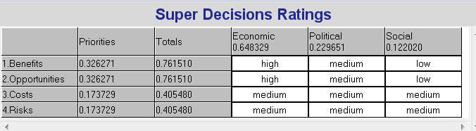
Figure 1 BOCR and Strategic Criteria Rankings
The rating system shows that “Benefits” and “Opportunities” were given the same weight and they made more of an impact than “Costs” or “Risks”.
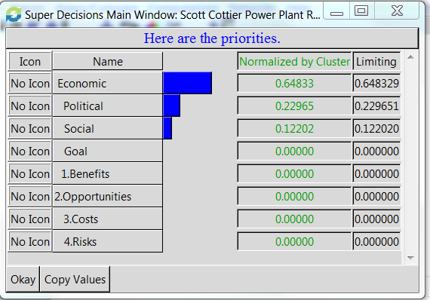
Figure 2 Strategic Criteria Priorities
As we can see from the priorities of the strategic criteria shown in figure 2, Economic (.648) has the highest weight followed by Political (.230) and lastly Social (.122). After the networks, sub-networks, clusters, and nodes were created and linked to one another, the pairwise comparisons were completed. Table 2 shows the summary of the normalized priorities for each of the BOCR networks and sub-networks relative to each decision.
Table 2 Normalized Priorities Summary
 | Sub-Networks | Close Plant | Do Nothing | Full Conversion | Partial Conversion
Benefits  .326 | Social .136  Economic .625  Political .238 | .216 | .269 | .225 | .289
Benefits  .326 | Social .136  Economic .625  Political .238 | .118 | .098 | .304 | .479
Benefits  .326 | Social .136  Economic .625  Political .238 | .199 | .114 | .336 | .349
Opportunities  .326 | Social .297  Economic .539  Political .163 | .187 | .133 | .319 | .361
Opportunities  .326 | Social .297  Economic .539  Political .163 | .118 | .098 | .271 | .512
Opportunities  .326 | Social .297  Economic .539  Political .163 | .104 | .106 | .438 | .356
Costs  .174 | Social .333  Economics .667 | .233 | .318 | .206 | .242
Costs  .174 | Social .333  Economics .667 | .007 | .373 | .382 | .238
Risks  .174 | Social .105  Economic .258  Political .637 | .677 | .168 | .096 | .098
Risks  .174 | Social .105  Economic .258  Political .637 | .428 | .125 | .219 | .228
Risks  .174 | Social .105  Economic .258  Political .637 | .200 | .512 | .119 | .169
In all of the sub-networks except for Risks, the Economic control criteria had the largest priority. A political sub-network was used in all networks except for Costs. Under economic benefits both Full Conversion and Partial Conversion had similar priorities (.304 and .479 respectively). Partial Conversion was shown to have the largest economic opportunities priority of .512 where this was due to the highest flexibility and moderate conversion costs. Under economic costs Do Nothing and Full Conversion have the highest priorities (.373 and .382 respectively). Both Partial Conversion and Full Conversion have the highest political priorities under the Benefits and Opportunities network.
The final results using the additive negative formula are shown in figure 3 where Partial Conversion was seen to be the best decision (.504) followed by Full Conversion (.289). Do nothing was seen to be the worst choice (-.118) and it was the only negative choice. Closing the Plant was next to last with a .173 priority.
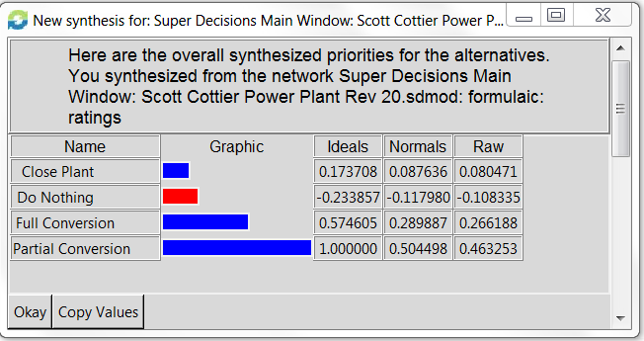
Figure 3 Synthesized Priorities Additive Negative Formula
Using the multiplicative formula, the decision did not change and can be seen in Figure 4. The ranking of the decisions did not change but Do Nothing did become positive which for the short term is logical.
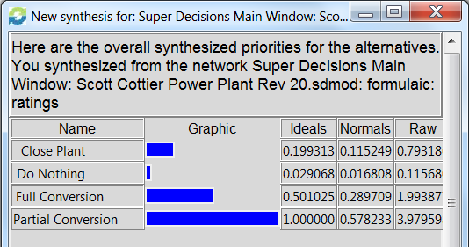
Figure 4 Synthesized Priorities using the multiplicative Formula
Some of the major contributing priorities to Partial Conversion are having the highest Economic Benefit as well as the highest Economic Opportunities. Partial Conversion also had more moderate costs and Risks than the next best choice, Full Conversion.

Sensitivity Analysis
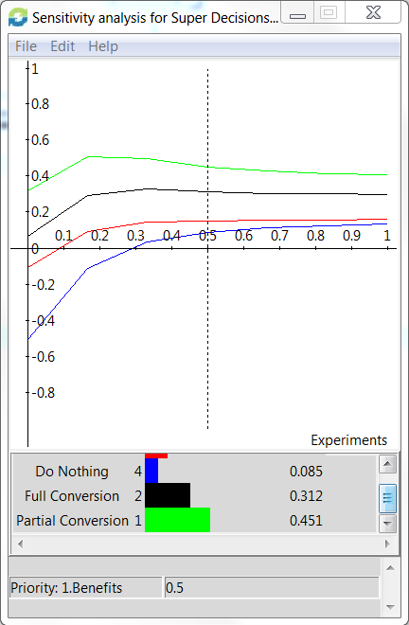
Figure 5 Sensitivity Analysis of Benefits
Figure 5 shows that the decision, Partial Conversion, dominates the other decisions over the full range (0-1) of the priority of Benefits. The second best alternative, Full Conversion, dominates both the two other alternatives of the full priority range. Do Nothing was seen to be the worst alternative over the entire priority range.
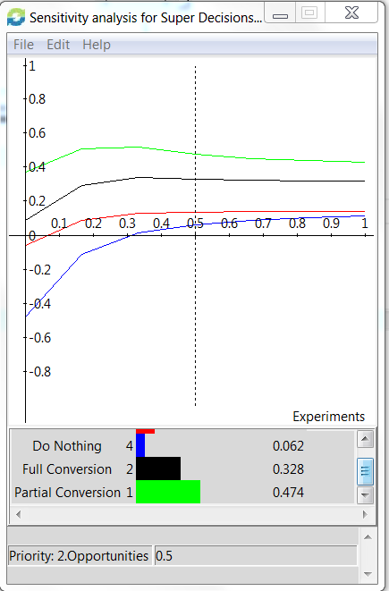
Figure 6 Sensitivity Analysis of Opportunities
The sensitivity analysis of Opportunities shown in figure 6 is similar to the analysis of Benefits where the alternative, Partial Conversion, is shown to dominate all other alternatives. Do Nothing was again shown to be the worst alternative.
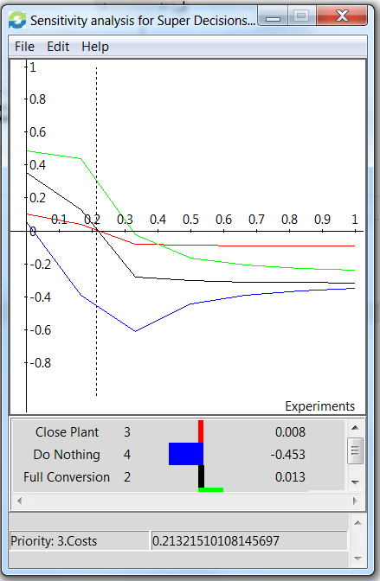
Figure 7 Sensitivity Analysis of Cost
The sensitivity of cost, Figure7, shows that the best alternative can change depending on the priority that cost is given. The alternative, Close Plant, starts (0 priority of Cost) as the next to last best choice then at .21 it overtakes Full Conversion for the second best choice and finally overtakes Partial Conversion at a priority of cost of .4. The way that Close Plant changes in rank logically makes sense because as costs increase there will be a point where costs become prohibitively expensive thus making Close Plant the best alternative.
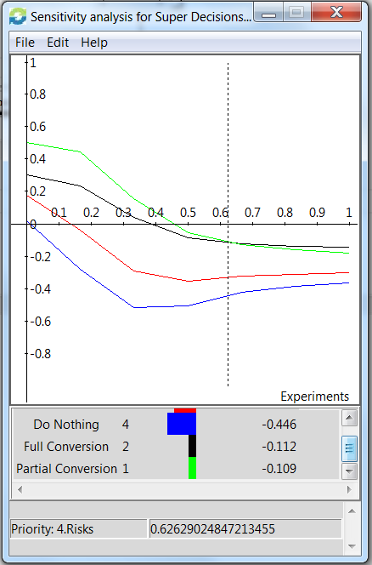
Figure 8 Sensitivity Analysis of Risks
Considering the risks that each decision carries, Partial Conversion shown in Figure 8, is seen to be the best alternative when the priority of risk is less than .626. Above this point Full Conversion becomes the best decision by a slight margin. Full Conversion will have the lowest carbon emissions and is therefore the best choice if carbon emission regulations become more stringent than what is currently being proposed by the EPA at 1000 lbs of CO2 per megawatt.
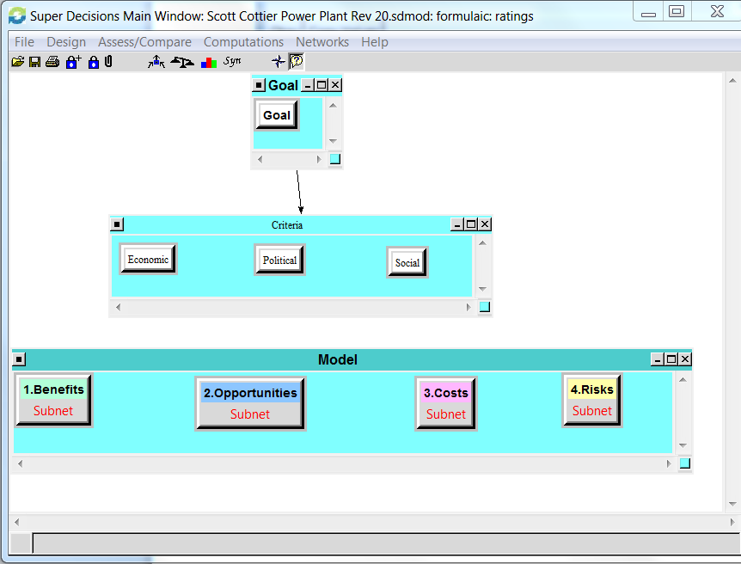
Figure 9 Top level of the model
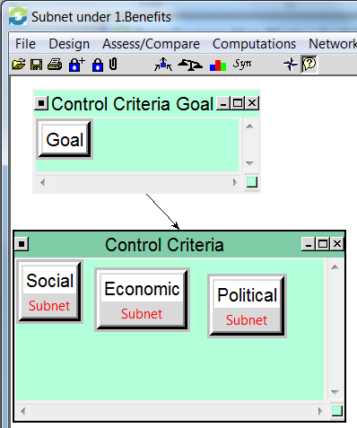
Figure 10 Benefits Sub-Network
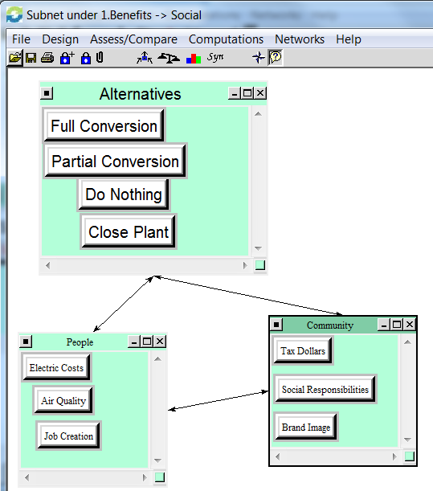
Figure 11 Social Sub-Network within Benefits

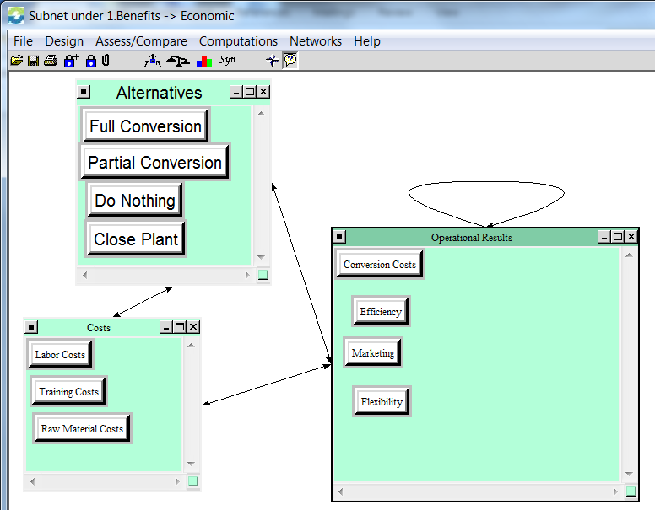
Figure 12 Economic Sub-Network within Benefits
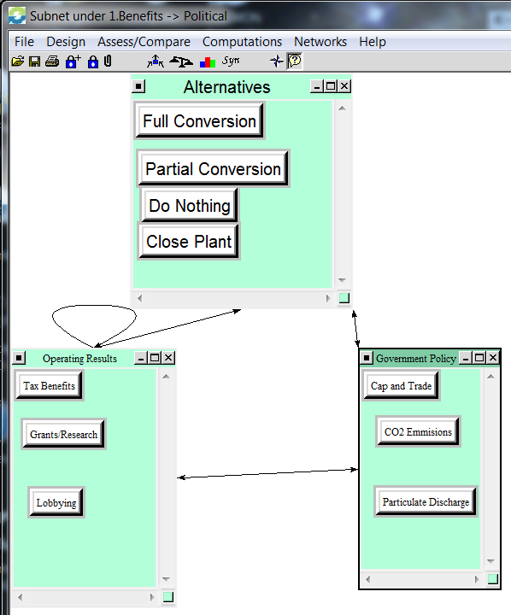
Figure 13 Political Sub-Network within Benefits
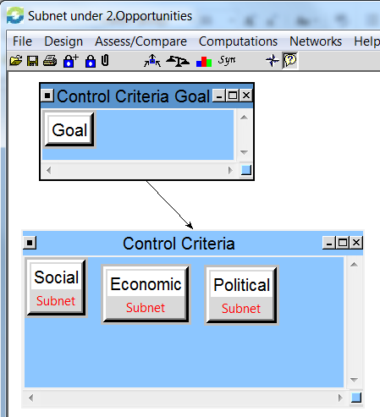
Figure 14 Opportunities Sub-Network
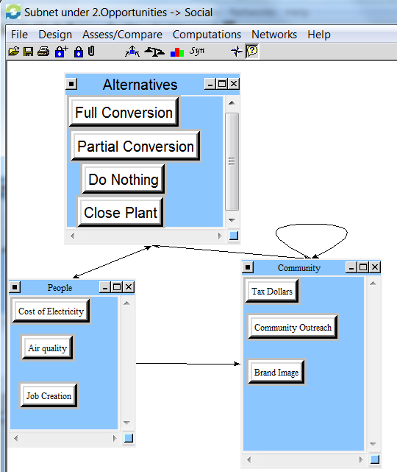
Figure 15 Social Sub-Network within Opportunities
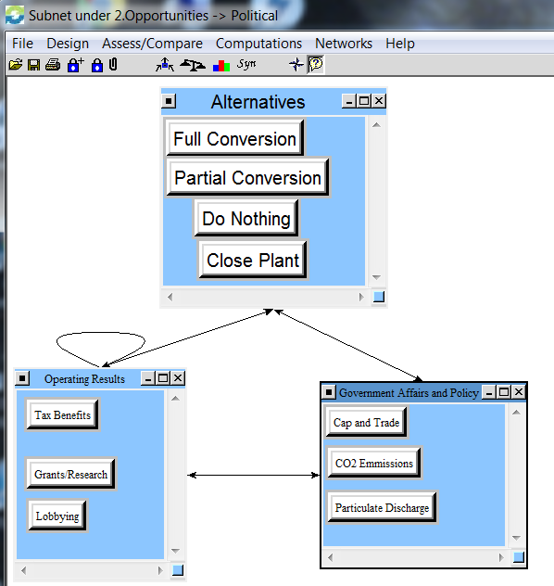
Figure 16 Political Sub-Network within Opportunities
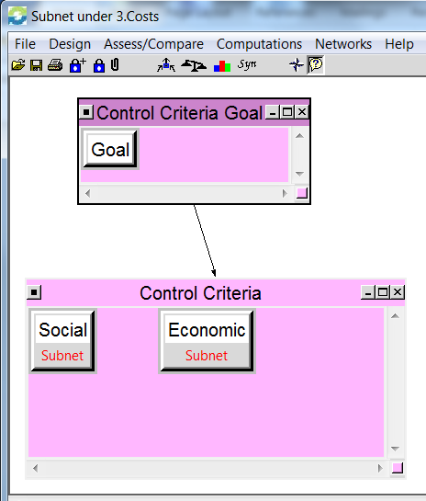
Figure 17 Costs Sub-Network
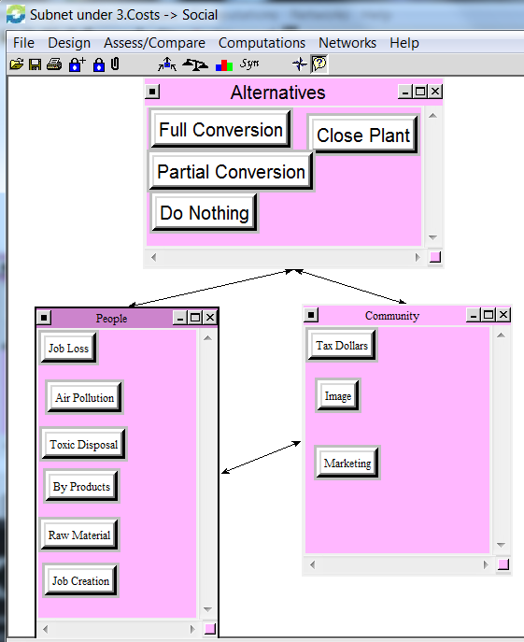
Figure 18 Social Sub-Network within Costs
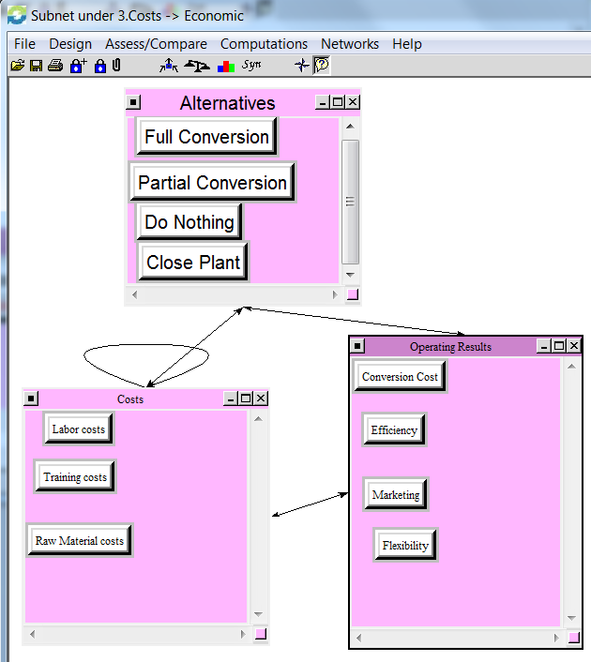
Figure 19 Economic Sub-Network within Costs
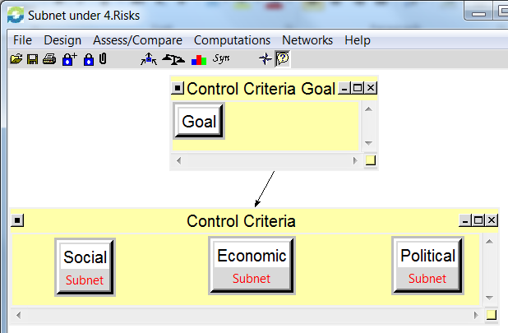
Figure 20 Risks Sub-Network
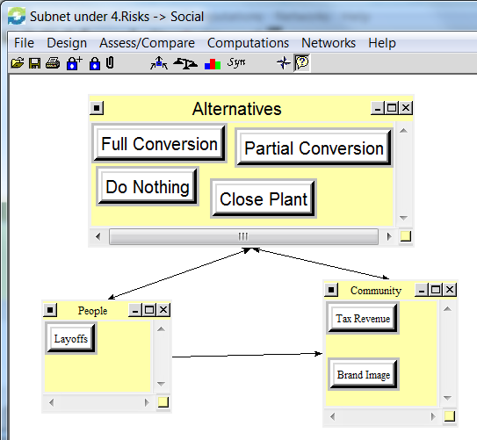
Figure 21 Social Sub-Network within Risks
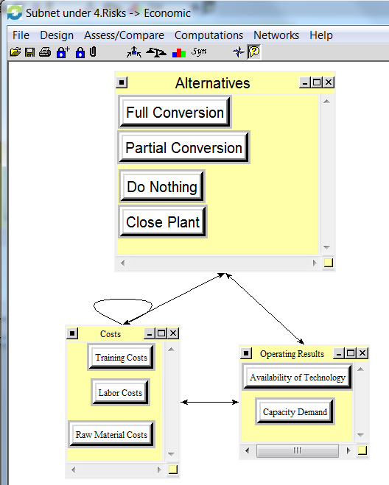
Figure 22 Economic Sub-Network within Risks
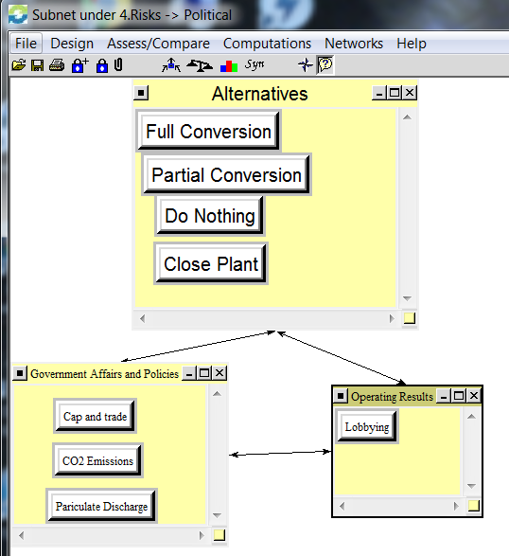
Figure 23 Political Sub-Network within Risks

SUMMARY
The team set out to try and determine what is the best option for a utility company with respect to what to do with a coal fired power plant. We decided that a utility would pursue four options for these plants, to do nothing with the plant, convert the plant to natural gas, convert the plant to co-fired, or to close the plant. As the model developed many interesting relationships were developed that led to the best decision being the co-fired power plant. This was determined after studying the benefits, opportunities, costs and risk. Within each of these fields, we looked at political, social, and economical aspects. These aspects were greatly researched to develop sub criteria that could be rated against the alternatives to derive the model. These comparisons led to the results discussed above. The next likely option for the utility would be to convert to natural gas, followed by closing the plant and lastly do nothing. These results were mainly driven by the price of raw materials, the cost of electricity, as well as the uncertainty of the political arena that exists today. These results were not surprising, as we see many utilities either exploring conversion options or choosing to shutter the plants permanently. FirstEnergy Generation, the local power supplier, has announced or already completed the closure of 10 coal fired power plants. Whereas, a company like AEP, has decided that it is best to convert its existing coal fired generation to natural gas where it makes economic sense based on the plants generation capacity. Moving forward, this issue will continue to challenge utilities and researchers, as they come up with the most cost effective way to make energy prices as low as possible.
CONCLUSION
From the research that was conducted, it is most economical for a utility to convert a coal fired power plant to a co-fired plant. This will limit the social, political and economic impacts that are described as part of the model. The analysis studied many sub criteria to those variables listed above and compared them to the four alternatives. These alternatives were to do nothing to the plant, convert the plant to natural gas, convert the plant to a co-fired plant, or to close the plant. When synthesizing the model it was determined that the worst option is to do nothing to the plant. This model can now be shown to the utilities to show them what decision to make.
FUTURE RESEARCH AND APPLICATIONS
While this model does look at many aspects of the decision of what to do with a coal fired power plant, it does not look at everything. One aspect that currently is not modeled is how the decision would change if we used the capacity of the plant in the decision. If the plant is a very large plant, this may change the outcome of the decision. Also with the research, the future ratings of some of these decisions may change. As the price of raw materials change, this decision could change. In the past, the energy industry has seen cheap natural gas and high coal prices. When this was seen before, many utilities left the plants as is and rode out the price swing. This could happen again but is less likely with the large supply of natural gas. Also the risk of certain equipment may decrease as technology is advanced. Currently many aspects of the ratings are evolving. As these decisions are made, the model can be updated to reflect the changes, and see how they affect the best option. At some point in time, this model will be able to be applied to other types of plants and determine a utility company’s best option for new generation capabilities.

