Abstract
The purpose of this project was to answer the question, how do you fix the economy? To begin, with we identified the criteria that would be used to make our decision. The majority of these criteria come directly from our presidential candidates’ (President Obama and Governor Romney) campaign platforms. Additional resources for obtaining and comparing criteria were The Economist magazine, conversations with professors of economics at the Katz Graduate School of Business, and personal thoughts/beliefs.
Once criteria were identified, we constructed and synthesized a model, using the Super Decisions software. By using Super Decisions, we were able to assign objective values to subjective measures. Who is able to solve such a complex problem without the assistance of such complex decision making software, like Super Decisions? So far, the answer is no one, as the economy continues to underperform. In fact, median incomes are down by 4.6% since mid-2009¹.
With the model constructed and pairwise comparisons completed, we were ready to synthesize the model to obtain results. Our alternative actions were: to maintain the status quo (do nothing, and allow the economy to self-correct), increase regulation by the federal government, and to decrease the amount of regulation by the federal government.
The overall outcome of the model is a recommendation for the federal government to decrease the amount of regulation. If we consider the economic principles being discussed, this makes perfect sense. First, by decreasing the amount of regulation, we are allowing consumers to have more control over their spending and the subsequent cash flows through the free market. Additionally, by reducing the tax rates, both federal and corporate, the government will allow for higher income rates, which in turn should lead to an increase in spending (assuming that the majority of goods are normal). The overall results of our model are shown below. Interpreting the results yields that a decrease to regulation is preferred to either an increase in regulation or maintaining the status quo (doing nothing).
Name | Ideals | Normals | Raw
Decrease Regulation | 1 | 0.8376 | 0.343515
Increase Regulation | 0.138094 | 0.115668 | 0.047437
Status Quo | -0.055793 | -0.046732 | -0.019166

Introduction
“No society can surely be flourishing and happy, of which the far greater part of the members are poor and miserable.” - Adam Smith, Father of Economics
On October 3, 2012, the two candidates for the American presidency, President Barack Obama and former Massachusetts governor Mitt Romney, met for the first of three presidential debates. The debate drew millions of viewers as the two candidates traded barbs over the present and future state of the American economy. The economy accounted for one-third of all debate time scheduled, and the sole topic was described as “domestic policy”. In reality, the debate focused entirely on fixing the economy. Obviously the economy is generally viewed as being troubled and in need of repair.
How bad is the economy? Let us look as some facts:
- President Obama inherited a deficit of over 10% of GDP, and it still stands at 7.8%².
- Federal spending will reach 24% of federal spending if it continues at the current rate².
- Unemployment is “stuck” at 8%, and growth has become stagnant at around 2%².

Almost all experts agree that the American economy has been in a state of recession since early 2008, when our country’s financial system’s infrastructure began to collapse. According to the Economist magazine, the American economy (hereafter referred to simply as “ the economy”) is rated as the number one most important criteria in choosing the country’s next president, and the majority of Americans feel that the economy needs to be “fixed”³. Ultimately the problem must be defined; a method for exiting this recession must be found, implemented, and supervised to ensure that the proper decisions were made. So, what is the best way to go about turning around the world’s second largest economy (behind only the European Union in GDP)⁴? To answer this question, we turned to Super Decisions and a BOCR ratings model.
Methodology
Definition of Key Terms: see Appendix A
Inalienable Truths or Important Assumptions
We decided on a framework for making our pairwise comparisons early in the decision making process. We determined that the following bullets are “inalienable truths”, or fundamental beliefs upon which we would base future pairwise comparisons:
- Private sector jobs are preferred over public sector jobs.
- Private sector unions are preferred over public sector unions.
- Public and private sector employment options are preferred over undocumented workers.
- Minimum wage increases are not preferred, due to the subsequent surplus of workers (unskilled) and increase in unemployment.
- A lower level of outsourcing was preferred to a higher level of outsourcing since we are attempting to “fix” the American economy, and outsourcing reduces the number of jobs in America.
- In terms of all taxes, lowering tax rates was preferred to raising tax rates, based on the assumption that lower taxes will generate freer cash flow through the economy as a whole.
- We considered all comparisons to be at the macroeconomic level, not the microeconomic level.
- Increased exports are preferred to a decreased level in exports.

The diagram below shows how our model was constructed:
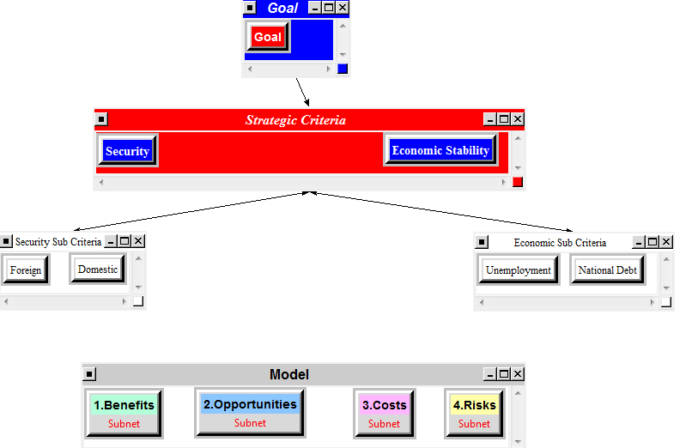

Control Criteria
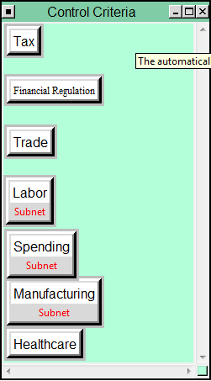
As discussed in the introduction, the above Control Criteria were obtained via research of each political candidate’s presidential platform for economic recovery. To identify which criteria merited subnets, we made pairwise comparisons of the Control Criteria and identified which criteria accounted for 60% of the total decision for each category: Benefits, Opportunities, Costs and/or Risks.
The priorities for the Benefits:
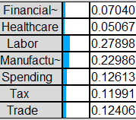

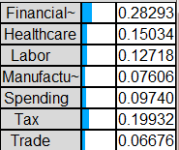
Opportunities:

Costs:
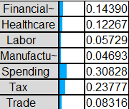
Risks:
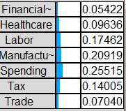

Once the rankings of the control criteria were completed, the applicable subnets were constructed. Additional relevant pairwise comparisons were made, and the model was synthesized. The final, overall, result was resoundingly in favor of decreasing federal regulation as an immediate means of fixing the economy.

Data
In each sub criteria, we then identified the main issues and factors related to the control criteria. For example, the model for Benefits—Labor is below.
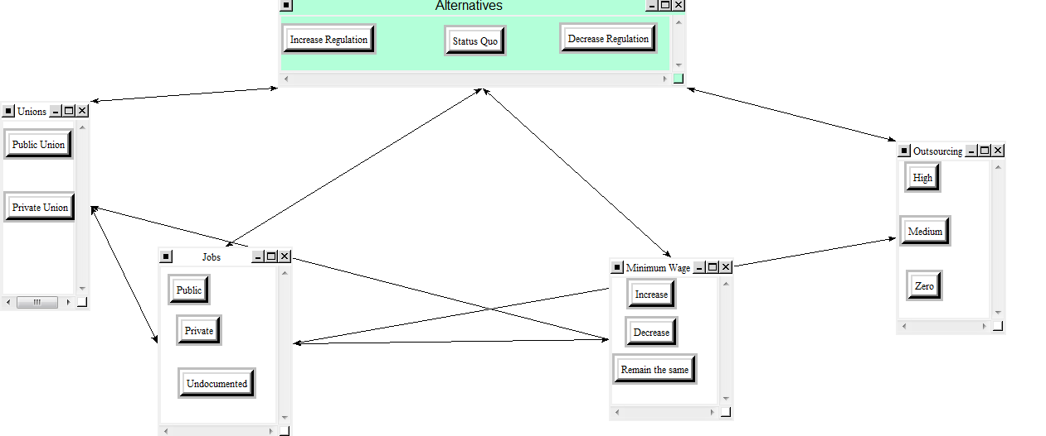
After making all the pairwise comparisons, we then synthesized the results to get the following table:
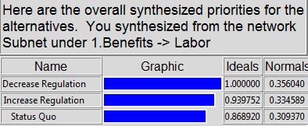
This shows that deregulating is the preferred choice for benefiting labor. Notice the closeness of the results. This shows why it is so difficult for our leaders to determine the right course of action.

Another example is below. This graph shows the Risks—Manufacturing subnet.

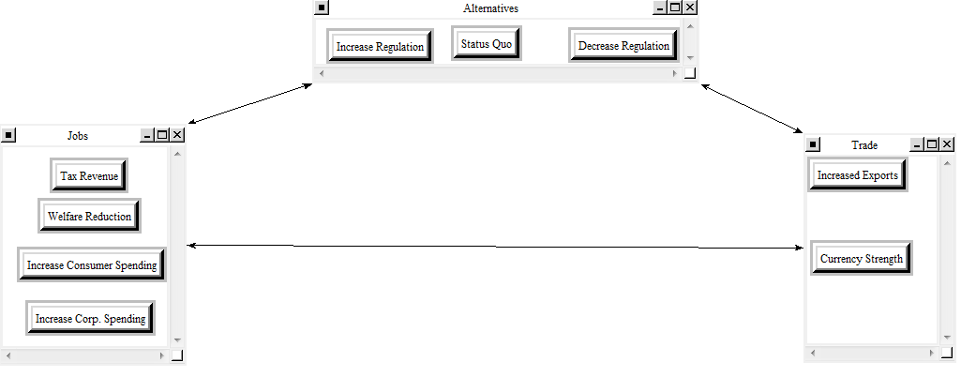

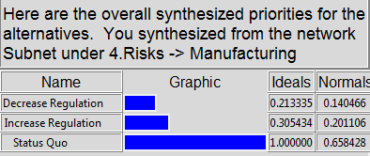
These results are particularly interesting. After making our comparisons and synthesizing, we determined that the riskiest course of action, in terms of manufacturing, is to do nothing. This also shows that increasing regulation could be riskier than decreasing regulation.
We made these observations and comparisons with each subnet in our control criteria. The next step was to synthesize our entire model.

Analysis
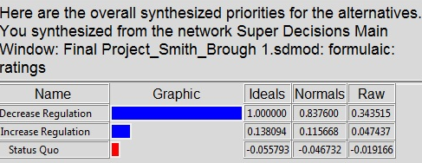
Above are the Additive Results from our synthesis of the model. The additive (negative) synthesis displays the best long term results. What our data shows, is that as time goes by, decreasing regulation is the best route for the government. Further, in the long run, remaining at the status quo will become the worst option.
For determining the best short term option, we use the multiplicative synthesis. The results are below. They are ranked similar to the additive (negative) results above, but the priorities have different values. This method tells us that decreasing regulation would give us the best short term results.
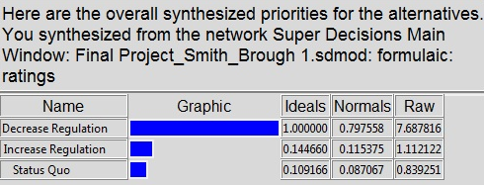
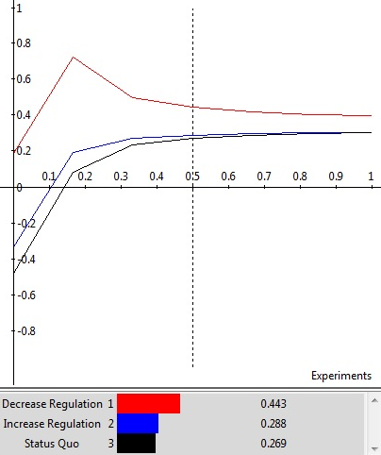
Performing a sensitivity analysis of the results with regard to the Benefits, Opportunities, Costs and Risks, also provides some interesting differences on which to compare results. The graph above is the sensitivity of the Benefits portion of the model, which was the most “sensitive” outcome to change.
Interpreting the graph above, we see that Decreasing Regulation is preferred across the entire model, and that the Status Quo starts to converge with Increasing Regulation only after a Decrease in Regulation peaks at a dependent variable (Fixing the Economy) level of approximately 0.18. Thus, at a goal of 1.0 (synthesized level of results) the two alternatives Status Quo and Increasing Regulation are almost equal. As the benefits becomes less important to fixing the economy (moving left on the graph), there is an increasing difference between each of the alternatives, particularly between Decreasing Regulation and the remaining two (Status Quo and Increasing Regulation).

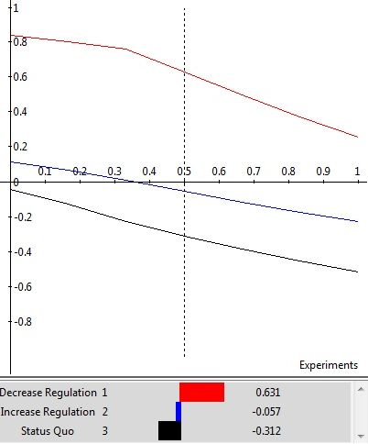
The above graph represents the Opportunities sensitivity analysis. We can interpret the graph to read that as the weight of opportunities increases, with regard to the end goal of fixing the economy, that there is a steady and even decline in each of the alternatives. For example, as Opportunities becomes increasingly important to fixing the economy, the alternative to Decrease Regulation becomes less and less desirable a method for achieving the end goal.
What is interesting is that the alternative to maintain the Status Quo is assigned a negative value for the entire decision. If we think critically about the decision as a whole confirms that the information about the Status Quo presented above is entirely correct. What opportunities are there in maintaining the Status Quo? The answer is none. If we maintain the status quo, then the implication is made that no new opportunities will be identified or chosen in fixing the economy.
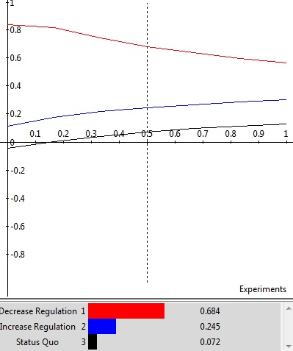
Next, as we analyze the sensitivity of Costs with regard to fixing the economy we see that the three alternative actions begin to converge as we move further to the right on the graph. This translates to the statement that as Costs become increasingly important to the overall decision on how to fix the economy that the difference between each alternative becomes smaller.
However, if we again think critically about the data represented on the graph, our comparisons are again confirmed as correctly reasoned. First, the line for Decreasing Regulation has a negative slope, or as we Decrease Regulation, we decrease overall costs. Conversely, as we increase regulation, which has a positive slope, we increase costs.
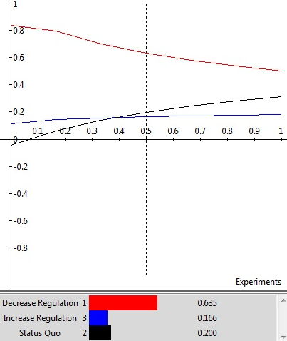
Finally, looking at the Risk sensitivity analysis above provides us with the only “cross-over” between the Status Quo and Increasing Regulation. We see on the graph above that when Risk is considered to be of approximately 40% importance to the overall goal of fixing the economy, that maintaining the Status Quo and Increasing Regulation are equal, or just as risky. If we increase the weight of risk to our overall goal above this level, then the Status Quo (doing nothing) becomes more and more risky.
Summary
The American economy is currently a focal point in the upcoming election. Both our candidates have differing views on how to fix the current state of the economy and we used the Super Decisions software to help us understand the best course of action. Our main goal was to determine whether the government should increase regulation, decrease regulation, or let the market figure it out by doing nothing. We then made control criteria based off what both President Obama and Mitt Romney feel are the main factors influencing the economy. After creating sub criteria and making pairwise comparisons, we synthesized our results to determine that the best course of action for our government is to scale back its operations and deregulate. Our model shows that America would best be served by a smaller government, rather than a larger one. We were also able to determine that the riskiest option moving forward is no action by the government. Some method of intervention or deregulation needs to happen in order for the economy to get moving again.
We do recognize however, that there is personal bias and beliefs in every comparison we made. We tried working through our personal political views by making objective comparisons. We further recognize that this model is a much simplified version of a very complex issue facing the country. Further study would need to be conducted on the effects deregulation would have on another sector. We understand deregulating every sector is impractical and unwise, as increasing regulation over certain sectors could be the best path to prosperity for America. However, the general goal for the government, based off our Super Decisions software, should be to scale back the size of government and free up the people and businesses to get the money moving through the economy again.

References
- Footnotes 1-4: Multiple Authors. “The Choice: US Election 2012, A Special Report”. The Economist 06-12 Oct. 2012: 3 – 22

- Obama, President Barack. Barack Obama Homepage. 01 Oct. 2012. <www.barackobama.com>.

- Romney, Mitt. Mitt Romney Homepage. 01 Oct. 2012. <www.mittromney.com>.

Appendix A – Definition of Key Terms
- Status Quo – an alternative action for the government to take in its goal of fixing the economy, namely to do nothing and allow the economy to self-correct.
- Increase Regulation – an alternative action for the government to take in its goal of fixing the economy, namely to increase the amount of control and regulation that it exercises on the American people and the economy as a whole.
- Decrease Regulation – an alternative action for the government to take in its goal of fixing the economy, namely to decrease the amount of control and regulation that it exercises on the American people and the economy as a whole.
- Labor – the segment of the economy related to employment. Sub-criteria include: Unions, Jobs, Minimum Wage and Outsourcing.
- Jobs – factors relating to the employment of the American workforce. Sub-criteria include: Private Jobs, Public Jobs and Undocumented Workers.
- Unions - an organization of workers who have banded together, often for the purpose of getting better working conditions or pay;
- Private Jobs – number of people employed by private firms in America.
- Public Jobs – number of people employed by the government; includes federal, state and municipal governments.
- Undocumented Workers – laborers working illegally in the U.S. May include workers without proper immigration documentation, workers being paid “under the table” (cash only, so no income tax is being paid), etc.
- Minimum Wage – the level of minimum wage, as defined by the federal law. We determined that the level of the minimum wage could be increased, decreased or remain the same.
- Trade – the transfer of ownership of goods (services excluded); also known as commerce. Sub-criteria include: Currency Strength and Increased Exports.
- Currency Strength – relative value of the U.S. dollar when compared to other global currencies.
- Financial Regulation – laws enacted by the U.S. federal government which is intended to stabilize the financial markets.
- Manufacturing – the sector of the economy concerned with the production of goods. The service sector was excluded for the purposes of this project. Sub-criteria include: Jobs and Trade.
- Healthcare – the effects of the Patient Protection and Affordable Care Act; commonly referred to as “Obamacare”. Sub-criteria include: repealing the act, replacing the act with another healthcare option and continuing with the act.
- Sarbanes-Oxley (SOX) – a United States federal law that increases the level of regulation imposed on publically traded companies.
- Dodd-Frank – controversial bill passed by the Obama Administration designed to regulate the financial industry.
- Bowles-Simpson – a bi-partisan commission created to make recommendations to the federal government on economic recovery.

Appendix B—BOCR Priorities Table

BOCR | Control Criteria | Elements | Priorities
Benefits | Labor | Increase Reg. | 0.35604
Benefits | Labor | Decrease Reg. | 0.3345
Benefits | Labor | Status Quo | 0.30937
Benefits | Spending | Increase Reg. | 0.33851
Benefits | Spending | Decrease Reg. | 0.37392
Benefits | Spending | Status Quo | 0.28752
Benefits | Manufacturing | Increase Reg. | 0.22957
Benefits | Manufacturing | Decrease Reg. | 0.47346
Benefits | Manufacturing | Status Quo | 0.29696
Opportunities | Tax | Increase Reg. | 0.2016
Opportunities | Tax | Decrease Reg. | 0.13599
Opportunities | Tax | Status Quo | 0.16239
Opportunities | Financial Regulation | Increase Reg. | 0.19068
Opportunities | Financial Regulation | Decrease Reg. | 0.54392
Opportunities | Financial Regulation | Status Quo | 0.26538
Opportunities | Labor | Increase Reg. | 0.21813
Opportunities | Labor | Decrease Reg. | 0.47527
Opportunities | Labor | Status Quo | 0.30658
Opportunities | Spending | Increase Reg. | 0.22348
Opportunities | Spending | Decrease Reg. | 0.47813
Opportunities | Spending | Status Quo | 0.29838
Opportunities | Healthcare | Increase Reg. | 0.09523
Opportunities | Healthcare | Decrease Reg. | 0.47619
Opportunities | Healthcare | Status Quo | 0.42857
Costs | Tax | Increase Reg. | 0.59752
Costs | Tax | Decrease Reg. | 0.19861
Costs | Tax | Status Quo | 0.20386
Costs | Financial Regulation | Increase Reg. | 0.37941
Costs | Financial Regulation | Decrease Reg. | 0.32394
Costs | Financial Regulation | Status Quo | 0.29666
Costs | Spending | Increase Reg. | 0.499
Costs | Spending | Decrease Reg. | 0.20979
Costs | Spending | Status Quo | 0.29114
Costs | Healthcare | Increase Reg. | 0.29166
Costs | Healthcare | Decrease Reg. | 0.20833
Costs | Healthcare | Status Quo | 0.5
Risks | Labor | Increase Reg. | 0.24073
Risks | Labor | Decrease Reg. | 0.20516
Risks | Labor | Status Quo | 0.5541
Risks | Spending | Increase Reg. | 0.24056
Risks | Spending | Decrease Reg. | 0.13242
Risks | Spending | Status Quo | 0.67012
Risks | Manufacturing | Increase Reg. | 0.2011
Risks | Manufacturing | Decrease Reg. | 0.14046
Risks | Manufacturing | Status Quo | 0.65842

