Larry Garchar
BQOM 2521
Final Project

HR Machine Learning / AI Platform Selection
Background
For this project I chose to investigate the decision of upgrading my company’s Human Resource platform to include machine learning and artificial intelligence capabilities. Human Resources has been widely associated with heavy administrative tasks that require a lot of time and personnel. While it would be great to analyze a single HR platform, this is simply not practical as there are too many factors involved and is outside of the scope of this project. Under the umbrella of HR technology falls several subsets including talent acquisition, employee development, compliance, wellbeing and employee engagement, employee self-service, and chatbots (1). I will be looking specifically at the wellbeing and employee engagement, as that is the area, I have the most amount of experience with.
When it comes to wellbeing and employee engagement, I am referring to how an employee feels physically, socially, financially, and emotionally. Also, being able to target behaviors that lead to subpar work performance. These areas can have a positive or negative effect on a company’s culture as well as high indirect costs associated with poor mental or physical wellbeing.
Problem
In the past HR departments would rely on subjective information to report on the culture and wellbeing of a company. Most of the data was anecdotal and not much could be utilized. Currently, within the last several years, many wellbeing enterprise companies have emerged and function as more of a “tech” company. The wellbeing tech companies implement artificial intelligence into their platform to provide personalized solutions to the employee based of their trends and habits. The companies can also provide extensive reporting that can provide a more holistic view of their workforce and the correlations associated with specific at-risk populations.

Assumptions
Being familiar with the subset of HR technology, we can assume all the alternatives are the leading wellbeing and engagement vendors on the market today for companies with greater than 10,000 employees. This decision is based off the viewpoints of the HR project manager.

Strategic Criteria
The strategic criteria that was used to rate the Benefits, Opportunities, Costs, and Risks sub-networks were the following:
- Technology
- Investment
- User Experience
- Integration
Alternatives
- Limeade – Software company with a platform that integrates well-being, engagement, inclusion, and communications solutions into one seamless employee experience. (2)
- Virgin Pulse – Designs technology that cultivates good lifestyle habits for your employees. Focuses on delivering superior outcomes for the employees and business. (3)
- Glint – A people success platform built on a new approach that helps organizations increase employee engagement, develop their people, and improve business results. (4)
- Culture Amp – Focus on employee engagement, experience, and effectiveness through automated employee surveys designed to understand and act on employee feedback. (5)

The Model
BOCR Table
Benefits | Opportunities
- Economic  - Admin  - Resource Allocation  - Consolidation  - Organizational  - System Upgrade  - Efficiency  - Employee Satisfaction | - Economic  - International  - New processes  - Reputation  - Organizational  - Analytics  - Reporting  - Strategy
Costs | Risks
- Economic  - Implementation  - Maintenance  - Annual Fees  - Organizational  - Training  - Cross-integration  - Internal Marketing | - Economic  - Productivity Loss  - Exceed Budget  - Stakeholders support  - Organizational  - Employee Buy-in  - Product Failure  - Vendor Issues

Criteria
- Benefits
  - I felt there were two large aspects that project managers needed to consider in the benefits category: Economic and Organizational.
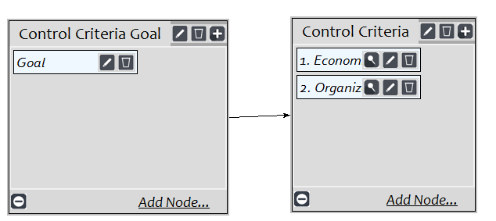

  - In the economic subnet, I placed the following criteria:
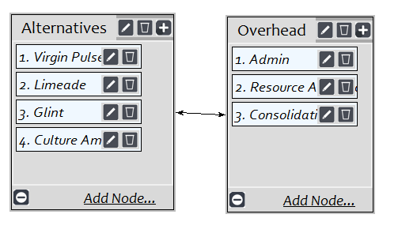
  - In the organizational subnet, I placed the following criteria:
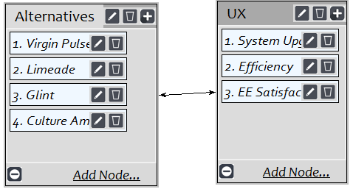

- Opportunities
  - The two main control criteria were economic and organizational.
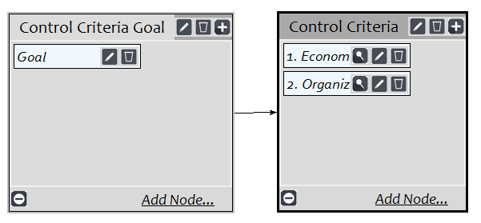
  - In the economic subnet, I placed the following criteria:
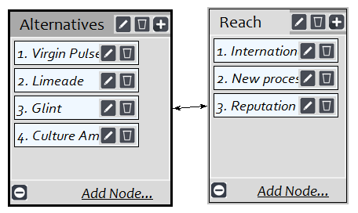
  - In the organizational subnet, I placed the following criteria:
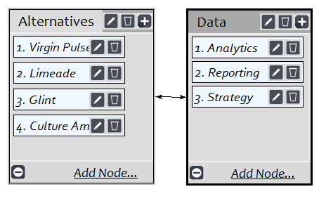
- Costs
  - The two main control criteria were economic and organizational.
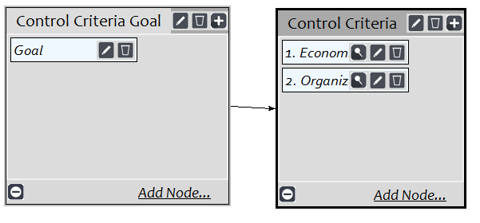
  - In the economic subnet, I placed the following criteria:
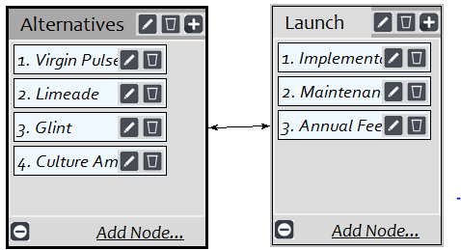
  - In the organizational subnet, I placed the following criteria:
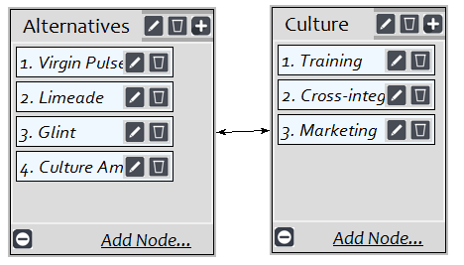

- Risks
  - The two main control criteria were economic and organizational.
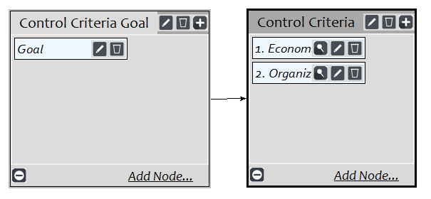
  - In the economic subnet, I placed the following criteria:
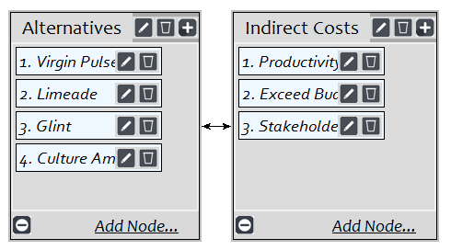
  - In the organizational subnet, I placed the following criteria:
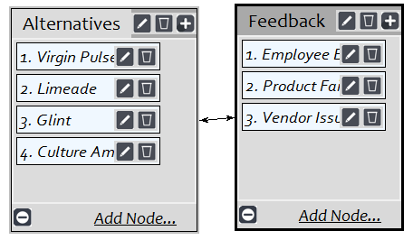

Results
- Benefits: Virgin Pulse
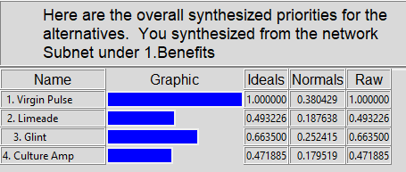

- Opportunities: Virgin Pulse
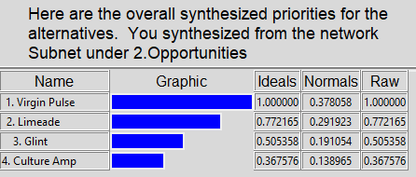
- Costs: Virgin Pulse
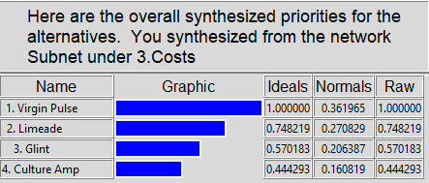
- Risks: Virgin Pulse
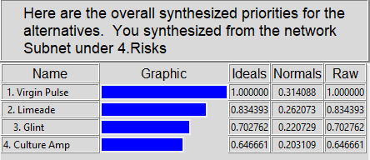

Sensitivity Analysis
- Benefits
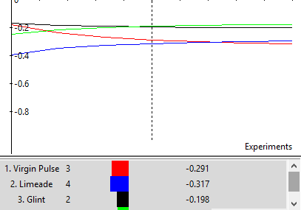
- Opportunities
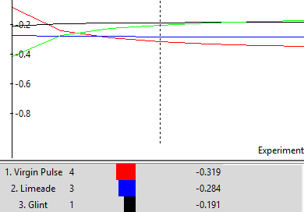
- Costs
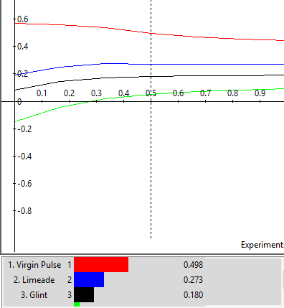
- Risks
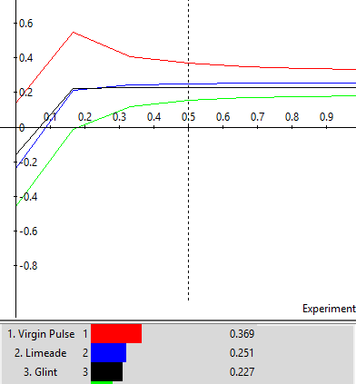

Conclusion
Selecting Virgin Pulse as the best choice for the HR AI Wellbeing platform appears to be clear. The vendors were similar in many aspects making the pairwaise comparisons a bit of challenge. I ultimately felt Virgin Pulse was the best decision based off their reputation, scalability, and international landscape.

References
- https://www.forbes.com/sites/joshbersin/2018/06/18/ai-in-hr-a-real-killer-app/#2fb5ee5648f1
- https://www.limeade.com/our-story/
- https://www.virginpulse.com/about-us/
- https://www.glintinc.com/
- https://www.cultureamp.com/plans-and-pricing/#top-banner

