When Should the United States Withdraw the Majority of Remaining Combat Troops from Iraq?

BQOM 2521 - Decision Making in a Complex Environment
Spring 2006
The Katz Graduate School of Business

Tori Hinde
Elena Koneva
Nichol Mason

April 12, 2006

Table of Contents

Introduction………………………………………………………………………………2
Alternatives………………………………………………………………………………3
The Model………………………………………………………………………………..5
Benefits Synthesis……………………………………………………………………..13
Opportunities Synthesis……………………………………………………………….14
Costs Synthesis………………………………………………………………………..15
Risks Synthesis………………………………………………………………………..16
Results………………………………………………………………………………….17
Benefits Sensitivity…………………………………………………………………….19
Costs Sensitivity……………………………………………………………………….20
Opportunities Sensitivity………………………………………………………………21
Risks Sensitivity………………………………………………………………………..22
Definition of Terms…………………………………………………………………….23
Introduction

December 7, 1941 was quoted as “a day that will live in infamy” by President Franklin Roosevelt. The attack on Pearl Harbor was a day when America mourned, not only for our servicemen, but for our lost sense of security. However, that day of infamy was a day for another generation. Those horrendous images of citizens crying in the streets, of rescue workers covered in debris, and a president stating we were no longer safe in our own country, had long since faded from the memories of Americans. That is until September 11, 2001. This is the day that will live in infamy for a new generation of Americans. This day started out just as any other - with daycare, school, and work, but ended with tears, fear, and a need to understand how we could not be safe in our own homes.

In the days that followed, President George W. Bush, as well as Congress, pledged to do everything in their power to ensure the future safety of the United States of America, and her citizens. As a result, swift action was taken. The Middle Eastern terrorist group Al-Qaeda was found responsible for the horrific 9/11 attacks. Congress authorized forces to go into Afghanistan, which was determined to be Al-Qaeda’s breading grounds, and eliminate all forces deemed hostile towards the US.. Operation Enduring Freedom began October 7, 2001, and for a few brief moments Americans thought they were safe.

Then came news that Saddam Hussein was manufacturing Weapons of Mass Destruction in Iraq. Saddam had not learned from Operation Desert Storm in 1991. He was now not only torturing and murdering his own people, he had sinister plans for the U.S.A. Action had to be taken, and on March 20, 2003 Operation Iraqi Freedom ensued. By April 9, 2003 Baghdad had fallen and Saddam’s tyrannous rule had ended. Now, three years later, it has become necessary to identify strategies to withdraw troops from Iraq and allow Iraq’s government and citizens to take charge of their own country.

The question this paper attempts to answer is “When should the majority of remaining U.S. combat troops withdraw from Iraq. Five alternatives were identified:
Withdraw Within 1 year – Withdraw the majority of US combat troops by April 2007.
Withdraw in 2-5 years – Withdraw the majority of US combat troops during the period of April 2008 and April 2011.
Withdraw After 5 years – Withdraw the majority of US combat troops after April 2011.
Iraq Government Request to Withdraw – Withdraw the majority of US combat troops according to a timeline established by the Iraqi government.
Withdraw Within 3 Months and Redeploy Troops Within the Region – Pull combat troops from Iraq and redeploy them to Qatar, Turkey, Kuwait, Bahrain, and UAE.

Alternatives
Our alternatives were strongly influenced by the following key stakeholders and/or players:
- US President
- US Pentagon
- US Congress – divided into Democratic and Republican views
- US Citizens
- US Allies
- US Adversaries
- Iraqi Government
- Iraqi Religious Sects

The following five alternatives were used in our ANP model:
- U.S. to withdraw a majority of its troops from Iraq within 1 year

From a US perspective, this alternative is supported by the majority of its Citizens and many Democratic Party members. Many Democratic Congressional Senators and Representatives supported this alternative by proposing a plan that called for immediate withdraw of the US troops from Iraq. Supporters of this alternative believe the military mission has been completed and the progress must continue diplomatically. In addition, they also believe the US military is a target of the Iraqi insurgency and their presence promotes continued violence. Ultimately, the U.S. does not want its actions of withdrawal to be construed as a lack of credibility, commitment or staying power to accomplish its goal of winning the war in Iraq, but the Iraqi government must start to operate independently.

This alternative would require that the President and Congress agree that Iraq has sufficiently built a constitutional, representative government, sound economy and has sufficient forces to maintain order and fight terrorists/insurgency.

From an Iraq perspective, this alternative is supported by some Sunnis and other Iraqi sects that do not support the democracy initiatives. These supporters believe they have a greater opportunity to promote their government philosophies and polices should the US military to be there to interfere.

- U.S. to withdraw a majority of its troops in the next 2 to 5 years

From a US perspective, this alternative is primarily supported by the Republican Party and the Pentagon. This initiative is seen as a reasonable timeline for withdrawal from Iraq that would allow the following objectives to be accomplished:
  - Significant progress in the Iraqi political process
  - Consolidation of gains in training the Iraqi Security Forces
  - Commitment to and implementation of economic reforms by Iraqi leaders
  - Increased cooperation of Iraq’s neighbors
  - Expanded support from the international community
  - Continued support of the American people

It seems reasonable to assume that once U.S. military support and presence is substantially scaled back; ongoing consulting support by the US government and other Coalition members is still required to move Iraq along successful continuum.

From an Iraqi perspective, this alternative is supported primarily by the Kurds and Women. These Iraqi groups believe that the US military provides them a means of leverage and possibly protection as the democratic government is formed within their country.

- U.S. to withdraw a majority of its troops after 5 or more years

This alternative is a major component incorporated in President Bush’s National Victory Strategy. This strategy is broken down into three major tracks, that when achieved, would signal an appropriate time to withdraw U.S. forces from Iraq:
- Political Track involves working to forge a broadly supported national compact for democratic governance to guide the Iraqi citizens.
  - Metrics to determine success:
    - Benchmarks set forth in U.N. Security Council Resolution 1546
    - The number of Iraqis from all areas willing to participate in the political process as evidenced by the voter registration and turnout
- Security Track involves carrying out a campaign to defeat the terrorists and neutralize the insurgency, developing Iraqi security forces and strengthening the new government ability to protect the democracy.
  - Metrics to determine success:
    - Quality and quantity of Iraqi units
    - Number of actionable intelligence tips received from the Iraqis
    - Percentage of operations conducted by Iraqis alone or with minor coalition assistance
    - The number of car bombs intercepted or defused
    - Offensive operations conducted by Iraqi and Coalition forces
- Economic Track involves setting the foundation for a sound, growing and self-sustaining economy.
  - Metrics to determine success:
    - GDP
    - Per capital GDP
    - Inflation
    - Electricity generated and delivered
    - Barrels of oil produced and exported
    - Number of businesses opened

- U.S. to withdraw a majority of its troops upon the request of the Iraq government

This alternative assumes the U.S. President and Congress believe that Iraq’s long term viability would not be hindered, should the Iraqi interim government request the withdrawal of U.S. troops. Steady growth and support of the leading Shiite bloc, Sadr faction, in the Iraqi parliament could also promote Iraq’s decision to request the removal of U.S. troops. Per statistics from the CATO Foundation, 70% of Iraqi’s favor a timeline approach over the next two years. In the event that the general Iraqi population no longer favors US military presence, this could also trigger the Iraqi request for US military withdraw.

- U.S. to withdraw within 3 months and redeploy troops within the region.
This alternative was proposed and supported primarily by the Democratic Party. Congressman Jack Murtha has proposed the following three step process to:
  - Redeploy to the periphery – areas such as Kuwait, Bahrain, UAE, Turkey and or Qatar. The military forces deployed to these areas will serve a quick reactionary force available for deployment when necessary. It will allow the US military to recuperate and rejuvenate its personnel and prepare them for other military projects.
  - Reallocate Iraqi war funds to assist with internal security enhancement, increase benefits for military personnel and increase budgets for the State Department programs related democracy promotion.
  - Reengage with other countries around the world to assist with Iraq transformation and develop strategies to continue fighting terrorism nationally.
This alternative is seen as incentive to the Iraqi government and military forces to take control of their country. The supporters of this alternative also believe that US troops are impeding Iraqi progress by inciting insurgency attacks and creating an atmosphere of civil war.

The Model
ANP Model Description: (The model description is from the Encyclicon, by T. Saaty and M Ozdemir has been used as the example for our model report)
The Analytical Network Process model developed for this final project has four feedback sub-networks of control criteria: Benefits, Opportunities, Costs and Risks (BOCR). Each of these criteria has the set of its own sub-networks which contains control criteria and subcriteria defined specifically for each aspect of the analysis (set of control criteria for Benefits, the separate set of criteria for Cost etc,). All strategic, control criteria as well as subcriteria were determined through the research of the appropriate literature and consulting the professionals and appear to have importance during determining the outcomes and policy making decision (see the methodology part for more details). Sources include: National Strategy for Victory in Iraq, the Strategic Redeployment file from the Center for American Progress, the Iraq report to congress "Measuring Stability and Security in Iraq", and the House Budget Committee documents on the costs to date and costs to go of the Iraq war, as well as excepts from the House of Representatives website, and the research done by the professors at the Graduate School of Public and International Affairs at the University of Pittsburgh.

The assessment criteria used to identify the priorities of the BOCR merits are shown below:

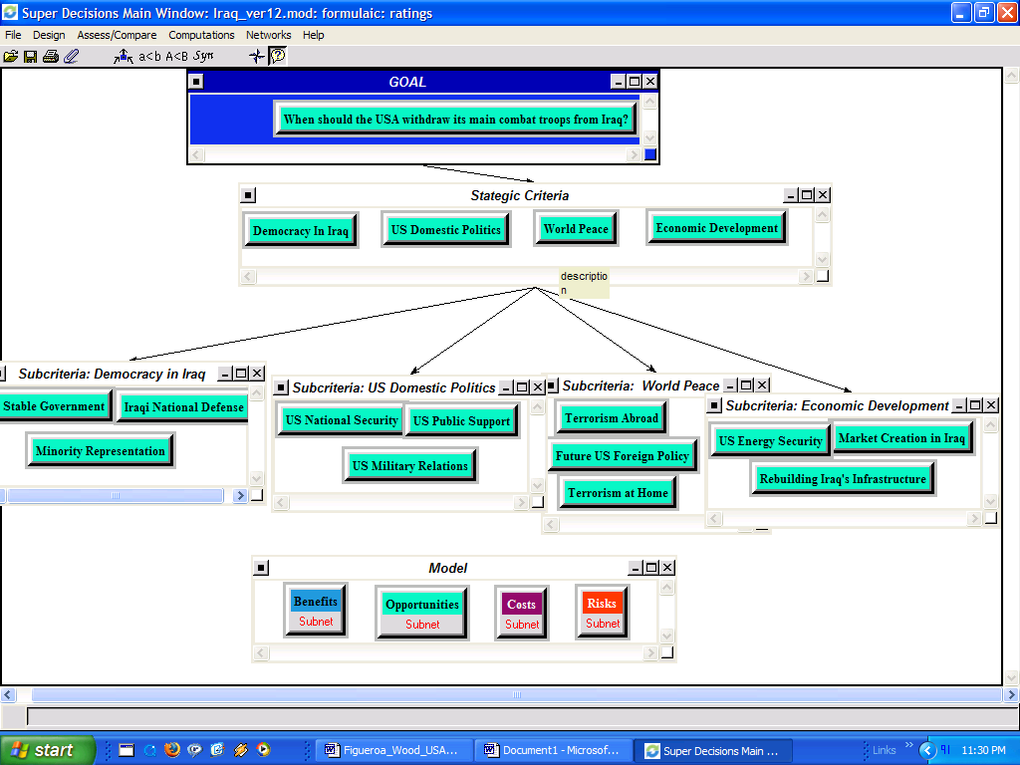

These criteria are Democracy in Iraq, US Domestic Politics, World Peace and Economic Development. All these criteria have subcriteria under them. For the strategic criterion Democracy in Iraq they are the following: Stable Government, Iraqi National Defense and Minority Representation; for the strategic criterion US Domestic Politics the subcriteria are the following: US National Security, US Public Support and US Military Relations; for the strategic criterion World Peace: Terrorism Abroad, Future US Foreign Policy, and Terrorism at Home; for the strategic criterion Economic Development the subcriteria include the following factors: US Energy Security, Market Creation in Iraq and Rebuilding Iraqi Infrastructure (see the definitions for each criterion in appendix).

Criteria | Subcriteria
Democracy in Iraq | Stable Government
 | Iraqi National Defense
 | Minority Representation
US Domestic Politics | US National Security
 | US Public Support
 | US Military Relations
World Peace | Terrorism Abroad
 | Terrorism at Home
 | Future US Foreign Policy
Economic Development | US Energy Security
 | Market Creation in Iraq
 | Rebuilding Iraq's Infrastructure

The following table illustrates the Benefits, Opportunities, Costs, and Risks (BOCR) that were identified for the evaluation of the 5 withdrawal alternatives. The BOCR represent the merits by which the criteria and subcriteria are compared.

Merits | Criteria | Sub-criteria | Merits | Criteria | Sub-criteria
Benefits | Economic | Iraq Economy | Costs | Economic | US Budget Deficit
 |  | US Economy |  |  | International Coalition Costs
 |  | World Economy |  | Political | Creating New Enemies
 | Political | Creating New Allies |  |  | Potential Government Corruption
 |  | US Bargaining Power |  |  | Iraq Initiative
 |  | US Presence in the Region |  | Security | Civil War in Iraq
 |  | Iraq Initiative |  |  | Destabilization of the Region
 | Security | Deterrence |  | Political | US Reputation
 |  | Anti-Terrorism | Risks |  | Iraq Initiative
 |  | Insurgency Warfare Training |  | Security | Increased Terrorism
Opportunities | Economic | US Economy | Opportunities | Political | Protection of US Allies
 |  | Iraq Economy |  |  | Spread of Democracy
 |  |  |  |  | Democracy in Iraq
 |  |  |  |  | Iraq Initiative

The four merits of BOCR were rated according to five intensities (very high, high, medium, low, and very low). The sample is shown in the table below. The intensities were derived from a pairwise comparison of all criteria and subcriteria.

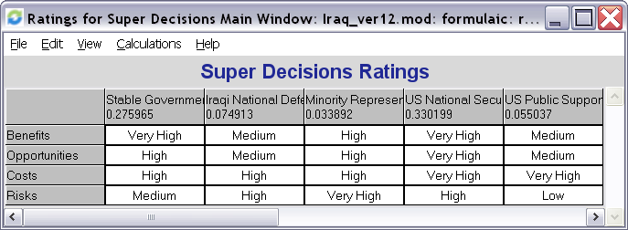

The intensities also have a numeric representation, shown in the table below:

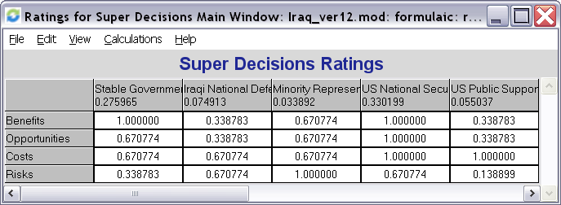

The BOCR model has its own set of control criteria, as has been mentioned above, and each of the control criteria is weighted based on importance. For example there are three Benefits control criteria: Economic (0.614), Political (0.268) and Security (0.117). The priorities or weights attached to each are obtained through pairwise comparison of their importance or impact. Again, the priorities for the criteria and subcriteria were obtained from pairwise comparison.

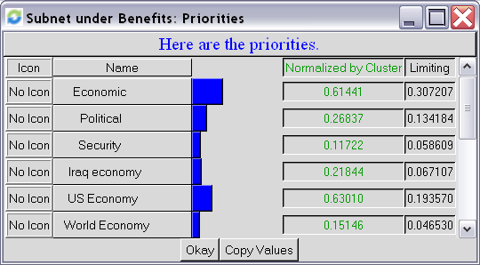

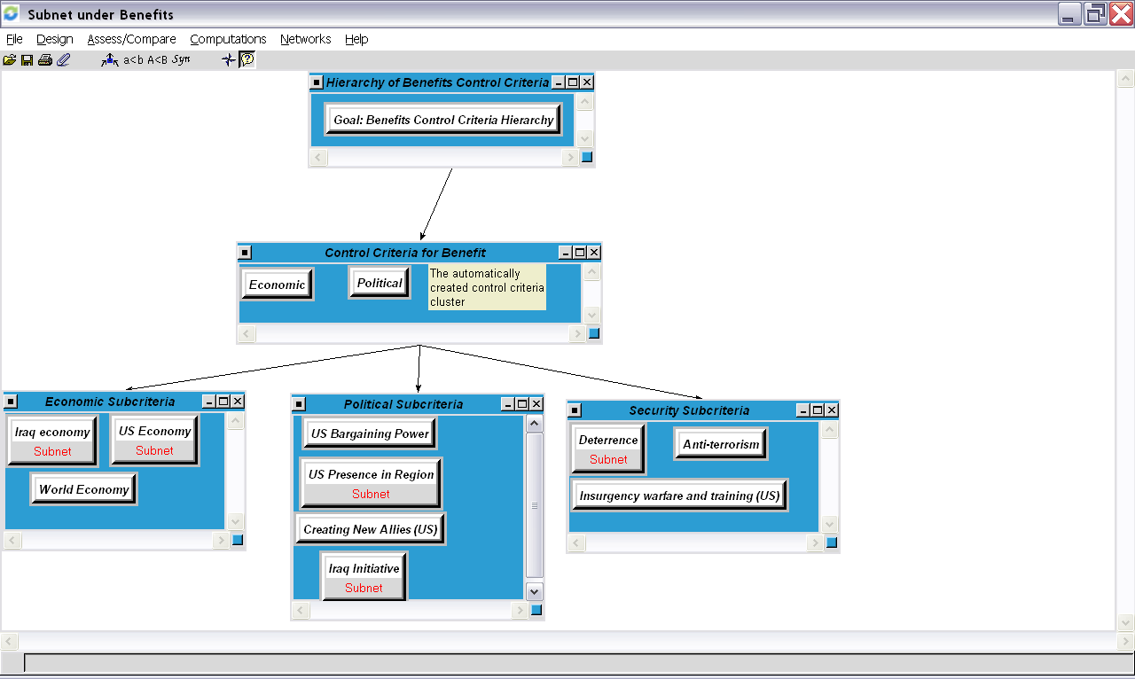

Each control criterion under the Benefits has the group of subcriteria. For instance, Economic control criterion has three subcriteria: Iraq Economy, US Economy and World Economy; Political control criterion has four subcriteria: US Presence in the Region, Iraq Initiative, Creating New Allies (US) and US Bargaining Power; Security control criterion has three subcriteria: Deterrence (of the potential enemies of the USA), Anti-terrorism and Insurgency warfare and training (US).

The subcriteria that received the highest priorities and the ones that we decided to explore in more details were used to determine the result. In our case for the Benefits part of the model they are Iraq Economy, US Economy as the subcriteria for the Economic control criterion; US Presence in Region and Iraq Initiative for the Political control criterion; and Deterrence for the Security Control criterion. For the demonstration and explanation purposes the Benefits subnet is being used.

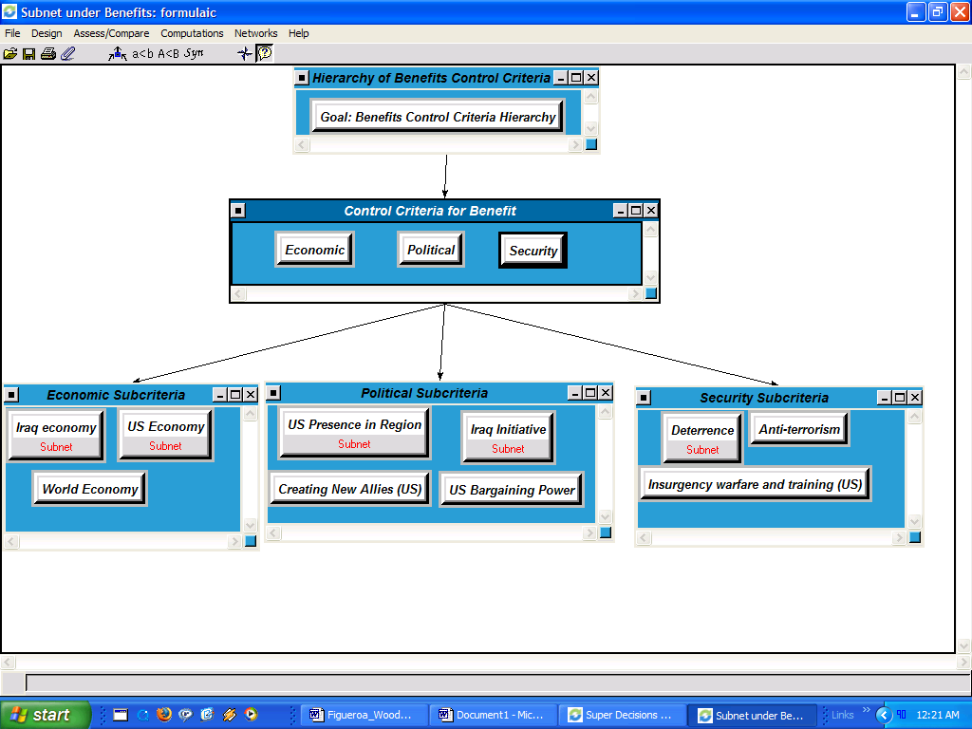
To demonstrate the relationships between clusters in the model (US Market Factors, Public Opinions, Dominant Parties and Alternatives) and the nodes in the clusters (Iraq Government request to withdraw, Redeploy Troops Within the Region, Withdraw after 5 years, Withdraw in 2-5 years, Withdraw within 1 year- nodes in the Alternatives cluster; Congress and President nodes for the Dominant Parties cluster; Press and US Citizens for the Public Opinion cluster; Oil Industry, Access to oil supply, US defense industry, US economic expenditure of war are the nodes in the US Market Factors cluster). We would use US Economy subnet. Similar but not exact logic was applied to the rest of the model. The structure of the US Economy subnet could be seen below:
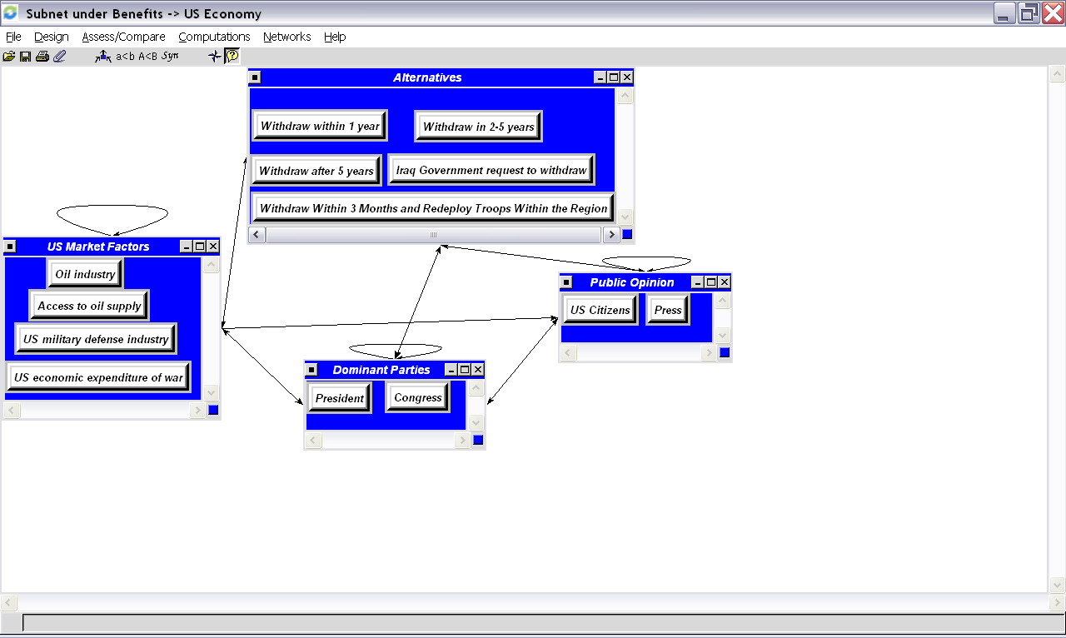

By being in Iraq, the US Economy benefits through participation of the Defense industry which sells various military goods and services to both US (arms, contracted soldiers, etc) and the new Iraqi Military (ammunition, consulting etc), the US economic expenditure of the war has two sides in the short run US Economy would benefit if US spends less time in Iraq accordingly spends less money, in the long run the US Economy would benefit through the government expenditure: government orders to various companies to provide for troops in Iraq, it generate demand in the economy, it boosts the economy and creates new jobs. A number of sources mentioned that one of the reasons why the USA decided to participate in the war is to secure oil supply, as Saddam had previously set oil fields on fire during Operation Desert Storm. That is why the oil industry and the whole economy would benefit from the future oil contracts (there is a large oil dependency in the economy, so the oil price has an effect on the whole chain of production and consumption processes). In the model the relationship between the node Oil Industry and the node Access to oil supply is shown by the loop above the cluster.

The President and Congress are the main parties that would effect the decision on how long the US troops would stay in Iraq and accordingly that decision would affect the market factors and their benefits.

The USA is a democracy, meaning the press and US citizens play an important role in the decision making process and articulating the policy issues. They were included in the model in order to incorporate all parties involved in determining the withdrawal outcome. As you can see from the screen above there is a relationship between citizens and the press.

We would like to expand and explain just a little bit more on relationships between the nodes that are represented in the model by the arrows. For example in the screen shot below, one could see the nodes and clusters outlined in red, it means that the President takes into the account Congress and US Citizens when he makes a decision as to which alternative to choose, that decision effects the US Market Factors, at the same time the US Market Factors try to lobby for their interests and have the potential to influence the President’s decision. From the statements made by the President to media and Congress, he would prefer to stay in Iraq as long as it is required (the alternative to withdraw after 5 years) but given certain circumstances probably would agree to alternative to withdraw 2-5 years.

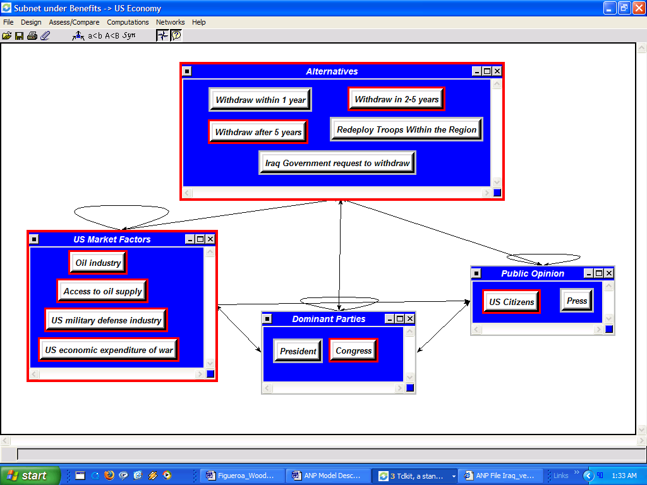

The same rules were applied for all BOCR model criteria (Opportunity, Cost and Risk).

Synthesis

Benefits Synthesis – As seen below, the options with the highest benefit is to withdraw after 5 years. The next best alternative is redeploy troops, followed by withdraw in one year and withdraw in 2-5 years. The worst alternative, in relation to benefits, is to allow the Iraq government to determine the timeline.

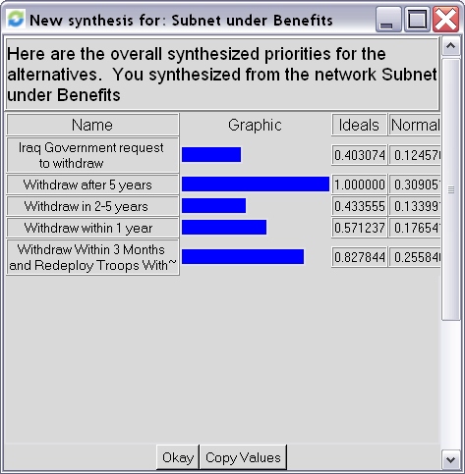

Opportunities Synthesis – As seen below, the options with the highest rate of opportunities is redeploy troops. The next best alternative is withdraw after 5 years, followed by withdraw in 2-5 years and is to allow the Iraq government to determine the timeline. The worst alternative, in relation to opportunities would be to withdraw in one year.

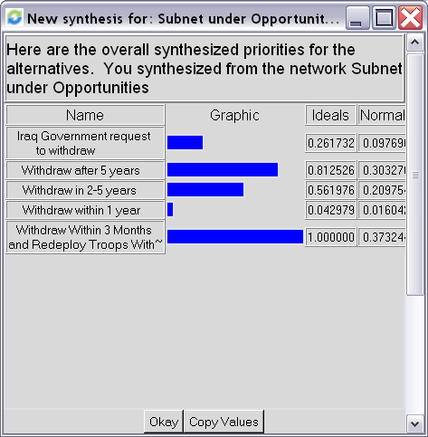

Costs Synthesis – As seen below, the options with the highest cost is to withdraw after 5 years. The next costliest alternative is to redeploy troops, followed by allowing the Iraq government to determine the timeline and withdraw in one year. The least costly alternative is to withdraw in 2-5 years.

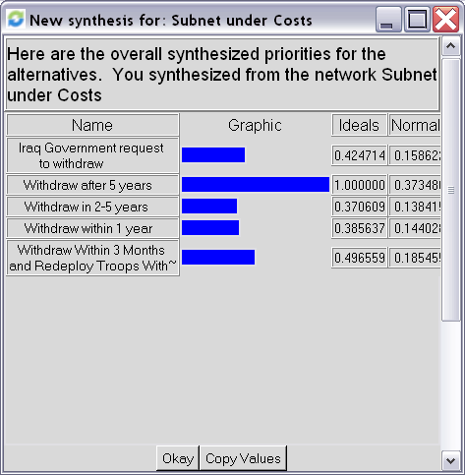

Risks Synthesis – As seen below, the options with the most amount of risk is to withdraw within 1 year. The next riskiest alternative is to allow the Iraq government to determine the timeline, followed by redeploying troops and withdraw within 5 years. The least risky alternative is to withdraw in 2-5 years.

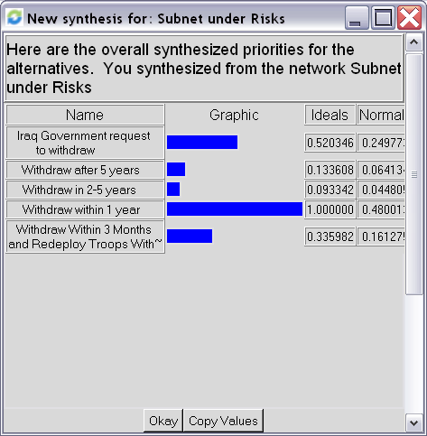

The synthesized results of the entire model which took into account the weighting factors of the strategic rating model discussed previously in this report is demonstrated in the table below. The outcome indicates that the highest rated alternative for the short run is to withdraw major US combat troops in 2-5 years.

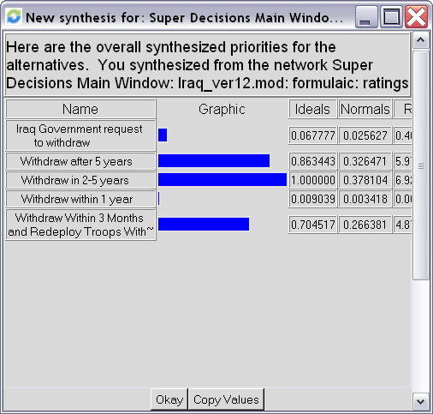

As the goal of this project was to determine the optimal US troop withdrawal strategy, it become necessary to look at the long run results. The long run results, and those that should be used, indicate the alternative with the best results for all participants is to redeploy the US troops within the region.

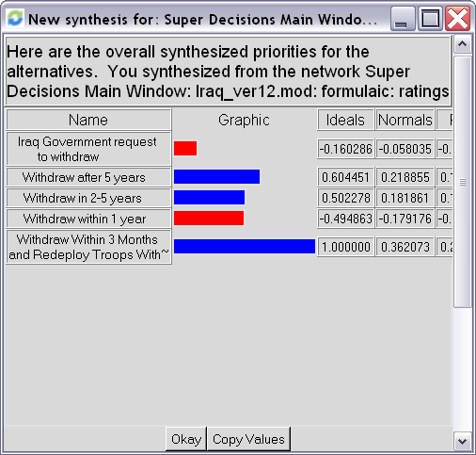
Sensitivity Analysis

Sensitivity Analysis – Benefits Priority

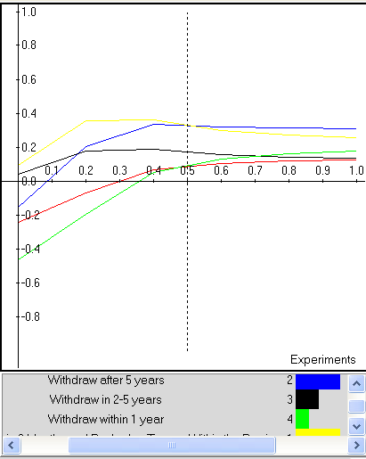

Based on our judgments and synthesized results, the benefits sensitivity analysis indicates that the alternative “Withdraw within 3 months and Redeploy Troops within the Region” is consistently higher as we approach the 0.5 weighting. As we increase the value level of benefits, alternative “Withdraw after 5 years” has more benefits.

The following sub-criteria could be identified as key drivers relating to benefits and its prioritization:
- Deterrence
- US Presence in the Region
- Iraq Initiatives
Sensitivity Analysis - Costs
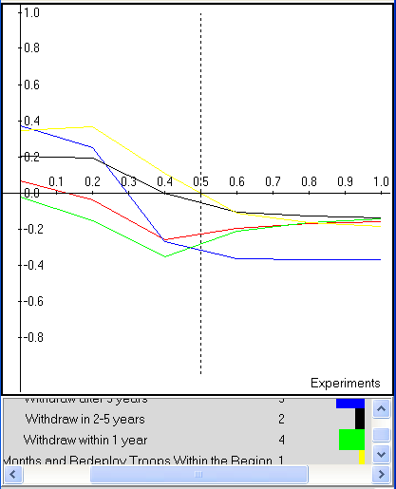

Based on our judgments and synthesized results, the cost sensitivity analysis indicates that the alternative “Withdraw within 3 months and Redeploy Troops within the Region” is consistently higher as we approach the 0.6 level. As we increase the value level of costs, the alternative Withdraw within 2-5 years” becomes more costly.

The following sub-criteria could be identified as key drivers relating to costs and its prioritization:
- Creating new enemies
- Iraq Initiatives
- US Deficit

Sensitivity Analysis - Opportunities
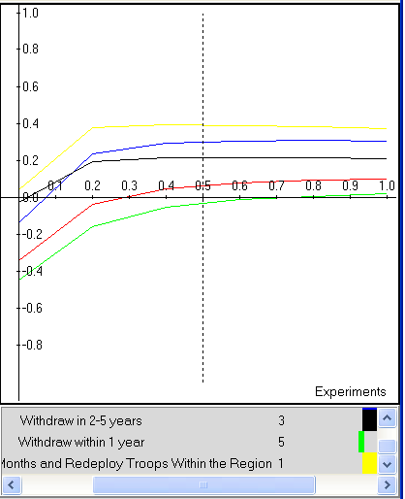

Based on our judgments and synthesized results, the opportunities sensitivity analysis indicates that the alternative “Withdraw within 3 months and Redeploy Troops within the Region” is consistently higher at all levels of importance.

The following sub-criteria could be identified as key drivers relating to opportunities and its prioritization:
- Protection of Allies
- Iraq Economy
- US Economy

Sensitivity Analysis - Risks
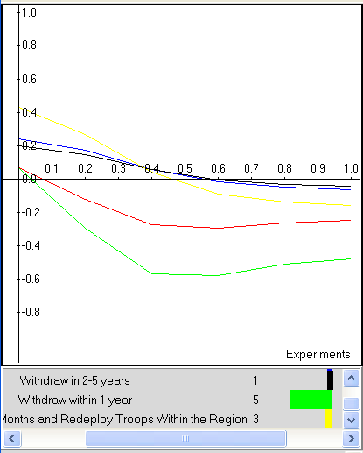

Based on our judgments and synthesized results, the risks sensitivity analysis indicates that the alternative “Withdraw within 3 months and Redeploy Troops within the Region” is consistently higher as we approach the 0.4 level. As we increase the value level of risks, the alternatives “Withdraw within 2-5 years” becomes more risky, followed closely by “Withdraw after 5 years”.

The following sub-criteria could be identified as key drivers relating to risks and its prioritization:
- Increased terrorism
- Iraq Initiatives
- US Reputation

Definition of Terms
Withdraw Within 1 year – Withdraw the majority of US combat troops by April 2007.
Withdraw in 2-5 years – Withdraw the majority of US combat troops during the period of April 2008 and April 2011.
Withdraw After 5 years – Withdraw the majority of US combat troops after April 2011.
Iraq Government Request to Withdraw – Withdraw the majority of US combat troops according to a timeline established by the Iraqi government.
Withdraw Within 3 Months and Redeploy Troops Within the Region – Pull combat troops from Iraq and redeploy them to Qatar, Turkey, Kuwait, Bahrain, and UAE.

Access to Oil Supply – The U.S.’s ability to gain access to Iraq’s oil supply
Adversaries – Those countries currently opposed to the U.S. or the democratic way of life.
Al-Qaeda – Militant group responsible for the 9/11 attacks.
Allies – Those countries that currently support the U.S.A. or the democratic process.
Anti-terrorism – Actions that prevent future terrorist attacks.
Arms Sales to Iraq – Sales of military equipment, such as munitions, to Iraq to support war efforts.
Bahrain – The country of.
China – The country of.
Civil War in Iraq – War between the Sunnis, Shi’ites, Kurds, and all other faction within Iraq.
Creating New Allies – The ability to establish a lasting amicable relationship with a country.
Defense Industry – The U.S. defense industry and its goods such as: ships, planes, weapons, tanks, etc.
Democracy in Iraq – The establishment of a government that is representative of its people.
Destabilization of the Region – The idea that the region will digress into civil war and bloodshed should troops withdraw.
Deterrence – The ability to squash terrorist feelings and training before they start.
Economic Development – The ability to establish a viable economy.
Education – The education of women and minorities that would allow them to become viable members of the Iraqi society.
FDI – Foreign Direct Investment
Financial Aid to Iraq – This is future financial aid, provided by the U.S. that would be needed to help Iraq.
Foreign Corporations – Non U.S. corporation vying to do business in Iraq.
France – The country of.
Future US Foreign Policy – The ability to set future U.S. foreign policy based on the results of the Iraq conflict.
Great Britain – The country of.
Human Life (Allies) – The loss of U.S. allies troops and civilians.
Human Life (Iraq) – The loss of Iraqi troops and civilians.
Human Life (US) – The lose of U.S. troops and civilians
Increased Terrorism – Increased attacks against U.S. troops or U.S. citizens
Insurgency Warfare and Training – Desert warfare and suicide bomber training.
International Coalition Costs – Costs incurred to coalition forces (excluding the U.S.A.) as a result of operations in Iraq.
Iran – The country of.
Iraq’s Access to the World Market – Iraq’s ability to trade globally.
Iraq Economy – The economy in the newly democratic Iraq.
Iraq Government – The newly democratic government of Iraq.
Iraq Initiative – Iraq’s government, military, police, and citizens, ruling and governing their own country with minimal assistance from coalition forces.
Iraq Insurgency – Those that revolt against the change in government and democratic philosophies.
Iraq Market Creation – The ability of the new Iraqi government to create a new market with viable and sustainable jobs for its citizens.
Iraqi National Defense – the newly trained Iraq forces and their ability to protect their countrymen.
Iraqi Overdependence on Coalition Forces – Iraq’s unwillingness to patrol its own country because coalition forces are doing it for them.
Italy – The country of.
Job Creation in Iraq – Creation of new types of jobs within Iraq that were not tolerated under Iraq’s previous government.
Kurds – Minority group that faced persecution under Saddam Hussein’s regime.
Kuwait – The country of.
Loss of Labor Force – Loss of labor due to those personnel being deployed as military.
Market Creation in Iraq – The ability of the new Iraqi government to create a new market with viable and sustainable jobs for its citizens.
Military Costs – Costs incurred due to troop deployment to Iraq.
Minority Representation – The representation of minority groups such as Sunnis, Kurds and Women.
Oil Industry – The OPEC oil industry.
Oil Price – The ability of the coalition troops and the new Iraqi government to help stabilize oil prices and production from Iraq.
Other Non-Iraqi Militant Groups – Militant groups based outside of Iraq, fighting or encouraging revolt within Iraq.
Other US Corporations – US corporations, other than those in the defense industry, wanting to do business with or in Iraq.
Outsourcing to Iraq – Outsourcing jobs to Iraq just as corporations have outsourced to countries like China and India.
Overextension of US Troops – U.S. troops spread too thinly over several areas, or the exhaustion of troops, causing them to work less efficiently.
Pentagon – The department responsible for all military branches.
Poland – The country of.
Political Stability in Iraq – Governmental stability resulting in change only through election.
Potential Government Corruption – The potential for corruption in Iraq should coalition forces withdraw.
Potential Exposure of US Military Secrets and Strategy – Exposure of sensitive information due to the capture of US military troops.
President – President George W. Bush
Press – The US press core covering the war in Iraq.
Protection of US Allies – Protecting those countries that could be at risk due to their allegiance to the U.S.A. and democratic principles.
Qatar – The country of.
Rebuilding Iraq’s Infrastructure – Rebuilding those services and building necessary to establish a politically, economically, and socially viable country.
Redistribution of Wealth – change in the distribution of wealth due to the creation of new jobs and markets.
Religious Militant Groups – Militant groups within Iraq that justifies revolution and violence through religion.
Russia – The country of.
Sale of other US Goods and Services – Sale of goods and services other that those tied to the defense industry.
Shi’ites – The Islamic group with majority representation in the new democratic government.
Spread of Democracy in the Region – The potential to spread democracy throughout the Middle East as a result of its adoption in Iraq.
Stable Government – A viable, functioning government, changing only through election.
Sunk Costs – Money already spent on war efforts.
Sunnis – The Islamic group that had majority representation under Saddam Hussein’s regime.
Syria – The country of.
Terrorism Abroad – Terrorism throughout the world (excluding the U.S.)
Terrorism at Home – Terrorism that take place on U.S. soil.
Training of Iraqi Labor – Training Iraqi citizens to maintain and advance their economic efforts.
Turkey – The country of.
UAE – United Arab Empire.
US Bargaining Power – The ability of the U.S. government to negotiate with foreign powers as a result of their actions in Iraq.
US Budget Deficit – Overspending of the US government to ensure the safety of the US public.
US Citizens – The US voting public.
US Congress – The currently congressional body.
US Domestic Politics – The ability of US executive and legislative bodies to deal with domestic issue, while still concentrating on war efforts.
US Economic Expenditure of the War – The estimated amount of money to be spent on Iraq war efforts.
US Economy – The potential benefit to the US economy.
US Energy Security – The stabilization of energy prices due to a stabilization of the Iraqi government.
US Military Relations – The morale of US troops and their relationship with those in command.
US National Security – The safety and security of US citizens.
US Presence in the Region – The presence of US troops within the region causing stability or revolution.
US Public Support – The support of US citizens for the strategies implemented by the US government.
US Reputation – The reputation and any effect on the US reputation as a result of decision made concerning Iraq.
Women Participation in Economy – The new role of women as a result in the change of Iraqi government.
World Bank – The World Bank and potential funds provided by the World Bank.
World Community – All nations excluding Iraq and the US, as they are evaluated individually.
World Economy – All economies excluding US and Iraq, as they are evaluated individually.
World Humanitarian Organizations – Humanitarian organizations that have and will aid the Iraqi government.
World Peace – Reducing the amount of violence currently endured by persons worldwide.

National Security Council. National Strategy for Victory in Iraq. November 2005.
Christopher Preble. Who Will Decide When We Leave Iraq?. www.cato.org.com. Accessed on April 3, 2006.
A definition of terms is included in the appendix.

