Bob Johnson
BQOM 2521 – Assignment M3:C
March 19, 2019

Problem Decision:
This coming weekend I will be traveling to New York City to visit my brother. As part of my planning process, I had to select a hotel that I would be staying at for the three nights that I will be in Manhattan. When previously visiting him, I had stayed at his apartment, so this was a new decision-making process for myself. His apartment is in the Kips Bay area of Manhattan, and ideally, I would like to be within walking distance of his place. At the same time, I will be driving into the city, so hotel parking (preferably affordable) is also high on my wish list. I wanted to stay in a nice hotel, but at the same time it did not need to be the Ritz Carlton. After some research, my alternatives lined up as follows:
Relational Model:
Alternatives:
- Lex Hotel NYC
- Park South Hotel
- The New York EDITION
Criteria:
- Location
- Hotel Parking
- Price
- Amenities
Below is a screenshot of my model in the Super Decisions software – sorry about the sizing in the software:
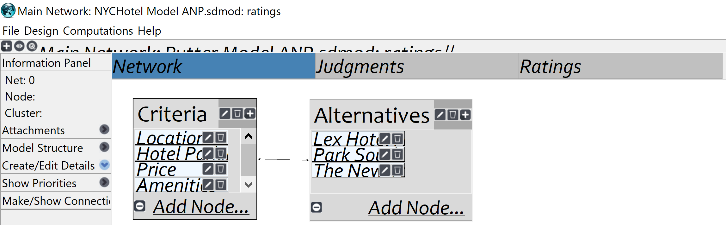
Below are screenshots of the profiles of criteria for the alternatives:
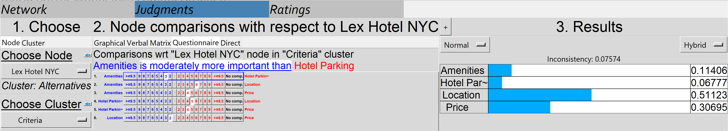
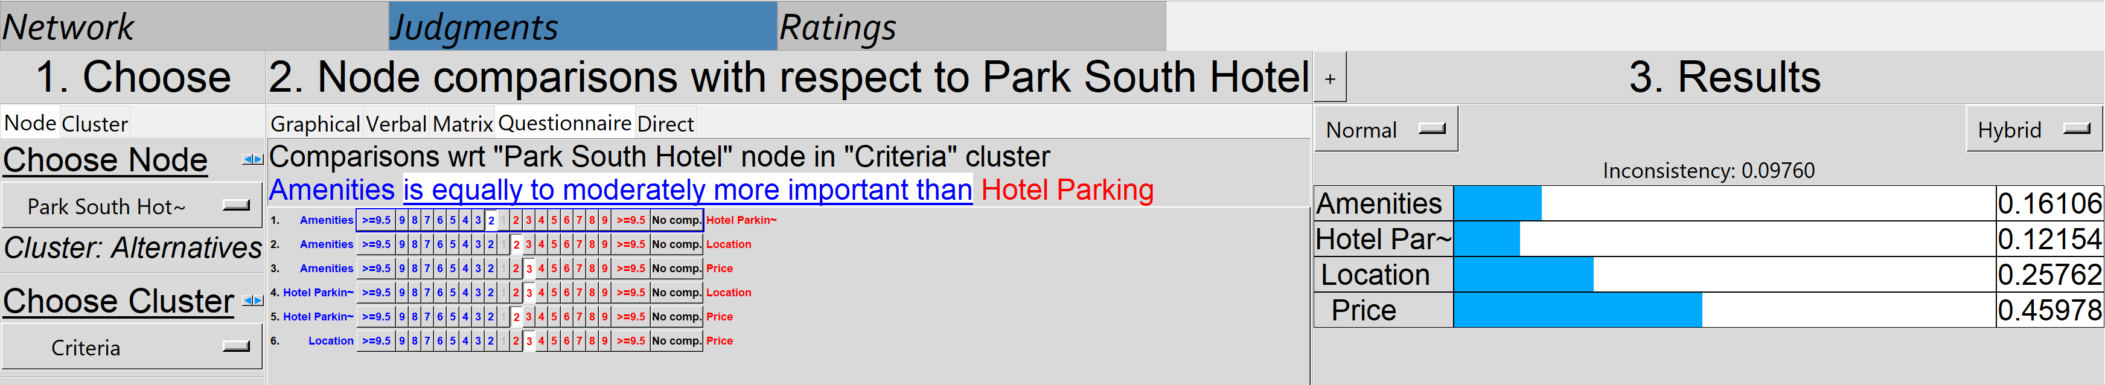
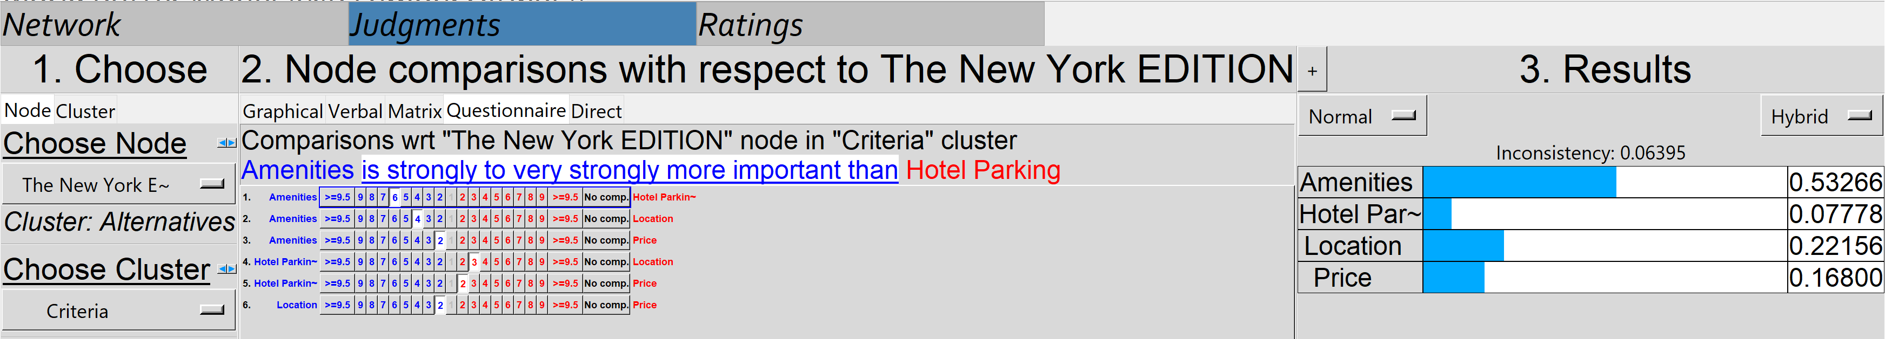
Below you can find screenshots of pairwise comparisons of criteria for each alternative:
- The Lex NYC
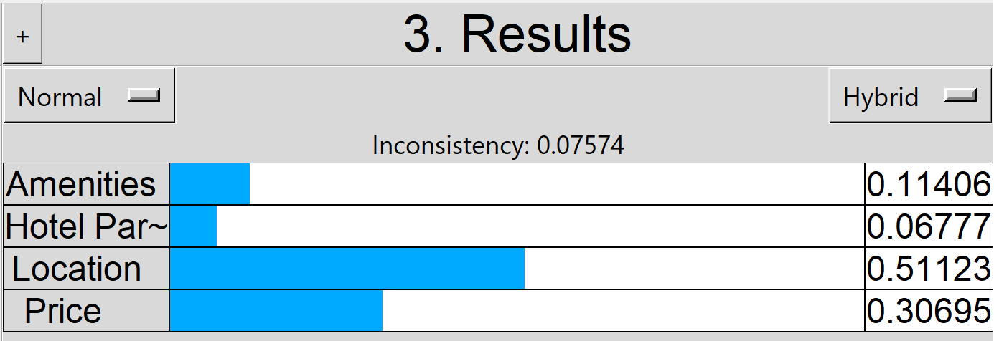
- Park South Hotel
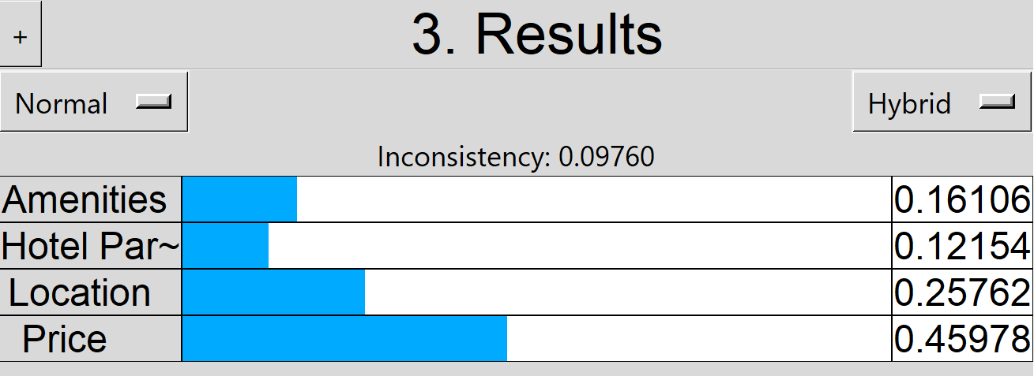
- The New York EDITION
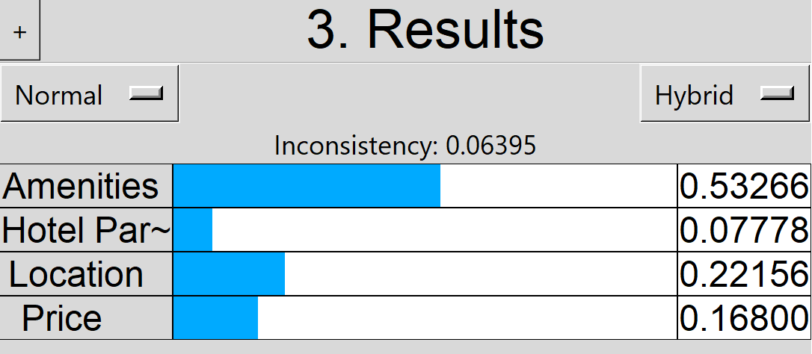

You will find screenshots of the unweighted super matrix and overall priorities below:
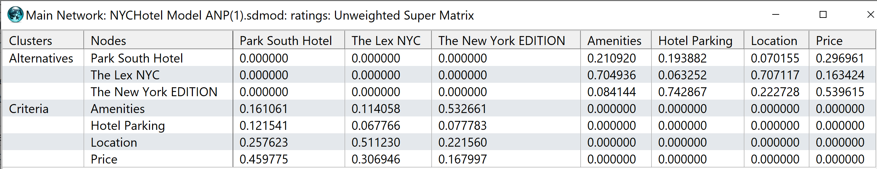
Judgement priorities:
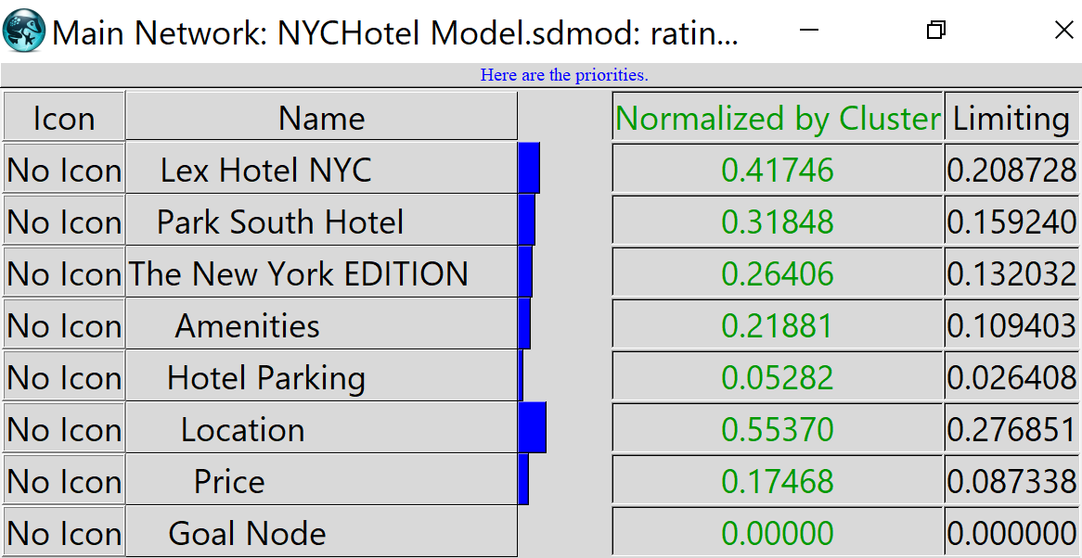
Ratings Priorities:
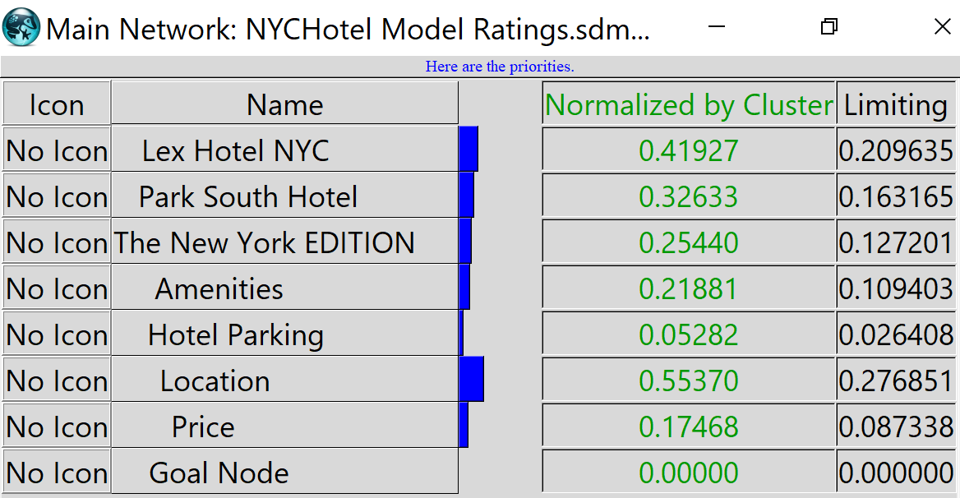
ANP Priorities:
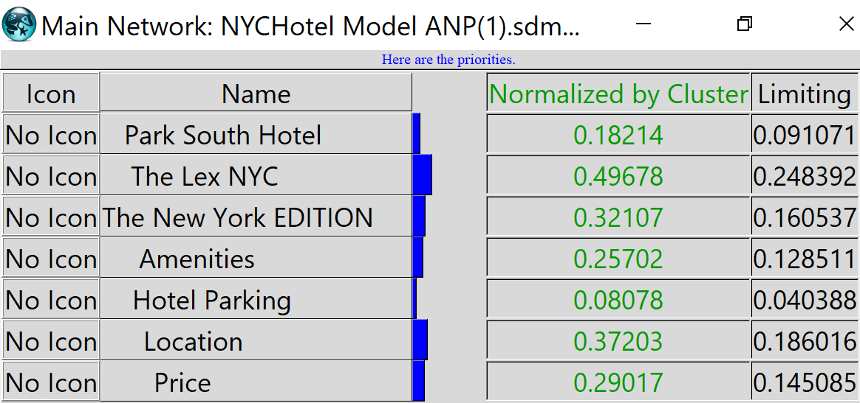
You can see a clear change in my priorities from judgements and ratings to ANP. I believe they are now more accurate because I have a better idea of what I am looking for from my decision in the ANP.
Also, here is a screenshot of the limit super matrix from the software:
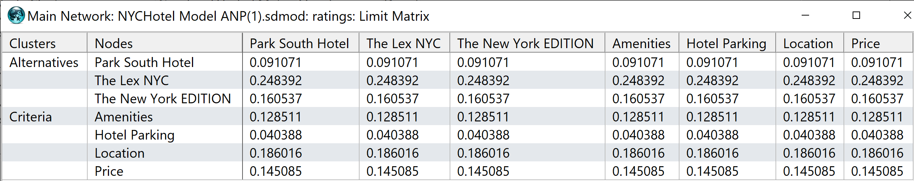
Now, to move on to the results and how they compare to previously completed models:
Judgements:
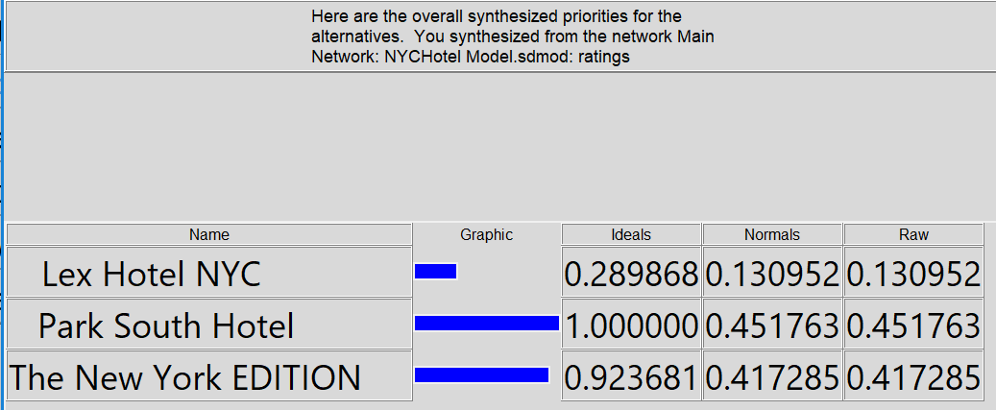
Ratings:
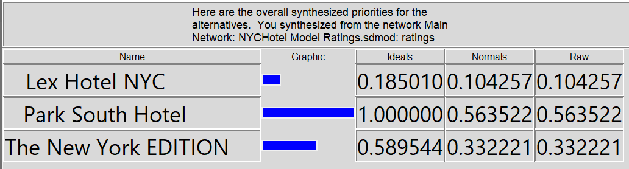
ANP Synthesis:
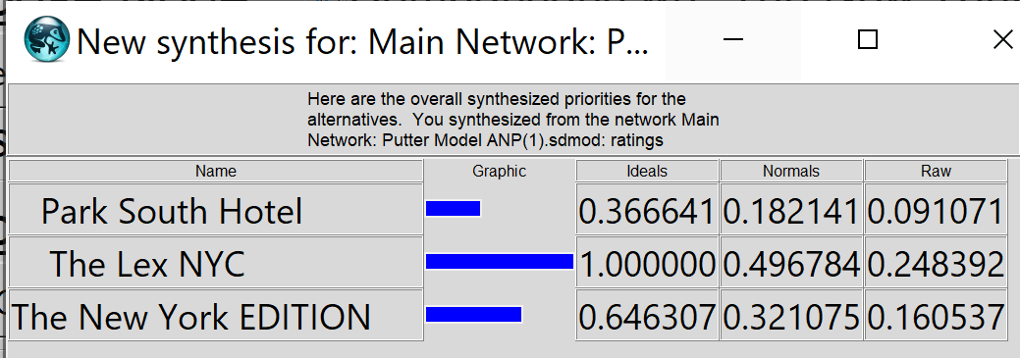
After completing the ANP, the results shifted drastically. Now, The Lex was the optimal decision according to the model, and Park South had fallen to the third best option. This is likely due to my priorities and their importance varying some from earlier models – however, I am a bit surprised that it swayed this much.

